
—------------ PROJECT of PROGRAMMING in C—-----------


Issue Description:

The project is about an efficient and robust way of management of student’s academic performance data .
Managing students academic records (subjects marks percentage,assigning grade) is a fundamental requirement of any educational institute . Performing these tasks manually (excel or other spreadsheets) is time-consuming and prone to human error and lacks the structural integrity needed for long-term data management.

The challenge addressed by this project is to make a single, reliable structure capable of accurately capturing this info and stores it accordingly.This system must overcome the limitations of flat-file processing by incorporating secure input handling and implementing a safe method for record removal that ensures the integrity and coherence of the remaining data set."

Objective of Project:
The main objective is to build a functional Student Grade Management system in C.

- Data Persistence: Implement File I/O to save and load student data permanently.
- Validation: Develop routines to validate all user inputs. This prevents bad data and program crashes.
- Modularity: Separate the code into .h and .c files. This enhances project readability and maintainability.
- Memory Management: Use malloc for dynamic memory allocation. This allows each student to have a variable number of subjects.
- Reporting: Accurately calculate percentages and assign letter grades.
- Record Management: Implement a Read-Rewrite-Replace mechanism. This achieves safe, permanent record deletion from the data file.

Software used:
- Operating System: Microsoft Windows 10/11
- Integrated Development Environment (IDE)/Text Editor: Visual Studio Code (VS Code)
- Compiler Toolchain: MinGW (Minimalist GNU for Windows)
- Language - C (As it is project of C programming)

ALGORITHM:

1. Main Program Flow :-
- START: Initialize the Student structure (std) and set the dynamic pointer (std.subjects) to NULL.
- Display Menu: Show the user the five main options (Create, Print, View History, Delete, Exit).
- Get Input: Accept the user's choice (1-5).
- Validate Choice: Check if the input is a valid number between 1 and 5. If invalid, display an error and return to Step 2.
- Process Choice:
  - Case 1 (Create): Call freeStudentMemory (cleanup old data), call handleStudentDetails (get new input), and call saveStudentToFile (write to disk).
  - Case 2 (Print): If std.subjects is not NULL, call showReportCard to display the current in-memory record. Otherwise, show an error.
  - Case 3 (View History): Call viewAllHistory to display the entire contents of student_records.txt.
  - Case 4 (Delete): Call the removeStudentRecord function (detailed in Algorithm 2).
  - Case 5 (Exit): Proceed to Step 6.
- Loop/Exit: If the choice was not 5, return to Step 2.
- Final Cleanup: If std.subjects is not NULL, call freeStudentMemory.
- END: Terminate the program.
FLOWCHARTS: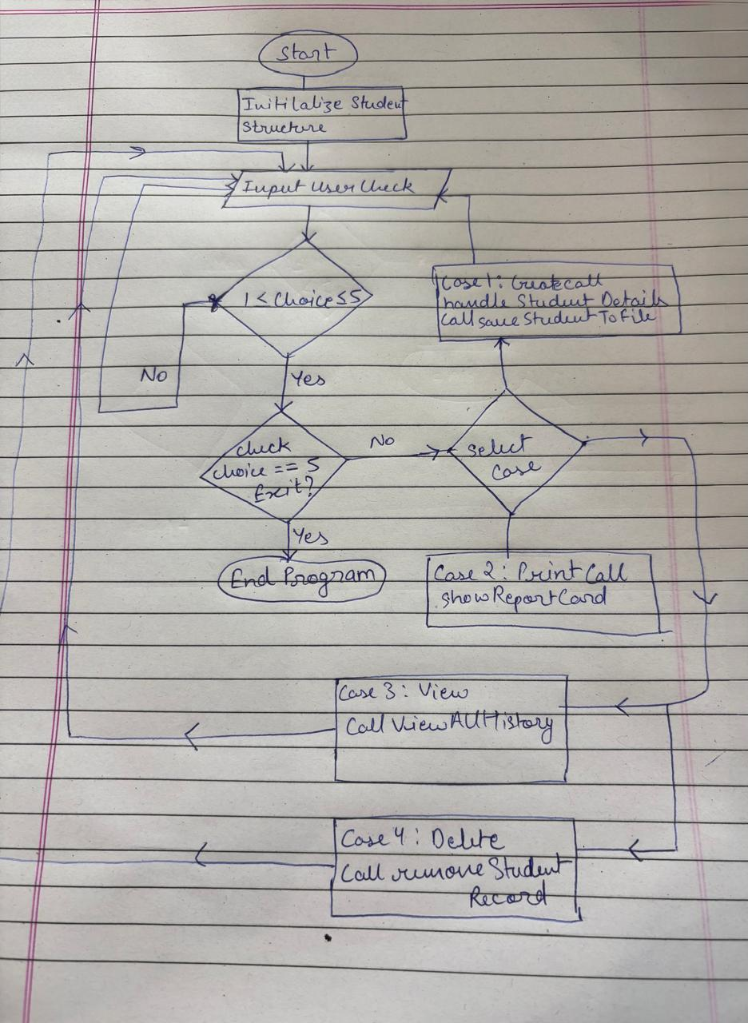

OUTPUTS: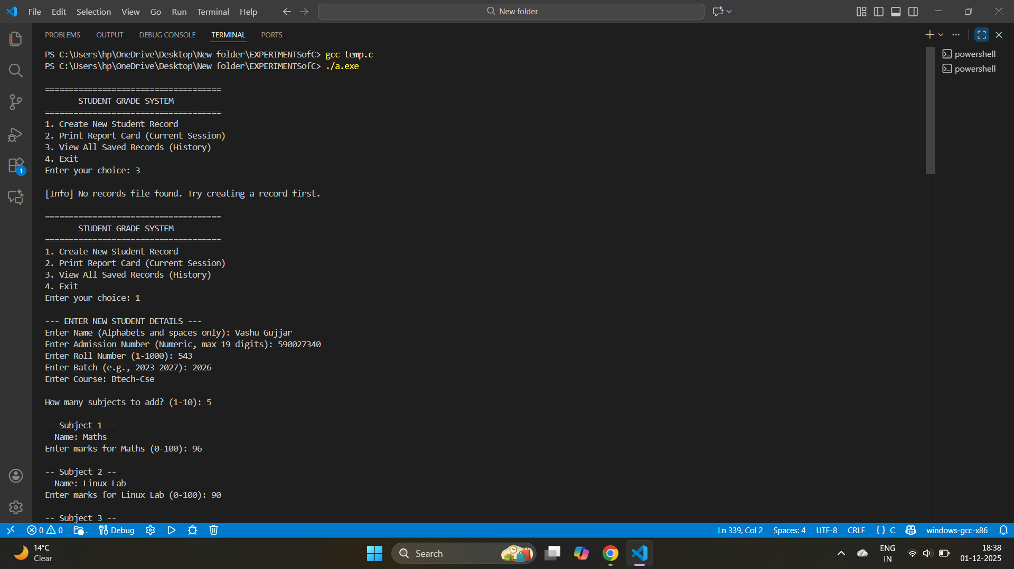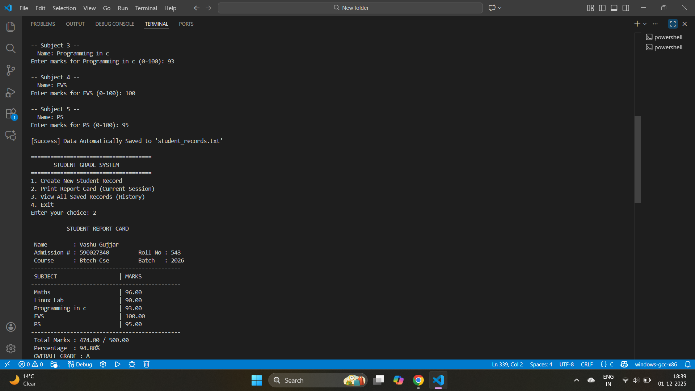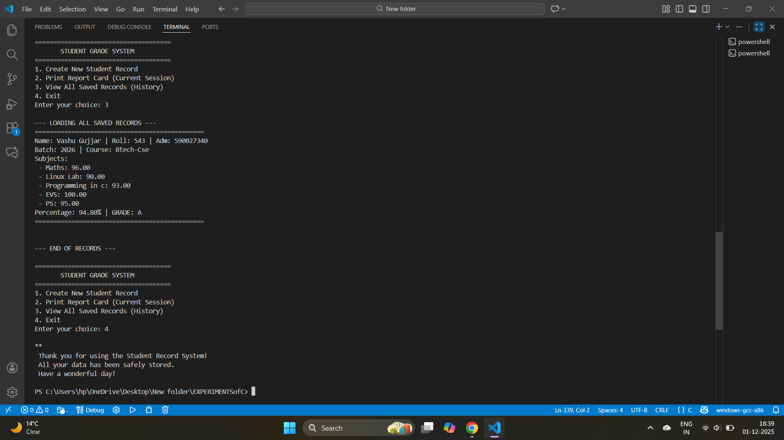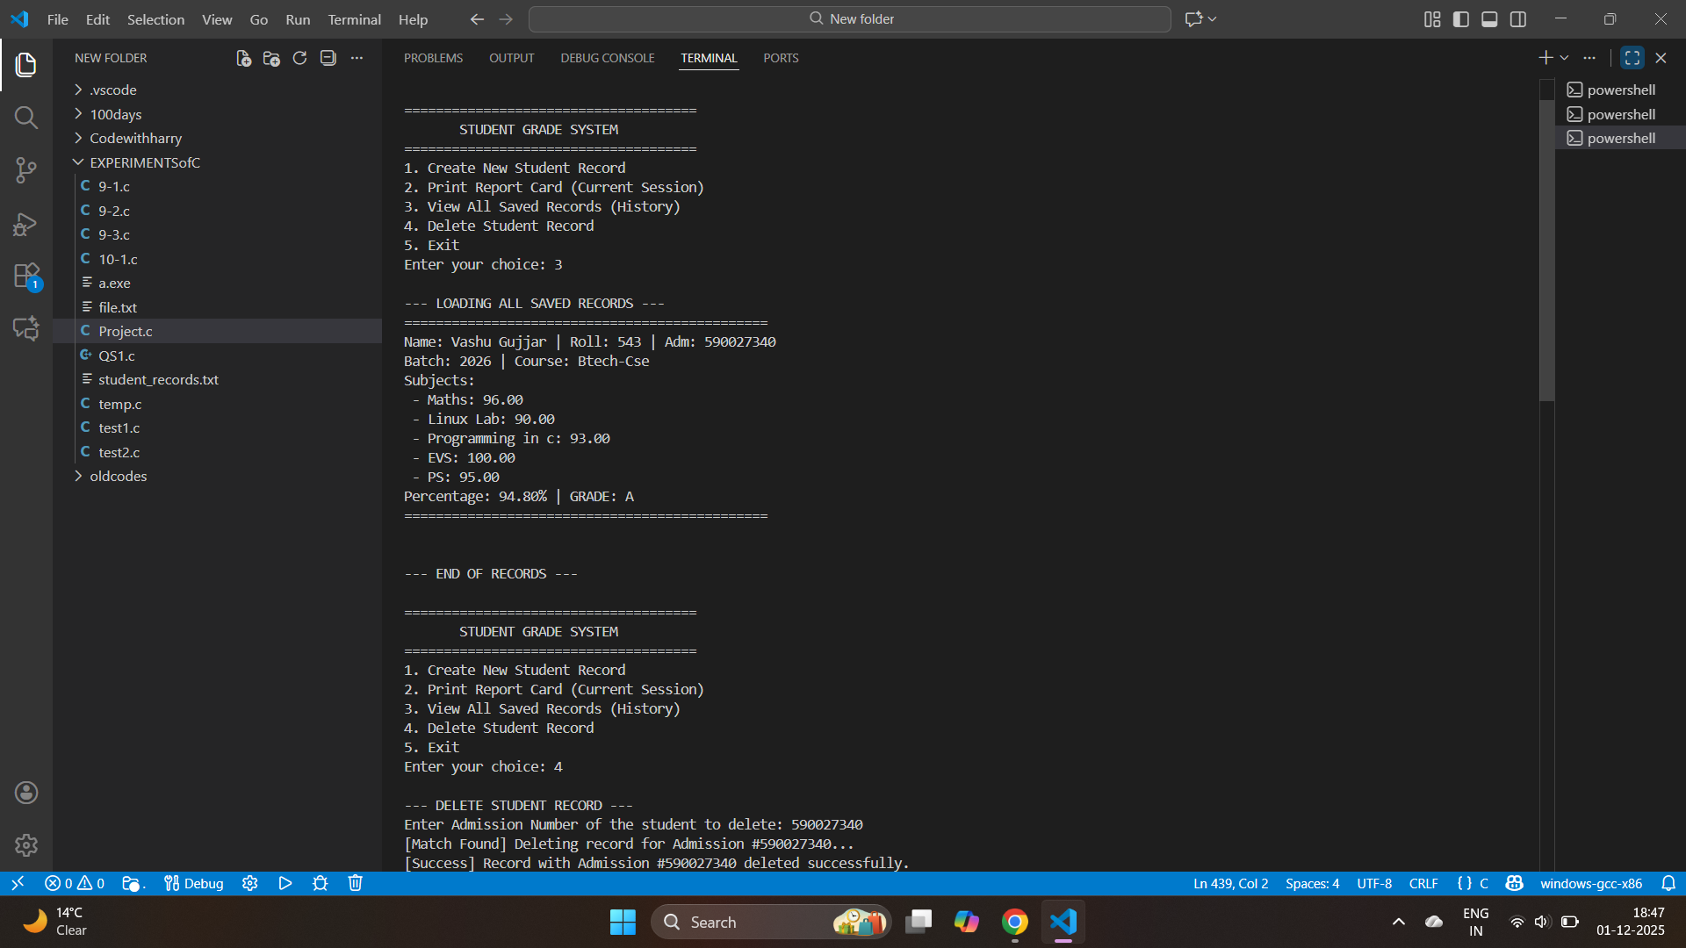

SOURCE CODE:
#ifndef STUDENT_GRADE_SYSTEM_H
#define STUDENT_GRADE_SYSTEM_H

#include <stdio.h>
#include <string.h>
#include <stdlib.h>
#include <ctype.h>

// --- Constants ---
#define MAX_NAME_LEN 50
#define MAX_ADM_LEN 20
#define FILE_NAME "student_records.txt"

// --- Structures ---

typedef struct {
char sub[30];
float marks;
} Subject;

typedef struct {
char name[MAX_NAME_LEN];
int roll_No;
char adm_No[MAX_ADM_LEN];
char batch[40];
char course[20];
int subcount;
Subject *subjects;
} Student;

// --- Function Prototypes ---

// Utility/Validation
void cleanInputBuffer();
int checkNameValidity(const char *name);
int checkIfNumeric(const char *ptr);
float enterCorrectMarks(const char *subname);
char getGrade(float percentage);

// Main System Logic
void handleStudentDetails(Student *s);
void showReportCard(const Student *s);
void freeStudentMemory(Student *s);
void saveStudentToFile(const Student *s);
void viewAllHistory();
void removeStudentRecord();

#endif

#include "student_grade_system.h" // Include the header to access structs and functions

int main() {
// Student structure definition is now inherited from the header
Student std;
std.subjects = NULL;

int choice;
do {
printf("\n=====================================\n");
printf(" STUDENT GRADE SYSTEM ");
printf("\n=====================================\n");
printf("1. Create New Student Record\n");
printf("2. Print Report Card (Current Session)\n");
printf("3. View All Saved Records (History)\n");
printf("4. Delete Student Record\n");
printf("5. Exit\n");
printf("Enter your choice: ");

char choiceBuffer[10];
if (fgets(choiceBuffer, sizeof(choiceBuffer), stdin) != NULL) {
if (checkIfNumeric(choiceBuffer)) {
choice = atoi(choiceBuffer);
} else {
choice = 0;
}
} else {
choice = 5;
}

switch (choice) {
case 1:
if (std.subjects != NULL) {
printf("\n[Info] Clearing current memory for new entry...\n");
freeStudentMemory(&std);
}
handleStudentDetails(&std);
saveStudentToFile(&std);
break;
case 2:
if (std.subjects != NULL) {
showReportCard(&std);
} else {
printf("\nERROR, No record in memory to print\n");
}
break;
case 3:
viewAllHistory();
break;
case 4:
removeStudentRecord();
break;
case 5:
printf("\n**\n");
printf(" Thank you for using the Student Record System! \n");
printf(" All your data has been safely stored. \n");
printf(" Have a wonderful day! \n");
printf("\n");
freeStudentMemory(&std);
break;
default:
printf("Invalid choice. Choose a number between 1 to 5\n");
}
} while (choice != 5);

return 0;
}

#include "student_grade_system.h" // Include the header file to access definitions

// --- Utility/Validation Functions ---

void cleanInputBuffer() {
int c;
while ((c = getchar()) != '\n' && c != EOF);
}

int checkNameValidity(const char *name) {
if (strlen(name) == 0) return 0;
for (int i = 0; name[i] != '\0'; i++) {
if (!isalpha((unsigned char)name[i]) && !isspace((unsigned char)name[i])) {
return 0;
}
}
return 1;
}

int checkIfNumeric(const char *ptr) {
char temp[50];
strncpy(temp, ptr, 50);
temp[49] = '\0';

temp[strcspn(temp, "\n")] = '\0';

if (strlen(temp) == 0) return 0;

for (int i = 0; temp[i] != '\0'; i++) {
if (!isdigit((unsigned char)temp[i])) return 0;
}
return 1;
}

float enterCorrectMarks(const char *subname) {
char buffer[50];
float marks = 0.0f;
int valid = 0;

do {
printf("Enter marks for %s (0-100): ", subname);
if (fgets(buffer, sizeof(buffer), stdin) != NULL) {
buffer[strcspn(buffer, "\n")] = 0;

int isFloat = 1;
int dotCount = 0;
int len = strlen(buffer);

if (len == 0) isFloat = 0;

for (int i = 0; i < len; i++) {
if (!isdigit((unsigned char)buffer[i])) {
if (buffer[i] == '.' && dotCount == 0) {
dotCount++;
} else {
isFloat = 0;
break;
}
}
}

if (isFloat) {
marks = atof(buffer);
if (marks >= 0.0f && marks <= 100.0f) {
valid = 1;
} else {
printf(" [Error] Marks must be between 0 and 100.\n");
}
} else {
printf(" [Error] Invalid input. Please enter numbers only.\n");
}
} else {
break;
}
} while (!valid);

return marks;
}

char getGrade(float percentage) {
if (percentage >= 90.0f) return 'A';
else if (percentage >= 80.0f) return 'B';
else if (percentage >= 70.0f) return 'C';
else if (percentage >= 60.0f) return 'D';
else if (percentage >= 50.0f) return 'E';
else return 'F';
}

// --- Main System Logic Functions ---

void handleStudentDetails(Student *s) {
char buffer[100];
int valid = 0;

printf("\n--- ENTER NEW STUDENT DETAILS ---\n");

do {
printf("Enter Name (Alphabets and spaces only): ");
if (fgets(s->name, MAX_NAME_LEN, stdin) != NULL) {
s->name[strcspn(s->name, "\n")] = 0;
if (checkNameValidity(s->name)) valid = 1;
else printf("Error: Name must only contain letters and spaces.\n");
} else break;
} while (!valid);

valid = 0;
do {
printf("Enter Admission Number (Numeric, max %d digits): ", MAX_ADM_LEN - 1);
if (fgets(s->adm_No, MAX_ADM_LEN, stdin) != NULL) {
s->adm_No[strcspn(s->adm_No, "\n")] = 0;
if (checkIfNumeric(s->adm_No)) valid = 1;
else printf("Error: Admission Number must be numeric.\n");
} else break;
} while (!valid);

valid = 0;
do {
printf("Enter Roll Number (1-1000): ");
if (fgets(buffer, sizeof(buffer), stdin) != NULL) {
if (checkIfNumeric(buffer)) {
s->roll_No = atoi(buffer);
if (s->roll_No > 0 && s->roll_No <= 1000) valid = 1;
else printf("Error: Roll Number must be in range 1-1000.\n");
} else printf("Error: Invalid input. Digits only.\n");
} else break;
} while (!valid);

printf("Enter Batch (e.g., 2023-2027): ");
fgets(s->batch, 40, stdin);
s->batch[strcspn(s->batch, "\n")] = 0;

printf("Enter Course: ");
fgets(s->course, 20, stdin);
s->course[strcspn(s->course, "\n")] = 0;

valid = 0;
do {
printf("\nHow many subjects to add? (1-10): ");
if (fgets(buffer, sizeof(buffer), stdin) != NULL) {
if (checkIfNumeric(buffer)) {
int count = atoi(buffer);
if (count > 0 && count <= 10) {
s->subcount = count;
valid = 1;
} else {
printf("Error: Subject count must be between 1 and 10.\n");
}
} else {
printf("Error: Invalid input. Enter a number.\n");
}
} else break;
} while (!valid);

s->subjects = (Subject*)malloc(s->subcount * sizeof(Subject));
if (s->subjects == NULL) {
printf("Memory Allocation Failed!\n");
exit(1);
}

for (int i = 0; i < s->subcount; i++) {
printf("\n-- Subject %d --\n", i + 1);
printf(" Name: ");
fgets(s->subjects[i].sub, 30, stdin);
s->subjects[i].sub[strcspn(s->subjects[i].sub, "\n")] = 0;

s->subjects[i].marks = enterCorrectMarks(s->subjects[i].sub);
}
}

void showReportCard(const Student *s) {
printf("\n");
printf(" STUDENT REPORT CARD \n");
printf("\n");
printf(" Name : %-30s\n", s->name);
printf(" Admission # : %-15s Roll No : %d\n", s->adm_No, s->roll_No);
printf(" Course : %-15s Batch : %s\n", s->course, s->batch);
printf("----------------------------------------------\n");
printf(" %-25s | %-10s \n", "SUBJECT", "MARKS");
printf("----------------------------------------------\n");

float total = 0.0f;
for (int i = 0; i < s->subcount; i++) {
printf(" %-25s | %-10.2f \n",
s->subjects[i].sub,
s->subjects[i].marks);
total += s->subjects[i].marks;
}
float percentage = (total / (s->subcount * 100.0f)) * 100.0f;
char overallGrade = getGrade(percentage);

printf("----------------------------------------------\n");
printf(" Total Marks : %.2f / %.2f\n", total, (float)s->subcount * 100.0f);
printf(" Percentage : %.2f%%\n", percentage);
printf(" OVERALL GRADE : %c\n", overallGrade);
printf("\n");
}

void saveStudentToFile(const Student *s) {
FILE *fp = fopen(FILE_NAME, "a");

if (fp == NULL) {
printf("\n[Error] Could not open file for writing.\n");
return;
}
float total = 0.0f;
for (int i = 0; i < s->subcount; i++) total += s->subjects[i].marks;
float percent = (total / ((float)s->subcount * 100.0f)) * 100.0f;
char overallGrade = getGrade(percent);

fprintf(fp, "==============================================\n");
fprintf(fp, "Name: %s | Roll: %d | Adm: %s\n", s->name, s->roll_No, s->adm_No);
fprintf(fp, "Batch: %s | Course: %s\n", s->batch, s->course);
fprintf(fp, "Subjects:\n");
for (int i = 0; i < s->subcount; i++) {
fprintf(fp, " - %s: %.2f\n", s->subjects[i].sub, s->subjects[i].marks);
}
fprintf(fp, "Percentage: %.2f%% | GRADE: %c\n", percent, overallGrade);
fprintf(fp, "==============================================\n\n");

fclose(fp);
printf("\n[Success] Data Automatically Saved to '%s'\n", FILE_NAME);
}

void viewAllHistory() {
FILE *fp = fopen(FILE_NAME, "r");
int ch;

if (fp == NULL) {
printf("\n[Info] No records file found. Try creating a record first.\n");
return;
}

printf("\n--- LOADING ALL SAVED RECORDS ---\n");
while ((ch = fgetc(fp)) != EOF) {
printf("%c", ch);
}
printf("\n--- END OF RECORDS ---\n");

fclose(fp);
}

void removeStudentRecord() {
FILE *fp, *ft;
char admToDelete[MAX_ADM_LEN];
char buffer[512];
int found = 0;

printf("\n--- DELETE STUDENT RECORD ---\n");
printf("Enter Admission Number of the student to delete: ");

if (fgets(admToDelete, MAX_ADM_LEN, stdin) == NULL) return;
admToDelete[strcspn(admToDelete, "\n")] = 0;

if (strlen(admToDelete) == 0) {
printf("[Error] Admission Number cannot be empty.\n");
return;
}

fp = fopen(FILE_NAME, "r");
if (fp == NULL) {
printf("\n[Info] No records file found or error opening file.\n");
return;
}

ft = fopen("temp_records.txt", "w");
if (ft == NULL) {
printf("[Error] Could not create temporary file.\n");
fclose(fp);
return;
}

while (fgets(buffer, sizeof(buffer), fp) != NULL) {
if (strstr(buffer, "==============================================") != NULL) {

if (fgets(buffer, sizeof(buffer), fp) == NULL) break;

char *admPtr = strstr(buffer, "Adm: ");

if (admPtr != NULL) {
admPtr += 5;
char currentAdm[MAX_ADM_LEN];
sscanf(admPtr, "%s", currentAdm);

if (strcmp(currentAdm, admToDelete) == 0) {
found = 1;
printf("[Match Found] Deleting record for Admission #%s...\n", admToDelete);
while (fgets(buffer, sizeof(buffer), fp) != NULL) {
if (strstr(buffer, "==============================================") != NULL) {
break;
}
}
continue;
}
}

fprintf(ft, "==============================================\n");
fprintf(ft, "%s", buffer);

} else {
fprintf(ft, "%s", buffer);
}
}

fclose(fp);
fclose(ft);

if (found) {
if (remove(FILE_NAME) != 0) {
printf("[Fatal Error] Could not delete original file.\n");
return;
}

if (rename("temp_records.txt", FILE_NAME) != 0) {
printf("[Fatal Error] Could not rename temporary file.\n");
return;
}
printf("[Success] Record with Admission #%s deleted successfully.\n", admToDelete);
} else {
remove("temp_records.txt");
printf("[Info] No record found with Admission #%s.\n", admToDelete);
}
}

void freeStudentMemory(Student *s) {
if (s->subjects != NULL) {
free(s->subjects);
s->subjects = NULL;
}
}

Conclusion:

This project demonstrate permanent data storage via file I/O and efficient dynamic memory allocation.The system successfully implement Read-Rewrite-Replace algorithm for secure record deletion,ensuring file integrity.
The modular code structure (using .h and .c files ) makes the system easily maintainable.

Future Enhancement:
The project can be improved by adding these key features:
- Record Modification (Update): Implement a function to change existing student details or marks (the missing "Update" feature).
- Weighted Grading: Enhance the grading logic to use multiple weighted components (like assignments and exams) to calculate the final subject marks.
- Data Retrieval: Add functions to search for specific student records and to sort the entire history by final percentage.

