THE COMPLETE
RAG ARCHITECTURES
MASTER STUDY GUIDE
A Presentation-Ready Reference for Retrieval-Augmented Generation Systems
22 Architectures • 6 Categories • 3 Core Modules
August 2026 Edition

MODULE 1: The Anatomy of a RAG System (The Baseline)

1.1 The Core Lifecycle
Think of a RAG system as a restaurant kitchen with a librarian attached. Before any customer (user) walks in, the librarian has already organized a giant reference library (Ingestion). When a customer places an order (query), the librarian sprints to fetch the exact right pages (Retrieval), and hands them to the chef, who cooks a fresh answer using those pages as ingredients (Generation).
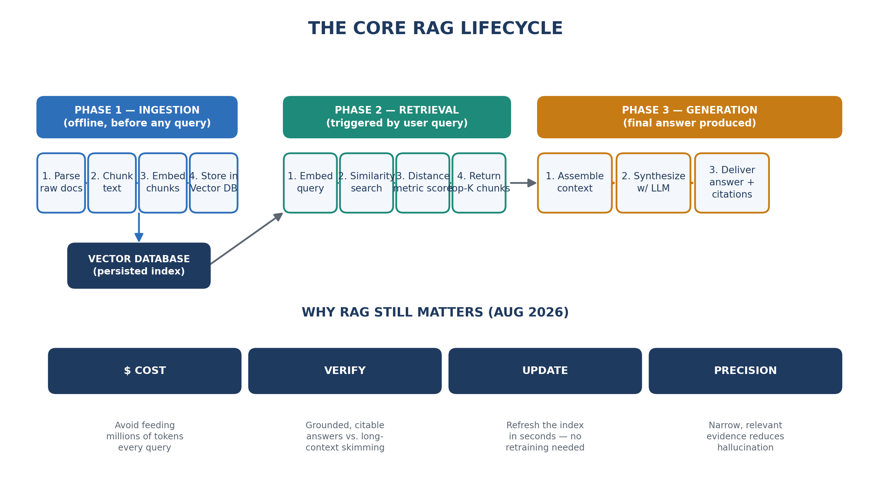
Figure 1 — The three-phase RAG lifecycle and why RAG still matters

PHASE 1 — Ingestion (before any user ever asks a question)
- Parsing: Raw source documents (PDFs, HTML, Word docs, Slack exports, database rows) are loaded and stripped of noise — headers, footers, boilerplate, broken formatting.
- Chunking: The clean text is sliced into digestible pieces (e.g., 200-500 tokens each). A chunk that's too big buries the signal; too small loses context.
- Embedding: Each chunk is passed through an embedding model, converting the text into a vector — a list of numbers representing its meaning in mathematical space.
- Vector Storage: These vectors (plus original text and metadata like source, date, author) are stored in a vector database (e.g., Pinecone, Weaviate, Qdrant, pgvector) for fast lookup later.

PHASE 2 — Retrieval (the moment a user asks something)
- Query Embedding: The user's question is converted into a vector using the same embedding model used during ingestion.
- Query Matching: The system searches the vector database for chunks whose vectors are mathematically 'closest' to the query vector.
- Distance Metrics: Closeness is calculated using metrics like Cosine Similarity (most common), Euclidean Distance, or Dot Product.
- Top-K Selection: The system returns the K best-matching chunks (e.g., top 5) — the 'evidence' the LLM will use.

PHASE 3 — Generation (the final answer is written)
- Context Assembly: Retrieved chunks are stitched into a single 'context block' and inserted into a prompt template alongside the original question.
- Context Synthesis: The LLM reads the question and the retrieved evidence together, generating an answer grounded in — and ideally citing — that evidence.
- Delivery: The final answer is returned to the user, often with source citations pointing back to the original documents.
The Golden Rule: RAG doesn't change what the LLM knows how to do (reason, write, summarize) — it changes what the LLM has in front of it when it does that reasoning.

1.2 The “Why”: Why RAG Still Matters in August 2026
A common objection today is: “Models now have 1M-10M token context windows — why not just paste the entire knowledge base into the prompt every time?” Four reasons RAG remains essential:
💰 Cost: Feeding millions of tokens into every query is extraordinarily expensive at scale. Retrieving only the relevant chunks instead of the entire corpus can cut inference cost by orders of magnitude across thousands of daily queries.
✅ Verification: Long-context 'needle in a haystack' recall degrades in practice. Retrieval narrows the field to only what's relevant and enables clean citation back to a specific source — critical for trust and auditability.
🔄 Dynamic Data Updating: Model weights are frozen at training time, but a company wiki or pricing sheet changes daily. RAG lets you update the retrieval index in seconds — no retraining, no fine-tuning.
🎯 Precision & Reduced Hallucination: Grounding generation in explicitly retrieved, verifiable text sharply reduces the chance the model invents facts, because it's 'reading off the page' rather than reciting fuzzy trained-in memory.

MODULE 2: The Complete Compendium of RAG Types & Architectures
This section provides an exhaustive breakdown of every major RAG type as of August 2026, organized into six architectural categories. Each type follows the same four-part structure: Concept, Data Flow, Pain Point Solved, and Use-Case.
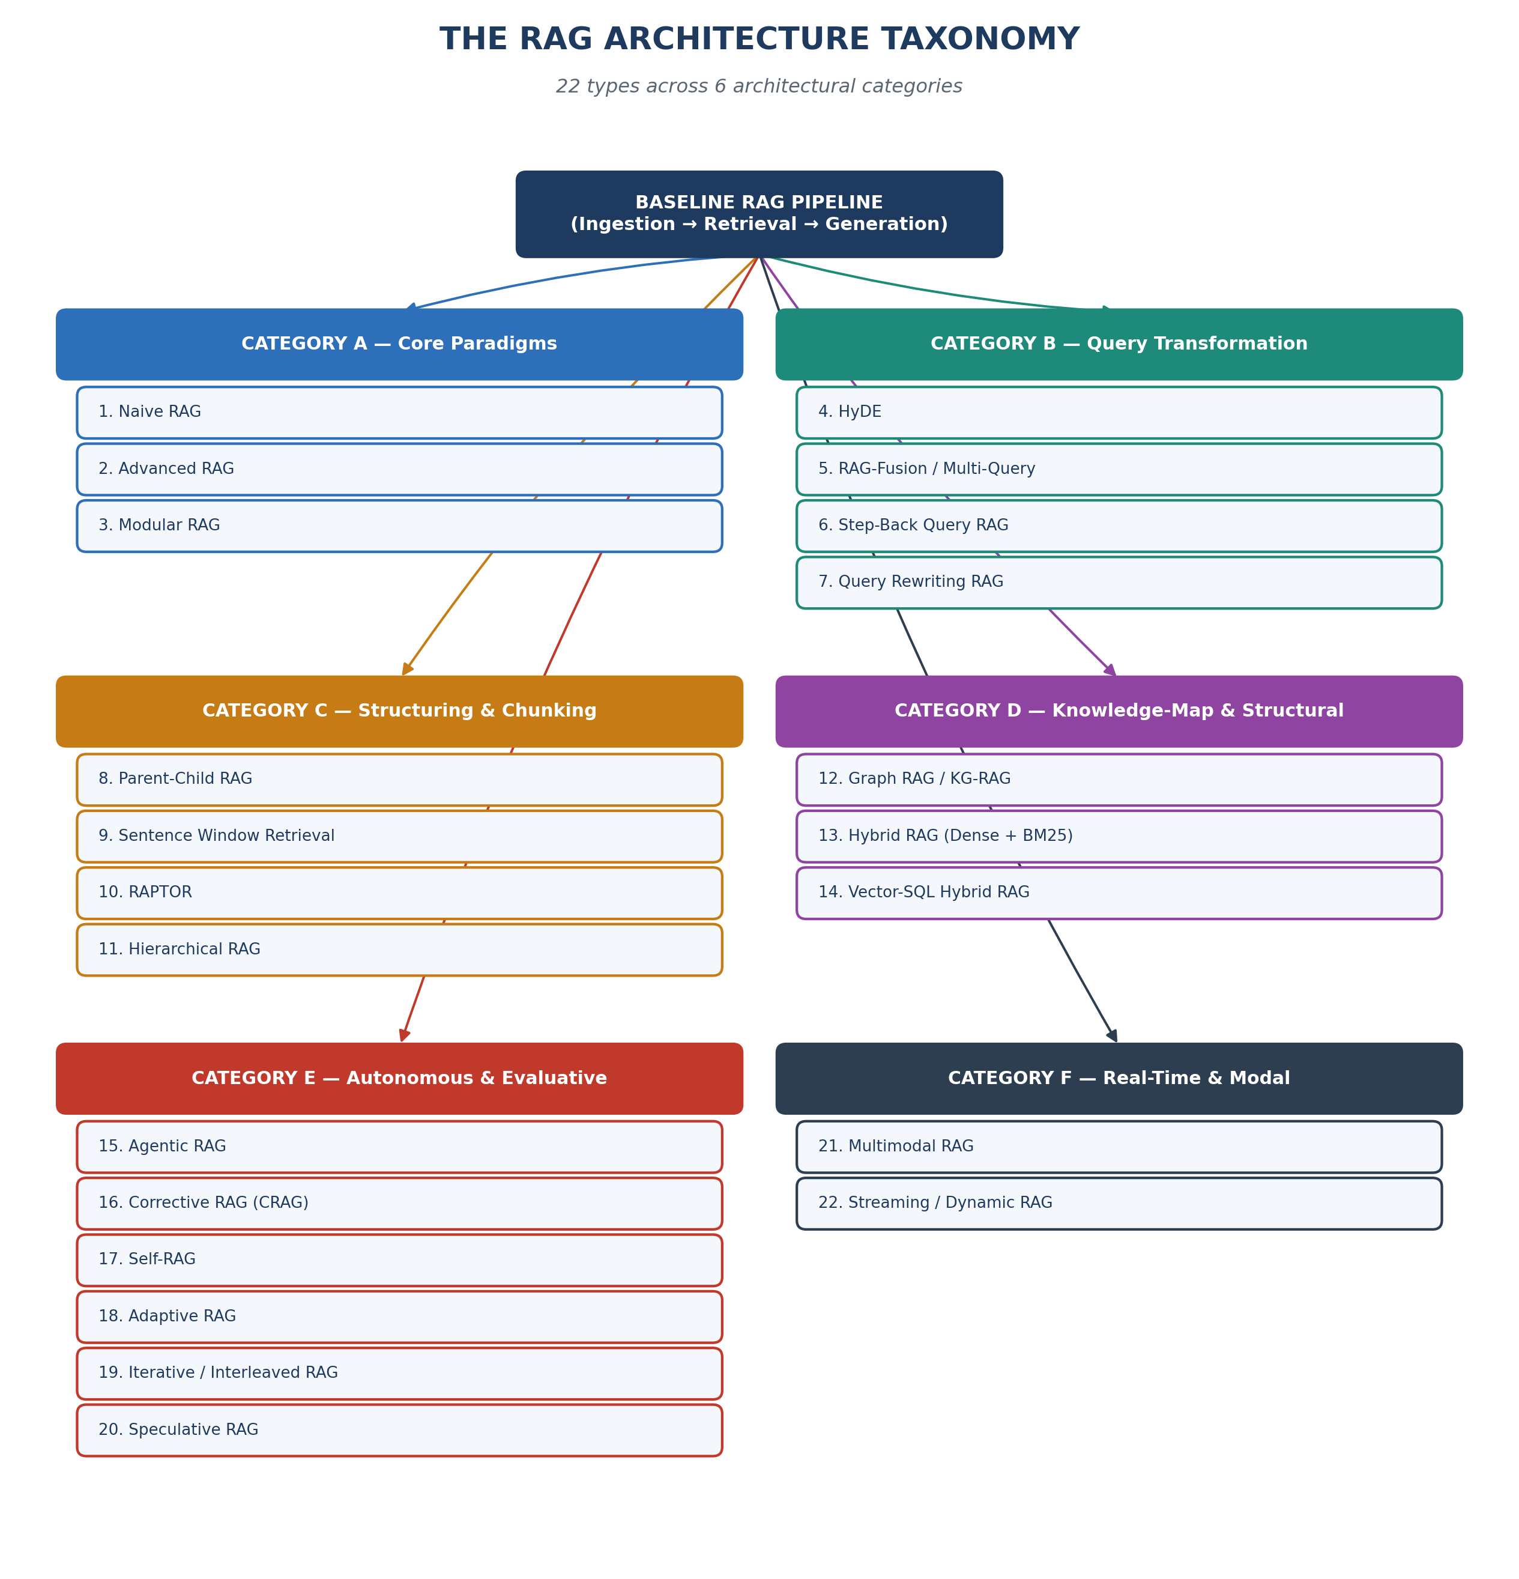
Figure 2 — The full RAG architecture taxonomy map

Category A: The Core Paradigms

1. Naive (Standard) RAG
💡 Concept: The 'vanilla' version — the three-phase pipeline with no bells or whistles. A librarian grabs the first five books that superficially look related and hands them straight to the chef, no double-checking.
⚙️ Data Flow:
1. Documents chunked and embedded once, offline.
2. User query embedded as-is.
3. Top-K nearest chunks retrieved via a single similarity search.
4. Chunks inserted into the prompt verbatim.
5. LLM generates an answer directly from that context.
🎯 Pain Point Solved: Solves the base problem of hallucination-from-no-context and stale knowledge. Does not solve retrieval precision, ranking quality, or complex multi-hop reasoning.
🏢 Use-Case: A simple internal FAQ bot over a small, clean, well-structured knowledge base (e.g., an HR policy chatbot) with simple, single-hop queries.

2. Advanced RAG (Pre/Post-Retrieval Optimization)
💡 Concept: Naive RAG with quality-control checkpoints added before the search (cleaning the question) and after the search (cleaning the results) — an editor polishes the question, then re-checks the books before they reach the chef.
⚙️ Data Flow:
1. Pre-retrieval: query is cleaned, expanded, or rewritten; metadata filters may be applied.
2. Query embedded and searched.
3. Post-retrieval: retrieved chunks are re-ranked by a cross-encoder re-ranker for true relevance, and irrelevant chunks are filtered/compressed.
4. Cleaned, ranked chunks passed to the LLM.
5. LLM generates the final answer.
🎯 Pain Point Solved: Fixes the 'garbage in, garbage out' problem of Naive RAG — poor query phrasing and noisy retrieved chunks that dilute answer quality.
🏢 Use-Case: Enterprise search assistants over large, messy document repositories (e.g., legal contract search) where raw similarity search returns too much noise.

3. Modular RAG (Plugin-Based Flexible Routing)
💡 Concept: Interchangeable Lego blocks — a routing module, a search module, a memory module, a fusion module — assembled and reordered depending on the task. The architectural 'framework' most other types plug into.
⚙️ Data Flow:
1. Incoming query hits a router module.
2. Router decides which retrieval module(s) to invoke (vector search, keyword search, an API call, SQL) based on query type.
3. Selected module(s) execute in parallel or in sequence.
4. A fusion module merges and deduplicates results from multiple sources.
5. Optional memory module injects conversation history.
6. LLM generates the final synthesized answer.
🎯 Pain Point Solved: Fixes the rigidity of a single, one-size-fits-all pipeline — different queries genuinely need different retrieval strategies.
🏢 Use-Case: A production-grade enterprise copilot handling document Q&A, structured database lookups, and live API calls all in one chat interface.

Category B: Query-Transformation & Optimization Tech

4. HyDE (Hypothetical Document Embeddings)
💡 Concept: The system first asks the LLM to imagine what a perfect answer would look like, then searches using that imagined answer — like describing your dream house so a friend can find real listings matching its 'shape.'
⚙️ Data Flow:
1. User submits a query.
2. LLM generates a hypothetical, plausible-sounding answer document (may contain inaccuracies — never shown to the user).
3. That hypothetical document is embedded (not the original query).
4. This hypothetical-document vector searches the vector database.
5. Real chunks resembling the hypothetical answer's phrasing/structure are retrieved.
6. LLM generates the final, grounded answer using the real chunks.
🎯 Pain Point Solved: Fixes the 'vocabulary mismatch' problem — short, terse questions often use different wording than the answer passages that satisfy them.
🏢 Use-Case: Technical/scientific Q&A systems where questions are casual but source documents use dense, formal, jargon-heavy language.

5. RAG-Fusion / Multi-Query RAG (with Reciprocal Rank Fusion)
💡 Concept: Instead of asking the librarian one question, you ask the same question rephrased five different ways, then combine and re-rank all the books each version returned — triangulating a target from multiple angles.
⚙️ Data Flow:
1. LLM generates N variations of the original query (different phrasings/angles).
2. Each variant query is independently embedded and searched.
3. Each search returns its own ranked list of chunks.
4. Reciprocal Rank Fusion (RRF) combines all lists — chunks appearing high in multiple lists get boosted scores.
5. The final fused, re-ranked list is passed to the LLM.
6. LLM synthesizes the answer.
🎯 Pain Point Solved: Fixes single-query blind spots — one phrasing of a question may miss relevant chunks a slightly different phrasing would catch.
🏢 Use-Case: Broad research or discovery queries (e.g., 'what are the risks of this M&A deal?') where the ideal answer spans multiple angles.

6. Step-Back Query RAG (Abstracting the Prompt for Broader Context)
💡 Concept: Before diving into specifics, the system asks a more general, 'zoomed-out' version of the question first — a doctor asking about overall health history before zeroing in on a specific symptom.
⚙️ Data Flow:
1. User asks a specific, narrow question.
2. LLM generates a 'step-back' abstraction — a broader, higher-level version of that question.
3. Both the original specific query AND the step-back query are used to retrieve chunks.
4. Both result sets are combined into context.
5. LLM answers the original specific question, now armed with fine-grained and broad background context.
🎯 Pain Point Solved: Fixes shallow answers to questions that actually require background/foundational context — narrow retrieval alone misses the 'big picture.'
🏢 Use-Case: Multi-step analytical or reasoning-heavy queries in finance, science, or policy analysis, where surface facts alone give an incomplete answer.

7. Query Rewriting / Reformulation RAG
💡 Concept: A dedicated 'translator' module sits between the user and the search engine, cleaning up typos, resolving ambiguous pronouns, and rewriting casual chat-speak into a clear, self-contained, searchable question.
⚙️ Data Flow:
1. Raw user query received (possibly full of typos, slang, or references like 'what about that one from before?').
2. A rewriting LLM call reformulates the query into a clear, standalone, context-resolved question, pulling in chat history if needed.
3. The rewritten query is embedded and searched.
4. Retrieved chunks passed to generation.
5. LLM answers using the clarified intent.
🎯 Pain Point Solved: Fixes poor retrieval caused by ambiguous, conversational, or context-dependent queries — critical in multi-turn chat.
🏢 Use-Case: Multi-turn conversational assistants and customer support chatbots where follow-up questions constantly reference earlier turns.

Category C: Advanced Structuring & Chunking Layouts

8. Parent-Child / Sub-Document RAG
💡 Concept: Search using small, precise index cards, but once you find the right one, hand the chef the entire chapter it came from — not just the card. Small chunks find things; big chunks explain things.
⚙️ Data Flow:
1. During ingestion, each document is split into small 'child' chunks AND larger 'parent' chunks that contain those children.
2. Only the small child chunks are embedded and indexed for search — sharper, more precise vector matches.
3. At query time, the system searches over child-chunk vectors.
4. Once a matching child is found, the system fetches its parent chunk via a stored mapping/ID reference.
5. The full parent chunk(s) are passed to the LLM as context.
6. LLM generates the answer with rich surrounding context, not a fragment.
🎯 Pain Point Solved: Fixes the chunk-size trade-off: small chunks retrieve precisely but lack context; large chunks have context but retrieve imprecisely.
🏢 Use-Case: Long-form legal or technical documents where a single sentence must be found precisely, but the LLM needs surrounding clauses to interpret it.

9. Sentence Window Retrieval
💡 Concept: A close cousin of Parent-Child RAG, but instead of a whole 'chapter,' you grab just the sentences immediately before and after the matched sentence — reading the paragraph around a highlighted line.
⚙️ Data Flow:
1. Documents split into individual sentences during ingestion, each embedded separately, tagged with document position.
2. At query time, a search matches on individual sentence vectors (maximum precision).
3. For each matched sentence, the system pulls a fixed 'window' of N sentences before and after it.
4. This expanded window (not the single sentence) is assembled into the context.
5. LLM generates the answer with local context intact.
🎯 Pain Point Solved: Fixes the loss of local context around a highly precise match — a single retrieved sentence is often too terse or ambiguous alone.
🏢 Use-Case: Dense technical manuals or medical literature, where one sentence contains the exact fact but surrounding qualification is essential.

10. RAPTOR (Recursive Abstractive Processing for Tree-Organized Retrieval)
💡 Concept: Build a tree — like a corporate org chart of information. Leaf nodes are raw text chunks; each layer above summarizes the layer below, up to one master summary at the top.
⚙️ Data Flow:
1. Documents chunked into base-level 'leaf' chunks and embedded (Layer 0).
2. Similar leaf chunks are clustered together using unsupervised clustering.
3. Each cluster is summarized by an LLM into a single higher-level node (Layer 1).
4. Steps 2-3 repeat recursively, building a full tree up to a root summary.
5. All nodes at every layer are embedded and indexed together.
6. At query time, retrieval searches across the whole tree, returning both fine-grained facts and thematic summaries.
7. LLM synthesizes an answer using whichever tree level(s) best match the question.
🎯 Pain Point Solved: Fixes RAG's blindness to 'big picture' or thematic questions that no single chunk could ever answer.
🏢 Use-Case: Summarizing or reasoning across extremely long documents — annual reports, book series, litigation discovery archives.

11. Hierarchical RAG (Multi-Tiered Global/Local Index Routing)
💡 Concept: A two-stage librarian system — first you go to the 'floor directory' to pick the right section of the library (global index), then search within that section for the exact book (local index).
⚙️ Data Flow:
1. A high-level global index is built — one summary/embedding per document, folder, or topic cluster.
2. A detailed local index is built underneath each global entry — the actual fine-grained chunks.
3. At query time, the system first searches the global index to identify the most relevant document(s)/cluster(s).
4. The local index within those selected documents/clusters is then searched for specific matching chunks.
5. Only chunks from the pre-filtered relevant zone are passed to the LLM.
6. LLM generates the answer.
🎯 Pain Point Solved: Fixes retrieval accuracy and speed at massive scale — searching every chunk in a million-document corpus is slow and noisy.
🏢 Use-Case: Enterprise-wide knowledge bases spanning many separate product lines or departments, where topic-level routing prevents cross-contamination.

Category D: Knowledge-Map & Structural Architectures

12. Graph RAG / KG-RAG (Knowledge Graph Entity-Relation Traversal)
💡 Concept: Instead of a pile of loose index cards, imagine a wall covered in sticky notes connected by strings — retrieval walks the strings to gather connected facts, not just fetch a note.
⚙️ Data Flow:
1. During ingestion, an LLM extracts entities and their relationships from source text, building a knowledge graph.
2. The graph is stored in a graph database, often alongside a traditional vector index for raw text.
3. At query time, entities are extracted from the user's question.
4. The system traverses the graph outward from those entities, following relevant relationship edges (multi-hop traversal).
5. Connected facts/entities gathered along the traversal path are assembled into context.
6. LLM generates an answer that correctly reflects multi-entity relationships.
🎯 Pain Point Solved: Fixes multi-hop reasoning failure — vector search finds similar text but has no concept of explicit relationships.
🏢 Use-Case: Corporate due-diligence, fraud investigation, or pharmaceutical research, where answers depend on tracing chains of relationships.

13. Hybrid RAG (Dense Vector + Sparse BM25 Keyword Matching)
💡 Concept: Run two search engines side by side — one that understands meaning (dense vectors) and one that's ruthlessly literal about exact words (BM25) — then merge results.
⚙️ Data Flow:
1. Documents are indexed twice in parallel: dense vector embeddings, and a sparse keyword index (BM25/TF-IDF).
2. At query time, the same query runs against both indexes simultaneously.
3. Dense search returns semantically similar chunks; sparse search returns chunks with exact keyword overlap.
4. Results from both are merged and re-ranked (often via RRF) into one unified ranked list.
5. Top merged results passed to the LLM for generation.
🎯 Pain Point Solved: Fixes the classic weakness of pure vector search on exact-match terms — product codes, error codes, rare proper nouns.
🏢 Use-Case: E-commerce product search or IT support ticketing, where users search using precise SKUs/error codes and natural language interchangeably.

14. Vector-SQL Hybrid RAG (Unstructured Text + Structured Tables)
💡 Concept: Some answers live in paragraphs; others live in spreadsheets. This lets one query pull from both — a research assistant who can read the footnotes and run the numbers.
⚙️ Data Flow:
1. Unstructured documents are chunked/embedded into a vector store; structured data remains in native SQL tables.
2. At query time, a router/LLM determines whether the question needs unstructured retrieval, a structured query, or both.
3. For the structured portion: the LLM generates a SQL query (text-to-SQL) and executes it against the database.
4. For the unstructured portion: a standard vector similarity search runs in parallel.
5. Both the SQL results and retrieved text chunks are merged into one context block.
6. LLM generates a single coherent answer synthesizing both numeric and narrative evidence.
🎯 Pain Point Solved: Fixes RAG's blindness to structured, tabular business data — vector search is fundamentally bad at precise aggregation and math.
🏢 Use-Case: Business intelligence copilots that must answer questions combining narrative complaints and numeric revenue trends in one response.

Category E: Autonomous, Evaluative & Iterative Systems

15. Agentic RAG (Autonomous LLM Research Loops with Multi-Tool Usage)
💡 Concept: The LLM becomes an autonomous research agent — it can decide to search the vector DB, then call a web search tool, then a calculator, then loop back and search again — all on its own judgment.
⚙️ Data Flow:
1. User query received by an LLM acting as a planning agent.
2. Agent decides which tool to invoke first (vector search, SQL, web search, calculator, code execution, etc.).
3. Tool executes; result is returned to the agent.
4. Agent evaluates whether it now has enough information to answer.
5. If not, agent decides on and invokes the next tool/action — this loop repeats.
6. Once the agent judges it has sufficient evidence, it synthesizes and returns the final answer.
🎯 Pain Point Solved: Fixes RAG's rigid, single-shot retrieval limitation — many real questions require multiple, sequential, decision-dependent lookups.
🏢 Use-Case: Complex research or analyst-style assistants requiring open-ended, multi-tool investigation (e.g., litigation + news + risk estimation).

16. Corrective RAG / CRAG (Algorithmic Validation with Web-Search Fallback)
💡 Concept: A built-in quality inspector grades every batch of retrieved documents before they reach the chef. If the batch is bad, it fetches fresher ingredients from the live web instead.
⚙️ Data Flow:
1. Standard retrieval occurs, pulling top-K chunks from the vector index.
2. A lightweight evaluator model grades the retrieved chunks as Correct, Ambiguous, or Incorrect.
3. If Correct: chunks are refined/compressed and passed straight to generation.
4. If Incorrect: the system discards internal chunks and triggers a live web search fallback.
5. If Ambiguous: both internal chunks and supplementary web results are combined.
6. LLM generates the final answer from whichever evidence passed inspection.
🎯 Pain Point Solved: Fixes silent failures — Naive RAG confidently generates an answer even from irrelevant retrieved chunks.
🏢 Use-Case: Customer-facing support bots where internal documentation may be incomplete, and fallback to verified external sources improves reliability.

17. Self-RAG (Token-Level Self-Critique and Dynamic Retrieval)
💡 Concept: The model constantly asks itself, mid-sentence, 'Do I need to look something up right now?' and grades its own output for being supported, relevant, and useful as it goes.
⚙️ Data Flow:
1. LLM begins generating a response to the query.
2. At each step, the model emits special reflection tokens deciding: 'Retrieve now?'
3. If yes, a retrieval call is triggered on the fly, mid-generation.
4. After generating a candidate segment, the model self-critiques it: is it relevant, supported, and useful?
5. Low-scoring segments are revised or regenerated.
6. The final response is assembled only from segments that pass the model's own self-critique.
🎯 Pain Point Solved: Fixes wasteful, unnecessary retrieval and unsupported/hallucinated claims slipping through unchecked.
🏢 Use-Case: Long-form, high-stakes content generation (e.g., medical or financial report drafting) needing independently verifiable claims.

18. Adaptive RAG (Intent-Routing Based on Query Complexity)
💡 Concept: A triage nurse decides how serious your case is before routing you — a simple sniffle goes straight to a quick checkup, a complex case gets full specialist review.
⚙️ Data Flow:
1. Incoming query hits a lightweight complexity classifier.
2. Classifier labels the query as: simple/no-retrieval-needed, single-step, or complex/multi-hop.
3. Query is routed to the matching pipeline strength based on that label.
4. The selected pipeline executes (zero retrieval calls up to a full multi-step agent loop).
5. LLM generates the final answer using whatever context that pipeline gathered.
🎯 Pain Point Solved: Fixes wasted compute/latency — running heavyweight multi-hop retrieval on a trivial query is slow and unnecessary.
🏢 Use-Case: High-traffic consumer chat products where query difficulty varies enormously turn-by-turn.

19. Iterative / Interleaved RAG (Continuous Generation-Then-Retrieval Loop)
💡 Concept: Rather than retrieve once and generate once, the system alternates: generate a bit, notice a gap, retrieve to fill that gap, generate more — like a student flipping back to source material paragraph by paragraph.
⚙️ Data Flow:
1. Initial retrieval pass gathers a starting context set.
2. LLM begins generating the answer using that context.
3. As generation proceeds, the system detects when the model needs a fact it doesn't currently have.
4. A fresh, targeted retrieval query is issued based on what's already been generated.
5. Newly retrieved chunks are injected, and generation continues.
6. Steps repeat until the full, multi-part answer is complete.
🎯 Pain Point Solved: Fixes single-shot retrieval's inability to support long, multi-part answers where later parts need different evidence than earlier parts.
🏢 Use-Case: Long-form report or multi-step tutorial generation, where each section logically requires its own distinct supporting evidence.

20. Speculative RAG (Small-Model Drafting, Large-Model Verification)
💡 Concept: A junior analyst (small, fast model) quickly drafts several candidate answers in parallel; a senior partner (large model) reviews and picks/refines the best one.
⚙️ Data Flow:
1. Retrieval returns a broader-than-usual set of relevant chunks, clustered into distinct evidence subsets.
2. A small, fast 'drafter' LLM generates a candidate answer in parallel for each evidence subset.
3. All candidate drafts are collected.
4. A large 'verifier' LLM reviews all drafts against the full evidence, scoring accuracy and coherence.
5. The verifier selects the best draft or synthesizes/edits a final answer combining the strongest elements.
6. Final verified answer is returned to the user.
🎯 Pain Point Solved: Fixes the latency/cost of always running a single, slow, expensive large model end-to-end.
🏢 Use-Case: Latency-sensitive, high-volume production systems (e.g., live customer chat) needing large-model-level quality without the latency.

Category F: Real-Time & Advanced Data Modal Elements

21. Multimodal RAG (Retrieving Charts, Images, Layouts, and Video Timeframes)
💡 Concept: The librarian's shelves aren't just books anymore — they include photo albums, blueprints, and video tapes. Retrieval must find and hand over any of these formats.
⚙️ Data Flow:
1. During ingestion, non-text elements (images, charts, video frames) are extracted alongside text, often using a vision model for rich descriptions.
2. Both text chunks and visual elements are embedded, sometimes in a unified multimodal embedding space.
3. At query time, the query (which may itself contain an image) is embedded and searched across both modalities.
4. Matching text chunks and matching images/chart crops/video timestamps are retrieved together.
5. A multimodal-capable LLM receives both the text context and the actual visual content as input.
6. LLM generates an answer that reasons over both text and visual evidence.
🎯 Pain Point Solved: Fixes RAG's traditional text-only blindness — critical information often lives in a chart, diagram, or photo, not prose.
🏢 Use-Case: Engineering documentation assistants retrieving the correct schematic, or financial tools reasoning over actual chart images from reports.

22. Streaming / Dynamic RAG (Querying Live, Continuous Data Telemetry Streams)
💡 Concept: A newsroom ticker that never stops — sensor readings, stock prices, live logs. Retrieval means 'tell me what's happening right now,' not 'find the right old book.'
⚙️ Data Flow:
1. A continuous data stream (IoT sensors, live logs, market data) is ingested incrementally through a stream-processing layer.
2. Incoming events are embedded and indexed in near-real-time, often into a rolling/time-windowed index.
3. At query time, retrieval targets the most recent, relevant window of the stream, often with time-based filters.
4. Retrieved live data points are assembled into context, often alongside relevant static/historical knowledge.
5. LLM generates an answer reflecting the current, live state of the system, not a stale snapshot.
🎯 Pain Point Solved: Fixes the 'freshness ceiling' of standard RAG, where the index is only as current as the last batch ingestion job.
🏢 Use-Case: Real-time operations dashboards or anomaly-detection copilots built on live infrastructure telemetry.

MODULE 3: Architectural Selection Matrix
A comprehensive side-by-side comparison of all 22 RAG types — implementation complexity, compute cost, primary structural strength, and when each is the wrong tool for the job.
RAG Type | Complexity | Compute Cost | Primary Strength | When to Avoid It
Naive (Standard) RAG | Low | Low | Fast to build; simple to reason about | Complex, multi-hop, or ambiguous queries
Advanced RAG | Medium | Medium | Cleaner retrieval via re-ranking + filtering | Ultra-low-latency requirements
Modular RAG | High | Medium-High | Maximum flexibility across query types | Small, single-purpose bots (overkill)
HyDE | Medium | Medium (extra LLM call) | Bridges question/answer vocabulary gap | Highly factual, keyword-exact queries
RAG-Fusion / Multi-Query | Medium | Medium-High (N searches) | Broader recall across phrasings | Simple, unambiguous single-fact queries
Step-Back Query RAG | Medium | Medium (extra LLM call) | Supplies missing background context | Narrow factoid lookups
Query Rewriting RAG | Low-Medium | Low-Medium | Handles conversational/ambiguous input | Single-turn, already-clear queries
Parent-Child RAG | Medium | Medium (dual storage) | Precision search + rich context delivery | Very short, atomic documents
Sentence Window Retrieval | Medium | Low-Medium | Maximum precision with local context | Documents needing broad thematic context
RAPTOR | High | High (recursive summarization) | Handles both detail and thematic queries | Small corpora; frequently-changing data
Hierarchical RAG | High | Medium-High | Scales to massive, multi-domain corpora | Small, single-topic knowledge bases
Graph RAG / KG-RAG | High | High (graph build + traversal) | True multi-hop relational reasoning | Unstructured, relation-poor content
Hybrid RAG (Dense+BM25) | Medium | Medium (dual index) | Balances semantic + exact-match recall | Purely conversational, non-technical text
Vector-SQL Hybrid RAG | High | Medium-High | Unifies narrative + numeric/tabular answers | Domains with no structured data at all
Agentic RAG | High | High (many LLM calls) | Handles open-ended, multi-step research | Latency-critical, simple lookups
Corrective RAG (CRAG) | Medium-High | Medium (evaluator + fallback) | Self-checks and recovers from bad retrieval | Static, already-reliable internal data
Self-RAG | High | High (fine-tuning + reflection tokens) | Built-in claim-level self-verification | Teams without capacity to fine-tune models
Adaptive RAG | Medium | Low-High (varies by route) | Cost/latency efficiency at scale | Low-traffic apps with uniform query types
Iterative / Interleaved RAG | High | High (repeated retrieval calls) | Supports long, multi-part evidence needs | Short, single-fact answers
Speculative RAG | High | Medium (parallel small + 1 large call) | Large-model quality at lower latency | Low-traffic, cost-insensitive setups
Multimodal RAG | High | High (vision models + storage) | Reasons over images/charts/video | Purely text-based knowledge bases
Streaming / Dynamic RAG | High | High (continuous infra) | Second-by-second data freshness | Static, rarely-changing knowledge

Quick-Reference Cheat Sheet for Your Presentation
- Struggling with vague questions? → HyDE, Query Rewriting, Step-Back
- Struggling with chunk size trade-offs? → Parent-Child, Sentence Window
- Struggling with “big picture” summarization? → RAPTOR, Hierarchical RAG
- Struggling with relationships between entities? → Graph RAG
- Struggling with exact-match terms (SKUs, codes)? → Hybrid RAG (BM25)
- Struggling with numbers/tables? → Vector-SQL Hybrid RAG
- Struggling with bad/irrelevant retrieval? → Corrective RAG, Self-RAG
- Struggling with multi-step research questions? → Agentic RAG, Iterative RAG
- Struggling with cost/latency at scale? → Adaptive RAG, Speculative RAG
- Struggling with images/video? → Multimodal RAG
- Struggling with live/real-time data? → Streaming RAG
End of Master Study Guide — ready for direct use in slide construction.

