Project Pizza House

Objective:

To implement a chatbot for a pizza shop which should be able to interact with customer for placing order, shows the pizza list with addons and track order after the placing of order.

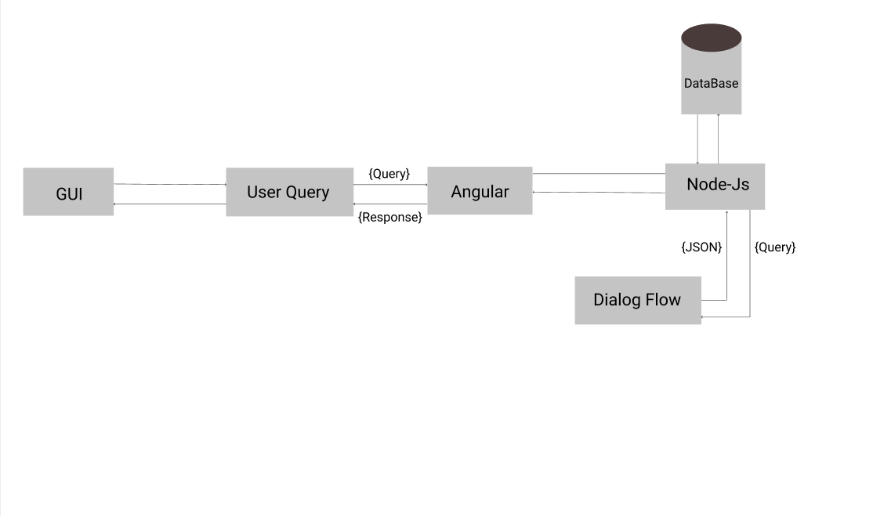Fig1:Chatbot Application Architecture

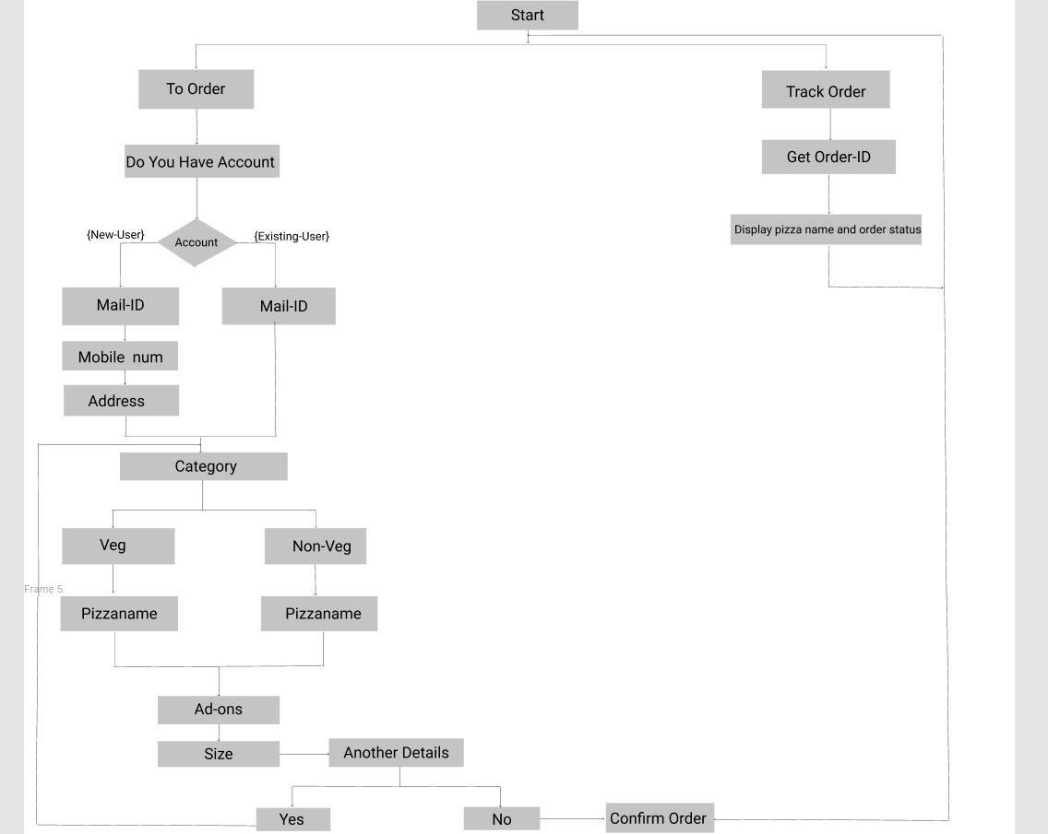

Fig 2: Flow diagram