- What is Git, write atleast 5 points?
- Git is a distributed version-control system for tracking changes in source code during software development.
- It is designed for coordinating work among programmers, but it can be used to track changes in any set of files.
- Its goals include speed, data integrity, and support for distributed, non-linear workflows
- As with most other distributed version-control systems, and unlike most client–server systems, every Git directory on every computer is a full-fledged repository with complete history and full version-tracking abilities, independent of network access or a central server.
- Git is free and open-source software distributed under GNU General Public License Version 2.
- What is the advantage & disadvantage of Git?
- Advantages:
  - Good distributed model as each developer gets a local repository with a full history of commits which makes git fast compared to other VCs.
  - Branching capabilities and merging are easy (as they are cheap), good data integrity.
  - They are free and open-source we can easily download the source code and performs changes to it. They can handle larger projects efficiently.
- Disadvantages:
  - GIT requires technical excellence and it is slower on windows. They have tedious command lines to input and doesn’t track renames.
  - They have poor GUI and usability. And also, they take a lot of resources which slows down the performance.
  - GIT doesn’t support checking out sub-trees. For each project, the central service would need to be set up for multiple package repositories.
- Git is written in which language?
- Git was designed as a set of programs written in C and several shell scripts that provide wrappers around those programs.

- How will you create a repository in git?
- In the upper-right corner of any page, use the drop-down menu, and select New repository.
- Type a short, memorable name for your repository. For example, "hello-world".
- Optionally, add a description of your repository. For example, "My first repository on GitHub."
- Choose a repository visibility.
- Select Initialize this repository with a README.
- Click Create repository.

- What does “git push” command do in Git?
- The git push command is used to transfer or push the commit, which is made on a local branch in your computer to a remote repository like GitHub.

- What is a commit message in Git?
- The commit command is used to save changes to a local repository after staging in Git. However, before you can save changes in Git, you have to tell Git which changes you want to save as you might have made tons of edits.

- What's the difference between a "pull request" and a "branch"?
- A branch is just a separate version of the code. A pull request is when someone take the repo, makes their own branch, does some changes, then tries to merge that branch in (put their changes in the other person's code repository).

- What is the difference between "git pull" and "git fetch"?
- git fetch is the command that tells your local git to retrieve the latest meta-data info from the original (yet doesn't do any file transferring. It's more like just checking to see if there are any changes available). git pull on the other hand does that AND brings (copy) those changes from the remote repository.

- How to revert previous commit in git?
- the revert command adds a new commit at the end of the chain to "cancel" changes.
- to end up with the two-line version is to add a new commit that has the third line removed—effectively canceling out that change. This can be done with a git revert command, such as:
$ git revert HEAD

- How to remove a file from git without removing it from your file system?
- This method will remove a single file from your Git repository without deleting the file from your local environment. Then when you run git push, the files will be removed in the remote repo.
git rm --cached filexample.txt
- you can do this for multiple files at one time.
git rm --cached file1.txt file2.txt file3.txt

- When do you use "git rebase" instead of "git merge"?
- Use merge in cases where you want a set of commits to be clearly grouped together in history.
- Use rebase when you want to keep a linear commit history.
- DON'T use rebase on a public/shared branch.

- Explain the Gitflow workflow with neat diagram?
- A Git Workflow is a recipe or recommendation for how to use Git to accomplish work in a consistent and productive manner. Git workflows encourage users to leverage Git effectively and consistently. Git offers a lot of flexibility in how users manage changes. Given Git's focus on flexibility, there is no standardized process on how to interact with Git. When working with a team on a Git managed project, it’s important to make sure the team is all in agreement on how the flow of changes will be applied. To ensure the team is on the same page, an agreed upon Git workflow should be developed or selected. There are several publicized Git workflows that may be a good fit for your team.
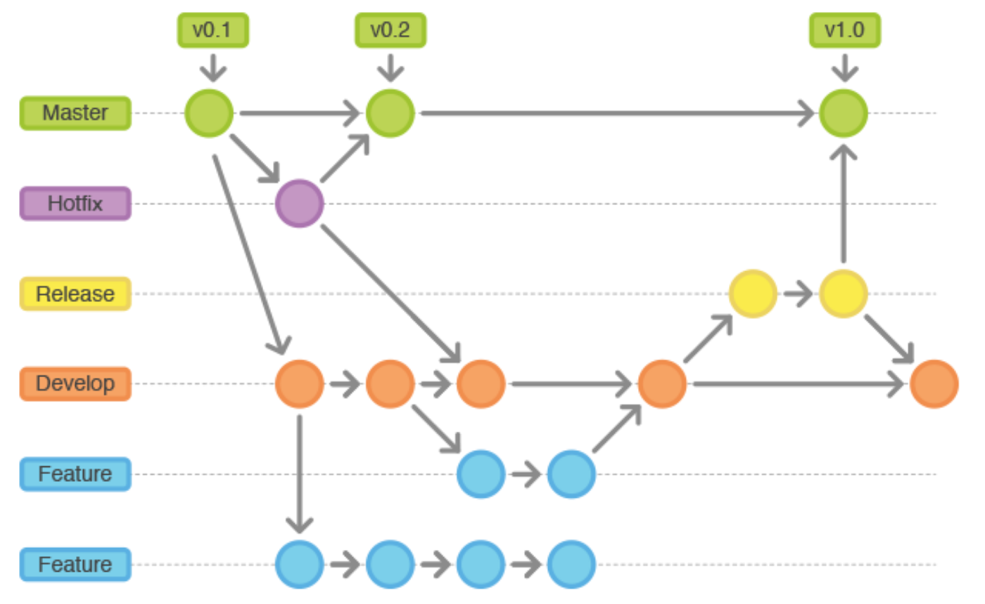
- How can we see 'n' most recent commits in GIT?
- git log lists the commits made in that repository in reverse chronological order; that is, the most recent commits show up first.
- One of the more helpful options is -p or --patch, which shows the difference (the patch output) introduced in each commit. You can also limit the number of log entries displayed, such as using -2 to show only the last two entries.

- How can we know if a branch is already merged into master in GIT?
- git branch --merged master lists branches merged into master

- What is the most popular branching strategy in GIT?
- Git Flow (Feature Based Development)
- This is one of the first major branching strategies that gained popularity. Git Flow describes multiple branches for development, releases and the orchestration between them. There are even scripts and extensions provided to help use/maintain Git Flow.

- How to delete a branch in Git?
- Delete a branch with git branch -d <branch>.
- Here's the command to delete a branch remotely: git push <remote> --delete <branch>.

- How do you clean unwanted files from working directory in Git?
- To remove directories, run git clean -f -d or git clean -fd
- To remove ignored files, run git clean -f -X or git clean -fX
- To remove ignored and non-ignored files, run git clean -f -x or git clean -fx

- How can we determine the commit that is the source of bug in Git?
- This command bisects (divides) your history between the good and the bad commit range. It points your current project state to a mid-range commit snapshot. The git bisect command then moves through every commit id between this range while pausing at each snapshot to allow you to test the code. If the bug exists, you declare the commit as bad, if not as good unless the search ends.
- git bisect<subcommand><options

- How can we see differences between two commits in Git?
- The git diff command is commonly used to get the unstaged changes between the index and working directory. It can be also be used to show changes between two arbitary commits
- git diff <commit-id> <commit-id>

- What is cherry-pick in Git?
- git cherry-pick is a powerful command that enables arbitrary Git commits to be picked by reference and appended to the current working HEAD. Cherry picking is the act of picking a commit from a branch and applying it to another. git cherry-pick can be useful for undoing changes.

- What is the use of Git log command?
- The Git Log tool allows you to view information about previous commits that have occurred in a project. The simplest version of the log command shows the commits that lead up to the state of the currently checked out branch. These commits are shown in reverse chronological order (the most recent commits first)

- What is the purpose of stash command in Git?
- Stashing takes the dirty state of your working directory — that is, your modified tracked files and staged changes — and saves it on a stack of unfinished changes that you can reapply at any time (even on a different branch).

- What is the use of status command in Git?
- The git status command displays the state of the working directory and the staging area. It lets you see which changes have been staged, which haven't, and which files aren't being tracked by Git. Status output does not show you any information regarding the committed project history.

- Explain the use of git rerere?
- The git rerere functionality is a bit of a hidden feature. The name stands for “reuse recorded resolution” and, as the name implies, it allows you to ask Git to remember how you've resolved a hunk conflict so that the next time it sees the same conflict, Git can resolve it for you automatically.

- Name atleast 5 GUI used for working on Git?
- QGit ‒ hassle-free Git GUI for Linux and it doesn’t cost a dime.
- Tortoise Git ‒ an open source and free Git GUI for Windows, straightforward to use and can be used with other development tools.
- Git-Xdev ‒ designed to be a top and maintainable Git GUI. It’s free and full-featured for most workflows.
- Aurees ‒ an easy to use free Git GUI client that enables users to work on Git operations effortlessly.
- Git Cola ‒ a free, simple yet powerful Git client that makes work-flows quick and efficient.

