Salesforce Developer Bridge Program
Hospital OPD Management System
Day 1 – Self Learning Track Documentation
- Vaishnavi (Team Lead)
- 23pa1a0572
- Date-28-07-2026

Introduction
The Salesforce Developer Bridge Program is designed to build practical Salesforce development skills through hands-on learning. As part of Day 1, I developed a Hospital OPD Management System to understand Salesforce data modelling, object relationships, Apex, SOQL, triggers, and Lightning Web Components.

Objectives
- Design a Hospital OPD data model.
- Create custom objects and fields.
- Establish object relationships.
- Learn Apex and SOQL fundamentals.
- Develop Apex triggers.
- Build a basic Lightning Web Component.

Data Modelling
For the Hospital OPD Management System, the data model was designed to manage patient records, doctor information, appointments, and prescriptions while maintaining accurate relationships between these entities.
Key Activities
- Identified the business entities.
- Created custom objects.
- Added required fields.
- Established Lookup and Master-Detail relationships.
- Verified the model using Schema Builder.

Custom Objects
Four custom objects were created to represent the Hospital OPD workflow.
Object | Purpose
Patient | Stores patient information such as age, gender, phone number, and blood group.
Doctor | Stores doctor details including specialization, experience, and contact information.
Appointment | Records appointments between patients and doctors, including date, time, and status.
Prescription | Stores medicines, dosage, duration, and notes prescribed during an appointment.

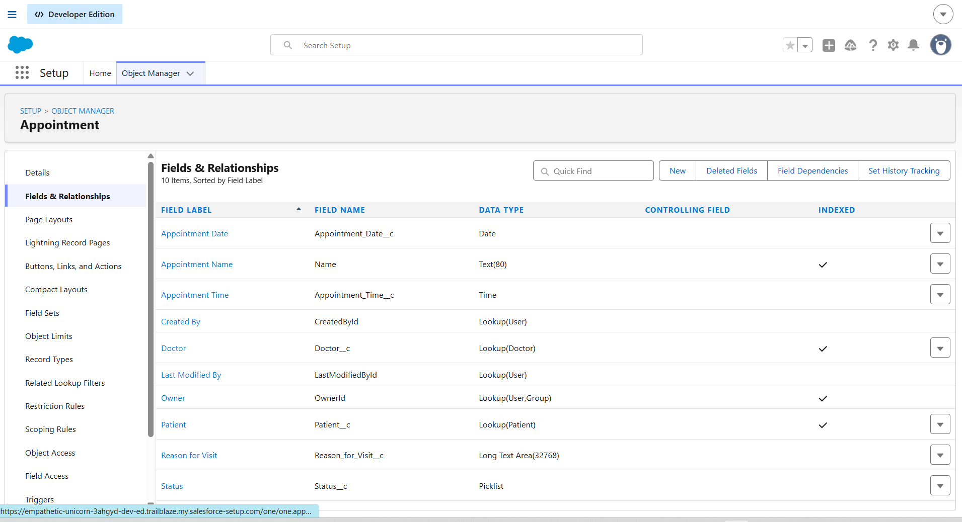

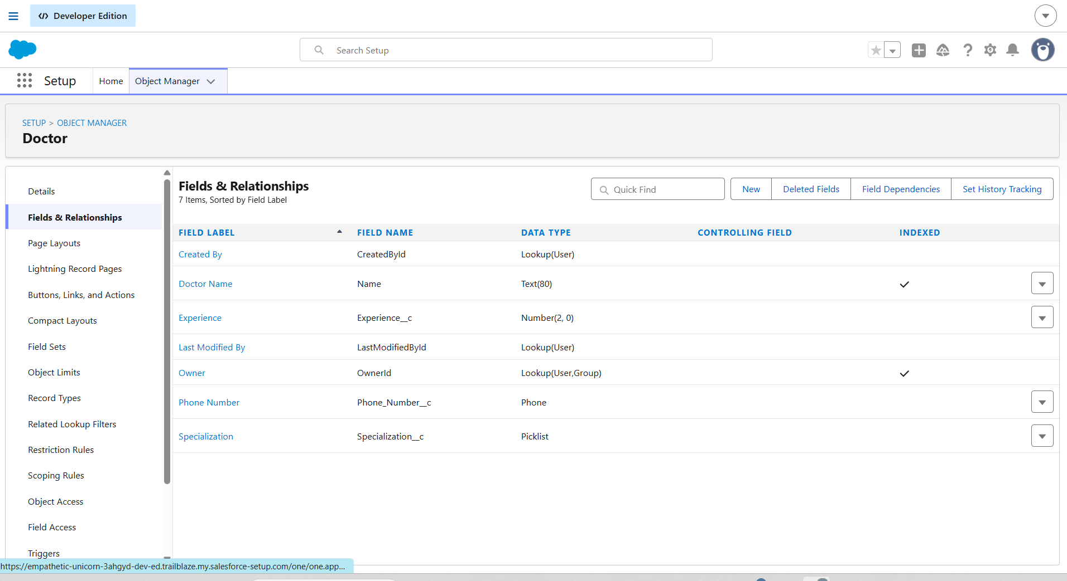
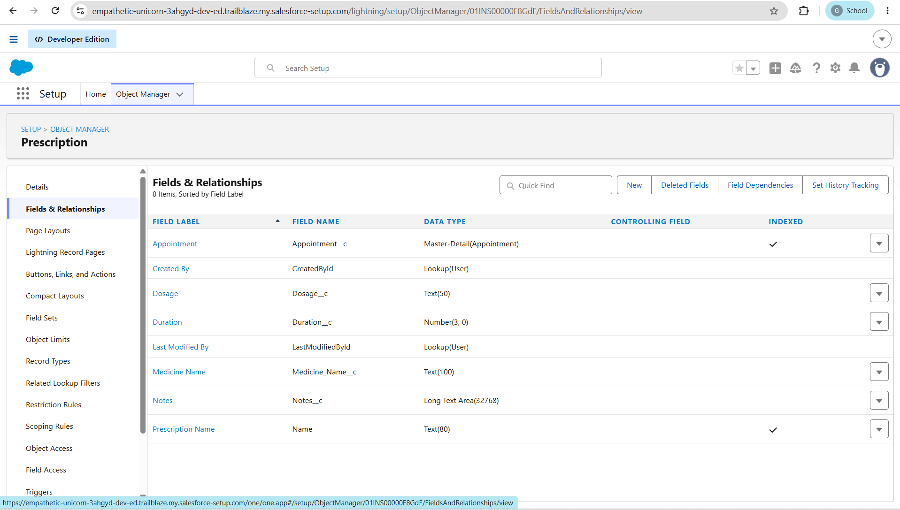

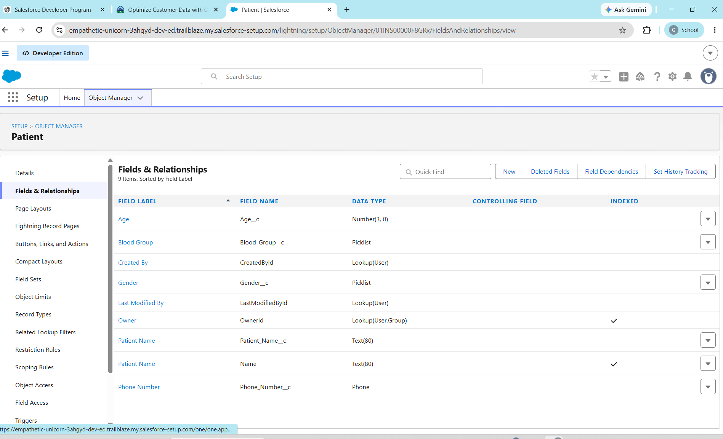

SOQL Queries
As part of the Hospital OPD Management System, SOQL (Salesforce Object Query Language) was used to retrieve and analyse data stored in custom objects. The following queries demonstrate filtering, sorting, relationship queries, aggregation, and comparison operations.

Objective
Retrieve all scheduled appointments.
SELECT Name, Appointment_Date__c, Status__c
FROM Appointment__c
WHERE Status__c = 'Scheduled'
Objective
Retrieve the latest five appointments.
SELECT Name, Appointment_Date__c, Status__c
FROM Appointment__c
ORDER BY Appointment_Date__c DESC
LIMIT 5

Objective
Retrieve appointment details along with the related patient and doctor.
SELECT Name,
Patient__r.Name,
Doctor__r.Name,
Appointment_Date__c,
Status__c
FROM Appointment__c
Objective
Count the total number of appointments.
SELECT COUNT(Id)
FROM Appointment__c

Objective
Retrieve prescriptions with a treatment duration of 7 days or more.
SELECT Name,
Medicine_Name__c,
Duration__c
FROM Prescription__c
WHERE Duration__c >= 7

Apex Trigger
An Apex Trigger was implemented on the Appointment object to automate business processes. The trigger executes Before Insert and After Update events, while all business logic is maintained in a separate Trigger Handler class following Salesforce best practices.
Trigger Events
- Before Insert
- After Update

Before Insert – Prevent Duplicate Appointments
Objective
Prevent duplicate appointment records for the same patient with the same doctor on the same appointment date.
Business Logic
- Checks existing appointment records.
- Compares Patient, Doctor, and Appointment Date.
- Displays an error message if a duplicate is found.

After Update – Update Related Patient Record
Objective
Automatically update the related Patient record when an appointment status changes to Completed.
Business Logic
- Checks if the appointment status is Completed.
- Updates the patient's Last Visit Date with the appointment date.
- Maintains accurate patient visit history.

Trigger Handler Pattern
The trigger follows the Trigger Handler Pattern, where the trigger only controls execution and all business logic is placed in a separate Apex class.
Benefits
- Improves code readability.
- Makes the code reusable and maintainable.
- Follows Salesforce development best practices.
- Simplifies testing and future enhancements.

Lightning Web Components
Lightning Web Components (LWC) is Salesforce's modern UI framework built using HTML, JavaScript, and CSS. It enables developers to create fast, reusable, and interactive components for Lightning Experience.

Objective
- Display records from a custom object.
- Retrieve data using the @wire service.
- Add the component to the Home Page using Lightning App Builder.

1. patientList.html
Responsible for the User Interface.
Functions:
* Displays Patient records in a table.
* Uses SLDS styling.
* Shows Loading spinner while data loads.
* Displays Error message if Apex fails.
* Displays "No patient records found" when no data exists.
* Uses lightning-card for Salesforce UI.

2. patientList.js
Responsible for Component Logic.
Functions:
* Imports Apex method getPatients.
* Uses @wire to fetch records automatically.
* Handles Loading, Error and Success states.
* Uses getter methods for cleaner code.
* Returns patient data to HTML.

3. patientList.js-meta.xml
Component Configuration File.
Functions:
* Makes component available in Lightning App Builder.
* Allows adding component to:
o Home Page
o App Page
o Record Page
* Restricts Record Page usage to Patient__c object.

Nam: | REGISTER NO: | LINK:
Koushik | 23pa1a4544 | https://drive.google.  com/drive/folders/  1BInIbtifTDjqdLjzXoHq_  dLM1RVlt1Ab?usp=sharing
Sri Datta Sai Vithal | 23pa1a4551 | https://drive.google.com/drive  /folders/  _2xOyVixGTM1Yn?usp=sharing
Gayathri | 23pa1a0566 | https://docs.google.com  /document/d/1r7tTKTG-  GQUjb8H78HNNqzqND  YSBrYYe/edit?usp=sharing  &ouid=109855680610728515  056&rtpof=true&sd=true
Shoba | 23pa1a04f1 | https://docs.google.com/document  /d/1oIkbceVt8  9Z0a9BDI6WJs4h5Pp-eyu-  1/edit?usp=drivesdk&ouid=  114002173865151456737&rtpof  =true&sd=true

