ASSIGNMENT – 2 – GITHUB CODES (OOP C++)

NAME: VAISHNAVI.V
REGISTER NUMBER: 2503917773822080
COURSE: MSc Data science
SEM: II-A
ROLL NUMBER: 68DS081
1.
#include<iostream>
#include<iomanip>
using namespace std;
//simple ATM program to 1.withdraw 2. deposit and check balance
class bankacc
{
private:
float bal;
public:
bankacc(float b)
{
bal=b;
}
void withdraw()
{
float wd;
cout<<"Enter withdraw amount:";
cin>>wd;
if(bal >= wd)
{
bal = bal - wd;
cout<<"Withdraw successful."<<endl;
cout<<"CURRENT BALANCE: Rs."<<fixed<<setprecision(2)<<bal<<endl;
}
else
{
cout<<"Insufficient balance."<<endl;
}
}
void deposit()
{
float dep;
cout<<"Enter amount for deposit: Rs.";
cin>>dep;
bal=bal+dep;
cout<<"Deposit is successful.\nCURRENT BALANCE: Rs."<<fixed<<setprecision(2)<<bal<<endl;
}
void checkBalance()
{
cout<<"CURRENT BALANCE: Rs."<<fixed<<setprecision(2)<<bal<<endl;
}

};
int main()
{
float balance;
cout<<"Enter your account balance: Rs.";
cin>>balance;
bankacc b(balance);
int c;
cout<<"Enter your choice: 1. withdraw \n2. deposit\n3. check balance\n";
cin>>c;
if(c==1)
{
b.withdraw();
}
else if(c==2)
b.deposit();
else if(c==3)
b.checkBalance();
else
cout<<"Invalid choice. Enter appropriate choice."<<endl;
return 0;
}
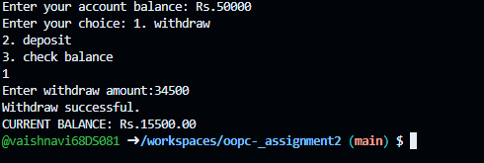
2.
//Student Class
//Create a class with:
//name,roll number,marks. Display student details
#include<iostream>
#include<string>
using namespace std;
class Student
{
private:
string name;
int rollNumber;
float marks;
public:
Student(string n, int roll, float m)
{
name=n;
rollNumber=roll;
marks=m;
}
void displayDetails()
{
cout<<"Name: "<<name<<endl;
cout<<"Roll Number: "<<rollNumber<<endl;
cout<<"Marks: "<<marks<<endl;
}
};
int main()
{
Student s("John", 123, 85.5);
s.displayDetails();
return 0;
}
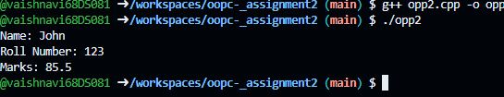
3. //Find Maximum Element in Array
#include<iostream>
using namespace std;
class Array
{
private:
int arr[100];
int size;
public:
void input()
{
cout<<"Enter the size of the array: ";
cin>>size;
cout<<"Enter "<<size<<" elements: ";
for(int i=0; i<size; i++)
{
cin>>arr[i];
}
}
void findMax()
{ int max=arr[0];
for(int i=1; i<size; i++)
{
if(arr[i]>max)
{
max=arr[i];
}
}
cout<<"Maximum element in the array is: "<<max<<endl;
}
};
int main()
{ Array a;
a.input();
a.findMax();
return 0;
}
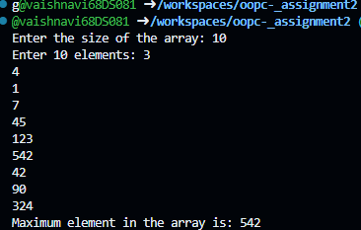
4.
//Number Pyramid
#include<iostream>
using namespace std;
class Pyramid
{
private:
int n;
public:
void input()
{
cout<<"Enter the number of rows for the pyramid: ";
cin>>n;
}
void display()
{ for(int i=1; i<=n; i++)
{
for(int j=1; j<=i; j++)
{
cout<<j<<" ";
}
cout<<endl;
}
}
};
int main()
{ Pyramid p;
p.input();
p.display();
return 0;
}
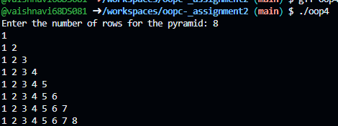
5. //Armstrong Number
#include<iostream>
using namespace std;
class Armstrong
{
private:
int num;
public:
void input()
{ cout<<"Enter a number: ";
cin>>num;
}
void checkArmstrong()
{ int originalNum=num;
int sum=0;
while(num>0)
{
int digit=num%10;
sum+=digit*digit*digit;
num=num/10;
}
if(sum==originalNum)
{
cout<<originalNum<<" is an Armstrong number."<<endl;
}
else
{ cout<<originalNum<<" is not an Armstrong number."<<endl;
}
}
};
int main()
{ Armstrong a;
a.input();
a.checkArmstrong();
return 0;
}
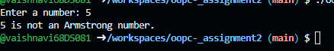
6. //Count Digits
#include<iostream>
using namespace std;
class CountDigits
{
private:
int num;
public:
void input()
{ cout<<"Enter a number: ";
cin>>num;
}
void count()
{ int count=0;
int temp=num;
while(temp>0)
{
temp=temp/10;
count++;
}
cout<<"Number of digits in "<<num<<" is: "<<count<<endl;
}
};
int main()
{ CountDigits cd;
cd.input();
cd.count();
return 0;
}
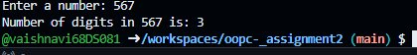
7. // C++ program to display Fibonacci series up to n terms
#include <iostream>
using namespace std;

int main() {
int n, first = 0, second = 1, next;

cout << "Enter number of terms: ";
cin >> n;

cout << "Fibonacci Series: ";

for(int i = 0; i < n; i++) {
cout << first << " ";

next = first + second;
first = second;
second = next;
}

return 0;
}
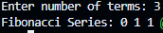
8. // C++ program to reverse a number
#include <iostream>
using namespace std;

int main() {
int num, reverse = 0, rem;

cout << "Enter a number: ";
cin >> num;

while(num != 0) {
rem = num % 10;
reverse = reverse * 10 + rem;
num = num / 10;
}

cout << "Reversed number: " << reverse;

return 0;
}
9. //Multiplication Table
#include <iostream>
using namespace std;

int main() {
int num;

cout << "Enter a number: ";
cin >> num;

cout << "Multiplication Table of " << num << endl;

for(int i = 1; i <= 10; i++) {
cout << num << " x " << i << " = " << num * i << endl;
}

return 0;
}
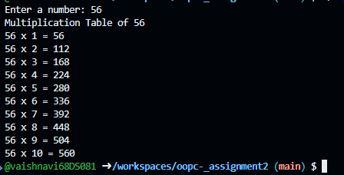
10.
//Pattern Programs
#include <iostream>
using namespace std;

int main() {
int rows;

cout << "Enter number of rows: ";
cin >> rows;

for(int i = 1; i <= rows; i++) {
for(int j = 1; j <= i; j++) {
cout << "*";
}
cout << endl;
}

return 0;
}

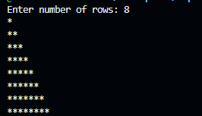
11.
//Generic Addition Function
#include <iostream>
using namespace std;

template <typename T>
T add(T a, T b) {
return a + b;
}

int main() {
int int1 = 5, int2 = 10;
double double1 = 3.5, double2 = 2.5;

cout << "Sum of integers: " << add(int1, int2) << endl;
cout << "Sum of doubles: " << add(double1, double2) << endl;

return 0;
}
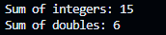
12.
//Template for Maximum Value
#include <iostream>
using namespace std;

template <typename T>
T maximum(T a, T b) {
return (a > b) ? a : b;
}

int main() {
int int1 = 5, int2 = 10;
double double1 = 3.5, double2 = 2.5;

cout << "Maximum of integers: " << maximum(int1, int2) << endl;
cout << "Maximum of doubles: " << maximum(double1, double2) << endl;

return 0;
}
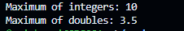//Template Class
//Create a template class Calculator with functions:
//add()
//subtract()
//multiply()
//
//Use it for both int and float.

#include <iostream>
using namespace std;

template <class T>
class Calculator {
T a, b;

public:
Calculator(T x, T y) {
a = x;
b = y;
}

void add() {
cout << "Addition = " << a + b << endl;
}

void subtract() {
cout << "Subtraction = " << a - b << endl;
}

void multiply() {
cout << "Multiplication = " << a * b << endl;
}
};

int main() {

// Integer type
Calculator<int> intCalc(10, 5);

cout << "Integer Operations:" << endl;
intCalc.add();
intCalc.subtract();
intCalc.multiply();

cout << endl;

// Float type
Calculator<float> floatCalc(2.5, 1.5);

cout << "Float Operations:" << endl;
floatCalc.add();
floatCalc.subtract();
floatCalc.multiply();

return 0;
}

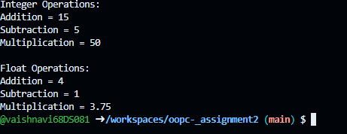
14.
//Student Record using Vector
#include <iostream>
#include <vector>
using namespace std;
class Student {
public:
string name;
int age;
Student(string n, int a) : name(n), age(a) {}
};
int main() {
vector<Student> students;
students.push_back(Student("Alice", 20));
students.push_back(Student("Bob", 22));
students.push_back(Student("Charlie", 19));

cout << "Student Records:" << endl;
for (const auto& student : students) {
cout << "Name: " << student.name << ", Age: " << student.age << endl;
}

return 0;
}
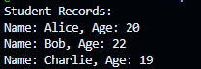
15.
//Swap Two Numbers using Pointers
#include <iostream>
using namespace std;
void swap(int* a, int* b) {
int temp = *a;
*a = *b;
*b = temp;
}
int main() {
int num1, num2;
cout << "Enter two numbers: ";
cin >> num1 >> num2;
cout << "Before swapping: num1 = " << num1 << ", num2 = " << num2 << endl;
swap(&num1, &num2);
cout << "After swapping: num1 = " << num1 << ", num2 = " << num2 << endl;
return 0;
}
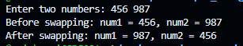
16.
//Runtime Polymorphism – Animal Sound
#include <iostream>
using namespace std;
class Animal {
public:
virtual void makeSound() {
cout << "Animal makes a sound" << endl;
}
};
class Dog : public Animal {
public:
void makeSound() override {
cout << "Dog barks" << endl;
}
};
class Cat : public Animal {
public:
void makeSound() override {
cout << "Cat meows" << endl;
}
};
int main() {
Animal* animal1 = new Dog();
Animal* animal2 = new Cat();
animal1->makeSound(); // Output: Dog barks
animal2->makeSound(); // Output: Cat meows
delete animal1;
delete animal2;
return 0;
}
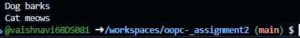
17.
//Abstract Class – Shape
//Create an abstract class Shape with a pure virtual function area().
//Derive classes Circle and Rectangle from Shape and implement the area() function.
#include <iostream>
using namespace std;

class Shape {
public:
virtual double area() = 0; // Pure virtual function
};

class Circle : public Shape {
private:
double radius;
public:
Circle(double r) : radius(r) {}
double area() override {
return 3.14 * radius * radius;
}
};

class Rectangle : public Shape {
private:
double length, width;
public:
Rectangle(double l, double w) : length(l), width(w) {}
double area() override {
return length * width;
}
};

int main() {
Shape* shapes[2];
shapes[0] = new Circle(5);
shapes[1] = new Rectangle(4, 6);

for (int i = 0; i < 2; i++) {
cout << "Area: " << shapes[i]->area() << endl;
delete shapes[i];
}

return 0;
}
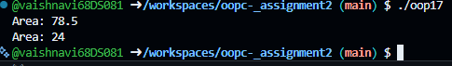
18.
//Animal Hierarchy
#include <iostream>
using namespace std;
class Animal {
public:
virtual void makeSound() {
cout << "Animal makes a sound" << endl;
}
};
class Dog : public Animal {
public:
void makeSound() override {
cout << "Dog barks" << endl;
}
};
class Cat : public Animal {
public:
void makeSound() override {
cout << "Cat meows" << endl;
}
};
int main() {
Animal* animal1 = new Dog();
Animal* animal2 = new Cat();
animal1->makeSound(); // Output: Dog barks
animal2->makeSound(); // Output: Cat meows
delete animal1;
delete animal2;
return 0;
}
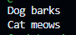
19. // multi-level inheritance
//Person → Student → Exam
#include <iostream>
using namespace std;
class Person {
public:
string name;
int age;
Person(string n, int a) : name(n), age(a) {}
void displayPerson() {
cout << "Name: " << name << endl;
cout << "Age: " << age << endl;
}
};
class Student : public Person {
public: int rollNumber;
Student(string n, int a, int roll) : Person(n, a), rollNumber(roll) {}
void displayStudent() {
displayPerson();
cout << "Roll Number: " << rollNumber << endl;
}
};
class Exam : public Student {
public: float marks;
Exam(string n, int a, int roll, float m) : Student(n, a, roll), marks(m) {}
void displayExam() {
displayStudent();
cout << "Marks: " << marks << endl;
}
};
int main() {
Exam exam("Alice", 20, 123, 85.5);
exam.displayExam();
return 0;
}
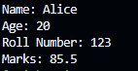
20. //Vehicle Information - multi level inheritance
#include <iostream>
using namespace std;
class Vehicle {
public: string brand;
Vehicle(string b) : brand(b) {}
void displayBrand() {
cout << "Brand: " << brand << endl;
}
};
class Car : public Vehicle {
public: string model;
Car(string b, string m) : Vehicle(b), model(m) {}
void displayCar() {
displayBrand();
cout << "Model: " << model << endl;
}
};
class ElectricCar : public Car {
public: int batteryCapacity;
ElectricCar(string b, string m, int capacity) : Car(b, m), batteryCapacity(capacity) {}
void displayElectricCar() {
displayCar();
cout << "Battery Capacity: " << batteryCapacity << " kWh" << endl;
}
};
int main() {
ElectricCar myCar("Tesla", "Model S", 100);
myCar.displayElectricCar();
return 0;
}
