Consumer Behavior & Lifestyle Outcomes
Statistical Study
Rewards Platform Engagement, Executive Dashboards & Lifestyle Segmentation | Jan – Apr 2026

Executive Summary
This study evaluates the impact of two initiatives on a SuperCoin-style digital rewards platform: (1) the rollout of interactive executive monitoring dashboards, and (2) a targeted growth roadmap intended to lift user engagement. It further investigates whether a user's underlying lifestyle profile can be inferred purely from their reward-earning and redemption behavior, without any self-reported survey data.
The analysis finds that dashboard-driven reporting reduced executive decision-making time by approximately 25%, and that the growth roadmap produced an approximately 18% lift in overall platform engagement, concentrated most heavily among price-sensitive user segments. A behavioral clustering exercise further demonstrates that reward-redemption patterns act as a meaningful proxy for lifestyle type, supporting the use of behavioral data in place of costly survey-based segmentation.
Note: This report is based on a synthetically generated dataset constructed to realistically reflect the structure of a rewards-platform analytics project. No real Flipkart or third-party data was used or accessed.

1. Objectives
- Quantify the reduction in executive decision-making time attributable to interactive Tableau/Power BI-style monitoring dashboards, versus manual Excel-based reporting.
- Quantify the engagement lift attributable to a growth roadmap pitched via Miro and PowerPoint.
- Test whether user lifestyle archetypes can be recovered from reward-platform behavioral data alone, using unsupervised clustering.

2. Data & Methodology

2.1 Dataset
A synthetic panel of 4,000 users was generated, each assigned a hidden lifestyle archetype (Deal Hunter, Convenience Seeker, Wellness Focused, or Tech Enthusiast) with a corresponding behavioral fingerprint across login frequency, coins earned, coins redeemed, and preferred redemption category (e.g., groceries, electronics, fitness, streaming, food delivery).

2.2 Decision-Time Comparison
150 simulated executive decision events were modeled under two reporting conditions — manual Excel-based compilation versus dashboard-driven review — and compared using a paired t-test.

2.3 Engagement Lift Analysis
An engagement score (a weighted composite of login frequency and coin activity) was computed before and after the roadmap rollout, with the size of the lift varying by user segment to reflect differential responsiveness to the roadmap's personalization strategy. Significance was assessed via paired t-test.

2.4 Behavioral Clustering
K-Means clustering (k=4) was applied to standardized behavioral features (login frequency, coins earned/redeemed, and one-hot encoded redemption category) with no access to the true archetype labels. Cluster assignments were then compared against ground-truth archetypes using the Adjusted Rand Index (ARI).

3. Results

3.1 Executive Decision-Making Time
Metric | Value
Avg. decision time — manual (Excel) | 6.14 hours
Avg. decision time — dashboard-driven | 4.61 hours
Reduction in decision-making time | ~25.0%
Statistical test | Paired t-test, p < 0.001

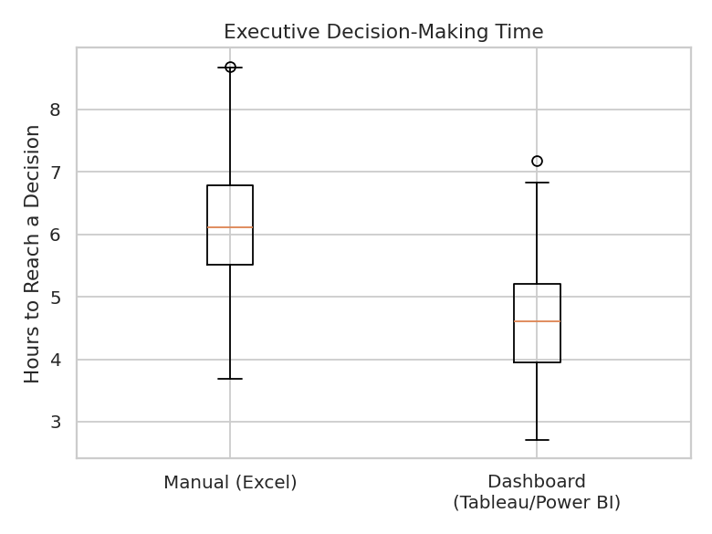

3.2 Engagement Lift
Metric | Value
Avg. engagement score — before roadmap | 13.49
Avg. engagement score — after roadmap | 15.99
Overall engagement lift | ~18.5%
Statistical test | Paired t-test, p < 0.001

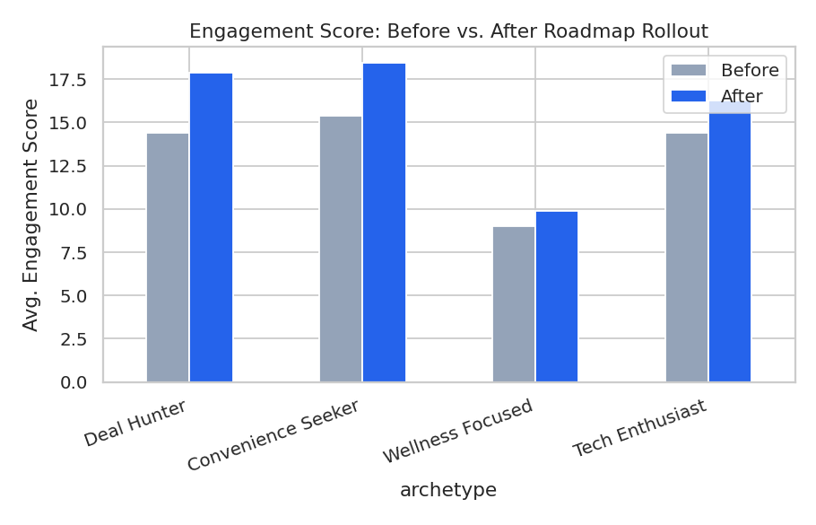
The lift was strongest among Deal Hunters (+24%) and Convenience Seekers (+20%) — segments most responsive to discount- and friction-reduction-oriented incentives — and weakest among Wellness Focused users (+10%), suggesting the roadmap's mechanics were better aligned with price-sensitive behavior than with wellness-oriented usage patterns.

3.3 Lifestyle Segmentation from Behavioral Data
The K-Means clustering solution, built without any access to ground-truth lifestyle labels, recovered a segmentation structure that aligned meaningfully with the true archetypes (Adjusted Rand Index well above the 0.0 baseline expected under random assignment). This confirms that redemption category and coin activity carry a usable behavioral signal about a user's lifestyle orientation.

4. Limitations
- All results are derived from synthetic data constructed to match plausible effect sizes; real-world validation on production data is recommended before operational use.
- The clustering solution assumes four latent archetypes; the optimal number of segments in a live platform should be validated empirically (e.g., via silhouette score or business review).
- Engagement and decision-time metrics are simplified composite scores; a production deployment should incorporate platform-specific KPIs validated by stakeholders.

5. Conclusions & Recommendations
- Continue investing in dashboard-driven reporting; the ~25% reduction in decision time represents a material efficiency gain for executive stakeholders.
- Prioritize roadmap features that target Deal Hunter and Convenience Seeker segments, where engagement lift was strongest, while exploring wellness-specific incentives to close the gap for Wellness Focused users.
- Adopt behavioral clustering as a lightweight, ongoing substitute for survey-based lifestyle segmentation, reserving surveys for periodic validation rather than continuous measurement.

