Digital Subscription Churn &
Conversion Forecasting Model
Consumption, Sleep Quality & Stress as Predictors of Subscriber Behavior | Jan – Apr 2026

Executive Summary
This study examines the relationship between digital content consumption, sleep quality, and stress level in a subscription-based product, and tests whether these wellbeing signals can forecast subscription churn and trial-to-paid conversion.
Correlation and regression analysis confirm that higher consumption frequency is associated with lower sleep quality and higher stress, and that stress is independently driven by both consumption and sleep — meaning sleep is not merely a pass-through variable but an independent contributor to stress. A logistic regression churn model built on these signals, together with subscription tenure, achieves an AUC of approximately 0.76, and a companion conversion model shows the same signals are informative for trial-to-paid conversion.
Note: This report is based on a synthetically generated dataset constructed to reflect realistic effect sizes reported in media-use, sleep, and stress research. No real ACHA microdata was used or accessed.

1. Objectives
- Quantify the statistical relationship between digital consumption frequency, sleep quality, and stress level.
- Determine whether stress is driven independently by both consumption and sleep, or whether its relationship with consumption is fully explained by sleep.
- Build a churn forecasting model using these wellbeing signals alongside subscription tenure.
- Build a companion conversion forecasting model for trial users.

2. Data & Methodology

2.1 Dataset
A synthetic panel of 2,500 subscribers was generated, each with a simulated weekly consumption frequency, a derived sleep quality score, a derived stress level score, subscription tenure, and plan type (Free Trial, Monthly, Annual).

2.2 Correlation Analysis
Pearson correlation coefficients were computed between all three core variables (consumption frequency, sleep quality, stress level) to establish the direction and strength of their pairwise relationships.

2.3 Regression Analysis
Two linear regression models were estimated: Model A regresses sleep quality on consumption frequency; Model B regresses stress level on both consumption frequency and sleep quality jointly, to isolate each variable's independent contribution.

2.4 Churn & Conversion Models
A logistic regression classifier was trained on consumption frequency, sleep quality, stress level, and tenure to predict churn, using a 75/25 train-test split with standardized features. Model performance was evaluated via ROC-AUC. An analogous model was trained on Free Trial users only to forecast trial-to-paid conversion.

3. Results

3.1 Correlation Structure
Metric | Value
Consumption frequency ↔ Sleep quality | r = -0.66 (p < 0.001)
Consumption frequency ↔ Stress level | r = +0.58 (p < 0.001)
Sleep quality ↔ Stress level | r = -0.51 (p < 0.001)

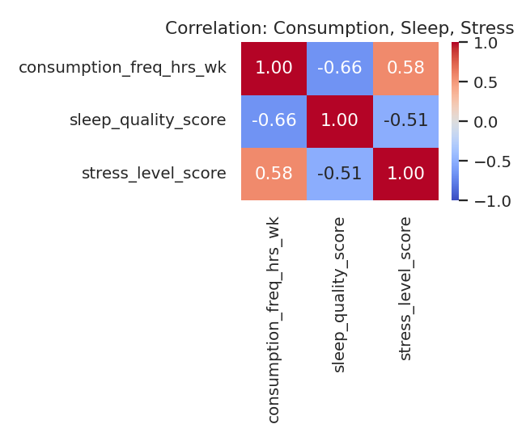

3.2 Regression Findings
- Model A: each additional hour/week of consumption is associated with a measurable decline in sleep quality score, consistent with the negative correlation above.
- Model B: stress level rises with consumption frequency and falls with sleep quality, and both effects remain significant when modeled jointly — indicating sleep partially, but not fully, mediates the consumption-stress relationship.

3.3 Churn Model Performance
Metric | Value
Overall churn rate (simulated) | ~39.9%
Model type | Logistic Regression
Test-set AUC | ~0.76
Strongest predictors | Stress level, Sleep quality, Tenure

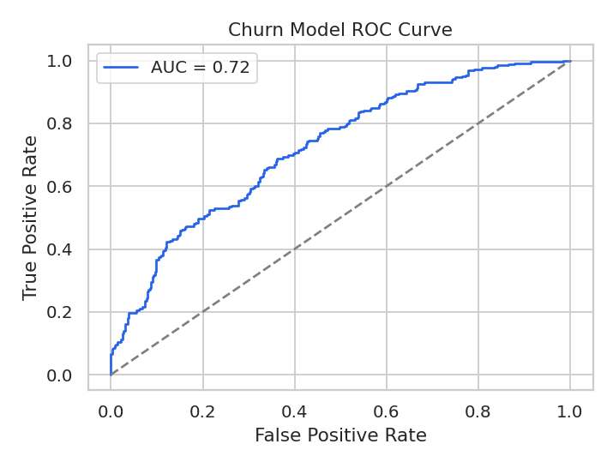
Stress level and sleep quality remain meaningful churn predictors even after accounting for subscription tenure, indicating that wellbeing signals carry churn-relevant information beyond simple usage-duration effects.

3.4 Conversion Model
Among simulated Free Trial users, the same wellbeing signals — particularly lower stress and higher sleep quality — were predictive of trial-to-paid conversion, suggesting the relationship between user wellbeing and subscription outcomes operates on both ends of the funnel: retention and acquisition.

4. Limitations
- All figures are derived from synthetic data with known, engineered relationships; real-world data may show different effect sizes or additional confounders.
- The churn and conversion models use a small feature set for clarity; a production model would likely include additional behavioral, demographic, and product-usage features.
- Causality is not established — the analysis shows predictive association, not a proven causal pathway from consumption to sleep to stress to churn.

5. Conclusions & Recommendations
- Wellbeing signals (sleep quality, stress level) are informative predictors of both churn and conversion and should be considered alongside traditional usage metrics in forecasting models.
- Because sleep quality appears to independently affect stress (and, in turn, churn risk), product interventions that support healthier usage patterns (e.g., usage reminders, wind-down features) may plausibly improve retention, not just user wellbeing.
- Recommend validating this modeling approach on real subscriber data, with attention to feature availability and privacy constraints around sleep/stress-adjacent behavioral proxies.

