**Student Name**: DADE VAISHNAVI

**Application Name**: STUDENT PROJECT MANAGEMENT

**PROJECT ABSTRACT:**

The Student Project Management is a system to store student, corresponding project information and provides faculty details under whom they are working. This application also helps to track the project status. This helps students and faculty to know the project status and feedback from the faculty.

1. Faculty can CREATE, READ and DELETE Students from the application.
2. Faculty can UPDATE the status of the project and provide the feedback.

**Entities:**

STUDENT

* Student entity describes the student information and project details corresponding to the student. Student details such as student id, student name, department, faculty id, specialization, project name, status and feedback on the project. Every student has unique id which is the primary key of the entity. While faculty id is the foreign key, references the faculty entity.

FACULTY

* Faculty entity describes the faculty details whereas faculty id, faculty name, department, designation and faculty education.

**Relations:**

STUDENT

* One student can do major project under only one faculty. This shows one to one relationship.

FACULTY

* One faculty can guide n number of students. The relationship is One to many

**Conceptual Model:**

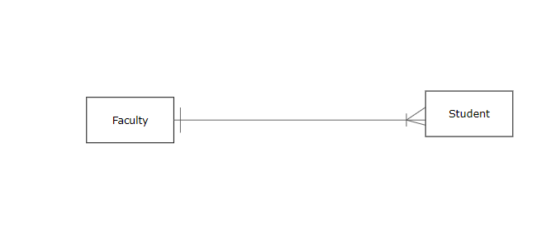

**Logical Model:**

