**1.Write a Python program to implement the Caesar cipher using Substitution**

**technique.**

# Expl: Implement Python program to illustrate Caesar Cipher Technique

def encrypt(text, s):

result = ""

# Traverse text

for char in text:

# Encrypt uppercase characters

if char.isupper():

result += chr((ord(char) + s - 65) % 26 + 65)

# Encrypt lowercase characters

elif char.islower(): # Added elif to explicitly check for lowercase

result += chr((ord(char) + s - 97) % 26 + 97)

else:

# If it's not an alphabet, keep it as is (spaces, numbers, symbols)

result += char

return result

# Check the function

text = input("Enter text to encrypt: ")

try:

s = int(input("Enter shift (0-25): "))

print("Cipher: " + encrypt(text, s))

except ValueError:

print("Enter a valid integer between 0 to 25")

**Enter text to encrypt: Hello World**

**Enter shift (0-25): 4**

**Cipher: Lipps Asvph**

**2.Write a Python program to implement and analysis of RSA.  
  
python -m pip install sympy**

# simple_rsa_sympy.py

from sympy import isprime, gcd, mod_inverse

#key generation

def generate_keys(p: int, q: int, e: int):

if not (isprime(p) and isprime(q)):

raise ValueError("Both numbers must be prime.")

if p == q:

raise ValueError("p and q should not be the same.")

n = p * q

phi_n = (p - 1) * (q - 1)

if gcd(e, phi_n) != 1:

raise ValueError(f"e = {e} is not coprime with phi(n) = {phi_n}. Choose a different e.")

d = mod_inverse(e, phi_n)

print("\nComputed values:")

print(f"n = {n}")

print(f"phi(n) = {phi_n}")

print(f"Private key d = {d}")

return (e, d, n)

# encryption function

def encrypt(message, e, n):

if not (0 <= message < n):

raise ValueError("Message integer must satisfy 0 <= message < n.")

return pow(message, e, n)

#decryption function

def decrypt(cipher, d, n):

return pow(cipher, d, n)

#main

if __name__ == "__main__":

try:

# User input for primes and exponent

p = int(input("Enter a prime number p: "))

q = int(input("Enter a different prime number q: "))

e = int(input("Enter public exponent e (coprime with phi(n)): "))

# Key generation

e, d, n = generate_keys(p, q, e)

#message input

message = int(input("\nEnter integer message to encrypt (0 <= m < n): "))

#encrypt

cipher = encrypt(message, e, n)

print(f"Encrypted message (integer): {cipher}")

#decrypt

decrypted = decrypt(cipher, d, n)

print(f"Decrypted integer: {decrypted}")

except ValueError as ve:

print(f"Error: {ve}")

**Enter a prime number p: 5**

**Enter a different prime number q: 7**

**Enter public exponent e (coprime with phi(n)): 11**

**Computed values:**

**n = 35**

**phi(n) = 24**

**Private key d = 11**

**Enter integer message to encrypt (0 <= m < n): 2**

**Encrypted message (integer): 18**

**Decrypted integer: 2**

**3.Write a Python program to implement the Diffie-Hellman Key Exchange**

**algorithm.**

# Diffie-Hellman Key Exchange Algorithm

# Step 1: Get public values from user

n = int(input("Enter a prime number (n): "))

g = int(input("Enter a primitive root modulo n (g): "))

# Step 2: Get private keys from Alice and Bob

x = int(input("Alice, enter your private key (x): "))

y = int(input("Bob, enter your private key (y): "))

# Step 3: Calculate public keys

A = pow(g, x, n) # (g^x) % n

B = pow(g, y, n) # (g^y) % n

print(f"\nAlice's Public Key (A) = {A}")

print(f"Bob's Public Key (B) = {B}")

# Step 4: Exchange public keys and compute shared secret

k1 = pow(B, x, n) # (B^x) % n

k2 = pow(A, y, n) # (A^y) % n

print(f"\nAlice's computed shared secret = {k1}")

print(f"Bob's computed shared secret = {k2}")

# Step 5: Verify

if k1 == k2:

print(f"\nKey exchange successful! Shared secret = {k1}")

else:

print("\nKey exchange failed!")

**Enter a prime number (n): 23**

**Enter a primitive root modulo n (g): 5**

**Alice, enter your private key (x): 6**

**Bob, enter your private key (y): 15**

**Alice's Public Key (A) = 8**

**Bob's Public Key (B) = 19**

**Alice's computed shared secret = 2**

**Bob's computed shared secret = 2**

**Key exchange successful! Shared secret = 2**

**4.Write a Python program to implement MD5 Algorithm**

# md5_example.py

import hashlib

def generate_md5(message: str) -> str:

"""Generate MD5 hex digest for the provided message string."""

# Create MD5 hash object

md5_hash = hashlib.md5()

# Convert string to bytes and update hash object

md5_hash.update(message.encode('utf-8'))

# Return hexadecimal digest

return md5_hash.hexdigest()

if __name__ == "__main__":

# Take input from user

text = input("Enter text to hash using MD5: ").strip()

md5_result = generate_md5(text)

print("Original Text:", text)

print("MD5 Hash:", md5_result)

**Enter text to hash using MD5: hello world**

**Original Text: hello world**

**MD5 Hash: 5eb63bbbe01eeed093cb22bb8f5acdc3**

**5.Write a Python program to implement SHA Algorithm**

# Program: Implement SHA-1 Algorithm using Python

import hashlib

# Function to generate SHA-1 hash

def generate_sha1(message):

# Create SHA-1 hash object

sha1_hash = hashlib.sha1()

# Convert string to bytes and update hash object

sha1_hash.update(message.encode('utf-8'))

# Return hexadecimal digest

return sha1_hash.hexdigest()

# Take input from user

text = input("Enter text to hash using SHA-1: ")

sha1_result = generate_sha1(text)

print("Original Text:", text)

print("SHA-1 Hash:", sha1_result)

**Enter text to hash using SHA-1: hello world**

**Original Text: hello world**

**SHA-1 Hash: 2aae6c35c94fcfb415dbe95f408b9ce91ee846ed**

**6.Explain and show the execution of basic network commands with different**

**options for each commands:**

**ifconfig, ping, netstat, Whois, dig, nslookup, traceroute, host,arp, hostname**

Software: Ubuntu 20. 0 4 LTS

Sudo apt install net-tools

1. ifconfig :

Linux ifconfig stands for interface configurator. It is one of the most basic commands used in network inspection. ifconfig is used to initialize an interface, configure it with an IP address, and enable or disable it. It is also used to display the route and the network interface.

Basic information displayed upon using ifconfig are:

1. IP address

2. MAC address

3. MTU(Maximum Transmission Unit)

To get all the details using ifconfig

Ifconfig

Using this command, you can get details of a specific interface. This is shown below.

Commands:

**ifconfig eno1**

**ifconfig lo**

ip command:

The ip addr command without any subcommands shows the network interface

information, including the associated IP addresses:

Syntax:

ip addr

**ip -4 addr** (IP Command is used to show network interface information)

**ip -6 addr** To set the size of MTU

By default, MTU has a size of 1500. This can be however set externally by the user using

ifconfig.

Syntax: Ifconfig eno1 mtu xxxx

2. Netstat:

netstat(Network Statistics) is the command that is used to display routing table,

connection information, the status of ports. i.e. it gives details information about

network activity on Linux System.

a. **netstat -r** Using -r flag will display the routing table

b. **netstat –a** use -a flag to show listening and non-listening sockets(TCP+ UDP)

c. **netstat –at** to show all TCP socket

d. **netstat –l** to show all active ports

e. **netstat –u** to show all UDP socket

3 .Whois

The whois command displays information about a website's record. You may get all the

information about a website regarding its registration and owner's information.

Syntax:

whois <websiteName>

Example:

**whois javatpoint.com**

4.dig

dig command stands for Domain Information Groper. It is used for retrieving information about

DNS name servers. It is basically used by network administrators. It is used for verifying and

troubleshooting DNS problems and to perform DNS lookups.

Syntax:

dig [server] [name] [type]

**dig geeksforgeeks.org**

5.ping :

Ping (Packet Internet Groper) command is the best way to test connectivity

between two nodes. Whether it is Local Area Network (LAN) or Wide Area

Network (WAN).

the ping command is used to ensure that a computer can communicate to a specified

device over the network. The pings command sends Internet Control Message

Protocol(ICMP) Echo Request messages in the form of packets to the destination

computer and waits in order to get the response back. Once the packets are received

by the destined computer, it starts sending the packets back. This command keeps

executing until it si interrupted.

Ping uses ICMP (Internet Control Message Protocol) to communicate to other

devices.

ping command provides details such as: number of packets transmitted

number of packets received

time taken by the packet to return

ping command in generally used for the following purposes: measuring the time taken by the packets to return to determine the speed of the

connection

to make sure that the network connection between the host and the destined

computer can be established

Example: **ping google.com**

**ping 216.58.203.142**

6. traceroute :

This utility uses the ICMP protocol and finds the hops involved in reading the destination

server. It also shows the time it takes between hops. This command is used to get the route

of a packet. i.e. to determine the path along which a packet travels. It also returns the

number of hops taken by the packet to reach the destination. This command prints to the

console, a list of hosts through which the packet travels in order to the destination.

Example:

**traceroute www.google.com**

**traceroute 4.2.2.2**

-4 Option: Use ip version 4 i.e. use IPv4

Syntax:

traceroute -4 google.com

-4 Option: Use ip version 6 i.e. use IPv6

Syntax:

traceroute -6 google.com

7. nslookup:

nslookup command queries the DNS in order to fetch the IP address or the domain

name from DNS records.

Example:

**nslookup www.facebook.com**

8. route:

route command also shows and manipulates the ip routing table

To see the default routing table in Linux, type the following command.

# **route**

9. host:

host command is used to find a domain name associated with the IP address or find an

IP address associated with the domain name. The returned IP address is either IPv4 or

IPv6.

Example:

**host www.google.com**

**host 31.13.78.35**

10. hostname To check and set the hostname of the server.

Example:

**hostname**

11. arp:

ARP(Address Resolution Protocol) command is used to display and modify

ARP cache, which contains the mapping of IP address to MAC address.

The system’s TCP/IP stack uses ARP in order to determine the MAC

address associated with an IP address.

ARP (Address Resolution Protocol) is useful to view/add the contents of the

kernel’s ARP tables. To see the default table use the command as.

# **arp -e**

**ifconfig eno1** - ifconfig (interface configurator) - configure network interfaces in Unix-like systems. It allows you to display, configure, and manage network interface settings like IP addresses, subnet masks, and interface status.



**ifconfig lo**

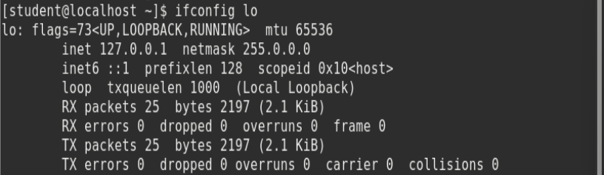

**ip -4 addr** - manage and retrieve information about network connections, specifically related to the Internet Protocol (IP)

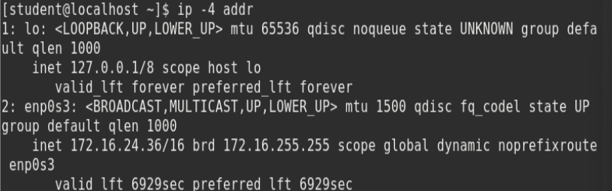

**ip -6 addr**

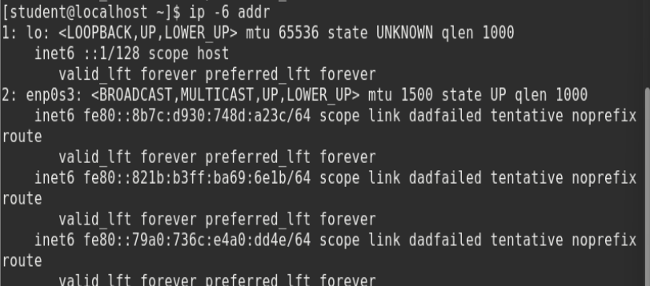

**netstat -r** - Using -r flag will display the routing table

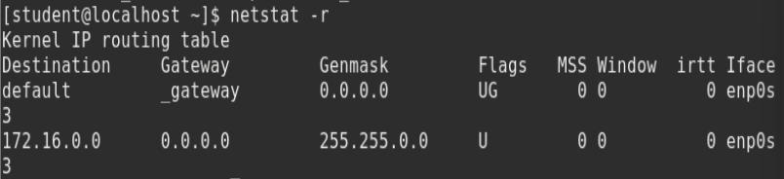

**netstat –a** - use -a flag to show listening and non-listening sockets(TCP+ UDP)

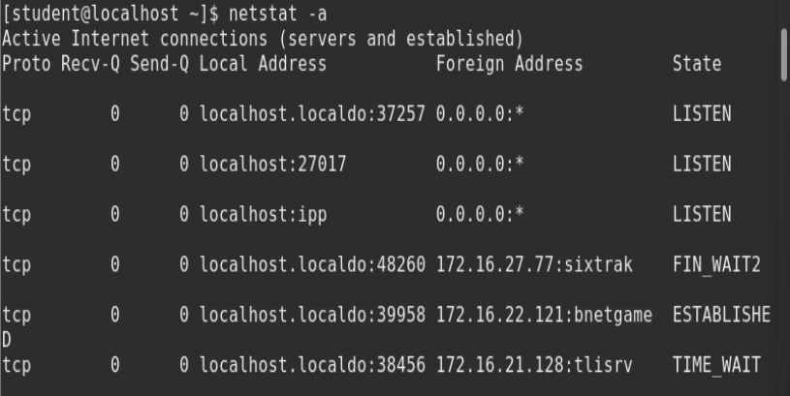

**netstat –at** - to show all TCP socket

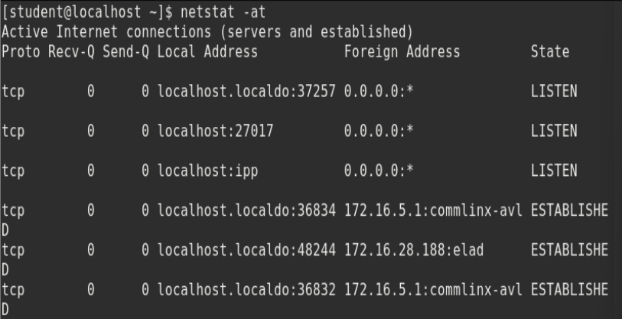

**netstat –l** - to show all active ports

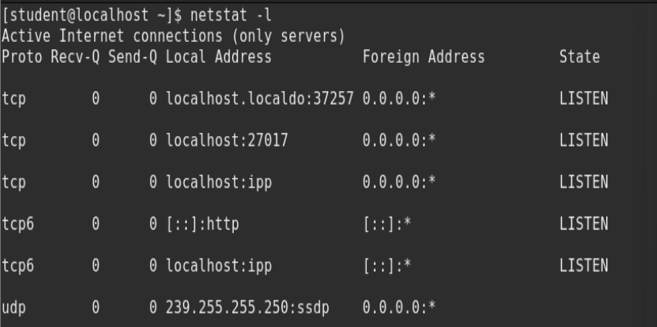

**netstat –u** - to show all UDP socket

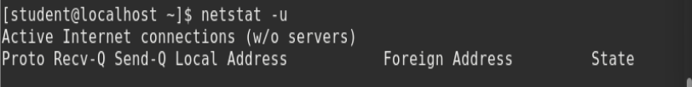

**whois** [**www.google.com**](http://www.google.com)- displays information about a website's record i.e., all the

information about a website regarding its registration and owner's information.

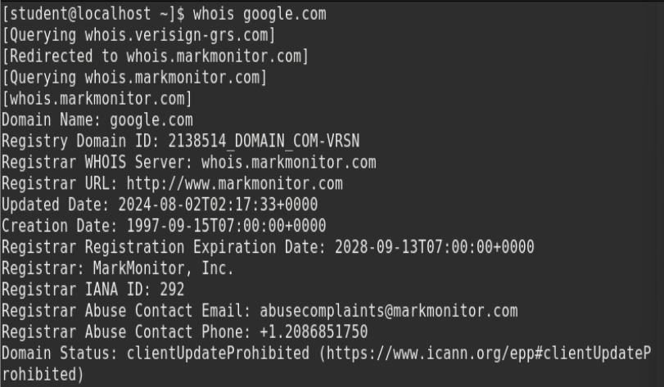

whois 8.8.8.8

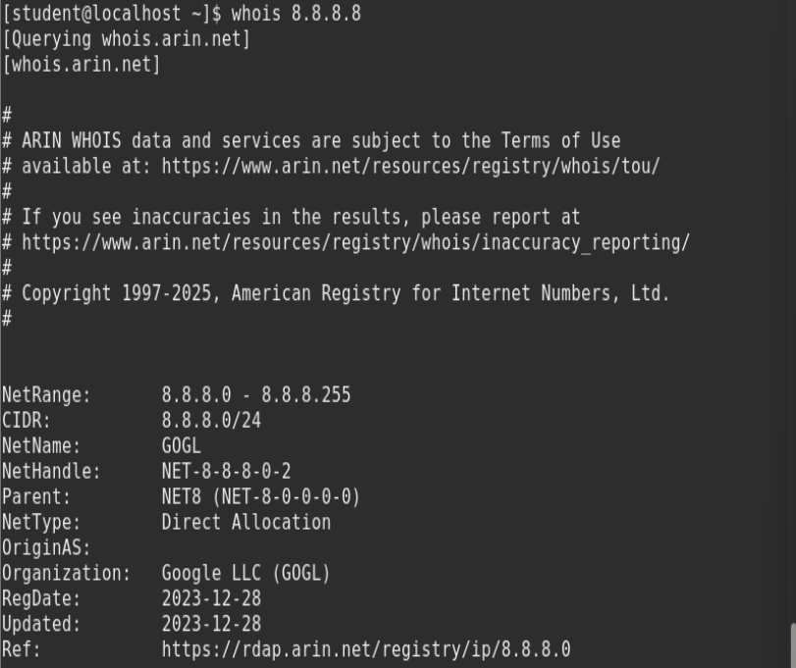

**dig** [**geeksforgeeks.org**](http://geeksforgeeks.org) - dig [server] [name] [type] - domain information groper - It is used for retrieving information about DNS name servers.

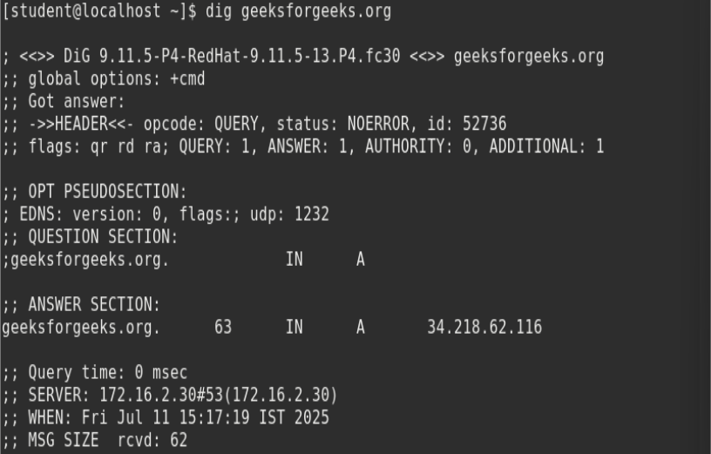

**ping** [**google.com**](http://google.com) - ping hostname or IP address - (Packet Internet Groper) - It is used to test connectivity between two nodes.

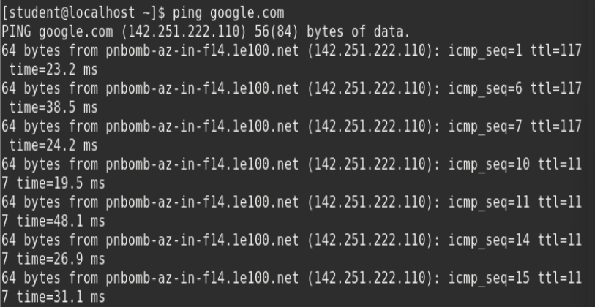

**traceroute** [**google.com**](http://www.google.com) - traceroute domain name or IP address - tool used to trace the path packets take from a source to a destination.

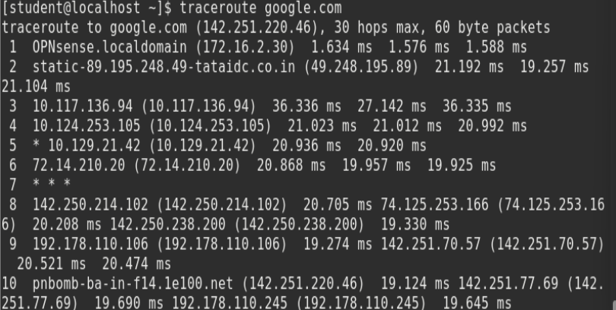

**nslookup** [**google.com**](http://google.com) - nslookup domain name or IP address - fetch the IP address or the domain name from DNS records.

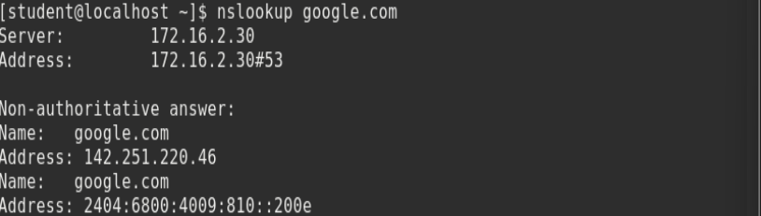

**route** - shows and manipulates the ip routing table

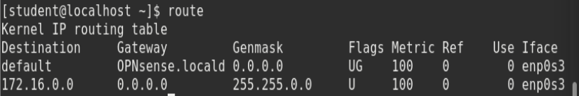

**host** - to find a domain name associated with the IP address or find an IP address associated with the domain name.



**hostname** - To check and set the hostname of the server.



**arp** - ARP(Address Resolution Protocol) - display and modify ARP cache, which contains the mapping of IP address to MAC address.

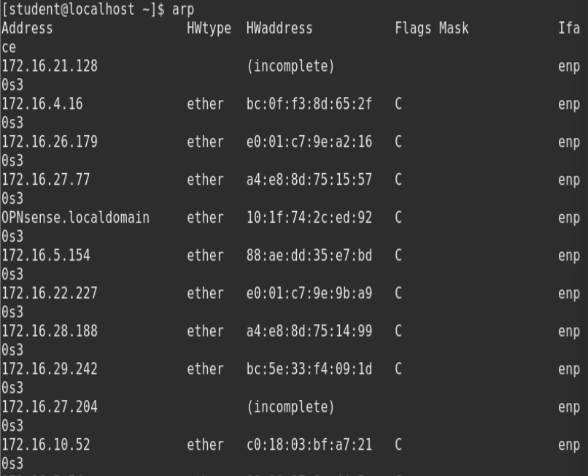

**7.Download and install Nmap. Use it with different options to scan open ports,perform OS, fingerprinting, do a ping scan, tcp port scan, udp port scan**

1. How to Install Nmap

On Linux (Ubuntu/Debian-based)

**sudo apt update**

**sudo apt install nmap -y OR sudo apt-get install nmap**

2. For version detection:

**nmap -sV <target-host's URL or IP>**

3. To scan a System with Hostname and IP address. First, Scan using Hostname

**nmap www.geeksforgeeks.org**

Now let’s Scan using IP Address

**nmap 172.217.27.174**

4. To scan using “-v” option: It is used to get more detailed information about the

remote machines. **nmap -v www.geeksforgeeks.org**

5.To scan multiple hosts: We can scan multiple hosts by writing IP addresses or

hostnames with **nmap. nmap 103.76.228.244 157.240.198.35 172.217.27.174**

6.To scan whole subnet: We can scan a whole subnet or IP range with nmap by

providing “*” with it. It will scan a whole subnet and give the information about

those hosts which are Up in the Network. **nmap 103.76.228.\***

7.To scan specific range of IP address: We can specify the range of IP addresses. This command will scan IP address 192.168.29.1 to 192.168.29.20 . **nmap 192.168.29.1-20**

8.To scan to detect firewall settings: Detecting firewall settings can be useful

during penetration testing and vulnerability scans. To detect it we use “-sA” option. This will provide you with information about firewall being active on the host. It

uses an ACK scan to receive the information. **sudo nmap -sA 103.76.228.244**

9.Here -sS flag is used for TCP SYN Scan, Which is a stealthy and efficient

method of scanning for open ports on a target system. **sudo nmap -sS <Domain Name>**

10. The “-sn” flag is used with nmap to perform a ping scan, which sends

ICMP requests to a target host or network to determine hosts is up or not. This checks which devices are alive in the network without scanning ports. **nmap -sn <Domain Name>**

**sudo nmap -sU <domain Name> ----> (UDP)**

11.The “-p” flag is used with nmap to perform scan on a specific port or

range of ports. ( In our case it will scan port 80,443 and 21 )

**nmap -p 80 443 21 <Domain Name>**

12.We can also specify the range of ports to scan on a network. ( In this case it

will scan all the ports in the range of 1 to 80 )

**nmap -p 1-80 <Domain Name>**

13.Here -A indicates aggressive, it will give us extra information, like OS

detection (-O), version detection, script scanning (-sC), and traceroute (–

traceroute). It even provides a lot of valuable information about the host. **nmap -A <Domain Name>**

14.Using this command we can discover the target hosting service or identify

additional targets according to our needs for quickly tracing the path. **nmap --trace out <Domain Name>**

15. Here it will display the operating system **sudo nmap -O <Domain Name>**

**8.Implement a code to simulate DOS attack.**

#include <stdio.h>

#include <string.h>

int main(void)

{

char buff[15];// buffer size = 15 bytes

int pass = 0;

printf("\n Enter the password: \n");

gets(buff); // ?? UNSAFE: no bounds checking

if(strcmp(buff, "thecorrectpaswd")) {

printf("\n Wrong Password \n");

}

else {

printf("\n Correct Password \n");

pass = 1;

}

if(pass) {

printf("\n Root privileges given to the user \n");

}

return 0;

}

gcc p8.c -o p8

p8.exe

Enter the password:

thecorrectpaswd

Correct Password

Root privileges given to the user

p8.exe

Enter the password:

vbjfdbvk

Wrong Password

9.Write a Python program to implement the Playfair cipher using Substitution technique.

# Exp9: Implement Python program to illustrate Playfair Cipher technique

# Step 1: Create the 5x5 key matrix

def generate_key_matrix(key):

key = key.lower().replace('j', 'i') # Replace 'j' with 'i'

matrix = []

used = set()

for char in key:

if char.isalpha() and char not in used:

used.add(char)

matrix.append(char)

# Fill remaining letters (excluding 'j')

for char in 'abcdefghiklmnopqrstuvwxyz':

if char not in used:

used.add(char)

matrix.append(char)

# Convert list into 5x5 matrix

return [matrix[i*5:(i+1)*5] for i in range(5)]

# Step 2: Preprocess plaintext into digraphs

def preprocess_text(text):

text = text.lower().replace('j', 'i').replace(' ', '')

pairs = []

i = 0

while i < len(text):

a = text[i]

b = 'x'

if i + 1 < len(text):

b = text[i + 1]

if a == b:

pairs.append((a, 'x'))

i += 1

else:

pairs.append((a, b))

i += 2

else:

pairs.append((a, 'x'))

i += 1

return pairs

# Step 3: Find character position in matrix

def find_position(matrix, char):

for row in range(5):

for col in range(5):

if matrix[row][col] == char:

return row, col

return None

# Step 4: Encrypt each pair using Playfair rules

def encrypt_pair(pair, matrix):

a, b = pair

row1, col1 = find_position(matrix, a)

row2, col2 = find_position(matrix, b)

if row1 == row2:

# Same row → shift right

return matrix[row1][(col1 + 1) % 5] + matrix[row2][(col2 + 1) % 5]

elif col1 == col2:

# Same column → shift down

return matrix[(row1 + 1) % 5][col1] + matrix[(row2 + 1) % 5][col2]

else:

# Rectangle rule → swap columns

return matrix[row1][col2] + matrix[row2][col1]

# Step 5: Full encryption function

def playfair_encrypt(plaintext, key):

matrix = generate_key_matrix(key)

print("Key Matrix:")

for row in matrix:

print(row)

pairs = preprocess_text(plaintext)

print("\nDigraphs:", pairs)

ciphertext = ''

for pair in pairs:

encrypted = encrypt_pair(pair, matrix)

print(f"{pair[0]}{pair[1]} → {encrypted}")

ciphertext += encrypted

return ciphertext.upper()

# Main program

plaintext = input("Enter text to encrypt: ")

key = input("Enter key: ")

ciphertext = playfair_encrypt(plaintext, key)

print("\nCiphertext:", ciphertext)

**Enter text to encrypt: Hello world**

**Enter key: monarchy**

**Key Matrix:**

**['m', 'o', 'n', 'a', 'r']**

**['c', 'h', 'y', 'b', 'd']**

**['e', 'f', 'g', 'i', 'k']**

**['l', 'p', 'q', 's', 't']**

**['u', 'v', 'w', 'x', 'z']**

**Digraphs: [('h', 'e'), ('l', 'x'), ('l', 'o'), ('w', 'o'), ('r', 'l'), ('d', 'x')]**

**he → cf**

**lx → su**

**lo → pm**

**wo → vn**

**rl → mt**

**dx → bz**

**Ciphertext: CFSUPMVNMTBZ**