Heart Disease Prediction
A Machine Learning Capstone Project
Predicting the Likelihood of Heart Disease Using Patient Clinical Data
Dataset: Heart Disease UCI (Kaggle)
Models: Logistic Regression, Decision Tree
Week 4 — Major Capstone Project

1. Introduction
Cardiovascular disease remains one of the leading causes of death worldwide, and early identification of at-risk patients can meaningfully improve treatment outcomes. This project builds a supervised machine learning pipeline that predicts whether a patient is likely to have heart disease based on routinely collected clinical measurements.
Two classification models — Logistic Regression and a Decision Tree — were trained and compared on the UCI Heart Disease dataset. The project covers the complete workflow: data cleaning, feature encoding and scaling, model training, performance evaluation, and packaging the trained models for reuse on new patient records.

1.1 Objective
- Clean and prepare a real-world, multi-source clinical dataset containing missing values and mixed data types.
- Train and compare two classification algorithms for binary heart-disease prediction.
- Evaluate model performance using accuracy, precision, recall, F1-score, confusion matrices, and ROC-AUC.
- Persist the trained models and preprocessing artifacts so they can be applied to new, unseen patients.

2. Dataset
The dataset used is the Heart Disease UCI dataset from Kaggle, which aggregates patient records from multiple clinical sites (Cleveland, Hungary, Switzerland, and the VA Long Beach). The raw file contains 920 patient records across 16 columns.
The identifier column (id) and the source-site column (dataset) were dropped, as they carry no predictive value. The original diagnosis column (num), which ranges from 0 (no disease) to 4 (increasing severity), was converted into a binary target: 0 = no disease, 1 = disease present (num > 0).
The remaining 13 features used for prediction are described below:
Feature | Description
age | Age of the patient (years)
sex | Sex (Male / Female)
cp | Chest pain type (typical angina, atypical angina, non-anginal, asymptomatic)
trestbps | Resting blood pressure (mm Hg)
chol | Serum cholesterol (mg/dl)
fbs | Fasting blood sugar > 120 mg/dl (True/False)
restecg | Resting electrocardiographic results
thalch | Maximum heart rate achieved
exang | Exercise-induced angina (True/False)
oldpeak | ST depression induced by exercise relative to rest
slope | Slope of the peak exercise ST segment
ca | Number of major vessels colored by fluoroscopy (0-3)
thal | Thalassemia status (normal, fixed defect, reversible defect)
target | Diagnosis label — 1 = presence of heart disease, 0 = absence

2.1 Class Balance
After cleaning, the dataset contains 508 patients labeled as having heart disease and 410 labeled as disease-free — a reasonably balanced split that does not require resampling techniques such as SMOTE.
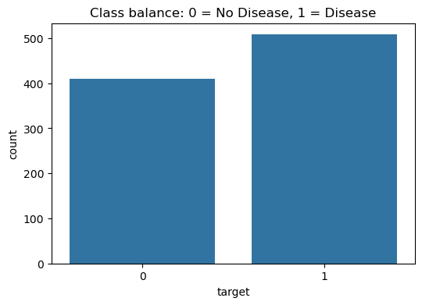
Figure 1. Class balance of the target variable (0 = No Disease, 1 = Disease).

2.2 Feature Correlation
A correlation heatmap was generated to inspect linear relationships between features and the target. Exercise-induced angina (exang), ST depression (oldpeak), chest pain type (cp), and maximum heart rate (thalch) show the strongest correlations with the presence of heart disease, consistent with established clinical risk factors.
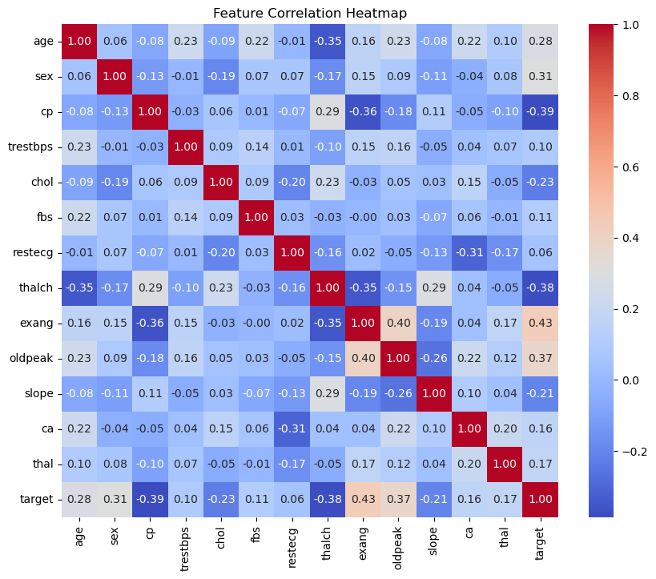
Figure 2. Correlation heatmap across all features and the target variable.

3. Methodology
The table below summarizes each stage of the preprocessing and modeling pipeline, in the order it was applied.
Stage | Steps Applied
Data Cleaning | Dropped non-predictive id/dataset columns; standardized missing-value markers; imputed numeric features with median values; imputed categorical features with mode.
Encoding | Label-encoded all categorical columns (sex, cp, fbs, restecg, exang, slope, thal); collapsed the original 5-level diagnosis (num) into a binary target (0 = no disease, 1 = disease).
Deduplication | Removed 2 duplicate patient records.
Train/Test Split | 80% / 20% stratified split (random_state = 42) to preserve class balance.
Imputation (fit on train) | SimpleImputer (median strategy) fit on training data, applied to both train and test sets to avoid leakage.
Scaling | StandardScaler fit on training data, applied to both train and test sets.
Model Training | Logistic Regression (max_iter = 1000) and Decision Tree (max_depth = 5), both with random_state = 42.
Evaluation | Accuracy, precision, recall, F1-score, confusion matrix, and ROC-AUC computed on the held-out test set.
Persistence | Trained models, scaler, imputer, label encoders, and feature order saved with joblib for reuse on new patient records.

All fitted preprocessing objects (imputer and scaler) were fit exclusively on the training split and then applied to the test split, preventing data leakage from test records into the training process.

3.1 Models Trained
- Logistic Regression — a linear baseline classifier (max_iter = 1000), well suited to interpreting the direction and relative strength of each clinical feature's effect on disease likelihood.
- Decision Tree Classifier — a non-linear model (max_depth = 5) capable of capturing feature interactions and threshold effects that a linear model would miss.

4. Results and Evaluation
Both models were evaluated on the same held-out 20% test set (184 patients). Summary metrics are shown below.
Model | Accuracy | Precision | Recall | F1 Score
Logistic Regression | 0.793 | 0.802 | 0.833 | 0.817
Decision Tree | 0.821 | 0.863 | 0.804 | 0.832

The Decision Tree achieved marginally higher accuracy (82.1% vs. 79.3%) and precision (86.3% vs. 80.2%), meaning it produced fewer false-positive disease predictions. Logistic Regression achieved higher recall (83.3% vs. 80.4%), meaning it missed fewer true disease cases. The choice between the two in a real clinical setting would depend on whether minimizing missed diagnoses (recall) or minimizing false alarms (precision) is the higher priority.

4.1 Confusion Matrices
The confusion matrices below break down predictions by class for both models on the test set.
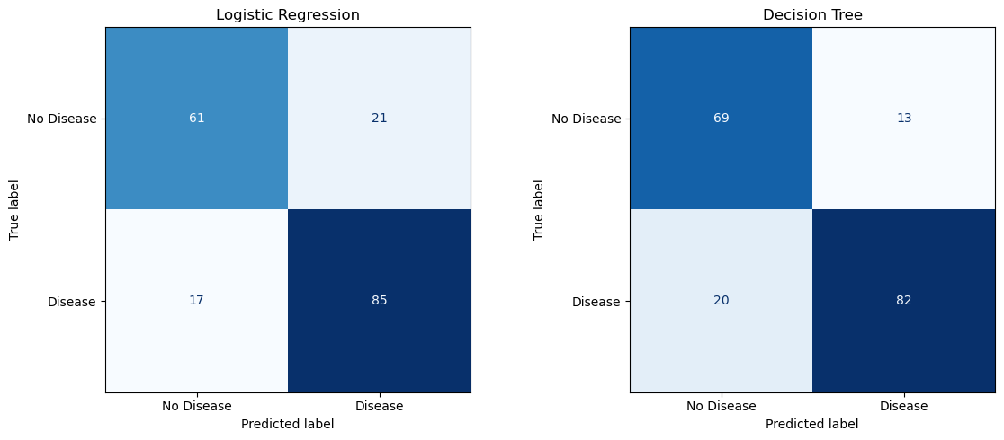
Figure 3. Confusion matrices for Logistic Regression (left) and Decision Tree (right).
Logistic Regression correctly identified 85 of 102 true disease cases (17 false negatives) and 61 of 82 true no-disease cases (21 false positives). The Decision Tree correctly identified 82 of 102 disease cases (20 false negatives) and 69 of 82 no-disease cases (13 false positives) — trading a slightly higher false-negative count for a notably lower false-positive count.

4.2 ROC Curve Comparison
The ROC curves and their associated AUC scores provide a threshold-independent view of each model's discriminative power.
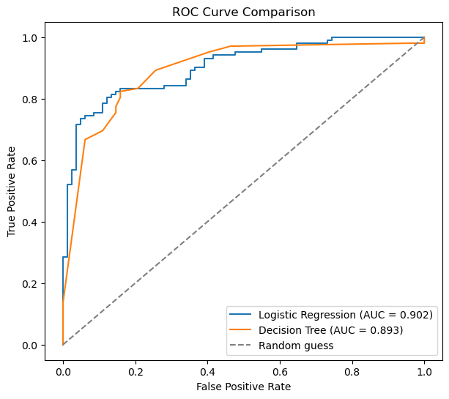
Figure 4. ROC curve comparison — Logistic Regression (AUC = 0.902) vs. Decision Tree (AUC = 0.893).
Both models achieved strong AUC scores above 0.89, indicating good separability between the two classes. Logistic Regression's slightly higher AUC (0.902 vs. 0.893) suggests it maintains a marginally better precision/recall trade-off across all possible classification thresholds, even though the Decision Tree edged it out at the single default threshold used for the confusion matrices and summary metrics table above.

5. Model Persistence and Inference
To make the models reusable beyond this notebook, all fitted pipeline components were serialized with joblib:
- logistic_regression_model.pkl and decision_tree_model.pkl — the two trained classifiers
- scaler.pkl — the fitted StandardScaler
- imputer.pkl — the fitted SimpleImputer
- label_encoders.pkl — per-column LabelEncoders for categorical fields
- feature_order.pkl — the exact column order expected by the models
A helper function, predict_patient(), reconstructs the full preprocessing pipeline (encode → impute → scale) for a single new patient record and returns both the predicted class and the predicted probability of disease, allowing the saved models to be applied directly to new patients without retraining.

6. Conclusion and Future Work
This project delivered a complete, end-to-end machine learning pipeline for heart disease prediction, from raw multi-site clinical data to two deployable, evaluated classification models. Both Logistic Regression and the Decision Tree achieved strong performance (AUC > 0.89), with each offering a different trade-off between precision and recall that would suit different clinical priorities.

6.1 Possible Improvements
- Try ensemble methods (Random Forest, Gradient Boosting/XGBoost) to potentially improve both accuracy and stability.
- Perform hyperparameter tuning (e.g., GridSearchCV) rather than fixed defaults for max_depth and max_iter.
- Apply k-fold cross-validation for a more robust estimate of generalization performance than a single train/test split.
- Investigate feature importance / SHAP values to improve clinical interpretability of predictions.
- Address the large number of missing values in fields like ca and thal (only ~309 and ~434 of 920 records respectively) with more sophisticated imputation, or evaluate whether these fields should be excluded.

