**High Level Design (HLD)**

**Heart Disease Diagnostic Analysis**



**Last date of revision: 18/11/2022**

****Vaishnavi Abbugari****

**Document Version Control**

|  |  |  |  |
| --- | --- | --- | --- |
| **Date Issued** | **Version** | **Description** | **Author** |
| **15th nov 2022** | **1.0** | **First Version of Complete HLD** | **vaishnavi** |
|  |  |  |  |

**Index**

**Abstract ...................................................................................................................................... 4**

**1 Introduction ............................................................................................................................ 5**

**1.1 Why this High-Level Design Document? ......................................................................... 5**

**1.2 Scope ................................................................................................................................ 6**

**2 General Description ................................................................................................................ 6**

**2.1 Product Perspective & Problem Statement ..................................................................... 6**

**2.2 Tools used ......................................................................................................................... 7**

**3 Design Details ......................................................................................................................... 8**

**3.1 Functional Architecture .................................................................................................... 8**

**3.2 How Power bi Works……………………………………………………………………………………………………. 9**

**3.3 Optimization ..................................................................................................................... 10**

**4 KPIs ......................................................................................................................................... 11**

**4.1 Types of KPIs……………………………………………………………………………………………………………… 12**

**5 Deployment ........................................................................................................................... 13**

**6 Scope of Deployment………………………………………………………………………………………………………. 15**

**7 Reference………………………………………………………………………………………………………………………… 16**

**Abstract**

**Heart disease is a term covering any disorder of the heart. Heart diseases have become a major concern to deal with as studies show that the number of deaths due to heart diseases have increased significantly over the past few decades in India it has become the leading cause of death in India. A study shows that from 1990 to 2016 the death rate due to heart diseases have increased around 34% from 155.7 to 209.1 deaths per 1 lakh population in India.**

**1 Introduction**

**1.1 Why this High-Level Design Document?**

**The purpose of this High-Level Design (HLD) Document is to add the necessary detail to the current project description to represent a suitable model for coding. This document is also intended to help detect contradictions prior to coding, and can be used as a reference manual for how the modules interact at a high level.**

**The HLD will:**

**• Present all of the design aspects and define them in detail**

**• Describe the user interface being implemented**

**• Describe the hardware and software interfaces**

**• Describe the performance requirements**

**• Include design features and the architecture of the project**

**• List and describe the non-functional attributes like:**

**o Security**

**o Reliability**

**o Maintainability**

**o Portability**

**o Reusability**

**o Application compatibility**

**o Resource utilization**

**o Serviceability**

**1.2 Scope**

* **The HLD documentation presents the structure of the system, such as the database architecture, application architecture (layers), application flow (Navigation), and technology architecture. The HLD uses non-technical to mildly-technical terms which should be understandable to the administrators of the system.**
* The High-Level Design (HLD) gives the project stakeholders a bird’s eye view of the system at the end of the project. At its core is the solution architecture, the process through which a solution is generated to solve a business problem and create customer value.
* Architecting a solution generates different concepts and selects an optimal candidate that satisfies the project’s risk, budgetary, and schedule constraints.

**2 General Description**

**2.1 Product Perspective & Problem Statement**

* Health care domain- an Introduction: The health care industry is one of the largest industries in the world, and it has a direct effect on the quality of life of people in each country. Health care (or healthcare) is the diagnosis, treatment, and prevention of disease, illness, injury, and other physical and mental impairments in humans.
* **The objective of the project is to perform data visualization techniques to understand the insight of the data. This project aims apply various Business Intelligence tools such as Tableau or Power BI to get a visual understanding of the data and helps in getting the clear insights from the data.**
* Health care is delivered by practitioners in medicine, chiropractic, dentistry, nursing, pharmacy, allied health, and other care providers. The health care industry, or medical industry, is a sector that provides goods and services to treat patients with curative, preventive, rehabilitative or palliative care.

**2.2 Tools used**

**Business Intelligence tools and libraries works such as NumPy, Pandas, Excel, python, PowerBi, Matplotlib, Seaborn, Warnings, Date and Time and Jupyter Notebook are used to build the whole framework.**

**3 Design Details**

**3.1 Functional Architecture**

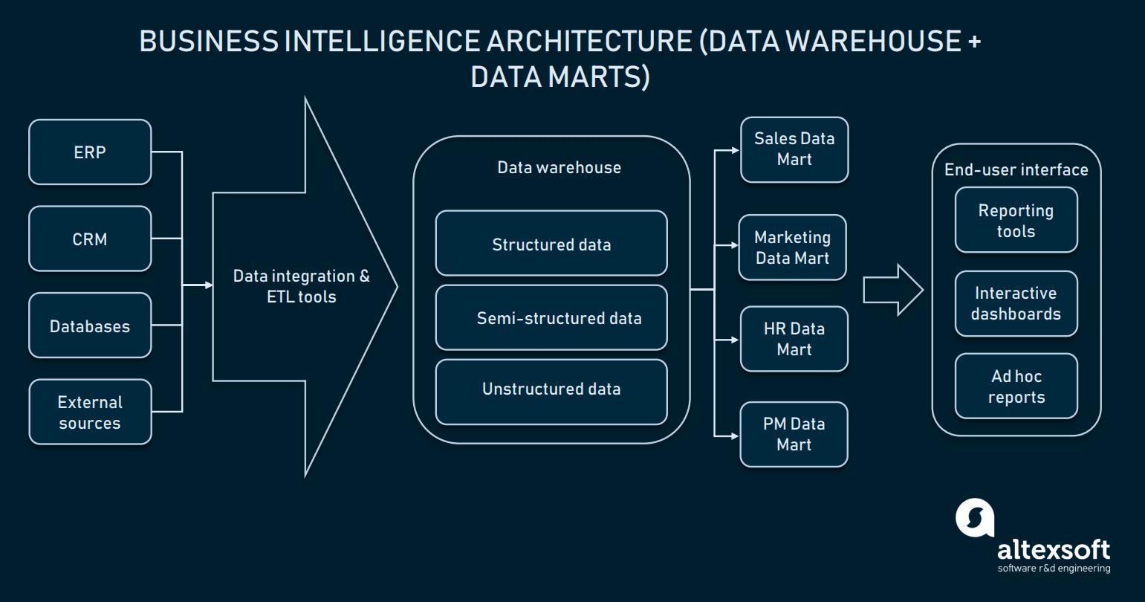

**FIGURE 1.1**

**3.2 How Power Bi works**

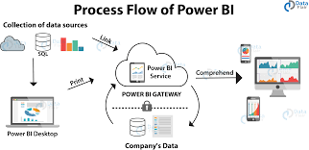

**FIGURE 1.2**

**3.3 Optimization**

⦁ Your data strategy drives performance

⦁ Minimize the number of fields

⦁ Minimize the number of records

⦁ Optimize extracts to speed up future queries by materializing calculations, removing columns and the use of accelerated views

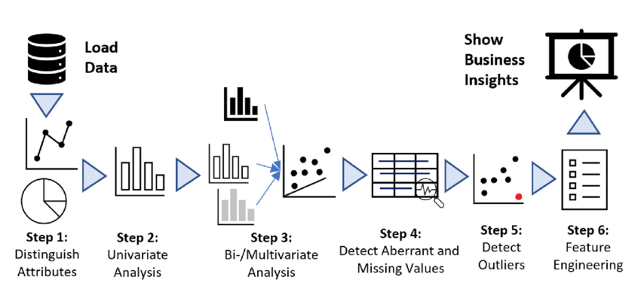

**FIGURE 1.3**

**4 KPIs(Key Performance Indicators)**

**KPIs in healthcare industry:**

* Healthcare KPIs are quantifiable or measurable factors that reflect upon the goals of an organization. Working without KPIs can create vagueness around performance, and comparing the progress of an organization over different time periods can become very difficult.
* Health care KPIs are well-defined performance measures or metrics with which you can observe, analyze, optimize and transform health care facility services. They measure the progress of the facility and show how successful it is.
* Healthcare KPI examples:

1. **Average patient weight time:** The Average Patient Wait Time is a very useful nurse KPI example for measuring and tracking business objectives around patient satisfaction and capacity management.

Patient wait time can be calculated by finding the average amount of time a patient must wait from the moment they walk into a hospital or healthcare clinic until the time they are able to be seen by a healthcare professional. KPI Example: Decrease average patient wait time to 10 min.

1. **Bed occupancy rate:** The bed occupancy rate measures the proportion of hospital beds in use at any one time. Bed occupancy is a good indication of a hospital's ability to provide safe and effective treatments to patients. Therefore, bed occupancy is a great KPI for measuring operational and capacity objectives. Once the KPI is measured and tracked, healthcare providers are able to estimate whether or not more space and beds are needed. KPI Example: Decrease bed occupancy rates to 82% by 10/11/2024.
2. **Average hospital stay:** Just as the name implies, this KPI tracks the average length of time patients stay in the hospital. While this metric is very useful, it's also very general - using average hospital stay as a single KPI to track all the different categories of stay in your facility won't prove to be very helpful. The recovery from heart surgery will almost always be a longer stay than a patient who underwent cataract surgery. Instead, this KPI should be broken up and used for each category. KPI Example: Maintain the average hospital stay for shoulder arthroplasty of 2 days by 31/12/24.
3. **Average Insurance Claim Processing Time and Cost:** This can be calculated by finding the mean of the total time and total cash spent by a hospital on insurance claims. A low amount denotes that the hospital gets the payment faster and there are low charges on treatment fees. KPI Example: Reduce average insurance processing time by 20% by 31/12/2024.

**Types of KPIs**

* Lagging vs. leading KPIs Lagging KPIs measure the current state of a business and its achievements toward a goal after a set period of time. Leading KPIs measure and determine a business’ future state.
* High vs. low KPIs Key performance indicators that target an entire organization’s goals are called high KPIs. These indicators measure the company’s success as a whole. KPIs that target smaller projects, such as departmental strategies, are called low KPIs.

**Types of KPIs**

A business’s ability to track its progress toward a goal is only effective as the quality of its KPIs , a good KPI should have the following qualities:

* Specific: A KPI should be a detailed, simple and clear description of what exactly you want to achieve. For example, “Improve customer satisfaction” is too broad. A better KPI is, “Improve customer satisfaction ratings by 10% by the end of Q3.”
* Measurable: As demonstrated in the example above, KPIs should be quantifiable to establish an exact definition of success. When thinking about ways to measure, consider using dollar amounts, percentages or raw numbers.
* Achievable: It's best that your KPIs are ambitious yet attainable within reason. This ensures individuals working toward them are motivated and challenged but don’t burn out. It also helps set realistic expectations with stakeholders and company leadership.
* Relevant: Your KPI should help advance the larger key business objective(s) of the team above you. For example, if you're on a client success team that falls under the company’s marketing organization, your KPI should align with marketing objectives. All KPIs should align with a larger key business objective.
* Time-bound: Select an ambitious yet realistic amount of time in which you’ll measure your progress toward a KPI. For example, you might decide you want to achieve a certain amount of renewal sales by the end of a quarter, month or calendar year.
* Evaluate:
* Regularly examining your KPIs is a great way to ensure you’re still working toward the right objectives.
* What could be the various questions should come into your mind while examining KPIs.
* What are the main blockers to success?
* Is my KPI still relevant?
* Do I have the right budget, tools, talent and support?
* After this KPI period is complete, what should be measured next?

**5 Deployment**

**data and analytics couldn’t come at a better time. Your company, no matter what size, is already collecting data and most likely analyzing just a portion of it to solve business problems, gain competitive advantages, and drive enterprise transformation. With the explosive growth of enterprise data, database technologies, and the high demand for analytical skills, today’s most effective IT organizations have shifted their focus to enabling self-service by deploying and operating power bi at scale, as well as organizing, orchestrating, and unifying disparate sources of data for business users and experts alike to author and consume content.**

**Scope of Deployment**

**Created a power bi dashboard**

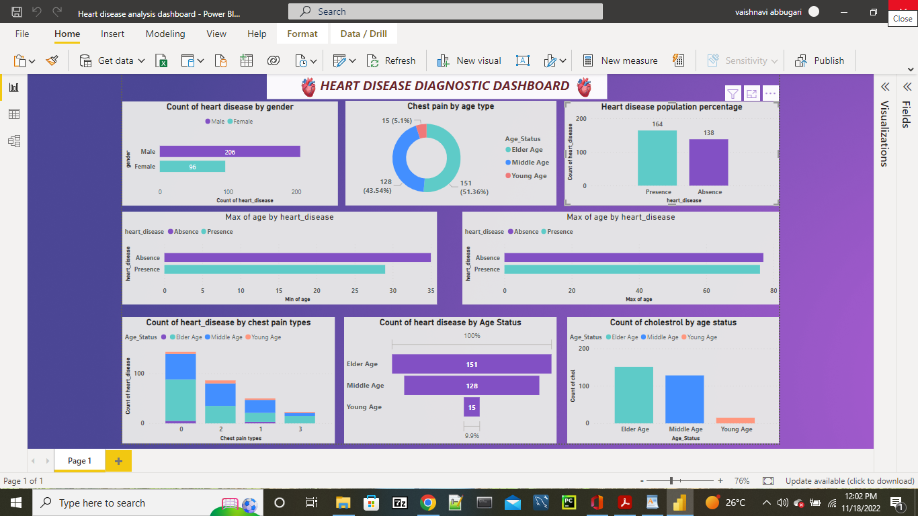

**REFERENCE**

1.Fig 1.1URL:

https://content.altexsoft.com/media/2019/04/word-image-51.png.webp

2.Fig1.2URL: https://th.bing.com/th/id/OIP.AgpIUl3MuUdXPa5JmjcLoQHaDmpid=ImgDet&rs=1