

VAISHNAVI AHUJA

MBA. Tech (IT), SEMESTER 6

SAP ID: 70411017005

COMPANY: VASHISHTHA TECHNOCLOGIES

**Use Case:**

The student is almost about to reach the college. He/She is very late and needs to park their vehicle in the shortest time possible before examination begins. The student opens the app and exactly knows which parking spots have already been occupied in the imaginary parking lot and which are still open.The student can then just directly drive to that exact spot to part his car rather than taking a trial and error approach and wasting crucial time for parking. Once the student parks his car, he reserves that spot so that other students who use that app know that that spot has already been reserved now and they need to find parking at some other spot.

**Project:**

Assuming an android app is planned to be developed for your college parking lot. The goal of this android app would be to see if there are any vacant spots in the parking lot to park the student’s vehicle. If there are any , where in the parking lot is that spot (imaginary spots/marking/maps) . There will also be some kind of dashboard to see summary. For example: 10 OPEN, 110 Booked, 1 HANDICAP, 30 FACULTY. The student clicks on 10 OPEN spots and finds the spot closest to him.

**=> Create wireframes and designs for such imaginary android app. (We just want to see designs - no coding needed)**

**SOLUTION:**

The application allows the students and the faculty at NMIMS to pre-book their parking slot, which stays reserved for 20 minutes from the time of booking.

First of all, the user will have to log in. If the user is not signed up for the application, he/she can sign up, enter their details including name, SAP ID, Course, and if the user is a student/faculty member. The authentication for each user at the time of sign up is done by the help of OTP, which is sent to their registered contact number at college, and there is also an option to authenticate using email id. This would allow only the students/faculty from NMIMS to be able to use the app.

Once the user has logged in, he/she can select from their saved vehicles (Or add a new vehicle, view a vehicle, delete a vehicle from the list) and search for a parking slot.

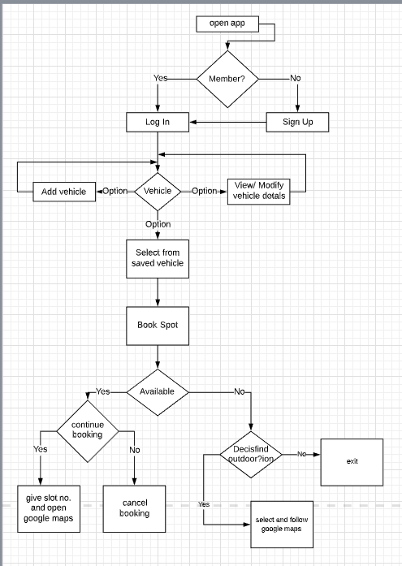

78 slots are reserved for the students, 40 for the faculty, 120 for 2 Wheelers and 15 for the handicapped people. If there is a handicapped individual in the vehicle, there is a checkbox for the same in the saved vehicles window, which can be checked and the access to the reserved slots for handicapped would be provided.

Now, the possibilities of searching can be: Student is searching for a spot (4 wheeler), Faculty member is searching for a spot, an individual is searching for a 2 wheeler spot, or a vehicle with a handicapped person is searching for a spot. On the basis of previous selections, number of open, booked and reserved slots will be shown.

On selecting book a slot, a map would be opened, from where the individual can select where they wish to park.

A slot number will be assigned to them for 20 minutes, and that will show booked to other users. If the person doesn’t come in 20 minutes, it will be available to other users. Once the slot number is assigned, the user can follow that position using Google maps.

Just in case, if there aren’t any available slots, the user can choose to find parking slots nearby college, and follow that location using Google maps. Outside as well, certain slots are reserved for faculty and handicapped individuals.

There are two modes available in the UI/UX design, normal mode and dark mode, which is now available in most android devices.

