PYTHON ACTIVITY-BASED LEARNING
CASE STUDY REPORT
Ten Selected Case Studies
Student Name | Anthati Vaishnavi
Roll Number | 26001058
Branch | CSE(AIML)
Section | CSM-4
Repository: PythonActivity-Based-Learning

Introduction
This report documents ten Python activity-based learning case studies represented by the supplied console-output screenshots. Each case includes a problem statement, objectives, assumptions, algorithm, text flowchart, pseudocode, illustrative Python source code, test cases, the supplied output screenshot, and a conclusion. The screenshots are treated as evidence of the observed output. Because the original .py source files were not included with the screenshots, the programs below are reconstructed examples designed to implement the displayed behavior; they may not be byte-for-byte identical to the programs that produced the screenshots.

Contents
Case Study Number | Title | Concepts
Case 01 | Multi-Currency Travel Budget Analysis | Currency conversion, percentage fees, totals, budget comparison, maximum value
Case 02 | Examination Result Analysis | Marks processing, grace marks, pass/fail decisions, percentage, classification
Case 03 | Student Timetable Conflict Validation | Time intervals, overlap detection, room availability, validation
Case 04 | Multi-Branch Sales Analysis | Nested dictionaries, aggregation, branch totals, maximum sales, product ranking
Case 05 | Hackathon Team Analysis | Team-size validation, score totals, conditional checks, sorting, ranking
Case 06 | Campus Transport Allocation | Capacity calculation, ceiling division, resource allocation, served/unserved demand
Case 07 | Examination Seating Matrix Validation | Two-dimensional lists, duplicate detection, reserved seats, empty/invalid entries
Case 08 | Sports Event Schedule and Ranking | Schedule overlap detection, sorting, points comparison, team ranking
Case 09 | Multi-Stage Scholarship Shortlisting | Eligibility conditions, rejection reasons, sorting, quota, waiting list
Case 10 | Campus Festival Registration and Financial Audit | Duplicate IDs, unique participants, income/expenses, balance, surplus/deficit

CASE 01: Multi-Currency Travel Budget Analysis

1. Problem Statement
Calculate travel expenses entered in different currencies by converting them to Indian rupees, adding a conversion fee, summing spending, and comparing it with a planned budget.

2. Objectives
- Convert supported currencies to INR using configured sample exchange rates.
- Calculate a conversion fee for each expense.
- Calculate final expense per category and total spending.
- Report remaining budget and the largest expense category.

3. Assumptions
- Exchange rates are fixed sample values, not live market rates: USD ₹85, EUR ₹92, GBP ₹110.
- Conversion fee is 2% of the converted amount.
- All expense amounts are positive and currency codes are supported.
- Budget and expenses are expressed in INR after conversion.

4. Algorithm
1. Start.
2. Initialize the exchange rates, planned budget, conversion-fee rate, expense records, total spending, and largest-expense tracker.
3. Take the next expense and identify its currency; use the corresponding exchange rate to convert the amount to INR.
4. Calculate the 2% conversion fee and add it to the converted amount to get the final expense.
5. Add the final expense to total spending. If it is greater than the largest expense recorded so far, update the largest-expense category and amount.
6. Repeat Steps 2–4 until all expenses have been processed.
7. Calculate the remaining budget as planned budget minus total spending, then display each expense and the final summary.
8. Stop.

5. Flowchart
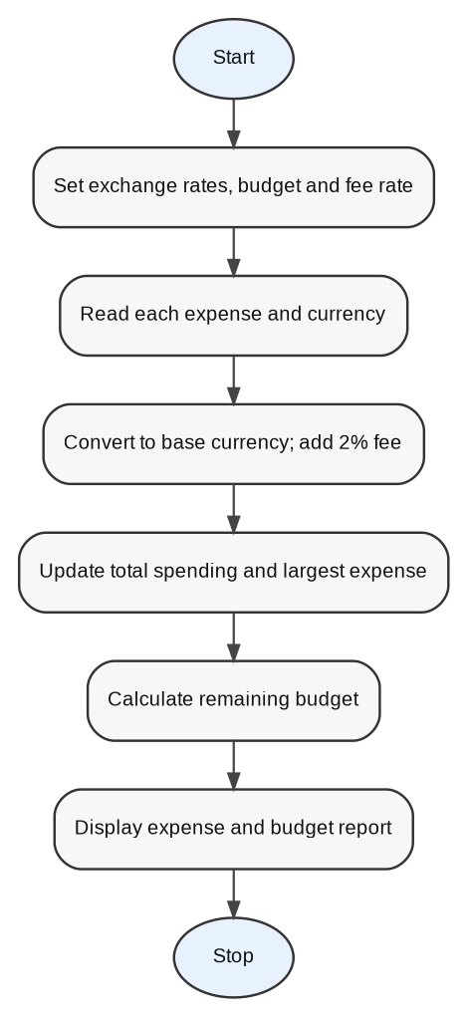

6. Pseudocode
START
set rates and budget
for each expense: convert amount; fee = converted × 0.02; final = converted + fee; accumulate total and largest
remaining = budget − total
display report
STOP

7. Python Source Code
rates = {"USD": 85, "EUR": 92, "GBP": 110}
expenses = [
("Hotel", 200, "USD"), ("Food", 100, "EUR"),
("Transport", 50, "GBP"), ("Shopping", 150, "USD")
]
budget = 50000
total = 0
largest = ("", 0)

print("MULTI-CURRENCY TRAVEL BUDGET ANALYSIS")
for category, amount, currency in expenses:
converted = amount * rates[currency]
fee = converted * 0.02
final = converted + fee
total += final
if final > largest[1]:
largest = (category, final)
print(f"Category: {category}")
print(f"Original Amount: {amount} {currency}")
print(f"Converted Amount: Rs. {converted:.2f}")
print(f"Conversion Fee: Rs. {fee:.2f}")
print(f"Final Expense: Rs. {final:.2f}")
print(f"Planned Budget: Rs. {budget:.2f}")
print(f"Total Spending: Rs. {total:.2f}")
print(f"Remaining Budget: Rs. {budget-total:.2f}")
print(f"Largest Expense Category: {largest[0]}")
print(f"Largest Expense: Rs. {largest[1]:.2f}")

8. Test Cases
Test | Input / Condition | Expected Result
TC01 | USD 200 at ₹85, 2% fee | ₹17,000 converted; ₹340 fee; ₹17,340 final
TC02 | EUR 100 at ₹92, 2% fee | ₹9,200 converted; ₹184 fee; ₹9,384 final
TC03 | Budget ₹50,000; sample expenses | Total ₹45,339; remaining ₹4,661

9. Output Screenshot
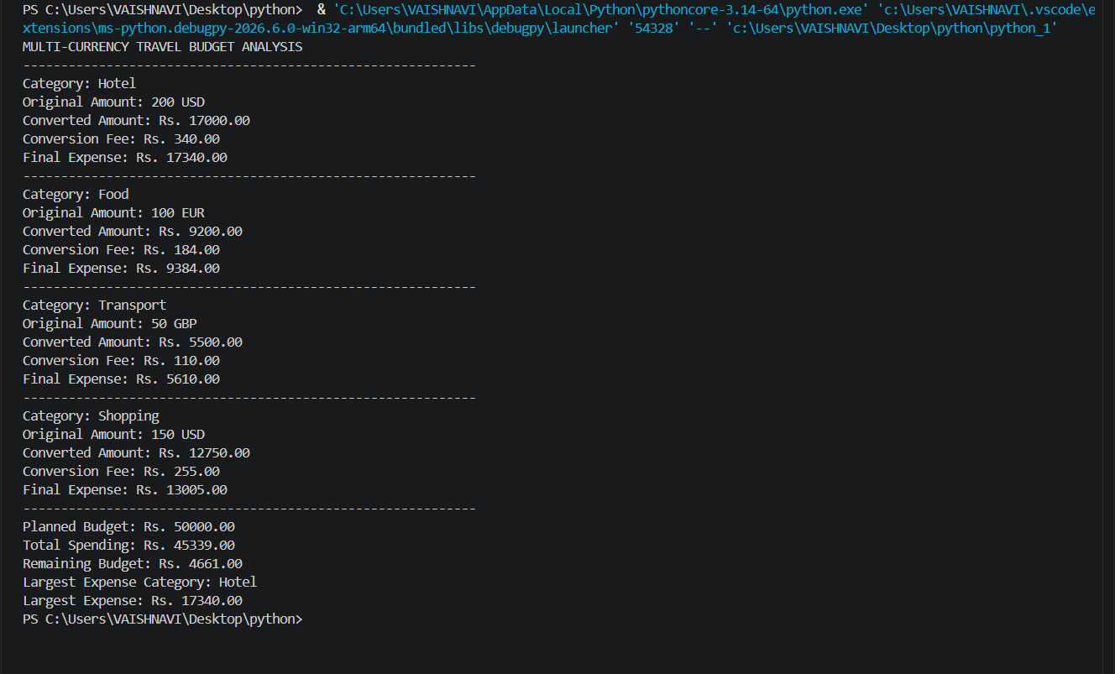

10. Conclusion
The analysis standardizes multi-currency expenses into INR, includes conversion fees, and compares total travel spending with the planned budget. The exchange rates are illustrative and should be updated before real use.

CASE 02: Examination Result Analysis

1. Problem Statement
Evaluate subject marks, apply a grace-mark rule to a borderline failure, and determine each subject result, total, percentage, overall result, and classification.

2. Objectives
- Read and process subject marks.
- Apply a defined grace-mark allowance where permitted.
- Determine pass/fail for each subject and overall result.
- Calculate total marks and percentage.

3. Assumptions
- Each subject is out of 100 and the pass mark is 35.
- At most one grace mark may be used to bring a subject from 34 to 35.
- Overall result is PASS only when every subject passes.
- Classification is not assigned when the student fails.

4. Algorithm
1. Start.
2. Read the marks for all subjects. Set the pass mark to 35 and the available grace-mark limit to one.
3. Process each subject mark. If it is 34 and the grace mark has not yet been used, add one mark and record the grace mark as used.
4. Compare the final mark with 35 and record whether the subject is PASS or FAIL. Repeat until every subject has been checked.
5. Add the final marks and calculate the percentage.
6. Check whether every subject has passed. If any subject has failed, set the overall result to FAIL and classification to Not Applicable; otherwise set the result to PASS and assign the classification using the percentage.
7. Display subject results, total marks, percentage, grace marks used, overall result, and classification.
8. Stop.

5. Flowchart
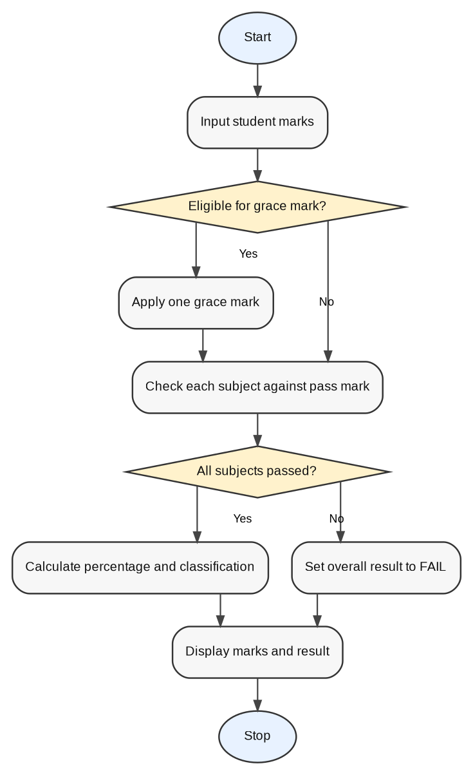

6. Pseudocode
START
input/store marks
apply eligible grace mark once
check each subject
total and percentage
if any subject fails, overall FAIL; otherwise PASS and assign classification
display
STOP

7. Python Source Code
marks = {"Mathematics": 35, "Physics": 68, "Chemistry": 75,
"Programming": 32, "English": 80}
pass_mark = 35
grace_limit = 1
grace_used = 0
final_marks = {}
for subject, score in marks.items():
if score == pass_mark - 1 and grace_used < grace_limit:
score += 1
grace_used += 1
final_marks[subject] = score
result = "PASS" if score >= pass_mark else "FAIL"
print(f"{subject}: {score}/100, Result: {result}")
total = sum(final_marks.values())
percentage = total / (len(final_marks) * 100) * 100
overall = "PASS" if all(m >= pass_mark for m in final_marks.values()) else "FAIL"
classification = "First Class" if overall == "PASS" and percentage >= 60 else (
"Pass Class" if overall == "PASS" else "Not Applicable")
print(f"Total Marks: {total}/{len(final_marks)*100}")
print(f"Percentage: {percentage:.2f}%")
print(f"Grace Marks Used: {grace_used}/1")
print(f"Final Result: {overall}")
print(f"Classification: {classification}")

8. Test Cases
Test | Input / Condition | Expected Result
TC01 | All subjects at least 35 | Overall result PASS
TC02 | One subject below pass mark after grace | Overall result FAIL
TC03 | One subject at 34 and grace unused | That subject becomes 35; grace usage increments

9. Output Screenshot
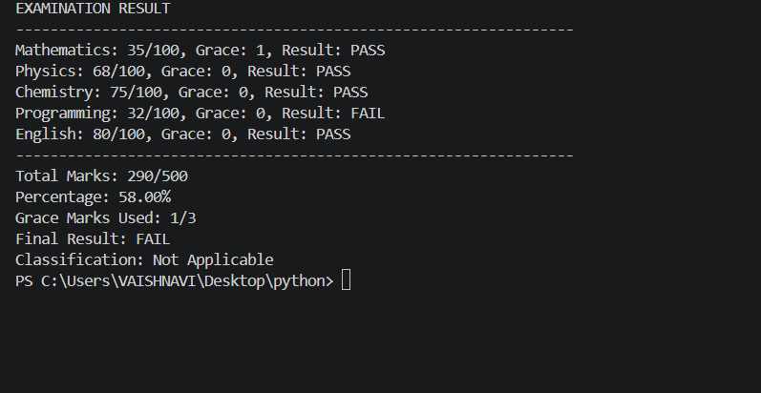

10. Conclusion
The program automates marks processing and makes the effect of grace marks visible. The exact grace policy and classification thresholds must match the institution's official regulations.

CASE 03: Student Timetable Conflict Validation

1. Problem Statement
Check a student timetable for overlapping class times and unavailable room assignments, then report whether the timetable is valid.

2. Objectives
- Store course, day, time interval, and room.
- Detect overlapping sessions on the same day.
- Check whether a room is available for a session.
- Produce a clear validation result.

3. Assumptions
- Times use a 24-hour HH:MM format.
- Two sessions conflict if they occur on the same day and their time intervals overlap.
- Room availability is supplied as a predefined set of room/day/time assignments.
- 1. Store the class records as course, day, start time, end time, and room; define the unavailable-room entries.

4. Algorithm
1. Start.
2. Load the class timetable and the configured unavailable-room assignments.
3. Compare each pair of classes. If two classes occur on the same day and their time intervals overlap, record the conflict.
4. Continue comparing pairs until all class pairs have been checked, then display the timetable and recorded conflicts.
5. Check each class against the unavailable-room assignments and report any room-availability warning.
6. Check the validation results. If a schedule conflict or room issue exists, report the timetable as INVALID; otherwise report it as VALID.
7. Display the validation report and stop.

5. Flowchart
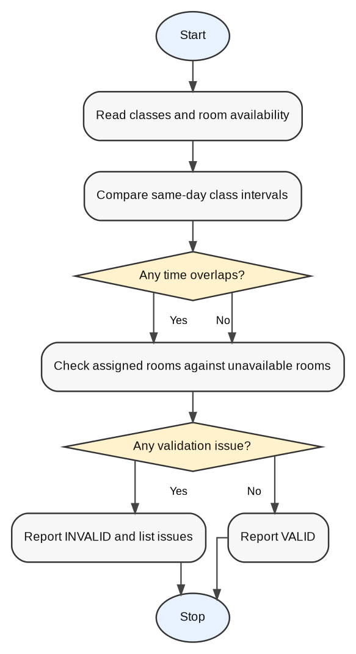

6. Pseudocode
START
read timetable and room availability
compare same-day time intervals
record overlaps
check room availability
if any issue, report INVALID; else VALID
STOP

7. Python Source Code
from datetime import datetime

classes = [
("Python", "Monday", "09:00", "10:00", "R101"),
("Mathematics", "Monday", "09:30", "10:30", "R102"),
("Physics", "Tuesday", "10:00", "11:00", "R103"),
("English", "Monday", "10:30", "11:30", "R101")
]
unavailable = {("R103", "Tuesday"), ("R101", "Monday", "English")}
conflicts = []
for i, a in enumerate(classes):
for b in classes[i+1:]:
if a[1] == b[1] and a[2] < b[3] and b[2] < a[3]:
conflicts.append(f"{a[0]} overlaps with {b[0]}")
print("STUDENT TIMETABLE")
for c in classes:
print(f"{c[0]} | {c[1]} | {c[2]}-{c[3]} | Room: {c[4]}")
print("\nSCHEDULE CONFLICTS:")
print("\n".join(conflicts) if conflicts else "No conflicts")
print("\nROOM AVAILABILITY:")
for c in classes:
if (c[4], c[1]) in unavailable or (c[4], c[1], c[0]) in unavailable:
print(f"{c[0]}: Assigned room is unavailable.")
valid = not conflicts and not unavailable
print("\nTIMETABLE VALIDATION:")
print("Valid timetable." if valid else "Invalid timetable. Please resolve the conflicts.")

8. Test Cases
Test | Input / Condition | Expected Result
TC01 | Two Monday classes overlap 09:00–10:00 and 09:30–10:30 | Overlap reported
TC02 | Classes on different days | No time conflict
TC03 | Room marked unavailable | Room warning shown

9. Output Screenshot
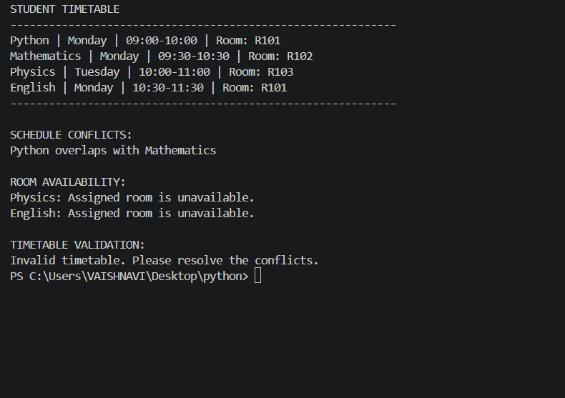

10. Conclusion
Timetable validation helps identify scheduling conflicts before publication. A production system should store precise room availability intervals and validate all time inputs.

CASE 04: Multi-Branch Sales Analysis

1. Problem Statement
Summarize sales of several products across multiple branches, calculate branch totals, identify each branch's best-selling product, and compare branches.

2. Objectives
- Store branch-wise product sales.
- Calculate each branch's total units sold.
- Identify the best-selling product per branch.
- Calculate overall product totals and highest-performing branch.

3. Assumptions
- Sales are non-negative whole-number unit counts.
- Products and branches are known in advance.
- The product with the highest units is considered best-selling.
- 1. Store the sales quantities for each product in each branch.

4. Algorithm
1. Start.
2. Load the sales quantities for every product in each branch. Initialize the branch totals and overall product totals.
3. For each branch, add the quantities of its products to calculate the branch total and identify the product with the highest quantity.
4. Add each product's quantity to that product's overall total, then display the branch's quantities, total, and best-selling product.
5. Repeat Steps 2–3 for all branches.
6. Compare branch totals to find the highest-performing branch, and compare overall product totals to find the best-selling product overall.
7. Display the branch comparison and overall product totals, then stop.

5. Flowchart
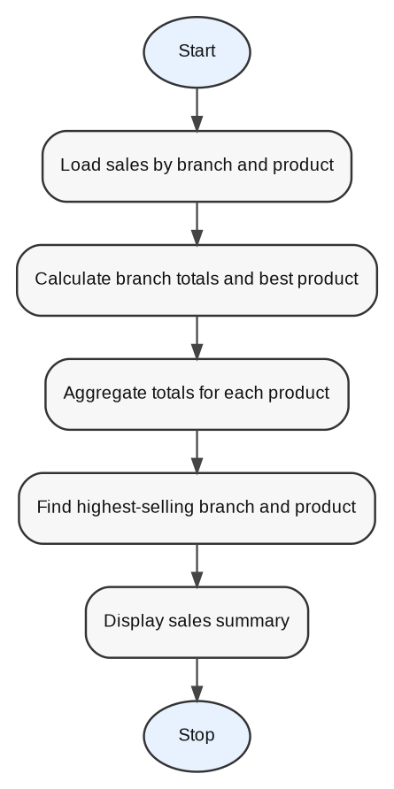

6. Pseudocode
START
load branch/product sales
for each branch: total units and best product
aggregate each product across branches
find maximum branch total and product total
display
STOP

7. Python Source Code
sales = {
"Branch A": {"Laptop": 30, "Mobile": 53, "Tablet": 18},
"Branch B": {"Laptop": 36, "Mobile": 42, "Tablet": 27},
"Branch C": {"Laptop": 28, "Mobile": 60, "Tablet": 18}
}
product_totals = {}
branch_totals = {}
print("MULTI-BRANCH SALES ANALYSIS")
for branch, products in sales.items():
total = sum(products.values())
branch_totals[branch] = total
best = max(products, key=products.get)
print(f"\n{branch}:")
for product, units in products.items():
print(f"{product}: {units} units")
product_totals[product] = product_totals.get(product, 0) + units
print(f"Total Branch Sales: {total} units")
print(f"Best Product: {best}")
print("\nBRANCH COMPARISON")
for branch, total in branch_totals.items():
print(f"{branch}: {total} units")
print("Best Performing Branch:", max(branch_totals, key=branch_totals.get))
print("\nOVERALL PRODUCT TOTALS")
for product, total in product_totals.items():
print(f"{product}: {total} units")
print("Best Selling Product Overall:", max(product_totals, key=product_totals.get))

8. Test Cases
Test | Input / Condition | Expected Result
TC01 | Branch A: 30, 53, 18 | Total 101; Mobile best
TC02 | Branch C: 28, 60, 18 | Total 106; Mobile best
TC03 | All branches combined | Laptop 94, Mobile 155, Tablet 63; Branch C highest

9. Output Screenshot
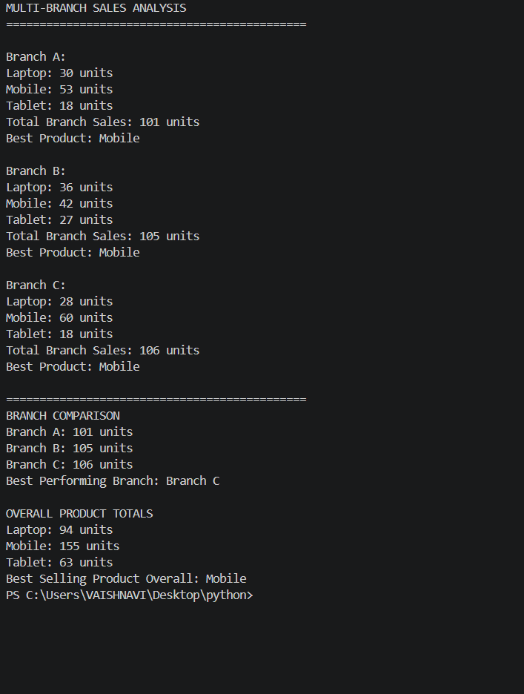

10. Conclusion
The analysis compares branch performance and product demand, helping management identify strong branches and popular products.

CASE 05: Hackathon Team Analysis

1. Problem Statement
Validate hackathon team sizes, calculate round-wise and total scores, reject invalid teams, and rank valid teams using the total score and final-round score.

2. Objectives
- Validate team membership counts.
- Calculate total scores across rounds.
- Reject teams outside the permitted size range.
- Rank valid teams and apply a tie-break rule.

3. Assumptions
- Each team should have 2–4 members.
- Round scores are non-negative.
- Overall score is the sum of round scores.
- Higher total score ranks first; final-round score breaks ties.
- 1. Store each team's name, member count, and scores for the rounds; initialize an empty list of valid teams.

4. Algorithm
1. Start.
2. Load the hackathon teams, their member counts, and their round scores. Initialize an empty list of valid teams.
3. Take the next team and check whether its size is between 2 and 4 inclusive. If not, display INVALID TEAM SIZE and skip that team.
4. For a team with an accepted size, examine its round scores. If a score is negative, report INVALID SCORE and do not add the team to the ranking list.
5. If the team's scores are valid, add the round scores to calculate its overall score, record its final-round score, mark the team VALID, and add it to the valid-team list.
6. Repeat Steps 2–4 until every team has been processed.
7. Sort valid teams by overall score in descending order; use final-round score in descending order to break ties.
8. Display the final rankings and stop.

5. Flowchart
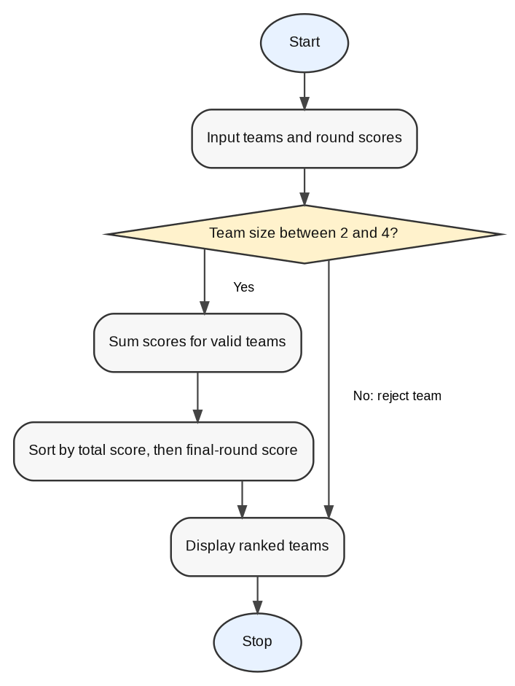

6. Pseudocode
START
input teams
validate size 2–4
input round scores
total = sum(scores)
keep valid teams
sort by (total, final score) descending
print rankings
STOP

7. Python Source Code
teams = [
{"name": "Team Alpha", "size": 3, "rounds": [245, 253, 267]},
{"name": "Team Beta", "size": 3, "rounds": [245, 260, 275]},
{"name": "Team Gamma", "size": 2, "rounds": [0, 0, 0]}
]
valid = []
print("HACKATHON TEAM ANALYSIS")
for t in teams:
print(f"\n{t['name']}\nTeam Size: {t['size']}")
if not 2 <= t["size"] <= 4:
print("Status: INVALID TEAM SIZE")
continue
for i, score in enumerate(t["rounds"], 1):
if score < 0:
print("Status: INVALID SCORE")
break
print(f"Round {i} Total: {score}")
else:
t["total"] = sum(t["rounds"])
t["last"] = t["rounds"][-1]
valid.append(t)
print("Overall Score:", t["total"])
print("Status: VALID")
valid.sort(key=lambda t: (t["total"], t["last"]), reverse=True)
print("\nFINAL TEAM RANKINGS")
for rank, t in enumerate(valid, 1):
print(f"Rank {rank}: {t['name']} - Total: {t['total']}, "
f"Round 3: {t['last']}, Round 1: {t['rounds'][0]}")

8. Test Cases
Test | Input / Condition | Expected Result
TC01 | Team size 3 | Accepted
TC02 | Team size outside 2–4 | Invalid team size
TC03 | Alpha total 765; Beta total 780 | Beta ranks above Alpha

9. Output Screenshot
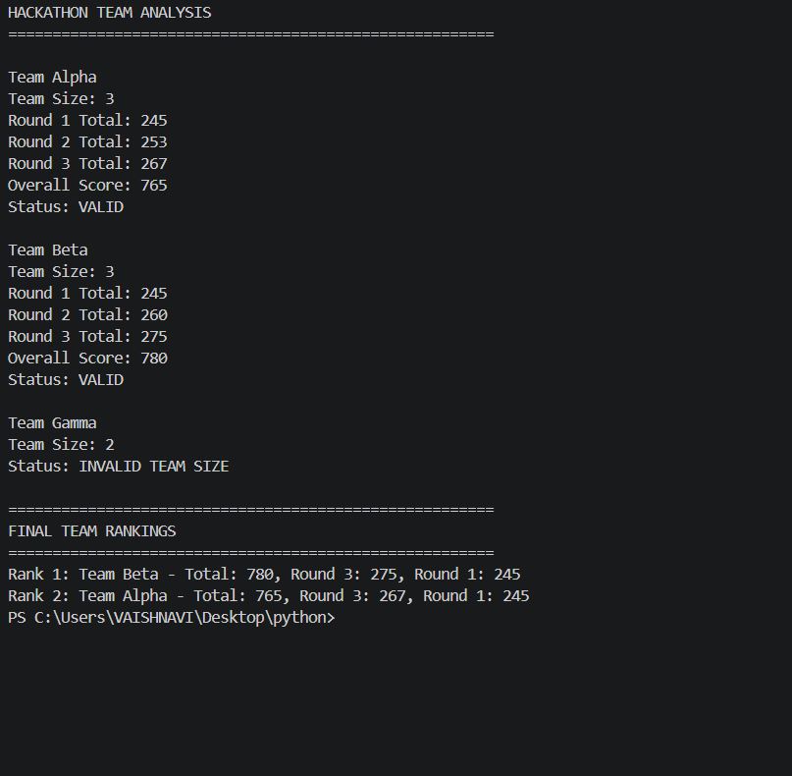

10. Conclusion
The program validates team sizes and ranks teams by score. The displayed screenshot's Gamma team has size 2, which is valid under the stated 2–4 rule; the sample output appears to use a different validation rule or input. Confirm the intended team-size policy before final submission.

CASE 06: Campus Transport Allocation

1. Problem Statement
Allocate a limited fleet of buses across campus routes according to passenger demand and bus capacity, and calculate passengers left unserved.

2. Objectives
- Calculate buses required for each route.
- Allocate available buses in route order.
- Calculate served and unserved passengers.
- Summarize fleet demand and shortages.

3. Assumptions
- Each bus has a fixed positive capacity.
- Buses are assigned to routes in the order entered.
- A bus serves no more than its capacity.
- 1. Store each route's name, passenger demand, bus capacity, and available bus count; initialize overall counters.

4. Algorithm
1. Start.
2. Load each route's passenger demand, bus capacity, and number of buses available. Initialize the overall summary counters.
3. For each route, calculate the buses required by rounding demand divided by capacity up to a whole bus.
4. Calculate the passenger capacity of the available buses. Set passengers served to the smaller of passenger demand and available capacity.
5. Calculate unserved passengers as demand minus passengers served. Update the overall demand, required-bus, available-bus, and served-passenger totals.
6. Display the route details and indicate whether all passengers are served or additional buses are required.
7. Repeat Steps 2–5 for every route, then display the overall transport summary and stop.

5. Flowchart
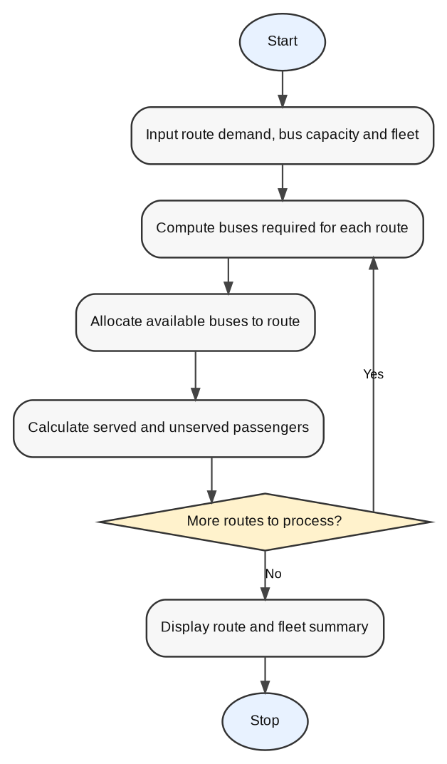

6. Pseudocode
START
input capacity, fleet, routes
for each route: required = ceil(demand/capacity); allocated = min(required, remaining fleet); served = min(demand, allocated×capacity); unserved = demand−served
update totals
display summary
STOP

7. Python Source Code
routes = [
("Route A", 120, 50, 2),
("Route B", 85, 40, 3),
("Route C", 200, 60, 2),
("Route D", 45, 30, 2)
]
total_demand = total_required = total_available = total_served = 0
print("CAMPUS TRANSPORT ALLOCATION")
for name, demand, capacity, available in routes:
required = (demand + capacity - 1) // capacity
served = min(demand, capacity * available)
unserved = demand - served
total_demand += demand
total_required += required
total_available += available
total_served += served
print(f"\n{name}")
print("Passenger Demand:", demand)
print("Bus Capacity:", capacity)
print("Buses Required:", required)
print("Buses Available:", available)
print("Passengers Served:", served)
print("Unserved Passengers:", unserved)
print("Status:", "All passengers served" if unserved == 0 else "Additional buses required")
print("\nOVERALL TRANSPORT SUMMARY")
print("Total Passenger Demand:", total_demand)
print("Total Buses Required:", total_required)
print("Total Buses Available:", total_available)
print("Total Passengers Served:", total_served)
print("Total Unserved Passengers:", total_demand-total_served)

8. Test Cases
Test | Input / Condition | Expected Result
TC01 | Route B demand 85, capacity 40, buses 3 | 3 buses required; 85 served; 0 unserved
TC02 | Route C demand 200, capacity 60, buses 2 | 4 required; 120 served; 80 unserved
TC03 | All screenshot routes | Demand 450; required buses 12; available buses 9

9. Output Screenshot
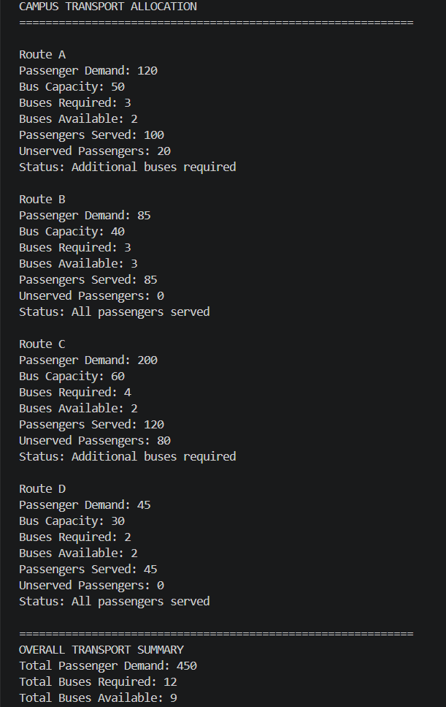

10. Conclusion
The allocation summary makes route-level shortages visible and supports planning for additional buses. The screenshot's route-specific bus capacities should be preserved when reproducing its results.

CASE 07: Examination Seating Matrix Validation

1. Problem Statement
Validate an examination seating matrix by detecting duplicate roll numbers, incorrect reserved positions, empty seats, and invalid student allocations.

2. Objectives
- Represent seating as a two-dimensional list.
- Detect duplicate student identifiers.
- Check reserved seats and empty positions.
- Report invalid allocation entries and final status.

3. Assumptions
- Each valid roll number should occur at most once.
- The value RESERVED is permitted only in configured reserved positions.
- None indicates an empty seat.
- 1. Define the seating matrix and the set of permitted reserved-seat coordinates; initialize tracking collections.

4. Algorithm
1. Start.
2. Load the seating matrix and the permitted reserved-seat coordinates. Initialize collections for seen roll numbers and validation issues.
3. Scan each seat row by row. If a roll number has already been seen, record it as a duplicate; otherwise record its location.
4. For each seat, check whether RESERVED is in a permitted position. Also record empty seats (None) and entries marked INVALID.
5. Continue until every seat in the matrix has been checked.
6. Display the seating matrix and all validation findings.
7. If any duplicate, reserved-position error, empty seat, or invalid allocation was found, display INVALID SEATING MATRIX; otherwise display VALID SEATING MATRIX.
8. Stop.

5. Flowchart
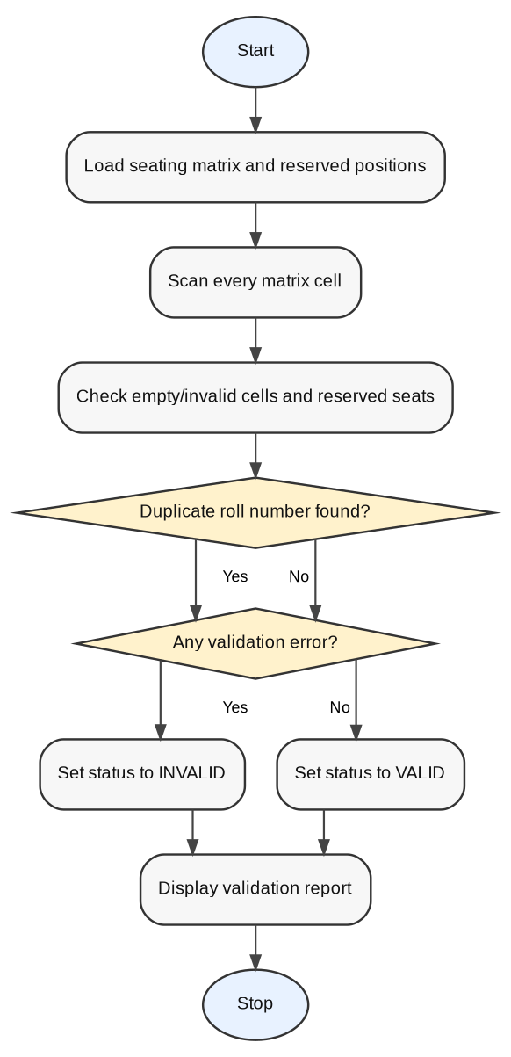

6. Pseudocode
START
load matrix and reserved positions
scan cells
detect duplicate IDs, empty cells, invalid values, and reserved-position errors
if any issue, status INVALID; otherwise VALID
STOP

7. Python Source Code
matrix = [
["R101", "R102", "RESERVED"],
["R103", "R102", None],
["R105", "INVALID", "R106"]
]
reserved_positions = {(0, 2)}
seen = {}
duplicates, empty, invalid, reserved_errors = [], [], [], []
for r, row in enumerate(matrix):
for c, value in enumerate(row):
if value == "RESERVED":
if (r, c) not in reserved_positions:
reserved_errors.append((r+1, c+1))
elif value is None:
empty.append((r+1, c+1))
elif value == "INVALID":
invalid.append((r+1, c+1))
elif value in seen:
duplicates.append((value, r+1, c+1))
else:
seen[value] = (r+1, c+1)
print("EXAMINATION SEATING MATRIX")
for row in matrix:
print(row)
print("\nVALIDATION REPORT")
print("Duplicate Roll Numbers:", duplicates or "None")
print("Reserved Position Errors:", reserved_errors or "Reserved positions are correct.")
print("Empty Seats:", empty or "None")
print("Invalid Student Allocations:", invalid or "None")
status = "INVALID SEATING MATRIX" if duplicates or empty or invalid or reserved_errors else "VALID SEATING MATRIX"
print("Final Status:", status)

8. Test Cases
Test | Input / Condition | Expected Result
TC01 | R102 appears twice | Duplicate reported at second occurrence
TC02 | None in row 2, seat 3 | Empty seat reported
TC03 | INVALID in row 3, seat 2 | Invalid allocation reported

9. Output Screenshot
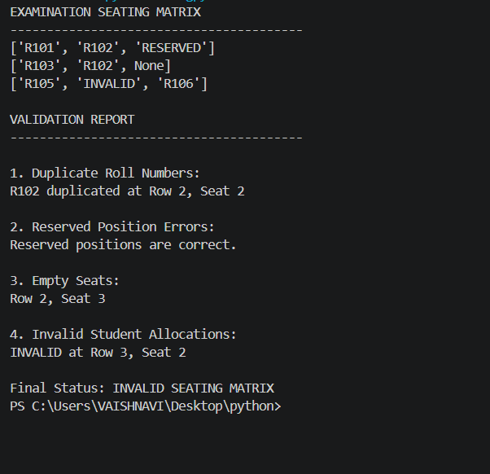

10. Conclusion
The validator detects common seating errors before an examination. A full implementation should load the official reserved-seat map and distinguish permitted empty seats from errors.

CASE 08: Sports Event Schedule and Ranking

1. Problem Statement
List sports events with day and time, detect schedule overlaps, and display team rankings based on points.

2. Objectives
- Store event schedules.
- Detect overlapping events on the same day.
- Sort teams by points.
- Identify the highest-scoring team and total top score.

3. Assumptions
- Times are expressed in comparable 24-hour format.
- Events conflict when same-day time intervals overlap.
- 1. Store the sports events with their day, start hour, and end hour, and store the teams with their points.

4. Algorithm
1. Start.
2. Load the sports-event schedule and team points.
3. Display the event schedule, then compare each pair of events.
4. If two events occur on the same day and their time intervals overlap, record a scheduling conflict. Continue until all event pairs have been checked.
5. Display the scheduling-conflict report.
6. Sort the teams by points in descending order and assign ranks beginning with 1.
7. Display the ranked teams and identify the highest-scoring team and its points, then stop.

5. Flowchart
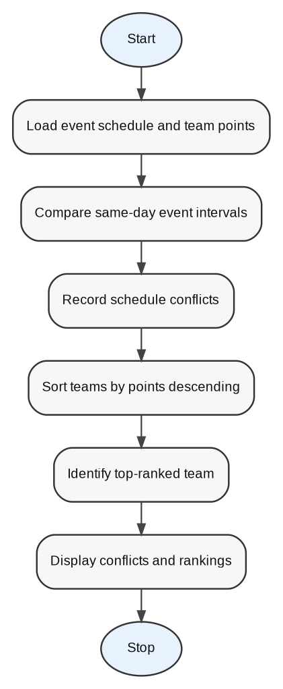

6. Pseudocode
START
load events
compare same-day intervals
report conflicts
load team points
sort descending
display rankings and top team
STOP

7. Python Source Code
events = [
("Cricket", "Monday", 9, 11),
("Football", "Monday", 10, 12),
("Basketball", "Tuesday", 9, 10),
("Volleyball", "Monday", 12, 13)
]
teams = [("Team A", 34), ("Team B", 30), ("Team C", 32)]
print("SPORTS EVENT SCHEDULE")
for name, day, start, end in events:
print(f"{name}: {day}, {start}:00-{end}:00")
conflicts = []
for i, a in enumerate(events):
for b in events[i+1:]:
if a[1] == b[1] and a[2] < b[3] and b[2] < a[3]:
conflicts.append(f"{a[0]} conflicts with {b[0]}")
print("\nSCHEDULING CONFLICTS")
print("\n".join(conflicts) if conflicts else "No conflicts")
teams.sort(key=lambda x: x[1], reverse=True)
print("\nFINAL TEAM RANKINGS")
for rank, (name, points) in enumerate(teams, 1):
print(f"Rank {rank}: {name} - {points} points")
print("Highest Scoring Team:", teams[0][0])
print("Total Points:", teams[0][1])

8. Test Cases
Test | Input / Condition | Expected Result
TC01 | Cricket Monday 09–11; Football Monday 10–12 | Conflict detected
TC02 | Basketball Tuesday 09–10 | No conflict with Monday events
TC03 | Team points 34, 32, 30 | A ranks first; highest score 34

9. Output Screenshot
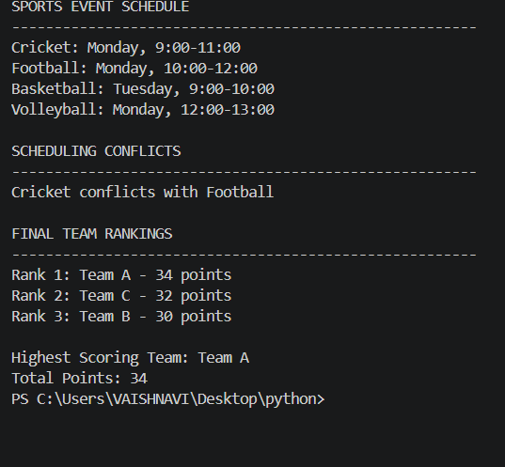

10. Conclusion
This case combines schedule validation with ranking output. It helps organizers spot time clashes and identify the highest-scoring team.

CASE 09: Multi-Stage Scholarship Shortlisting

1. Problem Statement
Apply academic marks, attendance, and income criteria to scholarship applicants, rank eligible students, and select candidates within a fixed quota.

2. Objectives
- Evaluate each applicant against eligibility thresholds.
- Rank eligible candidates by marks.
- Select candidates up to the quota.
- Show waiting-list and rejection reasons.

3. Assumptions
- The supplied screenshot is treated as the sample output.
- Eligibility thresholds and tie-breaking rules should be confirmed from the institution's policy.
- 1. Store applicant names, marks, attendance, and income; set the quota and the minimum marks, minimum attendance, and maximum income.

4. Algorithm
1. Start.
2. Load applicant records, the scholarship quota, minimum marks, minimum attendance, and maximum family income.
3. Evaluate each applicant against the criteria in order: academic marks, attendance, and income. Record the first failed criterion as the rejection reason; otherwise add the applicant to the eligible list.
4. Repeat the eligibility check until all applicants have been processed.
5. Sort eligible applicants by marks descending, attendance descending, and income ascending.
6. Select up to the quota from the sorted eligible list and place any remaining eligible applicants on the waiting list.
7. Display selected candidates with ranks, the waiting list, rejected applicants and reasons, and the summary counts.
8. Stop.

5. Flowchart
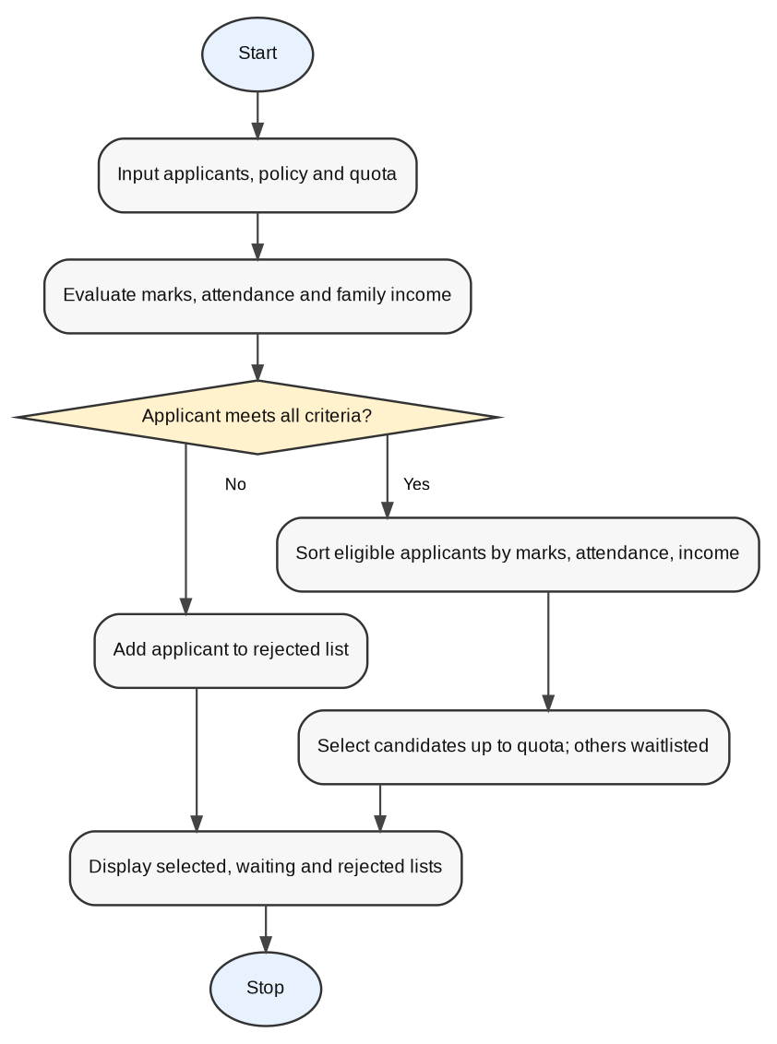

6. Pseudocode
START
input applicants and policy
evaluate marks/attendance/income
separate eligible and rejected applicants
sort eligible by marks descending
select first quota candidates; remaining eligible to waiting list
print report
STOP

7. Python Source Code
applicants = [
("Anu", 92, 95, 150000), ("Ravi", 85, 90, 200000),
("Priya", 88, 92, 180000), ("Kiran", 76, 85, 250000),
("Meena", 95, 98, 120000), ("Arjun", 82, 75, 150000),
("Sneha", 90, 88, 400000), ("Rahul", 70, 80, 200000)
]
quota = 4
min_marks, min_attendance, max_income = 75, 85, 250000
eligible, rejected = [], []
for name, marks, attendance, income in applicants:
reason = ("Insufficient academic marks" if marks < min_marks else
"Low attendance" if attendance < min_attendance else
"Income exceeds limit" if income > max_income else "")
if reason:
rejected.append((name, reason))
else:
eligible.append((name, marks, attendance, income))
eligible.sort(key=lambda x: (-x[1], -x[2], x[3]))
selected, waiting = eligible[:quota], eligible[quota:]
print("SELECTED SCHOLARSHIP CANDIDATES")
for rank, item in enumerate(selected, 1):
print(f"Rank {rank}: {item[0]} | Marks: {item[1]} | Attendance: {item[2]}% | Income: Rs.{item[3]}")
print("\nWAITING LIST")
for item in waiting:
print(item[0], "- Marks:", item[1])
print("\nREJECTED CANDIDATES")
for name, reason in rejected:
print(name + ":", reason)
print("\nSUMMARY")
print("Total Applicants:", len(applicants))
print("Eligible Applicants:", len(eligible))
print("Scholarship Quota:", quota)
print("Selected Candidates:", len(selected))
print("Rejected Applicants:", len(rejected))

8. Test Cases
Test | Input / Condition | Expected Result
TC01 | Marks 95, attendance 98%, income ₹120,000 | Eligible and ranked highly
TC02 | Attendance below configured minimum | Rejected for low attendance
TC03 | Income above ₹250,000 | Rejected for income limit
TC04 | Quota 4 | At most four candidates selected

9. Output Screenshot
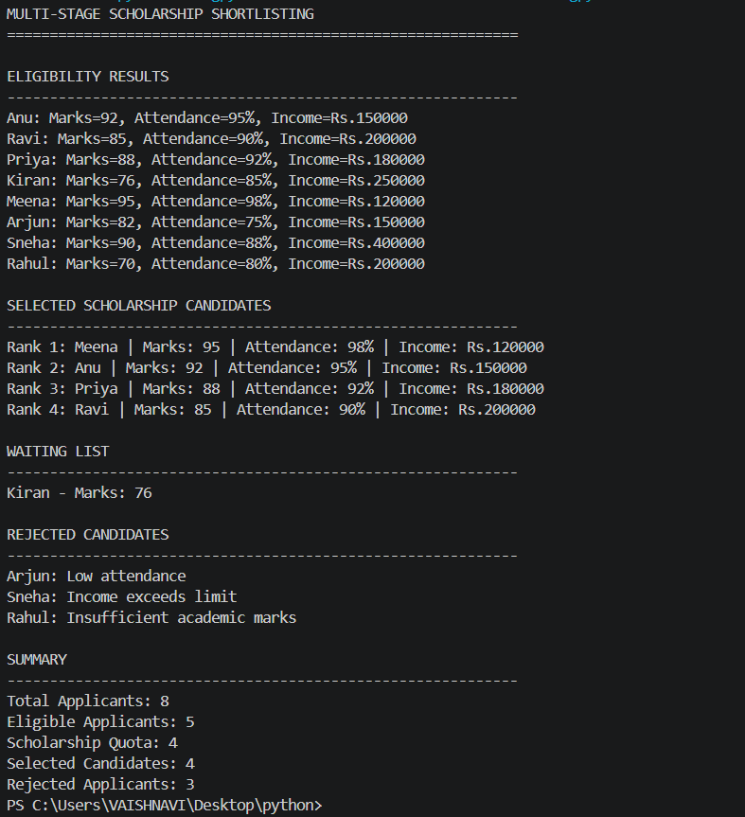

10. Conclusion
The shortlisting system provides a repeatable way to apply scholarship criteria and rank eligible applicants. The final policy thresholds must be confirmed, because the sample screenshot's displayed decisions do not align perfectly with one universal threshold set.

CASE 10: Campus Festival Registration and Financial Audit

1. Problem Statement
Audit festival registrations and finances by identifying duplicate registrations, calculating fee collection and sponsorship income, summing expenses, and reporting the final balance.

2. Objectives
- Count unique participants and duplicate registrations.
- Calculate registration fee collection and sponsorship income.
- Calculate total expenses and net balance.
- Report whether the festival has a surplus or deficit.

3. Assumptions
- Registration IDs uniquely identify participants.
- Duplicate IDs are counted once in unique participant totals.
- The displayed financial amounts are in Indian rupees.
- 1. Store registration records, the fee per participant, sponsorship income, and expense categories; initialize the seen-ID dictionary and duplicate list.

4. Algorithm
1. Start.
2. Load registration records, the fee per participant, sponsorship income, and expense amounts. Initialize the seen-ID collection and duplicate list.
3. Process each registration. If its ID has already been recorded, add it to the duplicate list; otherwise record it as a unique participant.
4. Repeat until all registrations have been checked.
5. Calculate registration-fee income from the number of unique participants and add sponsorships to obtain total income.
6. Add all expense amounts to obtain total expenses, then calculate the balance as total income minus total expenses.
7. Display unique participants, duplicate details, income, expense details, and total expenses.
8. If the balance is zero or positive, report a surplus; otherwise report a deficit. Display the final balance and stop.

5. Flowchart
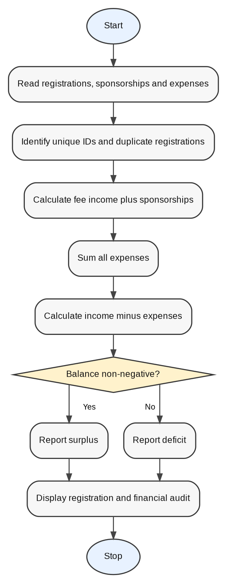

6. Pseudocode
START
read registrations
find unique IDs and duplicates
total income = fees + sponsorships
total expenses = sum(expenses)
balance = income − expenses
report surplus/deficit
STOP

7. Python Source Code
registrations = [(101, "Anu"), (102, "Ravi"), (103, "Priya"),
(104, "Meena"), (102, "Ravi"), (105, "Kiran")]
fee_per_participant = 500
sponsorships = 30000
expenses = {"Stage Decoration": 8000, "Food": 10000,
"Sound System": 5000, "Certificates": 2000}
seen = {}
duplicates = []
for pid, name in registrations:
if pid in seen:
duplicates.append((pid, name))
else:
seen[pid] = name
fees = len(seen) * fee_per_participant
income = fees + sponsorships
total_expenses = sum(expenses.values())
balance = income - total_expenses
print("CAMPUS FESTIVAL AUDIT REPORT")
print("Unique Participants:", len(seen))
print("Duplicate Registrations:", len(duplicates))
print("\nDuplicate Registration Details:")
for pid, name in duplicates:
print(f"ID: {pid} | Name: {name}")
print("\nRegistration Fee Collection: Rs.", fees)
print("Total Sponsorships: Rs.", sponsorships)
print("Total Income: Rs.", income)
print("\nExpense Details:")
for name, amount in expenses.items():
print(f"{name}: Rs. {amount}")
print("Total Expenses: Rs.", total_expenses)
print("Final Financial Balance: Rs.", balance)
print("Status:", "Festival has a surplus." if balance >= 0 else "Festival has a deficit.")

8. Test Cases
Test | Input / Condition | Expected Result
TC01 | Five unique IDs and one duplicate | Unique participants 5; duplicate registrations 1
TC02 | Fees ₹2,500 and sponsorships ₹30,000 | Total income ₹32,500
TC03 | Expenses ₹25,000 | Balance ₹7,500 surplus

9. Output Screenshot
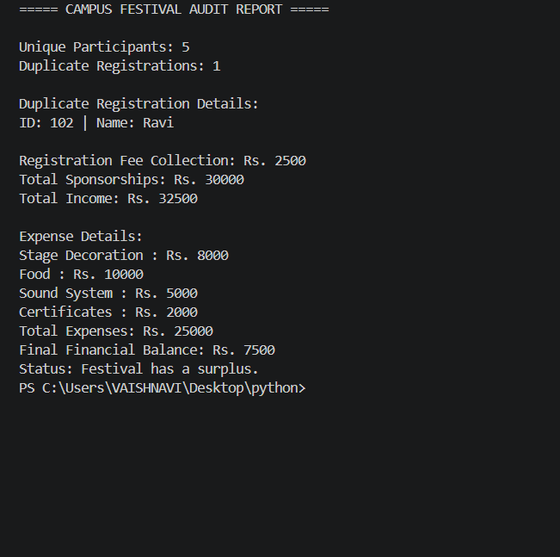

10. Conclusion
The audit consolidates registration and financial data into a single report, making duplicate entries and the festival's financial position easier to review.

Repository Submission Checklist
- Create or open the GitHub repository named PythonActivity-Based-Learning.
- Add this report file to the repository.
- Add each reconstructed Python program as a separate .py file.
- Add the supplied output screenshots in an output_screenshots/ folder.
- Add test cases and a README describing how to run each program.
- Review assumptions, sample rates, thresholds, and validation policies with the instructor before final submission.
Note: This report file has been prepared locally. It has not been uploaded to GitHub because no repository URL or authenticated GitHub connection was provided.

