**Name:Vaishnavi Badjate**

**Assignment 3**

**Objective-**Power BI Desktop, Cloud Service and End to End Workflow

Use Case Import list of the richest people using Query Editor

Source Richest people

**Analytics** - The raw data - your task is to transform it into something more

presentable.

**Report/Dashboard-** Richest people

Create a new Power BI report, and load in the data

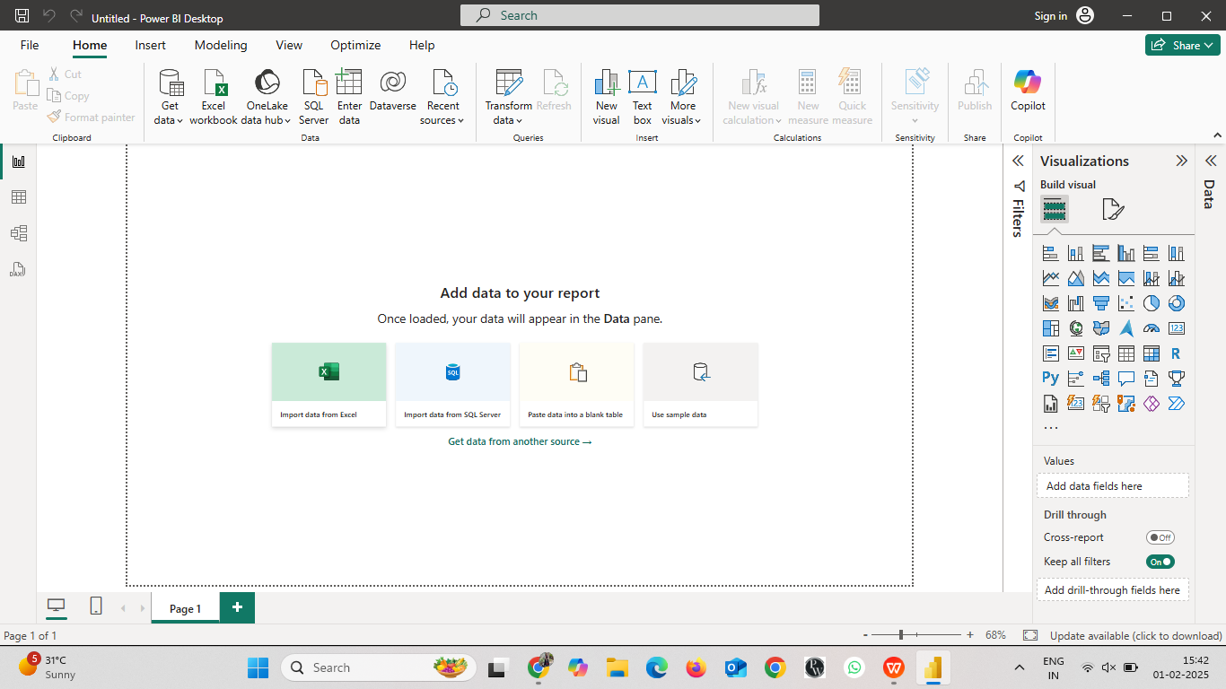

Click on import data from Excel,and load the dataset

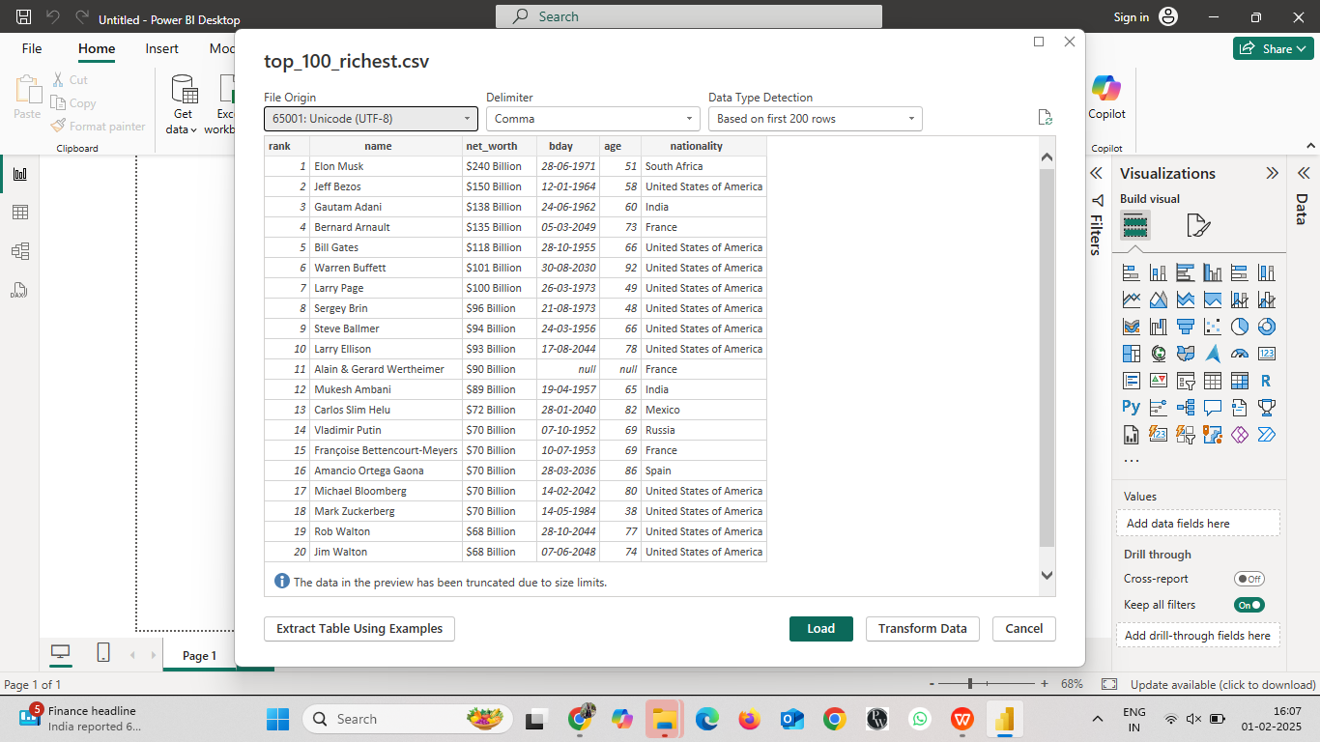

Some columns have been renamed, while each person's wealth (in billions of dollars) has been extracted

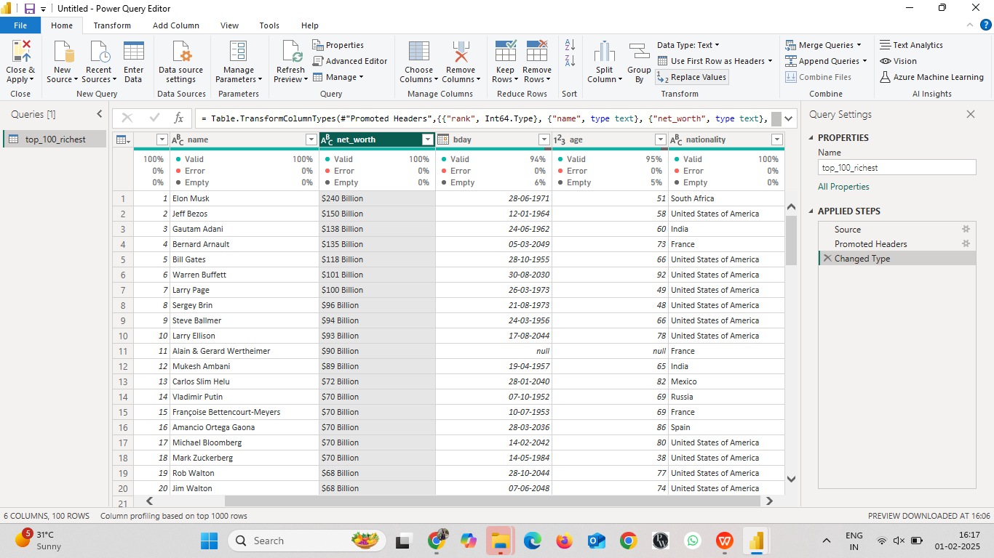

1. **Replace the word billion with an empty string.**

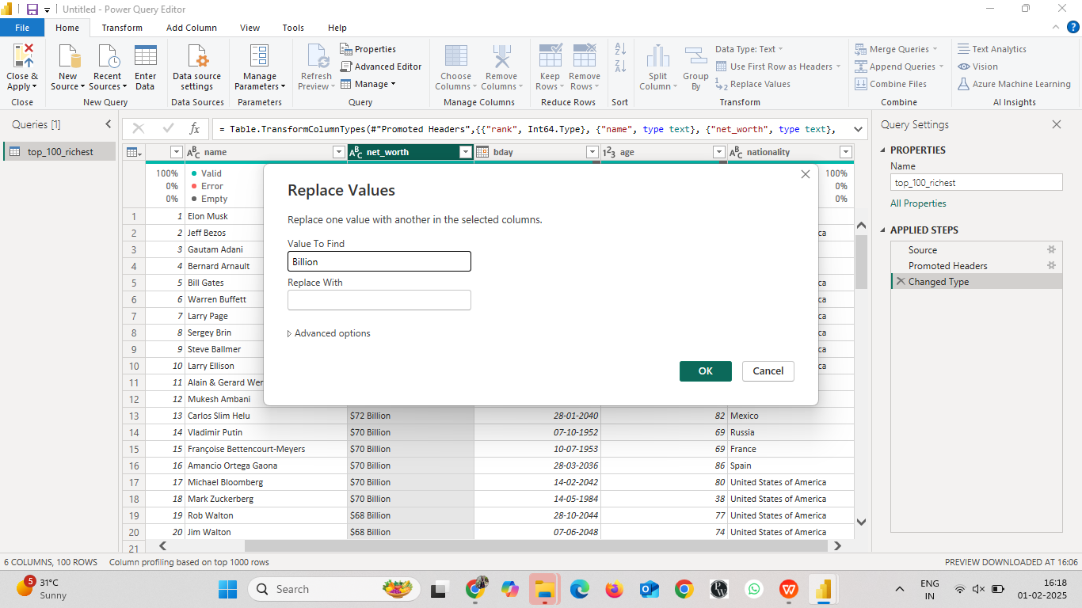

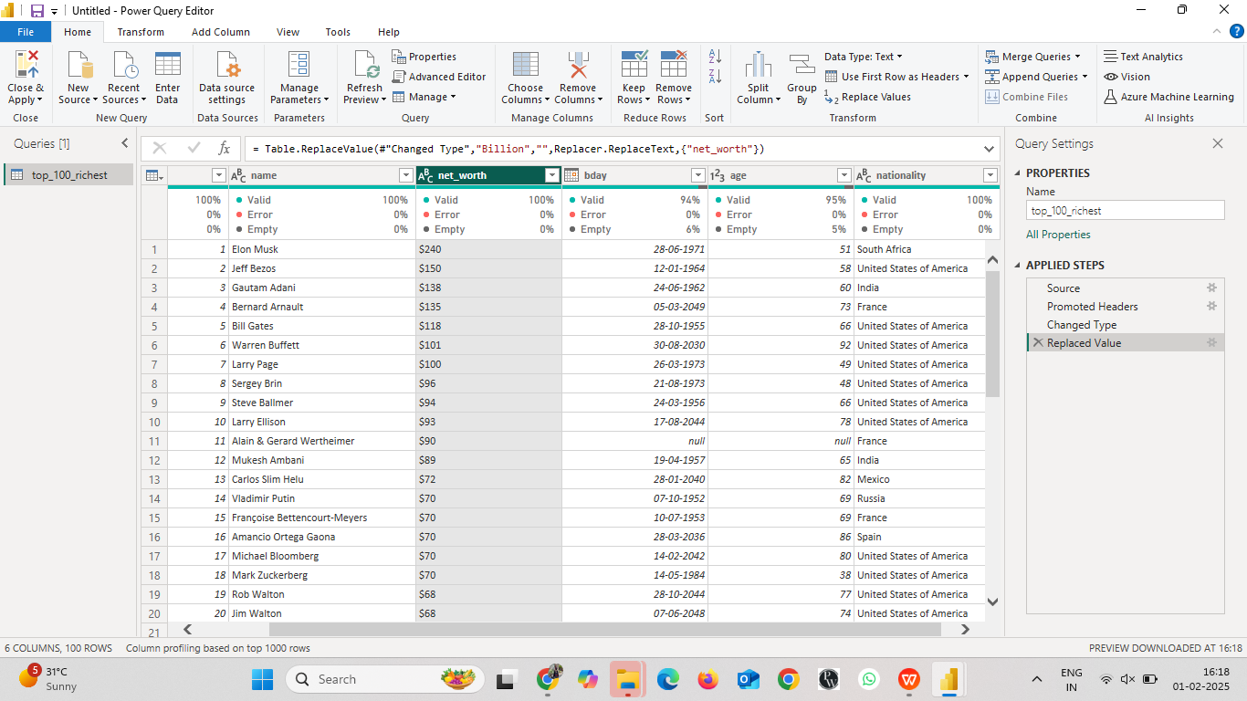

Here,we are able to see the row which was previously having Billions but now we have replaced the value of Billion empty string .so it is in the form of Text

1. **Replace the $ symbol with an empty string.**

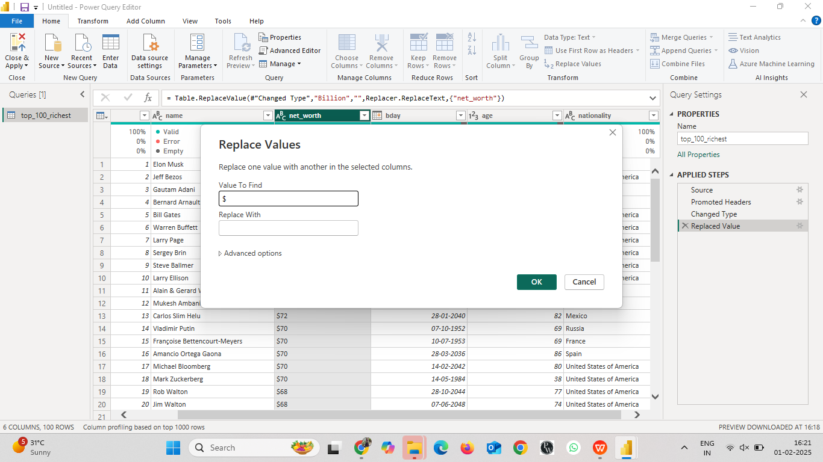

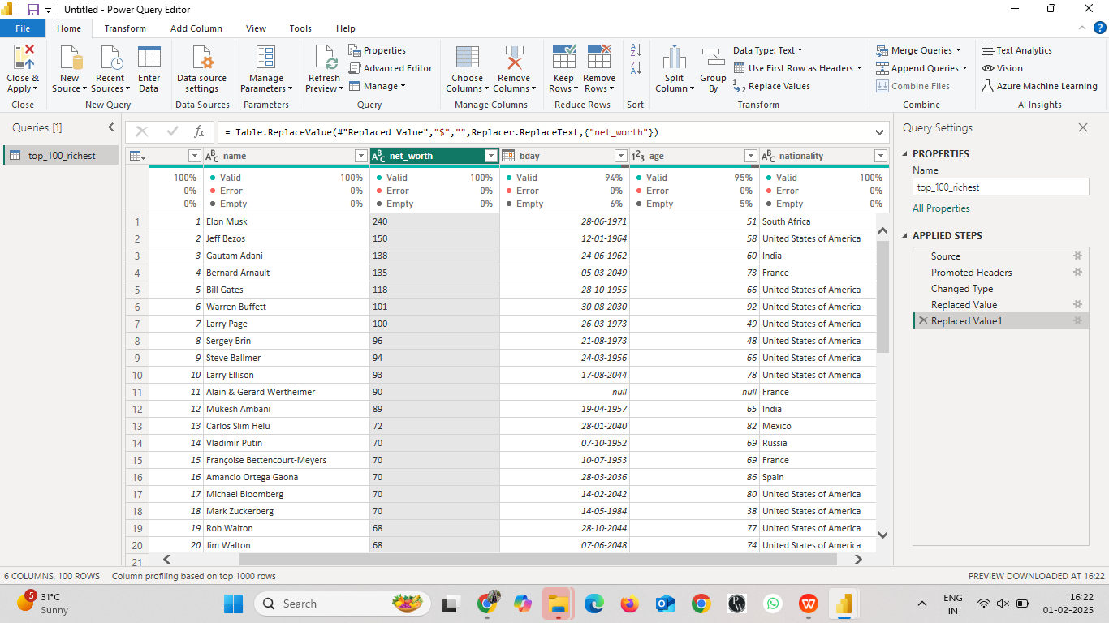

Here,we have removed also $ symbol from the column net_worth.but the datatype is text .

1. **Convert the resulting column to a whole number.**

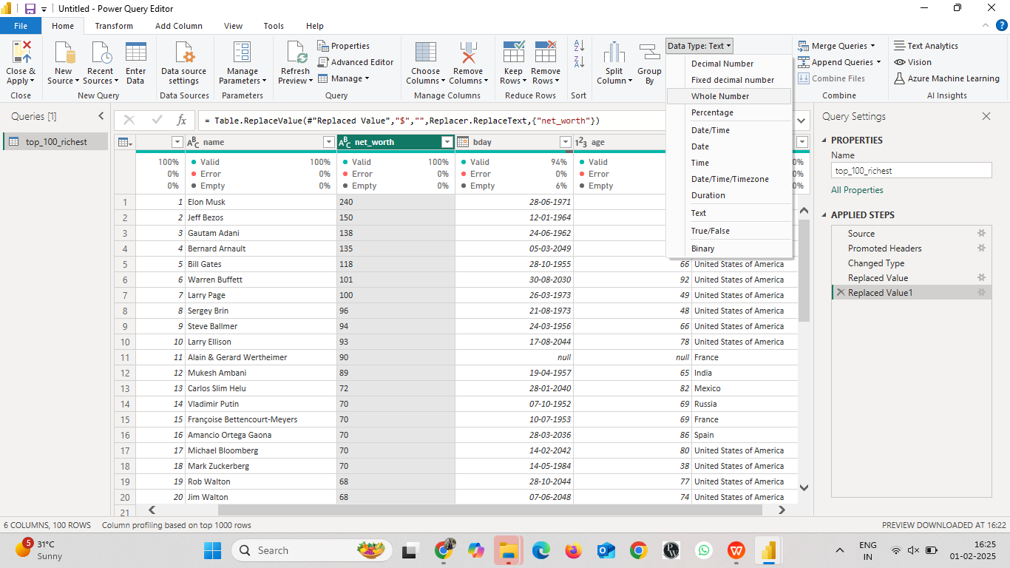

Here,we changed the datatype from Text to “WholeNumber”

**Create a chart just to prove that the billions really are being treated as numbers.**

Given below is the powerbi Report where we checked if the net_worth was converted to numerical values as befoe it was in text form.

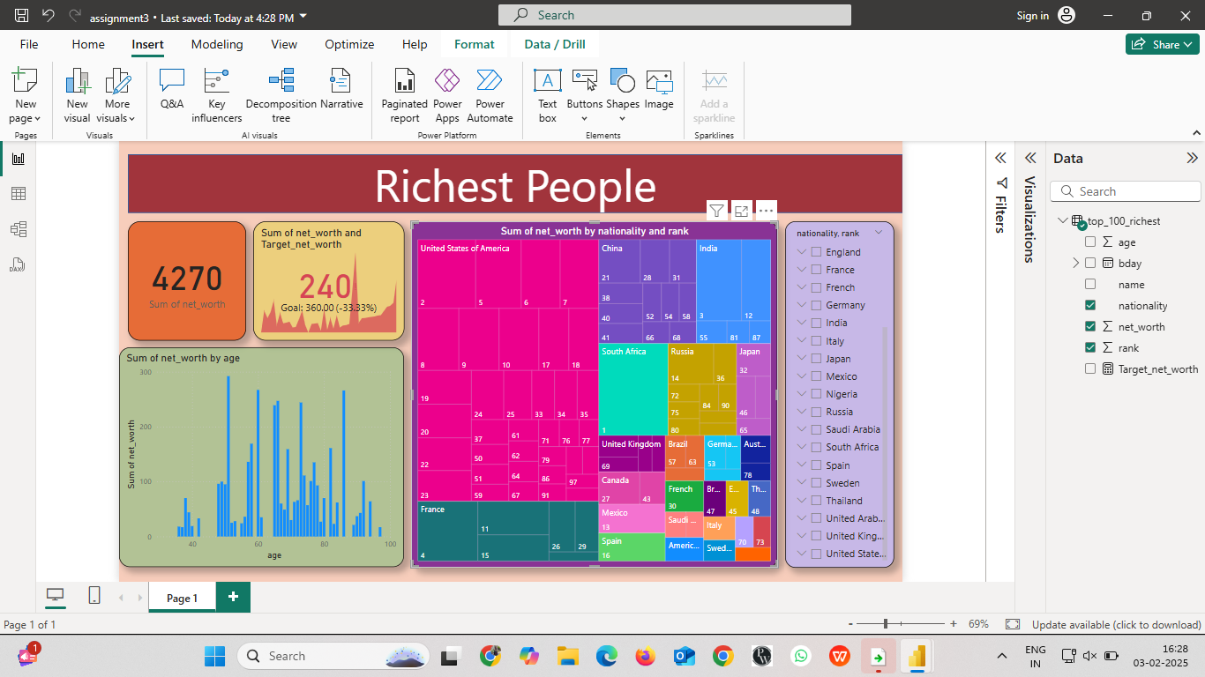

Result - Transform data using Query Editor

