Software Requirements Specification (SRS)
Project: Electronics Store Inventory Management System
Version: 1.0
Authors: Vaishnavi Bandaru, Valmiki Uma, Yerramilli Siva Sai Saharsh, Yashas
Team: 10
SRN: PES2UG24CS570, PES2UG24CS573, PES2UG24CS618, PES2UG24CS609
Date: 06-09-2026
Status: Draft / Proposed

Revision History
Version | Date | Author | Change Summary | Approval
1.0 | 06-09-2026 | Vaishnavi Bandaru, Valmiki Uma, Yerramilli Siva Sai Saharsh, Yashas | Initial SRS

Approvals
Role | Name | Signature / Email | Date
Course Coordinator

Table of Contents
- Introduction
- Overall Description
- External Interface Requirements
- System Features (Detailed)
- Non-Functional Requirements
5.1 Security
5.1.1 Security Objectives
5.1.2 Security Requirements
- Quality Attributes & Acceptance Tests
- UML Use-Case Diagram
- Requirements Traceability Matrix (RTM)

1. Introduction
1.1 Purpose
This document is a Software Requirements Specification (SRS) for an Electronics Store Inventory Management System. The system is intended to help electronics stores efficiently manage their products, inventory levels, suppliers, purchases, sales, and stock movements through a centralized software application.
The SRS defines the functional requirements, non-functional requirements, interfaces, security requirements, and acceptance criteria of the proposed system. It serves as a reference for the development, testing, and evaluation of the project.
1.2 Scope
The Electronics Store Inventory Management System is designed to assist store personnel in managing electronic products and their inventory.
The system will allow authorized personnel to:
- Manage product information.
- Track available stock.
- Manage supplier information.
- Record purchases and update inventory accordingly.
- Record sales and update inventory accordingly.
- Search for products.
- Identify low-stock products.
- Generate basic inventory and sales reports.
The system is intended for internal store use and does not provide a customer-facing shopping or e-commerce interface. Advanced accounting, online payment processing, delivery management, and external e-commerce integration are outside the scope of the project.
1.3 Audience
The intended audience for this document includes:
- Project developers
- Project team members
- Store administrators
- Store employees
- System testers
- Project evaluators/instructors
- Future system maintainers
1.4 Definitions and Acronyms
Term | Definition
SRS | Software Requirements Specification
UI | User Interface
DB | Database
SKU | Stock Keeping Unit
Admin | System administrator
Inventory | Collection of products and their available stock
Supplier | Entity that supplies electronic products to the store
Reorder Level | Minimum stock quantity at which replenishment is required
CRUD | Create, Read, Update, Delete
API | Application Programming Interface

2. Overall Description
2.1 Product Perspective
The Electronics Store Inventory Management System will be a centralized application connected to a database that stores information about products, categories, suppliers, users, purchases, sales, and inventory transactions.
The system will provide different interfaces depending on the user's role. Administrators will have access to management and reporting functions, while store employees will have access to operational functions such as viewing products, recording sales, and updating stock.
The system will automatically maintain inventory information based on recorded purchase and sales transactions.

2.2 Major Product Functions
The system shall provide the following major functions:
- User authentication
- Product management
- Inventory tracking
- Supplier management
- Purchase recording
- Sales recording
- Automatic stock updates
- Low-stock identification
- Product search
- Basic inventory and sales reporting
2.3 User Roles and Characteristics
Store Manager / Administrator:
The primary user responsible for managing products, suppliers, inventory, purchases, sales, and reports. This user has access to all system functions.
Store Staff/ Sales Staff:
Users responsible for day-to-day operations such as viewing products, checking stock, and recording sales. Access to administrative functions may be restricted.
2.4 Operating Environment
The system is expected to operate in the following environment:
- Desktop or laptop computer
- Modern web browser or supported desktop interface
- Application server/runtime environment
- Relational database management system
- Local or network-based environment
- Internet/network connection where required
The exact programming language, framework, and database technology will be determined during the system design phase.
2.5 Constraints
The system is subject to the following constraints:
- Only authorized users shall be permitted to access protected functions.
- Inventory quantities shall not become negative.
- Each product shall have a unique product identifier/SKU.
- The database shall maintain consistency between product, inventory, purchase, and sales records.
- The system shall use a relational database for structured inventory and transaction data.
- Access to administrative functions shall be restricted according to user roles.

3. External Interface Requirements
3.1 User Interfaces
The system shall provide a simple interface for authorized store personnel. The main pages shall include:
- Login Page – Authentication of authorized staff.
- Dashboard – Overview of products, stock levels, low-stock items, and recent transactions.
- Products & Inventory Page – View, add, update, and manage product and stock information.
- Suppliers & Purchases Page – Manage supplier information and record purchases.
- Sales Page – Record sales and automatically update inventory.
- Reports Page – View basic inventory, sales, and purchase reports.
3.2 Hardware Interfaces
The system does not require specialized hardware.
It shall operate using standard:
- Desktop computers
- Laptop computers
- Keyboard
- Mouse/touchpad
- Display monitor
Optional hardware such as barcode scanners may be considered as a future enhancement but is outside the core scope of this project.
3.3 Software Interfaces
The system shall interact with:
- Relational database management system for persistent storage.
- Application/backend services for business logic.
- Frontend/user interface for user interaction.
If required, the system may expose internal REST APIs between the frontend and backend.
3.4 Communication Interfaces
If implemented as a web-based application:
- Communication between client and server shall use HTTP/HTTPS.
- Database communication shall occur through the backend application.
- Sensitive information shall not be transmitted unnecessarily.

4. System Features
Each requirement below includes an acceptance criterion and test case reference. Requirement IDs follow the format ESIMS-F-###.
4.1 Authentication
Req ID | Requirement | Type | Priority | Source/Stakeholder | Acceptance Criteria / Test Case | Comments
ESIMS-F-001 | The system shall allow authorized store personnel to log in using valid credentials. | Functional | High | Store Staff | Valid credentials result in successful login. Test: TC-Auth-01 | —
ESIMS-F-002 | The system shall reject login attempts containing invalid credentials. | Functional | High | Security | Invalid credentials result in an error message. Test: TC-Auth-02 | —

4.2 Product & Inventory Management
Req ID | Requirement | Type | Priority | Source/Stakeholder | Acceptance Criteria / Test Case | Comments
ESIMS-F-003 | The system shall allow authorized personnel to add a new electronic product with details such as name, category, price, and quantity. | Functional | High | Store Staff | A valid product is successfully added. Test: TC-Prod-01 | —
ESIMS-F-004 | The system shall allow authorized personnel to update existing product information. | Functional | High | Store Staff | Updated product information is saved correctly. Test: TC-Prod-02 | —
ESIMS-F-005 | The system shall allow personnel to view the current stock quantity of each product. | Functional | High | Store Staff | Current stock quantity is displayed correctly. Test: TC-Inv-01 | —
ESIMS-F-006 | The system shall allow personnel to search for products using product name or product ID/SKU. | Functional | Medium | Store Staff | Matching products are displayed. Test: TC-Inv-02 | —
ESIMS-F-007 | The system shall identify products whose stock is at or below the configured reorder level. | Functional | High | Store Staff | Low-stock products are displayed. Test: TC-Inv-03 | —
ESIMS-F-008 | The system shall prevent inventory quantity from becoming negative. | Functional | High | Business Rule | A transaction exceeding available stock is rejected. Test: TC-Inv-04 | —

4.3 Supplier & Purchase Management
Req ID | Requirement | Type | Priority | Source/Stakeholder | Acceptance Criteria / Test Case | Comments
ESIMS-F-009 | The system shall allow personnel to add and update supplier information. | Functional | Medium | Store Staff | Supplier information is stored or updated successfully. Test: TC-Sup-01 | —
ESIMS-F-010 | The system shall allow personnel to record a purchase from a supplier. | Functional | High | Store Staff | Purchase transaction is successfully recorded. Test: TC-Pur-01 | —
ESIMS-F-011 | The system shall automatically increase the corresponding product stock when a purchase is recorded. | Functional | High | Inventory | Stock increases by the purchased quantity. Test: TC-Pur-02 | —

4.4 Sales Management
Req ID | Requirement | Type | Priority | Source/Stakeholder | Acceptance Criteria / Test Case | Comments
ESIMS-F-012 | The system shall allow personnel to record a sale containing one or more products. | Functional | High | Store Staff | A valid sale is successfully recorded. Test: TC-Sale-01 | —
ESIMS-F-013 | The system shall calculate the total amount of a sale based on product prices and quantities. | Functional | High | Business Rule | Calculated total matches the expected amount. Test: TC-Sale-02 | —
ESIMS-F-014 | The system shall automatically decrease product stock after a successful sale. | Functional | High | Inventory | Stock decreases by the quantity sold. Test: TC-Sale-03 | —

4.5 Reports
Req ID | Requirement | Type | Priority | Source/Stakeholder | Acceptance Criteria / Test Case | Comments
ESIMS-F-015 | The system shall generate a basic inventory report showing products and their current stock levels. | Functional | Medium | Store Staff | Inventory report displays current stock information. Test: TC-Report-01 | —
ESIMS-F-016 | The system shall generate a sales report for a selected date or date range. | Functional | Medium | Store Staff | Report displays sales within the selected period. Test: TC-Report-02 | —

5. Non-Functional Requirements
The following requirements define the quality attributes and operational characteristics of the system. IDs follow ESIMS-NF-###.
Req ID | Requirement | Category | Priority | Acceptance Criteria
ESIMS-NF-001 | The system shall respond to common operations such as product search and inventory lookup within 3 seconds under normal load. | Performance | High | 90% of tested requests complete within 3 seconds.
ESIMS-NF-002 | The system shall maintain consistent inventory quantities after purchase and sales transactions. | Reliability | High | Inventory values remain correct after tested transactions.
ESIMS-NF-003 | The system shall be available during the store's intended operating hours except during planned maintenance. | Availability | Medium | System remains accessible during testing.
ESIMS-NF-004 | The system shall provide a simple and consistent user interface that allows store personnel to perform common operations easily. | Usability | Medium | Users can complete common tasks without critical usability errors.
ESIMS-NF-005 | The system shall protect stored user and transaction information from unauthorized access or modification. | Security | High | Unauthorized access and modification attempts are rejected.

5.1 Security
5.1.1 Security Objectives
The system shall satisfy the following security objectives:
Security Objective 1 – Confidentiality:
The system shall ensure that user credentials and store transaction information are accessible only to authorized personnel.
Security Objective 2 – Integrity:
The system shall prevent unauthorized modification of product, inventory, purchase, and sales information.

5.1.2 Security Requirements
Req ID | Requirement | Type | Priority | Acceptance Criteria / Test Case
ESIMS-SR-001 | The system shall require users to authenticate before accessing protected functions. | Security | High | Unauthenticated users cannot access the system. Test: TC-Sec-01
ESIMS-SR-002 | The system shall restrict administrative functions to authorized personnel. | Security | High | Unauthorized users cannot access restricted functions. Test: TC-Sec-02
ESIMS-SR-003 | The system shall store passwords using secure hashing rather than plaintext. | Security | High | Passwords are not stored as plaintext. Test: TC-Sec-03
ESIMS-SR-004 | The system shall validate user input before processing or storing it. | Security | High | Invalid input is rejected appropriately. Test: TC-Sec-04
ESIMS-SR-005 | The system shall prevent unauthorized modification or deletion of inventory and transaction records. | Security | High | Unauthorized modification/deletion attempts are rejected. Test: TC-Sec-05

6. Quality Attributes & Acceptance Tests
The system shall be evaluated based on the following quality attributes:
6.1 Performance
The system shall provide timely responses for common operations such as product search, inventory lookup, and recording sales and purchases.
6.2 Reliability
The system shall maintain consistent inventory quantities after purchase and sales transactions. Failed transactions shall not result in incorrect or partial inventory updates.

6.3 Usability
The system shall provide clear menus, forms, tables, and feedback messages to allow store personnel to perform common operations easily.
6.4 Security
Only authenticated and authorized store personnel shall be able to access protected system functionality.
6.5 Maintainability
The system shall use a modular structure so that components such as product management, inventory management, sales, purchases, and reporting can be modified with minimal impact on other components.
Acceptance Criteria
The project shall be considered acceptable when:
- All high-priority functional requirements have been implemented and verified.
- All high-priority requirements have corresponding test cases.
- Inventory quantities remain accurate after purchase and sales transactions.
- Authentication and authorization tests pass for both defined user roles.
- All defined security requirements have been verified.
- Major store workflows operate successfully.
- The Requirements Traceability Matrix is complete.
- No critical defects remain at the time of submission.
Acceptance Test Suites
The following test suites shall be performed:
- Authentication and authorization testing
- Product management testing
- Supplier management testing
- Inventory testing
- Purchase transaction testing
- Sales transaction testing
- Search and filtering testing
- Report generation testing
- Performance testing
- Security testing
- Usability testing

7. System Models and Diagrams
7.1 UML Use-Case Diagram
Overall System Use-Case Diagram:
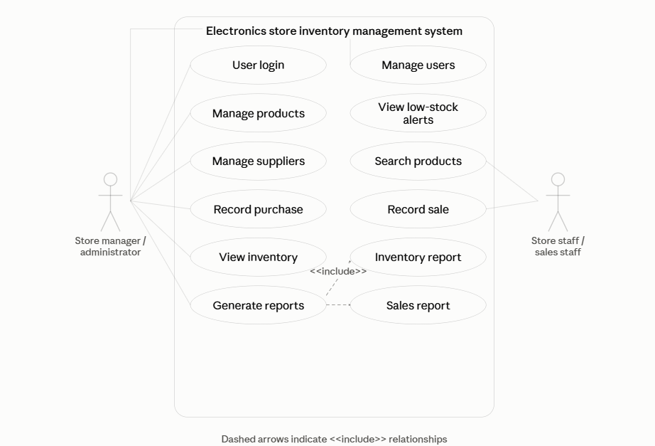
Sales & Inventory Use-Case Diagram: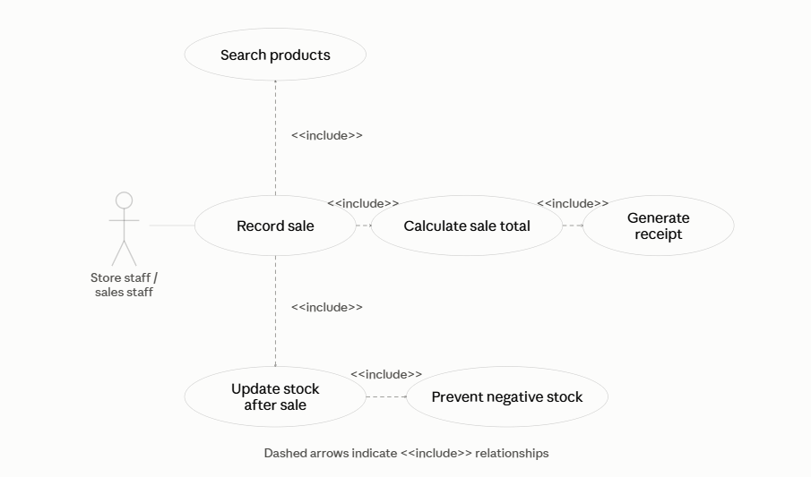
8. Requirements Traceability Matrix (RTM)
The Requirements Traceability Matrix (RTM) maps each system requirement to the corresponding system module and test case. It will be updated throughout the development and testing phases.
Req ID | Requirement Short | Section Ref. | Module | Test Case(s) | Status | Comments
ESIMS-F-001 | User login | 4.1 | Authentication Module | TC-Auth-01 | N | —
ESIMS-F-002 | Invalid login handling | 4.1 | Authentication Module | TC-Auth-02 | N | —
ESIMS-F-003 | Add product | 4.2 | Product Module | TC-Prod-01 | N | —
ESIMS-F-004 | Update product | 4.2 | Product Module | TC-Prod-02 | N | —
ESIMS-F-005 | View stock | 4.2 | Inventory Module | TC-Inv-01 | N | —
ESIMS-F-006 | Search products | 4.2 | Product Module | TC-Inv-02 | N | —
ESIMS-F-007 | Low-stock detection | 4.2 | Inventory Module | TC-Inv-03 | N | —
ESIMS-F-008 | Prevent negative stock | 4.2 | Inventory Module | TC-Inv-04 | N | Business rule
ESIMS-F-009 | Manage suppliers | 4.3 | Supplier Module | TC-Sup-01 | N | —
ESIMS-F-010 | Record purchase | 4.3 | Purchase Module | TC-Pur-01 | N | —
ESIMS-F-011 | Update stock after purchase | 4.3 | Inventory Module | TC-Pur-02 | N | —
ESIMS-F-012 | Record sale | 4.4 | Sales Module | TC-Sale-01 | N | —
ESIMS-F-013 | Calculate sale total | 4.4 | Sales Module | TC-Sale-02 | N | —
ESIMS-F-014 | Update stock after sale | 4.4 | Inventory Module | TC-Sale-03 | N | —
ESIMS-F-015 | Inventory report | 4.5 | Reporting Module | TC-Report-01 | N | —
ESIMS-F-016 | Sales report | 4.5 | Reporting Module | TC-Report-02 | N | —
ESIMS-NF-001 | Response time | 5 | Application | TC-Perf-01 | N | —
ESIMS-NF-002 | Inventory consistency | 5 | Database | TC-Rel-01 | N | —
ESIMS-NF-003 | Availability | 5 | Application | TC-Avail-01 | N | —
ESIMS-NF-004 | Usability | 5 | User Interface | TC-UX-01 | N | —
ESIMS-NF-005 | Data protection | 5 | Security Module | TC-Sec-01 | N | —
ESIMS-SR-001 | Authentication | 5.1.2 | Authentication Module | TC-Sec-02 | N | —
ESIMS-SR-002 | Access restriction | 5.1.2 | Authorization Module | TC-Sec-03 | N | Two user roles
ESIMS-SR-003 | Password hashing | 5.1.2 | Authentication Module | TC-Sec-04 | N | —
ESIMS-SR-004 | Input validation | 5.1.2 | Application | TC-Sec-05 | N | —
ESIMS-SR-005 | Transaction protection | 5.1.2 | Inventory/Sales Module | TC-Sec-06 | N | —

Status
- N — Not yet implemented/tested
- P — Partially implemented/tested
- A — Accepted/verified

