**Assignment No.:02**

**(Different way using scp Protocal)**

**Step-1: Launch instance name Jenkins Master**

Do all the configuration

1. Installing Java
2. Downloading Tomcat 9
3. Installing Jenkins war file inside tomcat webapps

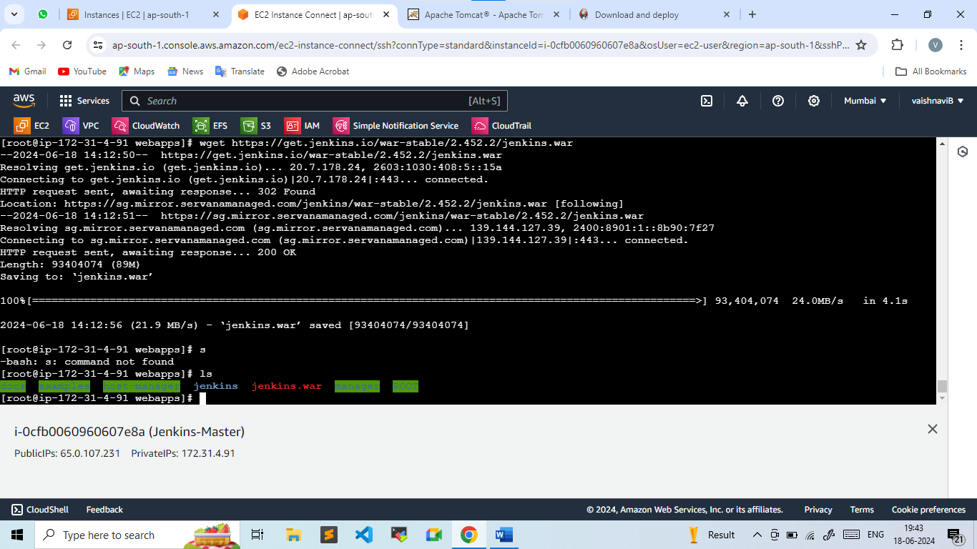

1. Accessing Jenkins Dashboard

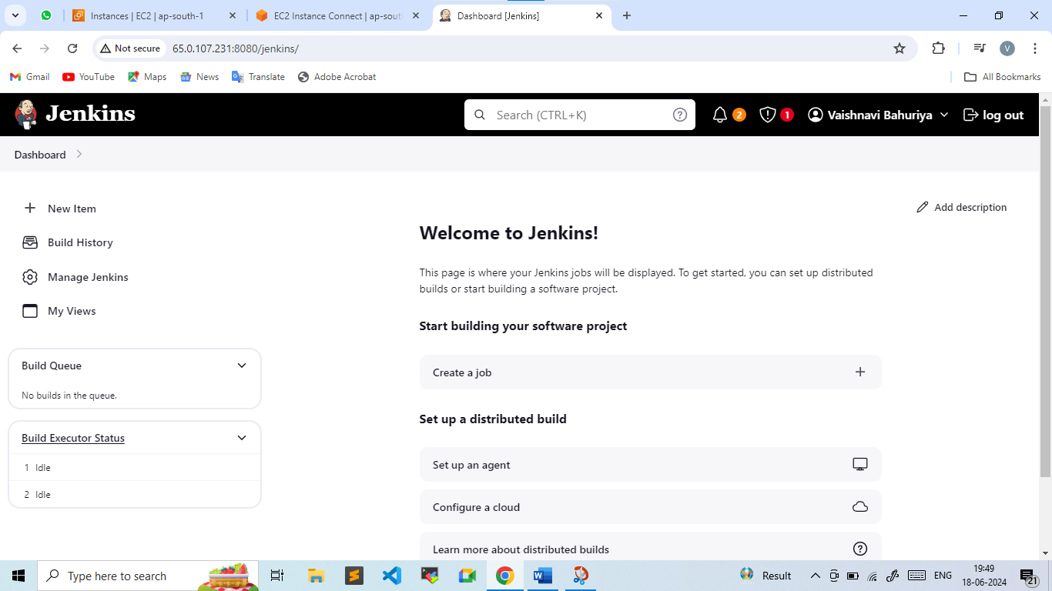

**Step-2: Maven installation and configuration in jenkins**

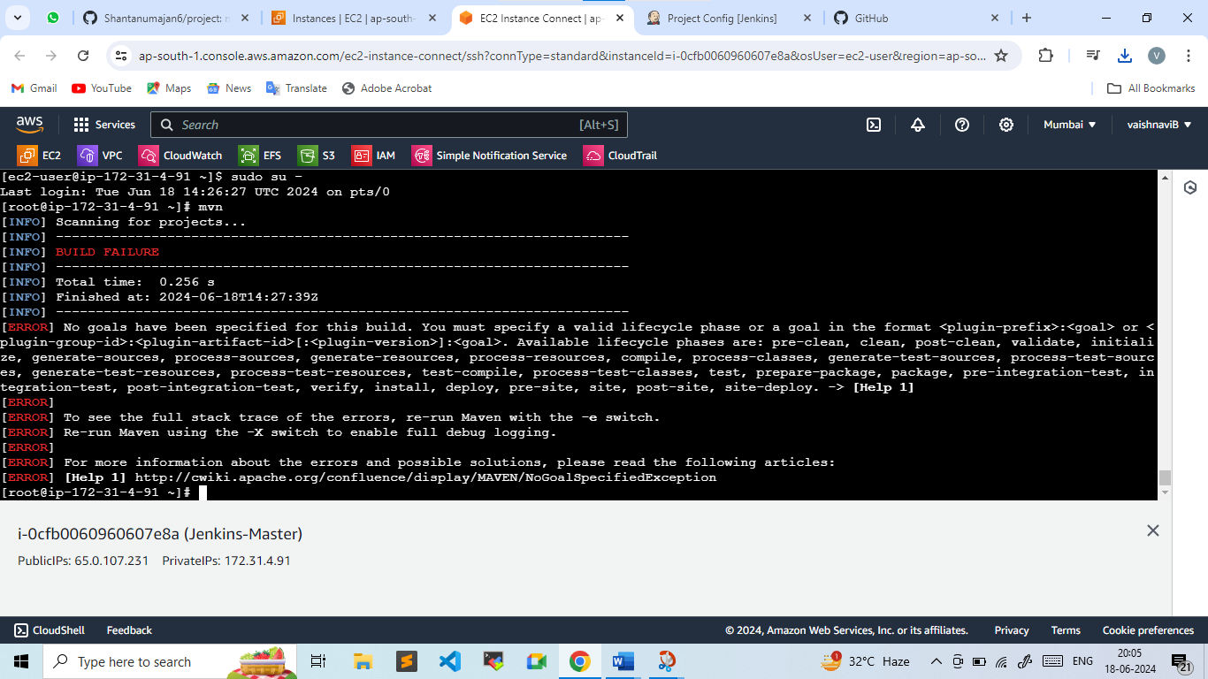

**Step-3: Creating and building a Job**

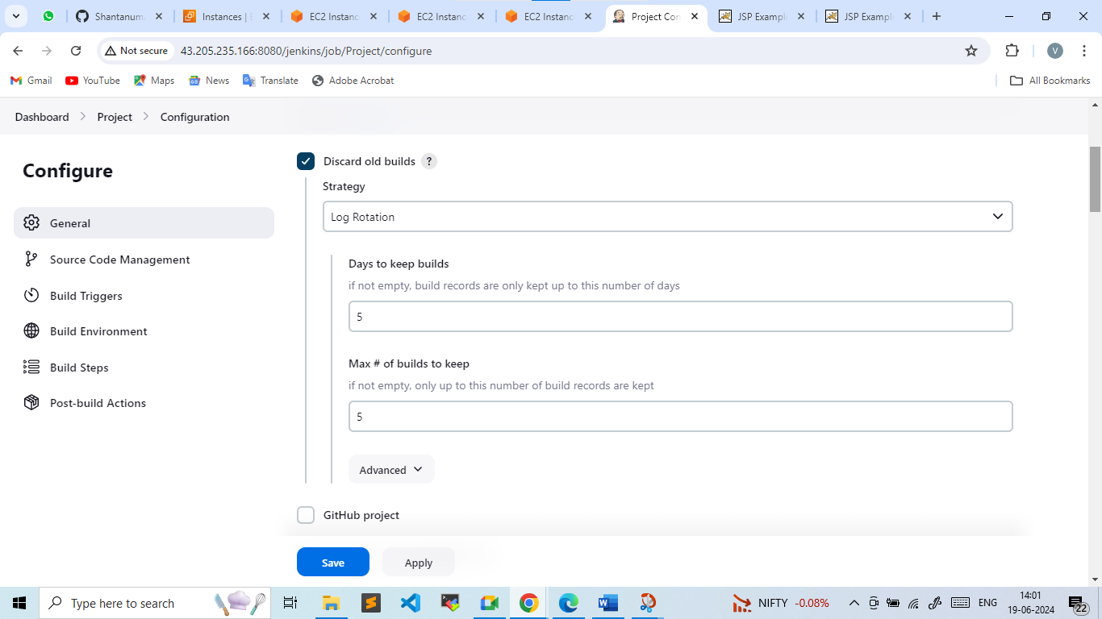

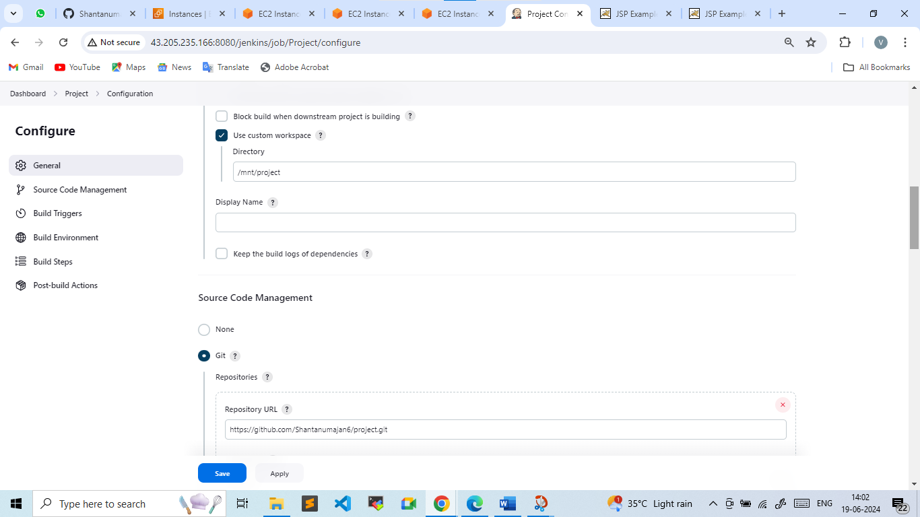

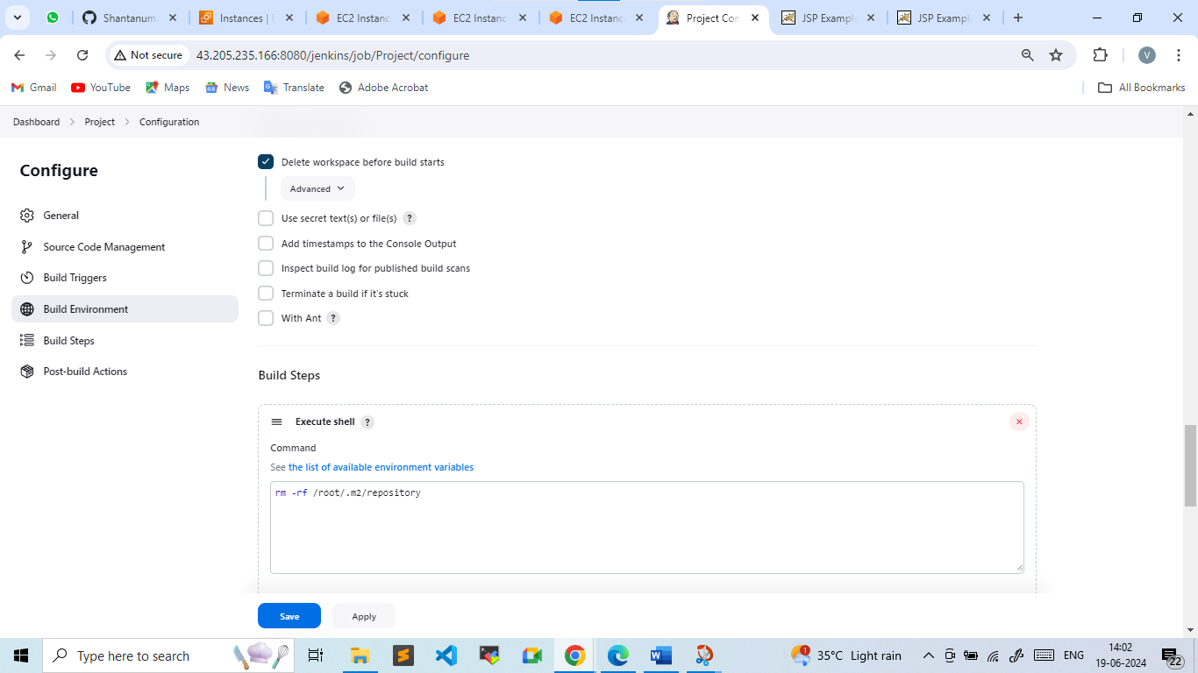

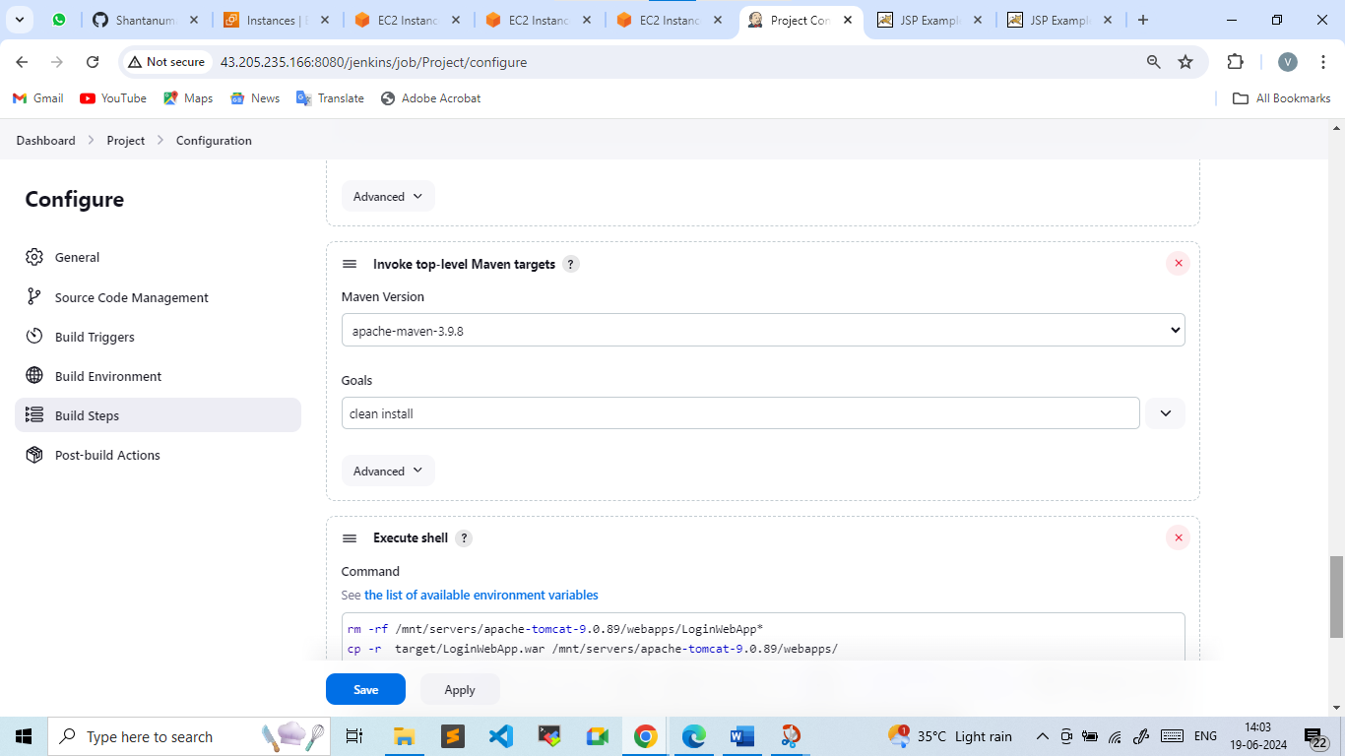

Apply & Save

Build Now

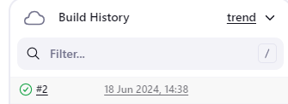

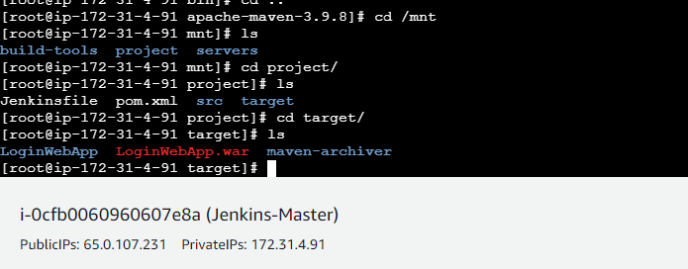

**Step-4:Launch and installed java and tomcat in machine 1 and Machine 2**

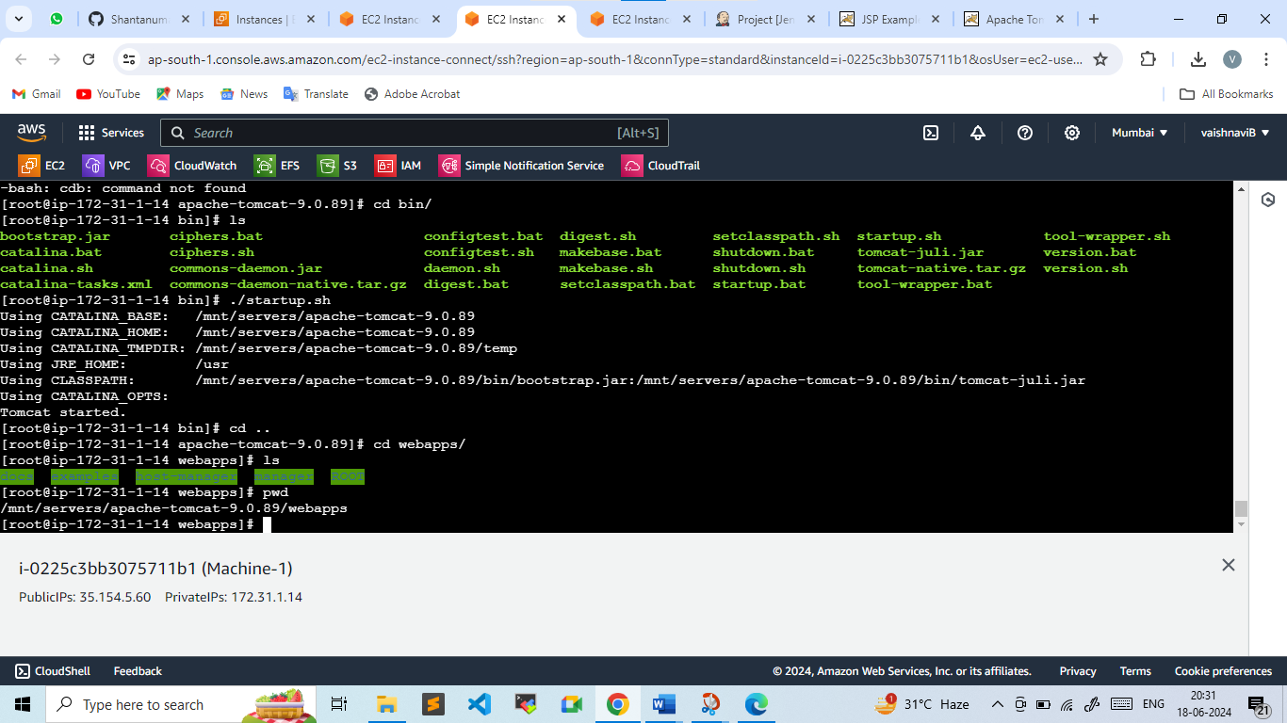

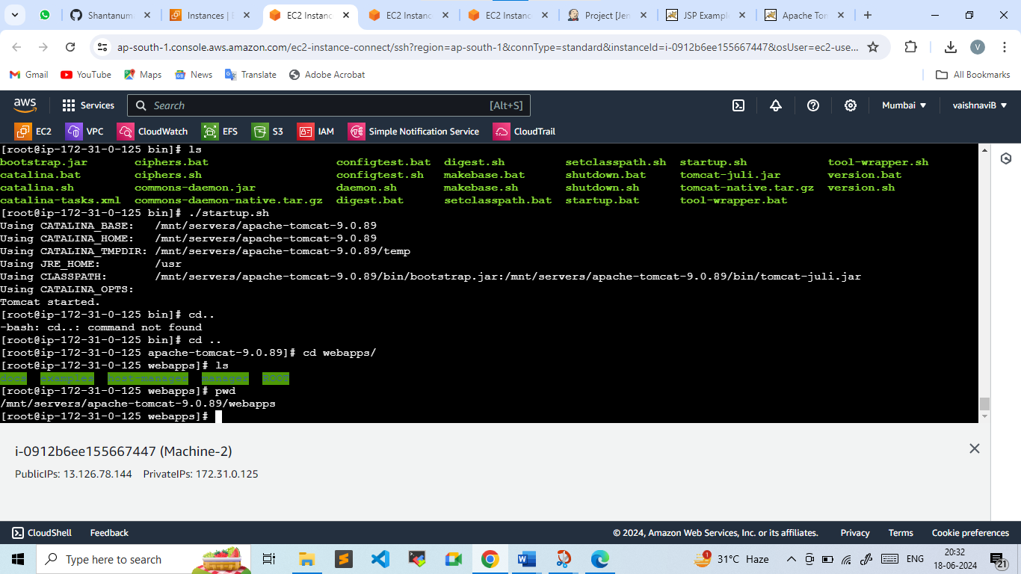

**Step-5:Now, we will be writing a script in execute shell to copy the LoginWebapp.war to other two machine**

In Jenkin-Master machine , first we need to edit Private key

* Vi linux-kp.pem
* Chmod -R 400 linux-kp.pem

Here we need to give permission to key to make it protected otherwise it will show error

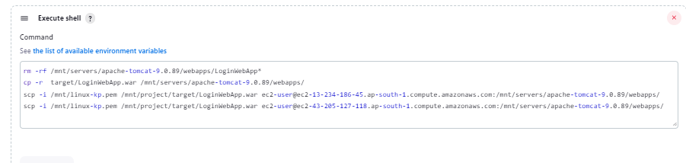

**Execute shell :**

rm -rf /mnt/servers/apache-tomcat-9.0.89/webapps/LoginWebApp*

cp -r target/LoginWebApp.war /mnt/servers/apache-tomcat-9.0.89/webapps/

scp -i /mnt/linux-kp.pem /mnt/project/target/LoginWebApp.war ec2-user@ec2-13-234-186-45.ap-south-1.compute.amazonaws.com:/mnt/servers/apache-tomcat-9.0.89/webapps/

scp -i /mnt/linux-kp.pem /mnt/project/target/LoginWebApp.war [ec2-user@ec2-43-205-127-118.ap-south-1.compute.amazonaws.com:/mnt/servers/apache-tomcat-9.0.89/webapps/](mailto:ec2-user@ec2-43-205-127-118.ap-south-1.compute.amazonaws.com:/mnt/servers/apache-tomcat-9.0.89/webapps/)

* Apply & save
* Build Now

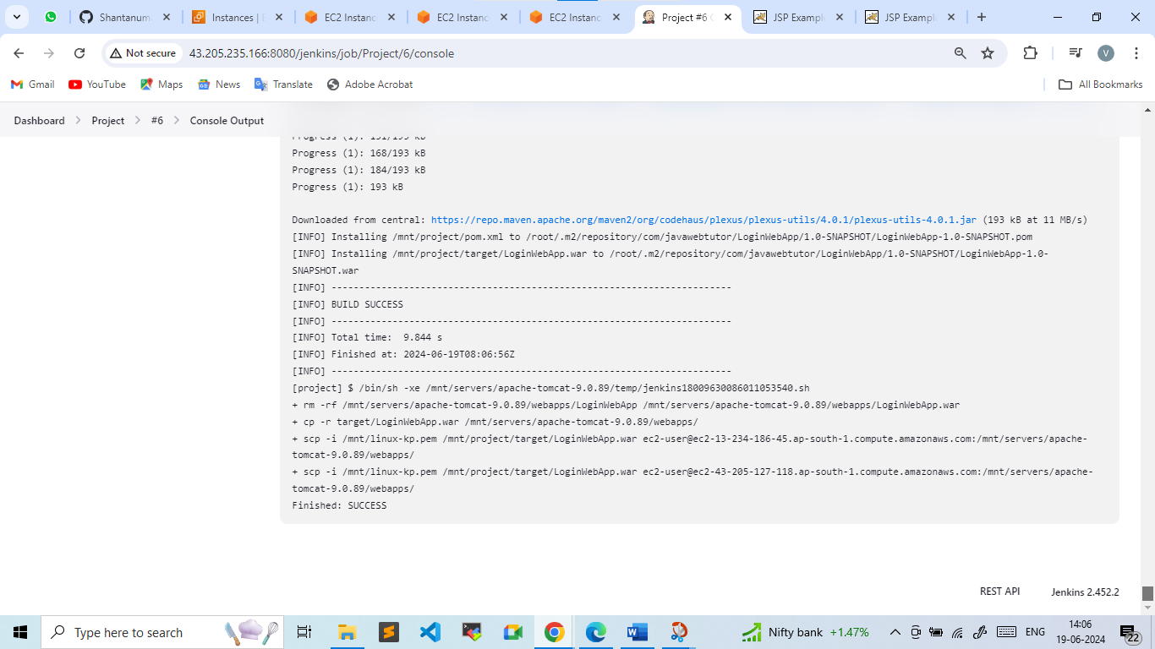

* Now the war file is successfully copied in both the machine on apache-tomcat webapps folder
* We can access website by publicip:8080/LoginWebApp

