**Assignment No.1**

**Step-1 : Launching an instance**

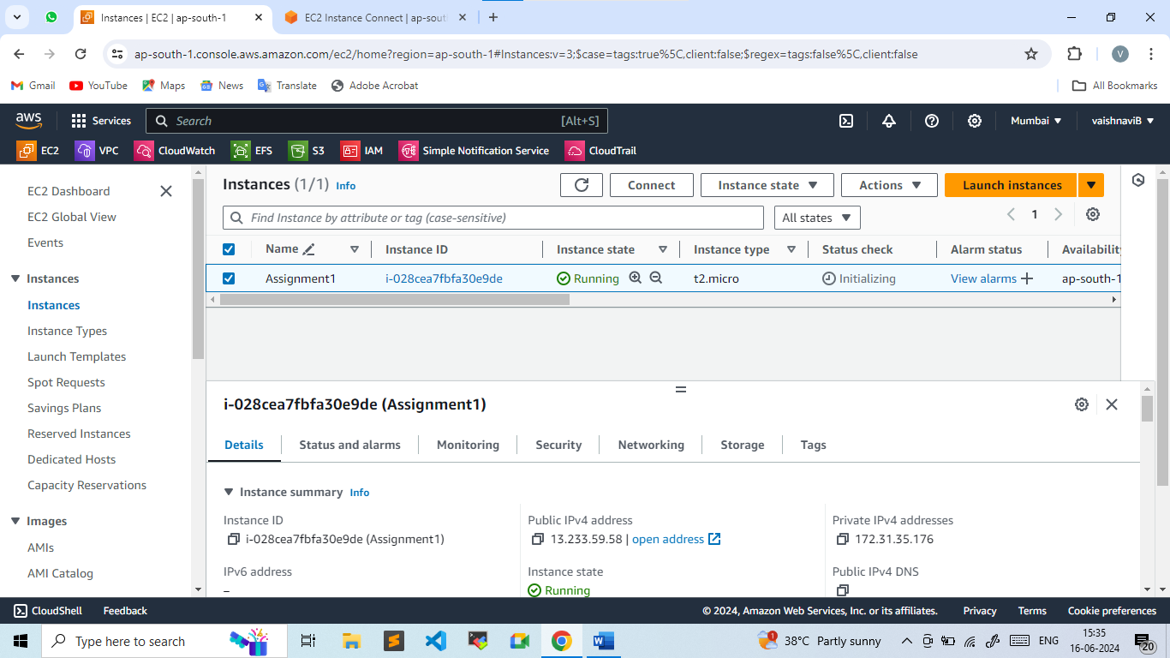

**Step-2 : Installing Java**

yum install java-11-amazon-corretto.x86_64

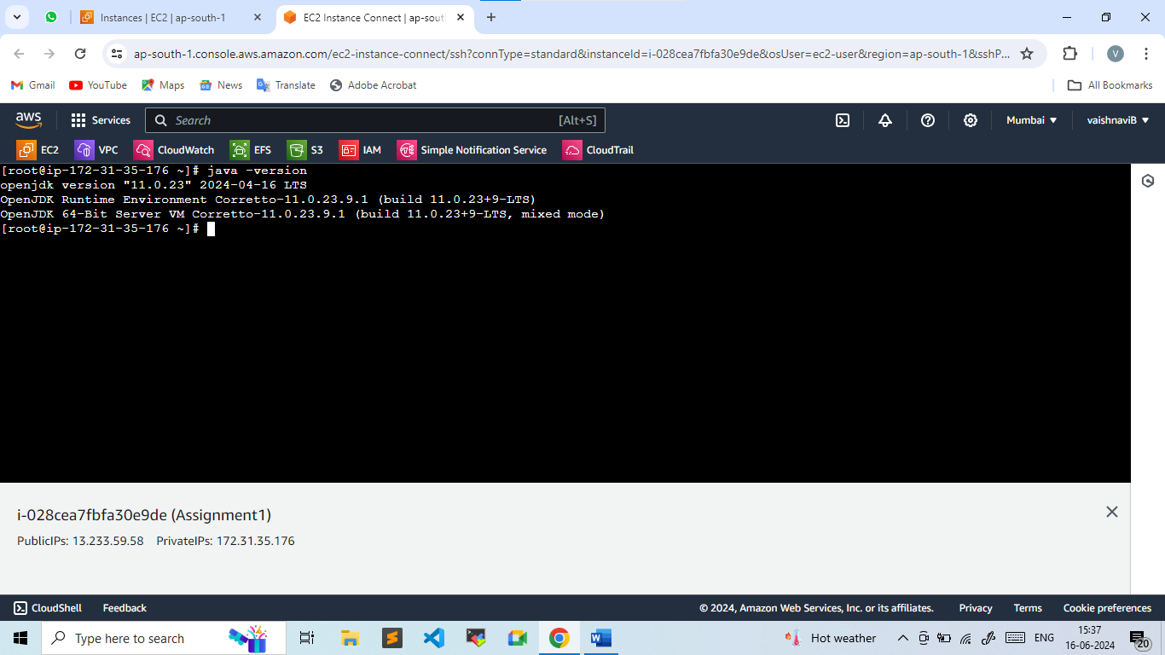

**Step-3: Downloading Apache Tomcat**

cd /mnt

mkdir servers

cd servers/

wget https://dlcdn.apache.org/tomcat/tomcat-9/v9.0.89/bin/apache-tomcat-9.0.89.zip

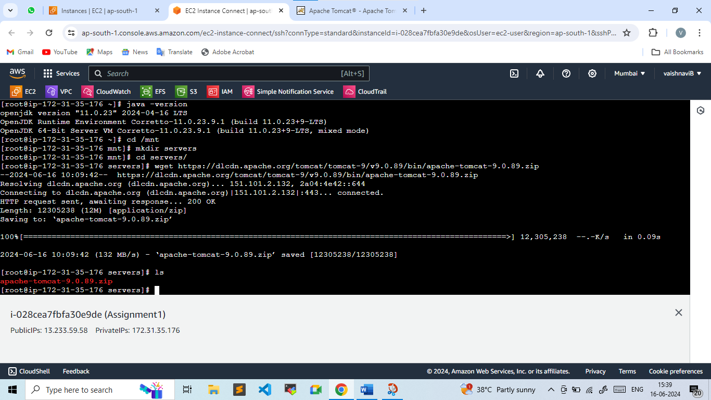

unzip apache-tomcat-9.0.89.zip

rm -rf apache-tomcat-9.0.89.zip

chmod -R 777 apache-tomcat-9.0.89/

**Step-4: Adding WAR file of Jenkins in webapps**

wget <https://get.jenkins.io/war-stable/2.452.2/jenkins.war>

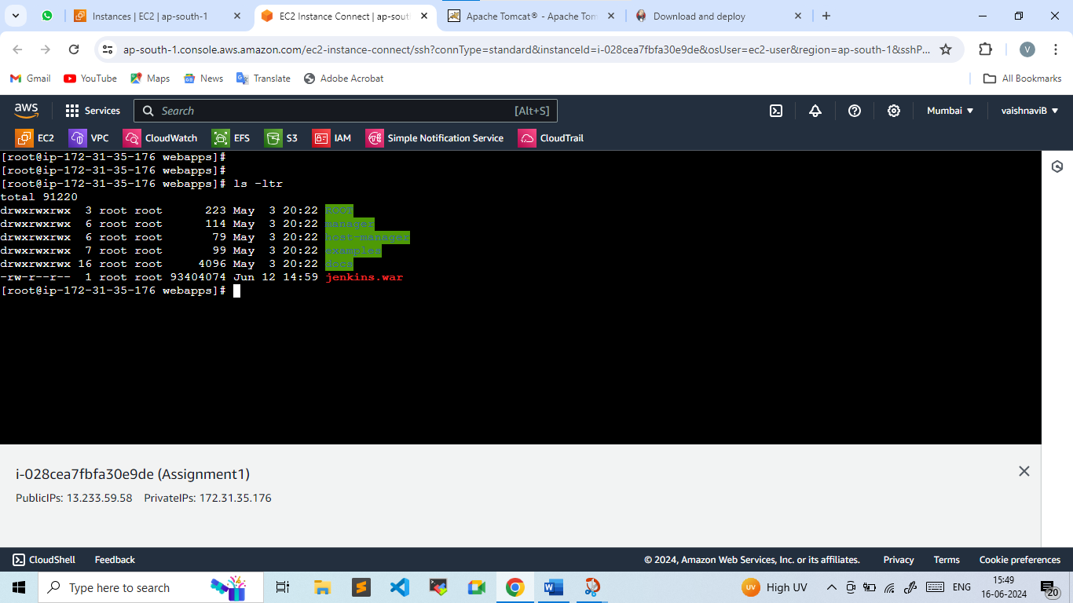

Starting apache-tomcat :

cd bin/

./startup.sh

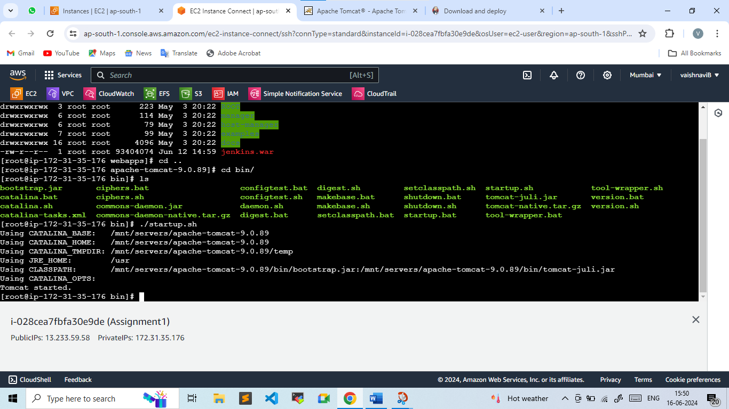

**Step-6: Login into Jenkins Dashboard**

To access Jenkins : 13.233.59.58:8080/Jenkins

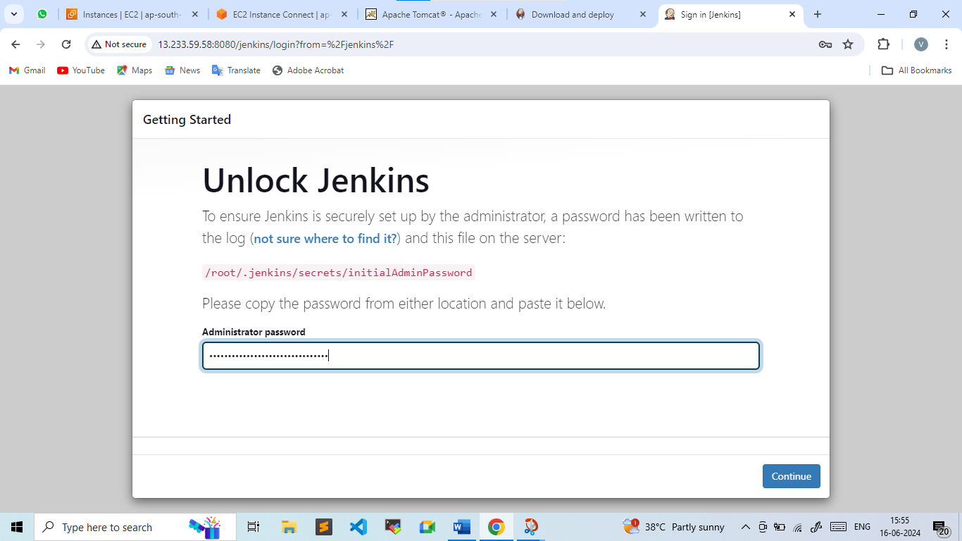

To get administrator Password :

cd /root/

ls -ltra

cd .jenkins/

cd secrets/

ls

cat initialAdminPassword

**Step-7 : Installation of suggested Plugins**

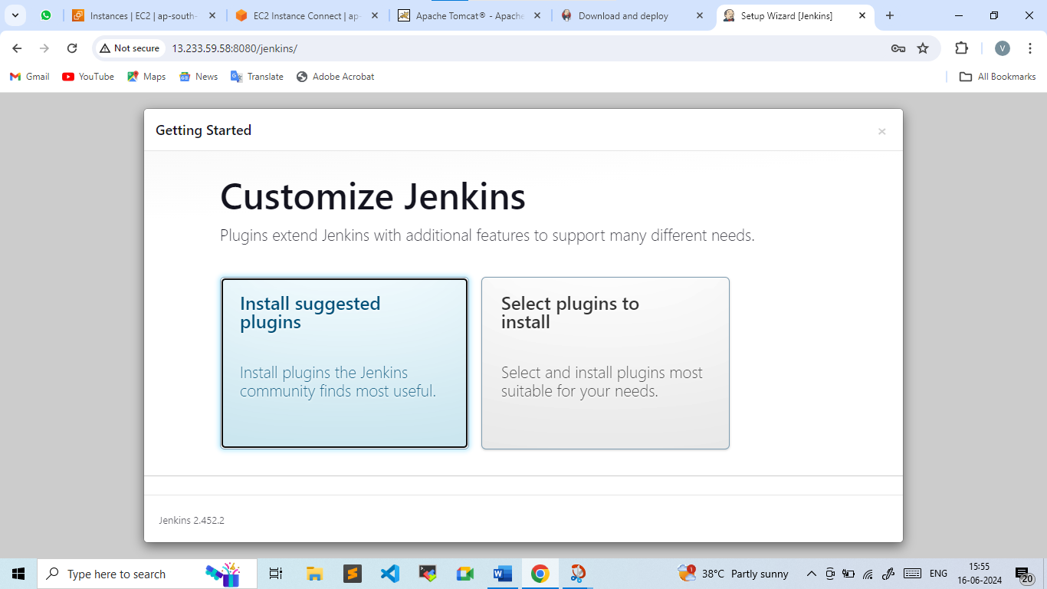

**Step-8: Create First Admin User**

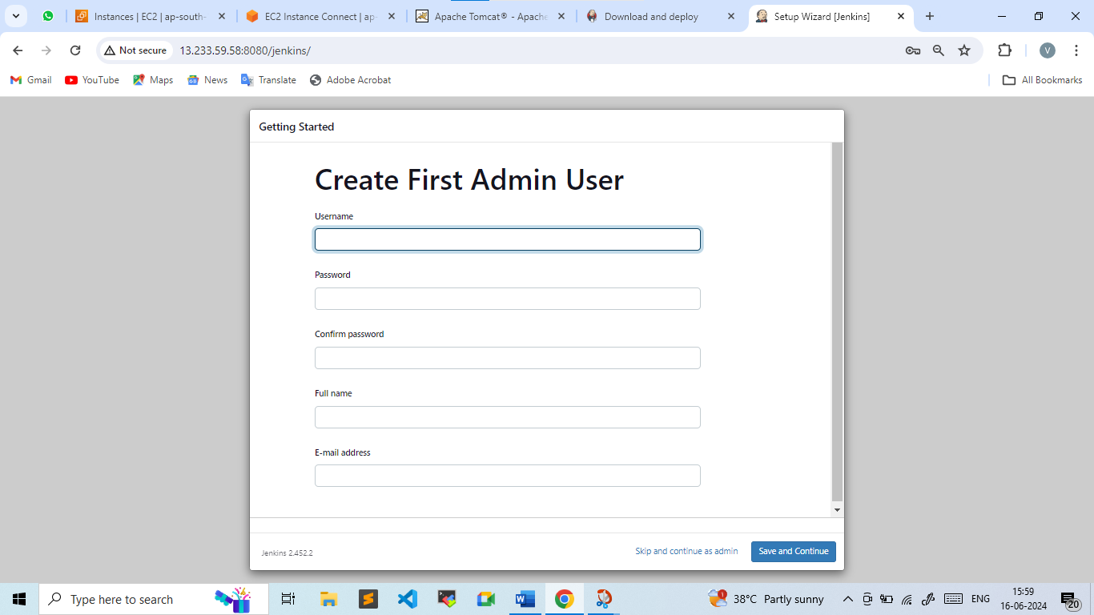

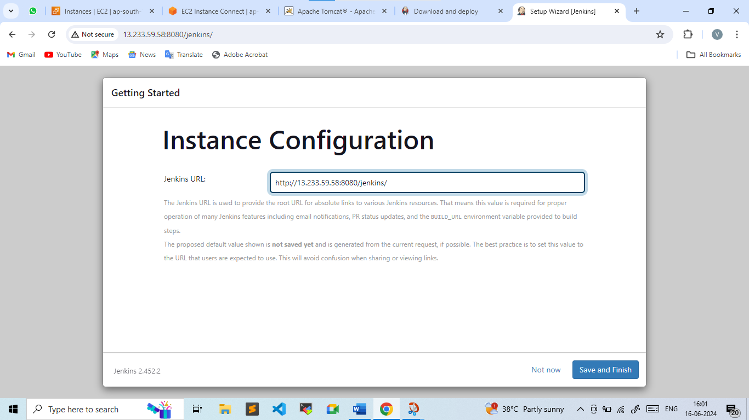

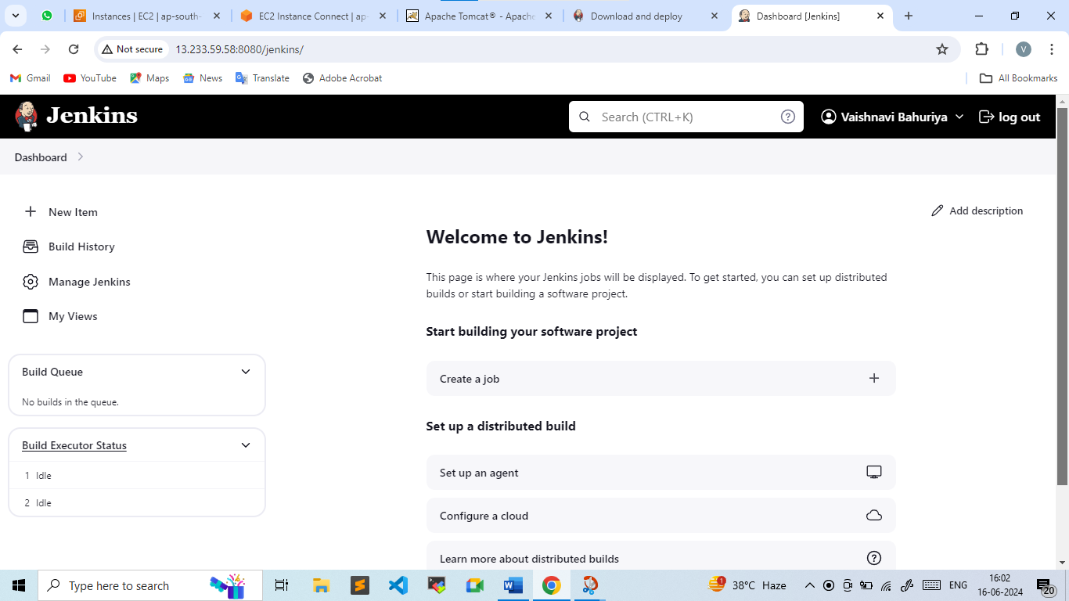

**Step-9:**

1. Now Creating 3 Jobs for Master branch ,2024Q1 branch & 2024Q2 branch.
2. Cloning Git repo for respective branch by providing Git Url
3. But before that we will be installing git in our machine

Yum install git -y

1. **Creating Job for Master branch**

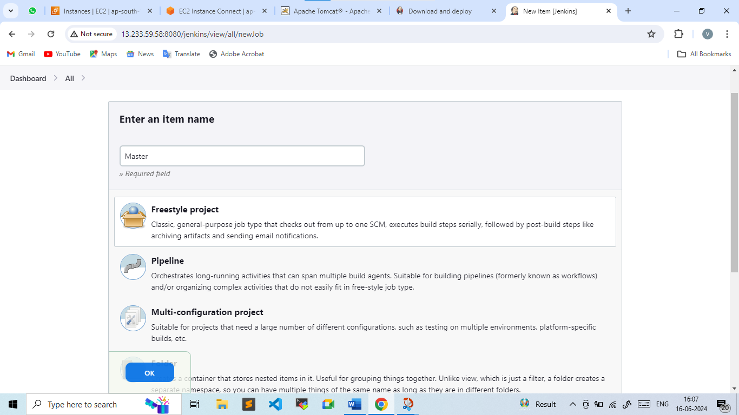

* **Added Custom Workspace**
* **Git Repository URL**

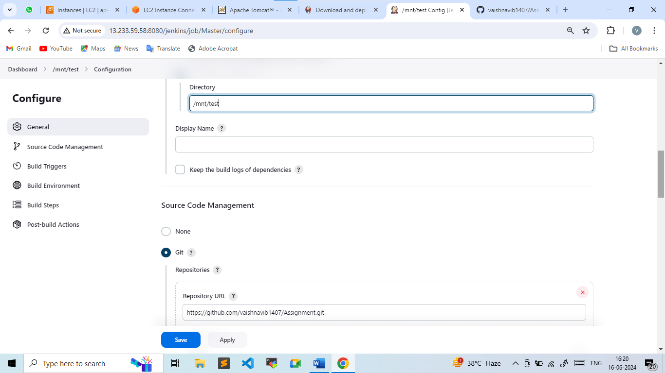

* **Added Script to Execute shell**

yum install httpd -y

service httpd start

cp -r /mnt/test/index.html /var/www/html

chmod -R 777 /var/www/html/index.html

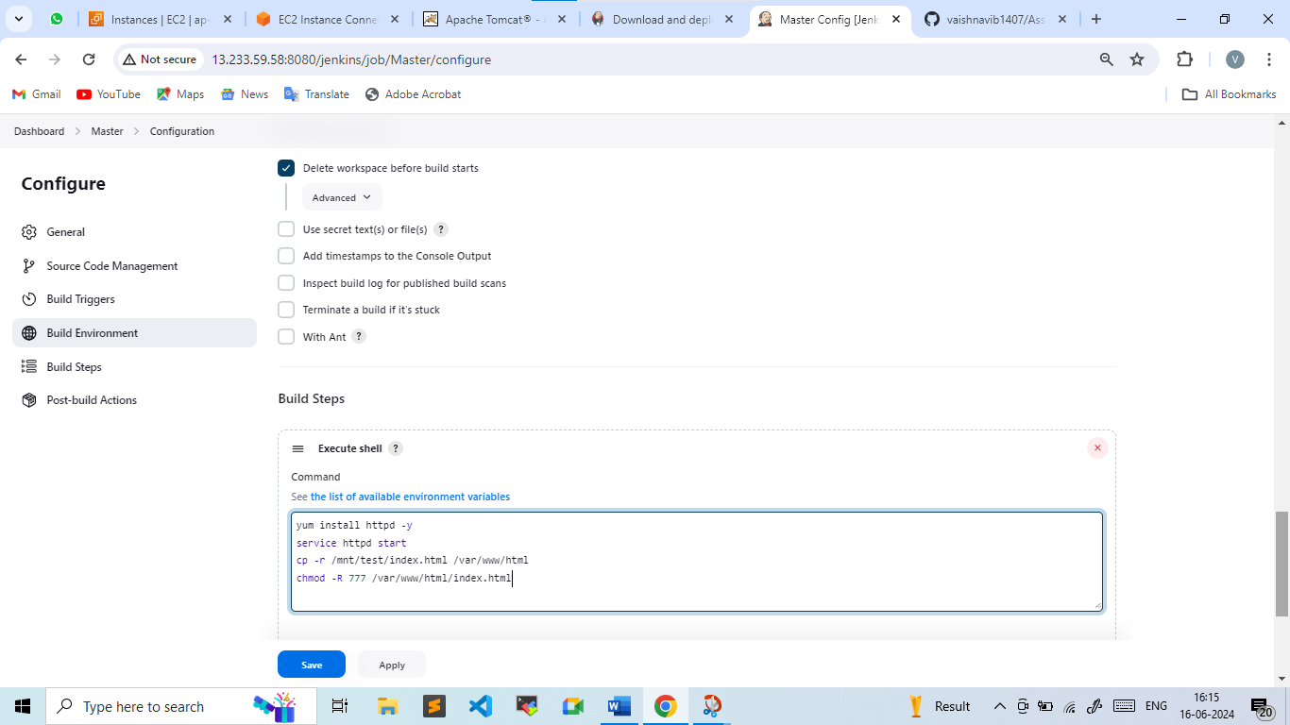

* **Apply & Save**
* **Doing same procedure to create Job for 2024Q1 & 2024Q2 branch**

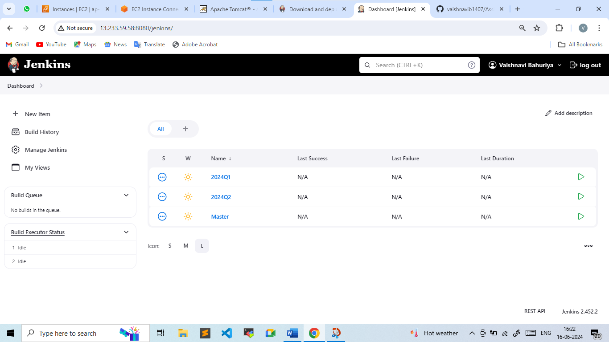

1. **Now whenever job will be build of any respective branch then that branch index.html file will be deploy**
2. **I did build Now for Master Job**

Here the job got executed and master branch index.html file is deployed

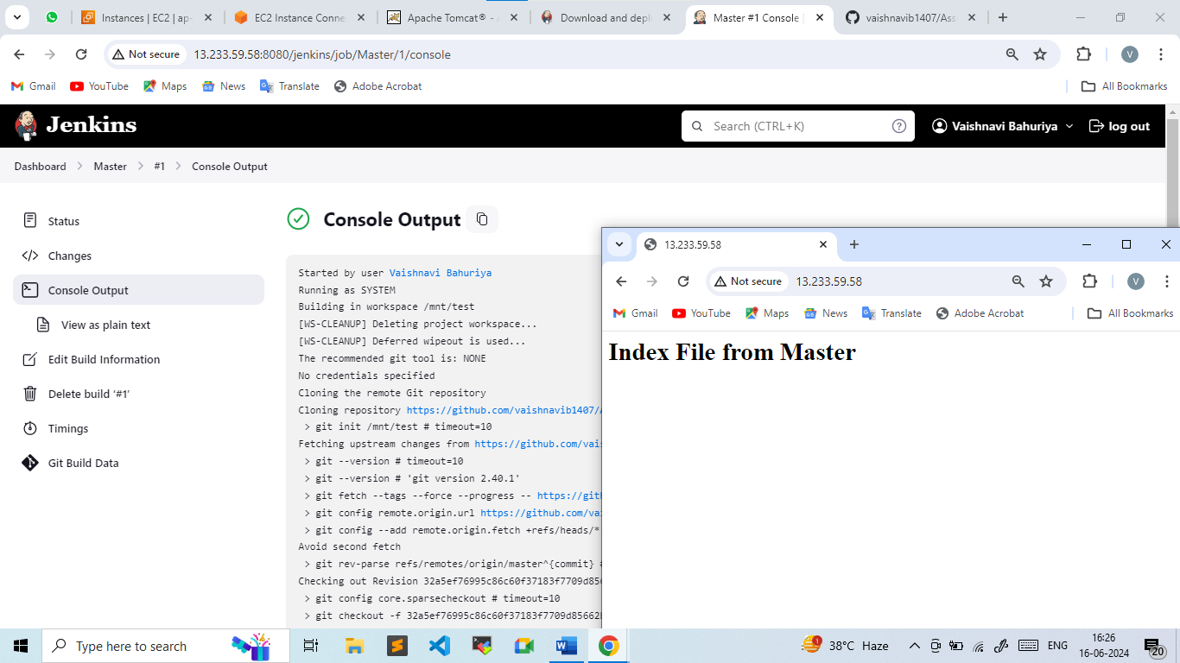

1. **For 2024-Q1 branch**

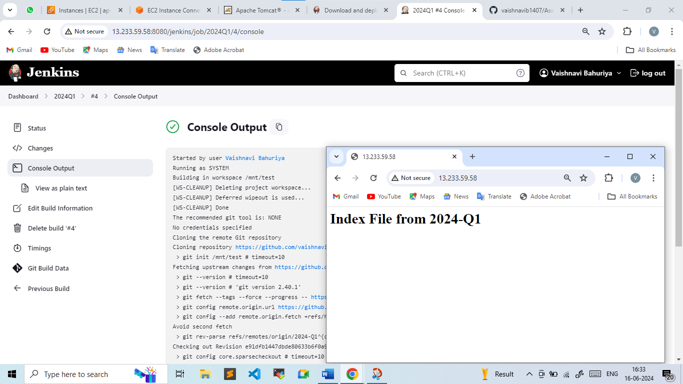

1. **For 2024-Q2 branch**

