**Assignment No.2**

In this scenario, we will be launching an ec2 instance naming Jenkin Master with certain configuration like installation of java, downloading configuring maven in it.

After that we want the war file which is in Jenkins master to deploy on other two machine in which only tomcat is downloaded.

**Step-1 :Maven Installation & Configuration in Jenkins**:

Cd /mnt

mkdir build-tools

cd build-tools/

wget <https://dlcdn.apache.org/maven/maven-3/3.9.7/binaries/apache-maven-3.9.7-bin.zip>

unzip apache-maven-3.9.7-bin.zip

rm -rf apache-maven-3.9.7-bin.zip

chmod -R 777 apache-maven-3.9.7/

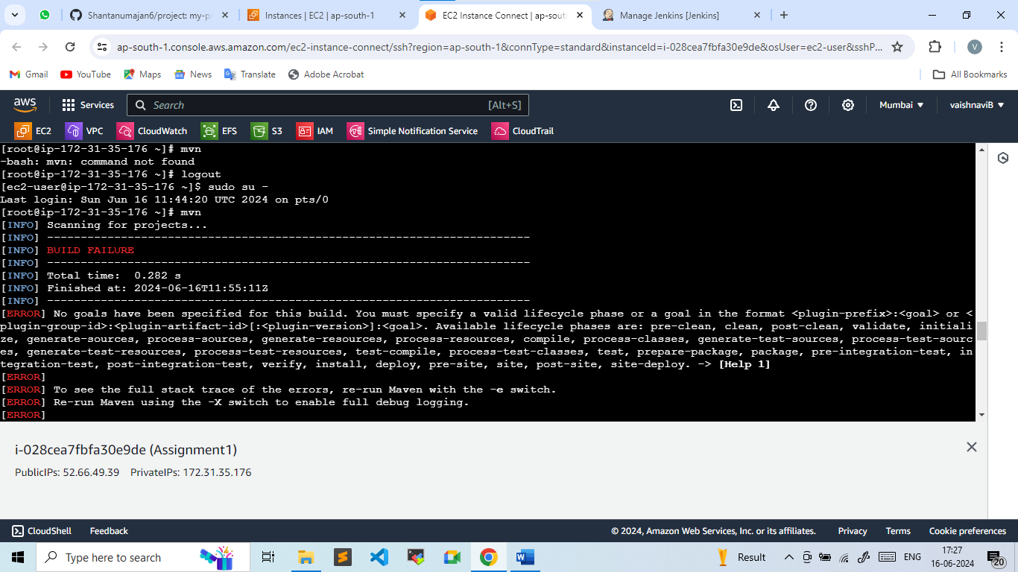

**Step-2: Creating Elastic File system**

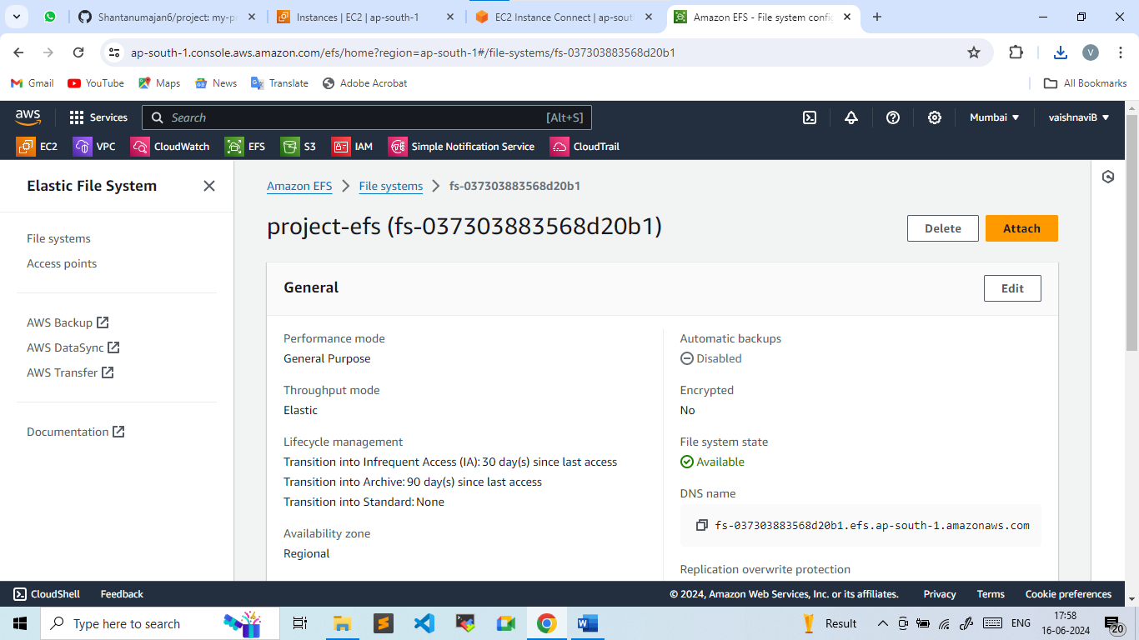

* **Mounting the efs on /mnt/servers directory**

sudo mount -t nfs4 -onfsvers=4.1,rsize=1048576,wsize=1048576,hard,timeo=600,retrans=2,noresvport 172.31.37.87:/ /mnt/server

**Step-3: Downloading apache tomcat**

Cd /mnt/servere

wget https://dlcdn.apache.org/tomcat/tomcat-9/v9.0.89/bin/apache-tomcat-9.0.89.zip

unzip apache-tomcat-9.0.89.zip

rm -rf apache-tomcat-9.0.89.zip

chmod -R 777 apache-tomcat-9.0.89.zip

cd apache-tomcat-9.0.89.zip

cd /bin

./startup.sh

Cd /webapp

Wget <https://get.jenkins.io/war-stable/2.452.2/jenkins.war>

**Step -4: Creating a Job**

Name : Project

Type : Freestyle

**Job Configuration:**

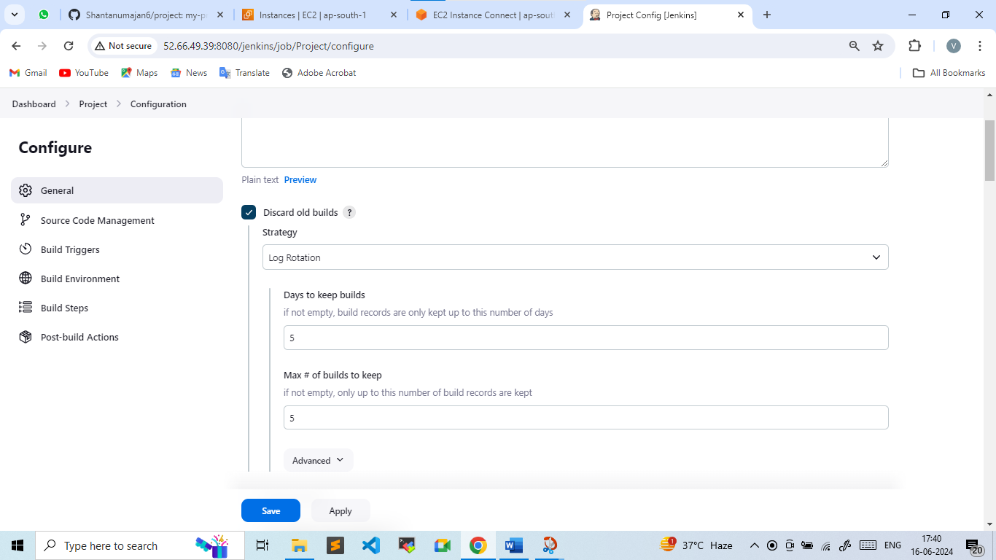

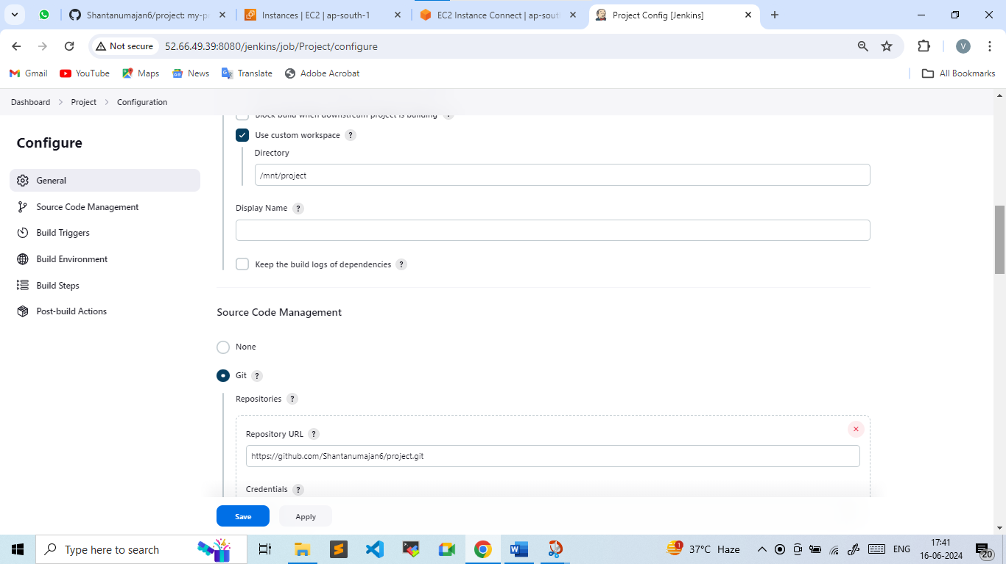

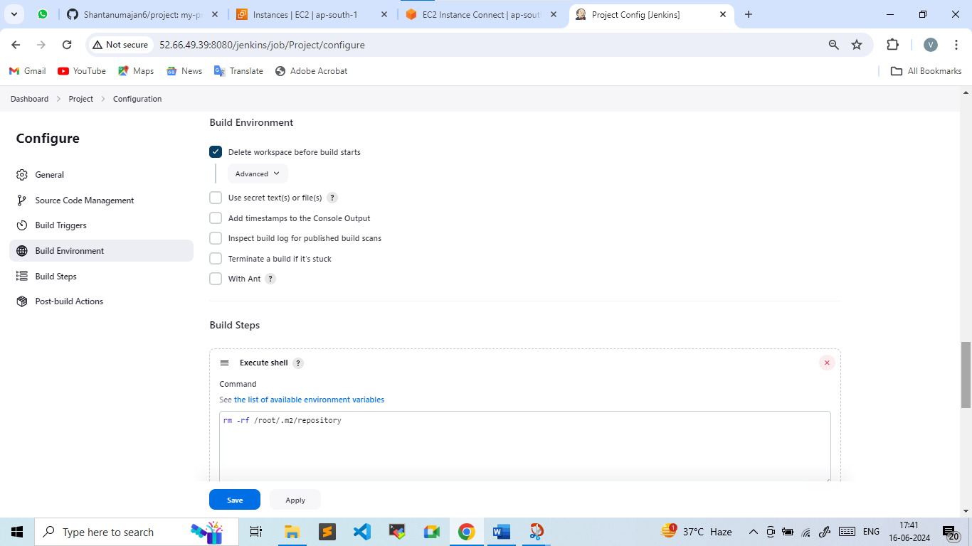

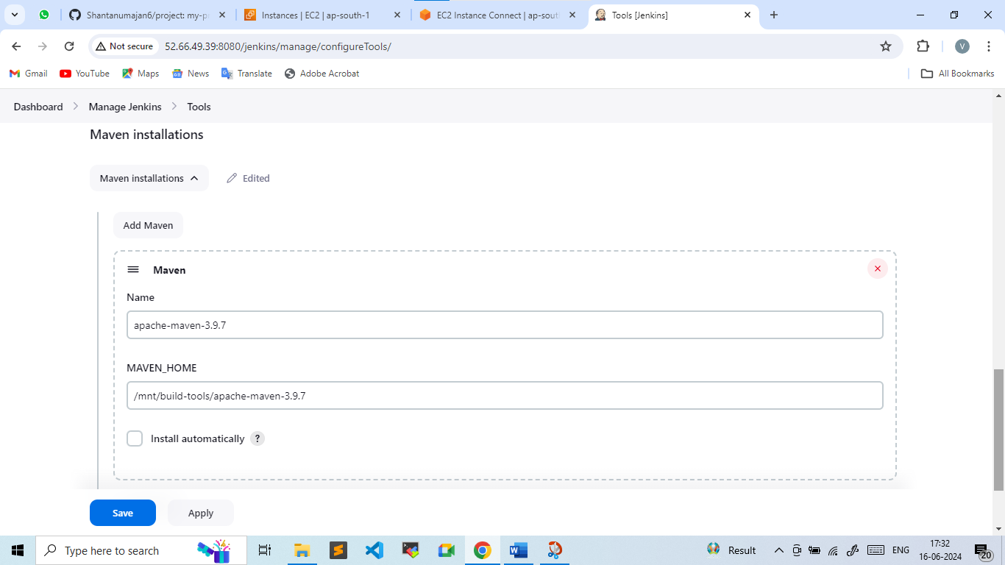

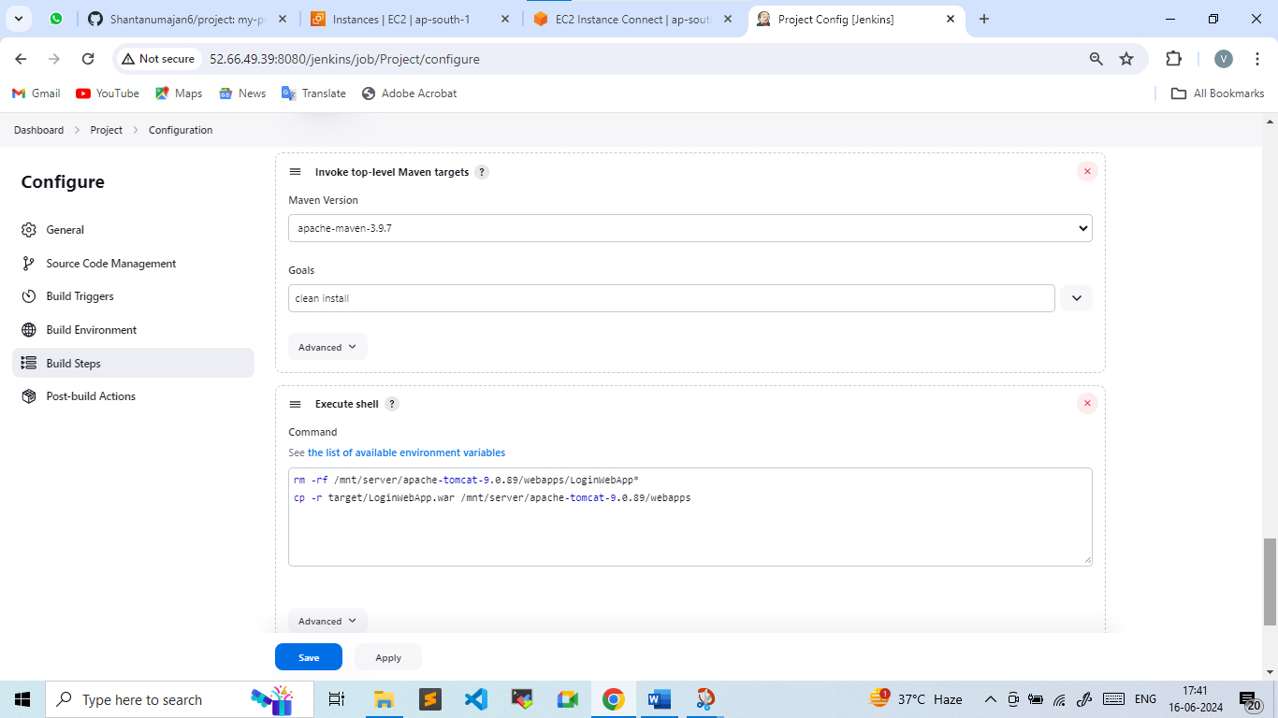

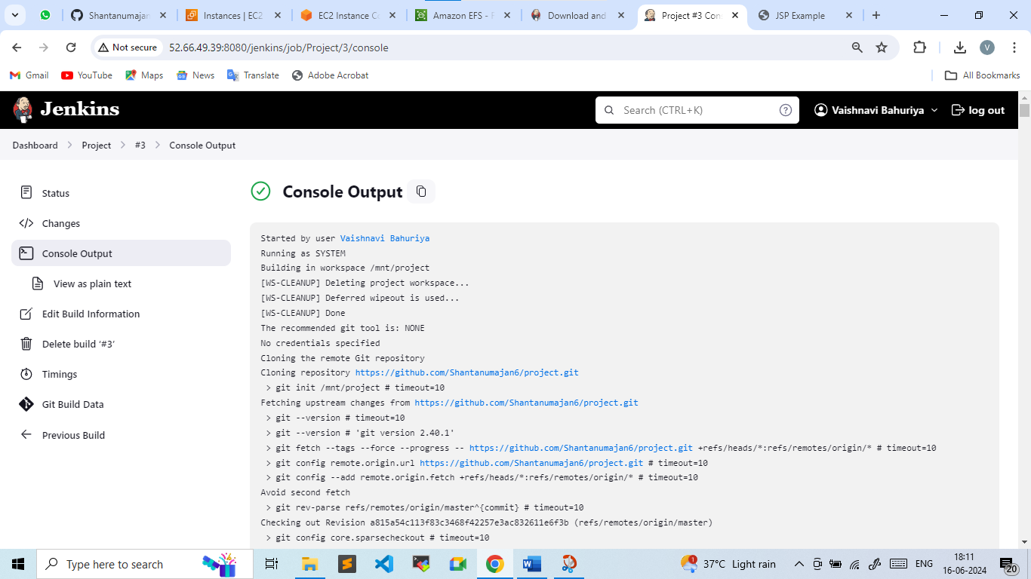

**Step-5: Launching two more machine and mounting efs on both the machine**

Install Java after launching in both the machine

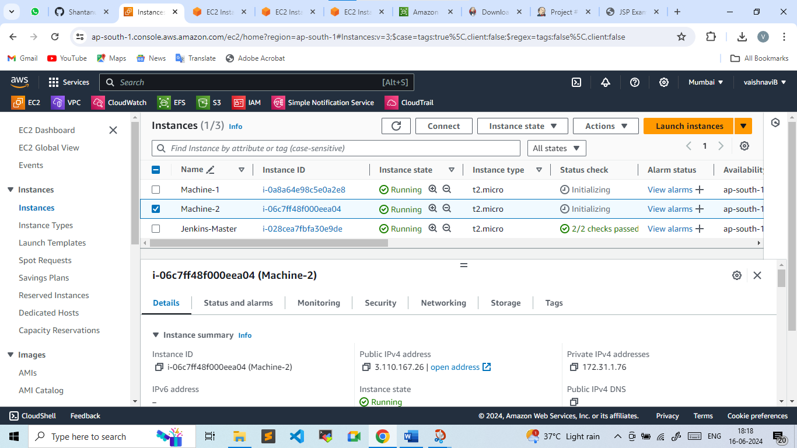

**Mounted Efs on machine-1 /mnt/servers directory**

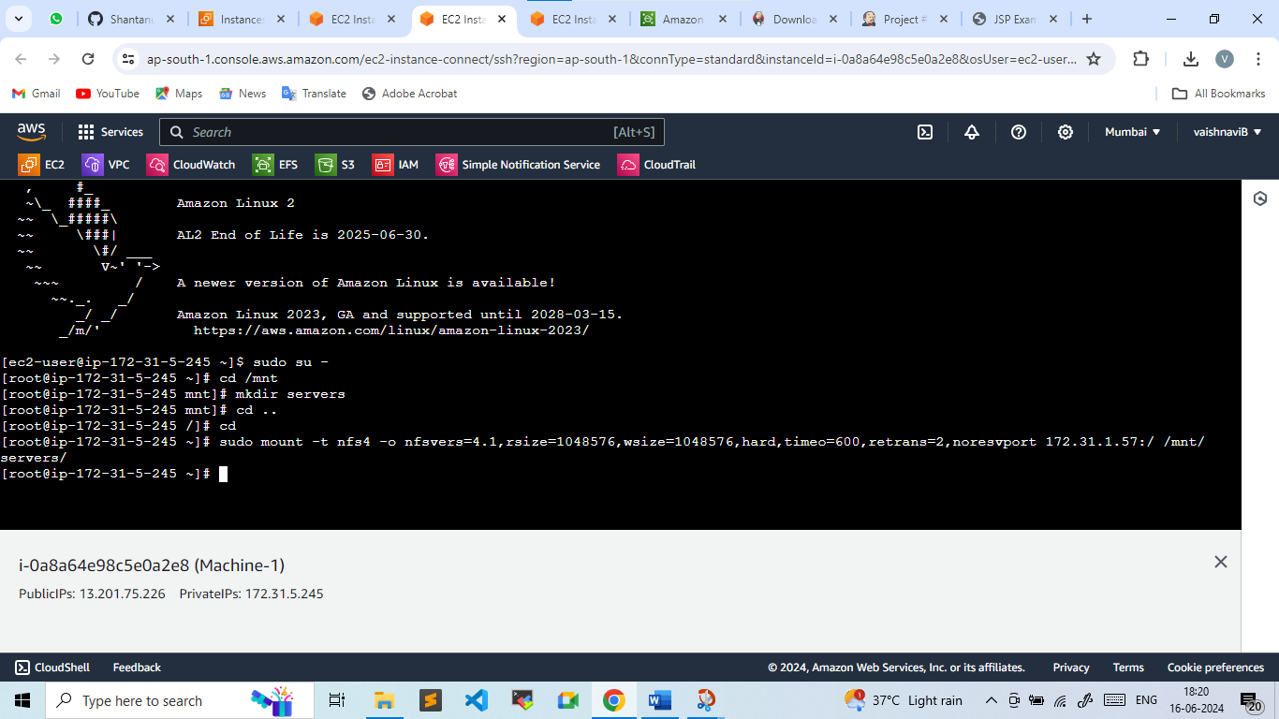

**Here we can see apache-tomcat**

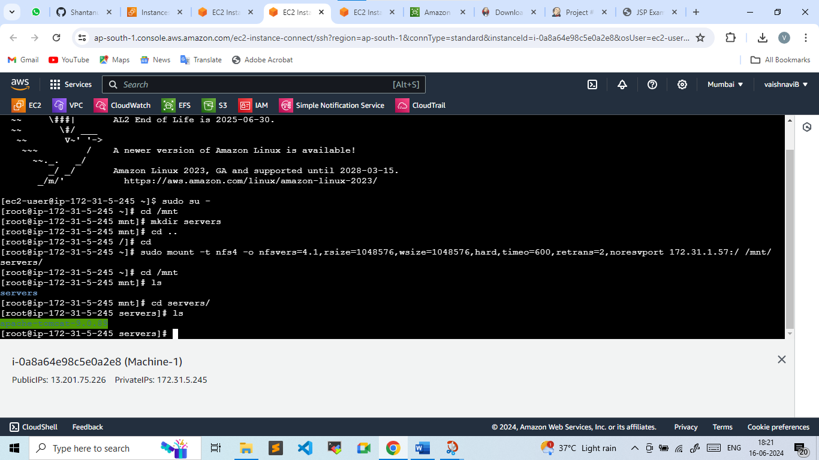

**Doing same in machine-2**

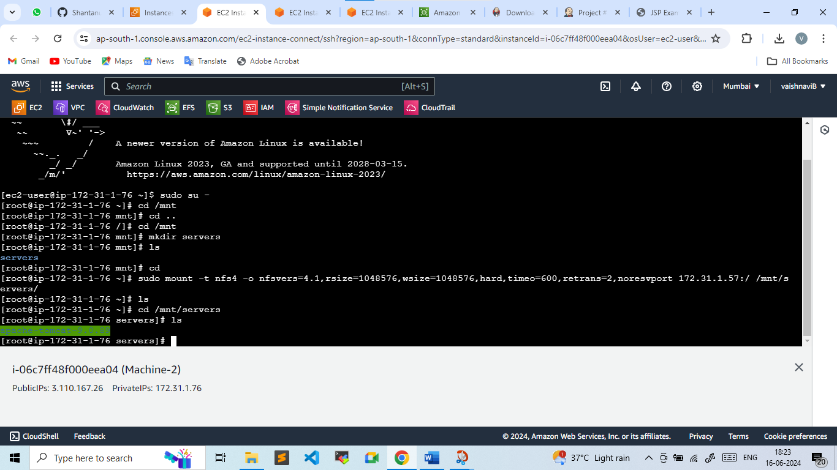

**Step-6: Build a job again and now with machine-1 & machine-2 we will access the website**

