**Docker**

**Assignment 1:** How can we share your image without uploading it to the registry

**Step-1: Launch an ec2 instance**

**Step-2: Install docker**

* yum install docker -y
* systemctl start docker

**Step-3: Download an image & create a container**

* docker run -itd ubuntu bash
* docker images
* docker ps

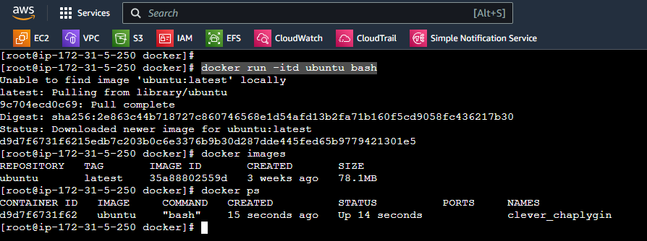

* docker rename clever_chaplygin test

**Step-4: Creating our own image**

* Login to container

docker exec -it test bash

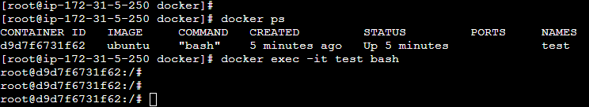

* Modifying the container by adding or installing packages
* apt-get update -y
* apt-get install apache2 vim -y
* vi index.html

Creating our own image: docker commit test vaishnavib14/velocity:1.0

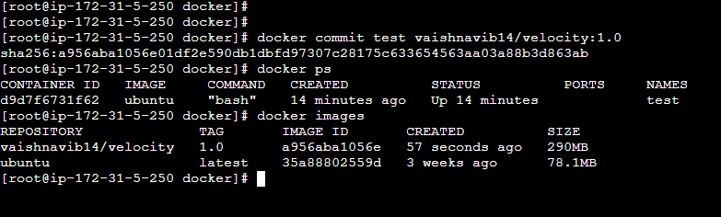

**Step-5: Creating tar of an image**

docker save -o velocity.tar vaishnavib14/velocity:1.0

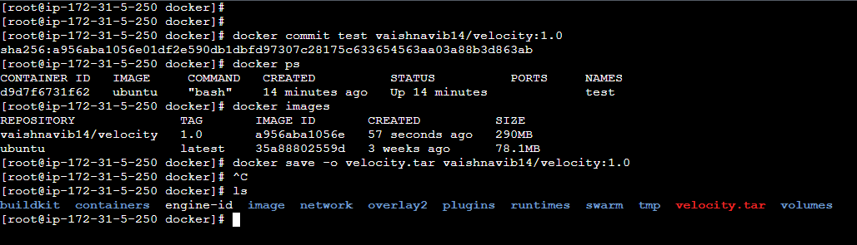

**Step-6:** Creating linux-kp.pem file

* vi linux-kp.pem
* chmod -R 400 linux-kp.pem

**Step-7: Launching another machine so that we can copy the image tar file here**

* yum install docker -y
* systemctl start docker
* chmod -R 777 /var/lib/docker

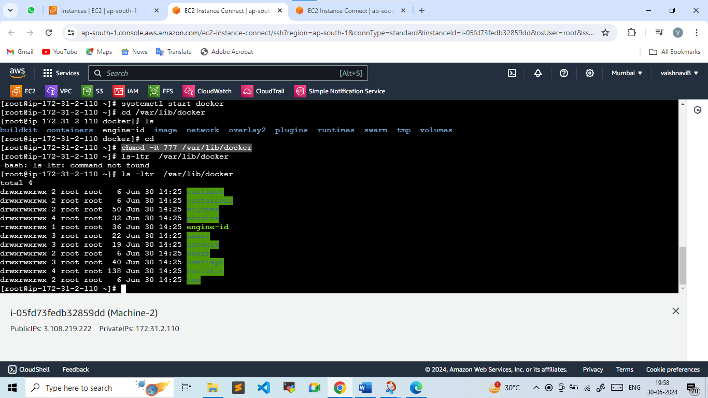

* scp -i linux-kp.pem velocity.tar [ec2-user@ec2-3-108-219-222.ap-south-1.compute.amazonaws.com:/var/lib/docker/image](mailto:ec2-user@ec2-3-108-219-222.ap-south-1.compute.amazonaws.com:/var/lib/docker/image)

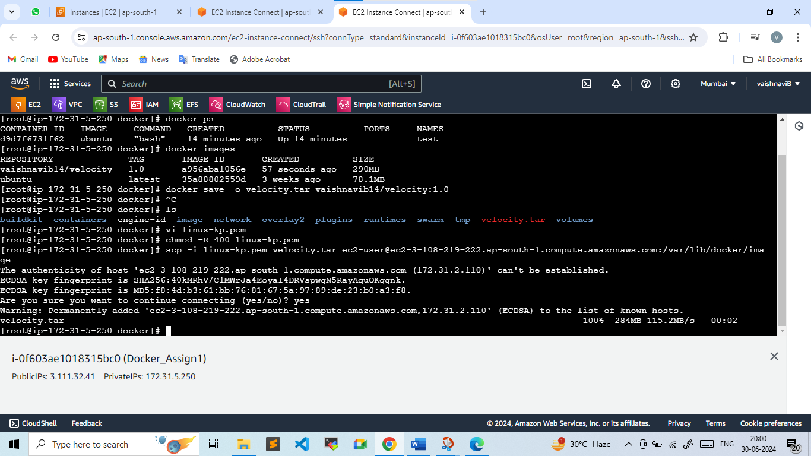

Machine-2: cd /var/lib/docker/image

