**Docker**

**Assignment No. 2: Deploying a war file in a tomcat container using Dockerfile**

Step.1: Launch an ec2 instance

Step.2: Install Docker

* Yum install docker -y
* Systemctl start docker
* Vi Dockerfile

FROM ubuntu

WORKDIR /mnt

RUN apt-get update && apt-get install openjdk-11-jdk maven wget git unzip -y

EXPOSE 8080

RUN git clone https://github.com/Shantanumajan6/project.git

RUN wget https://dlcdn.apache.org/tomcat/tomcat-9/v9.0.90/bin/apache-tomcat-9.0.90.zip

RUN unzip apache-tomcat-9.0.90.zip

RUN chmod -R 777 apache-tomcat-9.0.90

WORKDIR /mnt/project

RUN mvn clean install

RUN cp -r /mnt/project/target/LoginWebApp.war /mnt/apache-tomcat-9.0.90/webapps/

WORKDIR /mnt/apache-tomcat-9.0.90/bin

RUN chmod -R 777 startup.sh

RUN ./startup.sh

* docker build -t myassign:1.0 /root
* docker images
* docker run -itdp 8080:8080 --name test myassign:1.0
* docker ps -a

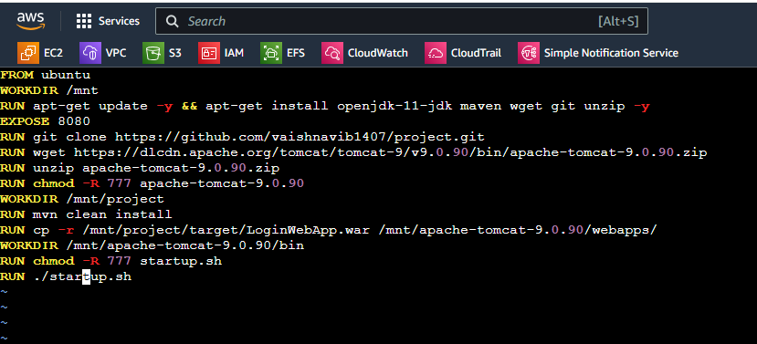

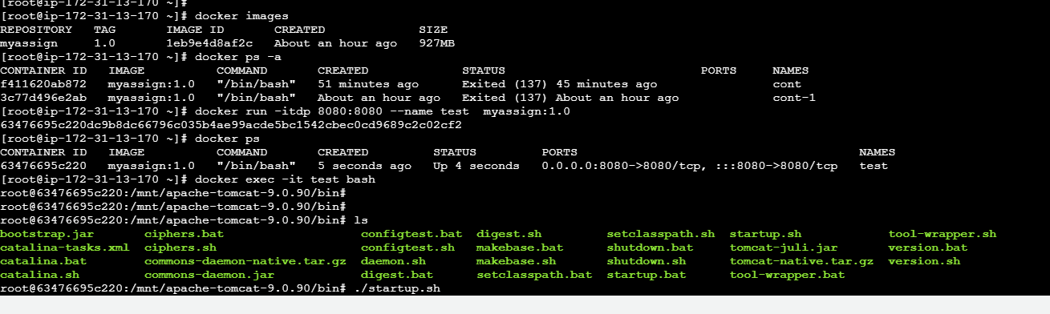

* docker exec -it test bash
* ./startup.sh
* Access the url 43.204.114.103:8080/LoginWebApp/

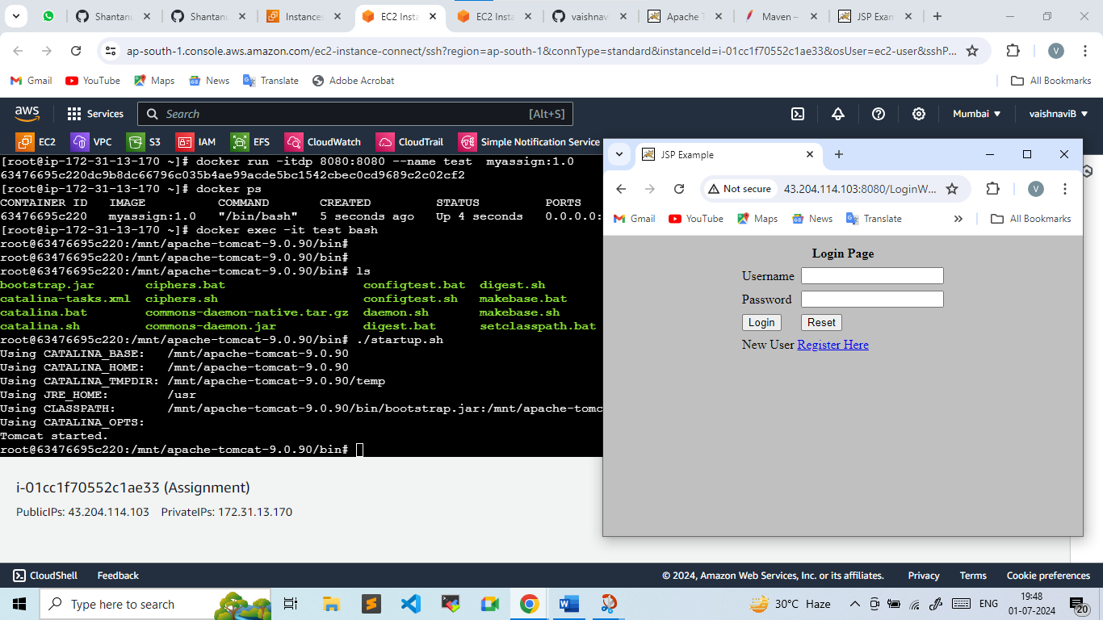

**Another way to do this Practical**

Step.1: Launch ec2 instance

Step.2: Install java ,maven configuration and copy the war file where dockerfile is present

Step.3: vi Dockerfile

FROM ubuntu

WORKDIR /mnt

RUN apt-get update && apt-get install openjdk-11-jdk wget unzip -y

EXPOSE 8080

RUN wget https://dlcdn.apache.org/tomcat/tomcat-9/v9.0.90/bin/apache-tomcat-9.0.90.zip

RUN unzip apache-tomcat-9.0.90.zip

RUN chmod -R 777 apache-tomcat-9.0.90

WORKDIR /mnt/apache-tomcat-9.0.90/bin

RUN chmod -R 777 startup.sh

RUN ./startup.sh

COPY LoginWebApp.war /mnt/apache-tomcat-9.0.90/webapps

~ 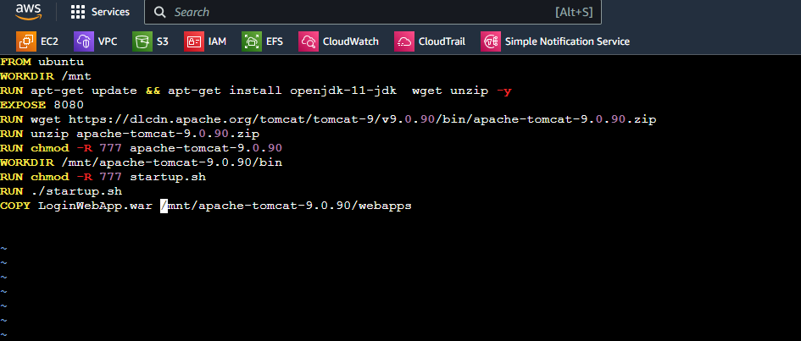

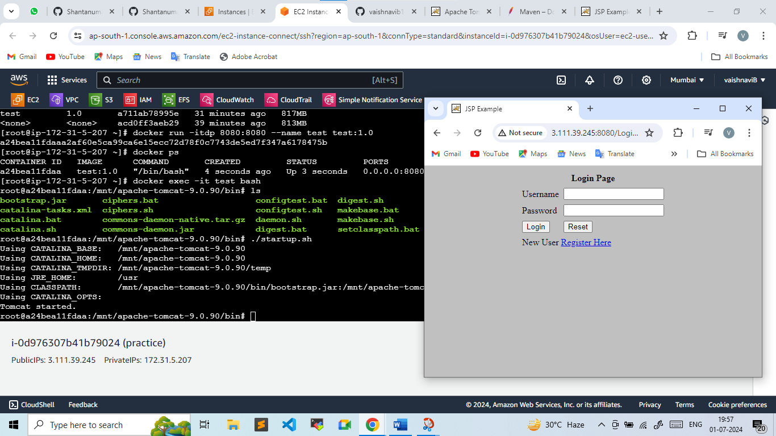

**Doing the same practical with the help of Jenkins**

* Vi Dockerfile

FROM ubuntu

WORKDIR /mnt

RUN apt-get update && apt-get install openjdk-11-jdk maven wget git unzip -y

EXPOSE 8080

RUN wget https://dlcdn.apache.org/tomcat/tomcat-9/v9.0.90/bin/apache-tomcat-9.0.90.zip

RUN unzip apache-tomcat-9.0.90.zip

RUN chmod -R 777 apache-tomcat-9.0.90

WORKDIR /mnt/apache-tomcat-9.0.90/webapps/

RUN wget https://get.jenkins.io/war-stable/2.452.2/jenkins.war

WORKDIR /mnt/apache-tomcat-9.0.90/bin

RUN chmod -R 777 startup.sh

RUN ./startup.sh

* docker build -t myassign:1.0 /root
* docker images
* docker run -itdp 8080:8080 --name test myassign:1.0
* docker ps -a
* docker exec -it test bash
* ./startup.sh

Now access the Jenkins dashboard

Publicip:8080/Jenkins

Here you will be getting the secrets directory in the same location .jenkins inside the container

* Creating a pipeline job in Jenkins

pipeline {

agent any

stages {

stage ("git") {

steps {

dir ("/mnt") {

git "https://github.com/Shantanumajan6/project.git"

}

}

}

stage ("Build") {

steps {

dir ("/mnt/project/") {

sh "mvn clean install"

}

}

}

stage ("Deploy") {

steps {

sh "cp -r /mnt/project/target/LoginWebApp.war /mnt/apache-tomcat-9.0.90/webapps/"

}

}

}

}