**RDS Assignment -1**

**Deploying war file in tomcat container**

Step-1: Creating RDS db.instance

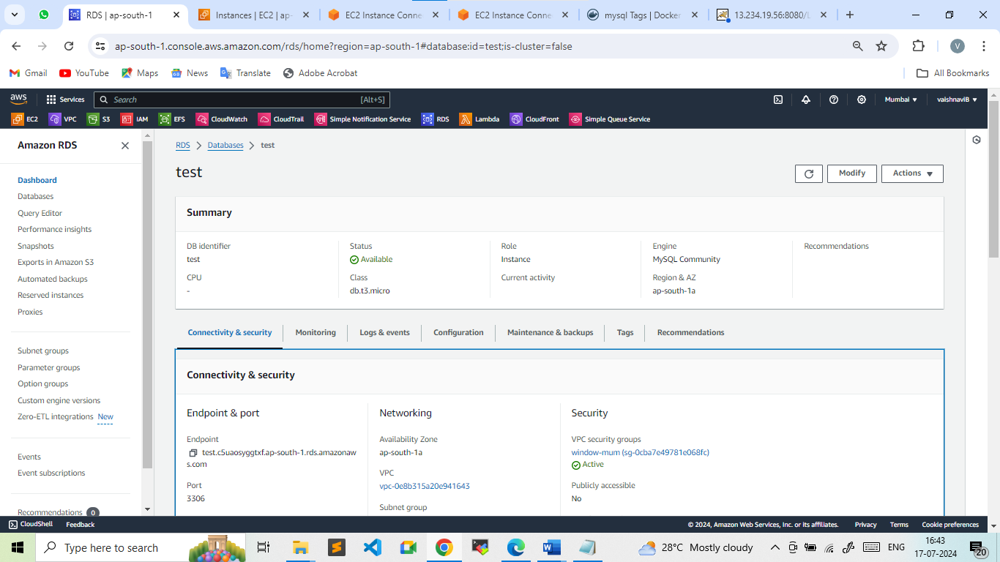

Step-2: Launch ec2 instance

* Installed Java, git, docker, and Maven with maven to build the war file.

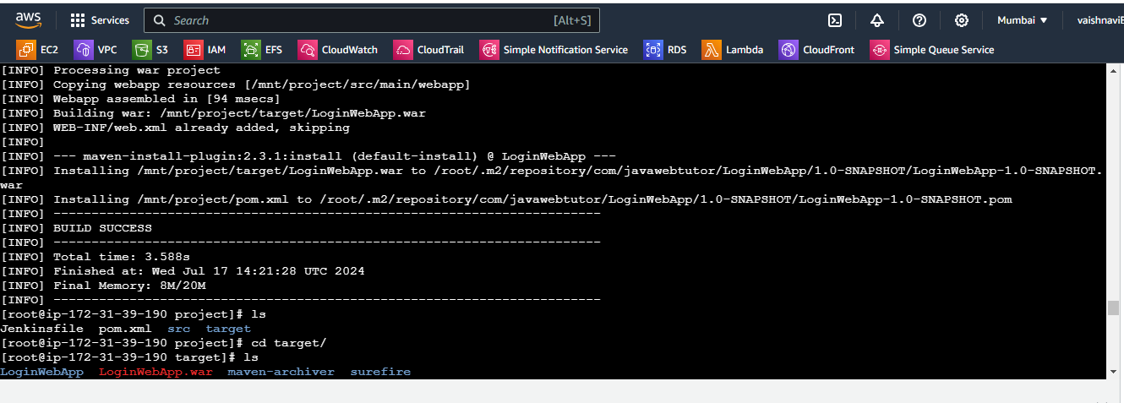

* Created tomcat container

docker run -itd --name cont-1 -p 8080:8080 -v /mnt/project/target/:/usr/local/tomcat/webapps/ tomcat:9

(Here we bind the /mnt/project/target **to** /usr/local/tomcat/webapps/)

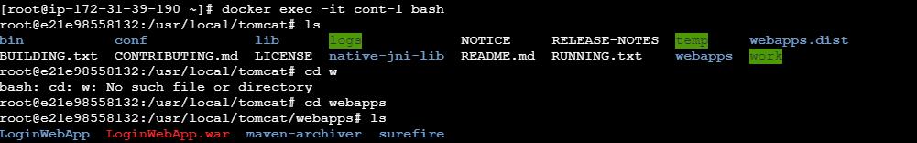

* Login to tomcat container
* docker exec -it cont-1 bash
* cd bin/
* ./shutdown.sh
* cd webapps/
* rm -rf LoginWebApp.war
* cd LoginWebApp
* vi userRegistration.jsp

Connection con = DriverManager.getConnection("jdbc:mysql://vaishnavi.c5uaosyggtxf.ap-south-1.rds.amazonaws.com:3306/test",

"admin", "vgb140795");

Step-3: Login to Mysql and creating database

* mysql -h vaishnavi.c5uaosyggtxf.ap-south-1.rds.amazonaws.com -u admin -p
* create database test;
* show databases;
* use test;

CREATE TABLE USER (

-> id int(10) unsigned NOT NULL auto_increment,

-> first_name varchar(45) NOT NULL,

-> last_name varchar(45) NOT NULL,

-> email varchar(45) NOT NULL,

-> username varchar(45) NOT NULL,

-> password varchar(45) NOT NULL,

-> regdate date NOT NULL,

-> PRIMARY KEY (id)

-> ) ENGINE=InnoDB DEFAULT CHARSET=latin1;

Step-4: Heading back to tomcat container

* Start the tomcat server again
* Cd bin/
* ./startup.sh

