**RDS Assignment -2**

**Deploy war in docker container , instead of RDS use Mysql docker container**

(Manual Way)

Step-1: Launching ec2 instance and installing all the requirements

* yum install java-11-amazon-corretto.x86_64 -y
* yum install maven git docker -y
* cd /mnt
* git clone <https://github.com/Shantanumajan6/project.git>
* cd project/
* mvn clean install

Step-2: Creating Docker Network and creating tomcat container and Mysql container inside it

* systemctl docker start
* docker network create mynetwork
* docker network ls
* docker run -itd --name tomcat_cont --network mynetwork -p 8080:8080 -v /mnt/project/target/:/usr/local/tomcat/webapps/ tomcat:9
* docker network inspect mynetwork
* docker run --name sql --network mynetwork -e MYSQL_ROOT_PASSWORD=root -d mysql:latest

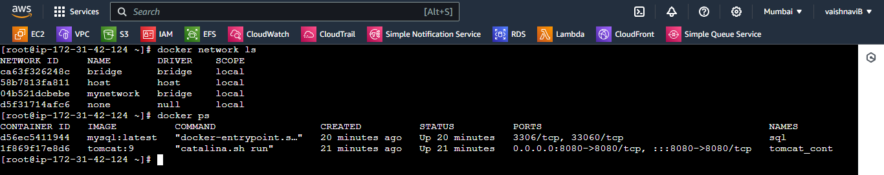

Step-3: Login to Mysql container and creating database inside it

* docker exec -it sql mysql -u root -p
* create database test;

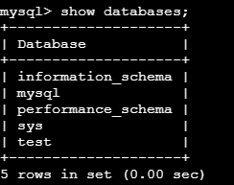

* use test;

CREATE TABLE USER (

id int(10) unsigned NOT NULL auto_increment,

first_name varchar(45) NOT NULL,

last_name varchar(45) NOT NULL,

email varchar(45) NOT NULL,

username varchar(45) NOT NULL,

password varchar(45) NOT NULL,

regdate date NOT NULL,

PRIMARY KEY (id)

) ENGINE=InnoDB DEFAULT CHARSET=latin1;

Step-4: Login to the tomcat container and made changes in userRegistration.jsp file for connection

* docker exec -it tomcat_cont bash
* cd webapps/
* cd LoginWebApp
* cat userRegistration.jsp

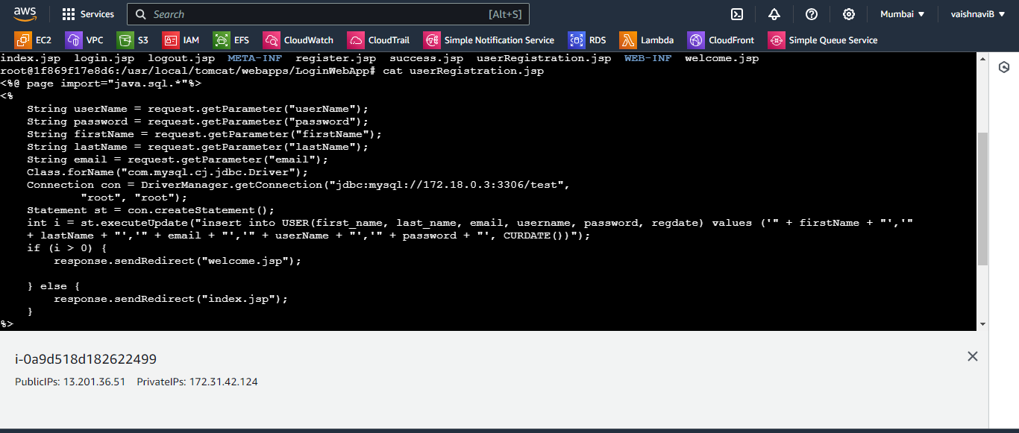

Connection con = DriverManager.getConnection("jdbc:mysql://172.18.0.3:3306/test",

"root", "root");

* To get the ip address
* docker network inspect mynetwork

(Here you can see the ip address of the sqlcontainer add that ip in LoginWebapp userRegistration )

* Access the application

<http://13.201.36.51:8080/LoginWebApp>

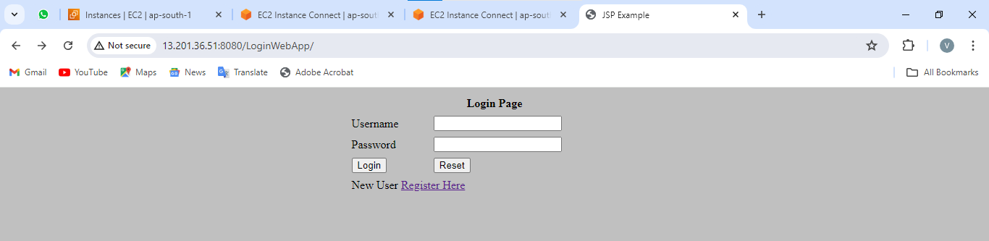

Add the details in registration form

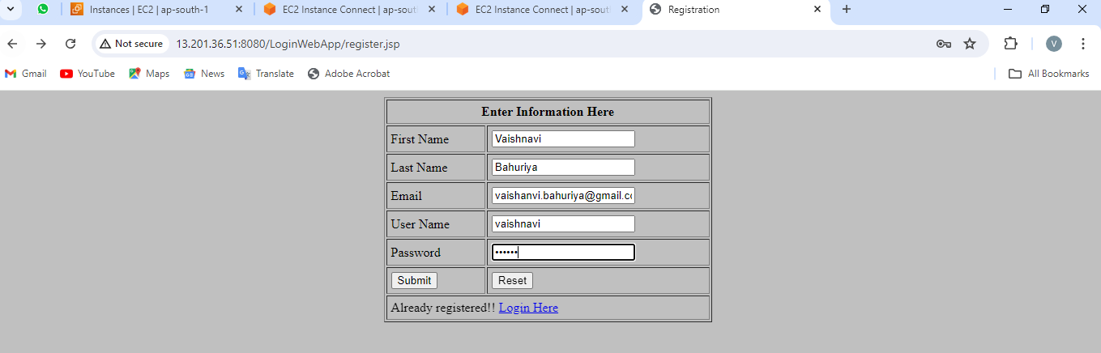

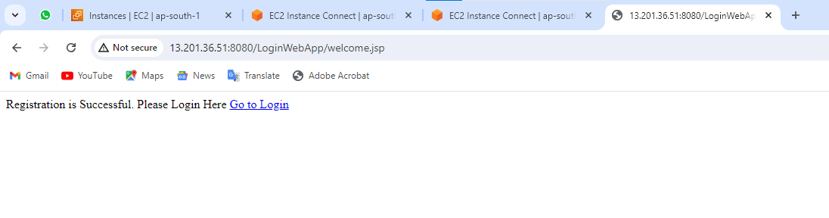

* Now check in Mysql container if the data is stored in database or not
* docker exec -it sql mysql -u root -p
* use test;
* select * from USER;

