As per your request we have designed Regression Algorithm to forecast water quality by using water Turbidty value. If Turbidity value < 1 then water quality will be consider as CLEAN and if more than 1 then water quality will be consider as DIRTY.

We have split dataset into TRAIN and TEST and regression algorithm get trained on 80% training data and then this trained model will be applied on 20% test data to forecast water quality

In below screen we are showing water quality forecasting using Turbidity

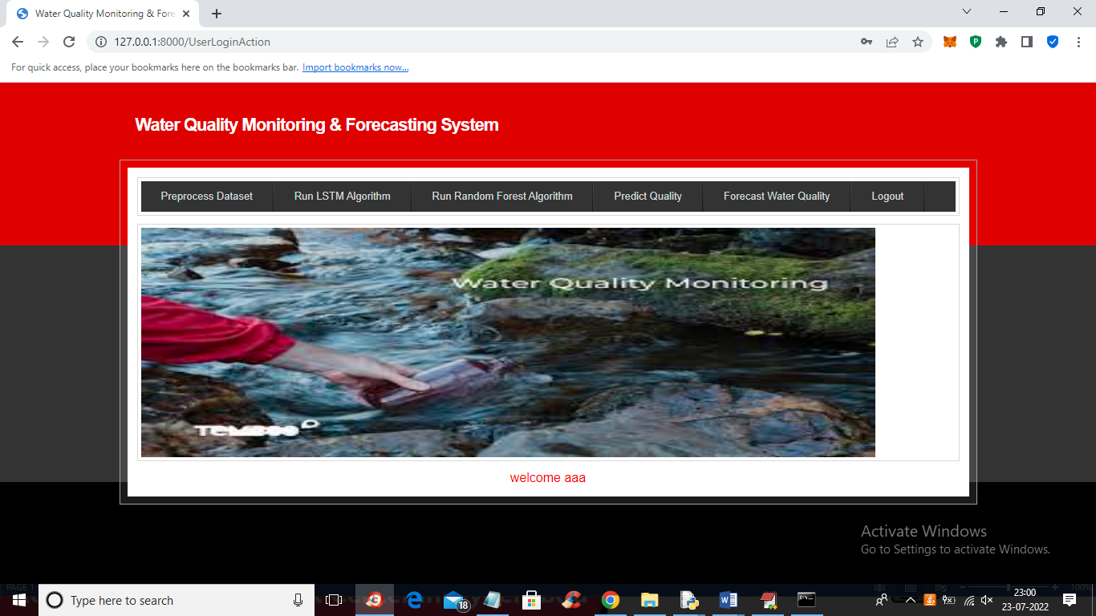

In above screen we have two links called ‘Predict Quality’ which will predict quality by using class label as 0 or 1 and now we have added another link called ‘Forecast Water Quality’ which will trained Regression algorithm using Turbidity and based on that value quality will be Forecast and now click on that link to get below output

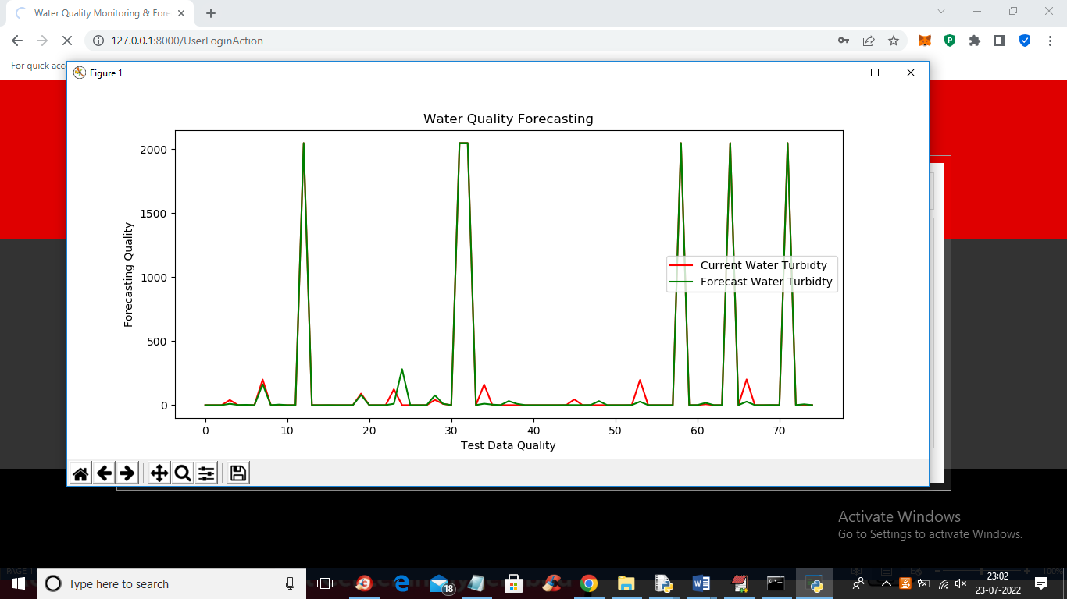

In above graph x-axis represents count of TEST data and y-axis represents Turbidity value and RED line represents ORIGINAL TEST DATA Turbidity and green line represents FORECASTED Turbidity value and we can see both lines are fully overlapping so prediction and test data values are accurate and now close above graph to view both TEST and predicted quality values

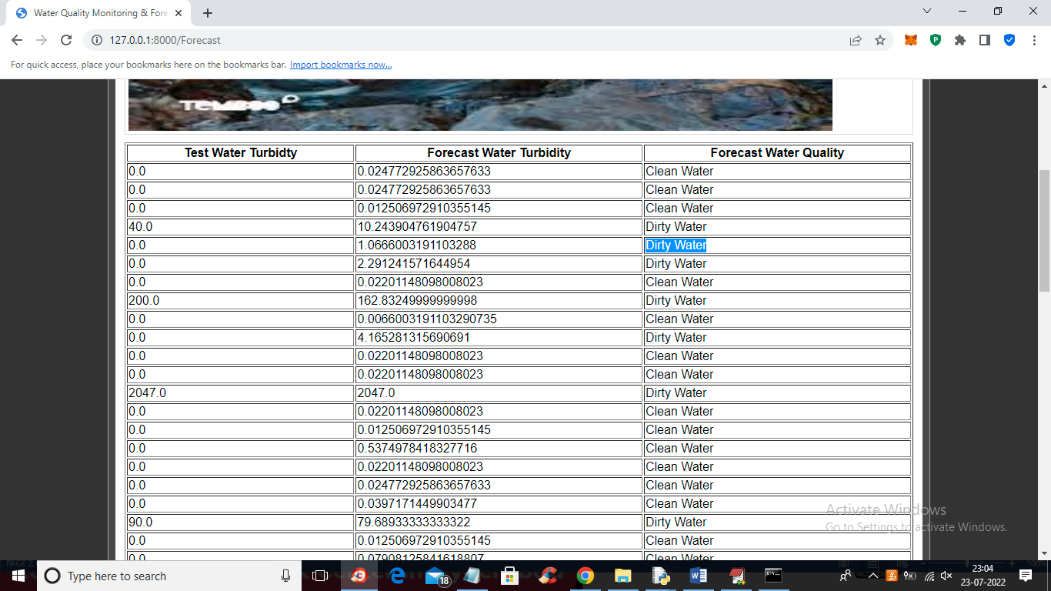

In above screen first column contains Test data Turbidity and second column contains Forecasted Turbidity and 3rd column contains water quality if forecasted Turbidity values > 1 then it will consider as DIRTY else clean. So by using regression model we have forecasted water quality based on Turbidity value