Software Engineering Tools Lab

Assignment No-1

(Module 1- Introduction to OSS)

PRN:2019BTECS00031

1. Weka is a GUI workbench that empowers data wranglers to assemble machine learning pipelines, train models, and run predictions without having to write code. Using Weka tool perform below tasks such as data preprocessing, data classification (use any appropriate ML algorithm) and data visualization efficiently on given dataset.

**PREPROCESSING**

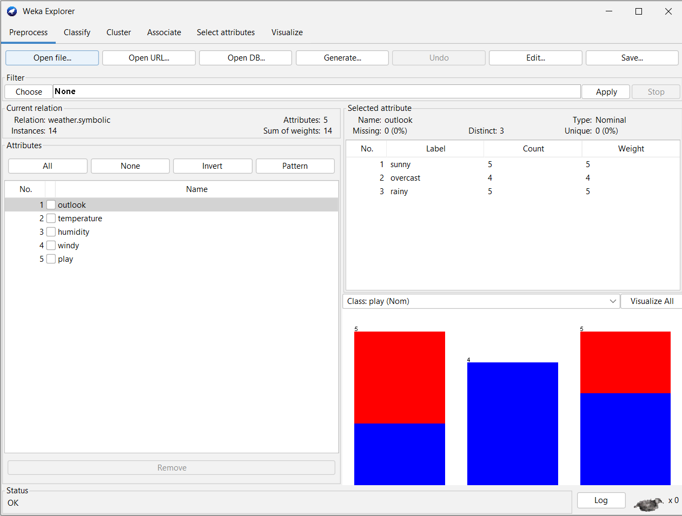

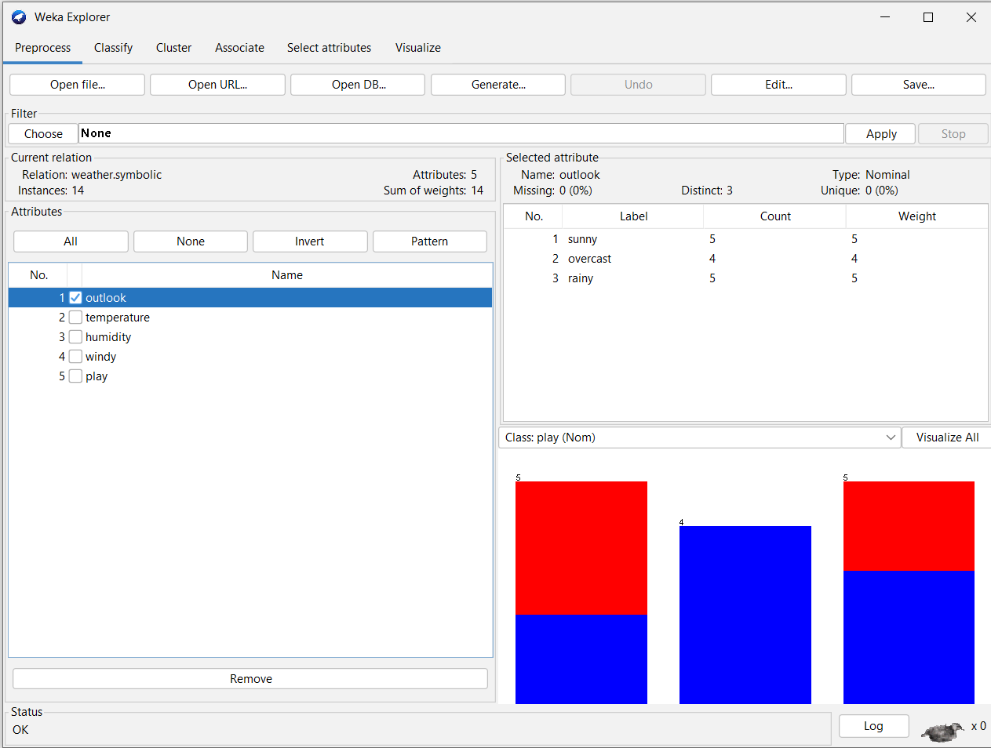

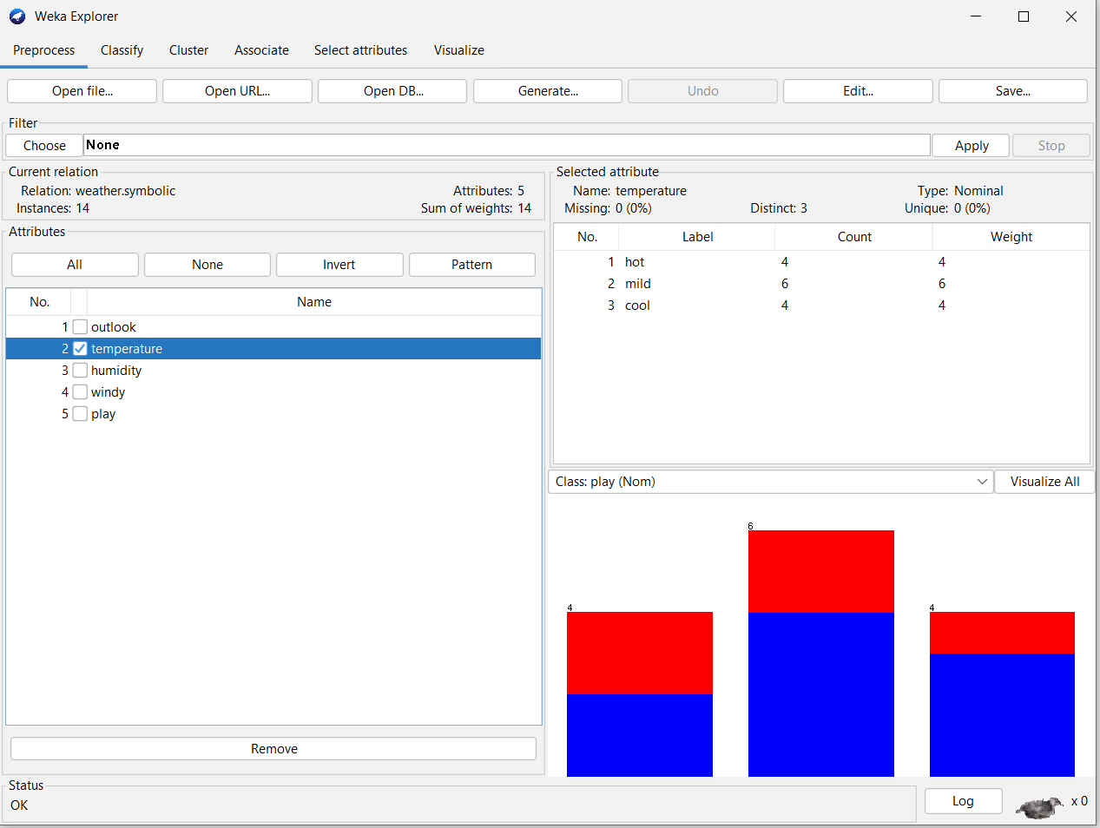

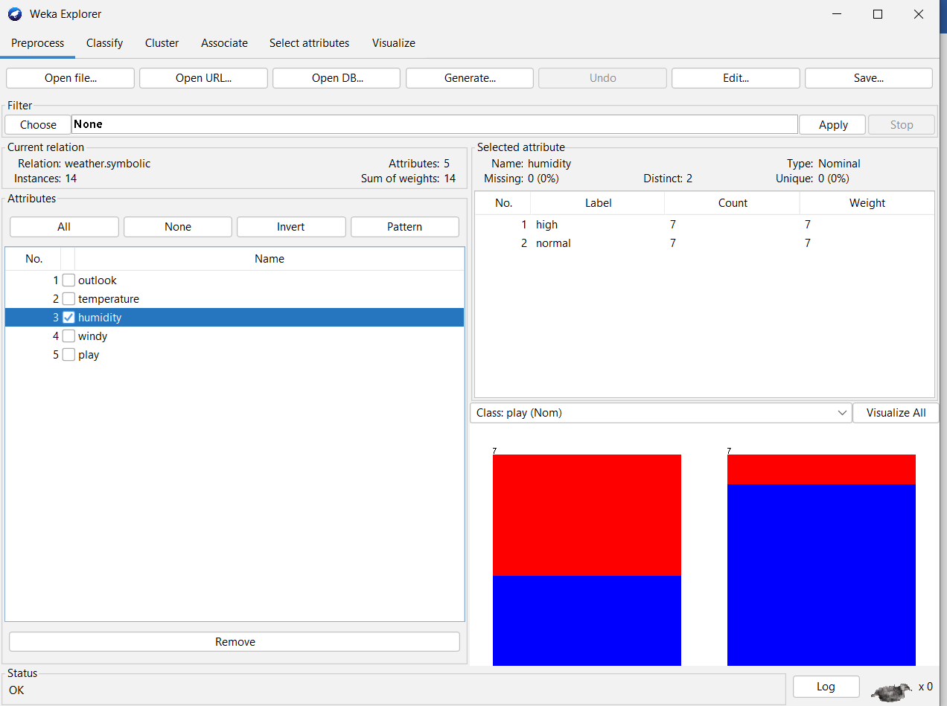

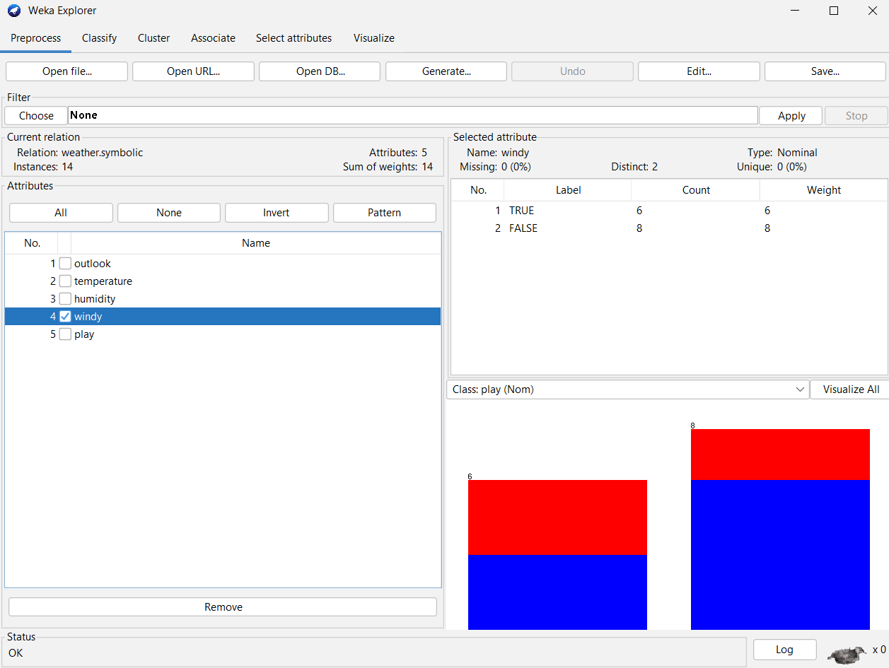

**CLASSIFICATION**

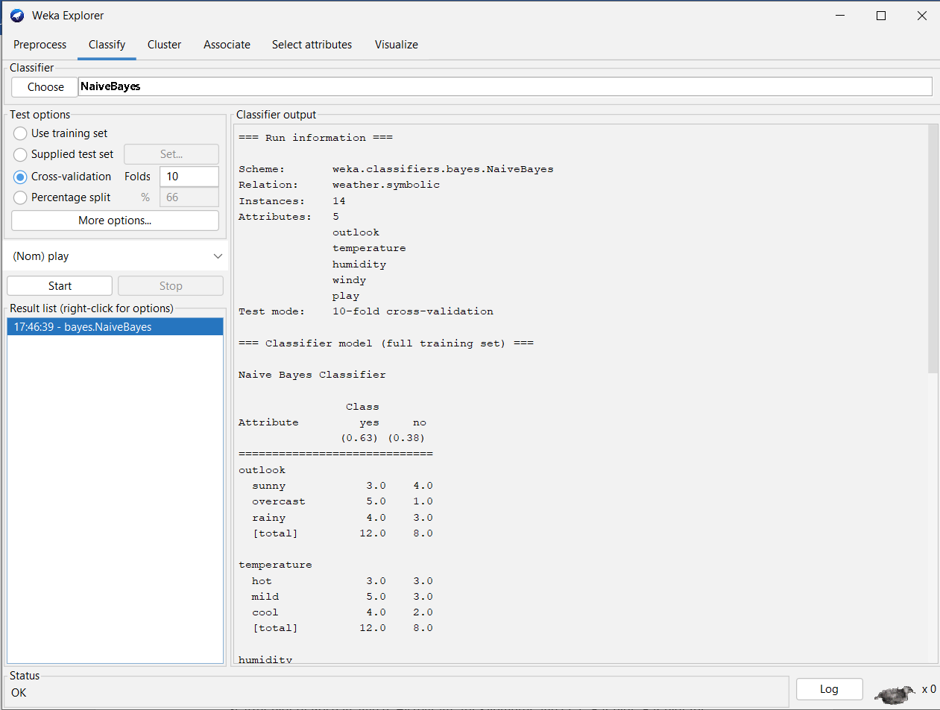

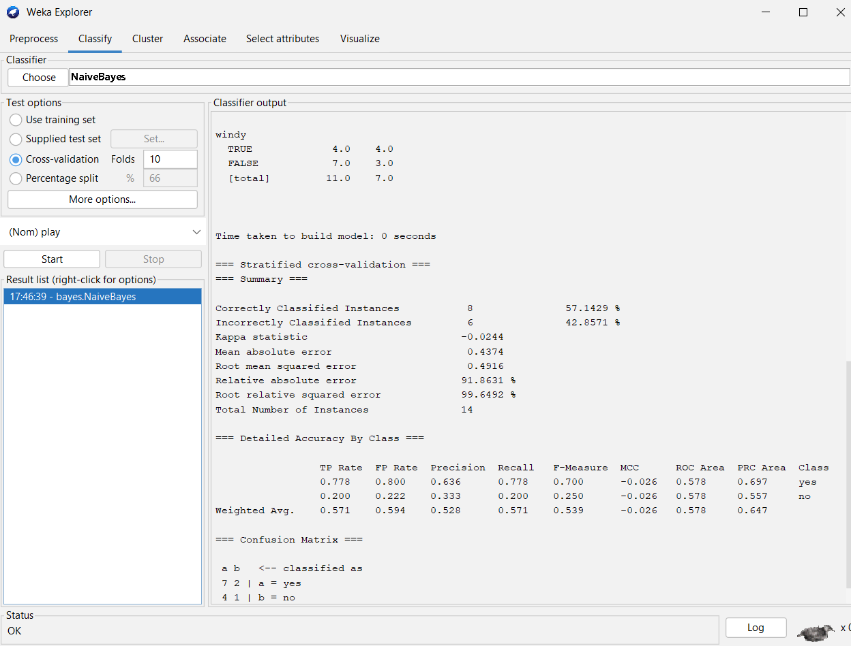

**DATA VISUALIZATION**

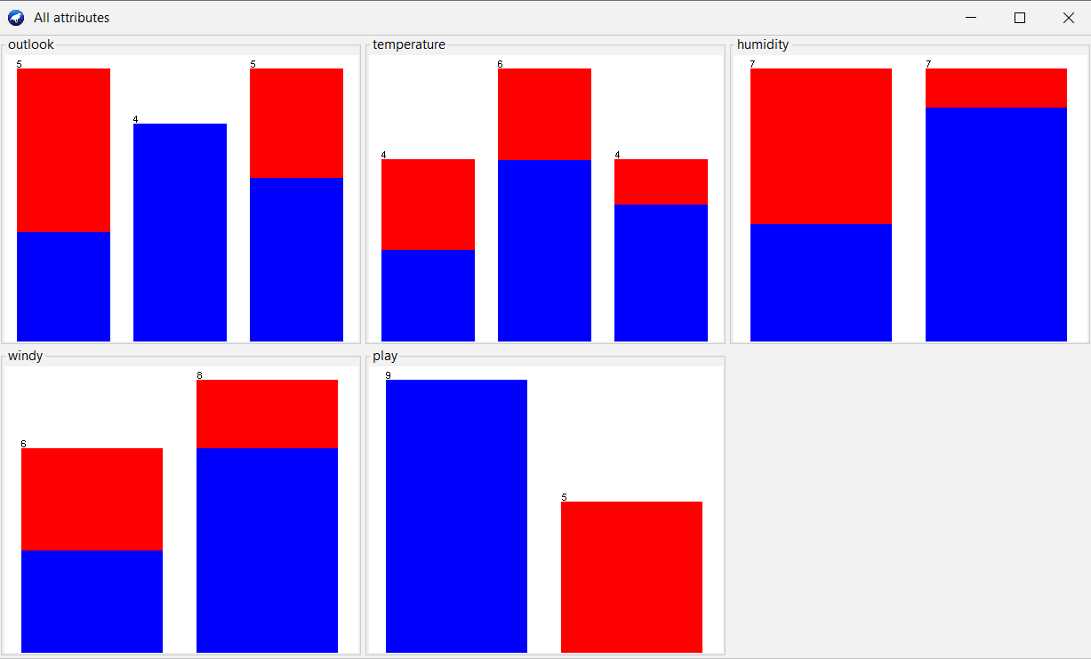

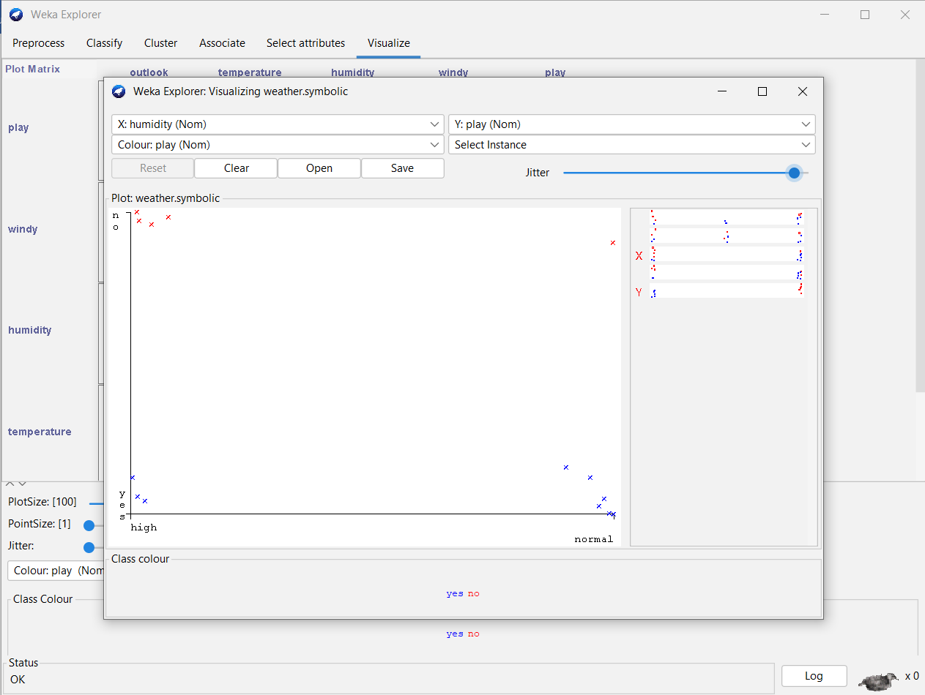

2. Orange is an easy to use data visualization tool with a large toolkit. In spite of being a GUI-based beginner-friendly tool, you mustn’t mistake it for a light-weight one. It can do statistical distributions and box plots as well as decision trees, hierarchical clustering and linear projections.

a. Install orange

b. Show data distribution

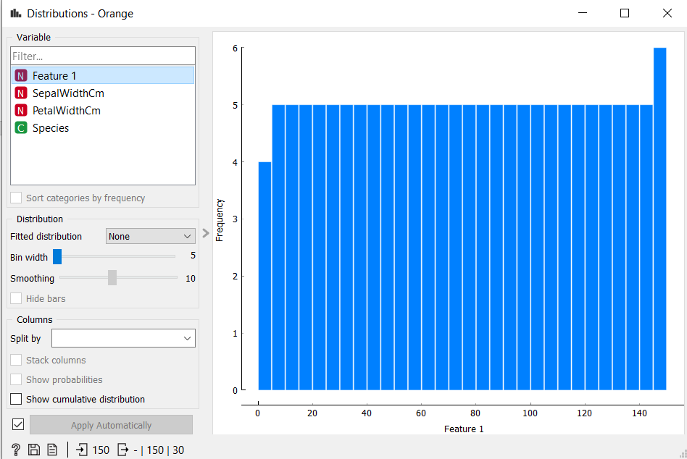

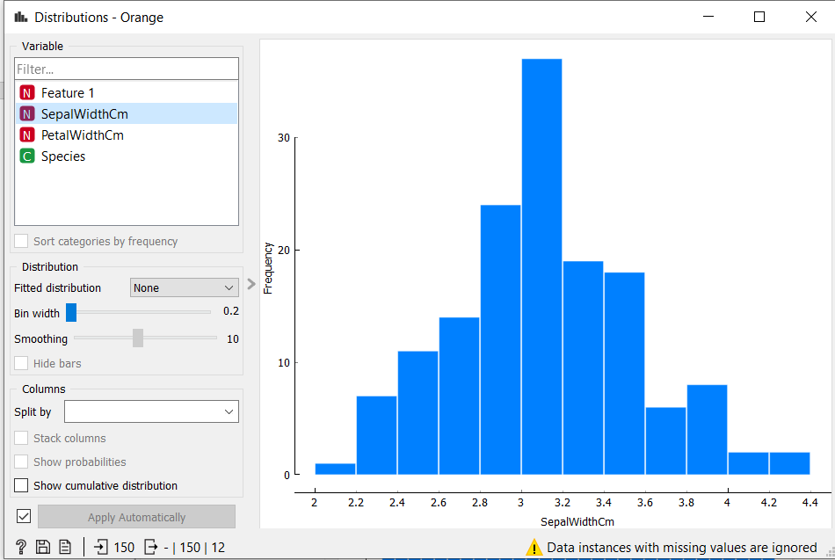

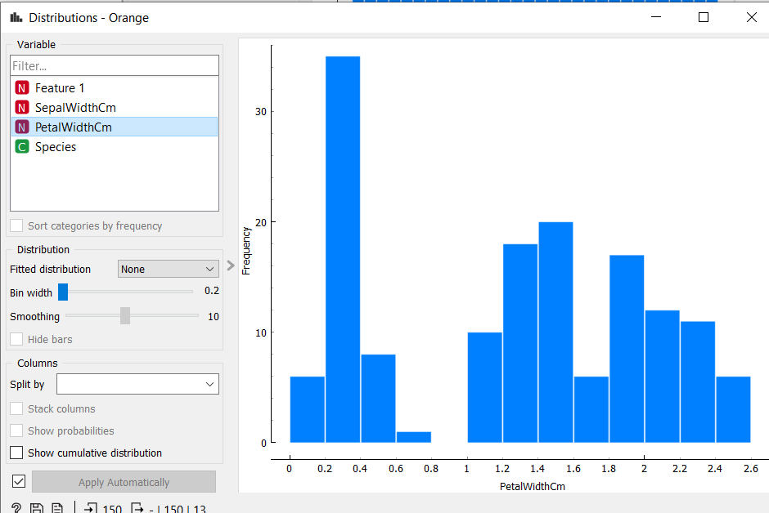

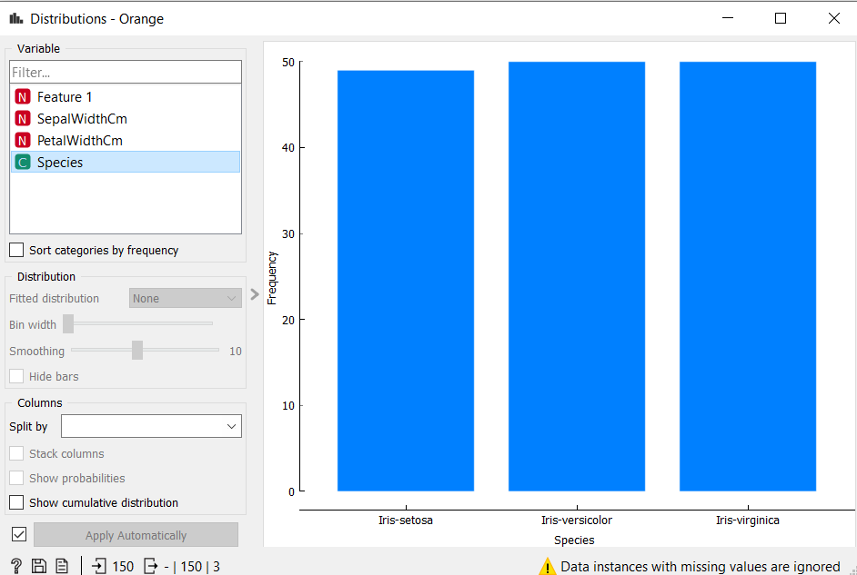

c. Show linear projection

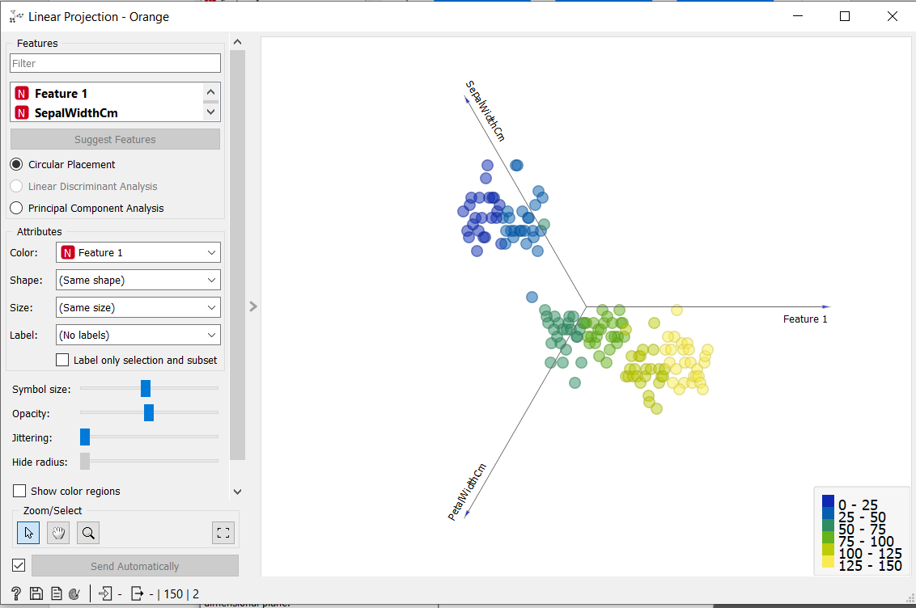

d. Show FreeViz Use dataset

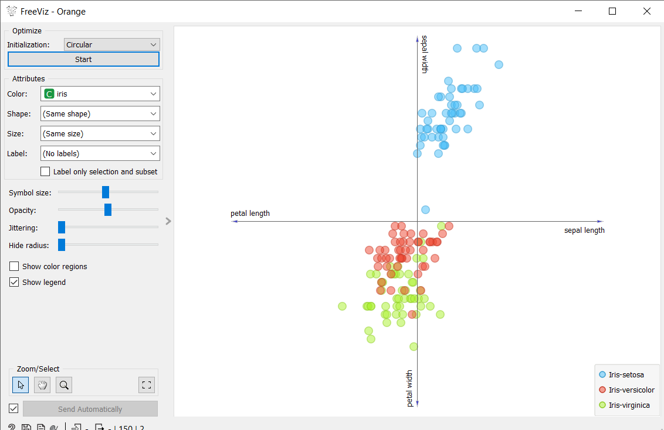

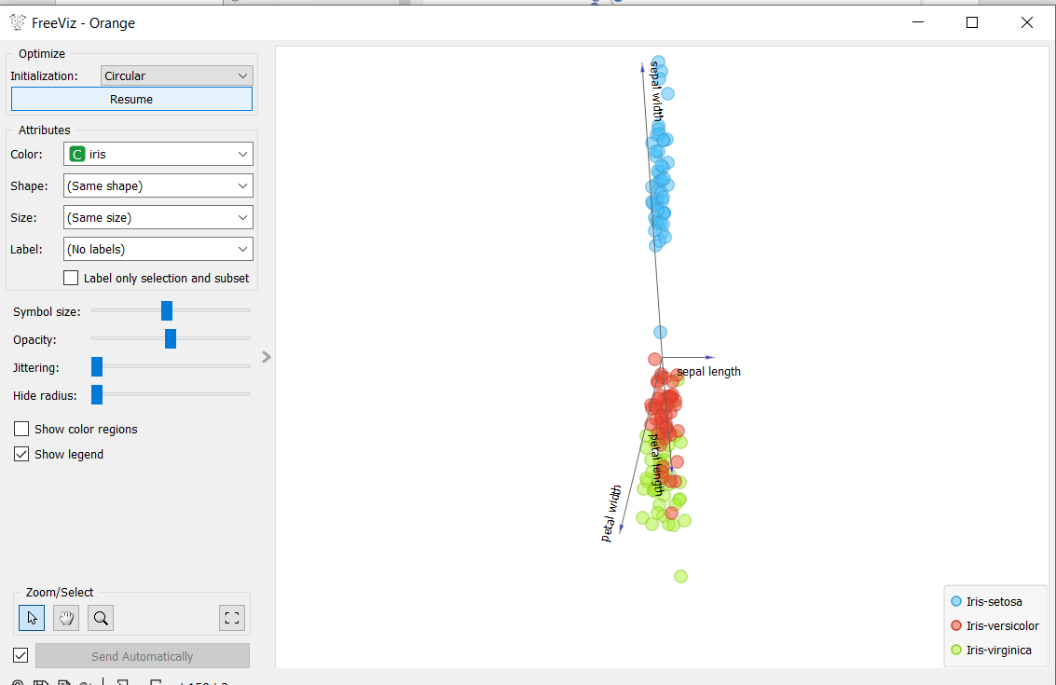

. 3. Differentiate in between free software, Open source software and proprietary software with respect to its properties.

|  |  |  |
| --- | --- | --- |
| **free software** | **Open source software** | **proprietary software** |
| Free software means software that respects users’ freedom and community. | In open source software the source code is public. | In proprietary software the source code is protected. |
| Free Software are open and tested by open collaboration | managed by an open source community of developers. | managed by an closed team of individuals or groups that developed it. |
| users have the freedom to run, copy, distribute, study, change and improve the software. | Users do not need to have any authenticated license to use this software. | Users need to have a valid and authenticated license to use this software. |
| Users can get free software for free of charge | Users can get open software for free of charge | Users must have to pay to get the proprietary software. |

4. Using Anaconda Python create Histogram, Scatter plot and Bar plot for the dataset given below. Dataset- https://drive.google.com/file/d/1i11BZFe8Xj9kNq7eeE9KOa_Iz1KhEdXJ/view

a. Scatter plot- Scatter plot of Price Vs Age

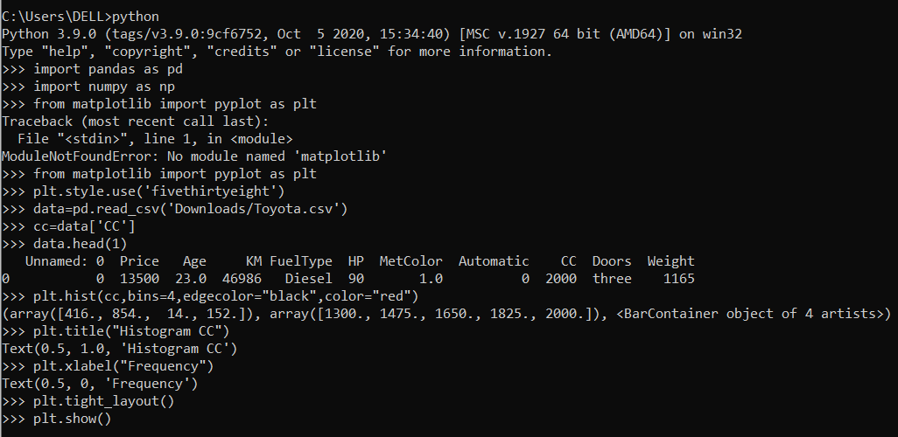

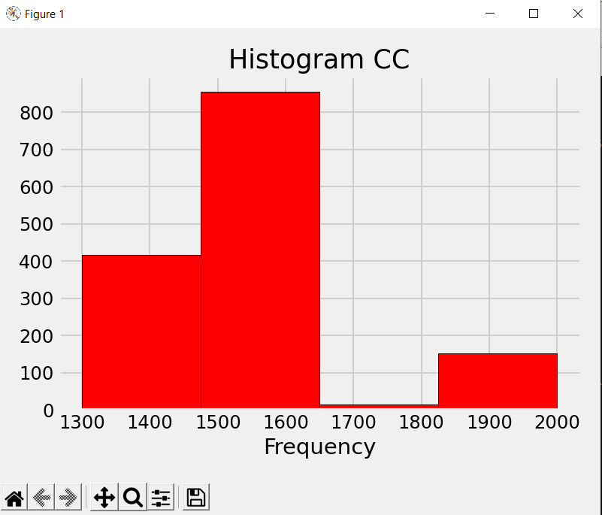

b. Histogram- for Kilometer and CC

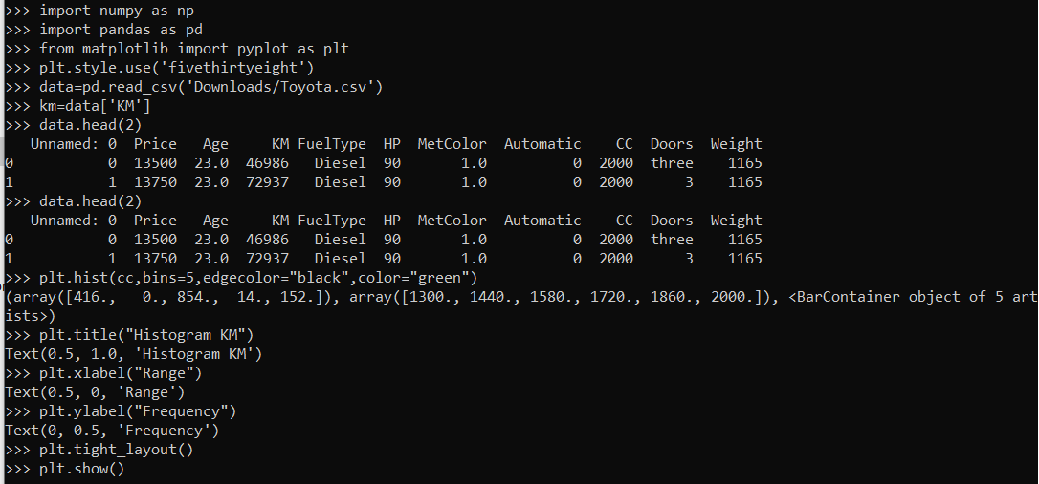

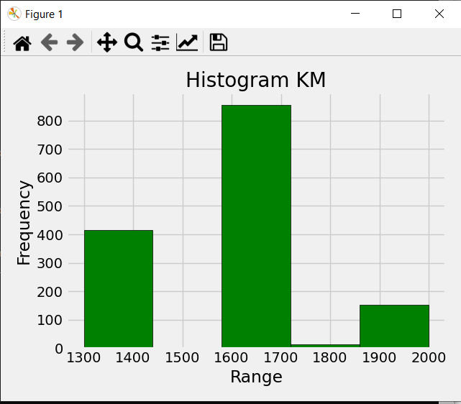

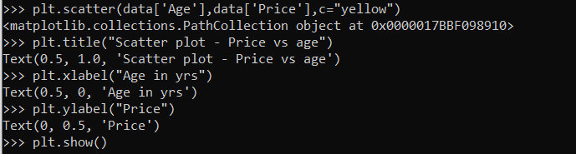

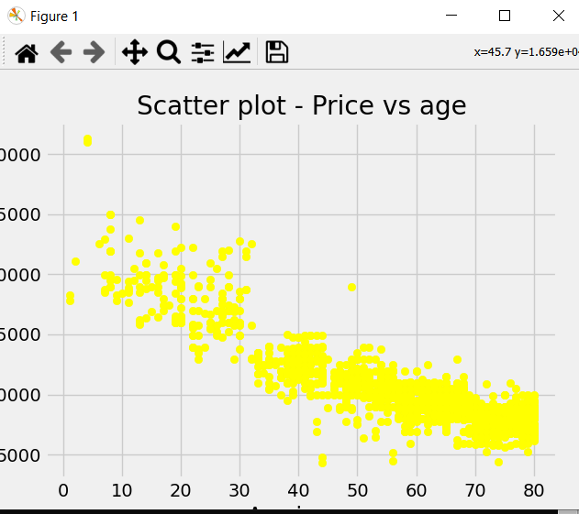

c. Bar plot- Bar plot for different fuel types

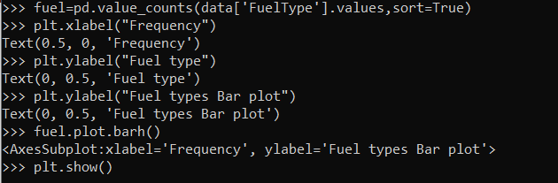

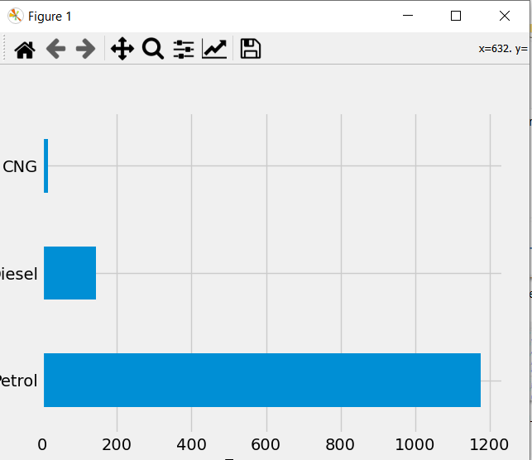

5. Enlist some examples along with its purpose and properties (at least 10) of FOSS and proprietary software with respect to database.