[College name]
[Department of Computer Engineering]
A Course Project Report on
Dynamic Pricing & Discount Rule Engine
Pricing rules as objects: an object-oriented design in C++17
Submitted in partial fulfilment of the course
CS2303 Object Oriented Programming
Submitted by
Vaishnavi Bhagwat
Roll No. [Roll No.] Division / Batch [Div / Batch]
Under the guidance of
[Guide name]
Academic Year 2026–27

Abstract
Retail pricing in India combines many kinds of offers: festive sales, quantity discounts, loyalty tiers, near-expiry markdowns, coupons and bank card offers, all on top of category-wise GST and a legal MRP ceiling. When these rules are written as nested if/else statements inside one pricing function, every new offer means editing and re-testing that function, and nobody can explain why a customer received a particular price.
This project builds a Dynamic Pricing & Discount Rule Engine in C++17 in which every pricing rule is an object. The engine talks only to an abstract DiscountRule interface, so a new kind of offer is added by writing one new class; the engine itself never changes (Open/Closed Principle). Conflicts between offers are settled by interchangeable policies (Strategy pattern), business safety checks such as a margin floor and the MRP ceiling are separate guard objects, and every decision is published to observers that build an explainable price trace.
Beyond the core engine the system adds a small rule language with its own lexer and parser, a validator that finds expired, unreachable, overlapping and margin-breaking rules, a what-if simulator, a best-offer optimizer, rule decorators (happy hour, cap, first order only) and a smart upsell advisor. The implementation has 87 headers and 75 source files (about 9,300 lines) organised in eight layers, and is verified by 486 GoogleTest unit tests that all pass.
Keywords: object-oriented design, SOLID principles, design patterns, C++17, rule engine, dynamic pricing, GST.

Table of Contents
Abstract 1
1. Introduction 4
1.1 Background 4
1.2 Motivation 4
2. Problem Statement and Objectives 5
2.1 Problem Statement 5
2.2 Objectives 5
3. Scope and Features 6
4. Tools and Technologies 7
5. System Architecture 8
6. Class Design 9
6.1 Domain Model 9
6.2 Discount Rule Hierarchy 9
6.3 Rule Decorators 10
6.4 Pricing Engine and its Collaborators 11
6.5 Rule Language 11
6.6 Rule Validation 12
7. Object-Oriented Concepts Applied 13
8. SOLID Principles 14
8.1 Single Responsibility Principle 14
8.2 Open/Closed Principle 14
8.3 Liskov Substitution Principle 14
8.4 Interface Segregation Principle 14
8.5 Dependency Inversion Principle 14
9. Design Patterns 16
10. Working of the System 17
10.1 Pricing Pipeline 17
10.2 Conflict Policies 17
10.3 Price Guards 17
10.4 Menu-Driven Interface 18
11. Innovations 19
12. Implementation Highlights 20
13. Testing 21
13.1 Running the Tests 21
14. Results and Sample Output 22
14.1 Invoice (first line and totals) 22
14.2 What-if Comparison 23
14.3 Smart Upsell Suggestions 23
14.4 Rule Check on the Shipped Data 23
15. Limitations and Future Scope 24
16. Conclusion 25
References 26
Appendix A: Building and Running 27
Project Structure 27

1. Introduction

1.1 Background
A shop’s final price is rarely just the selling price. A single order can qualify for a seasonal sale on one item, a quantity discount on another, a membership discount for the customer’s tier, a coupon on the order total and an instant discount from the customer’s bank. GST must then be added at each product’s own rate, and the result may never exceed the printed MRP. The order in which these rules apply, and which of them may be combined, changes the final amount.

1.2 Motivation
Pricing is an ideal problem for object-oriented design because the set of rules keeps changing while the pricing process stays the same. If each rule is an object that answers two questions (does it apply, and how much does it save), the pricing engine can treat all rules alike. New offers, new conflict policies and new safety checks then become new classes rather than edits to existing, tested code. The project uses this domain to demonstrate abstraction, inheritance, polymorphism, encapsulation, the five SOLID principles and several classic design patterns in working, tested code.

2. Problem Statement and Objectives

2.1 Problem Statement
Design and implement a console application that prices a shopping cart by applying configurable discount rules, resolves conflicts between competing offers, enforces business and legal limits, adds GST, and explains every decision, such that adding a new kind of offer never requires changing the pricing engine.

2.2 Objectives
- Model products, customers, carts and money with classes that protect their own invariants (for example, money is stored as whole paise, never as a floating-point number).
- Represent every pricing offer as an object behind one abstract interface, DiscountRule.
- Keep the pricing engine closed for modification: new offers, conflict policies and guards are new classes only.
- Load offers from data files (JSON and a readable text rule language) instead of hard-coding them.
- Record why every offer was applied or rejected, and show it on the invoice.
- Detect badly configured rules before they reach a customer.
- Prove correctness with automated unit tests for every class.

3. Scope and Features
Table 1: Features of the system
Feature | Description
GST invoice | Per-line item discounts, order-level offers, GST at 5 / 12 / 18% by product category, totals and savings against MRP.
Eight offer types | Percentage, quantity, seasonal, expiry markdown, membership tier, coupon, bank offer, and text-language rules.
Conflict policies | Stacking, BestDiscount and Priority; chosen at checkout and swappable at run time.
Price guards | Discount cap (60%), margin floor (cost + 8%) and MRP ceiling, applied to every line.
Explainable price trace | Every rule and guard decision, with its reason, printed under each invoice line.
Rule language | IF category == Clothing AND qty >= 3 THEN 5% OFF, parsed into an expression tree.
Rule validator | Finds expired, unreachable, overlapping and margin-breaking rules.
What-if simulator | Prices the same cart under every policy and membership tier, side by side.
Best-offer optimizer | Searches offer combinations for the lowest total that passes every guard.
Rule decorators | Wrap any offer as happy hour, capped at ₹N, or first order only, from JSON.
Smart upsell advisor | Suggests the item whose addition unlocks the most extra savings.
Session log | Optional log file of data loads, orders placed, rule reloads and errors.
Safety checks | Expired items cannot be sold; quantities are limited to 1,000 per line; bad data files are reported with the rule id and field.

4. Tools and Technologies
Table 2: Technology stack
Item | Choice | Purpose
Language | C++17 | Classes, inheritance, virtual functions, smart pointers, std::optional
Compiler | GCC 16 (MSYS2 UCRT64) on Windows 11 | Built with -Wall -Wextra -Wpedantic and zero warnings
Build system | CMake 3.20+ with Ninja | Cross-platform build; downloads the two libraries automatically
JSON library | nlohmann/json 3.11.3 | Reading catalog, customer and rule files
Test framework | GoogleTest 1.15.2 with CTest | 486 unit tests
Documentation | Doxygen, PlantUML | API reference and UML diagrams from the source
Version control | Git | Change history
Editor | Visual Studio Code | Editing, building and debugging

5. System Architecture
The system is divided into eight layers. Each layer may use only the layers below it, so business logic never depends on the console, and the domain model depends on nothing else in the project. Figure 1 shows the layers and their main classes.
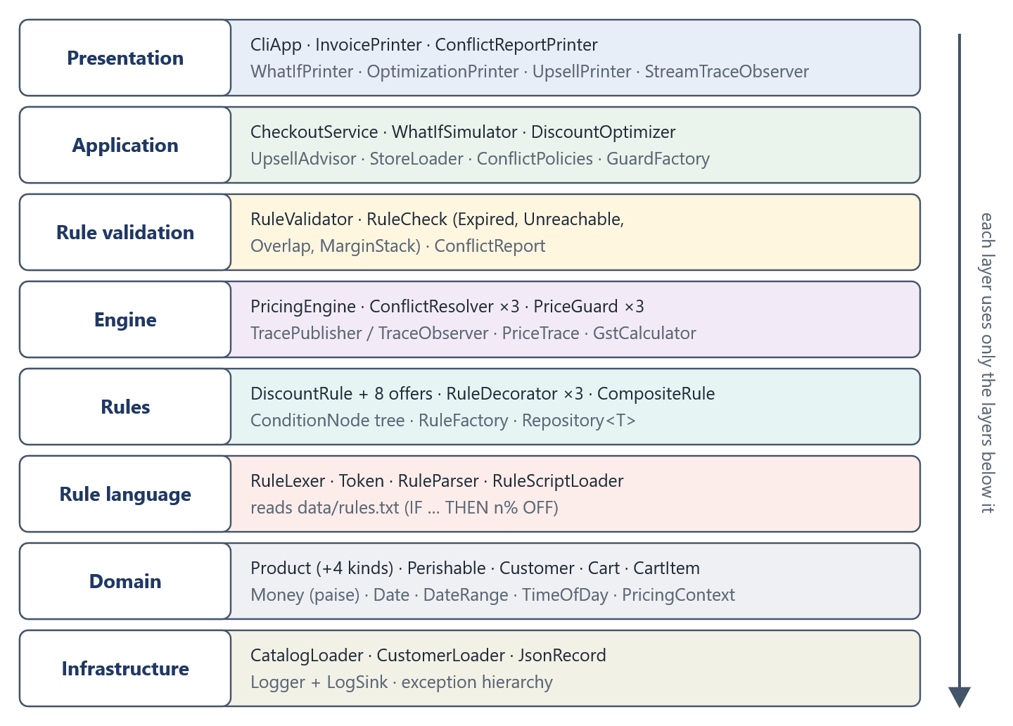
Figure 1: Layered architecture
Table 3: Responsibility of each layer
Layer | Responsibility
Presentation | Menus, invoices and reports on any std::ostream. Never prices anything itself.
Application | Use cases: checkout, what-if, optimizer, upsell, loading the shop data.
Rule validation | Static checks on the loaded rules; reuses the engine’s guards.
Engine | The pricing pipeline, conflict policies, guards, GST and the decision trace.
Rules | The offer classes, decorators, rule factory and a generic repository.
Rule language | Lexer and parser for text rules in data/rules.txt.
Domain | Products, customers, carts, money, dates and the pricing context.
Infrastructure | JSON loading, logging and the exception hierarchy.

6. Class Design

6.1 Domain Model
Product is an abstract class: every product has a cost price, selling price and MRP, but its GST rate and category are pure virtual functions answered by the four concrete subclasses. Grocery additionally implements the small Perishable interface, which is all the expiry markdown rule depends on. Money stores an amount as a 64-bit count of paise with overloaded operators, so rounding errors from floating-point arithmetic are impossible. PricingContext is a read-only view of everything a rule may look at: the cart, the customer, the order date and time, the coupon and the payment bank.
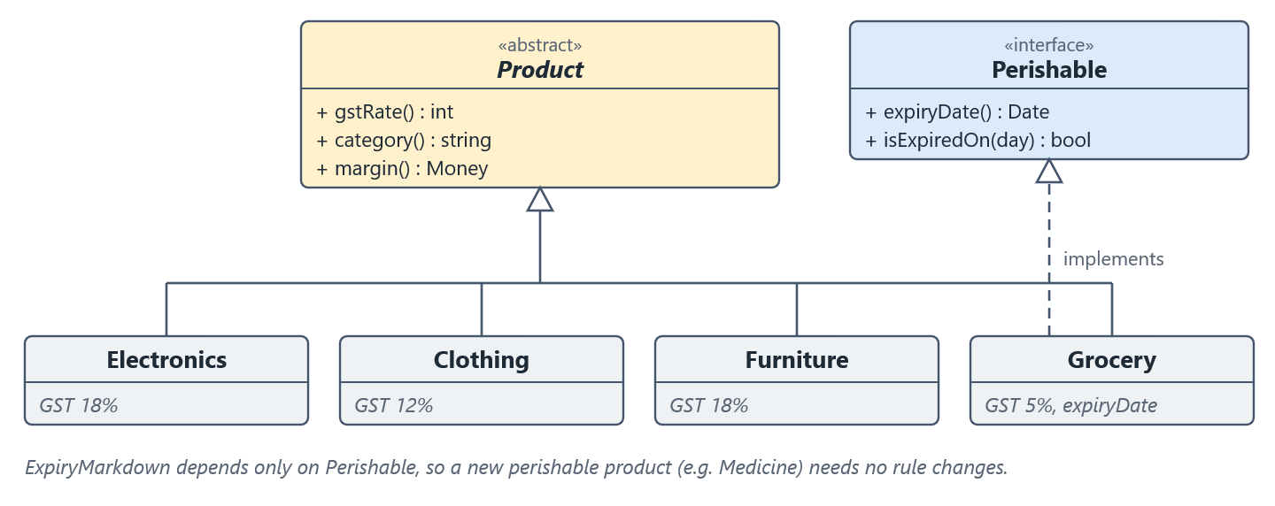
Figure 2: Product hierarchy and the Perishable capability

6.2 Discount Rule Hierarchy
Every offer derives from the abstract class DiscountRule. Two abstract intermediate classes split offers by how they are priced: ItemLevelRule prices each cart line, while CartLevelRule prices the order total. ItemLevelRule fixes the algorithm for isApplicable() and calculateDiscount() (marked final) and lets subclasses supply only two hooks, appliesToItem() and discountForItem() (Template Method pattern). Small role interfaces (IItemLevelRule, ICartLevelRule, IRedeemable) let the engine and checkout ask only for the capability they need (Interface Segregation).
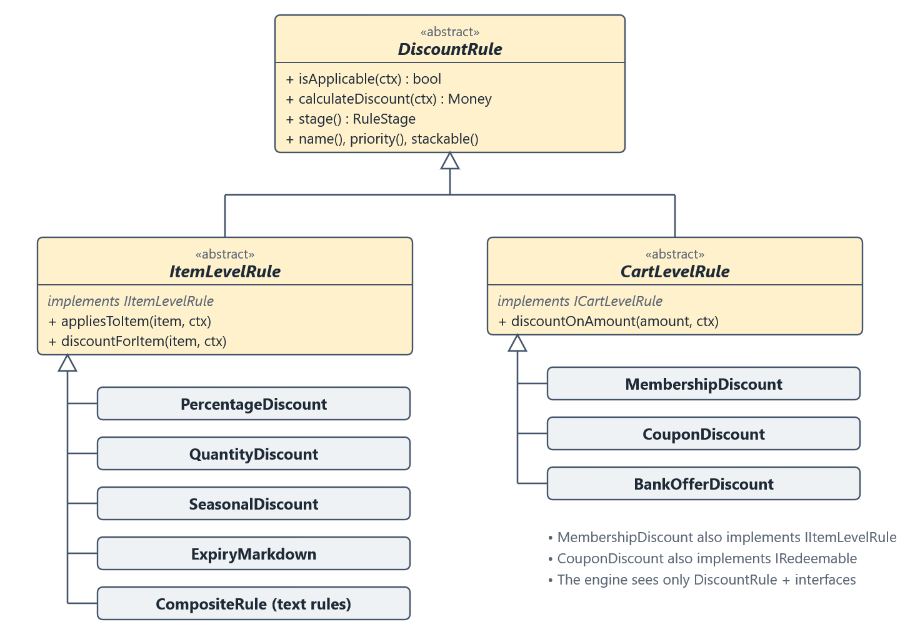
Figure 3: Discount rule class hierarchy

6.3 Rule Decorators
Shops attach the same restrictions to many different offers: a time window, a maximum saving, or new customers only. Writing a subclass for every combination would multiply classes. RuleDecorator instead is-a DiscountRule and has-a DiscountRule: it forwards every call to the offer it wraps and adds one condition (allows()) or one limit (limit()). Decorators can wrap other decorators, so a capped happy-hour offer is two small wrappers around an ordinary percentage discount (Figure 4). The engine, validator and checkout never know decorators exist.
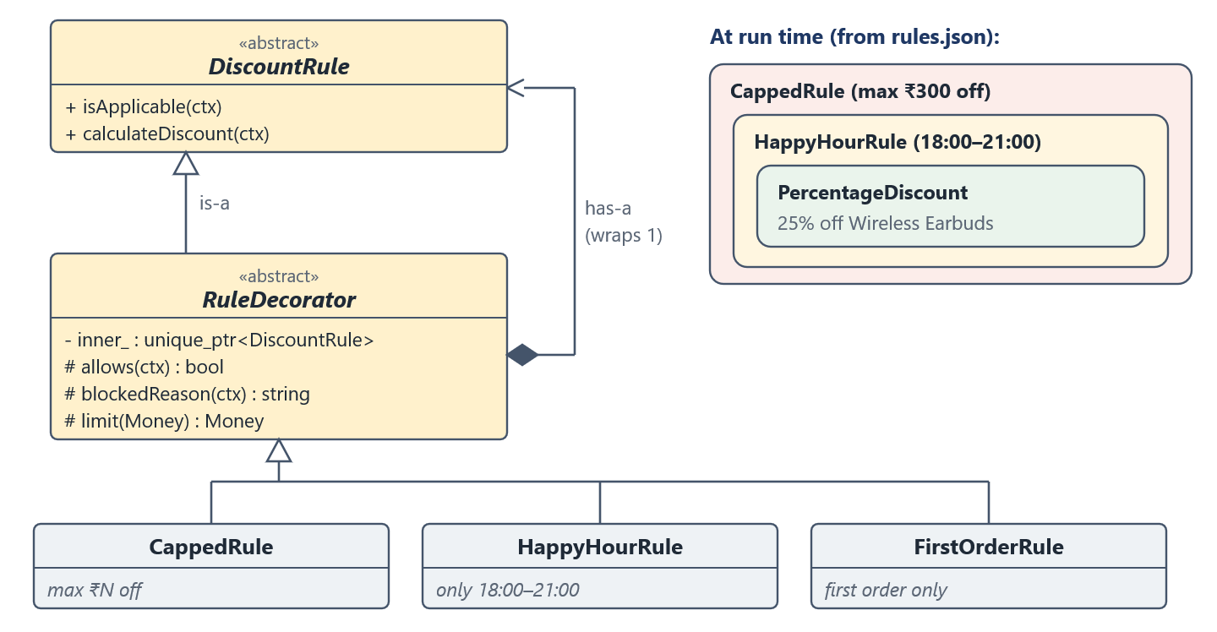
Figure 4: Decorator pattern for rules

6.4 Pricing Engine and its Collaborators
PricingEngine depends only on abstractions. It is given a ConflictResolver (the policy that decides between competing offers), owns a list of PriceGuard objects, and publishes every decision to TraceObserver objects. PriceTrace collects the decisions for the invoice, while StreamTraceObserver prints them live. Any of these can be replaced or extended without touching the engine.
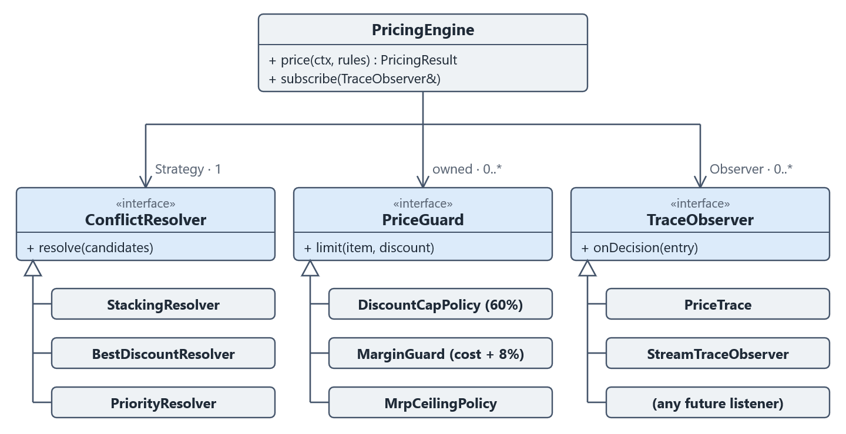
Figure 5: The engine and its Strategy and Observer collaborators

6.5 Rule Language
Rules can also be written in plain text, one per line, in data/rules.txt. RuleLexer turns a line into tokens, and RuleParser (a recursive-descent parser) builds a tree of ConditionNode objects (AndNode, OrNode, NotNode, ComparisonNode) wrapped in a CompositeRule. The tree is evaluated for each cart line (Composite and Interpreter patterns). Syntax errors are reported with the file, line and column.
[RULE <ID>:] IF <condition> THEN <N>% OFF [PRIORITY <n>] [STACKABLE|EXCLUSIVE] [NAME "<text>"]

RULE KURTA_BULK: IF category == Clothing AND qty >= 3 AND NOT tier == REGULAR
THEN 5% OFF PRIORITY 20
RULE BIG_BASKET: IF (category == Furniture OR category == Electronics)
AND cart_total >= 20000 THEN 3% OFF PRIORITY 10 NAME "Big basket bonus"

6.6 Rule Validation
RuleValidator runs a list of RuleCheck objects over the loaded rules and the catalogue: ExpiredRuleCheck (sales whose dates have passed), UnreachableRuleCheck (rules that match no product), OverlapCheck (rules covering the same products at the same time) and MarginStackCheck (stackable offers that together could push a price below cost + 8%). Each rule describes itself through virtual queries such as activePeriod(), scope() and maxPercentOff(), so the checks never need to know concrete rule types.

7. Object-Oriented Concepts Applied
Table 4: OOP concepts and where they are used
Concept | Where | How it is used
Encapsulation | Money, Cart, PricingResult | Private data with validated constructors; totals are computed, never stored twice.
Abstraction | DiscountRule, Product, PriceGuard | Pure virtual functions describe what, subclasses decide how.
Inheritance | Product subclasses; ItemLevelRule → PercentageDiscount | Single and multi-level inheritance reuse common data and code.
Multiple inheritance (interfaces) | CouponDiscount, Grocery, RuleDecorator | A class is-a base class and also implements small role interfaces.
Run-time polymorphism | PricingEngine, GstCalculator | Rules, guards and products are used only through base-class references.
Compile-time polymorphism | Repository<T> | One class template stores products, customers or rules.
Operator overloading | Money, Cart, TimeOfDay, Date | a + b, price * qty, cart += item, now < closing, os << money.
Composition and aggregation | PricingEngine, CompositeRule, CartItem | Objects built from other objects; owned or merely referenced.
Abstract classes and virtual destructors | All 17 interfaces and abstract bases | Safe deletion through a base pointer.
RAII and smart pointers | Repository, FileLogSink, RuleParser | std::unique_ptr owns every polymorphic object; files close automatically. No raw new/delete.
Exception handling | PricingError → ConfigError → RuleParseException | A hierarchy lets callers catch broadly or precisely.
const-correctness | PricingContext and all queries | Rules see the order through a read-only view.

8. SOLID Principles

8.1 Single Responsibility Principle
Each class has one reason to change. StoreLoader only loads data files, InvoicePrinter only formats a result, TracePublisher only fans decisions out to observers, and each PriceGuard performs exactly one check. CliApp only handles menus and delegates all work to application services.

8.2 Open/Closed Principle
The engine is closed for modification but open for extension. A unit test proves this: an offer type that exists only in the test file is priced correctly by the unchanged engine.
class FlatHundredPerLine final : public rules::ItemLevelRule { // a brand-new offer
public:
FlatHundredPerLine() : ItemLevelRule("FLAT100", "Rs 100 off every line", 10, true) {}
rules::RuleStage stage() const override { return rules::RuleStage::Quantity; }
bool appliesToItem(const CartItem&, const PricingContext&) const override { return true; }
Money discountForItem(const CartItem&, const PricingContext&) const override {
return rs(100);
}
};

TEST(PricingEngine, NewOfferTypeWorksWithoutChangingEngine) {
const FlatHundredPerLine flat;
...
const auto r = PricingEngine(kStacking).price(o.context(), RuleList{&flat});
EXPECT_EQ(r.itemDiscountTotal(), rs(200));
}

The same holds elsewhere: RuleFactory maps a type name to a creator function, so a JSON offer type is one registerType() call; conflict policies are passed to the CLI as a list, so its menu builds itself; and new decorators are registered the same way.

8.3 Liskov Substitution Principle
Any subclass can replace its base class. Every Product gives a valid GST rate, every ConflictResolver returns one verdict per candidate, and a decorated rule behaves exactly like a DiscountRule, including counting coupon uses. ItemLevelRule marks isApplicable() and calculateDiscount() as final, so subclasses cannot break that contract.

8.4 Interface Segregation Principle
Instead of one large interface, offers implement only what they need: IItemLevelRule for per-line pricing, ICartLevelRule for order pricing, IRedeemable for offers with a usage limit, and products implement Perishable only if they expire. DiscountRule does not carry a recordUse() method that most rules would ignore.

8.5 Dependency Inversion Principle
High-level code depends on abstractions that are injected from outside. PricingEngine receives a ConflictResolver& and a list of PriceGuard objects; CheckoutService receives a GuardFactory; Logger writes to LogSink objects; and ExpiryMarkdown depends on Perishable rather than the concrete Grocery class.
explicit PricingEngine(const ConflictResolver& resolver,
std::vector<std::unique_ptr<PriceGuard>> guards = defaultGuards());

9. Design Patterns
Table 5: Design patterns used
Pattern | Classes | Purpose
Strategy | ConflictResolver: Stacking, BestDiscount, Priority | Swap the conflict policy at run time.
Observer | TracePublisher, TraceObserver, PriceTrace, StreamTraceObserver | Report every decision to any number of listeners.
Template Method | ItemLevelRule, RuleDecorator | Fix the algorithm; subclasses fill in hooks.
Decorator | RuleDecorator: CappedRule, HappyHourRule, FirstOrderRule | Add conditions to any offer by wrapping it.
Factory (registry) | RuleFactory, CatalogLoader | Create objects from a type name in a data file.
Composite | ConditionNode: And, Or, Not, Comparison | Treat a condition tree and a single comparison alike.
Interpreter | RuleLexer, RuleParser, ConditionNode | Evaluate the text rule language.
Facade | CheckoutService, StoreLoader | One call hides engine, guard and loader wiring.
Repository | Repository<T> | Owns objects and finds them by id.
Null Object | Logger with no sinks | Logging can always be called; it is silent by default.

10. Working of the System

10.1 Pricing Pipeline
Figure 6 shows how one order is priced. Item offers run stage by stage on every cart line; where several apply, the chosen ConflictResolver decides which are given. The guards then check each line, order-level offers apply to what is left, their saving is split across the lines in proportion, and GST is added per line. Every step publishes its decision, so the invoice can explain each figure.
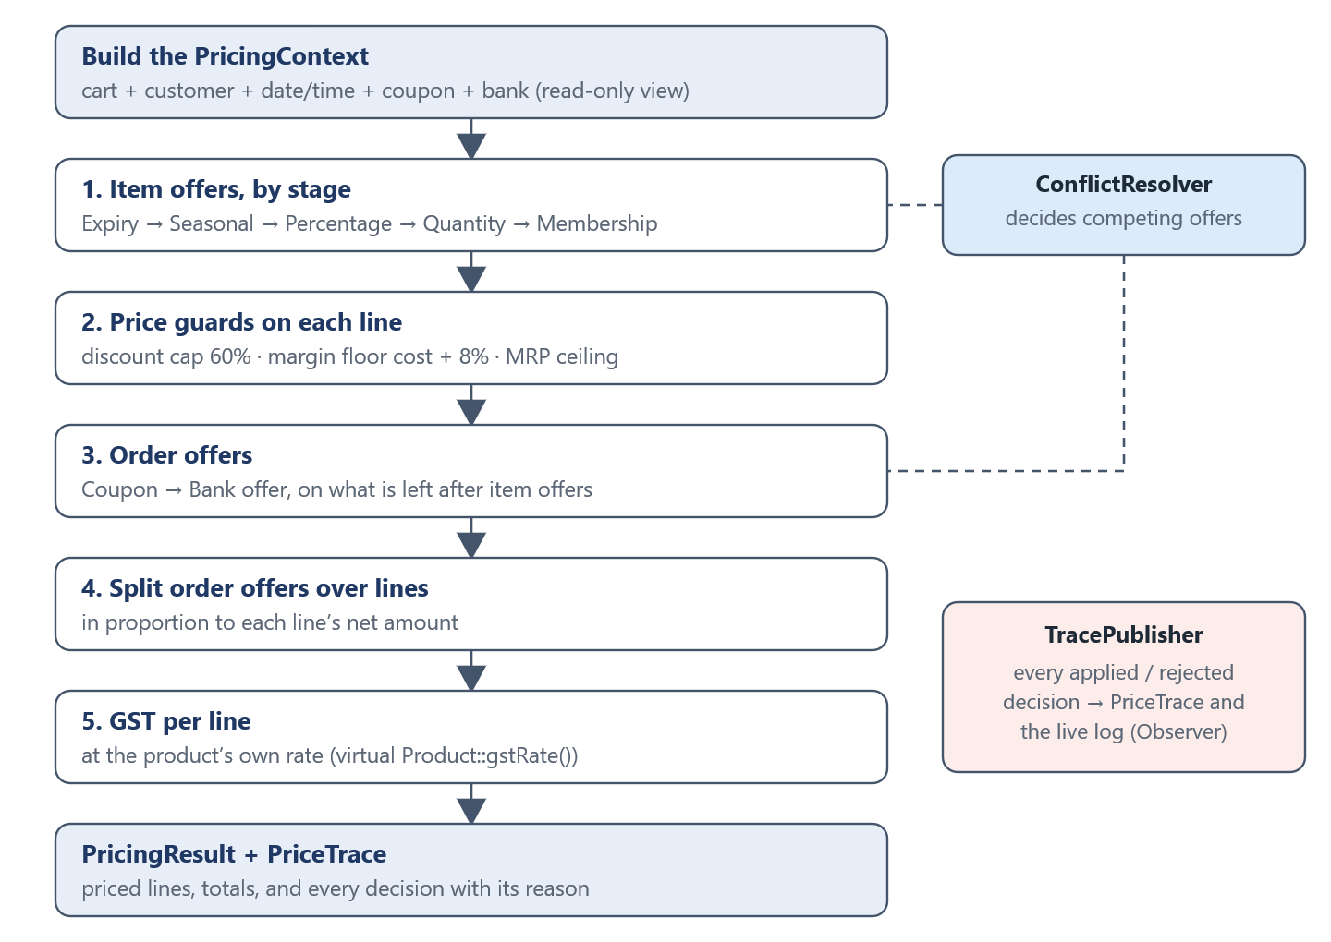
Figure 6: Pricing pipeline for one order

10.2 Conflict Policies
Policy | Behaviour
Stacking | Combines every stackable offer; a non-stackable offer is given alone only if it saves more than the whole stack.
BestDiscount | Gives only the single offer that saves the customer the most.
Priority | Gives only the offer with the highest priority, whatever it saves.

10.3 Price Guards
Guard | Rule enforced
DiscountCapPolicy | A line’s item discount may not exceed 60% of its selling price.
MarginGuard | A line’s net price stays at least 8% above cost; the guard only ever reduces a discount.
MrpCeilingPolicy | Price plus GST may never exceed the printed MRP; runs last so the legal limit always wins.

10.4 Menu-Driven Interface
1 View catalog 6 View price trace
2 Build cart 7 Run what-if
3 Pick customer 8 View conflict report
4 Apply coupon and bank 9 Reload rules
5 Checkout 10 Find best offer combination
0 Exit 11 Smart upsell suggestions

11. Innovations
- Explainable pricing. Every rule and guard decision is recorded with a reason (for example “only between 18:00 and 21:00 (ordered at 14:00)”) and printed under the invoice line it affected.
- Rule language. Shop staff can write offers in readable text; the parser reports mistakes with line and column numbers.
- Rule validator. Badly configured offers are found before checkout: expired sales, rules that match nothing, overlaps and stacks that would sell below cost.
- What-if simulator and optimizer. The same cart is priced under every policy and tier, and the best combination of offers is searched for automatically.
- Rule decorators. Happy hour, maximum saving and first-order-only restrictions can be attached to any offer from the data file, without new offer classes.
- Smart upsell advisor. For each catalogue product the advisor prices three carts through the real engine (the current cart, the cart plus that product, and the product alone). The difference, bonus = price alone − increase in the bill, is money saved only because of the combination. Because it compares prices rather than inspecting rule types, it already understands offers that will be written in future.
Example from the sample data: with two kurtas and the FESTIVE500 coupon in the cart, the advisor finds that a third kurta raises the bill by only ₹56.00 although it costs ₹1,120.00 on its own, because it unlocks both the buy-three discount and the coupon threshold.

12. Implementation Highlights
- Exact money. Money holds paise in a 64-bit integer; percentages round to the nearest paisa, and amounts are printed in the Indian digit grouping (₹3,00,000.00).
- Memory safety. Every polymorphic object is owned by std::unique_ptr; copying of polymorphic bases is deleted to prevent slicing; constructors that would bind a reference to a temporary are deleted.
- Validation at the boundary. Data files are checked field by field, and every error names the rule or product id and the field (rule 'R1': missing field "max").
- Business safety. Expired perishable items cannot be added to the cart or sold at checkout, and a cart line holds at most 1,000 units so totals cannot overflow.
- Portable build. CMake downloads the two libraries automatically; on Windows the C++ runtime is linked statically so the program runs from any terminal.

13. Testing
Every class is covered by GoogleTest unit tests, organised as one test file per class or per small family of classes (for example, the three conflict policies share test_conflict_resolvers.cpp). Tests build small carts with known products and check exact amounts in paise, error messages, and whole menu sessions driven by scripted input. There are 486 tests in 62 files (6,513 lines of test code), and all of them pass with zero compiler warnings.
Table 6: Unit tests by layer
Layer | Test files | Tests
Domain | 9 | 63
Rules | 19 | 164
Rule language | 3 | 34
Engine | 8 | 64
Rule validation | 3 | 28
Application | 6 | 40
Presentation | 7 | 53
Infrastructure | 7 | 40
Total | 62 | 486

Manual testing with unusual input found three defects, which were fixed and are now covered by regression tests: very large quantities could overflow and produce a negative bill; an expired product could be sold; and a wrapped explanation line could leave a blank line in the invoice.

13.1 Running the Tests
cmake -S . -B build -G Ninja
cmake --build build
ctest --test-dir build --output-on-failure

100% tests passed, 0 tests failed out of 486

14. Results and Sample Output
The following output is copied from a real run on 30 October 2026 for a Gold-tier customer buying a smartphone, three kurtas and a study chair, with the FESTIVE500 coupon and an HDFC card, under the Stacking policy.

14.1 Invoice (first line and totals)
========================================================================
TAX INVOICE
------------------------------------------------------------------------
Customer : Priya Sharma (CU42) Tier : Gold
Date : 2026-10-30 Offers resolved by : Stacking
Coupon : FESTIVE500
Paid with: HDFC
------------------------------------------------------------------------
1. Smartphone [E1] Electronics, GST 18%
1 x ₹15,000.00 (MRP ₹18,000.00) ₹15,000.00
- Festive Season Sale: 20% off Electronics -₹3,000.00
- Big basket bonus -₹450.00
- Loyalty Club member discount -₹750.00
* Guard adjustment +₹2,160.00
- Share of order offers -₹1,401.84
Taxable value ₹11,558.16
GST @ 18% ₹2,080.47
Line total ₹13,638.63
Why:
Percentage FURNITURE_10 rejected: does not cover Smartphone
Percentage KURTA_BULK rejected: does not cover Smartphone
Quantity BUY3_CLOTHING rejected: does not cover Smartphone
Seasonal FESTIVE_ELECTRONICS applied ₹3,000.00 off: stacked with
other stackable offers
Percentage BIG_BASKET applied ₹450.00 off: stacked with other
stackable offers
Membership LOYALTY_TIERS applied ₹750.00 off: stacked with other
stackable offers
Guard DiscountCapPolicy passed: discount ₹4,200.00 is within the
60% cap of ₹9,000.00
Guard MarginGuard raised price by ₹2,160.00: net price would fall
below cost + 8% (₹12,960.00)
Guard MrpCeilingPolicy passed: price incl. 18% GST ₹15,292.80 is
within MRP ₹18,000.00
... (lines 2 and 3 omitted) ...
Order offers
- FESTIVE500: Flat Rs 500 off on Rs 2,999+ -₹500.00
- HDFC Bank cards: 10% instant discount up to Rs 1,500 -₹1,500.00
... (reasons omitted) ...
------------------------------------------------------------------------
Subtotal ₹22,000.00
Item discounts -₹3,510.00
Order offers -₹2,000.00
Taxable value ₹16,490.00
GST ₹2,847.81
------------------------------------------------------------------------
GRAND TOTAL ₹19,337.81
------------------------------------------------------------------------
MRP total ₹26,600.00 You saved ₹7,262.19
========================================================================

The smartphone’s stacked offers would have taken it below cost + 8%, so MarginGuard reduced its discount by ₹2,160.00, and the trace explains why. The MRP total of the order is ₹26,600.00; the customer pays ₹19,337.81 including GST, a saving of ₹7,262.19 against MRP.

14.2 What-if Comparison
What-if: grand total (incl. GST) for this cart under each policy and tier

Tier Stacking BestDiscount Priority
Regular ₹19,911.31 < ₹20,638.81 ₹21,810.80
Silver ₹19,580.61 < ₹20,638.81 ₹21,810.80
* Gold ₹19,337.81 < ₹20,638.81 ₹21,810.80
Platinum ₹18,933.10 < ₹20,638.81 ₹21,810.80

* = this customer's tier < = cheapest policy for that tier
Lowest overall: Platinum with Stacking, ₹18,933.10

14.3 Smart Upsell Suggestions
Smart suggestions (policy Stacking)

1. Add 1 x Cotton Kurta (C1)
Bought alone it costs ₹1,120.00; added to this cart your bill
goes up by only ₹56.00 - you save ₹1,064.00 extra.
Unlocks: Buy 3 or more of a kurta/shirt, get 15% off, FESTIVE500: Flat Rs 500 off on Rs 2,999+
2. Add 1 x Wireless Earbuds (E2)
Bought alone it costs ₹1,146.96; added to this cart your bill
goes up by only ₹577.14 - you save ₹569.82 extra.
Unlocks: FESTIVE500: Flat Rs 500 off on Rs 2,999+
3. Add 1 x Denim Jeans (C2)
Bought alone it costs ₹1,790.88; added to this cart your bill
goes up by only ₹1,230.88 - you save ₹560.00 extra.
Unlocks: FESTIVE500: Flat Rs 500 off on Rs 2,999+

Prices include GST and every offer and guard, as at checkout.

14.4 Rule Check on the Shipped Data
Kind | Finding
Overlap | EOSS_CLOTHING and BUY3_CLOTHING both cover Clothing from 2027-01-15 to 2027-01-31 (intended: they stack).
MarginBreach | If every listed offer stacked on the smartphone (45% off), the price would fall below cost + 8%; MarginGuard prevents this at checkout.

15. Limitations and Future Scope
- The interface is a console menu; a web or GUI front end could reuse the application layer unchanged.
- Data lives in JSON and text files; a database could replace the loaders behind the same interfaces.
- GST rates are fixed per product class for illustration; a real system would read them from a tax table.
- Decorators can be set in JSON but not yet in the text rule language.
- The optimizer tries every combination of stackable offers, which grows quickly with many offers; pruning or dynamic programming would scale better.

16. Conclusion
The project shows that treating pricing rules as objects turns a fragile tangle of conditions into a system that is easy to extend, explain and test. Abstraction and polymorphism let the engine price any offer through one interface; the SOLID principles keep each class focused and the engine closed to change; and patterns such as Strategy, Observer, Template Method, Decorator and Composite give clean, well-known solutions to the problems that arose. New offers, policies, guards and rule restrictions were added during development without modifying the pricing engine, and the full test suite confirms the system behaves as intended.

References
- B. Stroustrup, The C++ Programming Language, 4th ed. Addison-Wesley, 2013.
- S. Meyers, Effective Modern C++. O’Reilly Media, 2014.
- E. Gamma, R. Helm, R. Johnson and J. Vlissides, Design Patterns: Elements of Reusable Object-Oriented Software. Addison-Wesley, 1994.
- R. C. Martin, Agile Software Development: Principles, Patterns, and Practices. Prentice Hall, 2002.
- N. Lohmann, “JSON for Modern C++”, https://github.com/nlohmann/json
- Google, “GoogleTest User’s Guide”, https://google.github.io/googletest/
- Kitware, “CMake Documentation”, https://cmake.org/cmake/help/latest/
- cppreference.com, “C++ reference”, https://en.cppreference.com/

Appendix A: Building and Running
# Windows (MSYS2 g++): name the generator on the first configure
cmake -S . -B build -G Ninja
cmake --build build
ctest --test-dir build --output-on-failure

# run (options are all optional)
./build/pricing_engine --date 2026-10-30 --time 19:00 --log session.log

Project Structure
include/<layer>/ headers (presentation, application, validation, engine,
src/<layer>/ sources rules, language, domain, infrastructure)
tests/ unit tests, one file per class or class family
data/ catalog.json, customers.json, rules.json, rules.txt
docs/ UML diagrams (PlantUML), report, slides, viva notes
Doxyfile API documentation settings

