
Business Question and Visualization Report

Date | 7 October 2026
Team ID | Individual – Roll No. 10
Project Name | India’s Agricultural Crop Production Analysis
Maximum Marks | 5 Marks

Visualization development refers to the process of creating graphical representations of data to facilitate understanding, analysis, and decision-making. The goal is to transform complex datasets into visual formats that are easy to interpret, enabling users to gain insights and make informed decisions. Visualization development involves selecting appropriate visual elements, designing layouts, and using interactive features to enhance the user experience. This process is commonly associated with data visualization tools and platforms, and it plays a crucial role in business intelligence, analytics, and reporting
Business Questions and Visualisation
The process involves defining specific business questions to guide the creation of meaningful and actionable visualizations in Tableau. Well-framed questions help in identifying key metrics, selecting relevant data, and building visualisation that provide insights.
Project Data Overview
The visualization work uses the actual raw dataset provided for this project: Crop Production data.csv. The dataset contains 246,091 records and 7 columns: State_Name, District_Name, Crop_Year, Season, Crop, Area and Production. It covers crop-production observations across years in the dataset. The raw data contains 3,730 missing Production values and 0 duplicate rows. Visualizations involving Production or Yield should use appropriately cleaned records.
What is the overall agricultural production trend across the years in the dataset?
Visualization: Line chart showing total Production by Crop_Year.
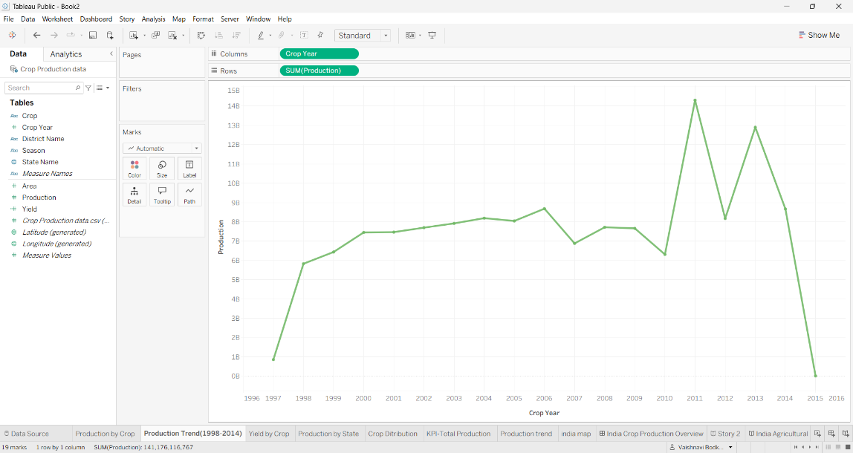

Which crops have the highest total production?
Visualization: Bar chart comparing total Production by Crop.
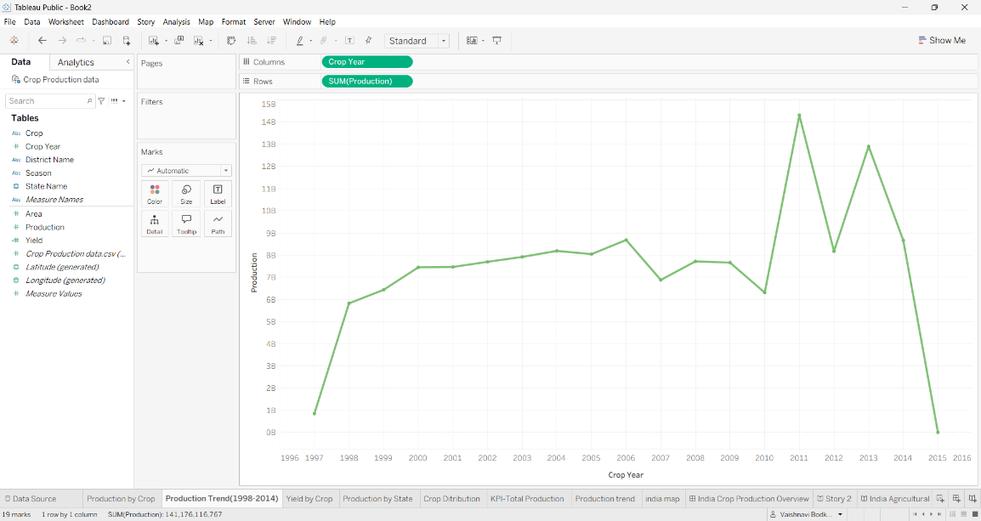
Which states have the highest agricultural production?
Visualization: Filled map showing total Production by State_Name.
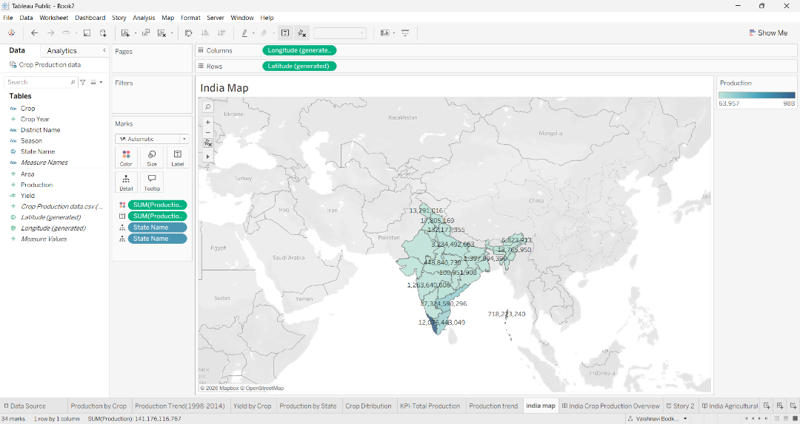

Which districts have the highest agricultural production?
Visualization: Bar chart or map comparing total Production by District_Name.
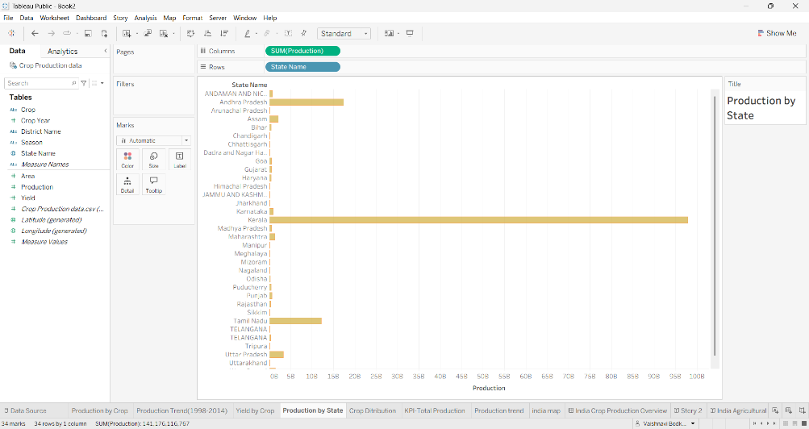
How does cultivated area change across the years?
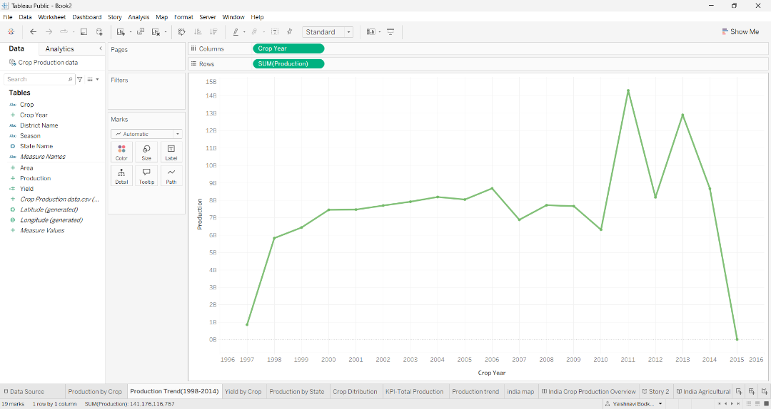Visualization: Line chart showing total Area by Crop_Year.

Which crops have the highest yield?
Visualization: Bar chart showing Yield by Crop, where Yield = Production / Area.
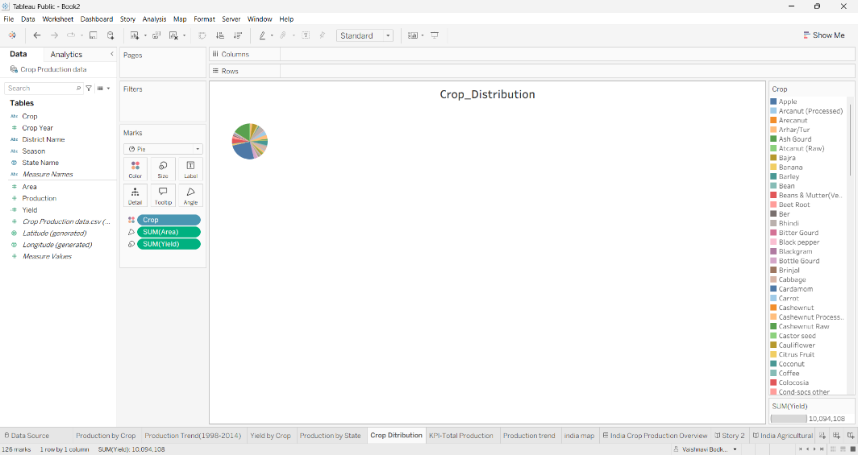
How does crop production vary across states and crops?
Visualization: Heatmap showing Production by State_Name and Crop.
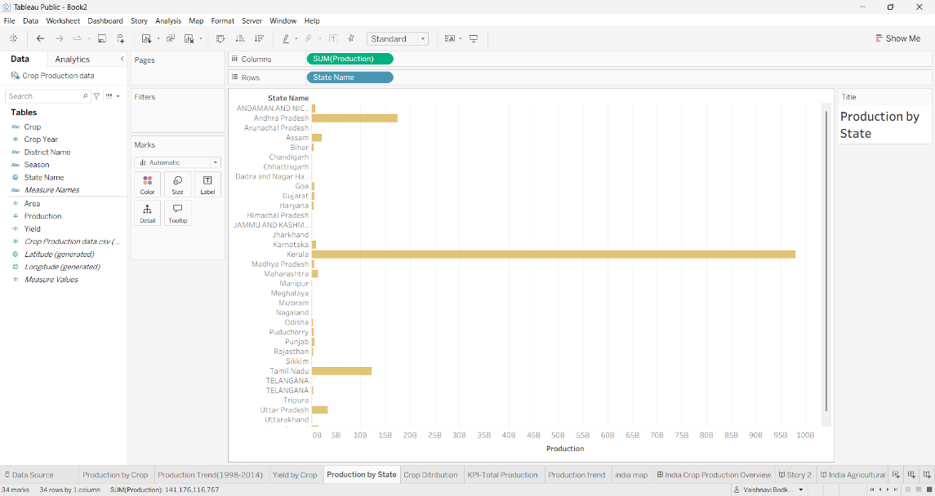

What is the relationship between cultivated area and production?
Vi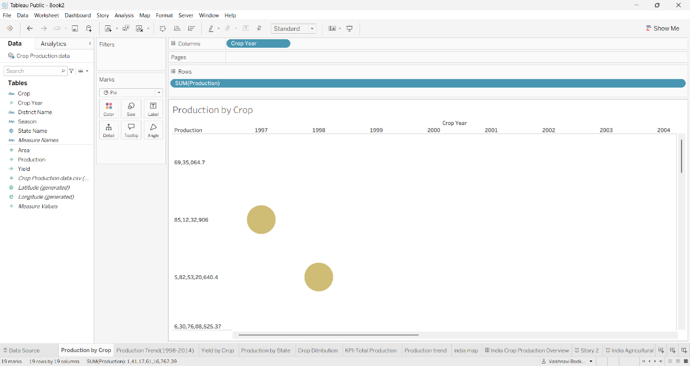sualization: Scatter plot comparing Area and Production.

Visualization Development Note
The visualizations are intended to support crop-wise, state-wise, district-wise, seasonal and yearly analysis in Tableau. Interactive filters can be used for Crop, State_Name, District_Name, Season and Crop_Year. The calculated field Yield = Production / Area can be used where Area is valid and non-zero.

