DASHBOARD DESIGN REPORT
India's Agricultural Crop Production Analysis
Dashboard Title | India's Agricultural Crop Production Analysis
Visualization Tool | Tableau Public
Dashboard Link | https://public.tableau.com/app/profile/vaishnavi.bodkhe/viz/India_Agricultural_Crop_Production_Analysis_dashboard_twbx/IndiaCropProductionOverview?publish=yes
1. Dashboard Overview
The dashboard provides a consolidated visual view of India's agricultural crop production. It brings the major analytical charts into one interactive Tableau dashboard so that users can compare production, yield, crops, seasons, cultivated area, states and years from a single screen.
2. Dashboard Layout
The dashboard uses an Automatic size layout. The title is placed at the top, followed by two KPI cards. The remaining visualizations are arranged in a structured grid so that overall agricultural performance can be viewed first and detailed comparisons can be examined below.
3. KPI Cards
KPI | Displayed Value | Purpose
Total Agricultural Yield | 2,931,611,903 | Provides the overall yield figure shown on the dashboard.
Total Agricultural Production | 330,997,839,211 | Provides the overall production figure shown on the dashboard.
4. Visualizations Included in the Dashboard
Dashboard Visual | Chart Type | Purpose
Crop-wise Total Production Analysis | Horizontal bar chart | Compares total production across crops.
Season-wise Agricultural Production Share | Pie chart | Shows the share of production across Autumn, Kharif, Rabi, Summer, Whole Year and Winter.
State-wise Cultivated Area Comparison | Area comparison chart | Compares cultivated area by state and crop.
Agricultural Yield Trend (1997–2021) | Line chart | Shows the change in agricultural yield across the displayed years.
Year-wise Total Agricultural Production (1997–2021) | Bar chart | Compares total agricultural production year by year.
State-wise Agricultural Production Distribution | India map | Shows the geographic distribution of agricultural production.
Leading States by Agricultural Production | Ranked bar chart | Compares states according to agricultural production.
5. Dashboard Filters and Interactive Elements
• Production range control is available on the dashboard.
• Season categories are available through the dashboard legend.
• Crop and State selections are represented in the dashboard visual structure.
• Interactive Tableau marks and tooltips allow users to inspect individual chart values.
• The dashboard combines multiple views so that selections and comparisons can be explored without leaving the main dashboard.
6. Dashboard Observations
• Total Agricultural Production displayed: 330,997,839,211.
• Total Agricultural Yield displayed: 2,931,611,903.
• Coconut is the leading crop in the displayed crop-wise production chart.
• Whole Year is the largest segment in the displayed season-wise production chart.
• Kerala is the top state in the displayed Leading States by Agricultural Production chart, followed by Tamil Nadu and Karnataka.
• The yield trend contains a prominent peak around 2017.
• The map provides a quick geographic comparison of production across Indian states.
7. Dashboard Design Principles
• Clear hierarchy: project title → KPIs → detailed visualizations.
• Consistent Tableau formatting and readable chart titles.
• Combination of quantitative charts and geographic visualization.
• Compact arrangement that allows multiple views to be compared on one screen.
• Dashboard size set to Automatic for flexible viewing.
• Interactive visual elements support exploration of the displayed data.
8. Tableau Public Dashboard
The following is the Tableau Public dashboard link supplied for this project:
Dashboard: https://public.tableau.com/app/profile/vaishnavi.bodkhe/viz/India_Agricultural_Crop_Production_Analysis_dashboard_twbx/IndiaCropProductionOverview?publish=yes
9. Dashboard Screenshot
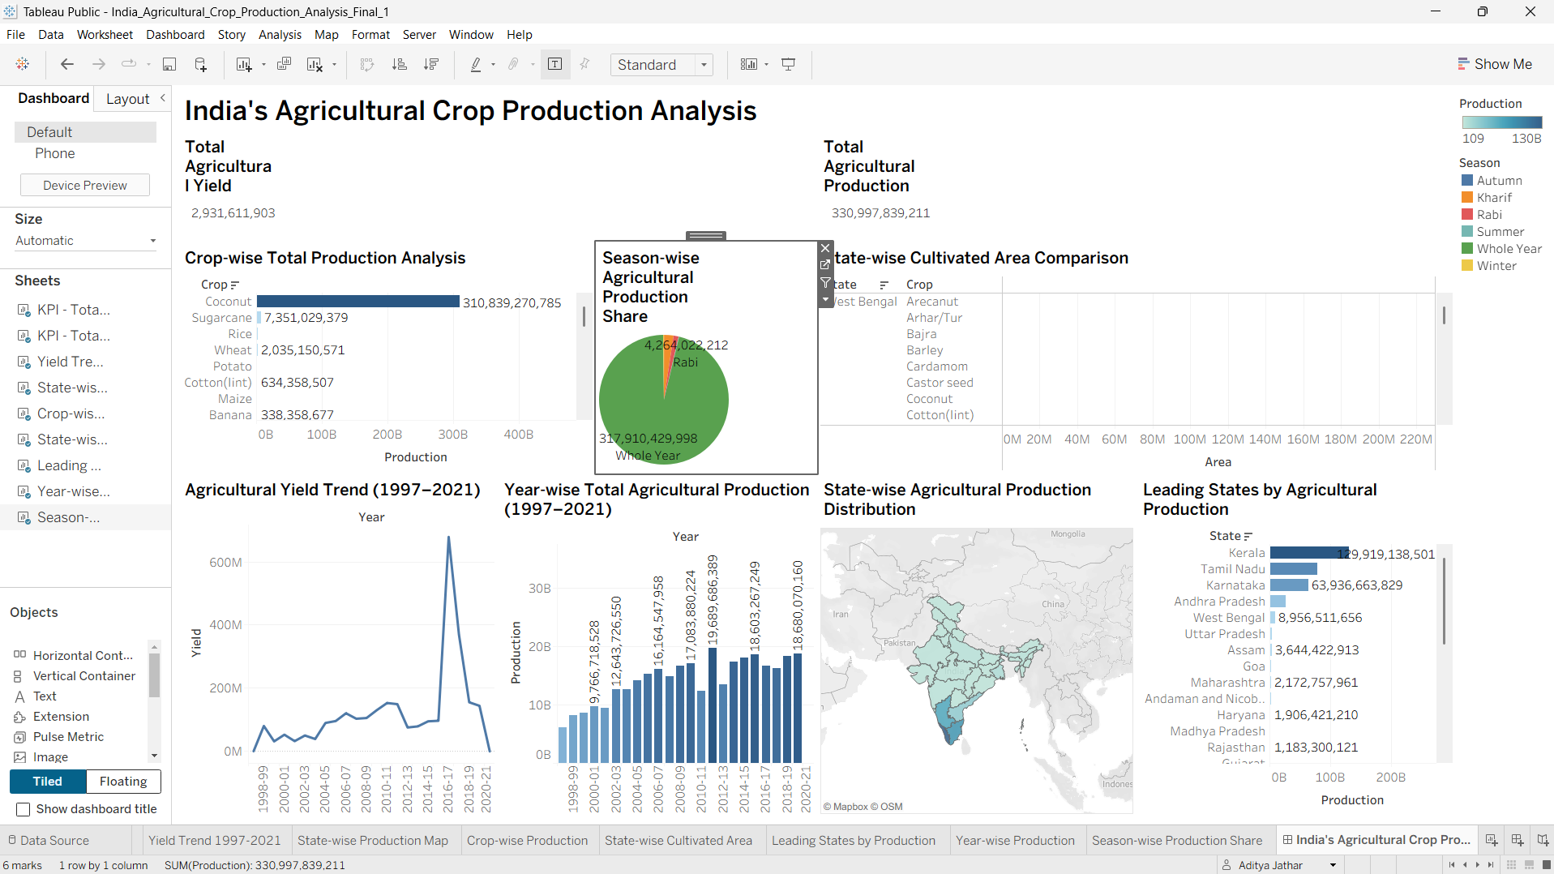
Figure: Tableau dashboard – India's Agricultural Crop Production Analysis
10. Conclusion
The completed Tableau dashboard provides a single interactive interface for analysing India's agricultural crop production. The combination of KPI cards, crop and season analysis, cultivated-area comparison, yield and production trends, geographic distribution and state ranking makes the dashboard suitable for presenting the major findings of the project clearly and efficiently.

