Phase 7: Project Demonstration

System Workflow
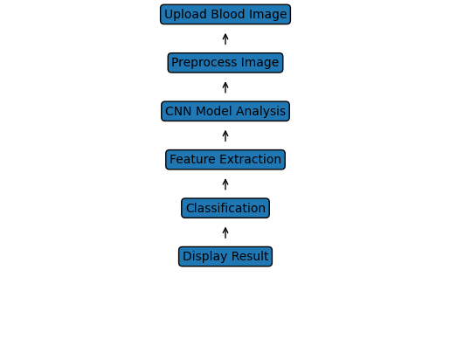
1. Upload blood smear image
2. Image preprocessing
3. CNN model analyzes the image
4. Model classifies image
5. Result displayed to the user

Application Screenshots
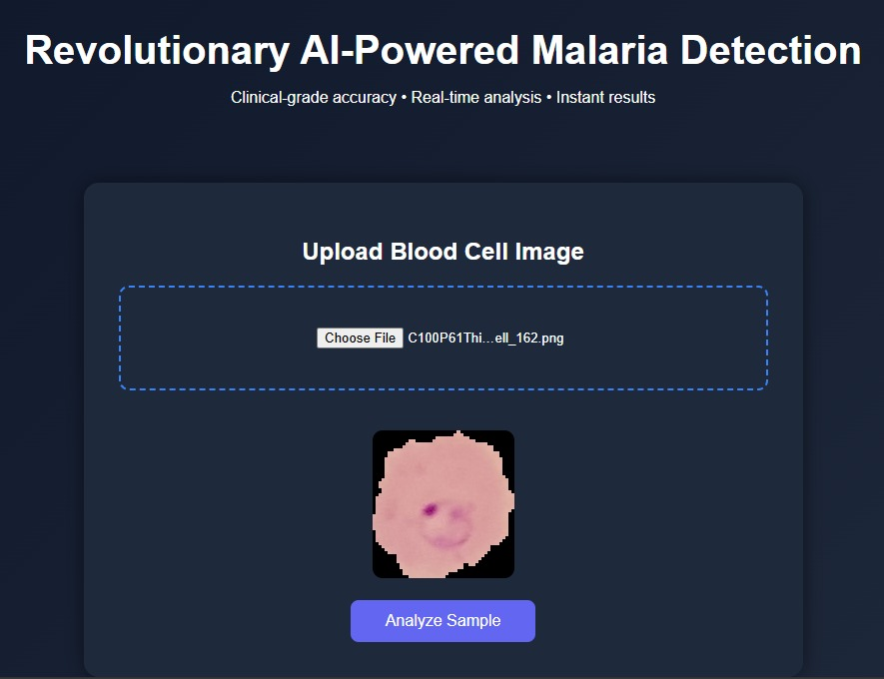
User Interface for uploading blood cell image
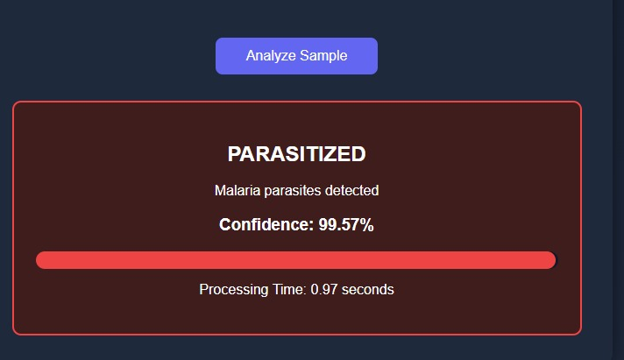
Prediction result showing malaria parasite detection

Performance Metrics
Accuracy: 94%
Precision: 93%
Recall: 92%
F1 Score: 92%

Demo Video
Google Drive Link: https://drive.google.com/file/d/1YvnFBgWn7C-coYViilKVItljTRcJ5fK_/view?usp=sharing

Project Github link
https://github.com/abhinandangoswami/Smartbridge

