# **Explorative Analysis of Factors Causing Relapse of Patients due to Alcohol within a month and three month**

Dr P.G Sunitha Hiremath  
Departmnt of Computer Science and  
Engineering  
KLE Technological University  
Hubli, Karnataka  
[pgshiremath@kletech.ac.in](mailto:pgshiremath@kletech.ac.in)

Swarna Patil   
Departmnt of Computer Science and*.*Engineering  
KLE Technological University  
Hubli, Karnataka  
[swarnalpatil@gmail.com](mailto:swarnalpatil@gmail.com)

Vaishnavi C G   
Departmnt of Computer Science and*.*Engineering  
KLE Technological University  
Hubli, Karnataka[vaishanvicg63@gmail.com](mailto:vaishanvicg63@gmail.com)

Aniket  
Departmnt of Computer Science and*.*Engineering  
KLE Technological University  
Hubli, Karnataka

[Pujarianiket502@gmail.com](mailto:Pujarianiket502@gmail.com)

Bibijan A Matte  
Departmnt of Computer Science and*.*Engineering  
KLE Technological University  
Hubli, Karnataka  
[mba45541@gmail.com](mailto:mba45541@gmail.com)

Vivek V.Pais  
SDM De – addiction and Research Center, Ujire, India[vivekvpais@gmail.com](mailto:vivekvpais@gmail.com)

*Abstract*

*Purpose*: To analyze the factors that lead a patient to relapse with a month and three due to alcoholism.

***Background***: The data used for this analysis was gathered from a local rehabilitation center, including 329 patients’ details. The dataset includes both categorical and numerical variables, providing insights into the patients' characteristics upon admission to the rehabilitation center. The correlation between the factors was found out using Spearman’s correlation coefficients.

***Findings***: Out of 329 male patients74(22.5%) relapsed within a month and 34(10.3%) relapsed within three months. Our analysis focuses on identifying factors influencing sobriety for at least three months compared to relapse within one. We found that some of the factors equally effect both the period of sober groups, such as age (majority aged 35-41), living with family (94%), SSLC education (32.2%), and mean alcohol use duration (15 years). However, differences emerge.The reasons for early relapse of sober group (0-30) isWillingness (r=-0.06, p=0.595) where as for the other group(30-90) it is increased to(r=0.118,p=0.505).Reason for sobriety of the sober group(30-90) is Risk level(r=0.0511,p=0.773).it is found to be increased for the sober group(0-30)i.e. (r=-0.181,p=0.1226) .

***PracticalImplementation***: The analysis of this report will help understand the factor responsible for the relapse of the patients. Which help for future prevention method and proper treatment.

***Keywords***: Relapse, Period of Sober, Alcohol.

# **Introduction**

Alcoholism is an addiction of a person towards excessive alcohol consumption. At a national level, approximately 2.7 percent of the population (29 million people) are affected by alcohol dependence. Puducherry (48.3%), Punjab (44 %), Andhra Pradesh (43.5 %), and Karnataka (40.3 %). With a population size of 6.7 crore Karnataka had alcohol addict count of 94.5 lakhs. The prevalence of alcohol consumption among males witnessed a slight rise, with the proportion increasing from 28.3% to 29.2% over the specified period. Furthermore, it is noteworthy that in 2005, approximately 19% of alcohol consumers acknowledged their daily drinking habits, which saw a subsequent increase to 22% in 2015.

To address the pressing issue of alcohol addiction, the Government has established dedicated rehabilitation centers. Even after taking treatment at rehab center patients tend to relapse. About 50% of patients who received treatment relapse within 3 months. There is evidence that approximately 90 percent of alcohol dependents are likely to experience at least one relapse over the 4-year period following treatment.[1]. Therefore, in this analysis we look into the factors responsible for relapse in patients.

# **Literature & Survey**

The study performed on 70 patients say that the mean age of patients was 41 and complete abstinence was shown by only 31% [2].

In the same study the mean age of first drink was 22 years. And Graduation was the educational status of the higher odds of relapse.

Studies conducted in Kerela shows that the average alcohol onset age decreased from 24 years to 17 years [5].

According to the study conducted by Ghulam it was found that the reason for starting alcohol was because of friends i.e., 93% people’s reason were friends [9].

A study conducted in Vietnam say that there was a direct relation between craving, negative emotions and maladaptive copings [3]. In article [4] authors say that the reason for relapse was desire for positive mood. Recent research has highlighted the significance of a gene-environment relationship, along with biological and psychosocial factors interact to influence an individual's relapse [4]. In the article [7,6] factor such as age, religion, marital status, unemployed, poor literacy, family type, family history are associated with relapse. Article [8] conducted studies from northern India says that the factor such as withdrawal symptoms (81.3%), inability to control urges (8%), and boredom or frustration (6.6%) are the prominent factor for relapse.

# **METHODOLOGY**

1. ***Data Collection and Description***

The data used for this analysis was gathered from a local rehabilitation center, encompassing information about 329 patients. The dataset includes both categorical and numerical variables, providing insights into the patients' characteristics upon admission to the rehabilitation.

1. ***Data Pre-processing***

As the data was raw data, it needed some processing to be done. The methods followed are

* Handling Null values
* Overcome redundancy in data
* Spelling error handling
* Grouping of values in ranges
* One hot encoding done on categorical data

In one hot encoding the attributes having categorical data that cannot be given a specific order, or that cannot be labeled under a specific name are One hot encoded. For the simplicity of our analysis this step was used,because it converted categorical data into numerical data. Performing one hot encoding on the Colum made all its tuples as new columns of the data set.

1. ***Feature Selection***

Feature Selection is on the weighted step/process in data analysis. As the name suggest feature selection is selection of the feature that go hand – in – hand with our target variable. It involves determining which variables or attributes have the most significant impact on the target variable or the outcome of interest.

The process of feature selection helps in improving the accuracy and efficiency of predictive models by reducing the dimensionality of the dataset and eliminating irrelevant or redundant features. The feature selection on this data was done using “Select K Best.” In the Select K Best method, the goal is to select the K best features from a dataset based on their statistical significance and relevance to the target variable. On performing feature selection on our data set the count of attributes decreased from 200 to 22 attributes/columns.

# **Data Analysis**

The target variable for our analysis is period of sober. Focusing on the what factor led patients to relapse with a month and within three months.

We check the statistical interpretation of the features selected with target variable.

From our analysis out of 74 people who relapsed within a month, 57(77%) of them received treatment only once. 27 out of 34 i.e., 79% relapsed within three months were treated only once.

***AGE***

**Table 1: Variation of Age with Period of Sober**

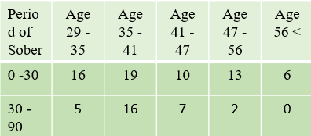

Age plays an important role for analyzing the pattern of relapse in a population. Impact of age on relapse can vary individually.

The above table (Table 1) gives us the count of the people who relapsed within a month and three and to which age group they belong. We can infer that majority of patient of age 35 – 41 relapses within a month. The same pattern is observed in patients that relapse within three months. This age people are Middle Aged.

Middle aged people go through big changes in their lives, like starting a new job, having problems in their relationships, or taking on more responsibilities with their families, it can make it harder for them to recover from their alcohol addiction [2].

***Living Arrangement***

**Table 2: Living Arrangement With Period of**

**Sober**

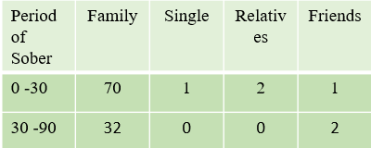

Living arrangements can have a significant impact on the relapse of individuals recovering from alcohol addiction. The environment in which a person lives plays a crucial role in their daily routines, support system, and exposure to triggers or temptations. Understanding how living arrangements affect relapse can provide valuable insights for designing effective interventions and support systems.

From table 1.1 we can see that people that relapse within a month and three months live with their family. 70/74 people who relapse within a month stay with their family. The same trend is followed by the people who relapse with three months with count as 32/34.

***Family History of Alcoholism and Marital status***

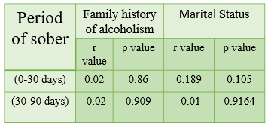

From the above analysis we found that living arrangementhas greater impact on period of sober .And Family history of alcoholism and marital status represents living status of a patient. Around 72% of patients who relapsed within a month were married, compared to 76% in the other group(30-90).We can say that family history of alcoholism also affects the period of sober.

***Education***

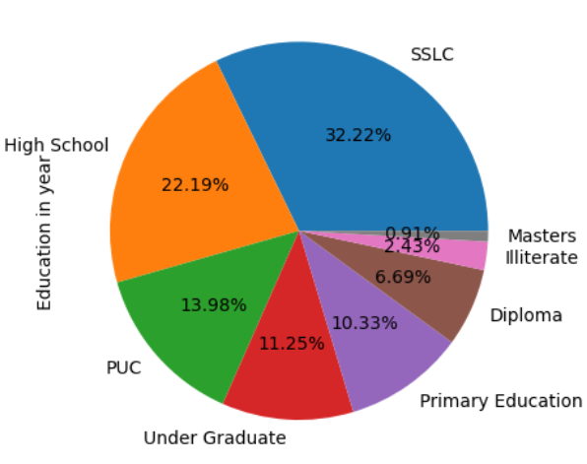

**Fig : 1.0**

Education is very important parameter which can help us understand the mentality, social behavior of a person. It cannot alone be a sole criterion for relapse as the effect of education is not same for all i.e., it changes person to person.

From our analysis we have found out that people who relapsed within a month or three have more people falling into SSLC education level.

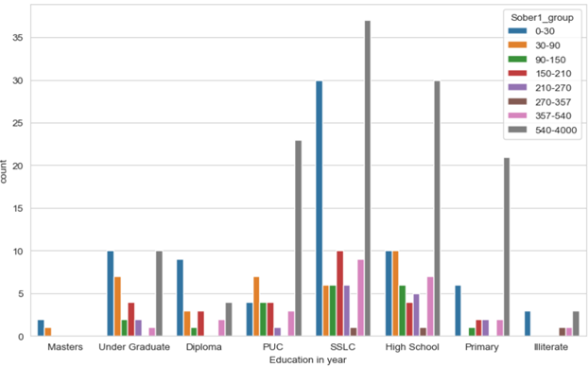

**Fig: 1.1**

***Psychiatric Problem***

***Table3: Percentage of Psychiatric Problem with Period of Sober.***

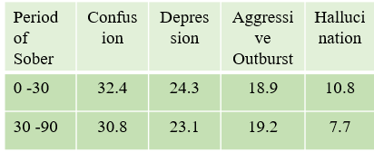

Psychiatric problem arises due to the improper functioning of the brain or some part of the brain. There are many factors that lead to dysfunction of the brain and the symptoms of this is reflected by human being.

On analysis of the data that we had, we found out that the patients suffered from various psychiatric problems. Among the patients who experienced relapse within a three-month period, it was found that 7.7% reported the presence of hallucinations as a psychiatric symptom. Similarly, for those who relapsed within one month, the percentage of patients encountering hallucinations rose slightly to 10.8%

Above table (1.2) shows what is most common psychiatric problem faced by the people who relapse within a month i.e., patients having period of sober less than 30 days. Confusion and Depression is the most common problem faced by the patients

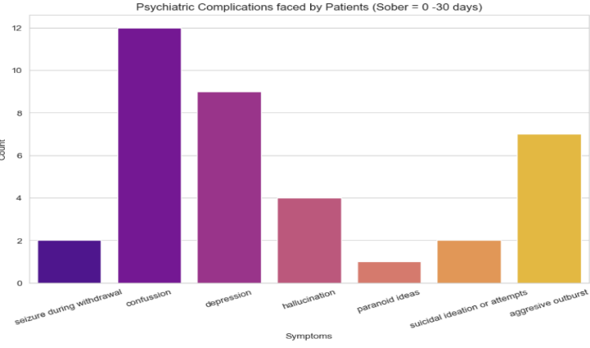

**Fig: 1.3**

Above figure shows (fig: 1.3) other psychiatric problems that face are hallucination, paranoid ideas, suicidal ideas. Chemicals present in the alcohol hinder the normal functioning of the brain. Alcohol stimulates GABA (Gamma – Aminobutyric Acid) receptors and thereby dampens the activity in the brain[1]. Paranoid idea is the reason marks the difference between two period of sober groups.

***Occupation***

***Table 4: Occupation V/s Period of Sober***

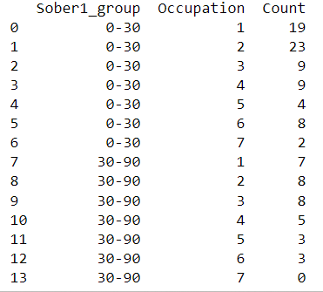

***1=Agriculturist***

***2=Worker***

***3=Coolie***

***4= Businessman***

***5= Government Job***

***6=Professional Job***

***7=Unemployed***

Occupation can have an influence on alcohol consumption patterns and behaviors. The nature of one's occupation can affect factors such as work-related stress, work-life balance, social environments, and access to alcohol, which can all impact alcohol use. Occupations that require long hours or irregular shifts may impact an individual's work-life balance.

23 out of 74 people work as worker such as daily wage workers, sweeper, watchman etc, who relapsed within a month. Speaking about patients who relapse within three months 23.5% are Worker or Coolie.

Working environment where labor/physical work is needed people belonging to that occupation tend to relief their tiredness, stress using alcohol.

The occupation that most of the patients follow who relapse within a month is Worker. If we look into the people who relapse within 3 months is that their occupation is Worker and Coolie. Count of unemployed is less in both the category.

***Reason for Staring Alcohol***

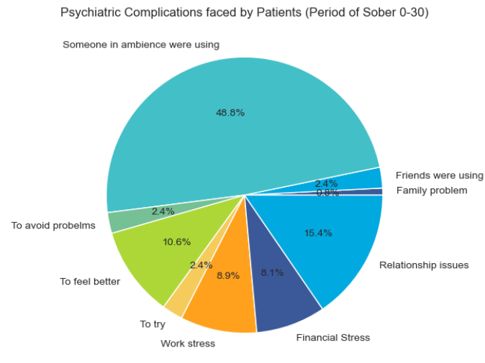

**Fig:1.4**

As we have read the article till this point question might have aroused that why do people start drinking?

Two motives for alcohol consumption have been emphasized in the etiological and the reason for drinking literature: a) people drink alcohol to cope up with stress and b) people drink alcohol because of social influence [2]. A study done by [3] says that the reason to start alcohol consumption were identified as curiosity and peer pressure.

In our analysis we found out that the reason for starting alcohol for the patients was the people in their ambience. Main reason was due to presence of alcohol in family and friends (48.9%). Also, there are 2.4% of people who started drinking out of curiosity, 10% of the people drank to overcome their emotions.

Analysis has found that the stress that is observed by most of the patients is relationship issue. 15.4% of total patient faced relationship issue, 8.1% and 8.9% of people faced financial stress and work-related stress.

***Duration of use of alcohol***

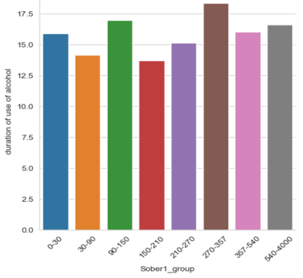

**Fig: 1.4**

From the analysis that we have done so far, we see that there is significant difference between the withdrawal symptoms and psychiatric problems faced by the patients who relapse within a month and three. The reason for this can be seen from the above bar graph where the people who relapsed within a month have more duration of use of alcohol i.e., 16 years, while people who relapsed within three months have been consuming alcohol since 14years.

***Withdrawal Symptoms***

***Table 6: % of Withdrawal Symptoms WRT period of Sober.***

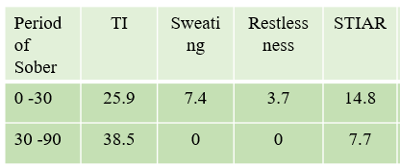

**TI = Tremorse, Insomnia**

**STIAR = Sweating, Tremors, Insomnia, Anxiety, Restlessness**

When someone with alcohol addiction abruptly stops or significantly reduces their alcohol consumption, they may experience a range of physical and psychological symptoms known as withdrawal. These symptoms arise as the body and brain adjust to the absence of alcohol, highlighting the physiological dependence that has developed [1].

From the table we see that the difference between the people who replace within a month and three is that only 7.7% patients who relapse within three months experience severe withdrawals (Tremors, Insomnia, Sweating, Anxiety, Restlessness) and this percentage increased to 14.8% who relapse with a month

Withdrawal symptoms sometime can be so intense that it will be unbearable and this might lead the patient to relapse back to consuming alcohol in more quantity than earlier.

***Major factors***

***Table 7: Correlation and level of significance of MajorFactors WRT to Period of Sober.***

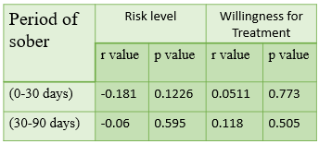

Conversely, willingness shows a positive impact on the period of sobriety, indicating its potential to support longer periods of abstinence. Moreover, the risk level of alcohol and family history of alcoholism also directly influence early relapse.

# **Conclusion**

The analysis of 329 patients' data indicates that several factors significantly influence the period of sobriety. These factors include marital status, family history of alcoholism, duration of alcohol use, age at onset of alcohol consumption (AAO), and various psychiatric issues like paranoid ideas, suicidal thoughts, depression, and aggressive outbursts. Additionally, the reasons for starting alcohol use, willingness for treatment, risk level, work-related stress, and withdrawal symptoms like insomnia and tremors play essential roles in determining the period of sobriety.

These findings suggest that achieving longer periods of sobriety can be enhanced by giving equal importance to mental health alongside other de-addiction medical treatments. By addressing the psychological aspects and providing adequate support, rehabilitation programs may yield better outcomes for individuals seeking to overcome alcohol dependency.

# **References**

1. Becker HC. Alcohol dependence, withdrawal, and relapse. Alcohol Res Health. 2008;31(4):348-61
2. Rena Stanley, Sugaparaneetharan Ayyanar, Ramanujam Venkatasamy, J. Vijay Anto. A study of factors associated with relapse of drinking during a 1 year follow-up: a retrospective cohort of 70 males treated as in-patient for alcohol dependence syndrome. International Journal of Contemporary Medicine Surgery and Radiology. 2019;4(2):B76-B79.
3. Van Trieu, N., Uthis, P. and Suktrakul, S. (2021), "Alcohol dependence and the psychological factors leading to a relapse: a hospital-based study in Vietnam", Journal of Health Research, Vol. 35 No. 2, pp. 118-131. https://doi.org/10.1108/JHR-07-2019-0157
4. Kadam M, Sinha A, Nimkar S, Matcheswalla Y, De Sousa A. A Comparative Study of Factors Associated with Relapse in Alcohol Dependence and Opioid Dependence. Indian J Psychol Med. 2017 Sep-Oct;39(5):627-633. doi: 10.4103/IJPSYM.IJPSYM_356_17. PMID: 29200559; PMCID: PMC4980898
5. Nair UR, Vidhukumar K, Prabhakaran A. Age at Onset of Alcohol Use and Alcohol Use Disorder: Time-trend Study in Patients Seeking De-addiction Services in Kerala. Indian J Psychol Med. 2016 Jul-Aug;38(4):315-9. doi: 10.4103/0253-7176.185958. PMID: 27570342; PMCID: PMC4980898.
6. Sau M, Mukherjee A, Manna N, Sanyal S. Sociodemographic and substance use correlates of repeated relapse among patients presenting for relapse treatment at an addiction treatment center in Kolkata, India. Afr Health Sci. 2013;13:791–9. [PMC free article] [PubMed] [Google Scholar]
7. Leach D, Kranzler HR. An interpersonal model of addiction relapse. Addict Disord Their Treat. 2013;12:183–92. [PMC free article] [PubMed] [Google Scholar]
8. Mattoo SK, Chakrabarti S, Anjaiah M. Psychosocial factors associated with relapse in men with alcohol or opioid dependence. Indian J Med Res. 2009;130:702–8. [PubMed] [Google Scholar]
9. Ghulam R, Rahman I, Naqvi S, Gupta SR. An epidemiological study of drug abuse in urban population of Madhya Pradesh. Indian J Psychiatry. 1996;38:160–5. [PMC free article] [PubMed] [Google Scholar]
10. [a-study-of-factors-contributing-relapse-in-alcohol-dependence-and-intra-group-comparison-for-factors-influencing-delay-in-treatment-seeking-after-relapse_December_2020_9603116961_1611779.pdf (worldwidejournals.com)](https://www.worldwidejournals.com/international-journal-of-scientific-research-(IJSR)/recent_issues_pdf/2020/December/a-study-of-factors-contributing-relapse-in-alcohol-dependence-and-intra-group-comparison-for-factors-influencing-delay-in-treatment-seeking-after-relapse_December_2020_9603116961_1611779.pdf)