# **Explorative Analysis of Factors Causing Relapse of Patients due to Alcohol within a month and three month**

Dr P.G Sunitha Hiremath   
Departmnt of Computer Science and   
Engineering  
KLE Technological University   
Hubli, Karnataka  
pgshiremath@kletech.ac.in

Swarna Patil   
Departmnt of Computer Science and*.*Engineering  
KLE Technological University   
Hubli, Karnataka  
swarnalpatil@gmail.com

Vaishnavi C G   
Departmnt of Computer Science and*.*Engineering  
KLE Technological University   
Hubli, Karnatakavaishanvicg63@gmail.com

Aniket  
Departmnt of Computer Science and*.*Engineering  
KLE Technological University   
Hubli, Karnataka

Bibijan A Matte  
Departmnt of Computer Science and*.*Engineering  
KLE Technological University   
Hubli, Karnataka  
mba45541@gmail.com

Vivek V.Pais  
SDM De – addiction and Research Center, Ujire, Indiavivekvpais@gmail.com

*Abstract-*

This report presents an in-depth analysis of the factors contributing to relapse among patients with alcohol addiction, based on a comprehensive research methodology involving the collection of data from individuals undergoing alcohol addiction treatment programs in a rehab center.

Out of 329 patients, 74 (22.5%) had a period of sober between 0-30 days, while 34 (10.3%) had a period of sober between 30 -90 days. The majority of patients in both groups were aged between 35 and 41. 94% of patients in the former and latter groups lived with their families. Among patients who relapsed within one month, 32.4% experienced psychiatric complications such as confusion and depression. Similarly, among patients who relapsed within three months, 30.8% faced the same psychiatric problems. This complication may be due to the working environment as 31.08% patients who relapsed within a month and 23.5% who relapsed within three months worked as laborers, daily wage workers, sweepers. If we dig down deeper for the reason for starting alcohol consumption, we see that the people in our ambience affect our behavior. 48.8% who relapsed within a month started drinking alcohol due to influence of the family or friends, same pattern is observed by patients who relapse within three months. During the de-addiction process, 25.9% of those who relapsed within a month and 38.5% of those who relapsed within three months experienced t

The difference between the people who replace within a month and three is that only 7.7% patients who relapse within three months experience severe withdrawals (Tremors, Insomnia, Sweating, Anxiety, Restlessness) and this percentage increased to 14.8% who relapse within a month. For those who relapse within three months, 7.7% report hallucinations, while the percentage slightly increases to 10.8% for those who relapse within one month. These differences may be due to duration of alcohol consumption, with those who relapse within one month having a longer duration (around 16 years) compared to those who relapse within three months (around 14 years). The percentage of withdrawals and psychiatric is more in people relapsed within one month may be because 32% of patients have taken treatment for 8 days, this in another group increases to 38%. 10% of the former group were at the high-risk level of ethanol (>300) content, while the later group percentage was 2%. Among those who relapse within one month, 68% consumed nicotine, with 35% reporting consumption in the form of gutka and 18% in form of cigarettes. Similarly, among those who relapse within three months, around 64% consumed nicotine, with 29% consuming gutka, 26% consuming cigarettes.

The analysis of this report will help understand the factor responsible for relapse of the patients. Which help for future prevention method and proper treatment.

.

# **Introduction**

Addiction is a condition that arises due to frequent high consumption of substance leading to dependency, craving on that substance. It is a neuropsychological disorder where in body indulge itself in unethical behavior providing short term sensory rewards despite knowing the harmful consequence.

Alcoholism is addiction of a person towards excessive alcohol consumption. At a national level, approximately 2.7 percent of the population (29 million people) are affected by alcohol dependence. Puducherry (48.3%), Punjab (44 %), Andhra Pradesh (43.5 %), and Karnataka (40.3 %), over 40 percent of alcohol consumers exhibit patterns of alcohol dependence. With a population size of 6.7 crore Karnataka had alcohol addict count of 94.5 lakhs. The prevalence of alcohol consumption among males witnessed a slight rise, with the proportion increasing from 28.3% to 29.2% over the specified period. Furthermore, it is noteworthy that in 2005, approximately 19% of alcohol consumers acknowledged their daily drinking habits, which saw a subsequent increase to 22% in 2015.

To address the pressing issue of alcohol addiction, the Government has established dedicated rehabilitation centers. These centers provide support and treatment to individuals struggling with alcohol addiction, offering services such as detoxification, counseling, therapy, and skill-building programs. This initiative reflects the government's commitment to tackling alcohol addiction and promoting recovery for those in need.

# **Literature and Survey**

In the article [5,6] factor such as age, religion, marital status, unemployed, poor literacy, family type, family history are associated with relapse. Article [7,8] conducted studies from northern India says that the factor such as withdrawal symptoms (81.3%), inability to control urges (8%), and boredom or frustration (6.6%) are the prominent factor for relapse.

Alcohol is often used as a coping mechanism for stress relief, but there is limited understanding of the individual factors and how the relationship between stress and alcohol use unfolds over time. It is revealed that stress-induced alcohol consumption is influenced by age, has a significant genetic component, and arises from the interplay between the stress and reward systems. [10]

According to the study conducted by Ghulam it was found that the reason for starting alcohol was because of friends i.e., 93% people’s reason were friends [4].

Studies performed in article [6] state that 50% – 70% of the patient are unable to remain abstinent during after one year of treatment.

Article [9] study examined the association of the relapse with the clinical parameter and psychosocial factors.

Our Analysis is based on the niche data. It helps realize the relapse pattern of the ambience. Our analysis also included model building process.

# **METHODOLOGY**

1. ***Problem Statement***

Even after putting efforts to reduce alcohol addiction and undergoing treatment for that cause, many numbers of patient return back to alcohol consumption(relapse). Therefore, analyzing the cause/factors that lead patient to relapse.

1. ***Data Collection and Description***

The data for the analysis has been collected from a local rehabilitation center. The data is categorical and numerical having information about the patient during their admission in the rehabilitation center, during their stay in the rehabilitation center. This data has male information and total number of patients is 329. Also the data tells us about the treatment, care given to the patient during its period of stay.

1. ***Data Preprocessing***

As the data was raw data, it needed some processing to be done. The methods followed are

* Handling Null values
* Overcome redundancy in data
* Spelling error handling
* Grouping of values in ranges
* One hot encoding done on categorical data

In one hot encoding the attributes having categorical data that cannot be given a specific order, or that cannot be labeled under a specific name are One hot encoded. For the simplicity of our analysis this step was use cause it converted categorical data into numerical data. Performing one hot encoding on the Colum made all its tuples as new columns of the data set.

1. ***Feature Selection***

Feature Selection is on the weighted step/process in data analysis. As the name suggest feature selection is selection of the feature that go hand – in – hand with out target variable. It involves determining which variables or attributes have the most significant impact on the target variable or the outcome of interest.

The process of feature selection helps in improving the accuracy and efficiency of predictive models by reducing the dimensionality of the dataset and eliminating irrelevant or redundant features. The feature selection on this data was done using “Select K Best”. In the Select K Best method, the goal is to select the K best features from a dataset based on their statistical significance and relevance to the target variable. On performing feature selection on our data set the count of attributes decreased from 200 to 22 attributes/columns.

1. ***Model Building***

Model building is a crucial part of data analysis. It involves constructing a predictive model that help us relate and understand the relation between various variable and target variable.

Model was build using two algorithms that are GaussianNB, and KNN Classifier. In KNN classifier the model finds the nearest neighbor to the incoming variable and labels it accordingly.

# **Data Analysis**

The target variable for our analysis is period of sober. Focusing on the what factor led patients to relapse with a month and within three months.

We check the statistical interpretation of the features selected with target variable

***AGE***

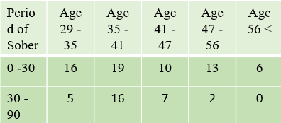

**Table : 1.0**

Age plays a important role for analyzing the pattern of relapse in a population. Impact of age on relapse can vary individually.

The above table (Table 1) gives us the count of the people who relapsed within a month and three and to which age group they belong. We can infer that majority of patient of age 35 – 41 relapses within a month. The same pattern is observed in patients that relapse within three months. This age people are Middle Aged.

Middle aged people go through big changes in their lives, like starting a new job, having problems in their relationships, or taking on more responsibilities with their families, it can make it harder for them to recover from their alcohol addiction[2].

***Living Arrangement***

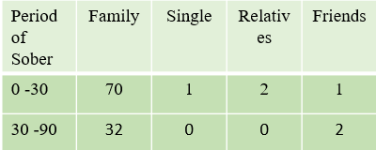

**Table : 1.1**

Living arrangements can have a significant impact on the relapse of individuals recovering from alcohol addiction. The environment in which a person lives plays a crucial role in their daily routines, support system, and exposure to triggers or temptations. Understanding how living arrangements affect relapse can provide valuable insights for designing effective interventions and support systems

From table 1.1 we can see that people that relapse within a month and three months live with their family. 70/74 people who relapse within a month stay with their family. The same trend is followed by the people who relapse with three months with count as 32/34.

***Education***

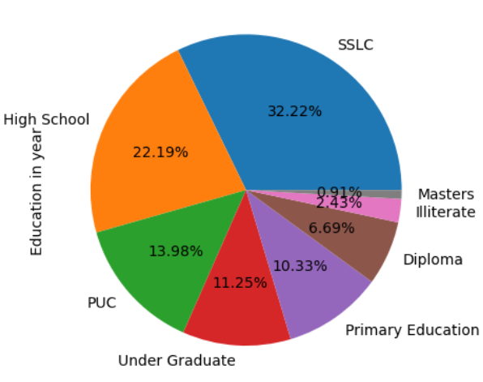

**Fig : 1.0**

Education is very important parameter which can help us understand the mentality, social behavior of a person. It cannot alone be a sole criteria for relapse as the effect of education is not same for all i.e., it changes person to person.

From our analysis we have found out that people who relapsed withing a month or three have more people falling into SSLC education level.

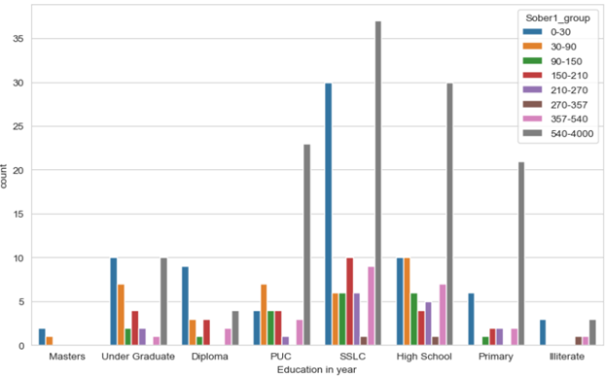

**Fig: 1.1**

***Psychiatric Problem***

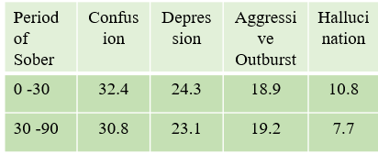

**Table: 1.2**

Psychiatric problem arises due to the improper functioning of the brain or some part of the brain. There are many factors that lead to dysfunction of the brain and the symptoms of this is reflected by human being.

On analysis of the data that we had, we found out that the patients suffered from various psychiatric problems. Among the patients who experienced relapse within a three-month period, it was found that 7.7% reported the presence of hallucinations as a psychiatric symptom. Similarly, for those who relapsed within one month, the percentage of patients encountering hallucinations rose slightly to 10.8%

Above table(1.2) shows what is most common psychiatric problem faced by the people who relapse within a month i.e. patients having period of sober less than 30 days. Confusion and Depression is the most common problem faced by the patients

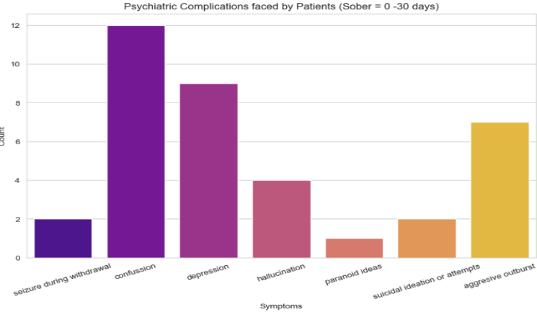

**Fig: 1.3**

Above figure shows (fig: 1.3) other psychiatric problems that face are hallucination, paranoid ideas, suicidal ideas. Chemicals present in the alcohol hinder the normal functioning of the brain. Alcohol stimulates GABA(Gamma – Aminobutyric Acid) receptors and thereby dampens the activity in the brain.[1].

***Occupation***

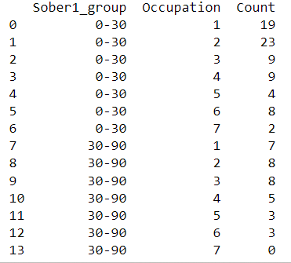

***1=Agriculturist 2=Worker 3=Coolie 4= Businessman***

***5= Government Job 6=Professional Job 7=Unemployed***

**Table: 1.2**

Occupation can have an influence on alcohol consumption patterns and behaviors. The nature of one's occupation can affect factors such as work-related stress, work-life balance, social environments, and access to alcohol, which can all impact alcohol use. Occupations that require long hours or irregular shifts may impact an individual's work-life balance

23 out of 74 people work as worker such as daily wage workers, sweeper, watchman etc, who relapsed within a month. Speaking about patients who relapse within three months 23.5% are Worker or Coolie

Working environment where labor/physical work is needed people belonging to that occupation tend to relief their tiredness, stress using alcohol.

The occupation that most of the patients follow who relapse within a month is Worker. If we look into the people who relapse within 3 months is that their occupation is Worker and Coolie. Count of unemployed is less in both the category.

***Reason for Staring Alcohol***

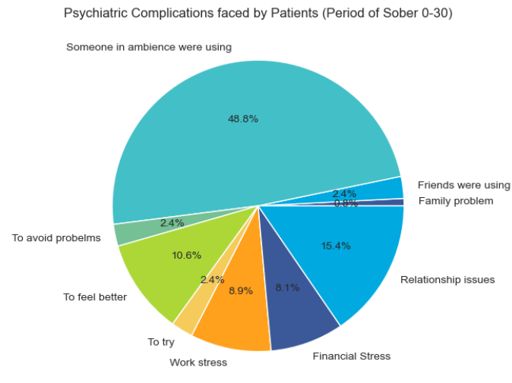

**Fig: 1.4**

As we have have read the article till this point question might have arise that why do people start drinking?

Two motives for alcohol consumption have been emphasized in the etiological and the reason for drinking literature: a) people drink alcohol to cope up with stress and b) people drink alcohol because of social influence[2]. A study done by [3] says that the reason to start alcohol consumption were identified as curiosity and peer pressure.

In our analysis we found out that the reason for starting alcohol for the patients was the people in their ambience. Main reason were due to presence of alcohol in family and friends (48.9%). Also there are 2.4% of people who started drinking out of curiosity, 10% of the people drank to overcome their emotions.

Analysis has found that the stress that is observed by most of the patients is relationship issue. 15.4% of total patient faced relationship issue, 8.1% and 8.9% of people faced financial stress and work-related stress.

***Duration of use of alcohol***

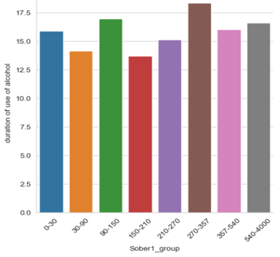

**Fig : 1.4**

From the analysis that we have done so far, we see that there is significant difference between the withdrawal symptoms and psychiatric problems faced by the patients who relapse within a month and three. The reason for this can be seen from the above bar graph where the people who relapsed within a month have more duration of use of alcohol i.e.,. 16 years, while people who relapsed within three months have been consuming alcohol since 14years.

***Treatment Period***

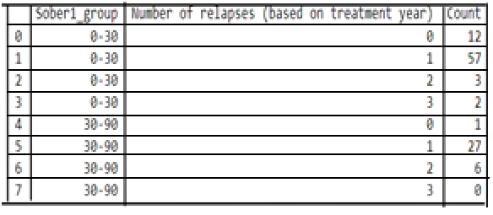

**Table: 1.3**

Services at rehabilitation center includes support and treatment to the patient admitted in there. The treatment varies from one patient to another patient. From the above table we can infer that period of treatment taken does have role to play in relapse of a patient. It is seen that the patient who receive treatment once have more likely chances to relapse with a month or three.

From our analysis out of 74 people who relapsed within a month, 57(77%) of them received treatment only once. 27 out of 34 i.e., 79% relapsed within three months were treated only once.

***Withdrawal Symptoms***

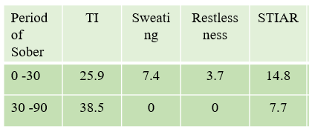

**TI = Tremorse, Insomnia**

**STIAR = Sweating, Tremors, Insomnia, Anxiety, Restlessness**

**Fig: 1.5**

When someone with alcohol addiction abruptly stops or significantly reduces their alcohol consumption, they may experience a range of physical and psychological symptoms known as withdrawal. These symptoms arise as the body and brain adjust to the absence of alcohol, highlighting the physiological dependence that has developed [1].

From the table we see that the difference between the people who replace within a month and three is that only 7.7% patients who relapse within three months experience severe withdrawals(Tremors, Insomnia, Sweating, Anxiety, Restlessness) and this percentage increased to 14.8% who relapse with a month

Withdrawal symptoms sometime can be so intense that it will be unbearable and this might lead the patient to relapse back to consuming alcohol in more quantity than earlier.

***Model Building***

Model Building is done to extract useful knowledge about the data. The model was build using Machine Learning algorithms such as K-Nearest Neighbour, GaussianNB.

In this phase the data is divided into training data and test data. 70% of our data was used to train the model and rest 30% data was to test the correctness of the model.

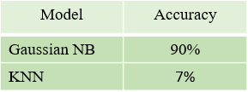

**Table: 1.5**

# **Conclusion**

This analysis has shown that what factor help or are the cause for patient to relapse early.

We have seen Withdrawal symptoms, Psychiatric problems, social relation, workplace ambience, age , educational level as the factor that lead to the early relapse of the patients.

the study showed that people who relapsed within one month after stopping alcohol had more severe withdrawal symptoms like tremors, insomnia, sweating, anxiety, and restlessness. They also reported experiencing hallucinations, more often compared to those who relapsed within three months. The main reason for these differences seems to be the length of time they had been drinking alcohol. Those who relapsed sooner had been drinking for around 16 years, while those who relapsed later had been drinking for about 14 years. These analysis shoes the importance of considering withdrawal symptoms, psychiatric factors, and the duration of alcohol use when helping people recover from addiction. By addressing these factors in treatment and support, we can improve the chances of long-term recovery.

## **References**

1. https://www.candi.nhs.uk/news/unhealthy-mix-between-alcohol-and-mental-health
2. @article{ABBEY1993659,

title = {The relationship between reasons for drinking alcohol and alcohol consumption: An interactionalapproach}, <https://www.sciencedirect.com/science/article/pii/0306460393900196>

1. Blomqvist J. Treated and untreated recovery from alcohol misuse: Environmental influences and perceived reasons for change. Subst Use Misuse. 1999;34:1371–406. [PubMed] [Google Scholar]
2. Ghulam R, Rahman I, Naqvi S, Gupta SR. An epidemiological study of drug abuse in urban population of Madhya Pradesh. Indian J Psychiatry. 1996;38:160–5. [PMC free article] [PubMed] [Google Scholar]
3. Sau M, Mukherjee A, Manna N, Sanyal S. Sociodemographic and substance use correlates of repeated relapse among patients presenting for relapse treatment at an addiction treatment center in Kolkata, India. Afr Health Sci. 2013;13:791–9. [PMC free article] [PubMed] [Google Scholar]
4. Leach D, Kranzler HR. An interpersonal model of addiction relapse. Addict Disord Their Treat. 2013;12:183–92. [PMC free article] [PubMed] [Google Scholar]
5. Maulik PK, Pal HR, Tripathi BR, Pandey RM. Reason for relapse in opioid dependent subjects. J Subst Abuse Treat. 2002;22:135–40. [PubMed] [Google Scholar]
6. Mattoo SK, Chakrabarti S, Anjaiah M. Psychosocial factors associated with relapse in men with alcohol or opioid dependence. Indian J Med Res. 2009;130:702–8. [PubMed] [Google Scholar]
7. Chauhan VS, Nautiyal S, Garg R, Chauhan KS. To identify predictors of relapse in cases of alcohol dependence syndrome in relation to life events. Ind Psychiatry J. 2018 Jan-Jun;27(1):73-79. doi: 10.4103/ipj.ipj_27_18. PMID: 30416295; PMCID: PMC6198591.
8. Antonia Abbey, Mary Jo Smith, Richard O. Scott,

The relationship between reasons for drinking alcohol and alcohol consumption: An interactional approach,

<https://doi.org/10.1016/0306-4603(93)90019-6>.

(https://www.sciencedirect.com/science/article/pii/0306460393900196)

**IEEE conference templates contain guidance text for composing and formatting conference papers. Please ensure that all template text is removed from your conference paper prior to submission to the conference. Failure to remove template text from your paper may result in your paper not being publishe**