Cricket Player Performance Tracking Application : CRICKSTATS

NAME:VAISHNAVI D

COLLEGE NAME:ARIGNAR ANNA GOVT.ARTS AND SCIENCE COLLEGE FOR WOMEN

COLLEGE CODE:TVU304
NM ID:5320377B7CBA821B6F94ACAB55EC597E
TEAM MEMBERS:
1.KAVIYA.G
2.KHADERMA.M
4.PAVITHRA.I
3.SHALINI.S

User Story
As a Salesforce Admin, I want to create a comprehensive Cricket Player Performance Tracking Application within Salesforce to capture, manage, and analyze detailed match-by-match performance information of cricket players. The application will include custom objects such as Player and Match Performance, with carefully defined fields and relationships to maintain accurate and organized player statistics. By utilizing Master-Detail and Lookup relationships, the application will enable efficient tracking of individual player performances, match statistics, and team-related information. It will also support reports and dashboards for analyzing player performance, identifying trends, comparing statistics, and generating meaningful insights. This application will help coaches, team managers, and administrators make data-driven decisions and support effective player development and performance management.

1. INTRODUCTION
1.1 Project Overview :
CRICKSTATS is a Salesforce-based Cricket Player Performance Tracking Application developed to efficiently record, manage, monitor, and analyze the performance of cricket players across different matches. The application provides a centralized platform for maintaining detailed player profiles and match-wise performance statistics in a structured and organized manner.
The system utilizes custom objects, fields, Master-Detail and Lookup relationships, reports, dashboards, and Salesforce automation features to maintain accurate and accessible cricket performance data. It enables administrators and team management to record important statistics such as runs, wickets, overs, catches, strike rate, economy rate, and other relevant match-performance details.
CRICKSTATS helps coaches, analysts, and administrators easily monitor individual and team performance, identify performance trends, generate meaningful reports, and visualize statistics through dashboards. By providing organized and data-driven insights, the application supports effective performance analysis, player development, team management, and strategic decision-making.

1.2 Purpose :
The main purpose of the CRICKSTATS – Cricket Player Performance Tracking Application is:
- To digitize and maintain detailed cricket player performance records.
- To improve the accuracy, consistency, and accessibility of match statistics.
- To provide efficient performance analysis through reports and dashboards.
- To track and monitor player performance on a match-by-match basis.
- To support player development and effective team planning.
- To identify performance trends and generate meaningful statistical insights.
- To reduce manual data entry and improve data management.
- To utilize Salesforce features and automation for efficient performance tracking

2. IDEATION PHASE
2.1 Problem Statement (Customer Problem Statement Template)

Problem Statement (PS) | I am (Customer) | I’m trying to | But | Because | Which makes me feel
PS-1 | A cricket team coach | Monitor player performance across multiple matches | It is difficult to access complete and accurate performance statistics quickly | Player data is maintained manually in different files and records | Difficult to make timely performance-based decisions
PS-2 | A team manager | Maintain and update complete player and match records | Managing and verifying large amounts of data is time-consuming | Most performance records are entered and maintained manually | Time-consuming and inefficient
PS-3 | A sports analyst | Analyze player statistics and identify performance trends | Comparing player performances across different matches is difficult | There is no centralized system for organizing and analyzing performance data | Difficulty in generating meaningful performance insights
PS-4 | A cricket administrator | Generate reports and dashboards for player performance | Preparing reports manually requires additional effort | Performance information is not available in a single centralized platform | Delayed reporting and reduced efficiency
PS-5 | A player development coordinator | Track individual player progress over time | It is difficult to identify consistent performance patterns | Historical match-by-match statistics are not organized effectively | Difficulty in planning player development activities

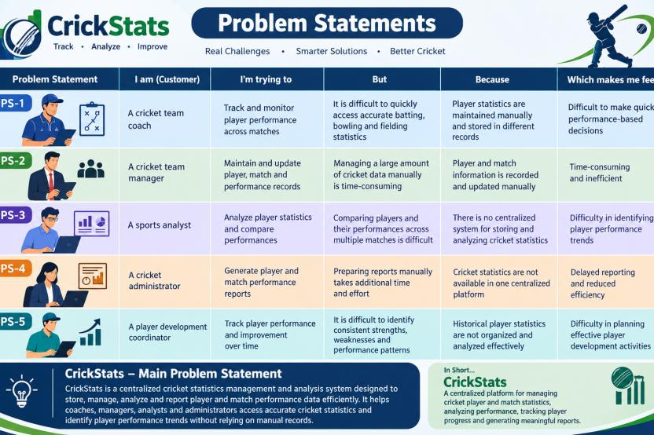

2.2 Empathy Map Canvas
Target Users
- Team Managers
- Coaches
- Analysts
- Salesforce Admins
Empathy Analysis
Aspect Description
- Think & Feel: Need accurate data, better insights
- Hear: Feedback from management
- See: Multiple data sources
- Say & Do: Collect statistics manually
- Pain: Data errors, delays
- Gain: Faster decisions, automation
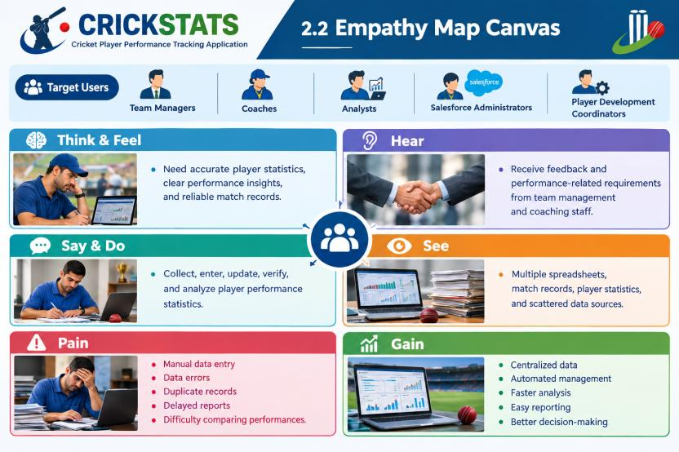

2.3 Brainstorming
During the brainstorming phase, several possible solutions were identified to improve cricket player performance management, statistical tracking, and analysis.
Brainstormed Ideas
- Web-Based Player Management System – Manage player profiles, match records, and performance information through a web application.
- Mobile Statistics Tracker – Provide quick access to player statistics and match-wise performance through a mobile-friendly platform.
- Salesforce-Integrated CRM – Use Salesforce to centrally manage player information, performance records, and related data.
- AI-Based Performance Prediction – Analyze historical statistics to identify performance patterns and provide predictive insights.
- Dashboard-Based Analytics – Present player statistics through interactive reports, charts, and dashboards for easier analysis.
Selected Idea
Salesforce-Based Cricket Player Performance Tracking Platform (CRICKSTATS)
The selected idea is CRICKSTATS, a Salesforce-based platform designed to centralize player information, record match-wise performance, generate reports and dashboards, and support efficient cricket performance analysis.

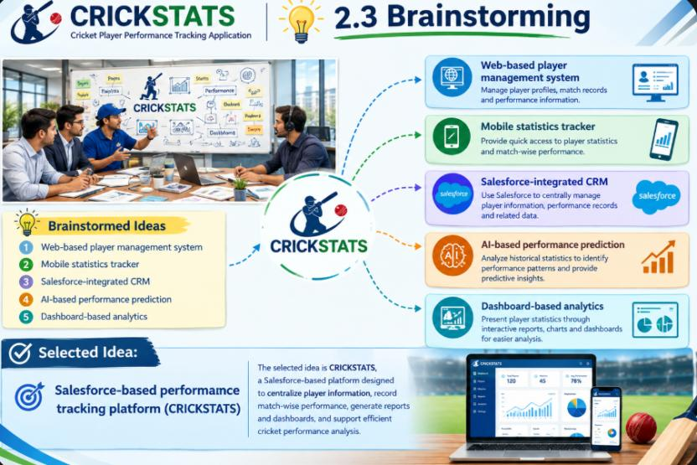

3.REQUIREMENT ANALYSIS PHASE

3.1 Customer Journey Map
The Customer Journey Map describes the step-by-step experience of users while using the CRICKSTATS – Cricket Player Performance Tracking Application, from accessing the system to making performance-based decisions.
Journey Stages:
- Login
- Enter Player Data
- Record Match Performance
- Generate Reports
- Analyze Results
- Decision Making

Journey Stage | User Activity | User Need / Outcome
1. Login & Access | User logs into the CRICKSTATS Salesforce application. | Secure and authorized access to the system.
2. Manage Player Information | User enters and updates player profiles and basic details. | Maintain accurate and organized player records.
3. Record Match Performance | User records match-wise statistics such as runs, wickets, overs, catches, and other performance details. | Maintain complete and accurate performance data.
4. Generate Reports & Dashboards | User generates reports and views performance dashboards. | Obtain clear and structured statistical information.
5. Analyze Performance | User compares player statistics and identifies performance trends. | Understand player strengths, weaknesses, and progress.
6. Performance-Based Decision Making | Coaches, managers, and analysts use the insights to support team planning and player development. | Make informed decisions based on reliable performance data.

Customer Journey Flow:
Login → Manage Player Information → Record Match Performance → Generate Reports & Dashboards → Analyze Performance → Performance-Based Decision Making

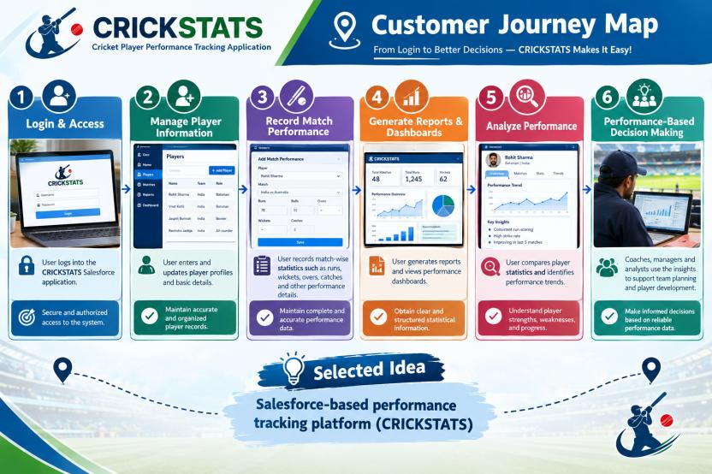

3.2 Solution Requirements
The proposed CRICKSTATS – Cricket Player Performance Tracking Application provides the following functional requirements to efficiently manage player information, record match performance, analyze statistics, and support performance-based decision-making.
Functional Requirements
FR No | Requirement | Description
FR-1 | Player Profile Management | Allows authorized users to create, view, update, and manage complete player profiles and relevant details.
FR-2 | Match Performance Recording | Enables users to record and maintain match-wise player statistics such as runs, wickets, overs, catches, and other performance details.
FR-3 | Dashboard Generation | Provides interactive dashboards to display player statistics, performance summaries, comparisons, and trends.
FR-4 | Performance Reports | Enables users to generate detailed reports based on player, match, and team performance for easy analysis and reference.
FR-5 | Salesforce Flow Automation | Automates important processes such as data validation, record updates, notifications, and other performance-tracking activities using Salesforce Flow.

Non-Functional Requirements (NFRs) – CRICKSTATS
The CRICKSTATS – Cricket Player Performance Tracking Application should satisfy the following non-functional requirements to ensure that the system is user-friendly, secure, reliable, efficient, and scalable.

NFR-1: Usability
The system should provide a simple and intuitive interface that allows coaches, managers, analysts, and administrators to use the application efficiently without extensive technical knowledge.
Requirements:
- Simple and user-friendly interface
- Clear navigation and organized menus
- Easy-to-understand forms and dashboards
- Minimal learning time
- Consistent interface across the application
Example:
A new coach should be able to log in, access player records, enter match performance, and view reports with minimal guidance.

NFR-2: Security
The system should protect player information and performance records from unauthorized access or modification.

Requirements:
- User authentication
- Role-based access control
- Appropriate permissions for different users
- Secure management of player and match data
- Regular data backup
Example:
Coaches and analysts can access performance information according to their assigned permissions, while administrators can manage system configuration and user access.

NFR-3: Reliability
The system should consistently perform its intended functions and maintain accurate player and match records.
Requirements:
- Accurate data storage
- Error handling and validation
- Data backup and recovery
- Prevention of duplicate or invalid records
- Stable system operation
Example:
When match performance details are submitted, the system should validate the information and store the record correctly without data corruption.

NFR-4: Performance
The system should provide quick responses while processing player records, match statistics, reports, and dashboards.

Requirements:
- Fast page and record loading
- Quick report generation
- Efficient dashboard performance
- Optimized data retrieval
- Minimal response delay
Example:
When an analyst requests a player performance report, the system should retrieve and display the required statistics within a reasonable response time.

NFR-5: Availability
The system should remain accessible to authorized users whenever performance information is required.
Requirements:
- High system availability
- Minimal service interruption
- Cloud-based accessibility
- Backup and recovery mechanisms
- Reliable access through supported devices
Example:
Coaches and analysts should be able to access CRICKSTATS whenever they need player statistics for match preparation or performance analysis.

NFR-6: Scalability
The system should be capable of handling an increasing number of players, teams, matches, and performance records without significantly affecting system performance.

Requirements:
- Support increasing amounts of player data
- Accommodate multiple teams and competitions
- Handle growing performance records
- Support additional reports and dashboards
- Maintain efficient performance as data volume increases

Example:
If CRICKSTATS expands from managing a single team to multiple teams and leagues, the application should continue to manage player and match data efficiently.

3.3 Data Flow Diagram
Data Flow
User → Salesforce UI → Player Object → Match Performance → Reports → Dashboard

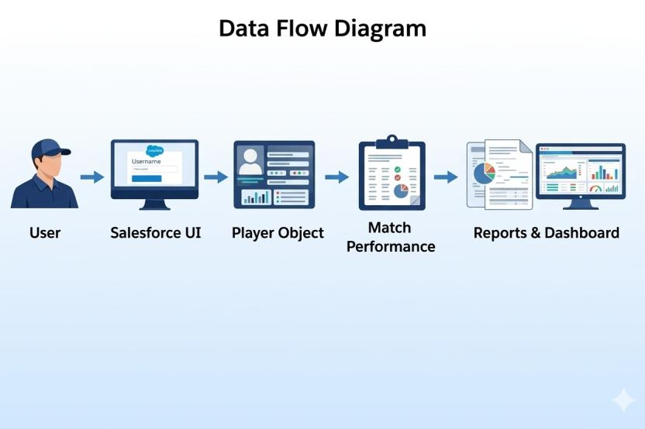
3.4 Technology Stack
The CRICKSTATS – Cricket Player Performance Tracking Application is developed using Salesforce platform technologies to manage player information, record match performance, automate processes, and analyze performance data.
Layer | Technology | Purpose
User Interface | Salesforce Lightning Experience | Provides a user-friendly interface for managing player and match information.
Application Platform | Salesforce Platform | Provides the core environment for developing and managing the CRICKSTATS application.
Data Management | Salesforce Custom Objects | Stores player profiles, match details, and performance records in a structured manner.
Database / Storage | Salesforce Cloud Database | Provides centralized cloud-based storage for application data.
Analytics | Salesforce Reports & Dashboards | Generates reports, charts, and visual performance insights.
Automation | Salesforce Flow | Automates record updates, validation, notifications, and other business processes.
Security | Salesforce Profiles & Permission Sets | Controls user access and protects application data based on user roles.

Technology Stack Summary
Salesforce Lightning → Salesforce Platform → Custom Objects → Salesforce Cloud → Reports & Dashboards → Salesforce Flow → Profiles & Permission Sets
This technology stack enables CRICKSTATS to provide a centralized, secure, automated, and efficient platform for cricket player performance tracking and analysis.

4. PROJECT DESIGN PHASE

4.1 Problem–Solution Fit
The CRICKSTATS – Cricket Player Performance Tracking Application is designed to address the major challenges involved in traditional cricket performance management. The system provides a structured and centralized approach to managing player profiles, match records, and performance statistics.Traditional methods of maintaining player and match information through spreadsheets or manual records can result in data duplication, entry errors, difficulty in updating records, and time-consuming management. CRICKSTATS addresses these issues by using Salesforce Custom Objects and automated processes for organized and consistent data management.The challenge of scattered performance information is addressed by maintaining player and match records in a centralized Salesforce environment. This allows authorized users to easily access and update relevant information.To overcome difficulties in performance analysis, CRICKSTATS uses Salesforce Reports and Dashboards to present player statistics in a clear and meaningful format. Users can review match-wise performance, compare statistics, and identify performance trends more efficiently.
The system also reduces the effort involved in manual report preparation and routine data management through Salesforce Flow automation. Automated processes help improve efficiency and maintain consistency across records.
Overall, CRICKSTATS provides a centralized, secure, automated, and data-driven solution that connects traditional cricket performance management challenges with modern Salesforce-based technology.
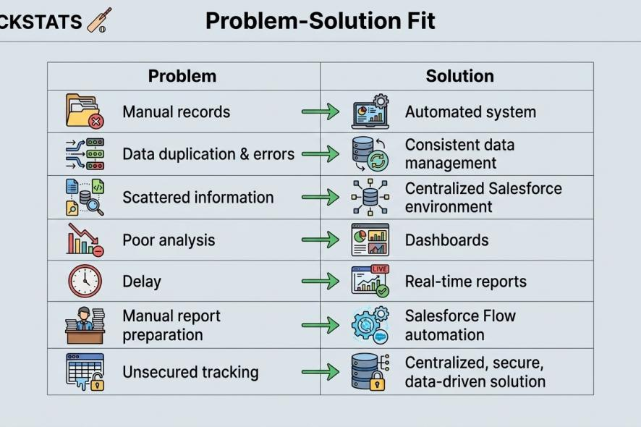

4.2 Proposed Solution
Description
CRICKSTATS provides:
- Custom objects (Player, Match Performance)
- Master-detail relationships
- Roll-up summaries
- Lightning App
- Automated flows
- Interactive dashboards

Key Features

Centralized database

Live statistics

Secure access

Scalable design

Easy reporting

4.3 Solution Architecture
Architecture Layers
- Presentation Layer (Lightning UI)
- Application Layer (Flows, Logic)
- Data Layer (Objects)
- Analytics Layer (Reports)
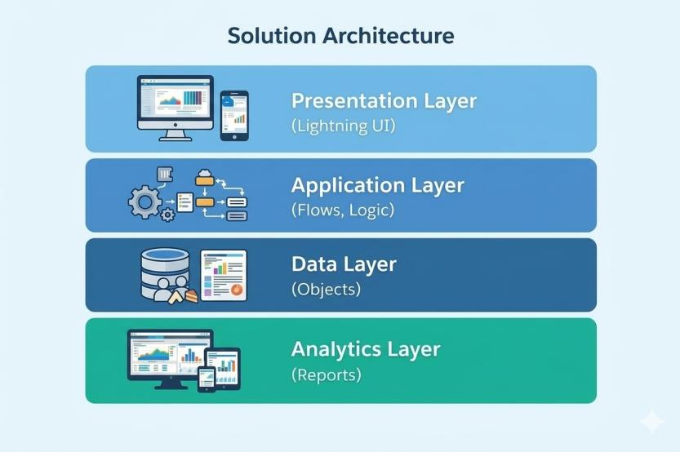

5. PROJECT PLANNING & SCHEDULING

5.1 Project Planning
- Agile-based execution
- Object creation → automation → reporting
- Sprint-wise development
- Salesforce object and data model creation
- Automation and validation implementation
- Reports and dashboard development
- Testing and final integration
Product Backlog, Sprint Schedule, and Estimation (4 Marks)
Use the below template to create product backlog and sprint schedule
Sprint | Functional Requirement (Epic) | User Story Number | User Story / Task | Story Points | Priority | Team Members
Sprint-1 | Salesforce Setup | USN-1 | As an admin, I want to configure the Salesforce environment so that the CRICKSTATS application can be developed. | 2 | High | Member1
Sprint-1 | Data Modeling | USN-2 | As an admin, I want to create Player and Match Performance objects so that cricket data can be stored systematically. | 3 | High | Member2
Sprint-1 | Data Structure | USN-3 | As an admin, I want to create required fields for player and match records so that complete performance details can be captured. | 3 | High | Member 3
Sprint-1 | Relationships | USN-4 | As an admin, I want to establish relationships between objects so that player and match data can be connected effectively | 3 | High | Member 4
Sprint-1 | Navigation | USN-5 | As a user, I want appropriate tabs and navigation so that I can easily access CRICKSTATS features. | 2 | Medium | Member 5
Sprint-2 | UI Design | USN-6 | As a coach, I want a dedicated Lightning App so that performance tracking features are available in one place. | 3 | High | Member1
Sprint-2 | Page Layout | USN-7 | As a user, I want customized page layouts so that relevant information is displayed clearly during data entry. | 3 | High | Member2
Sprint-2 | Validation | USN-8 | As a system, I want to validate player and match data so that incorrect entries can be prevented. | 3 | Medium | Member3
Sprint-2 | Automation | USN-9 | As a system, I want automated flows to update relevant records so that data management becomes efficient. | 5 | High | Member4
Sprint-2 | Security | USN-10 | As an admin, I want to configure profiles and permissions so that users can access only authorized information. | 3 | Medium | Member5
Sprint-3 | Reports | USN-11 | As an analyst, I want to generate player performance reports so that match statistics can be analyzed easily. | 3 | High | Member1
Sprint-3 | Dashboards | USN-12 | As a coach, I want performance dashboards so that player statistics and trends can be viewed visually. | 5 | High | Member2
Sprint-3 | Testing | USN-13 | As a developer, I want to test objects, flows, reports, and dashboards so that the system works correctly. | 3 | High | Member 3
Sprint-3 | Integration | USN-14 | As an admin, I want all application components to work together so that the complete CRICKSTATS system functions smoothly. | 3 | High | Member4
Sprint-3 | Documentation | USN-15 | As a team member, I want to document the implemented features so that the project can be presented and maintained effectively. | 2 | Medium | Member5

Project Tracker, Velocity & Burndown Chart: (4 Marks)
Sprint | Total Story Points | Duration | Sprint Start Date | Sprint End Date (Planned) | Story Points Completed (as on Planned End Date) | Sprint Release Date (Actual)
Sprint-1 | 16 | 13 Days | 05-Aug-2026 | 17-Aug-2026 | 16 | 17-Aug-2026
Sprint-2 | 22 | 13 Days | 18-Aug-2026 | 28-Aug-2026 | 22 | 28-Aug-2026
Sprint-3 | 22 | 13 Days | 31-Aug-2026 | 12-Sep-2026 | 21 | 12-Sep-2026
Sprint-4 | 20 | 13 Days | 13-Sep-2026 | 25-Sep-2026 | 20 | 25-Sep-2026

6. Project Development Phase:

Project Flow

Milestone 1 : Creation of developer account
Milestone 2 : Object Creation
Milestone 3 : Tabs
Milestone 4 : The Lightning App
Milestone 5 : Fields & Relationships
Milestone 6 : Roll-up Summary
Milestone 7 : Flows

Implementation

Milestone 1 - Salesforce developer account creation :

Activity 1: Creating Developer Account:

Creating a developer org in salesforce.
- Go to https://developer.salesforce.com/signup
- On the sign up form, enter the following details :

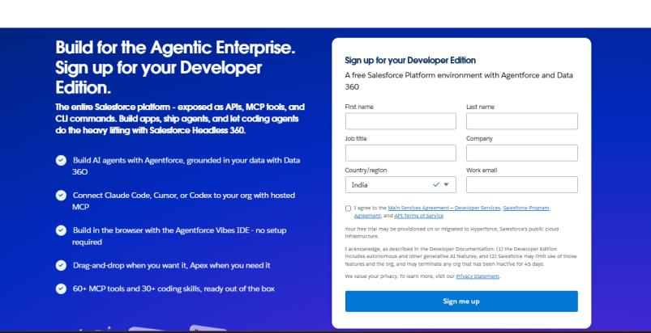

- First name & Last name
- Email
- Role : Developer
- Company : College or Company Name
- County : India
- Postal Code : pin code
- Username : should be a combination of your name and company
This need not be an actual email id, you can give anything in that format : username@organization.com
Click on sign me up after filling these.

Activity 2: Account Activation :

- Go to the inbox of the email that you used while signing up. Click on the verify account to activate your account. The email may take 5-10mins.

- Click on Verify Account.
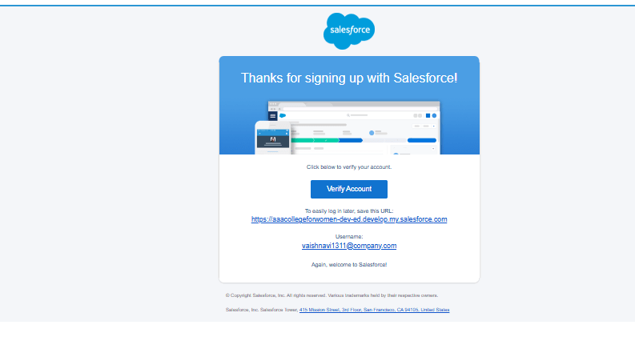

- Give a password and answer a security question and click on change password.

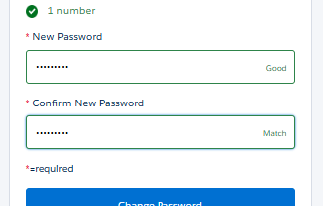

- Then you will redirect to your salesforce setup page.

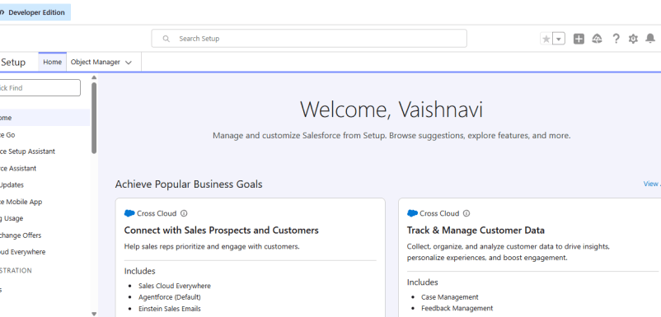

Milestone 2 - Object Creation

Activity 1 : Player Object

- In your Salesforce org, click gear icon on the top left and select Setup to open Setup.
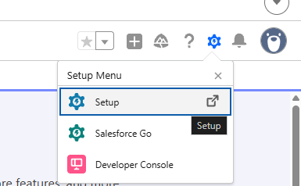

- Click the Object Manager tab. If you don’t see it, enter Object Manager in the Quick Find box.
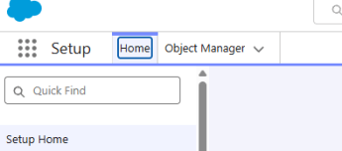

- On the Object Manager page, click Create | Custom Object.

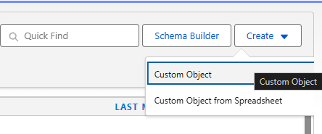
- From the setup page → Click on Object Manager → Click on Create → Click on Custom Object.
- Label : Player
- Plural Label : Players
- Enter Record Name Label and Format
Record Name : Player Name
Data Type : Text
- In Optional features : check the boxes for Allow Reports | Allow Activities | Track Field History.
- Search Status : check the box for Allow Search.
- Save

Activity 2 : Match Performance Object

- From the setup page → Click on Object Manager → Click on Create → Click on Custom Object.
- Label : Match Performance
- Plural Label : Match Performances
- Enter Record Name Label and Format
Record Name : Customer Account Name
Data Type : Text
- In Optional features : check the boxes for Allow Reports | Allow Activities | Track Field History.
- Search Status : check the box for Allow Search.
- Save.

Milestone 3 - Tabs

Activity 1 : Custom tabs creation

- Go to setup page → type Tabs in Quick Find bar → click on tabs → New (under custom object tab)
- Select Object(Player) → Select the tab style → Next (Add to profiles page) keep it as default → Next (Add to Custom App) uncheck the include tab .
- Make sure that the Append tab to users' existing personal customizations is checked.
- Click save.
- Repeat the same steps for Match Performances.

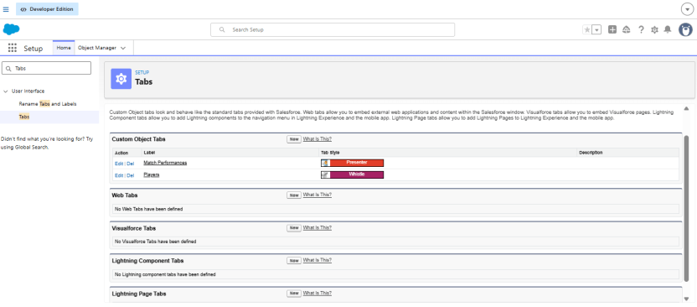

Milestone 4 - The Lightning App

Activity 1 : Create a lightning app

- Go to setup page → search “app manager” in quick find → select “app manager” → click on New lightning App.
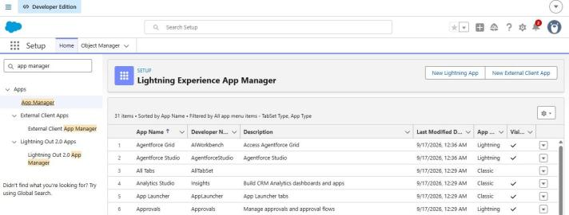

- Fill the app name in app details and branding as follow
App Name : CRICKSTATS
Developer Name : Auto Populates
Add image optional (if you want to give any image you can otherwise not mandatory) - Add Primary color Hex or leave it to default.
Then click Next.

- In App options
Navigation style : Standard navigation
Setup experience : setup
Supporters form factors : Desktop and phone
Then click Next

- In Utility items
Utility Bar alignment : Default
Then click Next.

- Navigation items
Select the created Custom Objects and required standard objects
- Players
Match Performances
Reports
Dashboards

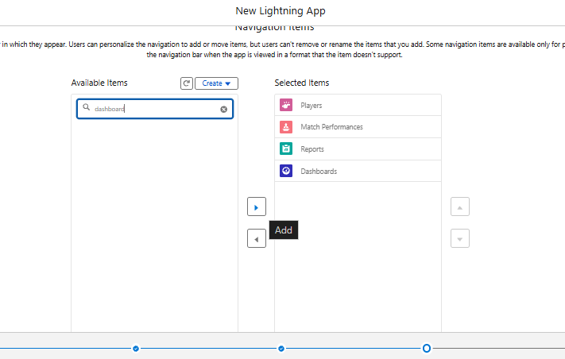
- To Add User Profiles : System Administrator
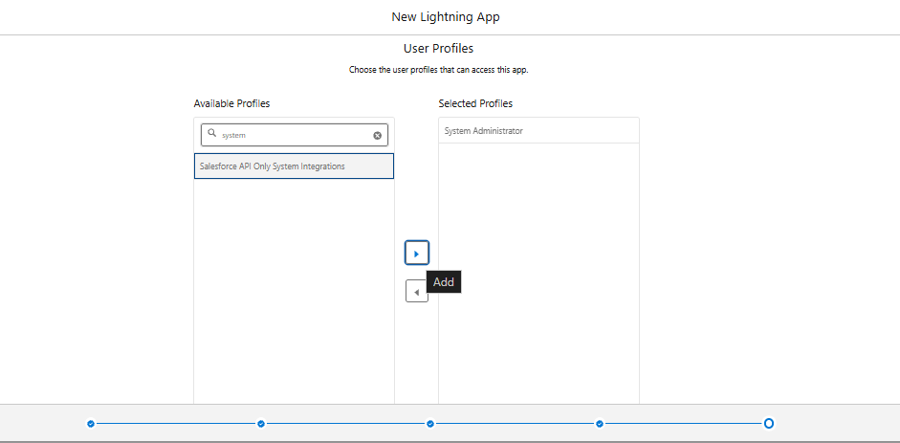
- Click Save & Finish.

Milestone 5 : Fields & Relationships

Activity 1 : Create Custom fields for Player object

- In your Salesforce org, click gear icon on the top left and select Setup to open Setup.
- Click the Object Manager tab. If you don’t see it, enter Object Manager in the Quick Find box.
- From the object manager page, In the Quick Find box, Search for the custom object you just created : Player
- From the sidebar, click Fields & Relationships. Notice that there are already some fields there. Those are the standard fields.
- Click New to create a custom field. Tip: Before creating a new field, do a quick search to make sure a similar one doesn’t already exist.
- Next, choose a data type as Text. Choosing a data type helps you format the field input.

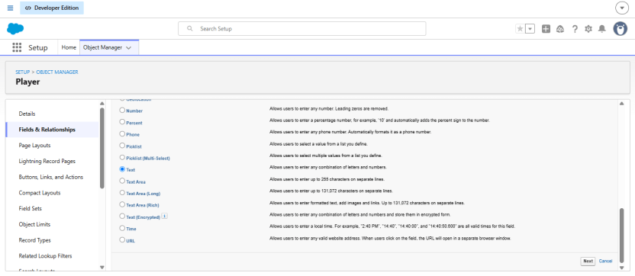

- Click on next.

- Data Type : Text
Field Label: Player Name
Field Name : Auto Populates
Length : 50
Click on Next → Next → Save and new.

- Repeat the Same steps for remaining fields

- Data Type : Text
Field Label: Player Number
Field Name : Auto Populates
Length : 3
Click on Next → Next → Save and new.

- Data Type : Rich Text Area
Field Label : Profile Picture
Field Name : Auto Populates
Click on Next → Next → Save and new.

- Data Type : Date
Field Label : Date of Birth
Field Name : Auto Populates
Click on Next → Next → Save and new.

- Data Type : Picklist
Field Label : Role
Field Name : Auto Populates
Value : Enter value, with each value separated by a new line.
Batsman
Bowler
Batsman & Wicket Keeper
All Rounder

- Data Type : Picklist
Field Label : Batting Style
Field Name : Auto Populates
Value : Enter value, with each value separated by a new line.
Right- Handed
Left - Handed
Click on Next → Next → Save and new.

- Data Type : Picklist
Field Label : Bowling Style
Field Name : Auto Populates
Value : Enter value, with each value separated by a new line.
Right-Arm Fast
Left-Arm Fast
Right-Arm Medium
Left-Arm Medium
Right-Arm Spin
Left-Arm Spin
Click on Next → Next → Save and new.

- Data Type : Picklist
Field Label : Nationality
Field Name : Auto Populates
Value : Enter value, with each value separated by a new line.
Australia
Bangladesh
England
India
New Zealand
Pakistan
South Africa
Sri Lanka
West Indies
Afghanistan
Zimbabwe
Ireland
Scotland
Netherlands
United Arab Emirates
Nepal
United States of America
Click on Next → Next → Save and new.

- Data Type : Picklist
Field Label : Team
Field Name : Auto Populates
Value : Enter value, with each value separated by a new line
Chennai Super Kings (CSK)
Delhi Capitals (DC)
Kolkata Knight Riders (KKR)
Mumbai Indians (MI)
Punjab Kings (PBKS)
Rajasthan Royals (RR)
Royal Challengers Bangalore (RCB)
Sunrisers Hyderabad (SRH)
Gujarat Titans (GT)
Lucknow SuperGiants (LSG)
- Data Type : Formula
Field Label : AVG Score
Field Name : Auto Populates
Formula Return : Number
Formula : IF(
Matches_Played__c > 0,
Total_Runs__c / Matches_Played__c ,
0
)
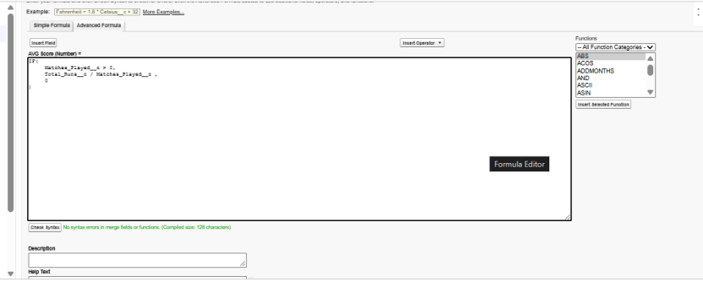
Click on Next → Next → Save & New.

- Data Type : Lookup Relationship
Related To : Match Performance
Field Label : Match Performance
Field Name : Auto Populates
Click on Next → Next → Save.

Activity 2 : Create Custom fields for Match Performance object.

- Data Type : Text
Field Label: Match Performance Name
Field Name : Auto Populates
Length : 80
Click on Next → Next → Save and new.

- Data Type : Checkbox
Field Label: Player of the Match
Field Name : Auto Populates
Click on Next → Next → Save and new.

- Data Type : Picklist
Field Label: Match Result
Field Name : Auto Populates
Value : Enter value, with each value separated by a new line
WON
LOST
DRAW
Click on Next → Next → Save and new.

- Data Type : Number
Field Label: Runs Scored
Field Name : Auto Populates
Click on Next → Next → Save and new.

- Data Type : Number
Field Label: Balls Faced
Field Name : Auto Populates
Click on Next → Next → Save and new.

- Data Type : Number
Field Label: Fours
Field Name : Auto Populates
Click on Next → Next → Save and new.

- Data Type : Number
Field Label: Sixes
Field Name : Auto Populates
Click on Next → Next → Save and new.

- Data Type : Number
Field Label: Overs Bowled
Field Name : Auto Populates
Click on Next → Next → Save and new.

- Data Type : Number
Field Label: Wickets Taken
Field Name : Auto Populates
Click on Next → Next → Save and new.

- Data Type : Number
Field Label: Runs Conceded
Field Name : Auto Populates
Click on Next → Next → Save and new.

- Data Type : Number
Field Label: Maiden Overs
Field Name : Auto Populates
Click on Next → Next → Save and new.

- Data Type : Number
Field Label: Stumpings
Field Name : Auto Populates
Click on Next → Next → Save and new

- Data Type : Number
Field Label: Catches
Field Name : Auto Populates
Click on Next → Next → Save and new.

- Data Type : Master - Detail Relationship
Related To : Player
Field Label : Player
Field Name : Auto Populates
Click on Next → Next → Save.

Milestone 6 : Roll-up Summary

Activity 1 : Create Roll-up Summary for Player object.

Note :- Roll-up Summary can only be created on parent object in Master- Detail Relationship.

- In your Salesforce org, click gear icon on the top left and select Setup to open Setup.
- Click the Object Manager tab. If you don’t see it, enter Object Manager in the Quick Find box.
- From the object manager page, In the Quick Find box, Search for the custom object you just created : Player
- From the sidebar, click Fields & Relationships. Notice that there are already some fields there. Those are the standard fields.
- Click New to create a custom field. Tip: Before creating a new field, do a quick search to make sure a similar one doesn’t already exist. Click Next,
- Choose a data type as Roll-up Summary. Click Next.
Field Label: Matches Played
Field Name : Auto Populates
Summarized Object : Match Performances
Select Roll-up Type : COUNT

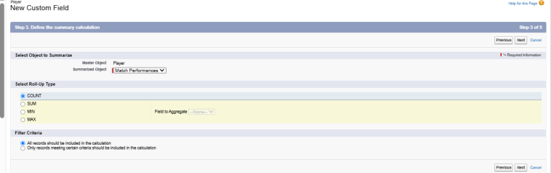

Filter Criteria : All records should be included in the calculation.
Click on Next → Next → Save and new.

- Data Type : Roll-up Summary
Field Label: Number of 50’s
Field Name : Auto Populates
Summarized Object : Match Performances
Select Roll-up Type : COUNT
Filter Criteria : Only records meeting certain criteria should be included in the calculation.
Click on Next → Next → Save and new.
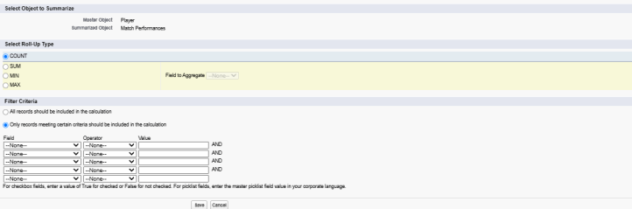

- Data Type : Roll-up Summary
Field Label: Number of 100’s
Field Name : Auto Populates
Summarized Object : Match Performances
Select Roll-up Type : COUNT
Filter Criteria : Only records meeting certain criteria should be included in the calculation.
Click on Next → Next → Save and new.

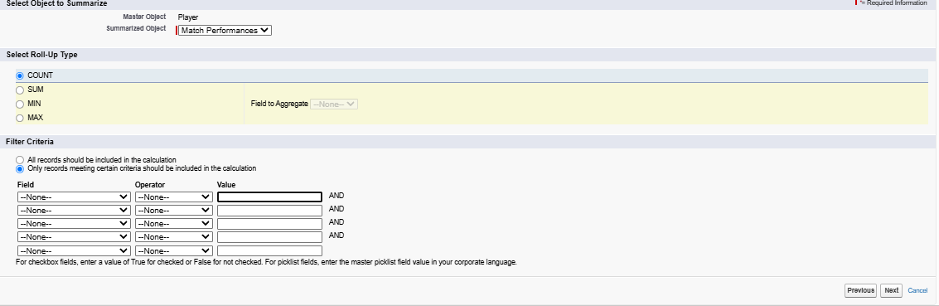

- Data Type : Roll-up Summary
Field Label: Total 4’s
Field Name : Auto Populates
Summarized Object : Match Performances
Select Roll-up Type : SUM
Field To Aggregate : Fours
Filter Criteria : All records should be included in the calculation.
Click on Next → Next → Save and new.

- Data Type : Roll-up Summary
Field Label: Total 6’s
Field Name : Auto Populates
Summarized Object : Match Performances
Select Roll-up Type : SUM
Field To Aggregate : Sixes
Filter Criteria : All records should be included in the calculation.
Click on Next → Next → Save and new.

- Data Type : Roll-up Summary
Field Label: Total Runs
Field Name : Auto Populates
Summarized Object : Match Performances
Select Roll-up Type : SUM
Field To Aggregate : Runs Scored
Filter Criteria : All records should be included in the calculation.
Click on Next → Next → Save and new.

- Data Type : Roll-up Summary
Field Label: Total Overs
Field Name : Auto Populates
Summarized Object : Match Performances
Select Roll-up Type : SUM
Field To Aggregate : Overs Bowled
Filter Criteria : All records should be included in the calculation.
Click on Next → Next → Save and new.

- Data Type : Roll-up Summary
Field Label: Total Wickets
Field Name : Auto Populates
Summarized Object : Match Performances
Select Roll-up Type : SUM
Field To Aggregate : Wickets Taken
Filter Criteria : All records should be included in the calculation.
Click on Next → Next → Save and new.

- Data Type : Roll-up Summary
Field Label: Total Stumpings
Field Name : Auto Populates
Summarized Object : Match Performances
Select Roll-up Type : SUM
Field To Aggregate : Stumpings
Filter Criteria : All records should be included in the calculation.
Click on Next → Next → Save and new.

- Data Type : Roll-up Summary
Field Label: Total Catches
Field Name : Auto Populates
Summarized Object : Match Performances
Select Roll-up Type : SUM
Field To Aggregate : Catches
Filter Criteria : All records should be included in the calculation.
Click on Next → Next → Save and new.

Milestone 7 : Flows

Activity 1 : Screen Flow

- Go to setup, Type Flow in quick find box → Click on the Flow and Select the New Flow.

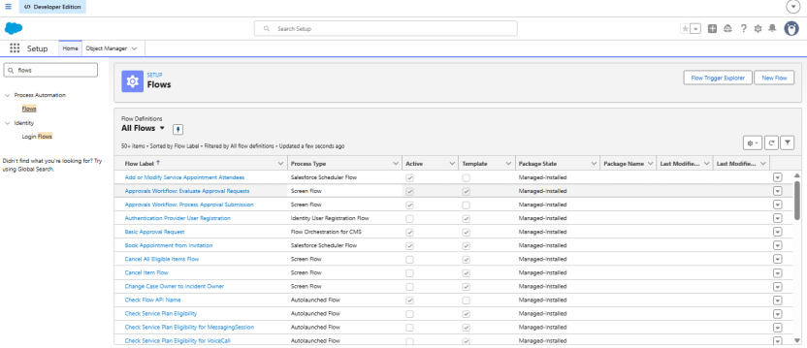

- Select Screen Flow and click Create.
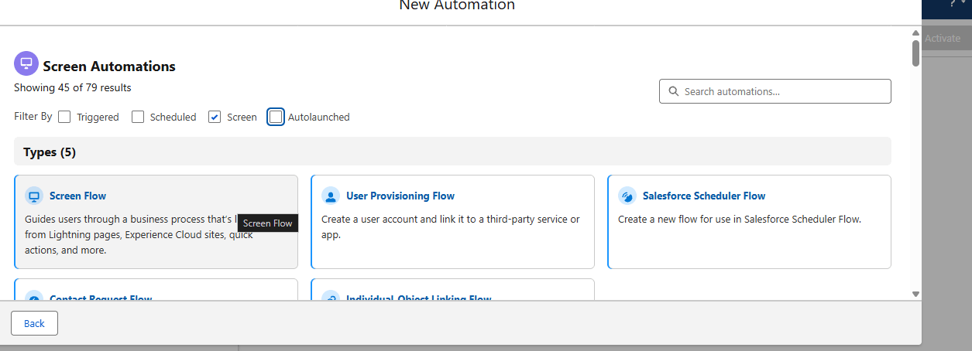
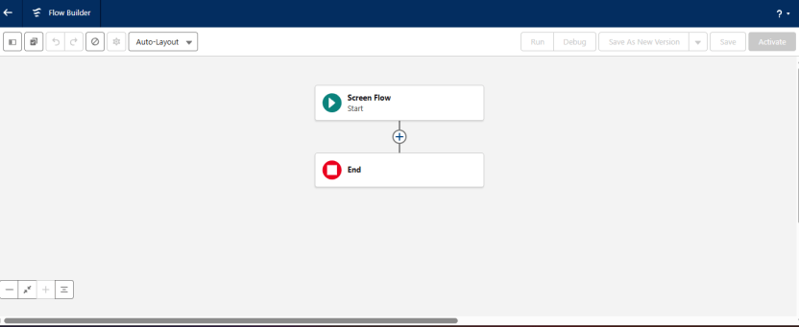

- Click (+) Icon on the flow builder and Select Screen Component.
Label : Players screen
API : Players_screen
Select the Picklist component and place it on the screen.
Label : Team
API : Team
From Component Pane on the left side select Component Type : Picklist
Data Type : Text
Choice : Click New Choice Resources
Resource Type : Picklist Choice Set

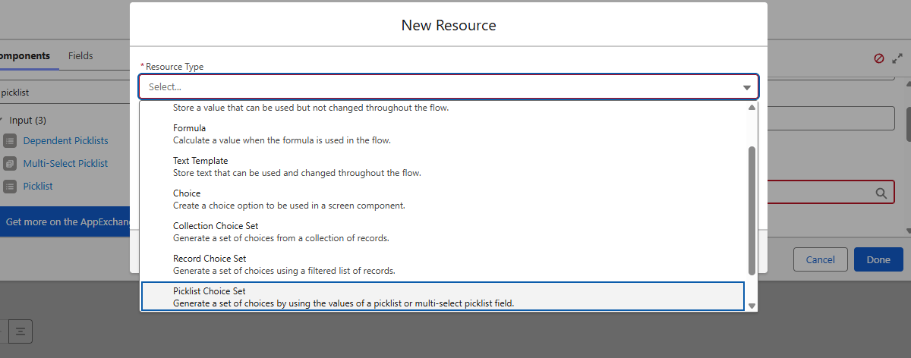

API Name : Team
Object : Player
Data Type : Picklist
Field : Team
Click Done.
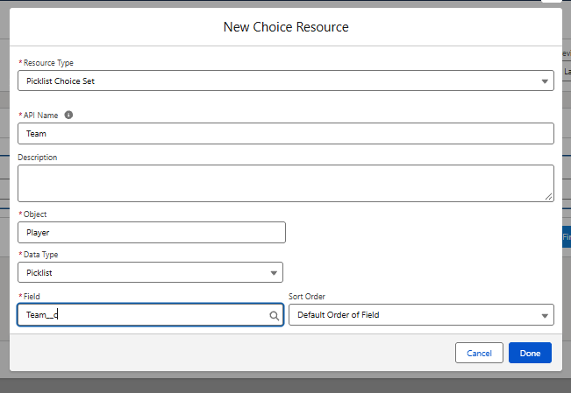

- Click (+) Icon on the flow builder and Select Get Records Component.
Label : Players
API Name : Players
Object : Player
Filter player records :
Field : Team
Operator : Equals
Value : Click New Resource
Resource Type : Variable
API Name : Dynamic
Data Type : Text
Default Value : Screen component : Team (Picklist)

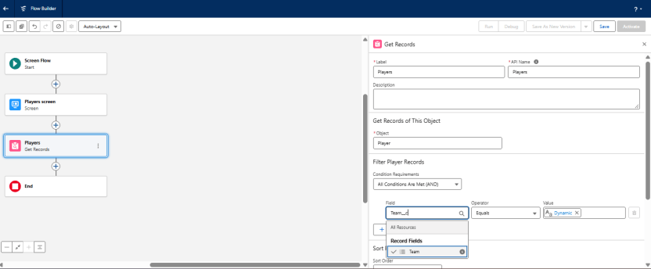

- Click (+) Icon on the flow builder and Select Screen Component.
Label : Player_info
API Name : Player_info
From Component Pane on the left side select Component Type : Data table
API Name : Player_info_table
Label : Data Table
Configure Data Source : Source Collection : Players from players (Player__c)

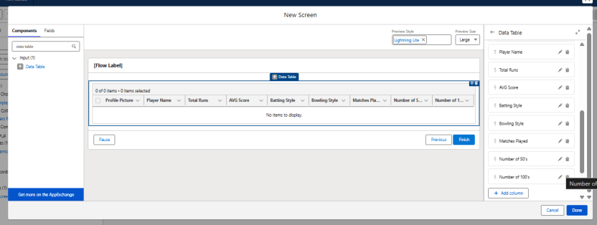

In Configure Columns : Add all the required Columns
Profile Picture | Player Name | Total Runs | AVG Score | Batting Style | Bowling Style | Matches Played | Number of 50’s | Number of 100’s
Click Done.

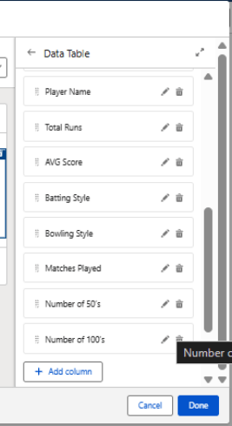
Click Save.
Flow Label : Player Flow
Flow API Name : Player_Flow
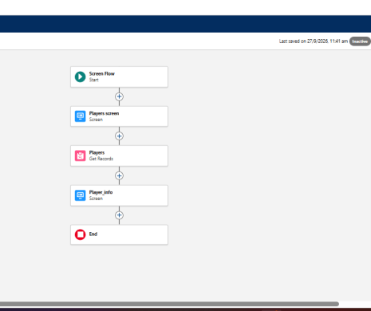
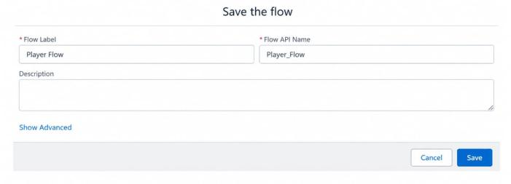

Activity 2 : Flow on Home Page

- On your CRICKSTATS Application on the top right of the Navigation Bar click on Personalize your nav bar icon (Pencil Icon) and Add Home Page and click Save.

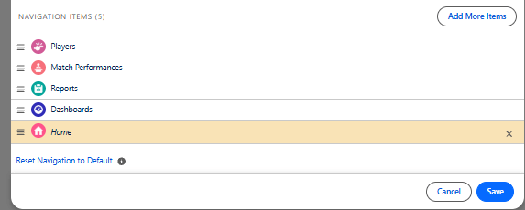

- Remove all other components and Add FLOW component from the standard components on the left side.
- Flow : Players Flow

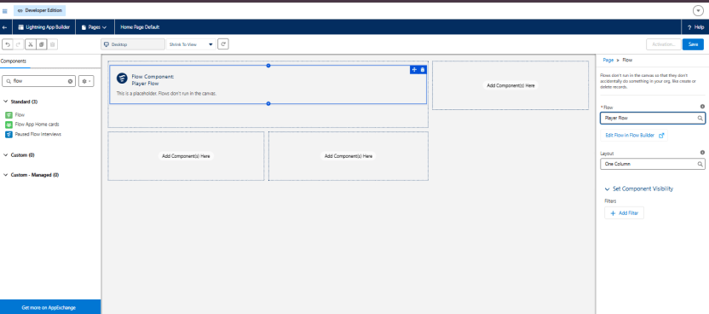

- Click Save and Activation.
- Click on App Default and select Assign to Apps.

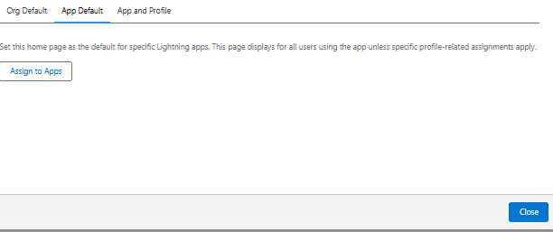
- Select CRICKSTAS App and Click Next and then click Save.

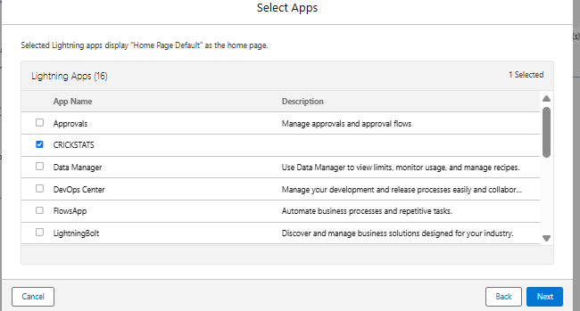

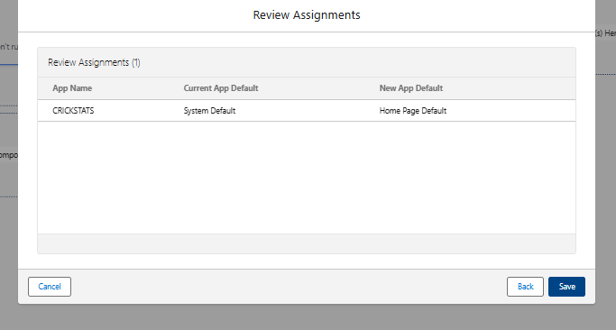

7. FUNCTIONAL & PERFORMANCE TESTING
During the testing phase, the CRICKSTATS – Cricket Player Performance Tracking Application was thoroughly tested using the Salesforce Lightning interface to ensure that all implemented features function correctly. Testing was carried out for Player and Match Performance record creation, data entry, validation rules, object relationships, automation, reports, and dashboards.
The Player and Match Performance objects were tested to verify that records could be created, updated, and retrieved successfully. Validation rules were tested to ensure that mandatory fields were completed and that invalid performance values were prevented. The Domestic and International match categories were also verified to ensure that the appropriate record types and related information were displayed correctly.
Salesforce Flow automation was tested to confirm that required records and player statistics were updated automatically when relevant changes were made. Roll-Up Summary fields were also verified to ensure accurate calculation of performance statistics such as total runs, total wickets, averages, and other performance metrics.
Finally, Salesforce Reports and Dashboards were tested to ensure that player performance data was displayed accurately and could be used for effective performance analysis and decision-making.

NOTE : Enter some records in the Player Object and Match Performance Object to get the results.

- Select one Team from the Picklist and Click Next.

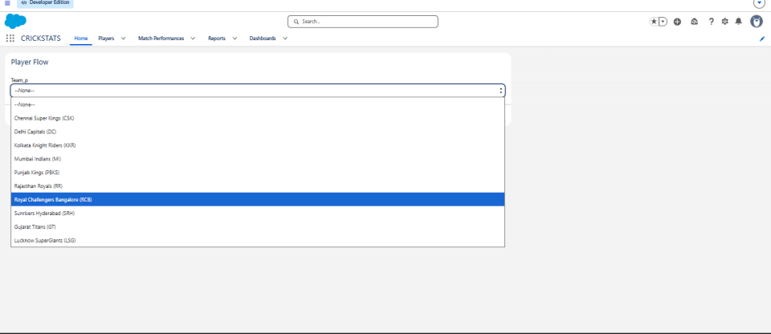

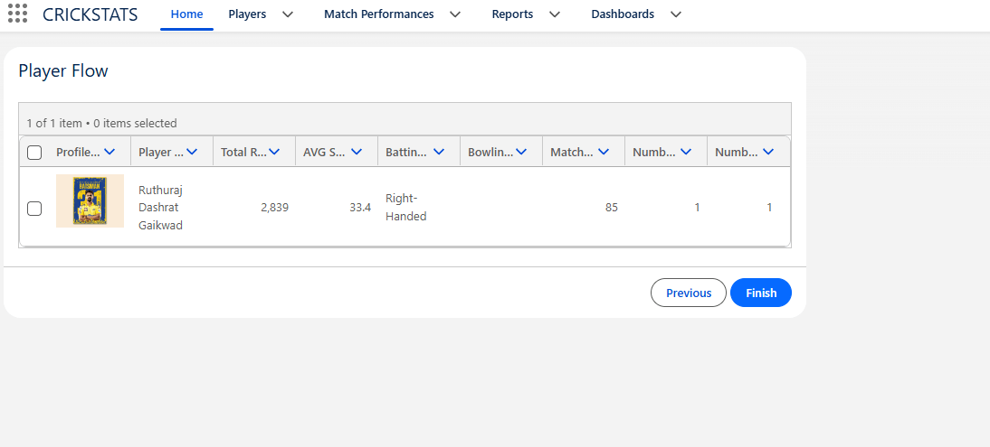
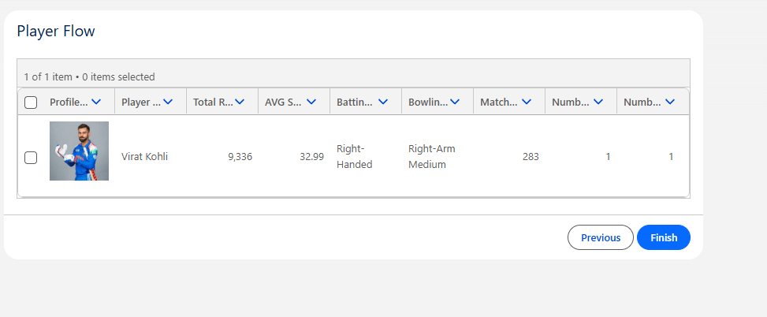
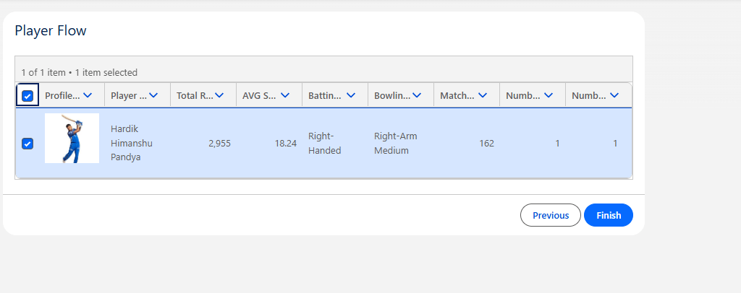

8. ADVANTAGES & DISADVANTAGES

Advantages
- Centralized Data Management – Stores player profiles and match performance records in a single Salesforce platform.
- Easy Performance Analysis – Reports and dashboards provide clear insights into player statistics and performance trends.
- Improved Data Accuracy – Validation rules and automation help reduce incorrect and duplicate data.
- Automated Processes – Salesforce Flow reduces repetitive manual tasks and improves efficiency.
- Secure Access – User permissions and Salesforce security features help protect player and performance information.
- Better Decision Support – Provides coaches and analysts with organized statistics for player evaluation and team planning.
- Scalable Platform – Can accommodate additional players, teams, matches, and performance records as the system grows.

Disadvantages
- Salesforce Dependency – The application depends on the Salesforce platform and its available features.
- Internet Requirement – A stable internet connection is generally required to access and operate the cloud-based system.
- Platform Cost – Certain Salesforce features and services may require paid licenses or subscriptions.
- Limited Offline Functionality – Most system operations require online access to Salesforce.
- Learning Requirement – Users may need basic knowledge of Salesforce features to manage the application effectively.

9. Conclusion:

CRICKSTATS successfully implements a cloud-based cricket performance tracking system using Salesforce. The system automates data management, improves reporting accuracy, and supports informed decision-making.
The CRICKSTATS – Cricket Player Performance Tracking Application successfully provides a centralized Salesforce-based solution for managing and analyzing cricket player performance. The system enables efficient management of player profiles, match-wise performance records, statistical data, reports, and dashboards.
By utilizing Salesforce Custom Objects, Relationships, Validation Rules, Salesforce Flow, Reports, and Dashboards, the application reduces manual data management and improves the accuracy, consistency, and accessibility of performance information. It also helps coaches, managers, and analysts monitor player progress and obtain meaningful performance insights for effective team planning.
The project demonstrates the practical implementation of SDLC, Agile methodology, Salesforce CRM concepts, cloud-based data management, automation, and performance analytics. Overall, CRICKSTATS provides a structured and scalable approach to modern cricket performance management and can be further enhanced with advanced analytics and additional automation features.
The project demonstrates practical application of SDLC, Agile methodology, and CRM-based development.

10. FUTURE SCOPE
The CRICKSTATS – Cricket Player Performance Tracking Application can be further enhanced with advanced technologies and additional features to improve performance analysis and user accessibility.
- Mobile Application Integration – Develop a mobile application to provide convenient access to player records, match statistics, and performance reports.
- AI-Based Performance Analysis – Integrate Artificial Intelligence to analyze historical performance data and identify player performance patterns and trends.
- Video Analysis Integration – Enable integration of match videos with performance records for detailed player and match analysis.
- Advanced Player Ranking – Implement a ranking mechanism based on runs, wickets, strike rate, economy rate, consistency, and other performance parameters.
- Public Statistics Portal – Provide a dedicated portal for displaying selected player and match statistics to authorized or public users.
- Multi-League & Multi-Team Support – Extend the system to manage multiple teams, tournaments, leagues, and competitions within a single platform.
- Advanced Analytics Dashboard – Introduce additional interactive charts, performance comparisons, and trend analysis for more detailed insights.
- Automated Notifications – Add notifications for match updates, player milestones, performance changes, and important team activities.

11. APPENDIX
The appendix contains supporting information and reference materials related to the development and implementation of the CRICKSTATS – Cricket Player Performance Tracking Application.
- Salesforce Object and Field Details – Documentation of the custom objects, fields, relationships, and data structure used in the application.
- Player and Match Performance Records – Sample player profiles and manually entered match-wise performance statistics used for testing and validation.
- Validation Rules – Details of the validation rules implemented to maintain accurate and consistent data.
- Salesforce Flow Configurations – Documentation of automated flows used for record updates, data processing, and system automation.
- Reports and Dashboard Details – Supporting information related to performance reports, charts, and dashboards created for analysis.
- Testing Screenshots – Screenshots demonstrating the successful execution and testing of major CRICKSTATS features.

Thank You

