LOAN APPROVAL PREDICTION & CREDIT RISK ANALYSIS
A Business-Intelligence Data Analytics Project

Prepared as the final project of the
AICTE | IBM SkillsBuild Internship Program 2026
Data Analytics with AI: Foundation to Implementation
Sponsored by BharatCares

Intern: Gupta Vaishnavi Sureshbhai
Date: 23 September 2026

Contents
1. Introduction
2. Problem Statement & Project Approach
3. Dataset & Tools
4. Methodology
5. Data Cleaning & Quality Checks
6. Level 1 — Executive Overview (KPIs)
7. Levels 2 & 3 — Trends & Drivers
8. Level 4 — Risks & Opportunities
9. Prediction Model
10. Key Findings
11. Business Decisions / Recommendations
12. Conclusion
Appendix A — How to Run the Project

1. Introduction
This project was completed as the final deliverable of the AICTE | IBM SkillsBuild "Data Analytics with AI" internship program (sponsored by BharatCares, 17 August – 30 September 2026). It applies the complete data-analytics workflow — collection, cleaning, feature engineering, exploratory analysis, modeling, and business interpretation — to a real credit-lending dataset of 4,269 loan applications.
The analysis was carried out in Python (Pandas, NumPy, Matplotlib, Scikit-learn) inside a single Jupyter notebook ("Loan_Approval_Prediction.ipynb"), compatible with Google Colab. All code, outputs and generated charts are included with this report.

2. Problem Statement & Project Approach
Banks approve or reject loan applications based on the applicant's credit score (CIBIL), income, loan amount and term, owned assets, education and employment status. These decisions are typically made by officers using rules and experience — a process that is slow, inconsistent, and hard to explain at scale.
The goal of this project is to follow the Business Intelligence flow taught in the program:
Data → Information → Insight → Decision → Action
concretely, in five levels:
Level | What it answers
1. KPIs | What is happening? (approval rate, loan book size, applicant profile)
2. Trends | How do decisions behave across segments?
3. Drivers | Why? Which factors actually drive approval vs rejection?
4. Risks & Opportunities | What could go wrong? Where is untapped value?
5. Actions | What should the bank do with this?

A simple, explainable prediction model (Logistic Regression) is built to turn the driver analysis into a reusable risk-scoring tool that can pre-screen new applications and explain the reasons behind a decision.

3. Dataset & Tools
The dataset contains 4,269 loan applications with 13 columns. One row represents one loan application.
Column | Description
loan_id | Unique application ID
no_of_dependents | Number of dependents of the applicant
education | Graduate / Not Graduate
self_employed | Yes / No
income_annum | Annual income (INR)
loan_amount | Requested loan amount (INR)
loan_term | Loan term in years (2–20)
cibil_score | Credit score (300–900 scale)
residential_assets_value / commercial_assets_value / luxury_assets_value / bank_asset_value | Value of assets owned by the applicant (INR)
loan_status | Target — Approved / Rejected

Dataset source: Kaggle "Loan Approval Prediction Dataset" — https://www.kaggle.com/datasets/spsingh/loan-approval-prediction-dataset (a working copy of the exact file is included in data/ and linked in the README).
Tools used: Python 3, Pandas (data handling & statistics), NumPy, Matplotlib (charts), Scikit-learn (modeling), Jupyter Notebook / Google Colab (environment).

4. Methodology
- Collect and load the CSV dataset into a Pandas DataFrame.
- Clean and validate: fix whitespace in column names/values, check missing values, duplicates and value ranges, correct 28 rows with impossible negative asset values.
- Feature engineering: total assets, loan-to-income ratio, loan-to-assets ratio, CIBIL score bands.
- Compute KPIs and group/summarize by CIBIL band, demographics and loan-size ratios; create charts to compare.
- Identify risks and opportunities from the summaries.
- Build a Logistic Regression model on an 80/20 stratified split; evaluate with accuracy, precision, recall, F1, confusion matrix and ROC-AUC; cross-check with a Random Forest.
- Translate the results into recommended business actions.

5. Data Cleaning & Quality Checks
Before any analysis, the data was cleaned and validated:
Check | Result
Whitespace in column names / values | found and removed (a common real-world defect)
Missing values | 0 in every column
Duplicate loan IDs / rows | 0
CIBIL range | 300 – 900 (valid scale)
Invalid asset values | 28 rows had a negative residential asset value → corrected to 0
Decision values | exactly "Approved" / "Rejected"

Conclusion: after one real correction (28 negative asset values), all 4,269 applications are valid and move into the analysis.

6. Level 1 — Executive Overview (KPIs)
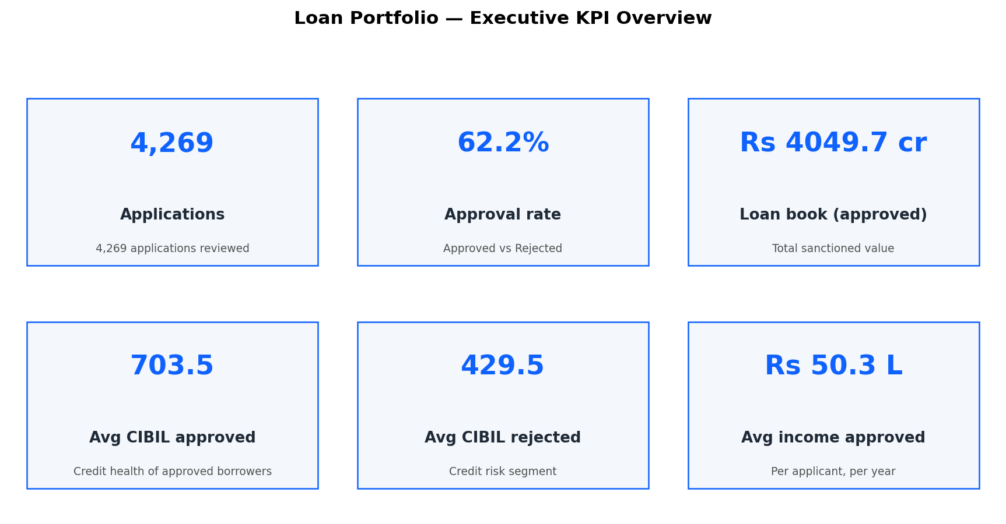
Figure 1 — Executive KPI dashboard.
Metric | Value
Total applications | 4,269
Approved / Rejected | 2,656 / 1,613
Overall approval rate | 62.2%
Total loan book of approved loans | Rs 4,049.7 crore
Average income — approved / rejected | Rs 50.3 L / Rs 51.1 L (per year)
Average CIBIL — approved / rejected | 703.5 / 429.5
Average loan size — approved | Rs 152.5 lakh

Observation: average income is almost identical between approved and rejected applicants — income alone does not explain decisions. The average CIBIL gap, however, is huge (703.5 vs 429.5), which points directly at the credit score as the factor to investigate.

7. Levels 2 & 3 — Trends & Drivers

7.1 Credit score (CIBIL) — the dominant driver
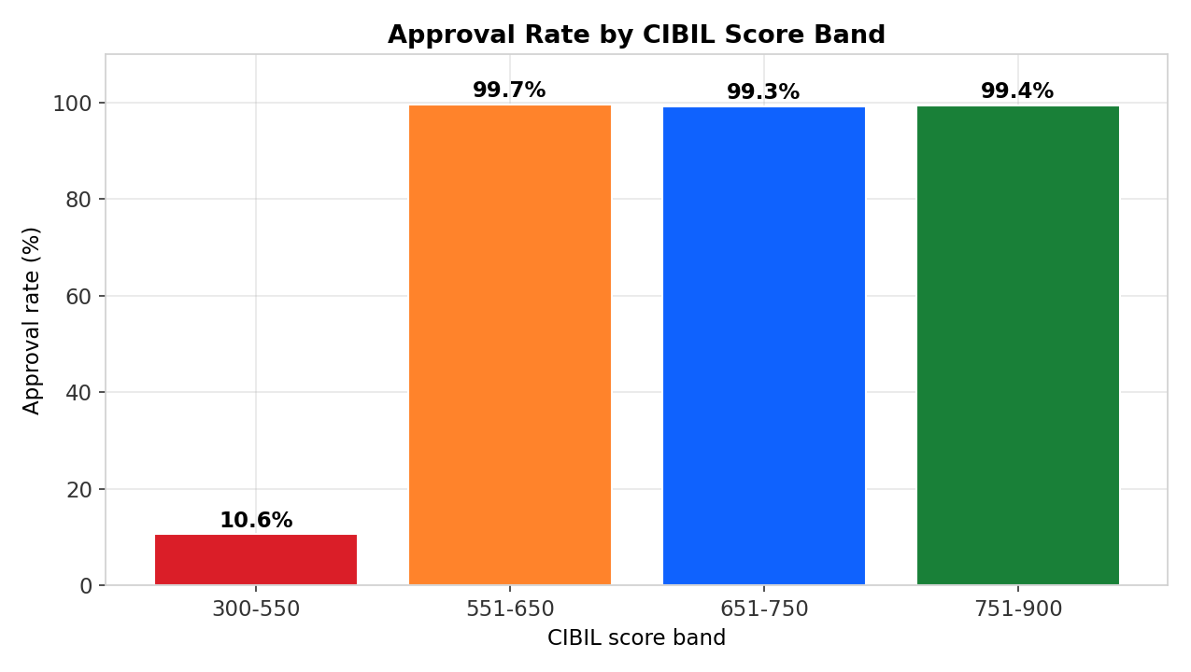
Figure 2 — Approval rate by CIBIL score band.
Applicants with CIBIL 300–550 are approved only 10.6% of the time, while every band above 550 is approved at 99.3–99.7%. In practice the bank applies a credit-score floor around 550. This single factor explains nearly all of the variance in decisions.

7.2 CIBIL score distribution
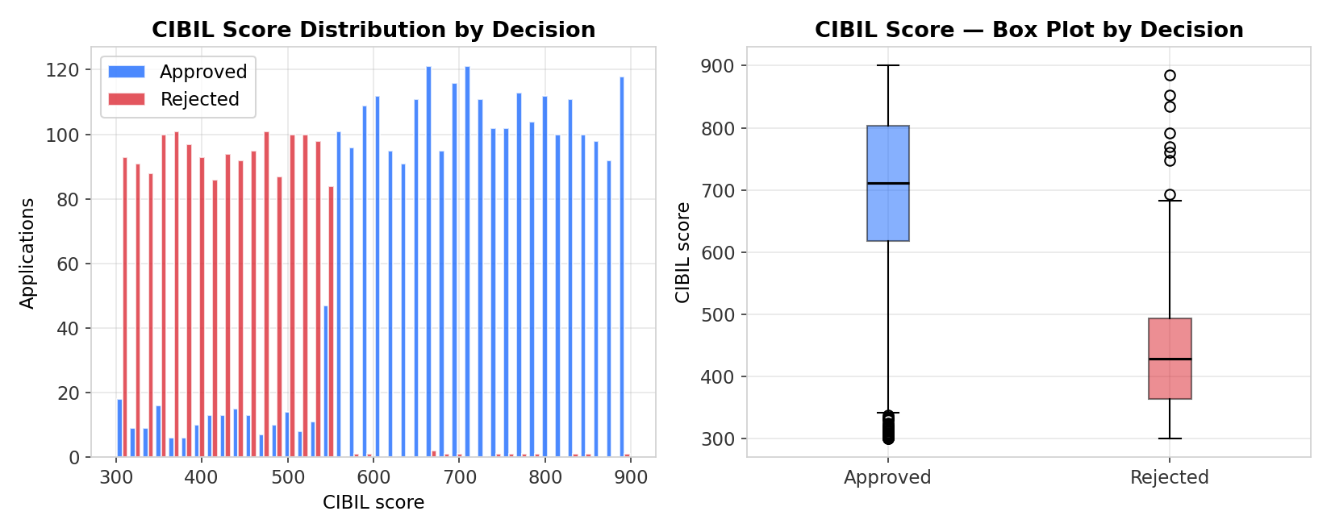
Figure 3 — CIBIL score distribution and box plot, approved vs rejected.
The two populations barely overlap: the typical rejected applicant scores near 430 while the typical approved applicant scores near 700. A visible minority in the low band does get approved (about 10.6%), which becomes an opportunity later.

7.3 Factors that do NOT matter
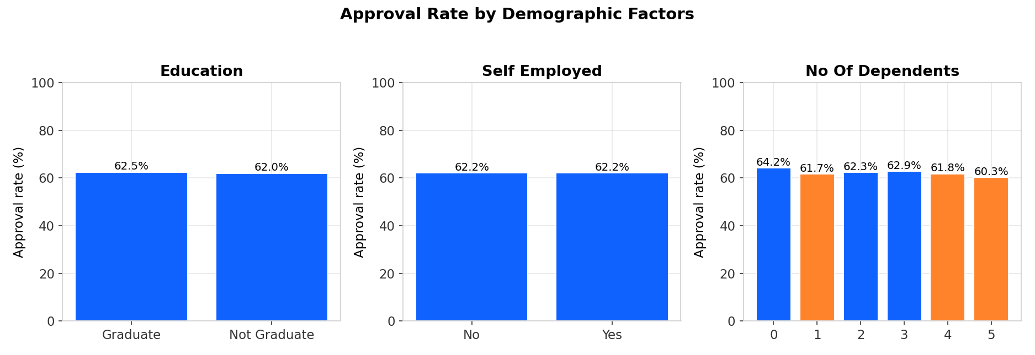
Figure 4 — Approval rate by education, employment status and dependents.
Approval rates are essentially flat (≈ 62%) across education (Graduate 62.5% vs Not Graduate 62.0%), employment (self-employed 62.2% vs salaried 62.2%) and number of dependents (60.3–64.2%). These demographics do not drive the decision. This is an important fairness insight: rejection risk concentrates in the credit score, not in who the person is.

7.4 Loan size vs income and assets
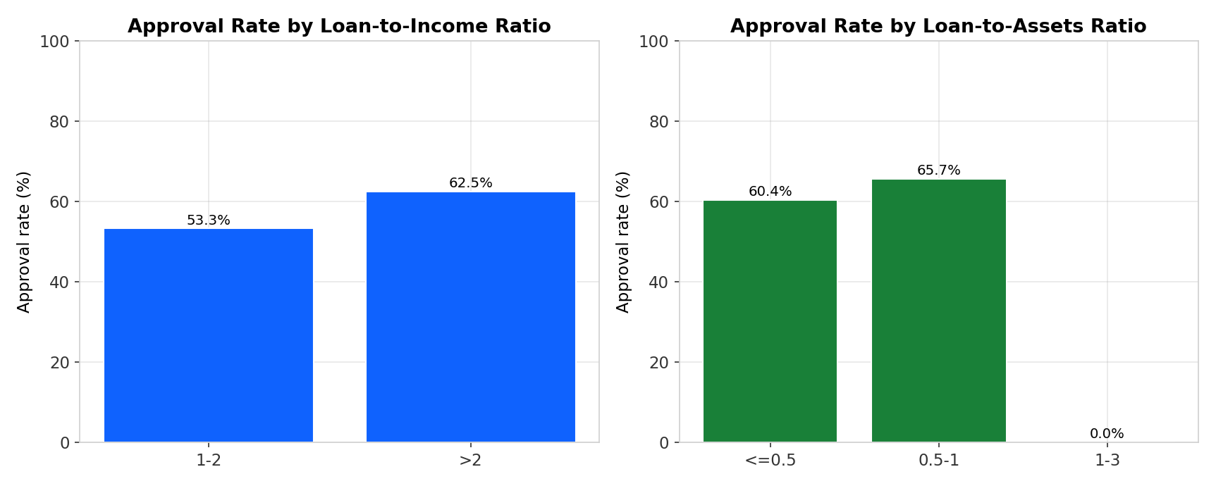
Figure 5 — Approval rate by loan-to-income and loan-to-assets ratio.
A loan asking 1–2× the applicant's annual income sees the approval rate dip to 53.3% (vs 62.5% for larger ratios, which are mostly asked by high earners). More decisive: when the loan exceeds the applicant's total assets (ratio > 1), the approval rate is 0% — the bank never sanctions a loan larger than the asset value behind it.

8. Level 4 — Risks & Opportunities
Type | Statement
Risk | Thin-credit segment: ~59% of applicants sit in the CIBIL 300–550 band and are almost never approved (10.6%). This is currently treated as near-total risk, excluding most first-time borrowers.
Risk | Collateral ceiling: loans above 1× total assets are auto-rejected — asset-light, high-score applicants (young professionals) are blocked regardless of income.
Risk | Model/process risk: because one variable (CIBIL) explains ~all decisions, the current process is essentially a score cutoff; any miscalibration or score manipulation directly flips outcomes.
Opportunity | Score-driven but fair: education, employment and dependents show no effect, so the bank can safely market to those segments without extra risk.
Opportunity | The ~245 approved sub-550 applicants prove thin-credit lending is possible for the right profiles — a small pilot (co-borrower, smaller ticket) could expand reach.
Opportunity | A transparent model lets officers explain every rejection — better customer experience and faster re-application after score improvement.

9. Prediction Model
A Logistic Regression model (StandardScaler → LogisticRegression in a scikit-learn Pipeline) was trained on 80% of the data and evaluated on the untouched 20% test set. Features: CIBIL score, income, loan amount, term, dependents, total assets, loan-to-income, loan-to-assets, education and employment dummies.
Metric | Value (held-out test set)
Accuracy | 91.1%
Precision (approved) | 0.92
Recall (approved) | 0.94
F1 (approved) | 0.93
ROC-AUC | 0.973
Random Forest cross-check accuracy | 99.9% (CIBIL = 82% of feature importance)

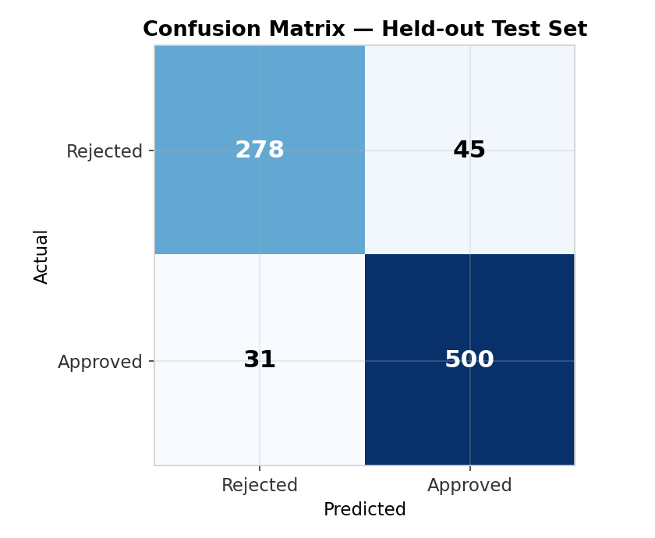
Figure 6 — Confusion matrix on the held-out test set.
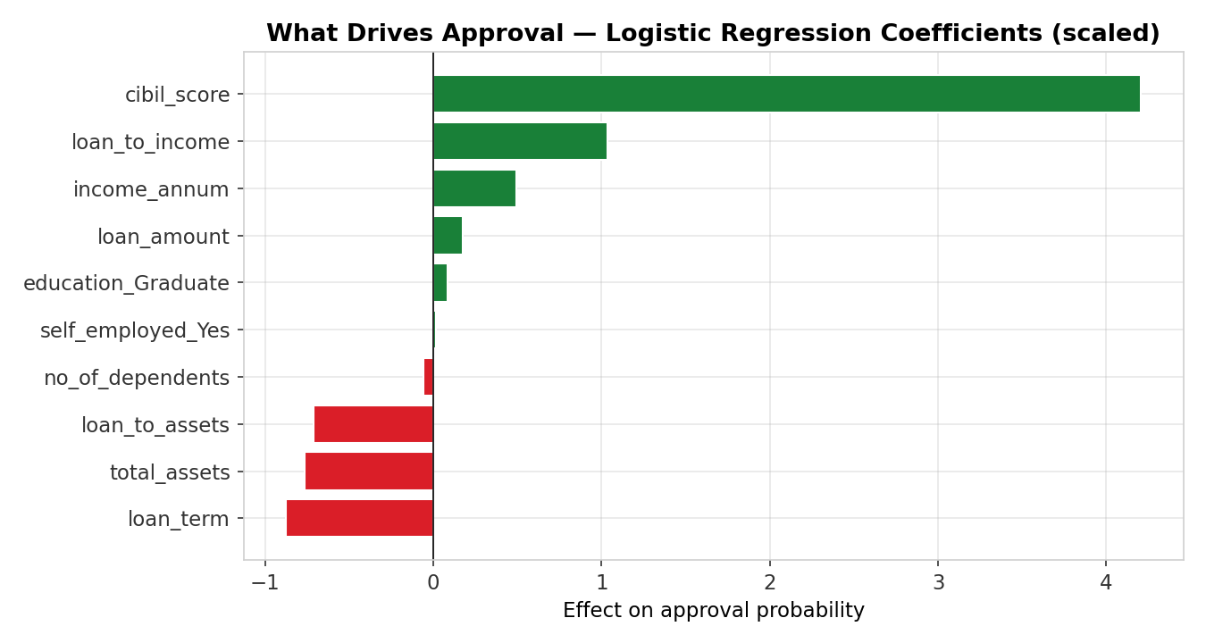
Figure 7 — Logistic regression coefficients: what drives approval.
The model confirms the EDA story: CIBIL score is by far the strongest positive driver of approval; longer loan terms and larger loans relative to assets push the decision toward rejection; education and employment status carry almost zero weight. Because the base model is logistic regression, every decision can be explained with plain reasons — exactly what a bank needs for fairness and regulation.

10. Key Findings
# | Finding | Evidence
1 | CIBIL score is the dominant driver of approval | 10.6% approval in 300–550 band vs 99.3–99.7% above 550; 82% RF feature importance
2 | Loans above total assets are never approved | 0% approval for loan-to-assets ratio > 1
3 | Income alone is not the decider | Avg income 50.3 L (approved) vs 51.1 L (rejected)
4 | Demographics do not affect decisions | Flat ~62% across education, employment, dependents
5 | The model pre-screens with high accuracy and explains itself | 91.1% accuracy, ROC-AUC 0.973; 99.9% with Random Forest
6 | The bank's book is concentrated and healthy | Rs 4,049.7 cr approved; avg CIBIL 703.5; avg ticket Rs 152.5 L

11. Business Decisions / Recommendations
- Keep the ~550 CIBIL floor, but publish it: applicants below 550 are approved only 10.6% of the time — tell them the threshold and the path to improve it instead of a silent rejection.
- Keep the collateral rule (loan ≤ total assets) and explain it to applicants blocked by it — a co-applicant's assets can be added to meet the rule.
- Add a loan-to-income sanity check as a secondary rule: flag applications where the loan exceeds ~1× annual income for officer review (approval dips to 53.3% in the 1–2× band).
- Pilot thin-credit lending using the profile of the ~245 approved sub-550 applicants: smaller ticket sizes plus a co-borrower, to grow the 59% segment the current process excludes.
- Market openly to all demographic segments (self-employed, graduates and non-graduates, families) — none of them change approval odds, so segment campaigns carry no extra risk.
- Deploy the model as a pre-screening layer in the application portal: instant decision plus top-3 reasons, speeding up approvals and improving the rejection experience.

12. Conclusion
Starting from 4,269 raw loan applications, the project followed the business-intelligence flow end-to-end. The KPIs showed a 62.2% approval rate on a Rs 4,049.7 crore approved loan book. The driver analysis proved the CIBIL score to be the dominant factor (approval jumps from 10.6% to ~99% above 550), that loans above total assets are never approved, and that demographics barely matter. The risk analysis identified the 59% thin-credit segment as both the biggest risk and the biggest untapped market. An explainable logistic regression model reproduces the bank's decisions at 91.1% accuracy (99.9% with a Random Forest cross-check) and can explain every decision. Finally, six concrete, evidence-backed actions were recommended to the bank.
The project demonstrates how a simple, well-documented analytics workflow turns historical loan decisions into a transparent, reusable decision tool — from raw data to business action.

Appendix A — How to Run the Project
1. Install dependencies: pip install -r requirements.txt
2. Open the notebook: jupyter notebook Loan_Approval_Prediction.ipynb (or upload it to Google Colab).
3. Run all cells. The notebook loads data/loan_approval_dataset.csv automatically (falling back to the hosted copy if the file is not present), regenerates all charts in outputs/, and prints the model evaluation. Full details in README.md.

