QUE1: Explain the difference between frontend, backend, and full-stack development with suitable real-world examples.
ANSWER :
Frontend development refers to everything that users see and interact with directly. It includes the layout, design, buttons, text, images, navigation menus, and overall user interface using HTML,CSS and java script.
Eg. When you open a website like Amazon, everything from the homepage, product listings, add-to-cart buttons, and checkout forms is built by frontend developers.

Backend development involves the logic, databases, and applications that powers the frontend. It’s not visible to users, but it makes everything work behind the scenes. It uses languages like python ,java ,c , c ++
Eg. When you log in to a website, the backend checks your credentials, retrieves your data, and responds with the correct content.

A full-stack developer works on both frontend and backend. They understand the complete process of web development from design to deployment.
Eg. A full stack developer is like a manager in the restaurant who manages both the internal activities and also how to make everything look appealing.

QUE 2 Create a simple diagram showing how the client-server model works in web architecture.
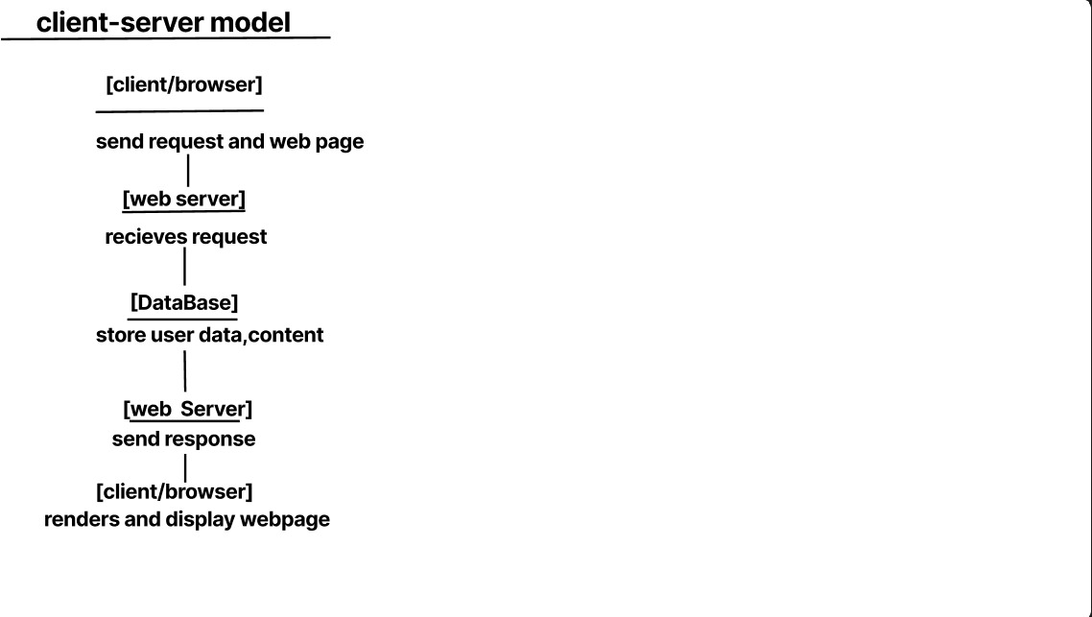

QUE: 4.Identify and list the tools required to set up a web development environment. Explain the purpose of each.

- Code editor (Like: vs code ) :- Used to write and edit code. Offers syntax highlighting, extensions, and debugging.
- Web browser(Like: chrome, edge, firefox ) :- To test and view web pages. Also includes developer tools for inspecting elements and debugging.
- Runtime environment(Like: Node js) :- Allows running JavaScript outside the browser, mainly used for backend and build tools.
- Framework/Libraries(Like: React, Django):- Provides a structure and pre-written code to speed up development and enforce best practices.
- Database tools(mysql, mongodb):- GUI tools to interact with databases, run queries, and visualize data.

QUE:5.Explain what a web server is and give examples of commonly used servers.
A web server is a software (and sometimes hardware) that serves web content to users over the internet or a local network.
When you enter a website URL (like www.example.com), your browser sends a request to a web server, which responds with the requested content — like an HTML page, image, video, or other resources.
Some commonly used web browser ae: Apache HTTP Server ,Nginx,LiteSpeed.

QUE 6 : Define the roles of a frontend developer, backend developer, and database administrator.
A frontend developer is responsible for building the user-facing parts of a website or web application — everything the user sees and interacts with.
A backend developer works on the server-side of the application. They handle the logic, data processing, and communication between the database and frontend.
A Database Administrator is responsible for managing and maintaining the database systems used in a project to store and retrieve data efficiently and securely.
QUE 7: Explain the difference between static and dynamic websites. Provide an example of each.
A static website displays fixed content. Each page is coded in HTML and shows the same information to every visitor unless manually updated.
A dynamic website displays content that can change based on user interactions, time, database data, etc. It involves backend processing and often uses databases.

QUE 8 : Research and list five web browsers. Explain how rendering engines differ between them.
Ans:-list of five web browsers are:-
Google chrome
Mozilla firefox
Opera
Microsoft edge
Apple safari

Google chrome and mozilla firefox use blink engine.it is fast and works well with modern websites.

Mozilla firefox uses it’s own engine named as gecko.

Apple safari uses the webkit rendering engine.
Opera uses the blink engine just like chrome and edge.

