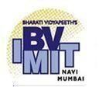

Bharati Vidyapeeth’s

Institute of Management & Information Technology

C.B.D. Belapur, Navi Mumbai 400614

**Vision:**

Providing high quality, innovative and value-based education in information technology to build competent professionals.

**Mission**

M1. Technical Skills:-To provide solid technical foundation theoretically as well as practically capable of providing quality services to industry.

M2. Development: -Department caters to the needs of students through comprehensive educational programs and promotes lifelong learning in the field of computer Applications.

M3. Ethical leadership:-Department develops ethical leadership insight in the students to succeed in industry, government and academia.

**CERTIFICATE**

This is to certify that the journal is the work of Ms.

**Vaishnavi Vidyadhar Kothawade** Roll No. 32 of **MCA** (**Sem - II** Div: **B**) for the academic year 2022 – 2023

Subject Solution:: **MCAL25**

Subject Name: **USER INTERFACE LAB**

Subject-in-charge Principal

Date:

External Examiner Date:

# Bharati Vidyapeeth's Institute of Management & Information

**Technology**

# MCA Semester II AY 2023-25 MCAL25: User Interface Lab

**INDEX**

# Division B Batch III

|  |  |  |  |
| --- | --- | --- | --- |
| **Sr.**  **No.** | **PRACTICAL DETAILS** | **DATE** | **SIGN** |
| 1 | Introduction to UI tool – Figma |  |  |
| 2 | Create an UX design for Figma Logo, College ID |  |  |
| 3 | Create an UX design for Login Page. (sign up and sign in) |  |  |
| 4 | Create an UX design to perform Boolean Operations. |  |  |
| 5 | To design newsletter page using grid and layouts. |  |  |
| 6 | Write a short note on User analysis, Task analysis, Domain analysis |  |  |
| 7 | Create a storyboard/Scenario using  <https://www.storyboardthat.com/> |  |  |
| 8 | Create Wireframe/Low fidelity Prototype for any system. |  |  |
| 9 | Create a sitemap of Mumbai Dabbawala web application. |  |  |
| 10 | Demonstrate an user persona - Design a persona |  |  |
| 11 | Create a conceptual design for Graphical Document Editor (Entity relationship Diagram – ERD and Class Diagram) Object model or entity-relationship diagram |  |  |
| 12 | Design any High fidelity Prototype (use Behance and ICON factory |  |  |
| 13 | Mini Project- Aim, Conceptual Design, Literature Review, Evaluation of the App based on User Experience, Evaluation based on Usability heuristics (Nielson), Improvements, Site Map, Create a Wireframe model using pencil tool, Screenshots, Conclusion |  |  |

**Q. Introduction to UI tool – Figma**

# Practical No.1

Figma is a UI/UX Design application available in Mac, Windows and also in web browsers. Using Figma we are able to create an excellent design, prototype and we can also generate our design as actual code like CSS, SVG. Figma is also capable of handing the vector files like SVG In simple words Figma is a design tool developed for all the designers.

## Tools and Interface

1. **Page**

Page is used to organize your design based on your preference. The page will be very useful when the number of your design elements are huge. We can able to create as much page as we need in Figma

## Frame

Frame is a container for all design elements in Figma similar to Artborad in other tools like Sketch, Adobe XD. To create a new Frame Click the **#** in the Top toolbar it will open the new right sidebar with all default Frame Sizes. If you want you can create a Frame with custom size. Press **A** or **F** key in your keyboard **to open the** right sidebar with default Frame Sizes**.**

Figma can handle any number of files in a single page without any delay while editing or while loading the Frames. We can Zoom out all the way to fit all the frames in a single screen and Zoom in all the way in to edit very tiny details in your design.

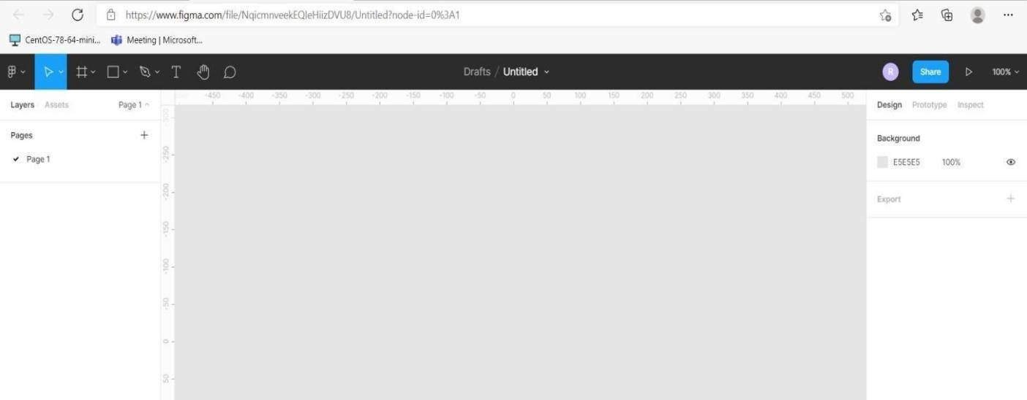

## Text and Shape tools

Text is a very important part, that is why Figma Provides a large number of features for Text. Some of the most important features are Font Family, Font Color including gradient color, change the letter case, decorations and more.

To select the text box click the **T**

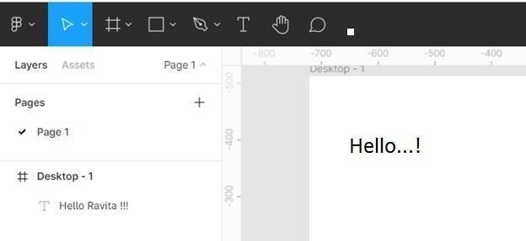

in the top toolbar or press **T** key from you keyboard.

## Shape Tools

In Designing tools All the Elements like button, Input box, Form, Header, Footer and section all of them are denoted using the Shares only. So Figma provide a list of share to create you design.

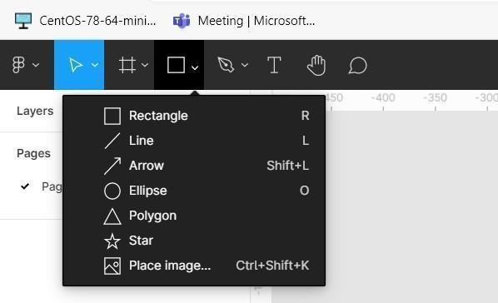

Share that are provided by the Figma tools are:

* + Rectangle
  + Line
  + Arrow
  + Ellipse
  + Polygon
  + Star

Shape border, background color, shadow and much more properties can be easily editable. For background color plain and gradient color features are also available.

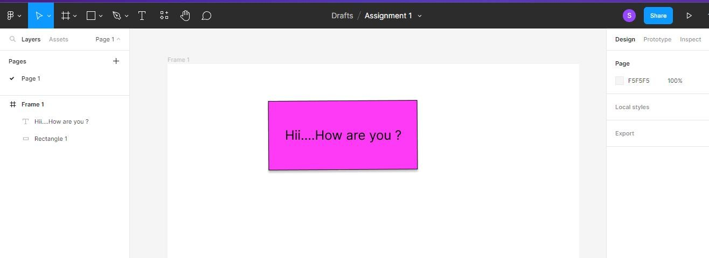

We can provide Border radius, Color, Strock and lot more, the best thing is we can able to add these properties to Multiple Elements at the same time by selecting all of them and the property values.

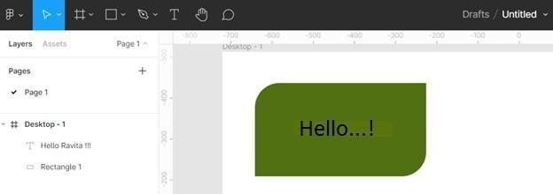

## Comments

The best and advanced feature in Figma is commenting on the design and prototype file. Comments take collaboration to the next level between the designers and client. You can use comments to respond to feedback, tweak your designs and iterate faster.

Click the comment icon in the toolbar to enter commenting mode. Once entered to the commenting mode cursor will turn into a location icon. Click at any location on the Canvas to create a comment.

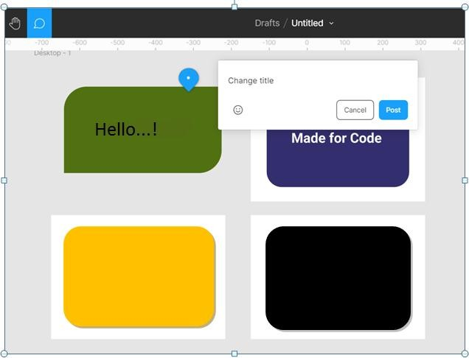

# Practical No.2

**Q. Create an UX design for Figma Logo, College ID**

## Design:

1. **Figma Logo: Output:**

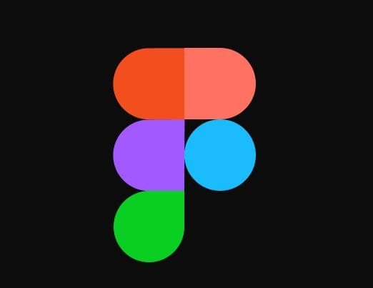

## IBM Logo: Output:

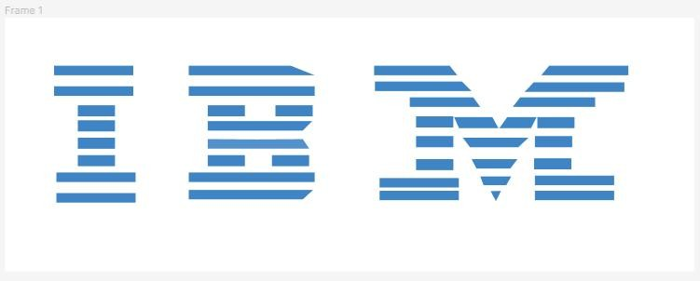

1. **Domino’s Logo: Output:**



1. **Student ID Card: Output:**

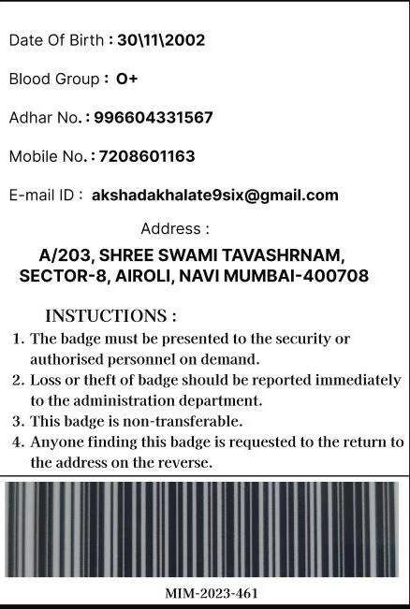

# Practical No.3

## Q. Create an UX design for Login Page. (Sign up and Sign in)

**Output:**

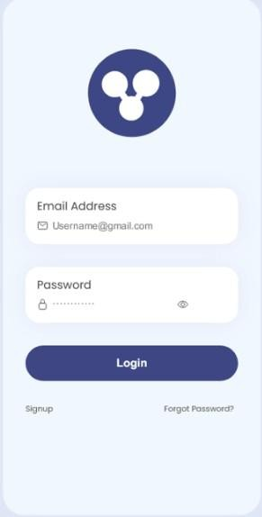

# Practical No.4

**Q. Create an UX design to perform Boolean Operations. Output:**

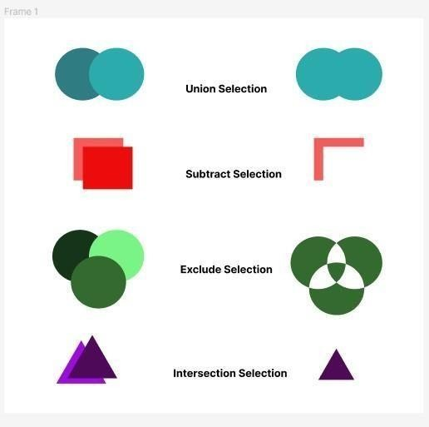

# Practical No.5

**Q. To design newsletter page using grid and layouts. Output:**

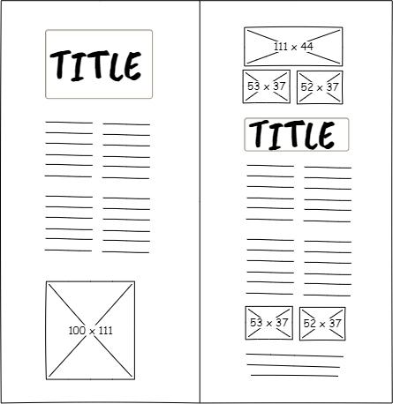

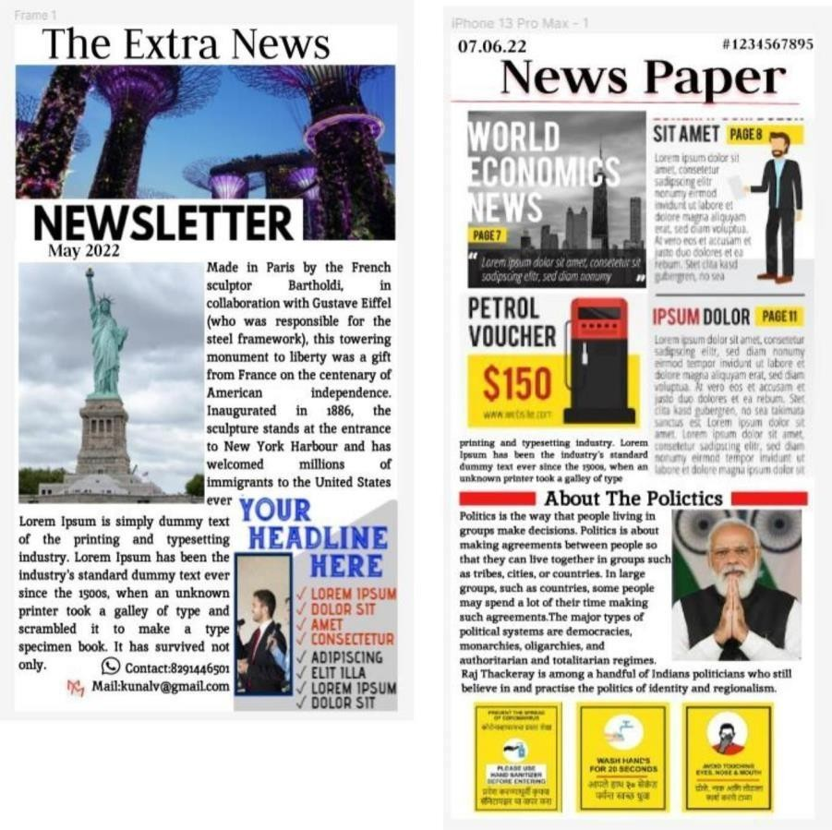

# Practical No.6

## Q. Write a short note on User analysis, Task analysis, Domain analysis User Analysis:

User analysis is a crucial step in UI design that involves understanding the target audience and their needs, preferences, and behaviors. This process involves gathering and analyzing data about the users, such as their demographics, goals, motivations, and skill levels. User analysis helps designers create user-centered designs by considering the users' perspectives and designing interfaces that align with their expectations.

## Task Analysis:

Task analysis is the process of breaking down complex tasks or processes into smaller, more manageable steps. In UI design, task analysis helps designers understand how users will interact with the interface to achieve their goals. By studying the sequence of actions and decisions required to complete a task, designers can identify pain points, optimize workflows, and design intuitive interfaces that facilitate efficient task completion.

## Domain Analysis:

Domain analysis involves gaining a deep understanding of the domain or industry for which the UI is being designed. It entails studying the specific terminology, concepts, and workflows that are relevant to the target domain. Domain analysis helps designers create interfaces that align with industry standards and conventions, ensuring that users can easily navigate and interact with the interface. It also enables designers to anticipate and address domain-specific challenges or requirements in the UI design process.

Overall, user analysis, task analysis, and domain analysis are integral components of UI design. By conducting user analysis, designers can create interfaces that meet the needs of the target audience. Task analysis helps designers optimize task flows and improve usability, while domain analysis ensures that the interface aligns with industry-specific requirements and conventions. Incorporating these analyses into the UI design process leads to more effective and user-friendly interfaces.

# Practical No.7

**Q. Create a storyboard/Scenario using https://[www.storyboardthat.com](http://www.storyboardthat.com/)**

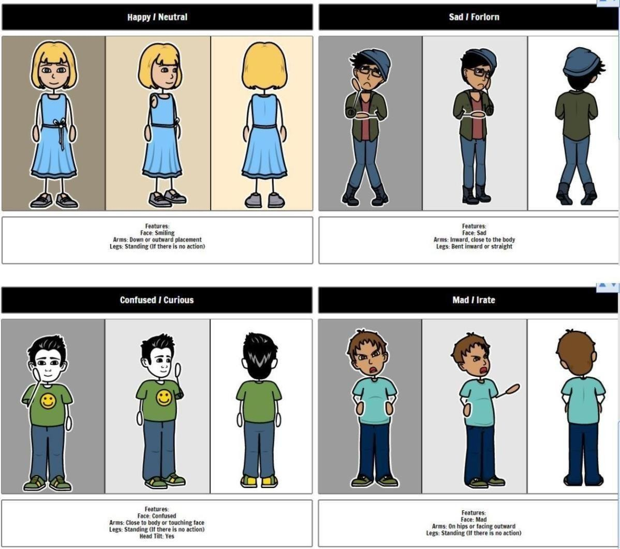

# Practical No.8

## Q. Create Wireframe/Low fidelity Prototype for any system.

Wireframe prototype for zomato:

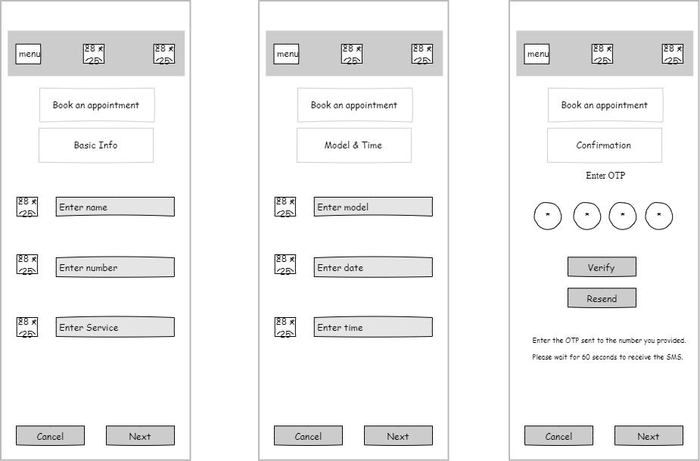

# Practical No.9

## Q. Create a sitemap of Hotel Management System.

Sitemap for Hotel Management System

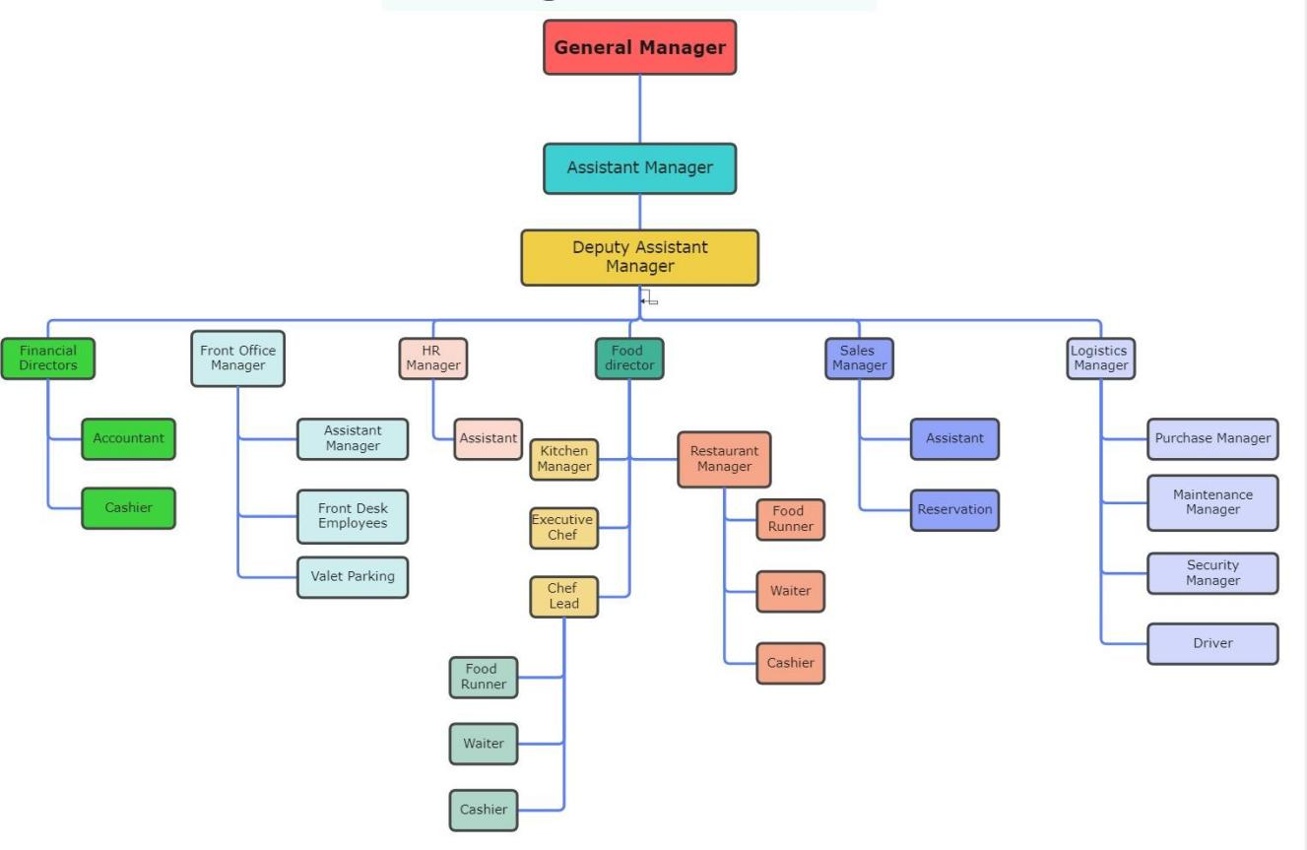

# Practical No.10

## Q. Demonstrate a user persona - Design a persona

User Persona:

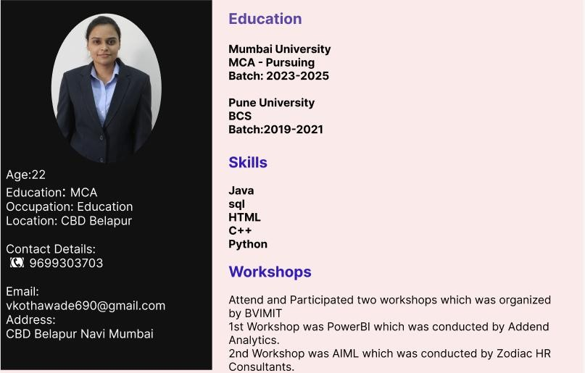

# Practical No.11

**Q. Create a conceptual design for Graphical Document Editor (Entity relationship Diagram – ERD and Class Diagram) Object model or entity-relationship diagram**

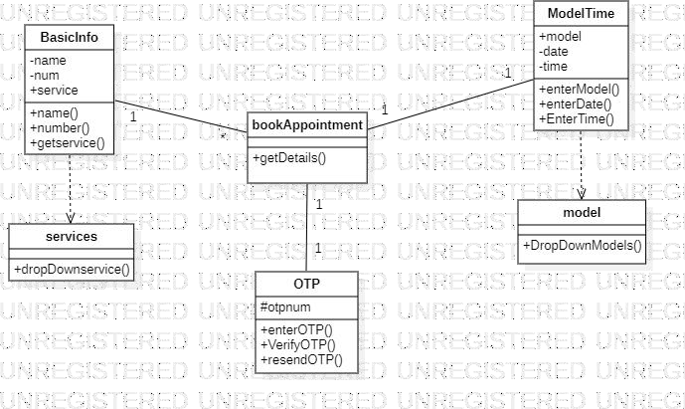

# Practical No.12

## Q. Design any High fidelity Prototype (use Behance and ICON factory) Output

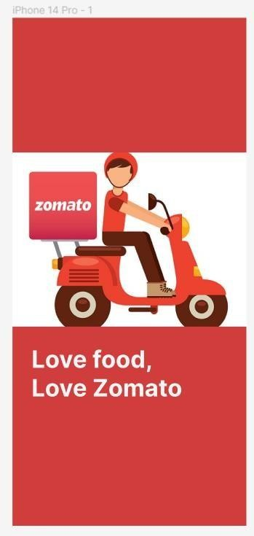 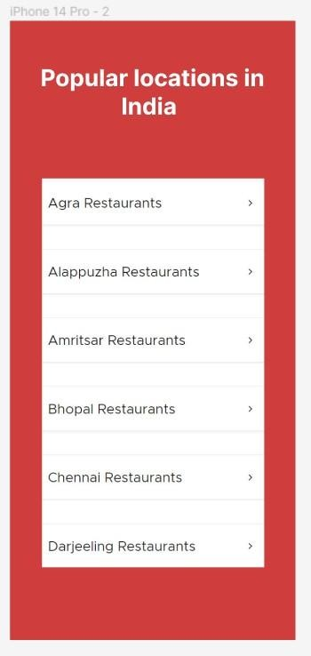



# Mini Project

Traditional Saree website Aim

To celebrate and preserve the timeless elegance of traditional Indian sarees, while providing a seamless online platform that offers a curated collection of high-quality sarees, exceptional customer service, and a cultural experience that transcends borders."

ER diagram

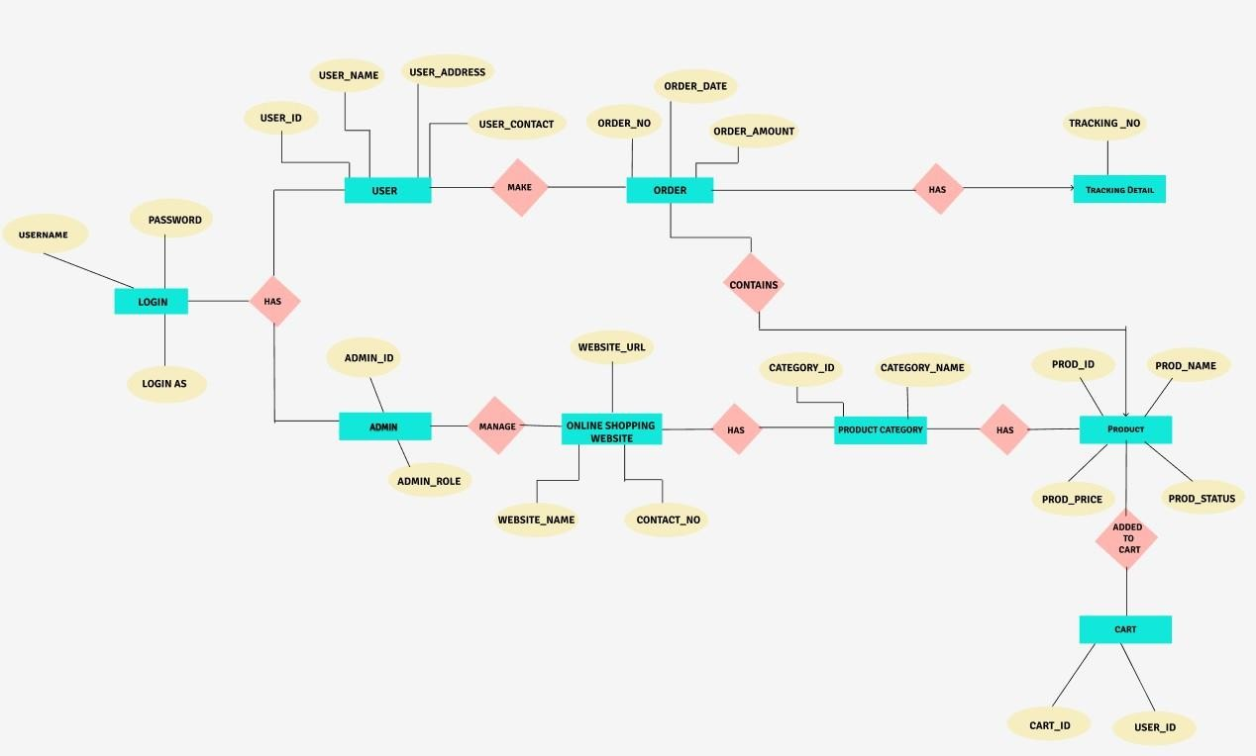

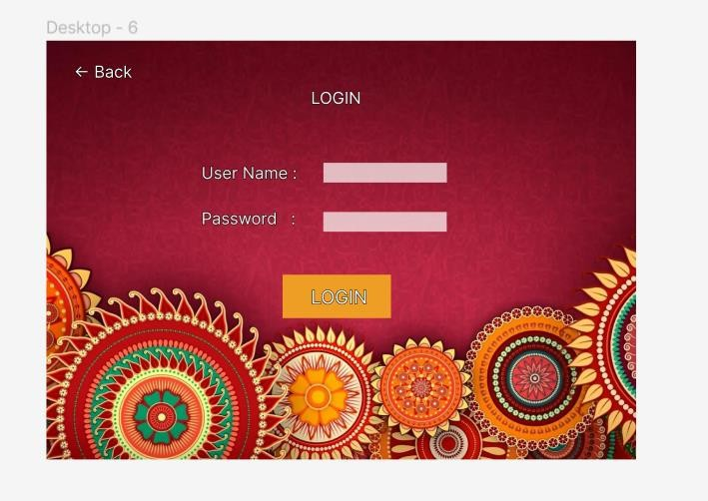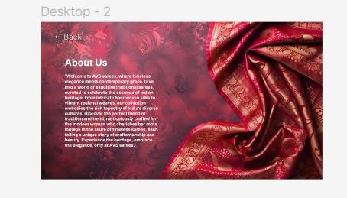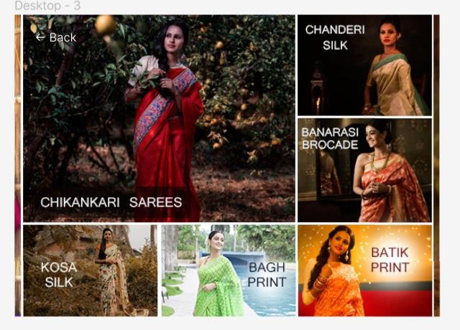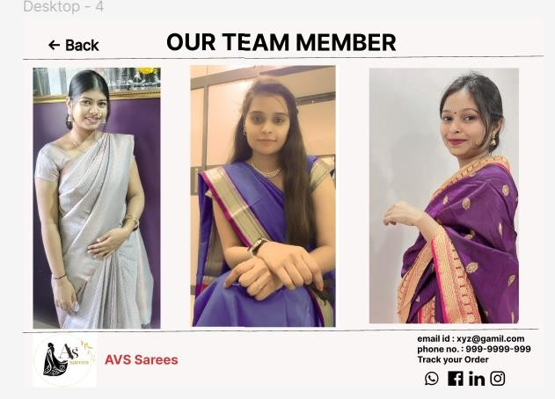

Conclusion

In conclusion, our traditional saree website celebrates the timeless elegance and cultural heritage of this iconic garment. Through a curated collection of exquisite sarees, we strive to offer a seamless online shopping experience that caters to the diverse tastes and preferences of our customers.

Whether it's for a special occasion or everyday wear, our commitment to quality craftsmanship and authentic designs ensures that each saree tells a unique story of tradition and beauty. Explore our

website and embark on a journey of sartorial splendor, where every drape is a celebration of heritage and grace.