**Assignment 06**: Assignment and practice of Prompt Engineering to craft effective prompts.

**Task 1: Prompt Categorization**

**"Generate a logo for a tech startup using neon colors."**



**Category: Visual  
 Reasoning:**

* This prompt involves creating a graphic design, specifically a logo.
* The emphasis on visual elements like "neon colors" and "tech startup" suggests a need for stylistic interpretation.
* It’s not asking for a description or explanation, but for a visual output.

**🔹 2. "Explain blockchain to a 5-year-old."**

**Category: Instructional  
 Reasoning:**

* This is a teaching-style prompt, asking for a simplified explanation of a complex concept.
* The target audience ("a 5-year-old") implies the need for age-appropriate language and analogies.
* The goal is to educate or inform, which makes it instructional.

**🔹 3. "You are a UX designer. Suggest improvements to this app layout."**

**Category: Conversational + Instructional  
 Reasoning:**

* This prompt sets up a role-play scenario ("You are a UX designer"), which is conversational in tone.
* It also expects practical advice or critique, which is instructional in nature.
* If accompanied by an image or layout, it could also lean into visual analysis, but as written, it’s primarily a role-based advisory prompt.

**Task 2: Refinement Practice**

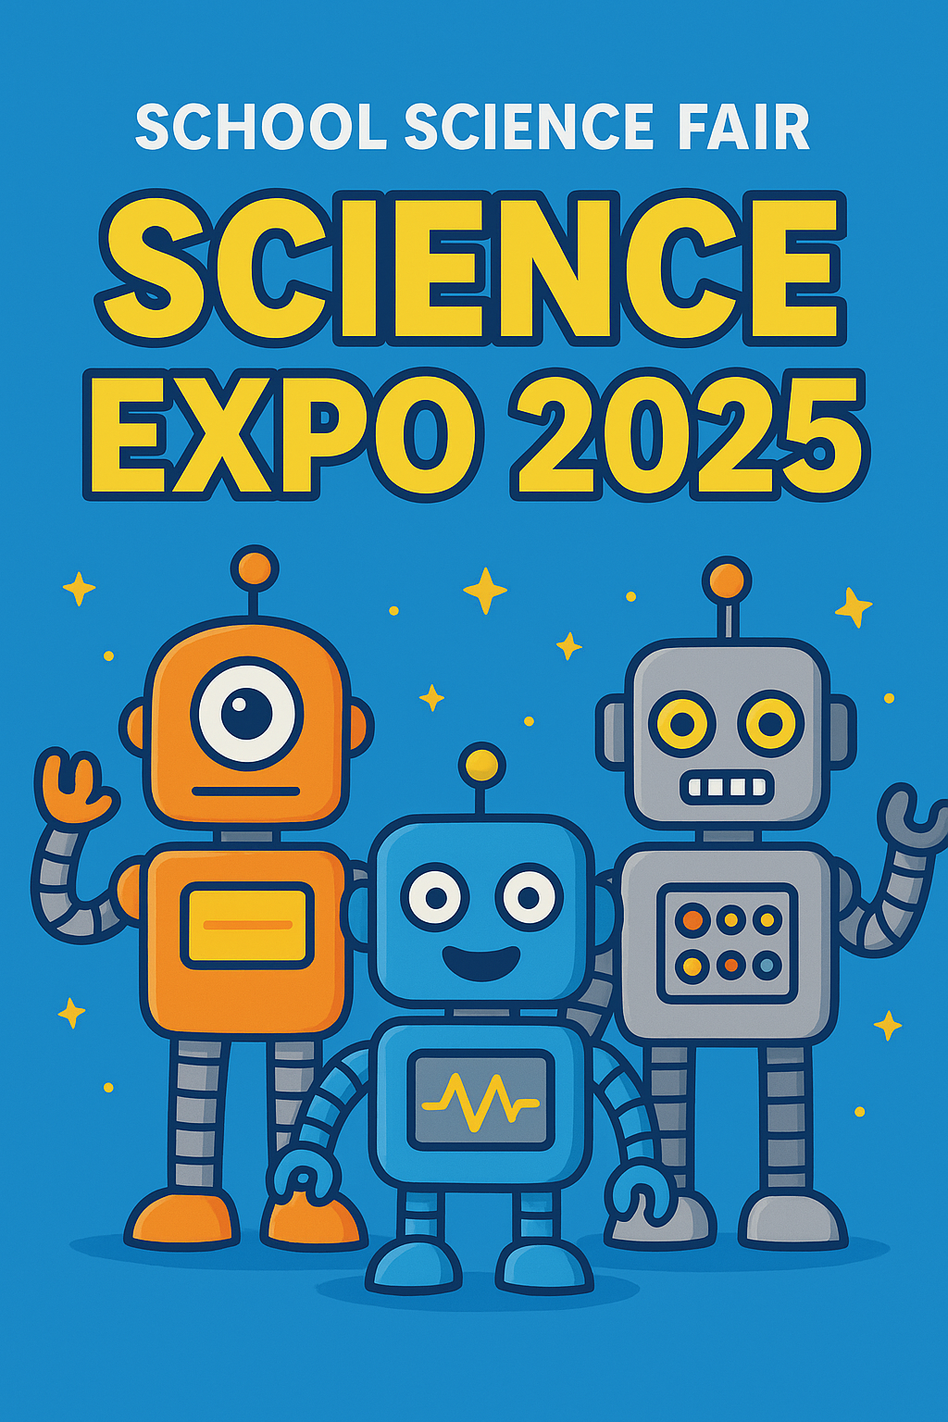

### **Task 3: Prompt Design Exercise**

### **ChatGPT (Text-Based Prompt)**

**Prompt:** *"Write a motivational speech for high school students about the importance of resilience, using simple language, real-life examples, and ending with an inspiring call to action."*

Why effective for ChatGPT:  
 ChatGPT is a language model, so this prompt gives clear direction about the tone (motivational), audience (high school students), content style (simple + real-life examples), and structure (ending with a call to action). This ensures a focused and audience-appropriate text output.

### **2. DALL·E (Image-Based Prompt)**

**Prompt:** *"Create a poster for an inter-school art festival with a pastel background, abstract paint splashes, and bold text that says ART FEST 2025."*

Why effective for DALL·E:  
 DALL·E is an image generation tool, so the prompt specifies:

* Purpose: Poster design
* Style: Pastel background + abstract paint splashes
* Text element: Bold “ART FEST 2025”  
   This level of detail ensures the generated image is visually aligned with the event’s theme.
* **3. SORA (Video-Based Prompt)**

**Prompt:** *"Generate a 20-second video showing a futuristic city at sunset, with flying cars moving between skyscrapers, glowing neon signs, and people walking on elevated glass pathways."*

Why effective for SORA:  
 SORA is a video generation tool, so the prompt includes:

* Duration: 20 seconds
* Setting: Futuristic city at sunset
* Dynamic elements: Flying cars, people walking
* Visual style: Neon, glass pathways  
   This helps SORA create a cohesive animated scene instead of random

visuals.

### **4. Coding / Logic Prompt**

**Prompt:** *"Write a Python program that takes a list of student names with marks, sorts them by marks in descending order, and prints the top three performers with their scores."*

**Why effective for coding tools:** For coding, the prompt is clear and structured:

* **Input type:** list of names and marks
* **Action:** sort by marks (descending)
* **Output:** top 3 performers with scores  
   This gives enough detail for the model to generate correct, runnable code.
* **5. Education / Training Prompt**

**Prompt:** *"Design a short interactive quiz for 8th-grade science students on renewable energy, with 5 multiple-choice questions and instant feedback after each answer."*

**Why effective for education/training tools:** This prompt is suited for training/learning platforms because it specifies:

* **Topic:** Renewable energy
* **Audience:** 8th-grade students
* **Format:** 5 MCQs
* **Interactivity:** Instant feedback after each answer  
   This ensures the generated content is not just informative but also **engaging and educational**.