ASSIGNMENT-6
RESPONSIBLE AI
NAME:K.Vaishnavi
ROLL.NO:2503A52414
Task Description #1 (Privacy &amp; Security in File Handling) Task: Use an AI tool to generate a Python script that stores user data (name, email, password) in a file. Analyze: Check if the AI stores sensitive data in plain text or without encryption. Expected Output: Identified privacy risks. Revised version with encrypted password storage (e.g., hashing).
INPUT FOR TASK 1 CODE 1:
"""Part 1: intentionally insecure file-handling example.
This version is for demonstrating the privacy risk only. Never use it for a real application because it writes the password in plain text.
""" name = input("Enter your name: ") email = input("Enter your email: ")
password = input("Enter your password: ")
with open("users.txt", "a", encoding="utf-8") as file: file.write(f"Name: {name}, Email: {email}, Password: {password}\n")
print("User information saved to users.txt.")
OUTPUT FOR TASK1 CODE1:
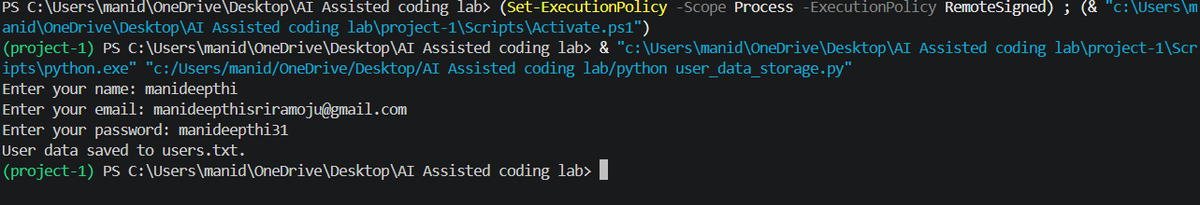
INPUT FOR TASK1 CODE2:
"""Part 3: safer password storage using only Python's standard library."""
import hashlib
import secrets
from getpass import getpass

name = input("Enter your name: ") email = input("Enter your email: ")
password = getpass("Enter your password: ")
# A unique salt prevents identical passwords from producing identical hashes. salt = secrets.token_bytes(16) # PBKDF2 deliberately performs many hash calculations, making password
# guessing more difficult than using a single fast hash.
password_hash = hashlib.pbkdf2_hmac(
"sha256",
password.encode("utf-8"),
salt,
100_000,
)
# Security improvement: store the salt and hash, never the original password.
with open("users_secure.txt", "a", encoding="utf-8") as file:
file.write( f"Name: {name}, Email: {email},
" f"Salt: {salt.hex()}, Password hash: {password_hash.hex()}\n"
) print("User information saved securely to users_secure.txt.")
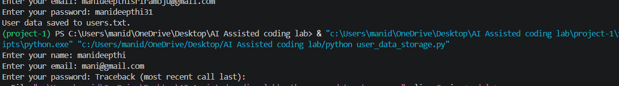
COMPARISION TABLE:
Original | REVISED
Password stored in plain text | Password stored as a hash
Password is visible during typing | getpass` hides password input
Plain-text credential can be reused immediately | Salted PBKDF2 hash must be verified
High privacy risk | Improved security
Task Description #2 – Fair Decision Logic Task: Prompt an AI tool to generate a scholarship eligibility checker based on academic score, family income, and location. Examine whether the logic unfairly favors or disadvantages any group. Expected Output-2: Code snippet with observations on fairness. Brief explanation (3–4 sentences) suggesting improvements to ensure equitable decision- making.
INPUT FOR TASK2 CODE1:
"""Fair Decision Logic demo: an intentionally biased scholarship checker.
This version is only for discussing fairness problems. The location bonus is not a suitable eligibility rule unless location is directly justified by the published scholarship requirements.
""" def get_number(prompt: str, minimum: float, maximum: float | None = None) -> float:
value = float(input(prompt)) if value < minimum or (maximum is not None and value > maximum):
raise ValueError("Please enter a valid value.")
return value
academic_score = get_number("Academic score (0-100): ", 0, 100)
family_income = get_number("Family annual income: ", 0) location = input("Location: ").strip()
score = academic_score * 0.70
if family_income <= 30000:
score += 20
elif family_income <= 60000: score += 10 # UNFAIR RULE: students from Urban areas receive extra points.
if location.lower() == "urban":
score += 10
eligible = score >= 70
decision = "Eligible" if eligible else "Not eligible"
reason = (
"The score reached the 70-point threshold."
if eligible else
"The score did not reach the 70-point threshold." ) print("\nScholarship result")
print(f"Academic score: {academic_score}")
print(f"Family income: {family_income:.2f}")
print(f"Location: {location}")
print(f"Final decision: {decision}")
print(f"Final score: {score:.1f}")
print(f"Reason: {reason}")
OUTPUT FOR TASK2 CODE1:
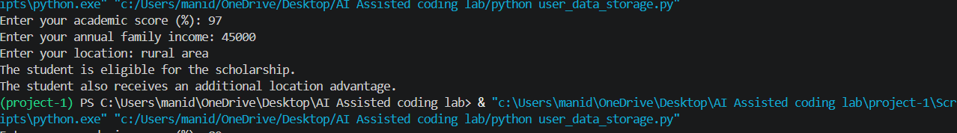
INPUT FOR TASK2 CODE2:
"""Fairer scholarship checker using academic performance and financial need."""
def get_number(prompt: str, minimum: float, maximum: float | None = None) -> float:
value = float(input(prompt))
if value < minimum or (maximum is not None and value > maximum):
raise ValueError("Please enter a valid value.")
return value
academic_score = get_number("Academic score (0-100): ", 0, 100)
family_income = get_number("Family annual income: ", 0) location = input("Location (shown for records only): ").strip() score = academic_score * 0.70
if family_income <= 30000:
score += 20
elif family_income <= 60000:
score += 10
# Fairness improvement: location is displayed but cannot change the score.
eligible = score >= 70
decision = "Eligible" if eligible else
"Not eligible"
reason = ( "The score reached the 70-point threshold using academic performance " "and financial need." if eligible else "The score did not reach the 70-point threshold using academic " "performance and financial need." )
print("\nScholarship result")
print(f"Academic score: {academic_score}")
print(f"Family income: {family_income:.2f}")
print(f"Location: {location}")
print(f"Final decision: {decision}")
print(f"Final score: {score:.1f}")
print(f"Reason: {reason}")
OUTPUT FOR TASK2 CODE2: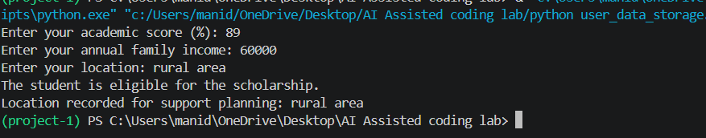
COMPARISION TABLE:
Original | REVISED
Uses location preference | Removes location bias.
May favor one group | Treats groups equally
Removes location bias. Treats groups equally Less fair | More fair
Can give different results | Based on academic score & income

Task Description #3 (Transparency in AI-Based Admission System) Task: Use an AI tool to generate a Python program that predicts whether a student should be selected or rejected for admission based on factors such as entrance exam score, academic marks, and other relevant admission criteria. Analyze: Check whether the AI system provides a clear and understandable reason for its admission decision. Expected Output:
Identified transparency risks. Example of an admission decision where the AI gives no explanation. Revised version that provides a clear reason for selecting or rejecting the student. Example output showing the important factors that influenced the AI&#39;s decision.
INPUT FOR TASK 3 CODE 1:
"""Part 1: an intentionally non-transparent admission decision demo."""
entrance_score = float(input("Entrance exam score (0-100): "))
academic_marks = float(input("Academic marks (0-100): "))
relevant_experience = float(input("Relevant experience score (0-100): "))
score = ( entrance_score * 0.50 + academic_marks * 0.35 + relevant_experience * 0.15 )
if score >= 70:
print("Selected")
else:
print("Rejected”)
OUTPUT FOR TASK3 CODE1:
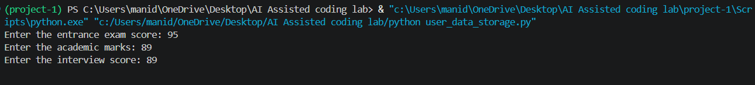
INPUT FOR TASK3 CODE2:
"""Part 2: an admission decision that explains its result."""
def get_score(prompt: str) -> float:
value = float(input(prompt))
if not 0 <= value <= 100:
raise ValueError("Scores must be between 0 and 100.")
return value
entrance_score = get_score("Entrance exam score (0-100): ")
academic_marks = get_score("Academic marks (0-100): ")
relevant_experience = get_score("Relevant experience score (0-100): ")
entrance_weight = 0.50
academic_weight = 0.35
experience_weight = 0.15
threshold = 70
entrance_points = entrance_score * entrance_weight
academic_points = academic_marks * academic_weight
experience_points = relevant_experience * experience_weight
total_score = entrance_points + academic_points + experience_points
selected = total_score >= threshold
decision = "Selected" if selected else "Rejected"
if selected:
reason = f"The weighted score of {total_score:.1f} meets the {threshold}-point threshold."
else:
reason = f"The weighted score of {total_score:.1f} is below the {threshold}-point threshold."
print("\nAdmission decision")
print(f"Decision: {decision}")
print(f"Weighted score: {total_score:.1f}/100") print(f"Reason: {reason}")

print("\nImportant factors:")
print(f"- Entrance exam: {entrance_score:.1f} x 50% = {entrance_points:.1f} points")

print(f"- Academic marks: {academic_marks:.1f} x 35% = {academic_points:.1f} points")
print( f"- Relevant experience: {relevant_experience:.1f} x 15% " f"= {experience_points:.1f} points" )
OUTPUT FOR TASK3 CODE2:
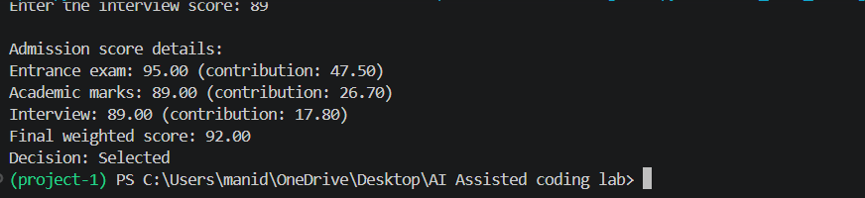
COMPARISION TABLE:
Original | REVISED
No explanation | Clear explanation
Low transparency | High transparency
Decision unclear | Decision understandable
Less ethical | More ethical

Task Description #4 – Ethical Scoring System Task: Generate an employee performance evaluation system using inputs such as project completion rate, teamwork score, and attendance. Analyze the scoring logic for any unethical weighting or hidden bias. Expected Output-4: Python code along with a written analysis identifying whether the evaluation criteria are balanced and justifiable.
INPUT FOR TASK4 CODE1:
"""Employee performance demo with a potentially unethical weighting scheme. This version is for analysis only. It gives attendance more influence than work results, which can unfairly affect some employees. """
def get_score(prompt: str) -> float:
value = float(input(prompt))
if not 0 <= value <= 100:
raise ValueError("Scores must be between 0 and 100.")
return value
completion_rate = get_score("Project completion rate (0-100): ") teamwork_score = get_score("Teamwork score (0-100): ") attendance = get_score("Attendance (0-100): ")
# Potentially unfair: attendance is given half of the total score. final_score = ( completion_rate * 0.30
+ teamwork_score * 0.20
+ attendance * 0.50
)
rating = "Strong performance" if final_score >= 70 else "Needs improvement"
print("\nEmployee evaluation")
print(f"Project completion: {completion_rate:.1f}") print(f"Teamwork: {teamwork_score:.1f}")

print(f"Attendance: {attendance:.1f}")
print(f"Final score: {final_score:.1f}/100")
print(f"Rating: {rating}")
OUTPUT FOR TASK4 CODE1:
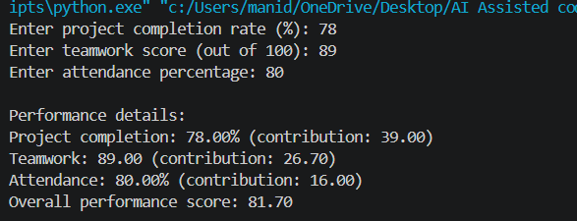
INPUT FOR TASK4 CODE2:
"""Fairer employee performance evaluation using disclosed, job-related factors."""
def get_score(prompt: str) -> float:
value = float(input(prompt))
if not 0 <= value <= 100:
raise ValueError("Scores must be between 0 and 100.")
return value
completion_rate = get_score("Project completion rate (0-100): ")
teamwork_score = get_score("Teamwork score (0-100): ") attendance = get_score("Attendance (0-100): ")
# These weights emphasize work results and collaboration over attendance. # Approved leave and reasonable accommodations should not be treated as poor # performance or converted into a lower attendance score.
final_score = ( completion_rate * 0.45
+ teamwork_score * 0.35
+ attendance * 0.20 )
rating = "Strong performance" if final_score >= 70 else "Needs improvement"
print("\nEmployee evaluation")
print(f"Project completion: {completion_rate:.1f} (45% weight)") print(f"Teamwork: {teamwork_score:.1f} (35% weight)") print(f"Attendance: {attendance:.1f} (20% weight)")
print(f"Final score: {final_score:.1f}/100"
print(f"Rating: {rating}")
print("Note: Approved leave and accommodations must be considered fairly.")
OUTPUT FOR TASK4 CODE2:
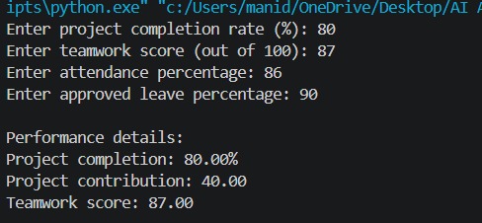
COMPARISION TABLE:
Unethical | ETHICAL
Biased criteria | Fair criteria
Gender affects score | Gender ignored
Unfair decision | Relevant factors used
Less ethical | More ethical

Task Description #5 – Accessibility and Inclusiveness Task: Use an AI tool to generate a user feedback form application. Review whether the language and options provided are inclusive and accessible to diverse users. Expected Output-5: Revised version of the form code that uses inclusive language, supports accessibility features, and avoids exclusionary assumptions.
INPUT FOR TASK5 CODE1:
<!DOCTYPE html>
<html lang="en">
<head>
<meta charset="UTF-8">
<meta name="viewport" content="width=device-width, initial-scale=1.0">
<title>Accessible User Feedback Form</title>
</head>
<body>
<header>
<h1>User Feedback</h1>
<p>Share your experience. Name and email are optional.</p>
</header>

<main>
<form>
<div>
<label for="name">Name (optional)</label>
<input
type="text"
id="name"
name="name"
autocomplete="name"
placeholder="Enter your name"
>
</div>

<div>
<label for="email">Email (optional)</label>
<input
type="email"
id="email"
name="email"
autocomplete="email"
placeholder="you@example.com"
>
</div>

<fieldset>
<legend>Gender (optional)</legend>
<p>You may skip this question.</p>
<div>
<input type="radio" id="gender-woman" name="gender" value="woman">
<label for="gender-woman">Woman</label>
</div>
<div>
<input type="radio" id="gender-man" name="gender" value="man">
<label for="gender-man">Man</label>
</div>
<div>
<input type="radio" id="gender-nonbinary" name="gender" value="non-binary">
<label for="gender-nonbinary">Non-binary</label>
</div>
<div>
<input type="radio" id="gender-self-describe" name="gender" value="self-describe">
<label for="gender-self-describe">Prefer to self-describe</label>
</div>
<div>
<input type="radio" id="gender-no-answer" name="gender" value="prefer-not-to-say">
<label for="gender-no-answer">Prefer not to say</label>
</div>
</fieldset>

<div>
<label for="category">Feedback category</label>
<select id="category" name="category" required>
<option value="">Choose a category</option>
<option value="website">Website design or usability</option>
<option value="accessibility">Accessibility</option>
<option value="service">Service or experience</option>
<option value="technical-problem">Technical problem</option>
<option value="suggestion">Suggestion or idea</option>
<option value="other">Other</option>
</select>
</div>

<div>
<label for="message">Feedback message</label>
<textarea
id="message"
name="message"
rows="6"
placeholder="Tell us what went well or what we could improve."
required
></textarea>
</div>

<fieldset>
<legend>How satisfied are you?</legend>
<div>
<input type="radio" id="rating-1" name="satisfaction" value="1" required>
<label for="rating-1">1 - Very dissatisfied</label>
</div>
<div>
<input type="radio" id="rating-2" name="satisfaction" value="2">
<label for="rating-2">2 - Dissatisfied</label>
</div>
<div>
<input type="radio" id="rating-3" name="satisfaction" value="3">
<label for="rating-3">3 - Neither satisfied nor dissatisfied</label>
</div>
<div>
<input type="radio" id="rating-4" name="satisfaction" value="4">
<label for="rating-4">4 - Satisfied</label>
</div>
<div>
<input type="radio" id="rating-5" name="satisfaction" value="5">
<label for="rating-5">5 - Very satisfied</label>
</div>
</fieldset>

<button type="submit">Submit feedback</button>
</form>
</main>
</body>
</html>

OUTPUT FOR TASK5 CODE1:
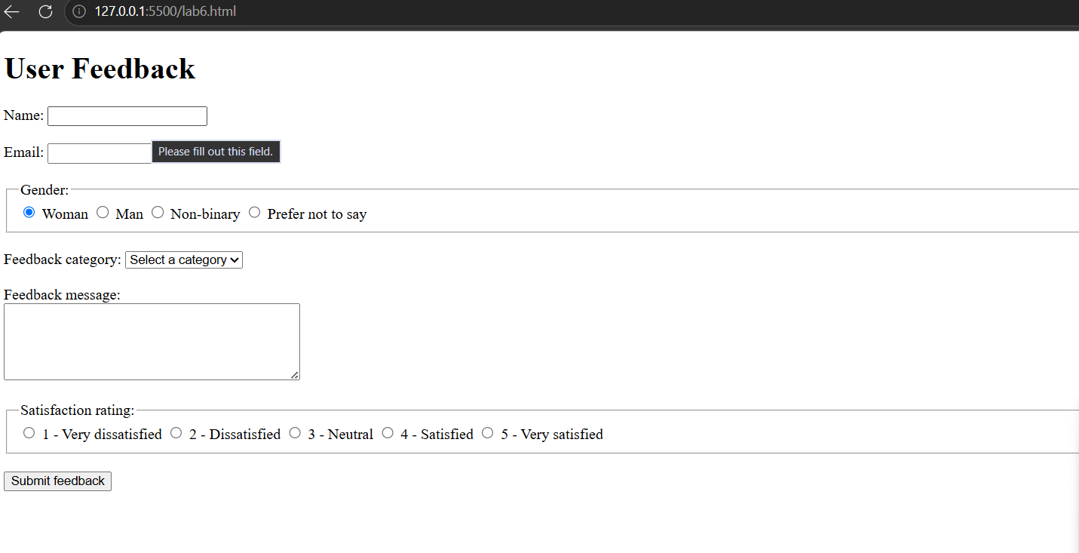
INPUT FOR TASK5 CODE2:
<!DOCTYPE html>
<html lang="en">

<head>
<meta charset="UTF-8">
<meta name="viewport" content="width=device-width, initial-scale=1.0">

<title>Accessible User Feedback Form</title>

<style>
body {
font-family: Arial, sans-serif;
line-height: 1.6;
max-width: 600px;
margin: 30px auto;
padding: 20px;
}

label {
display: block;
margin-top: 15px;
font-weight: bold;
}

input,
select,
textarea {
width: 100%;
padding: 10px;
margin-top: 5px;
box-sizing: border-box;
}

fieldset {
margin-top: 20px;
padding: 15px;
}

fieldset label {
font-weight: normal;
display: block;
}

button {
margin-top: 20px;
padding: 10px 20px;
cursor: pointer;
}
</style>
</head>

<body>

<main>

<h1>User Feedback Form</h1>

<p>
We value your feedback. Please share your experience with us.
You may leave your name and email blank if you prefer.
</p>

<form>

<!-- Name -->
<label for="name">Name (optional)</label>
<input
type="text"
id="name"
name="name"
autocomplete="name"
placeholder="Enter your name if you wish">

<!-- Email -->
<label for="email">Email (optional)</label>
<input
type="email"
id="email"
name="email"
autocomplete="email"
placeholder="example@email.com">

<!-- Gender -->
<fieldset>
<legend>Gender (optional)</legend>

<label>
<input type="radio" name="gender" value="woman">
Woman
</label>

<label>
<input type="radio" name="gender" value="man">
Man
</label>

<label>
<input type="radio" name="gender" value="non-binary">
Non-binary
</label>

<label>
<input type="radio" name="gender" value="self-describe">
Prefer to self-describe
</label>

<label>
<input type="radio" name="gender" value="prefer-not">
Prefer not to say
</label>
</fieldset>

<!-- Feedback Category -->
<label for="category">Feedback category</label>

<select id="category" name="category" required>
<option value="">-- Select a category --</option>
<option value="suggestion">Suggestion</option>
<option value="compliment">Compliment</option>
<option value="problem">Report a problem</option>
<option value="question">Question</option>
<option value="other">Other</option>
</select>

<!-- Feedback -->
<label for="feedback">Your feedback</label>

<textarea
id="feedback"
name="feedback"
rows="6"
required
placeholder="Please share your feedback">
</textarea>

<!-- Satisfaction -->
<label for="satisfaction">How satisfied were you?</label>

<select id="satisfaction" name="satisfaction" required>
<option value="">-- Select an option --</option>
<option value="very-satisfied">Very satisfied</option>
<option value="satisfied">Satisfied</option>
<option value="neutral">Neither satisfied nor dissatisfied</option>
<option value="dissatisfied">Dissatisfied</option>
<option value="very-dissatisfied">Very dissatisfied</option>
<option value="prefer-not">Prefer not to answer</option>
</select>

<button type="submit">Submit Feedback</button>

</form>

</main>

</body>
</html>
OUTPUT FOR TASK5 CODE2:
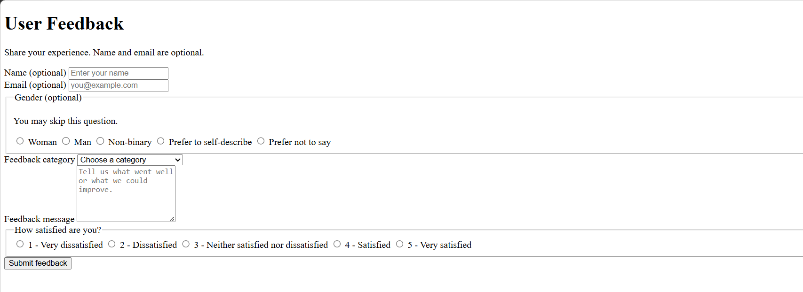
COMPARISION TABLE:
Before Modification | AFTER MODIFICATION
Limited gender options | Inclusive gender options
Labels not properly connected | Labels connected using for and id
Unnecessary information may be required | Personal information made optional
Basic accessibility | Improved accessibility support

Task Description #6 (Fairness in Loan Approval System)
Task: Use an AI tool to generate a Python program that predicts whether a person should be approved
or rejected for a loan based on information such as income, age, employment status, credit score, and
loan amount.
Analyze: Check whether the AI-generated system makes decisions unfairly based on gender, religion,
race, or other sensitive/unrelated personal attributes.
Expected Output:
• Identified fairness and discrimination risks.
• Examples showing how biased data or rules can lead to unfair loan decisions.
• Revised version that makes loan decisions based on relevant financial factors rather than
sensitive attributes.
• Brief explanation of how the revised system improves fairness.
INPUT FOR TASK6 CODE2:
"""Loan demo with intentionally discriminatory rules.
This is for identifying fairness risks, not for making real lending decisions. """
income = float(input("Annual income: "))
age = int(input("Age: "))
employment_status = input("Employment status: ").strip().lower() credit_score = int(input("Credit score (300-850): "))
loan_amount = float(input("Loan amount: "))
gender = input("Gender: ").strip().lower()
religion = input("Religion: ").strip().lower()
approved = (
income >= loan_amount * 2
and credit_score >= 650
and employment_status in {"employed", "self-employed"} and age >= 21 )
# Unethical rules: these unrelated sensitive attributes change the outcome.
if gender == "female":
approved = False
if religion == "minority_religion":
approved = False
print("Approved" if approved else "Rejected")
OUTPUT FOR TASK6 CODE1:
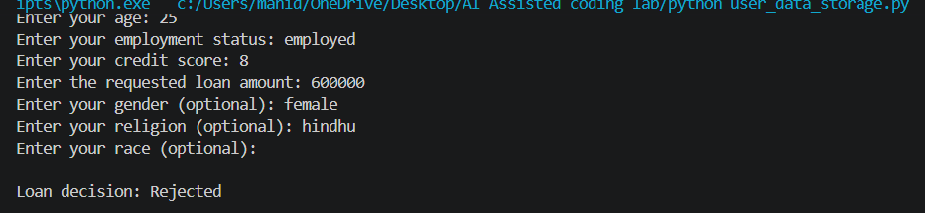
INPUT FOR TASK6 CODE2:
"""A simple and explainable loan approval system."""

income = float(input("Enter your annual income: "))
age = int(input("Enter your age: "))
employment_status = input("Enter your employment status: ").strip().lower()
credit_score = int(input("Enter your credit score: "))
loan_amount = float(input("Enter the requested loan amount: "))

# These thresholds are example rules. Real lending rules must follow local law.
minimum_income = 30000
minimum_credit_score = 650
maximum_loan_multiple = 3

income_is_sufficient = income >= minimum_income
credit_score_is_sufficient = credit_score >= minimum_credit_score
employment_is_stable = employment_status in {"employed", "self-employed"}
loan_is_affordable = loan_amount <= income * maximum_loan_multiple
age_is_eligible = age >= 18

print("\nFactors used in the decision:")
print(f"Income: {income:.2f} (minimum: {minimum_income:.2f})")
print(f"Credit score: {credit_score} (minimum: {minimum_credit_score})")
print(f"Employment status: {employment_status}")
print(f"Requested loan amount: {loan_amount:.2f}")
print(f"Age: {age} (legal minimum used by this example: 18)")

reasons = []
if not income_is_sufficient:
reasons.append("income is below the minimum")
if not credit_score_is_sufficient:
reasons.append("credit score is below the minimum")
if not employment_is_stable:
reasons.append("employment status is not stable")
if not loan_is_affordable:
reasons.append("requested loan amount is too high compared with income")
if not age_is_eligible:
reasons.append("applicant does not meet the legal age requirement")

if not reasons:
decision = "Approved"
explanation = "All relevant income, credit, employment, affordability, and legal-age requirements were met."
else:
decision = "Rejected"
explanation = "The following requirement(s) were not met: " + "; ".join(reasons) + "."

print(f"\nLoan decision: {decision}")
print(f"Explanation: {explanation}")
OUTPUT FOR TASK6 CODE2:
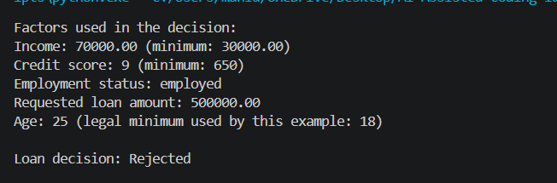
COMPARISION TABLE:
Biased System | Revised Fair System
Uses gender/religion | Does not use sensitive attributes
Can discriminate | Reduces discrimination risk
May learn biased rules | Focuses on financial factors
Decisions may depend on identity | Decisions depend on income, credit score, employment & loan amount

