Lab 11 – Data Structures with AI: Implementing Fundamental Structures
NAME:K.Vaishnavi
Roll no:2503A52414
Batch:14

Task Description #1 – Stack Implementation
Task: Use AI to generate a Stack class with push, pop, peek, and is_empty methods.
INPUT:
class Stack:
"""Implementation of a Stack using Python list."""

def __init__(self):
self.items = []

def push(self, item):
"""Add an item to the top of the stack."""
self.items.append(item)

def pop(self):
"""Remove and return the top item."""
if self.is_empty():
return "Stack is empty"
return self.items.pop()

def peek(self):
"""Return the top item without removing it."""
if self.is_empty():
return "Stack is empty"
return self.items[-1]

def is_empty(self):
"""Check whether the stack is empty."""
return len(self.items) == 0

stack = Stack()
stack.push(10)
stack.push(20)
stack.push(30)

print("Top:", stack.peek())
print("Popped:", stack.pop())
print("Stack empty:", stack.is_empty())

OUTPUT:
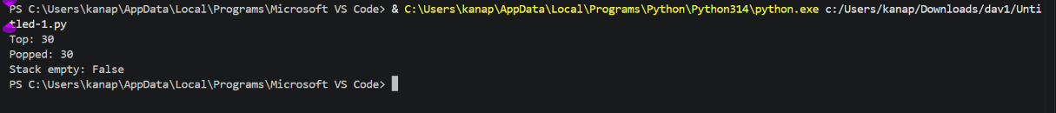

Task Description #2 – Queue Implementation
Task: Use AI to implement a Queue using Python lists.
INPUT:
class Queue:
"""Implementation of a Queue using Python list."""

def __init__(self):
self.items = []

def enqueue(self, item):
"""Add an item to the rear of the queue."""
self.items.append(item)

def dequeue(self):
"""Remove and return the front item."""
if self.size() == 0:
return "Queue is empty"
return self.items.pop(0)

def peek(self):
"""Return the front item without removing it."""
if self.size() == 0:
return "Queue is empty"
return self.items[0]

def size(self):
"""Return the number of items in the queue."""
return len(self.items)

queue = Queue()
queue.enqueue("A")
queue.enqueue("B")
queue.enqueue("C")

print("Front:", queue.peek())
print("Removed:", queue.dequeue())
print("Size:", queue.size())

OUTPUT:
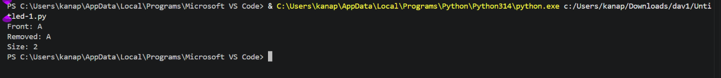

Task Description #3 – Linked List
Task: Use AI to generate a Singly Linked List with insert and display methods.
INPUT:
class Node:
"""Represents a node in a linked list."""

def __init__(self, data):
self.data = data
self.next = None

class LinkedList:
"""Implementation of a Singly Linked List."""

def __init__(self):
self.head = None

def insert(self, data):
"""Insert a new node at the end."""
new_node = Node(data)

if self.head is None:
self.head = new_node
return

current = self.head

while current.next:
current = current.next

current.next = new_node

def display(self):
"""Display all elements of the linked list."""
current = self.head

while current:
print(current.data, end=" -> ")
current = current.next

print("None")

linked_list = LinkedList()

linked_list.insert(10)
linked_list.insert(20)
linked_list.insert(30)

linked_list.display()

OUTPUT:
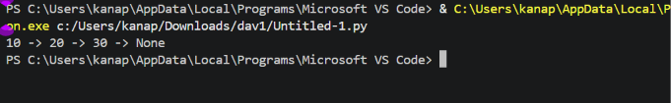
Task Description #4 – Binary Search Tree (BST)
Task: Use AI to create a BST with insert and in-order traversal methods.

INPUT:
class Node:
"""Represents a node in a Binary Search Tree."""

def __init__(self, data):
self.data = data
self.left = None
self.right = None

class BST:
"""Binary Search Tree implementation."""

def __init__(self):
self.root = None

def insert(self, root, data):
"""Recursively insert data into the BST."""
if root is None:
return Node(data)

if data < root.data:
root.left = self.insert(root.left, data)
else:
root.right = self.insert(root.right, data)

return root

def inorder(self, root):
"""Perform in-order traversal."""
if root:
self.inorder(root.left)
print(root.data, end=" ")
self.inorder(root.right)

bst = BST()

for value in [50, 30, 70, 20, 40, 60, 80]:
bst.root = bst.insert(bst.root, value)

print("In-order Traversal:")
bst.inorder(bst.root)

OUTPUT:
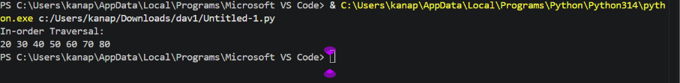

Task Description #5 – Priority Queue
Task: Use AI to implement a priority queue using Python’s heapq module.
INPUT:
import heapq

class PriorityQueue:
"""Priority Queue implementation using heapq."""

def __init__(self):
self.queue = []

def enqueue(self, item, priority):
"""Add an item with a priority."""
heapq.heappush(self.queue, (priority, item))

def dequeue(self):
"""Remove and return the highest-priority item."""
if not self.queue:
return "Priority Queue is empty"

priority, item = heapq.heappop(self.queue)
return item

def display(self):
"""Display all items in priority order."""
print(self.queue)

pq = PriorityQueue()

pq.enqueue("Normal Task", 3)
pq.enqueue("Urgent Task", 1)
pq.enqueue("Medium Task", 2)

print("Queue:")
pq.display()

print("Removed:", pq.dequeue())

OUTPUT:
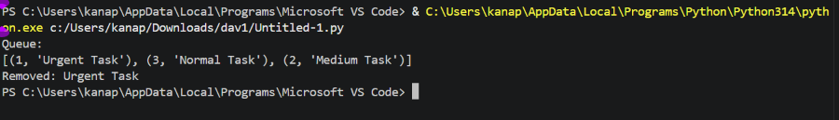

Task Description #6 – Deque
Task: Use AI to implement a double-ended queue using collections.deque.
INPUT:
from collections import deque

class DequeDS:
"""Double-ended queue implementation."""

def __init__(self):
self.items = deque()

def insert_front(self, item):
"""Insert an item at the front."""
self.items.appendleft(item)

def insert_rear(self, item):
"""Insert an item at the rear."""
self.items.append(item)

def remove_front(self):
"""Remove an item from the front."""
if not self.items:
return "Deque is empty"
return self.items.popleft()

def remove_rear(self):
"""Remove an item from the rear."""
if not self.items:
return "Deque is empty"
return self.items.pop()

def display(self):
"""Display the deque."""
print(list(self.items))

d = DequeDS()

d.insert_front(20)
d.insert_front(10)
d.insert_rear(30)

d.display()

print("Removed Front:", d.remove_front())
print("Removed Rear:", d.remove_rear())

d.display()

OUTPUT:
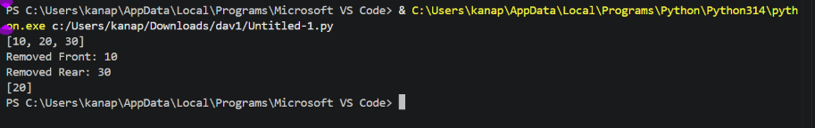

Task Description #7 Real-Time Application Challenge – Choose the Right Data Structure
Student Task:
• For each feature, select the most appropriate data structure from the list below:
o Stack
o Queue
o Priority Queue
o Linked List
o Binary Search Tree (BST)
o Graph
o Hash Table
o Deque
• Justify your choice in 2–3 sentences per feature.
• Implement one selected feature as a working Python program with AI-assisted code generation.

INPUT:
class CafeteriaQueue:
"""Manage cafeteria orders using FIFO queue."""

def __init__(self):
self.orders = []

def add_order(self, order):
"""Add a new order to the queue."""
self.orders.append(order)

def serve_order(self):
"""Serve the first order in the queue."""
if not self.orders:
return "No orders available."

return self.orders.pop(0)

def display_orders(self):
"""Display all pending orders."""
if not self.orders:
print("No pending orders.")
else:
print("\nPending Orders:")
for order in self.orders:
print("-", order)

cafeteria = CafeteriaQueue()

while True:
print("\n--- Cafeteria Order System ---")
print("1. Add Order")
print("2. Serve Order")
print("3. Display Orders")
print("4. Exit")

choice = input("Enter your choice: ")

if choice == "1":
order = input("Enter food order: ")
cafeteria.add_order(order)
print("Order added successfully.")

elif choice == "2":
served = cafeteria.serve_order()
print("Serving:", served)

elif choice == "3":
cafeteria.display_orders()

elif choice == "4":
print("Thank you!")
break

else:
print("Invalid choice.")

OUTPUT:
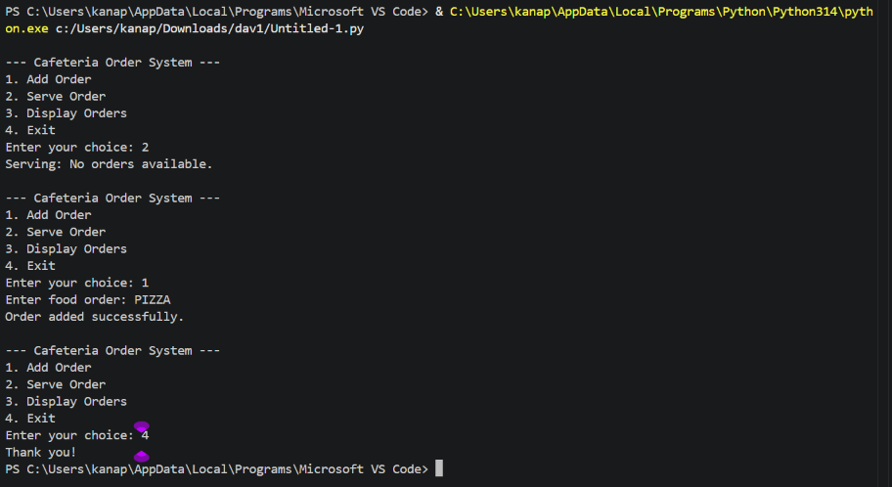

Task Description #8: Smart E-Commerce Platform – Data Structure Challenge
Student Task:
• For each feature, select the most appropriate data structure from the list below:
o Stack
o Queue
o Priority Queue
o Linked List
o Binary Search Tree (BST)
o Deque
• Justify your choice in 2–3 sentences per feature.
• Implement one selected feature as a working Python program with AI-assisted code generation.

INPUT:
class OrderQueue:
"""Manage e-commerce orders using FIFO queue."""

def __init__(self):
self.orders = []

def add_order(self, order):
"""Add an order to the queue."""
self.orders.append(order)

def process_order(self):
"""Process the oldest order."""
if not self.orders:
return "No orders available."

return self.orders.pop(0)

def display_orders(self):
"""Display all pending orders."""
if not self.orders:
print("No pending orders.")
else:
print("\nPending Orders:")
for order in self.orders:
print("-", order)

system = OrderQueue()

while True:
print("\n--- Smart E-Commerce Order System ---")
print("1. Add Order")
print("2. Process Order")
print("3. Display Orders")
print("4. Exit")

choice = input("Enter your choice: ")

if choice == "1":
order = input("Enter product/order name: ")
system.add_order(order)
print("Order added successfully.")

elif choice == "2":
order = system.process_order()
print("Processing:", order)

elif choice == "3":
system.display_orders()

elif choice == "4":
print("Exiting system...")
break

else:
print("Invalid choice.")

OUTPUT:
