1. Square:

1 1 1 1 1

2 2 2 2 2

3 3 3 3 3

4 4 4 4 4

5 5 5 5 5

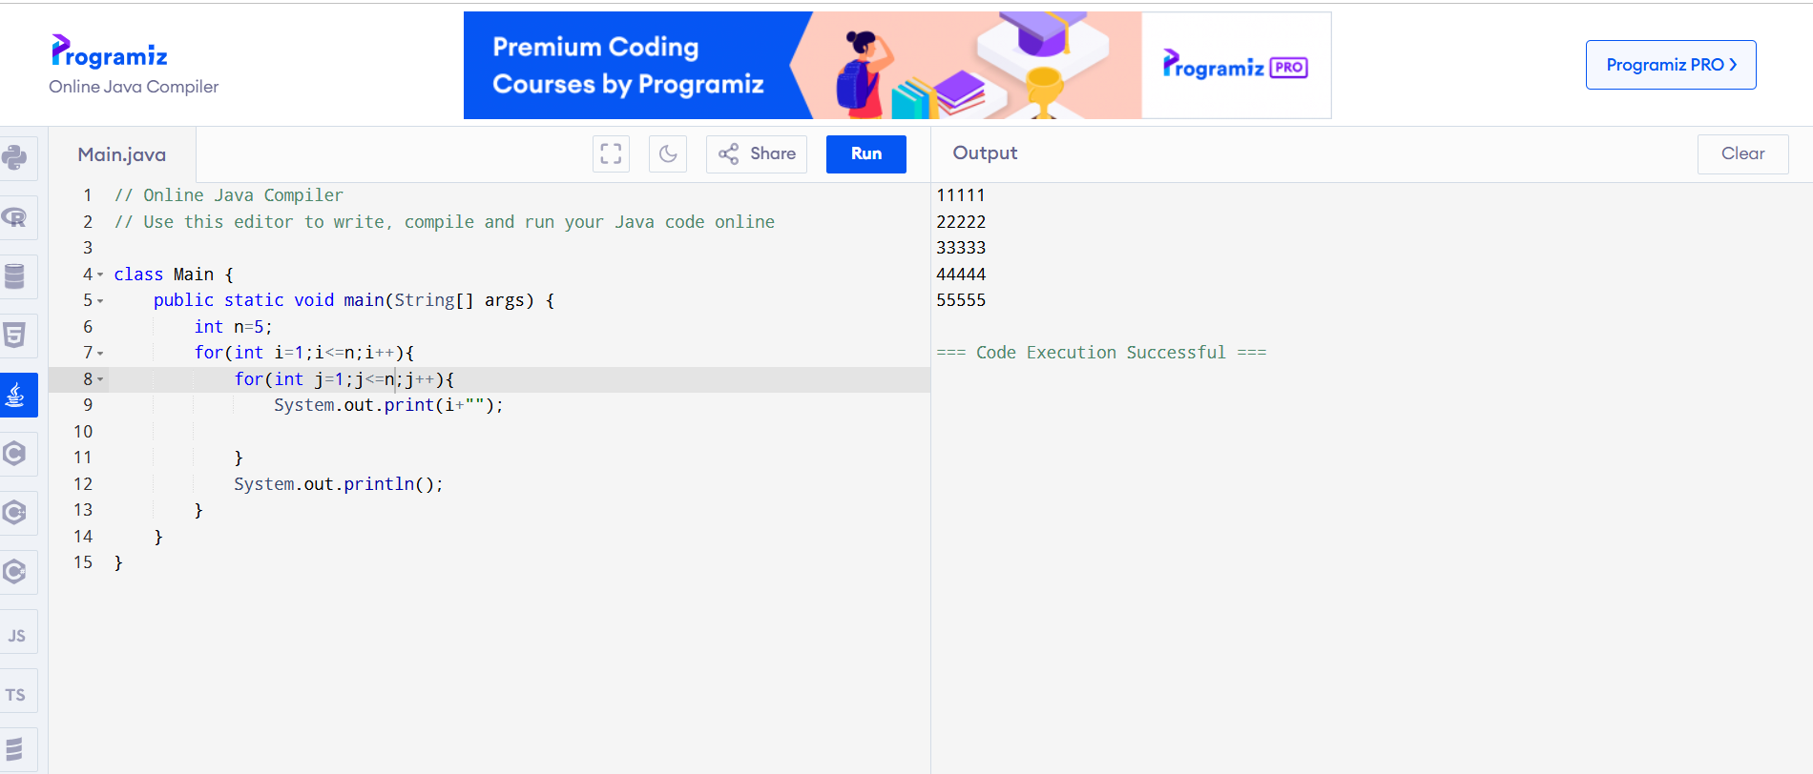

2. Triangle:

1

2 3

4 5 6

7 8 9 10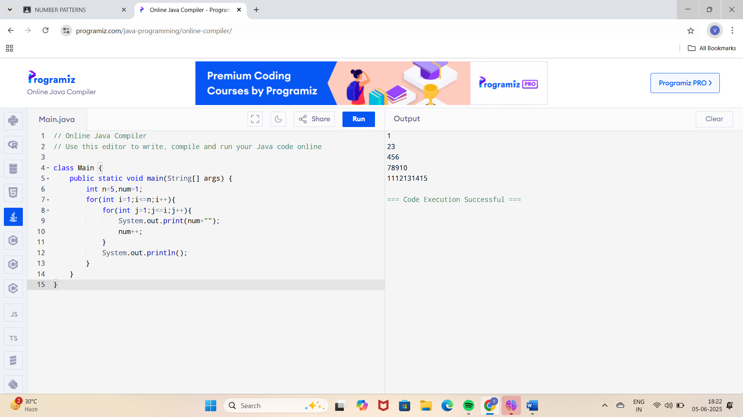

3. Square with logic:

01 02 03 04 05

06 07 08 09 10

11 12 13 14 15

16 17 18 19 20

21 22 23 24 25

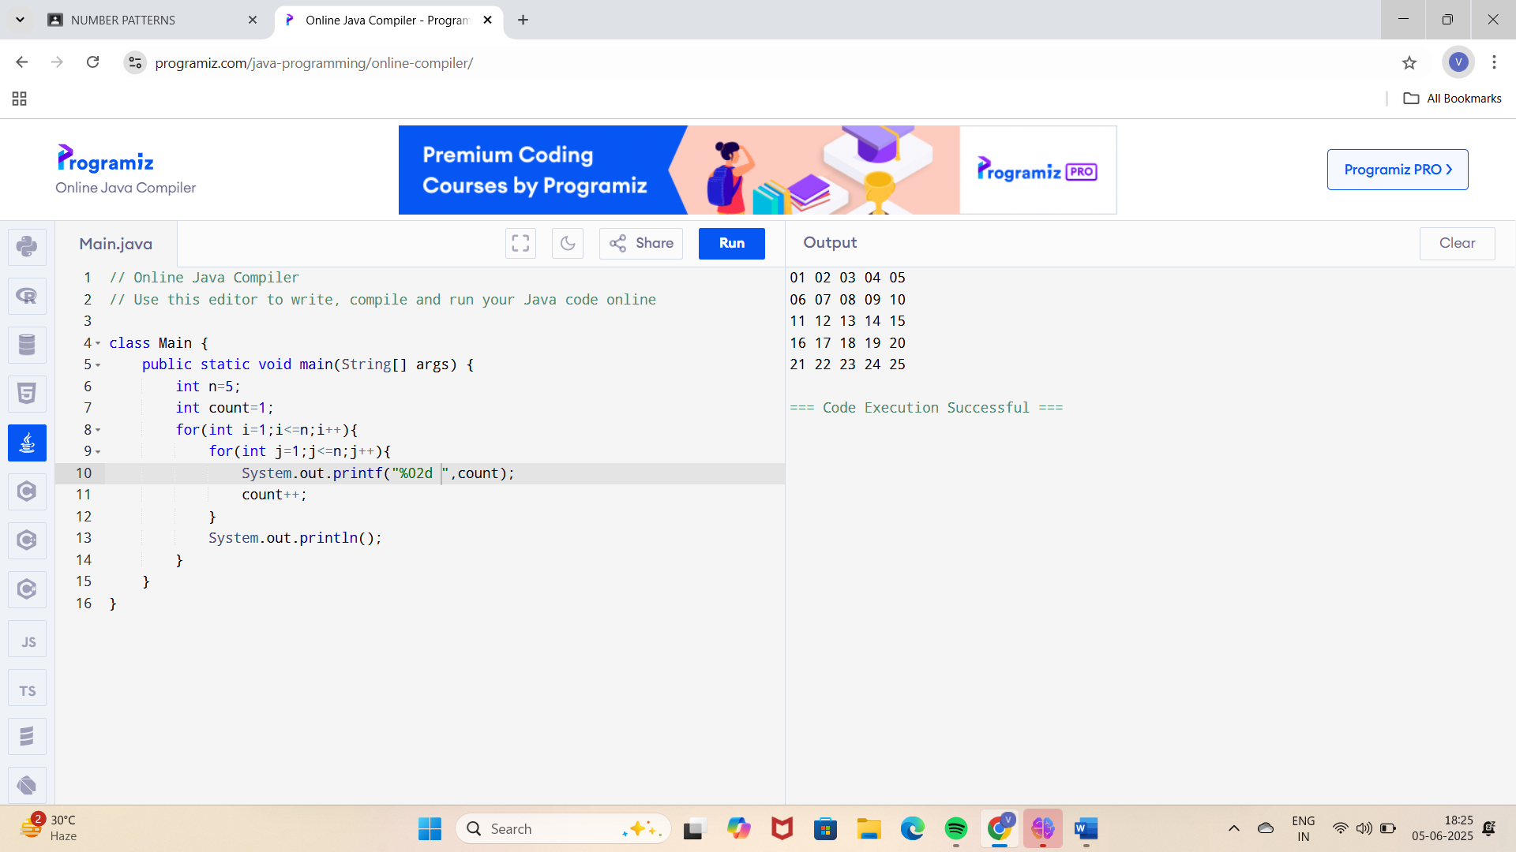

4.

1 2 3 4 5

2 3 4 5 6

3 4 5 6 7

4 5 6 7 8

5 6 7 8 9

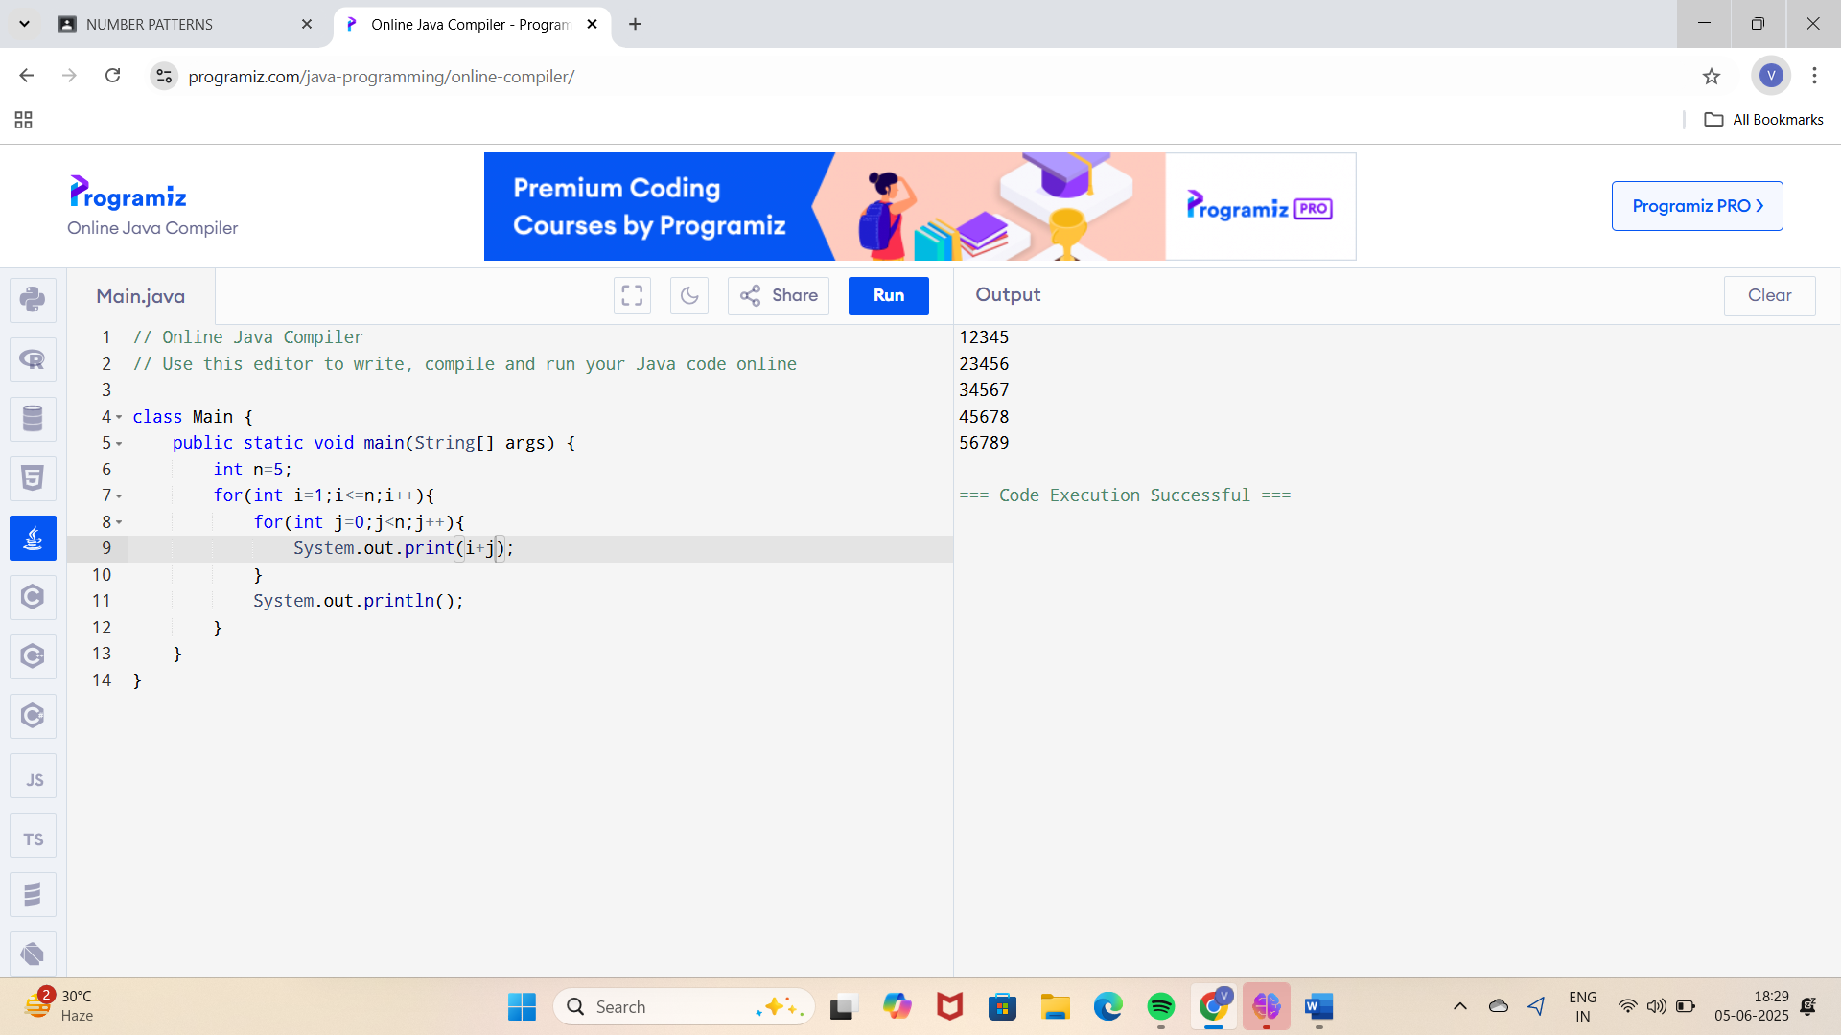

5. Diamond Number Pattern:

