**Title: Sender Policy Framework Record**

**Description:**

To check the spf record in <https://bugcrowd.com/engagements/sba-vdp> . It has no valid proof.

I used <https://www.kitterman.com/spf/validate.html> website to check the bug and it has no valid record in nwbc.com website

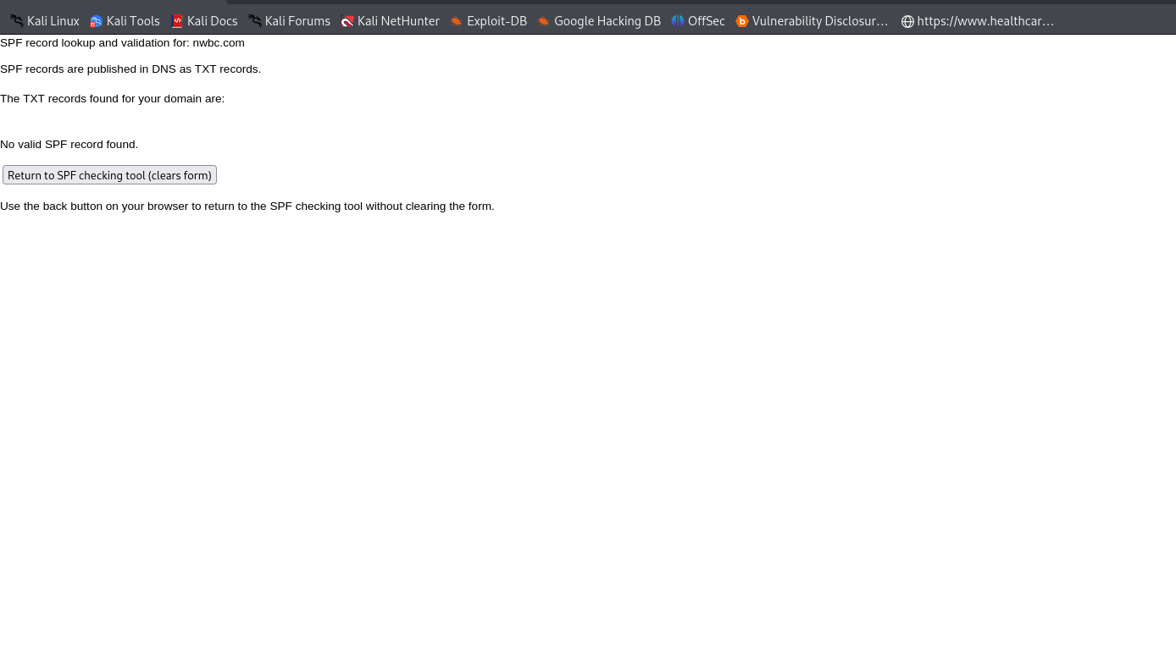

**POC:**

Using this bug some unknown person can easily can send the email spoofing to the victim.

I use **Emkei’s faker mail** https://emkei.cz/ website to send a fake mail to victim using my own mail id.

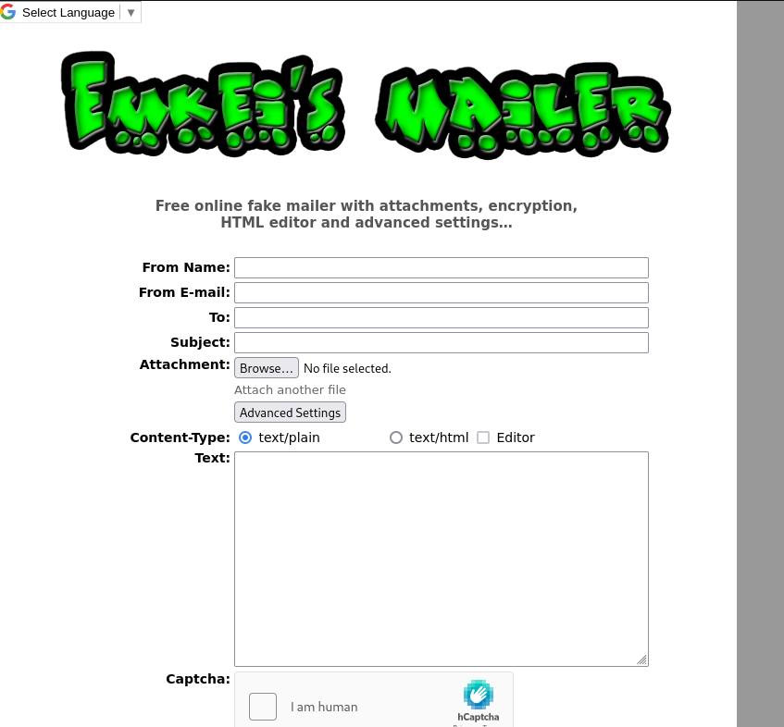

Using this app people can send email spoofing.

Enter the name like **Support center** to look like real mail.

To enter the mail id like [support@domainname.com](mailto:support@domainname.com) .

Send an mail to the victim email address.

