Report
Of
Artificial Intelligence Internship Program
Submitted To
School of Computer Science and Engineering
IILM University, Greater Noida, U.P.

In partial fulfilment of the requirement of degree of
B.Tech CSE

By
Roll Number of Student: 25SCS1003002368
Name of Student: VAISHNAVI
Batch: 2026-27
CANDIDATE'S DECLARATION
I, Vaishnavi, do hereby declare that the internship report titled "Development of an AI Powered Virtual Assistant" has been completed by me to fulfil the requirement for the award of the degree of Bachelor of Technology in CSE. All the references have been quoted and I have not taken as such any material from any other source. I affirm to you that this report is my own and has not been submitted to any other institute for any degree/diploma requirement and further I shall be solely responsible for any kind of copyright violation in this regard.
Signature
Student Name: Vaishnavi
Roll No.: 25SCS1003002368
ACKNOWLEDGEMENT
I am using this opportunity to express my gratitude to everyone who supported me throughout the Internship Program. I would like to sincerely thank Codec Technologies Pvt. Ltd. for granting me the opportunity to work as an Artificial Intelligence Intern and for providing an environment conducive to learning and practical exposure. I am especially grateful to Dr. Anurag Shrivastava, Program Manager, and my assigned project head(s) for their aspiring guidance, invaluably constructive criticism, and friendly advice throughout the course of this internship.
I am also thankful to the faculty of the School of Computer Science and Engineering, IILM University, for their continuous support and encouragement in the successful completion of this internship and report.
I express my gratitude to my parents for their blessings.
Signature
Student Name: Vaishnavi
Roll No.: 25SCS1003002368
INTERNSHIP COMPLETION CERTIFICATE
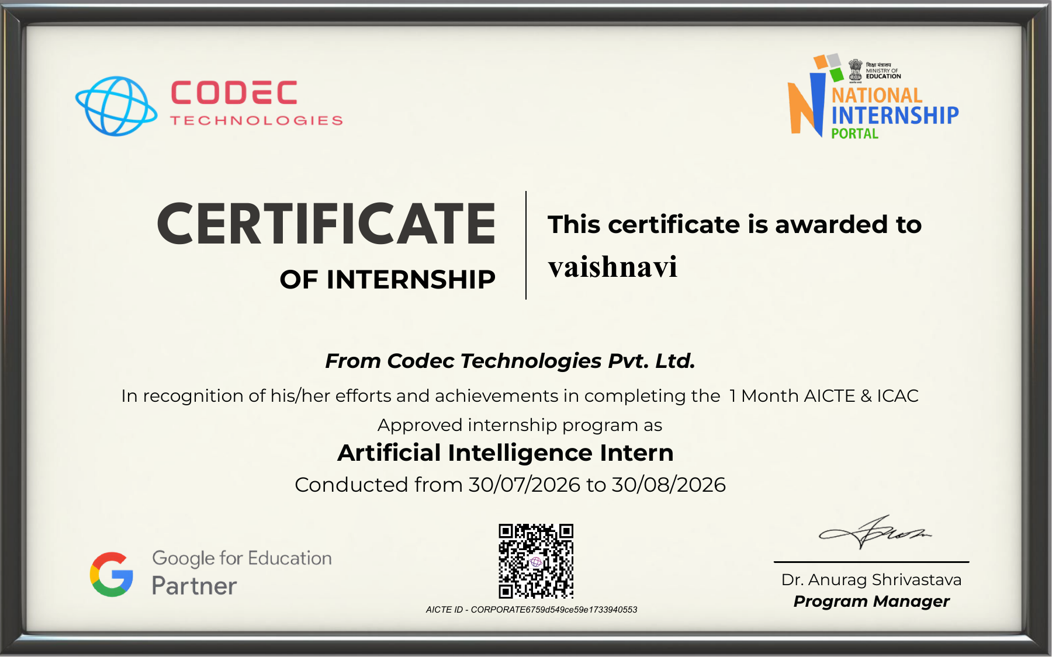

Detail | Information
Intern Name | Vaishnavi
Organization | Codec Technologies Pvt. Ltd.
Role | Artificial Intelligence Intern
Duration | 30/07/2026 to 30/08/2026 (1 Month)
Program | AICTE & ICAC Approved Internship Program
Issuing Authority | Dr. Anurag Shrivastava, Program Manager
AICTE ID | CORPORATE6759d549ce59e1733940553

TABLE OF CONTENTS
Chapter No. | Chapter Name | Page No.
 | Cover Page | ----
1. | Candidate's Declaration | i
2. | Acknowledgement | ii
3. | Internship Completion Certificate | iii
4. | Project Description | 1
 | 4.1 Introduction | 1
 | 4.2 Organization Profile | 2
 | 4.3 Problem Statement | 3
 | 4.4 Project Objectives | 4
 | 4.5 Scope of the Project | 5
 | 4.6 Technologies and Tools Used | 6
 | 4.7 System Architecture | 7
 | 4.8 Methodology | 9
 | 4.9 Expected Outcomes | 11
 | 4.10 Certificates of Completion & Communication Proof | 12
5. | Bibliography/References | 13
CHAPTER 4: PROJECT DESCRIPTION
4.1 Introduction
Artificial Intelligence has rapidly transformed the way humans interact with digital systems, and one of its most visible applications is the virtual assistant — a software agent capable of understanding natural language, performing tasks, and responding to user queries in a conversational manner. Virtual assistants such as Siri, Alexa, and Google Assistant have demonstrated how AI can simplify everyday tasks, from setting reminders to controlling smart devices and answering complex questions.
This internship, undertaken at Codec Technologies Pvt. Ltd. as part of the AICTE & ICAC approved Artificial Intelligence Internship Program, focused on the design and development of an AI-powered virtual assistant. The project involved building a system capable of processing natural language input, interpreting user intent, and generating contextually relevant responses using a combination of Natural Language Processing (NLP), Machine Learning (ML), and speech-processing techniques.
The internship provided hands-on exposure to real-world AI development practices, including data preprocessing, model training, API integration, and iterative testing — all of which are documented in this report.
4.2 Organization Profile
Codec Technologies Pvt. Ltd. is a global platform dedicated to empowering learners and connecting diverse talent with meaningful career opportunities worldwide. The organization delivers dedicated IT and business consultancy services across 27+ countries, with a strong focus on fostering global innovation and strategic growth.
Codec Technologies runs structured, industry-oriented internship programs — approved under AICTE and ICAC guidelines — that are designed to give students immersive, project-based learning experiences. These programs pair interns with assigned Project Heads and include performance evaluations, enabling participants to gain practical, industry-relevant skills alongside academic learning.
- Headquarters/Operations Hub: Chandivali IT Hub, Mumbai
- Mode of Internship: Pan India, Hybrid
- Focus Areas: IT consultancy, business consultancy, AI/ML training programs
- Program Authority: Dr. Anurag Shrivastava (Program Manager / Talent Acquisition Manager)
4.3 Problem Statement
Conventional customer support and personal task-management systems often rely on manual intervention or rigid, rule-based scripts that fail to interpret varied user phrasing, leading to poor user experience and inefficiency. There is a growing need for intelligent systems that can:
- Understand natural, unstructured human language rather than fixed commands.
- Accurately identify user intent even when phrasing varies.
- Provide fast, relevant, and context-aware responses.
- Operate across text and/or voice input without constant human oversight.
The core problem addressed in this project was: how to design a virtual assistant that can understand diverse natural language queries and respond intelligently and efficiently, reducing dependency on manual query handling.
4.4 Project Objectives
- To design and implement an AI-based virtual assistant capable of understanding natural language commands and queries.
- To integrate Natural Language Processing (NLP) techniques for intent recognition and entity extraction.
- To develop a response-generation module capable of producing accurate, context-aware replies.
- To incorporate speech-to-text and text-to-speech capabilities for voice-based interaction (where applicable).
- To test and evaluate the assistant's performance in terms of accuracy, response time, and usability.
4.5 Scope of the Project
The scope of this project is limited to developing a prototype AI virtual assistant capable of handling a defined set of tasks and query categories, such as answering FAQs, setting reminders, retrieving information, and performing basic conversational exchanges. The assistant was developed for demonstration and academic purposes and is not intended for full-scale commercial deployment.
The project covers:
- Text-based and/or voice-based query handling.
- Intent classification for a predefined domain of tasks.
- Integration with external APIs (e.g., for weather, search, or information retrieval) as applicable.
- Basic conversational memory for context retention within a session.
It does not cover large-scale multilingual support, enterprise-level security compliance, or continuous learning from live user data beyond the internship period.
4.6 Technologies and Tools Used
Category | Tools/Technologies
Programming Language | Python
NLP Libraries | NLTK, spaCy, Transformers (Hugging Face)
Machine Learning Frameworks | TensorFlow / PyTorch, Scikit-learn
Speech Processing | Google Speech-to-Text API, pyttsx3 / gTTS
Development Environment | Jupyter Notebook, VS Code
Version Control | Git, GitHub
APIs/Integrations | OpenAI API / relevant LLM API, weather/search APIs
Deployment (optional) | Flask/Streamlit for interface, Cloud hosting (as applicable)

4.7 System Architecture
The virtual assistant follows a modular pipeline architecture, where each stage processes the user's input sequentially before generating a final response.
flowchart TD
A [User Input: Text/Voice] --> B[Speech-to-Text Module]
B --> C [Text Preprocessing & Tokenization]
C --> D [Intent Recognition & Entity Extraction NLP/ML Model]
D --> E [Dialogue Manager / Context Handler]
E --> F [Task Execution Engine / API Calls]
F --> G [Response Generation Module]
G --> H [Text-to-Speech Module]
H --> I [Output to User: Text/Voice]
Module Description:
- Speech-to-Text Module – Converts spoken input into text (for voice-enabled interaction).
- Preprocessing & Tokenization – Cleans and structures raw text for model input.
- Intent Recognition & Entity Extraction – Uses NLP/ML models to determine what the user wants and extract relevant details.
- Dialogue Manager – Maintains conversational context across a session.
- Task Execution Engine – Executes the identified task, including any external API calls.
- Response Generation – Formulates a natural language reply.
- Text-to-Speech Module – Converts the text response into audio output when required.
4.8 Methodology
The development of the AI-powered virtual assistant followed an iterative, phased methodology:
- Requirement Analysis – Identified the target use cases and functionalities the assistant needed to support based on project guidelines from the assigned Project Head.
- Data Collection and Preparation – Gathered/curated datasets for training the intent classification model, including sample queries and corresponding intents/entities.
- Model Selection and Training – Selected suitable NLP/ML models (e.g., pretrained transformer models or custom classifiers) and trained them on the prepared dataset.
- Module Integration – Combined the speech processing, NLP, dialogue management, and response generation modules into a unified pipeline.
- Testing and Evaluation – Conducted functional testing to evaluate intent recognition accuracy, response relevance, and system responsiveness; refined the model based on observed errors.
- Feedback and Iteration – Incorporated performance feedback from weekly reviews conducted by the project supervisor to improve accuracy and usability.
- Documentation – Compiled findings, code, and results into the final report and project deliverables.
4.9 Expected Outcomes
- A functional prototype of an AI-powered virtual assistant capable of understanding and responding to natural language queries.
- Improved understanding of NLP pipelines, intent classification, and conversational AI design principles.
- Practical experience integrating multiple AI modules (speech, NLP, response generation) into a cohesive system.
- A measurable improvement in response accuracy and reduced response latency through iterative testing.
- Enhanced skills in Python-based AI development, model evaluation, and real-world project execution under industry mentorship.
4.10 Certificates of Completion and Other Communication Mail Proof
- Internship Completion Certificate (AICTE & ICAC Approved Program)
- Any email correspondence confirming project assignment, weekly review feedback, or internship completion
CHAPTER 5: BIBLIOGRAPHY/REFERENCES
- Jurafsky, D., & Martin, J. H. (2023). Speech and Language Processing (3rd ed. draft). Stanford University.
- Bird, S., Klein, E., & Loper, E. (2009). Natural Language Processing with Python. O'Reilly Media.
- Goodfellow, I., Bengio, Y., & Courville, A. (2016). Deep Learning. MIT Press.
- Hugging Face Documentation. Transformers Library. Retrieved from https://huggingface.co/docs
- Google Cloud Speech-to-Text API Documentation. Retrieved from https://cloud.google.com/speech-to-text
- Codec Technologies Pvt. Ltd. Internship Program Documentation and Offer Letter, 2026.

INTERNSHIP OFFER LETTER
Codec Technologies Pvt. Ltd.

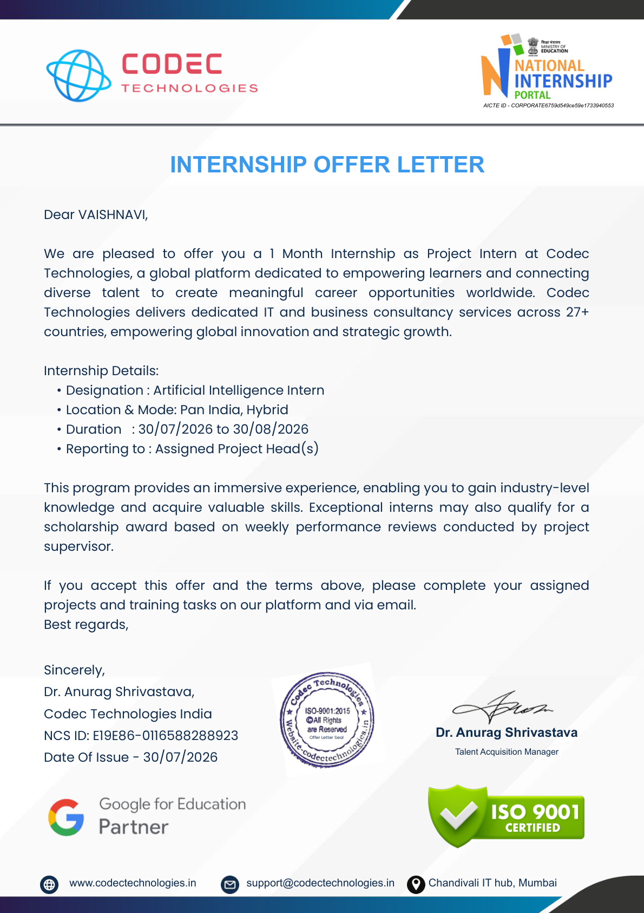
Offer Letter issued on 30/07/2026

