Amazon prime
Comparison 1
Movie Name vs Maturity Rating
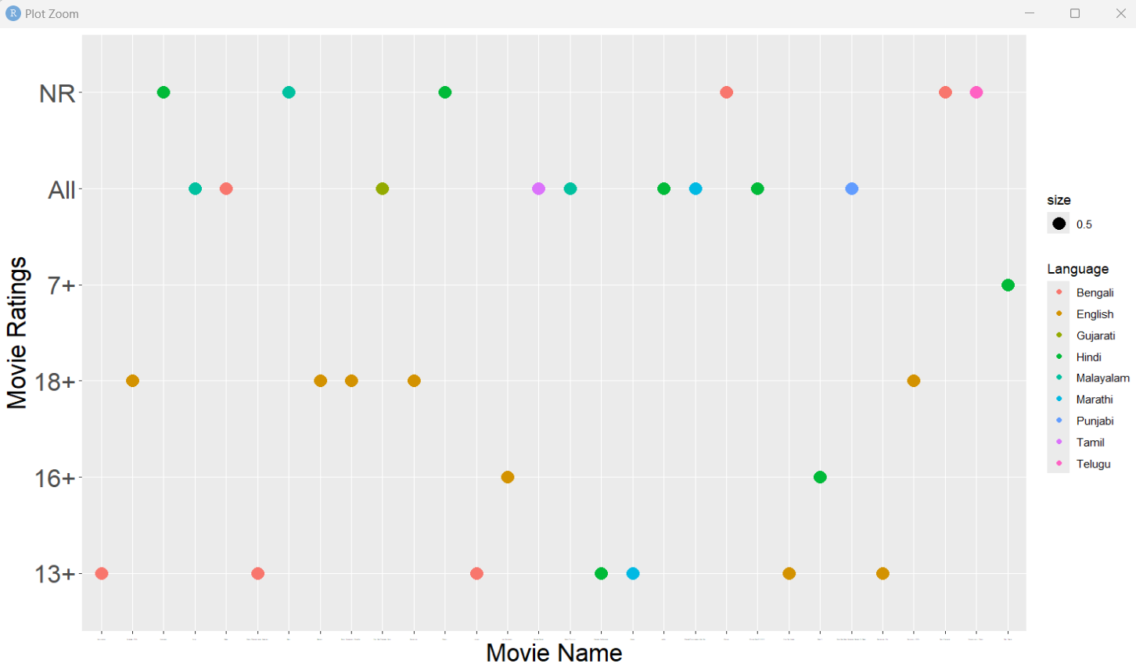
Comparison 2
Title vs imdb ratings
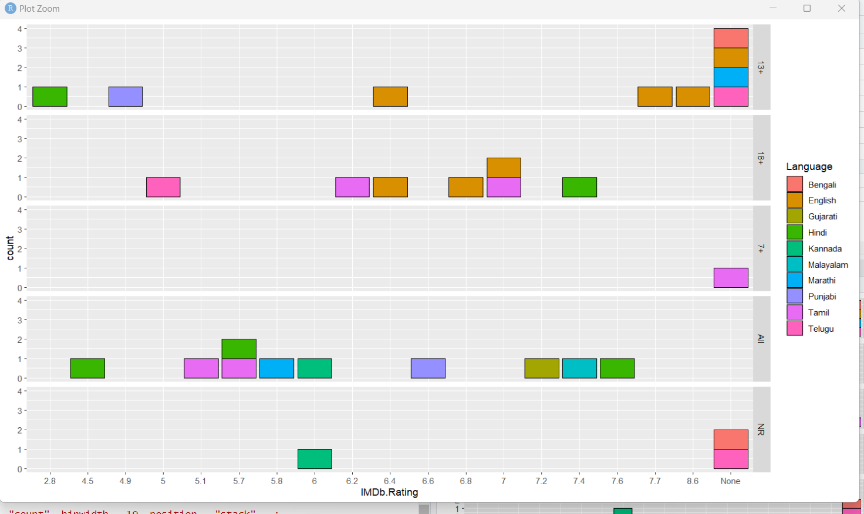
Comparison 3
Title vs date added
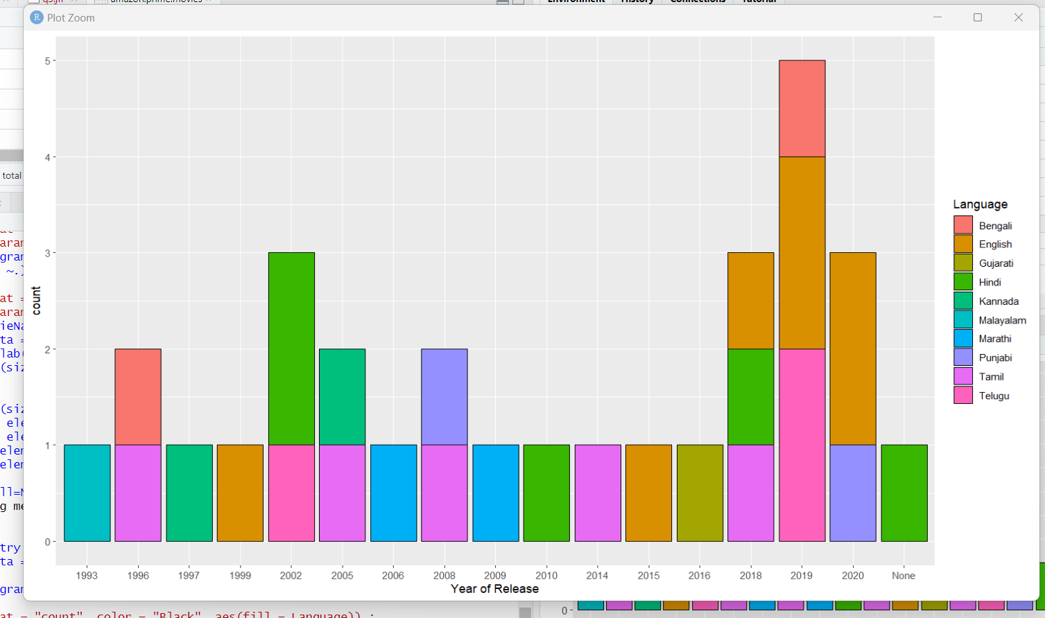

Disney_plus_hotstar
Comparison 1
Title vs IMDB Rating
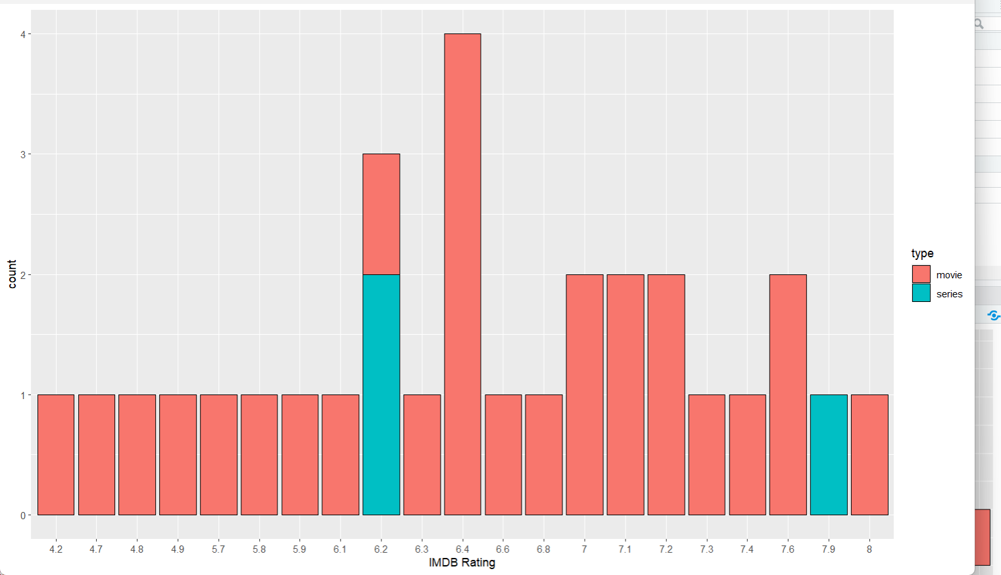

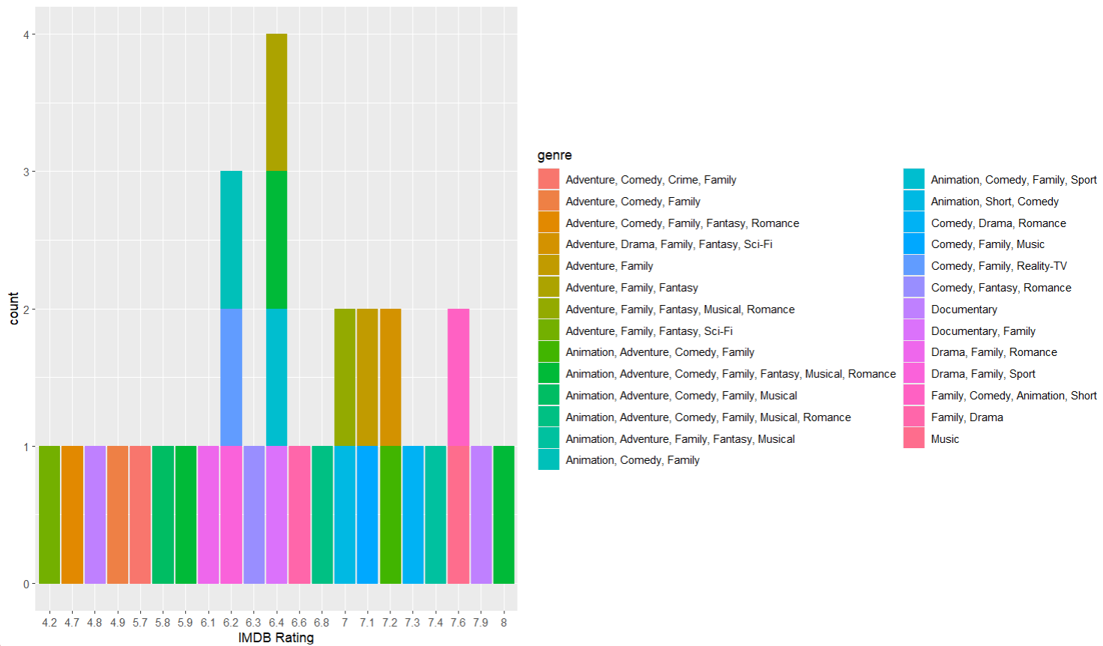
Comparison 2
Tile vs Awards
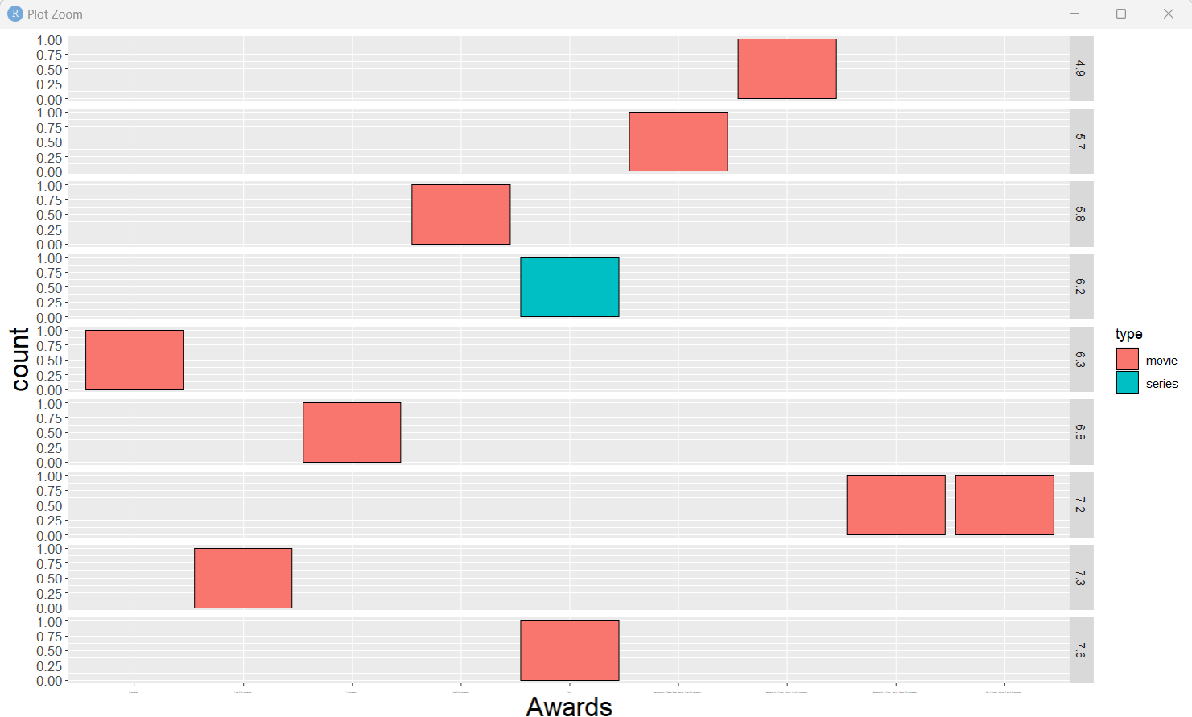

Comparison 3
Title vs IMDB Votes
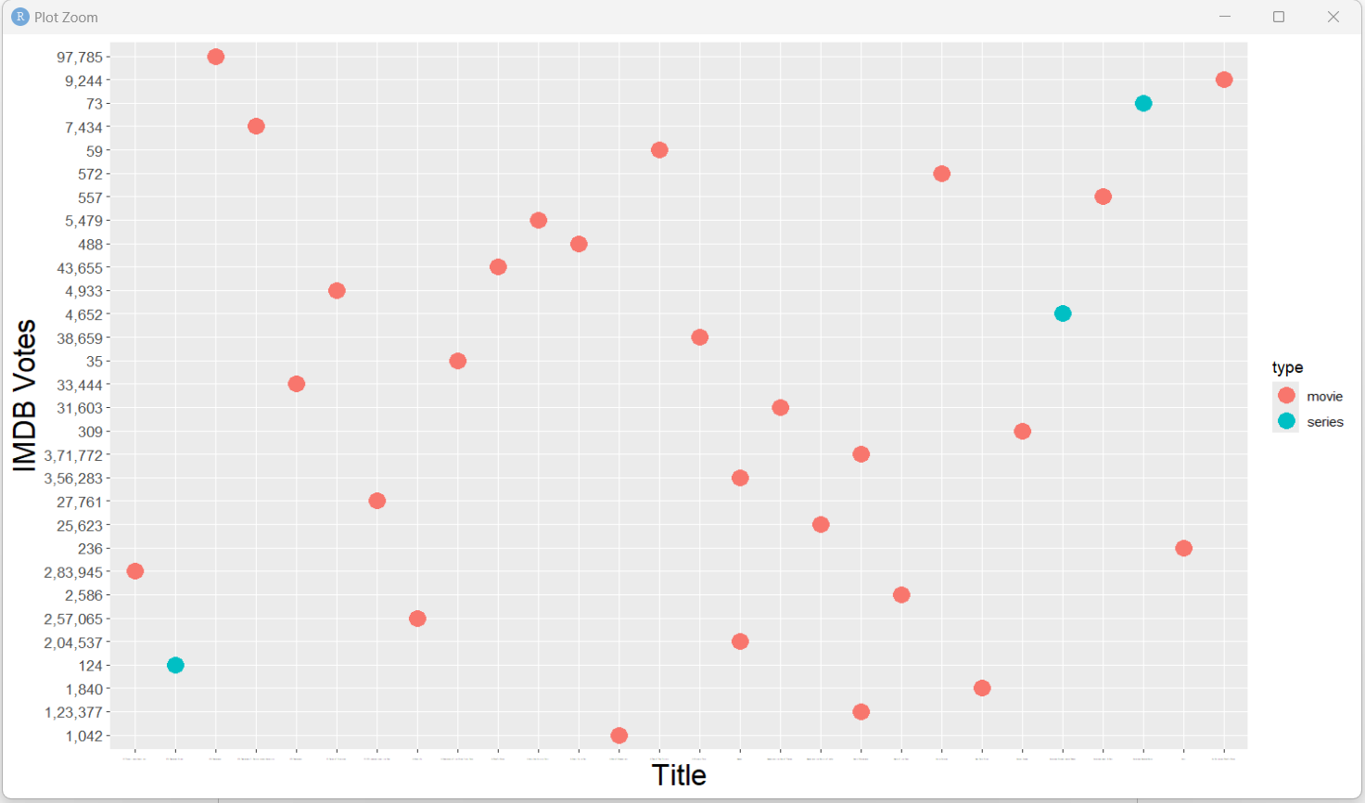
Comparison 4
Rated comparison
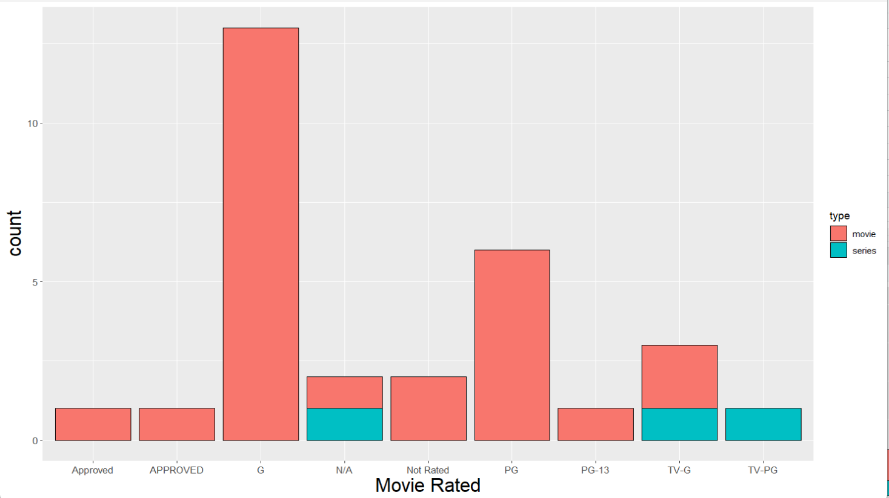

Netflix
Comparison 1
Title vs Rating
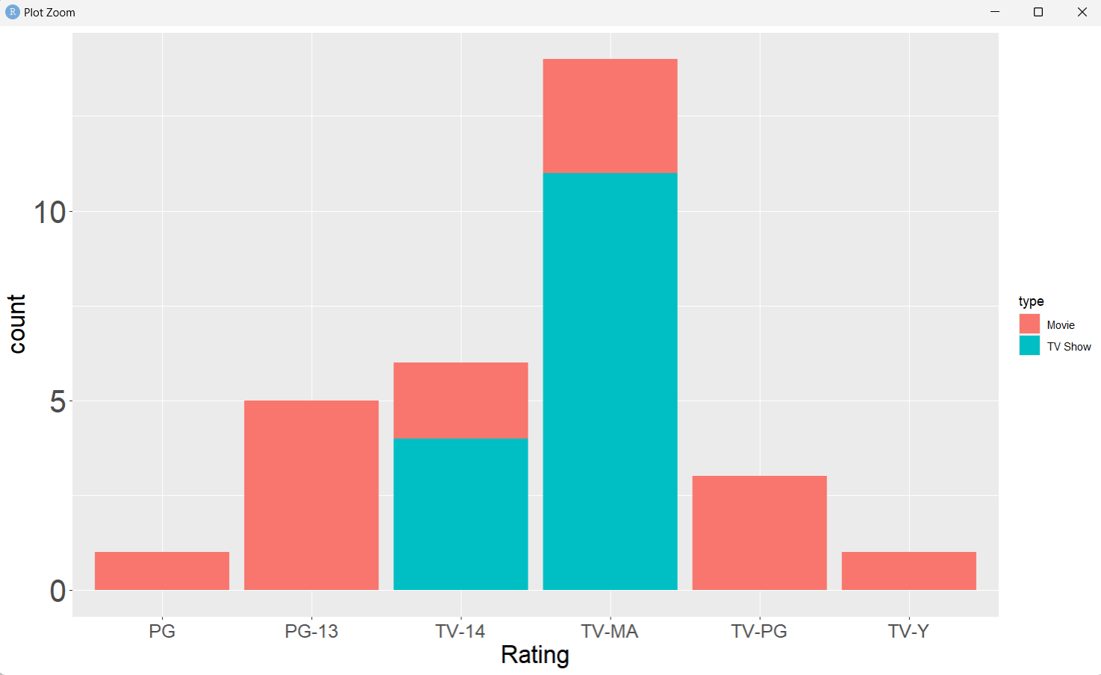
Comparison 2
Rating vs Type
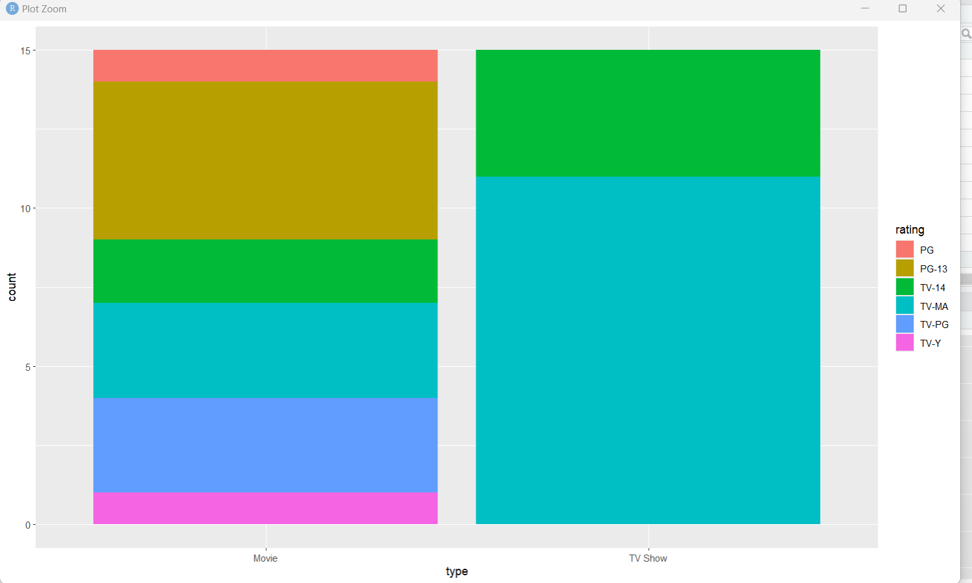

Comparison 3
Title vs Date Added
