A
PROJECT REPORT
on
Human Emotion Recognition
Submitted in partial fulfillment of requirements for the award of the Degree of
BACHELOR OF ENGINEERING
IN
CSE (ARTIFICIAL INTELLIGENCE & MACHINE LEARNING)

Submitted by
Ankam Veena Sree |  |  | 245322748004
Kallagunta Mythili |  |  | 245322748033
Kathoju Tejashwini |  |  | 245322748035
Under the guidance
of
Dr. K. Vinuthna
Associate Professor

NEIL GOGTE INSTITUTE OF TECHNOLOGY
Kachavanisingaram Village, Hyderabad, Telangana 500058.
Affiliated to Osmania University

2026

A
PROJECT REPORT
on
Human Emotion Recognition
Submitted in partial fulfillment of requirements for the award of the Degree of

BACHELOR OF ENGINEERING
IN
CSE (ARTIFICIAL INTELLIGENCE & MACHINE LEARNING)

Submitted by
Ankam Veena Sree |  |  | 245322748004
Kallagunta Mythili |  |  | 245322748033
Kathoju Tejashwini |  |  | 245322748035
Under the guidance
of
Dr. K. Vinuthna
Associate Professor


Department of CSE (Artificial Intelligence & Machine Learning)

NEIL GOGTE INSTITUTE OF TECHNOLOGY
Kachavanisingaram Village, Hyderabad, Telangana 500058.

May - 2026


DEPARTMENT OF CSE
(ARTIFICIAL INTELLIGENCE & MACHINE LEARNING)

CERTIFICATE

This is to certify that the Project Work entitled Human Emotion Recognition submitted by
Ankam Veena Sree, 245322748004, Kallagunta Mythili, 245322748033, Kathoju Tejashwini,
245322748035, is a Bonafide work carried out in partial fulfillment for the award of the degree of
Bachelor of Engineering in CSE (Artificial Intelligence & Machine Learning) from Neil Gogte Institute of Technology, affiliated to Osmania University, Hyderabad during the academic year 2022-2026.

Internal Guide Head of Department
Dr K Vinuthna Dr K Vinuthna
Associate Professor Associate Professor

External Examiner



DEPARTMENT OF CSE
(ARTIFICIAL INTELLIGENCE & MACHINE LEARNING)

DECLARATION

We declare that the Project entitled, Human Emotion Recognition is done by us under the guidance of Dr. K. Vinuthna, Associate Professor Department of CSE(Artificial Intelligence & Machine Learning), Neil Gogte Institute of Technology, affiliated to Osmania University.
Further the results embodied in this project have not been submitted to any other University or Institute for the award of any degree.

Ankam Veena Sree 245322748004
Kallagunta Mythili 245322748033
Kathoju Tejashwini 245322748035

ACKNOWLEDGEMENT

We would like to thank our internal guide Dr K Vinuthna, Associate Professor for this technical guidance and constant encouragement.

We would like to thank Dr. Vuppu Padmakar, Associate Professor, Project Co-ordinator, Neil Gogte Institute of Technology for having provided the freedom to use all the facilities available in the department and guidance and constant encouragement.

We would like to thank Dr K Vinuthna, Associate Professor and Head, Department of CSE (Artificial Intelligence & Machine Learning), Neil Gogte Institute of Technology for having provided the freedom to use all the facilities available in the department, especially the laboratories and the library.

We are happy to express our deep sense of gratitude to the principal of the college Prof. R. Shyam Sunder, Neil Gogte Institute of Technology, for having provided us with adequate facilities to pursue our project.

We sincerely thank our seniors and all the teaching and non-teaching staff of the Department of CSE (Artificial Intelligence & Machine Learning), for their timely suggestions, healthy criticism and motivation during this work.

Finally, we express our immense gratitude with pleasure to the other individuals who have either directly or indirectly contributed to our need at the right time for the development and success of this project work.

ABSTRACT
Mental health disorders, particularly major depression, represent one of the most significant and growing challenges faced by individuals and healthcare systems worldwide. Depression affects not only emotional well-being but also daily functioning, relationships, and overall quality of life. Millions of people experience varying levels of depression, many of whom remain undiagnosed due to social stigma, lack of awareness, or limited access to professional care. Accurate prediction of depression severity is therefore essential for timely intervention and effective treatment planning. Traditional diagnostic methods rely on clinical interviews and standardized questionnaires, which are often time-consuming, resource-intensive, and subject to subjective interpretation, potentially leading to inconsistent assessments. To address these limitations, this study proposes an automated framework that utilizes advanced Natural Language Processing (NLP) techniques and deep learning models to predict depression severity from textual data. The system analyzes usergenerated inputs such as personal statements or journal entries to extract meaningful insights. At its core, the framework employs a fine-tuned BERT (Bidirectional Encoder Representations from Transformers) model trained on a depression severity dataset. This model classifies text into four categories: minimum, mild, moderate, and severe. By leveraging contextual understanding and semantic analysis, the model effectively identifies linguistic patterns and emotional cues associated with different levels of depression. In addition to severity prediction, the system incorporates an emotion detection module that identifies key emotional states such as sadness, happiness, affection, frustration, nervousness, and excitement. This combined analysis enables a more comprehensive understanding of an individual’s mental condition by examining both the intensity of depression and the underlying emotional expression. Recognizing these emotional nuances enhances the accuracy of assessment and supports more personalized responses. Furthermore, the system provides tailored suggestions and supportive guidance based on the detected depression level and emotional state. These may include coping strategies, relaxation techniques, or recommendations to seek professional help when necessary. By integrating depression severity prediction with emotion recognition, the proposed system serves as an efficient and reliable assistive tool for mental health assessment. It contributes to the development of intelligent mental health monitoring systems that support early detection, reduce reliance on manual methods, and promote better decision making, ultimately improving patient outcomes and overall well-being.
CHAPTER PAGE
TITLE
NO NO
ACKNOWLEDGEMENT i
ABSTRACT ii
TABLE OF CONTENTS iii
LIST OF TABLES v
LIST OF DIAGRAMS vi
LIST OF FIGURES vii

TABLE OF CONTENTS
Chapter 1.0 Introduction 1
1.1 Outlines of the Topic 3
1.2 Brief Introduction of the Title 4
1.3 Aim of the Project 5
1.4 Scope of the Project Work 6
1.5 Organization of the Thesis (Outline of Presentation) 9
Chapter 2.0 Literature Review 11
2.1 Existing System Analysis 11
2.2 Research Gap 13
2.3 Proposed System 19
2.4 Objective of the Project (3 to 5) 22
2.5 Scope of the Present Work 23

Chapter 3.0 Methodology 25

3.1 Requirement Analysis 27
3.2 Existing Procedures and Methods 34
3.3 Proposed Method 35
3.4 Data Collation 36
3.5 System Architecture 39
3.6 Software Design and Development 43
Chapter 4.0 Implementation, Screen Shots & Testing 66
4.1 Implementation with Code Snippets 66
4.2 Screen Shots 71
4.3 Test Cases 79
Chapter 5.0 Results and Discussion 81
5.1 Discussion / Clarification on Results - Output 83
5.2 Comparative Study 84
5.3 Outcomes of the Present Work 84
Chapter 6.0 Summary and Conclusions 86
6.1 Future Scope 86
Appendix 89
References 95

LIST OF TABLES

S.No. | Table. No. | Name of the Table | Page No
1 | 2.1 | Literature Survey | 13
2 | 4.1 | Test cases | 79
3 | 3.1 | Sample User Input Data | 37
4 | 3.2 | Input Validation Summary | 37
5 | 3.3 | Features Used for Mental Health Prediction | 38
6 | 3.4 | Model Output and Response | 38

LIST OF DIAGRAMS

S.No. | Diagram. No. | Name of the Diagram | Page No
1 | 3.1 | Proposed System Architecture | 39
2 | 3.2 | Data Flow Diagram | 43
3 | 3.3 | Use case Diagram | 46
4 | 3.4 | Class Diagram | 48
5 | 3.5 | Sequence Diagram | 51
6 | 3.6 | Activity Diagram | 54
7 | 3.7 | Component Diagram | 57
8 | 3.8 | E-R Diagram | 62

LIST OF FIGURES

S.No | Figure No. | Name of the Figure | Page No
1 | 4.1 | Home Page | 71
2 | 4.2 | Sign Up Page | 72
3 | 4.3 | User Dashboard Page | 73
4 | 4.4 | Guided Exercises Page | 74
5 | 4.5 | AI Chat Interface (Mental Wellness Chat Page) | 75
6 | 4.6 | Crisis Support & Resources Page (Emergency Help  Interface) | 77
7 | 4.7 | Mood Tracker Page | 78
8 | 5.1 | Depression / Emotion Level Instances Graph | 81
9 | 5.2 | Classification Report Metrics Across Classes | 82

CHAPTER – 1
INTRODUCTION
Human emotions play a fundamental role in communication, decision-making, behavior, and overall mental well-being. Emotions such as happiness, sadness, anger, fear, excitement, frustration, and affection influence how individuals interact with others and respond to different situations. In the digital age, a significant portion of human communication occurs through text messages, emails, social media posts, online chats, blogs, and journals. These textual expressions often contain valuable emotional and psychological cues that can be analyzed using Artificial Intelligence techniques. As a result, Human Emotion Recognition has emerged as an important research area that focuses on identifying and interpreting emotions from human-generated data.
Traditional methods of understanding emotions usually depend on face-to-face observation, facial expressions, speech tone analysis, questionnaires, or clinical interviews. While these methods may be effective in controlled environments, they are often time-consuming, expensive, subjective, and difficult to scale for large populations. In addition, many people may hesitate to openly express their emotional struggles due to social stigma, lack of awareness, or limited access to professional support. Therefore, there is a growing need for intelligent automated systems that can detect emotions accurately and efficiently using easily available digital text data.
Recent advancements in Artificial Intelligence, Machine Learning, and Natural Language Processing (NLP) have made it possible to analyze textual information with high accuracy. NLP enables computers to understand human language, while Deep Learning models learn complex patterns and contextual meanings from text. Among these technologies, transformer-based architectures such as BERT (Bidirectional Encoder Representations from Transformers) have significantly improved the performance of text classification tasks. BERT can understand the meaning of words based on surrounding context, making it highly suitable for detecting emotional tone and psychological patterns in written language.
The proposed project, Human Emotion Recognition, is designed as an intelligent text-based system that identifies emotional states from user input and provides meaningful responses. The system analyzes textual data entered by the user through a chatbot interface and predicts emotions such as happiness, sadness, affection, frustration, nervousness, and excitement. In addition to emotion recognition, the system can also assist in identifying depression severity levels such as minimum, mild, moderate, and severe based on linguistic patterns found in the text. This integrated approach provides a more comprehensive understanding of the user’s mental and emotional condition.
The system uses a fine-tuned BERT model for text understanding and classification. User input is first preprocessed through cleaning, tokenization, padding, and encoding, after which it is passed to the trained model for prediction. Based on the identified emotion and severity level, the system generates personalized suggestions, supportive guidance, and recommendations. This makes the project more than just a prediction model—it functions as a smart wellness assistant capable of offering context-aware responses.
To ensure usability and real-time interaction, the project integrates modern technologies such as React.js for the frontend user interface, FastAPI for backend services, Python for model implementation, and database support for storing chat history, mood logs, and user records. The chatbot-based interface makes the system interactive, user-friendly, and accessible to users from different technical backgrounds. It also enables continuous monitoring of emotional trends over time through journaling and mood-tracking features.
This project has wide practical applications in mental health awareness, online counseling support, educational platforms, customer service systems, healthcare monitoring, and intelligent personal assistants. By combining emotion recognition with AI-driven assistance, the system contributes toward building more empathetic and human-centered digital technologies. It demonstrates how machine intelligence can be used responsibly to understand emotions, improve communication, and support well-being.
In conclusion, Human Emotion Recognition using Deep Learning and NLP is a modern solution that bridges the gap between human emotions and machine understanding. It offers a scalable, accurate, and real-time platform for recognizing emotions from text and providing intelligent support. As technology continues to advance, such systems can play a vital role in creating emotionally aware AI applications for the future.

1.1 Outlines of the Topic
Human Emotion Recognition is an emerging field of Artificial Intelligence that focuses on identifying and analyzing human emotions through computational techniques. Emotions are an essential part of human life, influencing communication, behavior, decision-making, and relationships. Understanding emotions can help machines interact with humans in a more natural, intelligent, and empathetic manner. With the increasing use of digital communication platforms such as social media, messaging applications, online forums, and virtual assistants, large amounts of emotional information are expressed through text. This creates an opportunity to develop systems that can automatically recognize emotions from written language.
The main objective of Human Emotion Recognition is to detect emotional states such as happiness, sadness, anger, fear, surprise, excitement, frustration, affection, and neutrality from user-generated input. In this project, emotion recognition is performed using textual data, where users communicate through a chatbot interface. The system processes the entered text, extracts meaningful features, and predicts the corresponding emotional state using advanced Natural Language Processing (NLP) and Deep Learning models.
Traditional emotion recognition methods relied on manual observation, surveys, questionnaires, facial expression analysis, or voice tone analysis. Although these methods are useful, they often require physical presence, specialized equipment, or expert interpretation. In contrast, text-based emotion recognition systems are more accessible, scalable, and suitable for real-time digital environments. They can analyze conversations instantly and provide immediate responses or support.
Recent advancements in Machine Learning and transformer-based models such as BERT (Bidirectional Encoder Representations from Transformers) have significantly improved the ability of computers to understand human language. These models capture contextual meaning, sentence structure, and semantic relationships, making them highly effective for emotion classification tasks. By using such models, the proposed system can recognize subtle emotional cues present in text more accurately than traditional methods.
The topic also extends beyond simple emotion detection. In many modern applications, Human Emotion Recognition is integrated with mental health monitoring, personalized recommendations, sentiment analysis, and intelligent assistance systems. In this project, along with identifying emotions, the system can also assist in understanding depression severity levels and generate suitable suggestions based on the user’s emotional condition.
Human Emotion Recognition has wide applications in healthcare, online counseling, education, customer support, social media analysis, gaming, smart devices, and human-computer interaction. It enables systems to become more responsive, adaptive, and human-centered. Therefore, this topic is highly relevant in today’s AI-driven world and has significant potential for future innovation.

1.2 Brief Introduction of the Title
The title Human Emotion Recognition refers to the process of identifying, analyzing, and classifying human emotions using computer-based technologies. Human emotions are natural psychological states such as happiness, sadness, anger, fear, excitement, frustration, affection, and neutrality. These emotions influence the way people think, communicate, and behave in daily life. Recognizing emotions accurately is important in creating intelligent systems that can understand users and respond appropriately.
In the modern digital world, people increasingly express their feelings through written text on platforms such as social media, chat applications, emails, blogs, and online forums. This textual information contains valuable emotional cues that can be analyzed using Artificial Intelligence techniques. Human Emotion Recognition systems aim to capture these cues and determine the emotional state of the user from their written communication.
The proposed project focuses on text-based Human Emotion Recognition using Natural Language Processing (NLP) and Deep Learning. NLP enables computers to process and understand human language, while Deep Learning models learn complex patterns from large datasets. In this project, a transformer-based model such as BERT (Bidirectional Encoder Representations from Transformers) is used to classify emotions with high accuracy by understanding the contextual meaning of words and sentences.
The system accepts user input in the form of text through a chatbot interface. The entered text is processed through various steps such as cleaning, tokenization, encoding, and model inference. Based on the analyzed content, the system predicts the user’s emotional state. In addition to emotion recognition, the system can also support mental wellness by identifying possible depression severity levels and generating suitable suggestions or guidance.
The title represents a modern AI application that bridges the gap between human emotions and machine understanding. It helps machines interact in a more natural, empathetic, and user-friendly manner. Human Emotion Recognition has applications in healthcare, counseling, education, customer service, smart assistants, and social media analysis. Thus, the project demonstrates the practical use of Artificial Intelligence in understanding and responding to human emotions effectively.

1.3 Aim of the Project
The main aim of the project Human Emotion Recognition is to design and develop an intelligent, efficient, and automated system capable of identifying human emotions from textual input by using advanced technologies such as Artificial Intelligence (AI), Natural Language Processing (NLP), and Deep Learning. The purpose of this system is to understand the emotional state of a user by analyzing the words, phrases, sentence structure, and contextual meaning present in their written text. Emotions are an important part of human life, and recognizing them accurately can help in creating smarter and more human-centered digital systems.
In the present digital era, people communicate extensively through text messages, emails, social media posts, blogs, online forums, and chatbot conversations. These textual communications often reflect emotions such as happiness, sadness, anger, fear, excitement, frustration, stress, and affection. Since millions of text messages are generated every day, manually analyzing such huge volumes of emotional data is difficult, time-consuming, and impractical. Therefore, one of the primary aims of this project is to automate the process of emotion recognition so that emotions can be detected quickly, accurately, and in real time.
Another significant aim of the project is to improve human-computer interaction by enabling machines to understand human emotions and respond intelligently. Traditional computer systems respond only to commands and data, but emotionally aware systems can recognize user feelings and provide appropriate replies. For example, if a user expresses sadness or stress, the system can provide comforting suggestions or motivational guidance. If a user expresses happiness, the system can respond positively. This helps in creating more interactive, personalized, and user-friendly applications.
The project also aims to make use of modern transformer-based deep learning models such as BERT (Bidirectional Encoder Representations from Transformers) to achieve higher prediction accuracy compared to traditional machine learning methods. Unlike older models, BERT understands the contextual meaning of words in a sentence by analyzing both previous and next words. This enables the system to detect emotions even when the language is complex, indirect, or subtle. As a result, the project aims to provide reliable and context-aware emotion classification.
A further aim of the project is to contribute toward mental wellness and emotional support. In many cases, people express stress, loneliness, anxiety, or depression through text. By analyzing emotional patterns, the proposed system can help in identifying possible depression severity levels such as minimum, mild, moderate, or severe. Based on the emotional condition detected, the system can generate suitable suggestions, relaxation techniques, coping strategies, or recommendations to seek professional help when necessary. Thus, the project serves as an assistive tool for emotional awareness and early mental health monitoring.
The project also aims to develop a complete software solution with a user-friendly chatbot interface. The frontend of the system allows users to interact easily, while the backend processes user input and generates predictions instantly. This ensures a smooth and efficient real-time experience. The system is intended to be scalable so that future enhancements such as multilingual support, voice-based emotion recognition, facial expression analysis, and mobile application deployment can be added later.
The specific aims of the project are as follows:
- To design and develop a text-based Human Emotion Recognition system using AI technologies.
- To classify emotions such as happiness, sadness, anger, fear, neutral, excitement, affection, and frustration.
- To apply Natural Language Processing techniques for understanding user-generated text data.
- To use Deep Learning models such as BERT for accurate and context-aware emotion prediction.
- To provide real-time emotion recognition through an interactive chatbot interface.
- To generate intelligent responses, personalized suggestions, and emotional support messages.
- To analyze emotional patterns for mental health awareness and possible depression detection.
- To improve human-computer interaction by making systems emotionally intelligent.
- To create a scalable and adaptable platform for future AI-based applications.
- To contribute toward socially beneficial technology that supports users emotionally.
In conclusion, the overall aim of the project is to combine Artificial Intelligence with human emotional understanding in order to build a smart, responsive, supportive, and efficient system. The project demonstrates how modern AI can be used not only for automation but also for understanding human feelings and enhancing digital experiences.

1.4 Scope of the Project Work
The scope of the project Human Emotion Recognition is centered on developing an intelligent system that can analyze textual input and identify the emotional state of a user using Artificial Intelligence, Natural Language Processing (NLP), and Deep Learning techniques. As digital communication becomes more common, understanding emotions through text has gained significant importance in many real-world applications. This project provides a modern solution for recognizing emotions accurately and efficiently through automated methods.
The primary scope of the project includes the detection of emotions such as happiness, sadness, anger, fear, excitement, frustration, affection, and neutrality from user-generated text. The system accepts textual input through a chatbot interface and processes the data using advanced language models such as BERT. By understanding the context and meaning of words, the model predicts the most relevant emotional category.
Another major scope of the project is the integration of mental wellness support features. In addition to recognizing emotions, the system can analyze emotional patterns and identify possible depression severity levels such as minimum, mild, moderate, and severe. This enables the system to act as an assistive tool for emotional awareness and early mental health monitoring.
The project also covers the development of a complete software application with both frontend and backend components. The frontend is designed using React.js to provide an interactive and user-friendly chatbot interface. The backend is implemented using Python and FastAPI to handle user requests, process data, run the prediction model, and generate responses in real time.
The scope further includes the implementation of supportive modules such as suggestion generation, mood tracking, journaling, and chat history storage. Based on the user’s emotional state, the system can provide suitable guidance, motivational messages, relaxation tips, or recommendations to seek professional help when required.
This project has broad practical applications in the following areas:
- Healthcare: Assisting in emotional monitoring and mental health awareness.
- Online Counseling: Supporting counselors with initial emotional assessment tools.
- Education: Understanding student emotions and improving learning environments.
- Customer Support: Enhancing chatbot responses based on customer emotions.
- Social Media Analysis: Studying public sentiment and emotional trends.
- Smart Assistants: Making AI assistants more human-centered and empathetic.
- Corporate Sector: Monitoring employee wellness and stress patterns.
The future scope of the project is also extensive. It can be expanded to include multilingual support, voice-based emotion recognition, facial expression analysis, mobile applications, wearable device integration, and advanced Large Language Models (LLMs) for more personalized responses.
However, the system is intended as an assistive tool and not as a replacement for professional medical diagnosis or therapy. Its purpose is to support emotional understanding and early awareness.
In conclusion, the scope of this project is wide and impactful, covering technical development, practical implementation, and future innovation in emotionally intelligent AI systems.

1.5 Organization of the Thesis
The project report on Human Emotion Recognition is organized in a systematic manner to present the complete details of the work carried out, starting from the introduction of the topic to the final conclusion and future enhancements. Each chapter focuses on a specific part of the project and collectively explains the objectives, design, implementation, results, and significance of the proposed system.
Chapter 1: Introduction
This chapter provides an overview of the project topic, background, and importance of Human Emotion Recognition. It explains the need for automated emotion detection systems in the modern digital world. The chapter also includes the outline of the topic, brief introduction of the title, aim of the project, scope of the project work, and organization of the thesis. It serves as the foundation for understanding the complete project.
Chapter 2: Literature Review
This chapter presents a detailed review of existing research works related to Human Emotion Recognition, Natural Language Processing, depression detection, sentiment analysis, and deep learning-based text classification. It includes the study of at least 25 research papers, their methodologies, datasets used, key findings, and limitations. This chapter also discusses the research gap identified in existing systems and introduces the proposed system to overcome those limitations.
Chapter 3: Methodology
This chapter explains the methodology adopted for developing the proposed system. It includes requirement analysis, both hardware and software requirements, data collection methods, preprocessing techniques, model training process, and system workflow. The chapter also describes the technologies used such as Python, FastAPI, React.js, BERT model, and database systems. Flowcharts, tables, and diagrams are used wherever necessary.
Chapter 4: Implementation, Screenshots, and Testing
This chapter focuses on the practical implementation of the project. It explains how the system was developed, integrated, and deployed. Important code snippets are provided to describe the functioning of the modules. Screenshots of the user interface, chatbot pages, dashboards, and outputs are included.
This chapter also contains test cases, testing strategies, and validation of system performance.
Chapter 5: Results and Discussion
This chapter presents the output generated by the Human Emotion Recognition system and analyzes the performance of the model. It includes evaluation metrics such as accuracy, precision, recall, and F1-score. Comparative studies with existing systems are discussed to show improvements achieved by the proposed system. The outcomes and effectiveness of the project are clearly explained.
Chapter 6: Summary and Conclusion
This chapter summarizes the entire work carried out in the project. It highlights the major contributions, achievements, and overall significance of the proposed system. The chapter concludes by explaining how the project successfully meets its objectives. It also includes future scope, suggesting possible enhancements such as multilingual support, voice emotion recognition, facial expression analysis, and advanced AI models.
Appendix
The appendix section contains supporting information such as additional data tables, screenshots, code modules, derivations, user manuals, and other supplementary material related to the project.
References
This section lists all books, journals, research papers, websites, and other sources referred to during the development of the project. References are arranged in a standard citation format such as IEEE, APA, or sequential style.
In conclusion, the thesis is organized in a clear and logical structure, allowing readers to understand every phase of the Human Emotion Recognition project from concept to implementation and future improvements.

Chapter- 2
Literature Review

2.1 Existing System Analysis
Human Emotion Recognition has become an important research area in Artificial Intelligence, Human-Computer Interaction, healthcare, education, and smart systems. Existing systems developed by researchers mainly focus on identifying human emotions through physiological signals, facial expressions, speech signals, and textual data. These systems attempt to analyze emotional states such as happiness, sadness, anger, fear, surprise, stress, and neutrality by observing different human responses. The base paper titled “Human Emotion Recognition: Review of Sensors and Methods” provides a comprehensive study of various sensors, recognition methods, and their applications in emotion detection.
Earlier systems of emotion recognition were primarily based on manual observation methods such as questionnaires, self-assessment reports, and psychological interviews. In these systems, users were asked to describe their feelings or answer predefined emotional surveys. Although such methods provided direct feedback, they were time-consuming, subjective, and often influenced by the individual’s willingness to share emotions honestly. Therefore, these methods lacked automation and were not suitable for real-time large-scale applications.
To overcome these limitations, researchers developed sensor-based automated emotion recognition systems. One of the most widely used methods is Electroencephalography (EEG), where sensors are attached to the scalp to measure brainwave activity. EEG-based systems analyze brain frequency bands such as alpha, beta, gamma, theta, and delta waves to identify emotional states. Many studies used EEG datasets like DEAP to classify emotions based on arousal and valence levels. These systems showed good performance in laboratory environments but required expensive hardware, proper sensor placement, and user cooperation.
Another important existing method is Electrocardiography (ECG), which measures the electrical activity of the heart. Since emotional states affect heart rate and heart rhythm, ECG signals were used to detect stress, sadness, joy, anger, and arousal levels. Researchers analyzed parameters such as QRS complex, heartbeats, and heart rate variability. ECG-based systems were useful in controlled environments, but the method required multiple electrodes, careful signal processing, and was sensitive to movement noise.
Several existing systems also relied on Galvanic Skin Response (GSR) or Electrodermal Activity. This technique measures changes in skin conductance caused by sweating, which is linked to emotional arousal. GSR systems were especially effective in detecting stress, excitement, engagement, anger, and frustration. These systems required fewer sensors and lower cost hardware compared to EEG and ECG, making them more suitable for wearable devices. However, GSR alone could not accurately determine emotional valence (positive or negative emotion), so it was often combined with other methods.
Researchers also proposed systems based on Heart Rate Variability (HRV) and Photoplethysmography (PPG). These methods measured pulse rate changes, blood volume variation, and heartbeat intervals to infer emotional states. Such systems were more comfortable, affordable, and easier to use than EEG or ECG. Wearable smart devices and smartwatches commonly use PPG sensors. However, HRV-based systems were affected by physical movement, fatigue, and environmental conditions, which reduced accuracy in real-world scenarios.
In addition to physiological systems, many modern existing systems focused on facial expression recognition using computer vision. Cameras captured images or videos of users, and machine learning algorithms classified facial emotions such as happy, sad, angry, surprise, and fear. These systems became popular due to contactless operation, but performance decreased under poor lighting conditions, occlusion, masks, head movement, and privacy concerns.
With the growth of online communication, another category of existing systems focused on textbased emotion recognition using Natural Language Processing (NLP). These systems analyzed user messages, tweets, reviews, and chats to identify emotions. Earlier NLP systems used traditional machine learning algorithms such as Naïve Bayes, Support Vector Machines (SVM), and Random Forest with hand-crafted features. While these methods were faster, they struggled to understand context, sarcasm, and complex language.
Recent advancements introduced Deep Learning and Transformer-based systems such as LSTM, CNN, BERT, RoBERTa, and XLNet for emotion recognition. These systems achieved higher accuracy because they understood contextual relationships between words. BERT-based systems particularly improved text emotion detection and depression severity classification. However, they required large training datasets, higher computational resources, and careful fine-tuning.
Although many existing systems achieved promising results, they still had several limitations:
- Many systems focused on only one input type (EEG, ECG, face, or text).
- Sensor-based systems required costly hardware and controlled environments.
- Traditional NLP systems lacked contextual understanding.
- Some systems only detected emotion but did not provide suggestions or support.
- Real-time chatbot integration was limited.
- Privacy concerns existed in camera and sensor-based methods.
- Many systems were not scalable for public use.
Based on the analysis of existing systems, it is clear that there is a need for an intelligent, realtime, affordable, and user-friendly solution. Therefore, the proposed project focuses on a textbased Human Emotion Recognition system using BERT, NLP, and chatbot integration, which overcomes many limitations of earlier approaches by providing accurate predictions, supportive suggestions, and easy accessibility.
Table 2.1 Literature Survey
S. No | Title | Authors | Year | Methodolo  gy |  | Dataset | Key  Findings | Limitations
1 | Depression  Prediction  Model based on NLP | Zhang et al. | 2025 | XLNetbased  NLP model |  | Weibo posts | Effective depression detection using XLNet | Chinese language only
2 | Explainable AI-driven depression detection from social media | Hameed et al. | 2025 | BERT/Ro  BERTa  LIME | + | Reddit posts | High accuracy with explainabi  lity | Dataset possible | bias

3 | Analyzing Depression  in  Colle  ge Students  Using NLP  and Machine  Learning | Wan et al. | 2025 | NLP embedding s + ML classifiers | College responses | Identified depression -related linguistic patterns | Students only
4 | Depression  Detection in Social Media Using NLP and Deep Learning | Authors  Unknown | 2025 | RoBERTa-  BiLSTM | Social media  posts | Better contextual detection | Social media  only
5 | Explainable  AI-driven  Depression Detection from Social  Media | Sidra  Hameed et al. | 2025 | SVM, RF,  XGBoost,  ANN +  LIME | Social media  posts | Transpare nt prediction  s | Dataset bias
6 | Detection of  Depression  Severity in  Social Media  Text | Qasim et al. | 2025 | NLP  techniques | Social media  posts | Identified severity levels | Clinical severity uncertain
7 | Early  Detection of  Mental Health Crises through AI | Mansoor et al. | 2025 | AI on  social media data | Social media  data | Early crisis identificati on | Social data only

8 | Screening for  Depression  Using  Natural  Language  Processing | Teferra et al. | 2024 | Literature review | Not  Applicabl  e | Reviewed NLP successes and ethics | No primary data
9 | NLP for  Depression  Prediction on  Sina Weibo | Zhang et al. | 2024 | NLP risk detection | Sina Weibo posts | Novel online depression detection method | Chinese platform only
10 | DepressionE mo:  Novel dataset for multilabel emotion detection | Rahman et al. | 2024 | Multilabel classificati on | Reddit posts | Created multiemotion dataset | Emotionfocused only
11 | Mental  Illness  Classificatio n on  Social Media  Texts  Using  Transformers | Arif et al. | 2024 | Transform er late  fusion | Reddit posts | Accurate multiillness classificati on | English only
12 | Depression  Detection from  Social  Media  Dataset  Using NLP | Shwetha et al. | 2024 | NLP techniques | Social media  posts | Accurate depression recognitio n | Generalization uncertain
13 | Federated  Learning for  PrivacyPreserving  Depression  Detection | Khalil et al. | 2024 | Federated  Learning | Simulate d multiling ual dataset | Privacypreserving detection | Needs validation
14 | Enhancing  Mental  Health with  Artificial  Intelligence | Olawade et al. | 2024 | Review  study | Not  Applicabl  e | Trends and future scope discussed | Review only
15 | Depression Detection from Social  Media Text  Analysis | Authors  Unknown | 2024 | NLP text analysis | Social media  posts | Depressio n detection through  text | Dataset unclear
16 | Depression  Detection  Using  Transformer-  Based  Models and  Metadata | M.  Kerasioti s et al. | 2024 | DistilBER  T +  metadata | Social media posts | Improved accuracy with metadata | Generalization uncertain

17 | DepressionE mo: Novel  Dataset for  Multilabel  Classificatio n | A.B.S.  Rahman et al. | 2024 | BART,  GANBERT,  XGBoost |  | Reddit posts | High F1- score emotion detection | Emotion-focused
18 | Synthetic  Data Generation with LLM for Improved  Depression  Prediction | Andrea  Kang et al. | 2024 | LLM  synthetic data |  | Clinical transcript s | Solved data scarcity issue | Synthetic realism concern
19 | Explainable  Emotion  Recognition in  Text Using  SHAP and  BERT | Kumar et al. | 2024 | BERT  SHAP | + | Social media posts | Interpreta ble emotion  prediction  s | High  computation cost
20 | Recognizing  Emotions from  Text Using  BERT-Based  Deep Learning | Devlin et al. | 2023 | BERT  transformer |  | GoEmoti ons Dataset | Strong multiclass emotion recognition | Needs large  dataset
21 | Early detection of depression using BERT and  DeBERTa | Devagupt am et al. | 2022 | BERT /  DeBERTa models |  | Reddit posts | Strong early detection capability | Dataset unclear
22 | Emotion  Detection in  Conversation s Using  RoBERTa | Majumde r et al. | 2022 | RoBERTa contextual learning |  | DailyDial og  Dataset | Improved dialogue emotion recognitio n | Limited domain
23 | Multimodal  Emotion Recognition with Text and  Speech  Features | Poria et al. | 2021 | Deep  learning fusion model |  | IEMOCA  P Dataset | Better than text-only methods | Needs  multimodal input
24 | Sentiment and Emotion  Analysis  Using LSTM  Networks | Huang et al. | 2021 | LSTM  network |  | Twitter  Dataset | Good sequential emotion detection | Lower than transformers
25 | GoEmotions:  A Dataset of  Fine-Grained  Emotions | Demszky et al. | 2020 | Dataset  creation |  | Reddit comment  s | Introduced  27 emotion categories  for NLP tasks | Reddit bias

2.2 Research Gap

Human Emotion Recognition has gained significant attention in recent years due to its wide applications in healthcare, education, customer support, security, and intelligent humancomputer interaction. Many researchers have proposed systems based on physiological sensors, facial expressions, speech signals, and textual analysis to identify emotional states such as happiness, sadness, anger, fear, stress, and neutrality. Although these existing systems have shown promising results, several important research gaps still remain. These limitations create the need for more efficient, accurate, scalable, and user-friendly emotion recognition systems.
One major research gap in existing systems is that many approaches focus only on a single source of data such as EEG signals, ECG signals, facial expressions, voice tone, or text. Human emotions are complex and can be expressed differently in different situations. Systems relying on only one modality may fail to capture the complete emotional condition of the user. For example, sensor-based systems may detect physiological stress but cannot understand the meaning behind the user’s thoughts expressed in text. Similarly, text-only systems may miss physiological cues. This indicates the need for integrated and context-aware solutions.
Another gap is that many physiological signal-based systems such as EEG, ECG, GSR, and HRV require specialized hardware sensors, controlled laboratory environments, and proper sensor placement. These systems are expensive, less convenient, and difficult to use in daily life. Users may feel uncomfortable wearing multiple sensors for long periods. Therefore, there is a need for non-invasive, affordable, and easily accessible systems that can work in realworld environments without complex hardware requirements.
Many traditional text-based emotion recognition systems used machine learning algorithms such as Naïve Bayes, Support Vector Machine (SVM), Logistic Regression, and Random Forest. These methods depend heavily on manually extracted features and fail to understand contextual meaning, sarcasm, ambiguous words, and long sentence dependencies. As a result, their performance is limited in real-world text classification tasks. This creates a research gap for adopting advanced transformer-based models like BERT that can better understand language context.
Another significant research gap is that several existing systems only focus on emotion classification and do not provide any practical assistance after prediction. Detecting sadness, stress, or frustration alone is not sufficient if the system does not offer supportive suggestions, guidance, or follow-up actions. In mental health related scenarios, users require meaningful responses, coping strategies, or recommendations. Hence, there is a need for emotion recognition systems integrated with personalized suggestion mechanisms.
Existing studies also show a lack of real-time chatbot integration. Many research models are limited to offline datasets and laboratory experiments. They classify emotions from precollected data but are not deployed as interactive applications that users can access directly. This creates a gap between research and real-world usability. A system with chatbot functionality can provide instant predictions, conversation-based interaction, and better user engagement.
Another gap is the limited focus on mental health monitoring and depression severity detection along with emotion recognition. Most systems treat emotion recognition and depression prediction as separate tasks. However, emotional patterns expressed in text often provide useful indicators of mental wellness. Integrating both tasks can improve the usefulness of the system for early awareness and support.
Several existing systems also suffer from the following issues:
- Limited multilingual support.
- Small or imbalanced training datasets.
- Reduced performance in informal text and slang language.
- Privacy concerns in camera-based systems.
- Lack of scalability for large user populations.
- High computational cost in some deep learning systems.
- Low personalization of responses.
To address these research gaps, the proposed project develops a Human Emotion Recognition system using NLP and BERT with chatbot integration. The system analyzes user text in real time, predicts emotions accurately, identifies possible depression severity levels, and provides personalized suggestions. It removes the dependency on expensive sensors, improves contextual understanding, and offers a practical user-friendly solution.
In conclusion, the existing research provides a strong foundation for Human Emotion Recognition, but gaps remain in accessibility, contextual intelligence, practical usability, realtime support, and integrated mental wellness assistance. The proposed work is designed to bridge these gaps and contribute toward more empathetic and intelligent AI systems.

2.3 Proposed System
The proposed system for the project Human Emotion Recognition is an intelligent and automated platform designed to detect the emotional state of a user from textual input by using Artificial Intelligence, Natural Language Processing (NLP), and Deep Learning techniques. The system is developed to overcome the drawbacks of existing methods that depend on costly sensors, manual observation, or traditional machine learning models with limited contextual understanding.
In the present digital world, people often express their emotions through text messages, chats, emails, blogs, and social media posts. These textual expressions contain important emotional cues that can be analyzed effectively using modern AI techniques. Therefore, the proposed system focuses on text-based emotion recognition, where the user enters text through an interactive chatbot interface and the system predicts the corresponding emotional state.
The user input is first processed through various NLP techniques such as text cleaning, tokenization, removal of unwanted characters, lowercasing, and encoding. These preprocessing steps convert raw text into a structured format suitable for prediction. After preprocessing, the text is passed to a fine-tuned BERT (Bidirectional Encoder Representations from Transformers) model. BERT is an advanced transformer-based model capable of understanding the contextual meaning of words by analyzing both previous and next words in a sentence. This helps the system identify emotions more accurately, even in complex or indirect expressions.
The proposed system classifies the user text into emotions such as happiness, sadness, anger, fear, excitement, frustration, affection, and neutral state. Along with emotion recognition, the system is also capable of identifying possible depression severity levels such as minimum, mild, moderate, and severe based on textual patterns. This combined approach makes the system more useful for emotional awareness and preliminary mental health monitoring.
After prediction, the system generates suitable responses and supportive suggestions according to the detected emotion. If the user expresses sadness or stress, the system may provide motivational guidance, calming tips, or encouraging messages. If positive emotions are detected, the system responds in a cheerful and engaging manner. In serious emotional conditions, the system can recommend seeking professional help. This makes the project not only a prediction model but also an assistive emotional support system.
The proposed system is implemented using modern technologies. The frontend is developed using React.js to provide an interactive and user-friendly chatbot interface. The backend is developed using Python and FastAPI to handle requests, process text, run the prediction model, and generate real-time responses. A database can also be integrated to store chat history, journaling data, and mood logs for future analysis.
The working process of the system is simple and efficient. The user enters text through the chatbot interface. The backend receives the text and performs preprocessing. The BERT model then predicts the emotion and possible severity level. Based on the prediction, the suggestion module generates an appropriate response, which is displayed instantly to the user. If required, the conversation history can be stored for mood tracking and future reference.
The proposed system offers several advantages over existing methods. It does not require physical sensors or special hardware, making it low-cost and easy to access. It provides realtime emotion detection with high accuracy. It improves human-computer interaction through intelligent responses and supports emotional well-being through personalized suggestions. The system is scalable and can be expanded in the future with multilingual support, voice-based emotion recognition, facial expression analysis, mobile applications, and advanced Large Language Models.

2.4 Objectives of the Project
The main objectives of the project Human Emotion Recognition are as follows:
- To develop an intelligent emotion recognition system that can analyze textual input and accurately identify human emotions such as happiness, sadness, anger, fear, excitement, frustration, and neutral state.
- To apply Natural Language Processing and Deep Learning techniques for understanding the contextual meaning of user text and improving the accuracy of emotion prediction.
- To design a real-time chatbot interface that allows users to interact easily with the system and receive instant emotional analysis and responses.
- To provide supportive suggestions and guidance based on the detected emotional state in order to improve user experience and promote emotional well-being.
- To create a scalable and practical platform that can be enhanced in future with multilingual support, voice emotion recognition, facial expression analysis, and advanced AI models.

2.5 Scope of the Present Work
The scope of the present work focuses on the development of an intelligent and text-based Human Emotion Recognition system that can analyze user input and identify emotional states using Artificial Intelligence, Natural Language Processing (NLP), and Deep Learning techniques. The project is designed to provide a practical solution for recognizing emotions from written text in real time through a user-friendly chatbot platform.
The present work mainly covers the detection of emotions such as happiness, sadness, anger, fear, excitement, frustration, affection, and neutral state from textual data. The system processes user text using preprocessing techniques and applies a fine-tuned BERT model to classify the emotion accurately by understanding the contextual meaning of the text.
Another important scope of the present work is the identification of possible depression severity levels such as minimum, mild, moderate, and severe based on user text patterns. This helps in supporting emotional awareness and preliminary mental health monitoring.
The project also includes the development of a complete software application with frontend and backend integration. The frontend is designed using React.js to provide an interactive chatbot interface, while the backend is developed using Python and FastAPI for handling requests, running the model, and generating responses in real time.
The present work further includes a suggestion generation module that provides suitable responses, motivational messages, and guidance based on the emotional state of the user. Chat history, journaling data, and mood tracking features can also be maintained for future reference.
The scope of the current project is limited to text-based emotion recognition and does not replace professional medical diagnosis or therapy. However, it serves as an assistive tool for emotional understanding and early awareness.
In conclusion, the present work provides a modern, accurate, and scalable system for emotion detection from text, with future possibilities of expanding into multilingual support, voice emotion recognition, facial analysis, and mobile application deployment.

CHAPTER – 3
METHODOLOGY

The methodology of the project Human Emotion Recognition describes the systematic approach followed for designing, developing, and implementing the proposed system. It explains how the project transforms raw textual input from the user into meaningful emotional predictions using Artificial Intelligence, Natural Language Processing (NLP), and Deep Learning techniques. A well-defined methodology is essential to ensure that the system works accurately, efficiently, and reliably in real-time environments.
The proposed methodology begins with collecting and preparing textual data required for training and testing the model. The dataset may consist of user-generated text, emotional statements, chat messages, social media content, or labeled emotion datasets containing categories such as happiness, sadness, anger, fear, excitement, frustration, affection, and neutral state. Proper data collection is important because the quality of the dataset directly affects model performance.
After data collection, the next step is data preprocessing. Raw text often contains unwanted symbols, punctuation marks, extra spaces, mixed cases, and irrelevant words. Therefore, preprocessing techniques are applied to clean and normalize the data. These steps include lowercasing, removal of special characters, tokenization, stop-word removal, stemming or lemmatization, and converting text into a structured format suitable for machine learning models. Preprocessing helps improve accuracy and reduces noise in the dataset.
Once preprocessing is completed, the cleaned text is passed through feature extraction and encoding methods. Since computers cannot directly understand raw language, text must be converted into numerical representations. In this project, transformer-based tokenization and embeddings are used through the BERT model. BERT captures semantic meaning and contextual relationships between words, making it highly suitable for emotion recognition tasks.
The core methodology of the project is based on a fine-tuned BERT (Bidirectional Encoder Representations from Transformers) model. BERT is trained on large amounts of text data and can understand language context by analyzing both left and right side words in a sentence. The pretrained BERT model is further fine-tuned on the selected emotion dataset so that it can classify emotions accurately according to project requirements.
During the training phase, the dataset is divided into training and testing sets. The training data is used to teach the model patterns associated with different emotions, while the testing data is used to evaluate model performance. The system learns to identify emotional expressions and sentence context through multiple training iterations. Performance metrics such as accuracy, precision, recall, and F1-score are used to measure the efficiency of the trained model.
After model training, the prediction system is integrated into a real-time application. A chatbotbased user interface is developed using React.js, where users can enter their text messages. The backend is developed using Python and FastAPI, which receives user input, preprocesses the text, loads the trained model, and returns the predicted emotion instantly. This creates a complete endto-end workflow from user input to output response.
In addition to emotion classification, the methodology also includes a suggestion generation module. Based on the predicted emotion and possible severity level, the system generates suitable recommendations such as motivational guidance, calming suggestions, or supportive responses.
This makes the project more practical and beneficial to users.
The methodology followed in this project can be summarized in the following steps:
- Collection of emotion-labeled textual dataset.
- Cleaning and preprocessing of text data.
- Tokenization and encoding using BERT tokenizer.
- Fine-tuning BERT model for emotion classification.
- Training and testing the model.
- Evaluating performance using standard metrics.
- Integrating the model with FastAPI backend.
- Developing chatbot frontend using React.js.
- Generating real-time predictions and suggestions.
- Storing chat history and mood records if required.
The proposed methodology provides several advantages such as higher accuracy, better
contextual understanding, real-time performance, and user-friendly interaction. Unlike traditional
methods, it does not require costly sensors or manual observation. It uses only textual input,
making the system more accessible and scalable.

3.1 Requirement Analysis (Software and Hardware)
Requirement analysis is an important stage in the development of the Human Emotion Recognition system. It involves identifying the software tools, hardware resources, and technical specifications required for successful implementation of the project. Proper requirement analysis helps ensure that the system performs efficiently, provides accurate predictions, and supports real-time user interaction through the chatbot interface.
The Human Emotion Recognition project is developed as a text-based intelligent application that uses Artificial Intelligence, Natural Language Processing (NLP), and Deep Learning techniques. Therefore, both software and hardware requirements are essential for smooth development, model execution, and deployment.
Software Requirements
The software requirements define the programs, frameworks, libraries, and operating systems needed for the project.
Operation System:
The project can be developed and executed on Windows 10, Windows 11, or Linux (Ubuntu 20.04 or higher). These operating systems provide stable environments for AI development and web deployment.
Programming Language:
Python is used as the main programming language because it offers extensive support for
Machine Learning, Deep Learning, and backend development. Python is widely preferred due to its simplicity and rich ecosystem of libraries.
Frontend Development:
The user interface is developed using React.js, along with HTML, CSS, and JavaScript. These technologies help create an interactive, responsive, and user-friendly chatbot interface for entering text and viewing predictions.
Backend Development:
The backend is implemented using FastAPI, a modern Python web framework used for handling API requests, connecting the frontend with the model, and generating real-time responses efficiently.
Deep Learning Framework:
PyTorch is used for implementing and fine-tuning the deep learning model. It provides flexibility and efficient tensor computation for training transformer-based models.
NLP Library:
The project uses Hugging Face Transformers, which provides access to pretrained BERT models and tokenizers for advanced text analysis and contextual understanding.
Development Environment:
Visual Studio Code is used as the code editor and development environment for writing, debugging, and managing project files.
Package Management:
pip (Python Package Manager) is used for installing and managing required libraries and
dependencies.
Hardware Requirements
The hardware requirements define the physical devices and system resources needed for development and execution.
Processor:
A minimum Intel Core i5 processor or higher is recommended for smooth execution of the system and faster model inference.
Processor Speed:
The processor should support a speed of 2.5 GHz or higher for efficient performance.
RAM:
A minimum of 8 GB RAM is required. However, 16 GB RAM is recommended for smooth execution of the BERT model and multitasking during development.
Storage:
At least 10 GB free disk space is required for storing project files, libraries, trained models, and datasets. SSD storage is preferred for faster access speed.
Internet Connectivity:
A stable internet connection is required for downloading pretrained models, installing libraries, API testing, and deployment setup.
Input and Output Devices:
Keyboard, mouse, and monitor are required for coding, testing, and user interaction.
Importance of Requirement Analysis
Requirement analysis helps in selecting the right technologies, estimating system performance, reducing development issues, and ensuring compatibility between software and hardware components. It also supports future scalability and maintenance of the project.

3.1.1 Functional Requirements
Input Handling
The system shall accept textual input from users through a chatbot interface. The input may consist of sentences, paragraphs, or conversational responses expressing thoughts, feelings, or experiences.
Text Preprocessing
The system shall preprocess the input text by performing cleaning, tokenization, padding, truncation, and encoding using a pretrained BERT tokenizer before passing it to the prediction model.
Emotion Detection
The system shall analyze the processed text using a fine-tuned BERT model to detect emotional states, including sadness, happiness, affection, frustration, nervousness, and excitement.
Depression Severity Classification
The system shall classify the user’s text into one of the following depression severity levels:
minimum,mild, moderate, or severe.

Suggestion Generation
Based on the predicted emotion and depression severity level, the system shall generate personalized suggestions or supportive guidance tailored to the user’s condition.
Real-Time Feedback
The system shall display the detected emotion, depression severity level, and corresponding suggestions instantly within the chatbot interface.
Session Handling
The system shall allow users to restart interactions and submit new responses for analysis.
Performance Metrics Tracking
The system shall evaluate and track model performance metrics such as accuracy, precision, recall, and F1-score during testing and validation phases.

3.1.2 Non-Functional Requirements
Performance Requirements
Performance requirements define the expected operational efficiency and system behavior of the Human Emotion Recognition System.
Response Time:
The system shall respond within 3–5 seconds for analyzing user input, detecting emotion, predicting depression severity, and generating suggestions under normal conditions.

Recovery Time:
In case of system failure, backend services shall restore operations within 15–30 seconds. The average repair time shall be less than 30 minutes under standard maintenance procedures.
Start-Up Shutdown Time:
The system shall become fully operational within 2–3 minutes of startup, including loading the pretrained BERT model and initializing server services.
Capacity:
The system shall handle up to 500–1000 concurrent users without significant performance degradation, depending on available server resources.
Resource Utilization:
The system shall efficiently manage CPU and memory usage during model inference. When stored session logs exceed a predefined limit (e.g., 100,000 records), older logs shall be archived or removed to maintain optimal performance.
Safety Requirements
The system is designed as an assistive mental health monitoring tool and not as a clinical diagnostic system. It shall include a disclaimer informing users that predictions and suggestions are for awareness purposes only and should not replace professional medical advice. The system shall ensure that it does not generate harmful, misleading, or inappropriate suggestion, especially in cases where severe depression is detected.
Security Requirements
The system shall implement secure communication between the frontend (React interface) and backend server using secure protocols such as HTTPS.
If user accounts are implemented, authentication mechanisms shall ensure that only authorized users can access personalized features.
User input data shall be handled securely and shall not be permanently stored without user consent. Any stored session data shall be protected against unauthorized access.
Sensitive mental health data shall be processed with confidentiality and in compliance with applicable data protection standards.
Software Quality Attributes
- Reliability:
The system shall maintain stable performance during continuous operation. In case of failure, proper error handling shall minimize disruption.
- Availability:
The system shall be accessible 24/7, allowing users to analyze their mental and emotional state at any time.
- Security:
Secure backend architecture and controlled access mechanisms shall protect user data and
prediction results.
- Maintainability:
The system shall follow a modular architecture separating frontend, backend, preprocessing, model inference, and suggestion modules. Proper documentation and coding standards shall ensure ease of maintenance.
- Usability:
The chatbot interface shall be intuitive, responsive, and user-friendly, enabling users from different technical backgrounds to interact easily.
- Scalability:
The system shall support future enhancements such as multilingual support, improved models, advanced personalization, and mobile integration without requiring major redesign.

3.1.5 SYSTEM OVERVIEW
The proposed system is an AI-powered Mental Health Chatbot designed to analyze user input and provide real-time mental health assessment along with supportive responses. The system leverages advanced Natural Language Processing (NLP) techniques and Large Language Models (LLMs) to understand user emotions and predict mental health conditions such as minimum, mild, moderate, and severe levels of depression or stress.
The system follows a client-server architecture where the user interacts with the application through a web-based interface. The frontend is developed using React.js, which provides a userfriendly chatbot interface for entering text input. This input is sent to the backend server through API requests.
The backend is built using Node.js and Express.js, which handle data processing, request management, and communication with the machine learning model. Once the user input is received, it undergoes preprocessing steps such as text cleaning, normalization, and tokenization to ensure consistency and accuracy.
The processed text is then passed to a BERT-based model, which is trained to classify the emotional and psychological state of the user. Based on the analysis, the system predicts the mental health condition level. The prediction is further enhanced using the Groq API, which enables fast and efficient LLM-based response generation.
After prediction, the system generates a context-aware and supportive response tailored to the user's condition. This response is sent back to the frontend and displayed in the chatbot interface, enabling real-time interaction.
Additionally, the system can store user interactions in a database for future analysis, improvement of model performance, and personalized recommendations. The overall design ensures scalability, efficiency, and accessibility, making mental health support available to users anytime and anywhere.
The system workflow can be summarized as follows:
- User enters text input through chatbot interface.
- Input is sent to backend server.
- Data preprocessing is performed.
- BERT model analyzes input and predicts condition.
- Groq API generates appropriate response.
- Output is displayed to the user.

3.2 EXISTING PROCEDURES AND METHODS
Existing procedures and methods for mental health assessment have evolved over time, primarily focusing on traditional, manual, and semi-automated techniques. One of the most widely adopted approaches is the use of standardized self-assessment questionnaires such as depression and anxiety scales, where individuals respond to a predefined set of questions that aim to evaluate their emotional and psychological state. These questionnaires are easy to administer and costeffective; however, they rely heavily on subjective responses and lack the ability to dynamically adapt based on user input. As a result, they may not always capture the true mental condition of an individual, especially when the user is unable or unwilling to accurately express their feelings. Another commonly used method is clinical diagnosis performed by trained psychologists or psychiatrists, which involves detailed interviews, observation, and professional judgment. While this approach provides a high level of accuracy and reliability, it is often timeconsuming, expensive, and not readily accessible to individuals in remote or underserved areas. Additionally, the availability of mental health professionals is limited, creating a gap between demand and accessibility of proper care.
With advancements in technology, mobile-based mental health applications have been introduced to provide basic support by tracking mood, behavior, and daily activities. These applications allow users to log their emotions and receive general suggestions for improving their mental wellbeing. However, most of these systems lack deep contextual understanding and rely on fixed patterns or predefined logic, resulting in generic and sometimes irrelevant feedback.
Similarly, rule-based chatbot systems have been developed to simulate conversations and provide mental health assistance. These chatbots operate on predefined rules and keyword matching techniques, which restrict their ability to understand complex natural language expressions, sarcasm, or emotional nuances present in human communication. Consequently, their responses are often repetitive and lack personalization. Furthermore, these systems are not capable of learning from user interactions or improving over time.
Overall, the existing procedures and methods suffer from several limitations, including lack of real-time intelligent analysis, inability to process unstructured textual data effectively, limited personalization of responses, and heavy dependence on human intervention. They also fail to provide continuous monitoring and immediate feedback, which are crucial for early detection and management of mental health conditions. These shortcomings highlight the need for a more advanced, automated, and intelligent system that can understand human emotions more effectively and provide timely, personalized support.

3.3 PROPOSED METHOD
The proposed method introduces an advanced AI-based Mental Health LLM chatbot system designed to provide real-time, intelligent, and personalized mental health assessment and support. This system leverages state-of-the-art Natural Language Processing techniques and deep learning models to analyze user input in the form of text and accurately interpret emotional and psychological states. Unlike traditional approaches, the proposed system focuses on understanding the context and semantics of user input rather than relying on predefined rules or static questionnaires. The system is developed using a MERN stack architecture, where the frontend built with React.js provides an interactive and user-friendly chatbot interface that allows users to communicate naturally. The backend, implemented using Node.js and Express.js, manages API requests, handles data processing, and facilitates communication with the machine learning components.
When a user submits textual input, the system first performs a series of preprocessing steps, including text cleaning, normalization, removal of unnecessary characters, and tokenization.
These steps ensure that the input data is structured and suitable for further analysis. The processed text is then passed to a BERT-based model, which is specifically designed to understand contextual relationships between words in a sentence. This model analyzes the input and classifies it into different mental health categories such as minimum, mild, moderate, or severe, based on the emotional intensity and patterns identified in the text. To enhance the system’s capability in generating meaningful and supportive responses, the proposed method integrates the Groq API, which enables high-speed inference using Large Language Models. This allows the system to generate context-aware, empathetic, and human-like responses tailored to the user’s condition.
The generated response is then sent back to the frontend and displayed in real time, enabling seamless interaction between the user and the chatbot. Additionally, the system can store user interaction data for future analysis, which can help in improving model performance and enabling personalized recommendations over time. The proposed method addresses the limitations of existing systems by providing accurate, scalable, and automated mental health support. It reduces dependency on manual intervention, improves accessibility for users regardless of location, and ensures timely assistance. By combining deep learning, NLP, and modern web technologies, the system offers a comprehensive and efficient solution for mental health assessment and support, making it suitable for real-world applications.

3.4 DATA COLLATION
Data collation refers to the systematic process of collecting, organizing, and structuring data in a format suitable for analysis and model processing. In the proposed Mental Health LLM system, data collation plays a critical role in transforming raw user inputs into structured information that can be effectively processed for mental health assessment and response generation.
The system accepts user input in the form of text, which may include sentences, paragraphs, or conversational messages entered through the frontend interface. This input is transmitted to the backend server, where it undergoes preprocessing and validation. The primary objective is to ensure that the input data is clean, meaningful, and suitable for analysis by the language model.
Initially, the raw input consists of unstructured textual data reflecting the user’s thoughts, emotions, or concerns. This data is essential for identifying mental health conditions such as stress, anxiety, or depression. Once the input is received, the system performs validation checks, including verifying that the input is not empty, ensuring appropriate text length, removing unwanted characters, and normalizing the text format.
After validation, the data is transformed into a structured representation that can be processed by the underlying machine learning model. This may involve tokenization, text cleaning, and encoding techniques. Structuring the data improves consistency and enables efficient processing by the LLM for accurate prediction and response generation.
Table 3.1 Sample User Input Data
Input_ID | User_Text
001 | I feel very stressed and unable to concentrate
002 | I am happy today and feeling motivated
003 | I feel anxious about my exams
004 | I am tired and losing interest in things
005 | I feel calm and relaxed

This table represents sample input provided by users in textual format. These inputs form the basis for mental health analysis and classification.
Table 3.2 Input Validation Summary

Parameter | Description
Input Type | Text (User Messages)
Input Length | Checked for minimum and maximum limits
Missing Input | Handled (Empty inputs rejected)
Noise Removal | Special characters and unwanted symbols removed
Text Normalization | Lowercasing and cleaning applied
This table summarizes the validation process applied to user inputs to ensure data quality and consistency before model processing.
Table 3.3 Features Used for Mental Health Prediction
Feature Name | Description
User_Text | Raw textual input from user
Tokens | Processed text units after tokenization
Sentiment Score | Emotional polarity of input
Keywords | Important words indicating mental state
The above features are extracted from user input and used by the LLM to understand emotional context and predict mental health conditions.
Table 3.4 Model Output and Response
Input_ID | Predicted  Condition | Confidence  Score | Generated Response
001 | Moderate Stress | 0.85 | Try relaxation techniques and take short breaks
002 | Positive Mood | 0.90 | Keep maintaining your positive mindset
003 | Anxiety | 0.88 | Practice deep breathing and stay organized
004 | Mild Depression | 0.82 | Consider talking to someone you trust
005 | Calm State | 0.92 | Great to hear! Continue your routine

This table represents the final output generated by the system, including predicted mental health conditions and corresponding responses. These outputs help users understand their mental state and provide supportive suggestions.

3.5 SYSTEM ARCHITECTURE
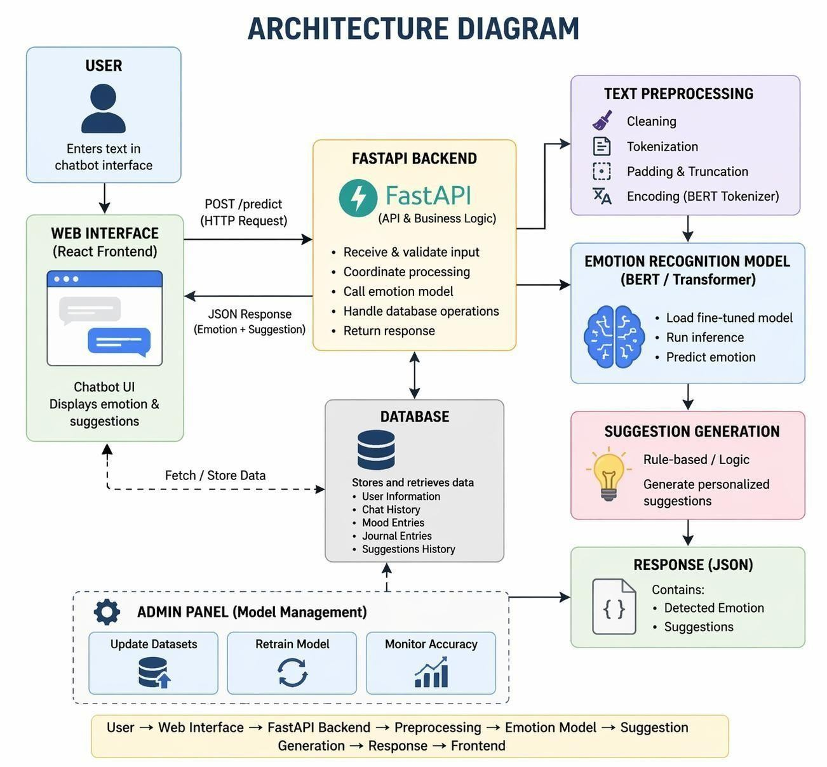
Dig.3.1: Architecture Diagram

Description:
This architecture diagram represents the overall design of the Human Emotion Recognition System.It illustrates how different components such as the User Interface, Backend (FastAPI), Machine Learning Model (BERT), Database, and Admin Panel interact with each other to process user input and generate emotion-based responses. The system follows a layered architecture where data flows from the user through processing modules and returns as meaningful output.
Main Components:
User
- The user interacts with the system through a chatbot interface.
- They enter text expressing their thoughts or emotions.
Web Interface (React Frontend)
- Provides a user-friendly chatbot UI.
- Sends user input to the backend via HTTP requests.
- Displays the predicted emotion and suggestions received from the backend.
FastAPI Backend
- Acts as the core controller of the system.
- Receives and validates user input.
- Coordinates all processing steps.
- Communicates with the emotion model and database.
- Returns the final response to the frontend.
Text Preprocessing Module
- Cleans and prepares input text.
- Performs tokenization.
- Applies padding and truncation.
- Encodes text using a BERT tokenizer for model compatibility.
Emotion Recognition Model (BERT / Transformer)
- Loads the trained machine learning model.
- Processes the encoded input text.
- Predicts the emotion (e.g., happy, sad, angry).
Suggestion Generation
- Generates suggestions based on the predicted emotion.
- Uses rule-based or logic-driven approaches.
- Provides personalized recommendations to the user.
Database
- Stores and retrieves system data.
- Includes user information, chat history, mood entries, journal entries, and suggestions.
- Supports data persistence and tracking.
Response (JSON)
- Contains the final output sent to the frontend.
- Includes detected emotion and generated suggestions.
Admin Panel
- Allows administrators to manage the system.
- Update datasets for training.
- Retrain the emotion model.
- Monitor system accuracy and performance.
Workflow:
- User enters text in the web interface.
- The frontend sends a request to the FastAPI backend.
- The backend preprocesses the text.
- The processed data is passed to the BERT model for emotion prediction.
- The system generates suggestions based on the predicted emotion.
- Data is stored/retrieved from the database as needed.
- The backend sends a JSON response (emotion + suggestion) to the frontend.
- The frontend displays the result to the user.

3.6 SOFTWARE DESIGN AND DEVELOPMENT

3.6.1 Data Flow Diagram
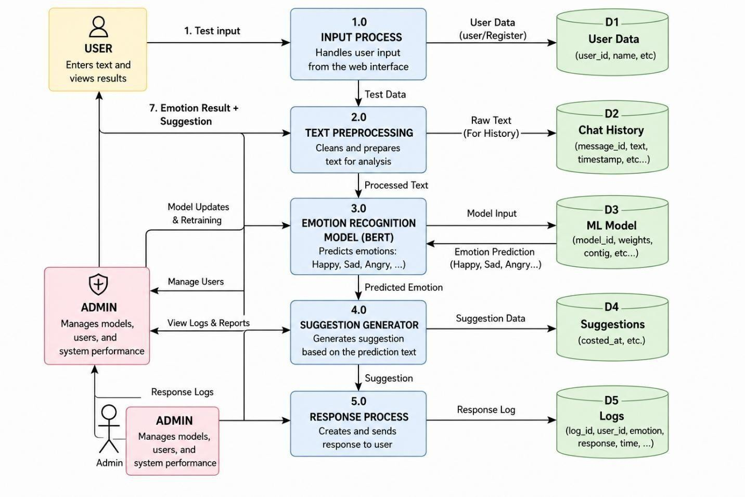
Dig.3.2: Data Flow Diagram
Description:
- The Data Flow Diagram (DFD) represents how data flows within the Human Emotion Recognition System.
- It shows the movement of data from user input to emotion prediction and final
response generation.
- The diagram includes processes, data stores, and external entities such as User and Admin.
External Entities:

User:
- Provides textual input through the web interface.
- Receives emotion prediction results and suggestions.
Admin:
- Manages system operations and monitors performance.
- Updates models and views system logs and reports.
Processes:
- Input Process:
  - Receives user input from the frontend.
  - Validates and forwards the data for processing.
- Text Preprocessing:
  - Cleans and tokenizes the input text.
  - Converts text into a suitable format for the model.
- Emotion Recognition Model:
  - Analyzes processed text using the BERT model.
  - Predicts the emotional state (happy, sad, angry, etc.).
- Suggestion Generator:
o Generates appropriate suggestions based on the detected emotion.
- Response Process:
  - Combines emotion prediction and suggestion.
  - Sends the final response back to the user.
Data Stores:
- D1–Users:
Stores user information such as ID, name, and email.
- D2–Chat History:
Stores user messages and previous interactions.
- D3–ML-Model:
Stores model files, configurations, and weights.
- D4–Suggestions:
Stores predefined suggestions for different emotions.
- D5–Logs:
Stores system logs, prediction results, and activity records.
Data Flow:
- User enters text input into the system.
- Input is processed and validated.
- Text is pre-processed and prepared for analysis.
- Processed text is sent to the emotion recognition model.
- Model predicts the emotion.
- Suggestions are generated based on the prediction.
- Final response (emotion + suggestion) is sent back to the user.
- Data is stored in respective data stores for future use.

3.6.2 Use-Case Diagram
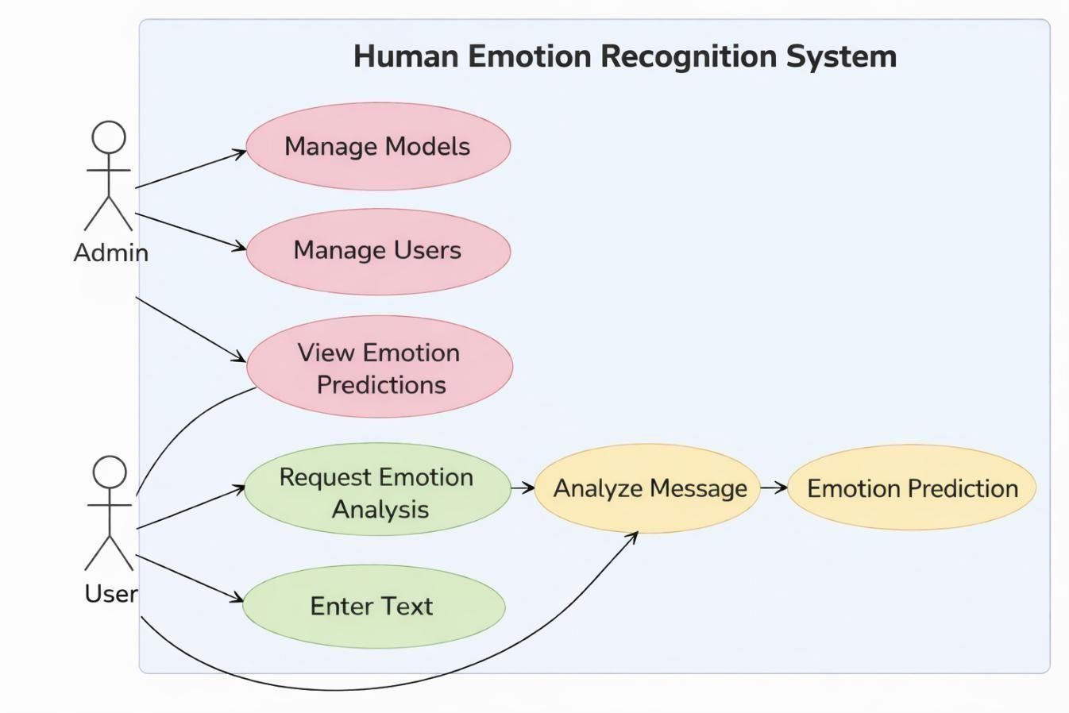
Dig.3.3: Use Case Diagram
Description
This use case diagram illustrates the interaction between two primary actors, namely the User and the Admin, with the Human Emotion Recognition System. It represents how different users interact with the system to perform various functionalities related to emotion analysis and system management.
Actors
- User:
The user interacts with the system through a chatbot interface to enter text describing their thoughts or emotions. The system processes this input and provides emotion prediction results. The user can repeatedly submit text for continuous analysis and feedback.
- Admin:
The admin is responsible for managing, maintaining, and monitoring the system. This includes updating machine learning models, managing user data, and ensuring the system operates efficiently and accurately.
Use Cases
- User Actions:
- Enter text describing thoughts or emotions.
- Request emotion analysis from the system.
- The system processes and analyzes the input using the emotion recognition model.
- View the predicted emotion result (e.g., happy, sad, angry).
- Submit additional text for further analysis if required.
- Admin Actions:
      - Manage and update machine learning models.
      - Manage user accounts and monitor system usage.
      - View emotion prediction logs and system outputs.
      - Monitor system performance, accuracy, and backend services.
      - Maintain and improve the overall functionality of the system.

3.6.3 Class Diagram:
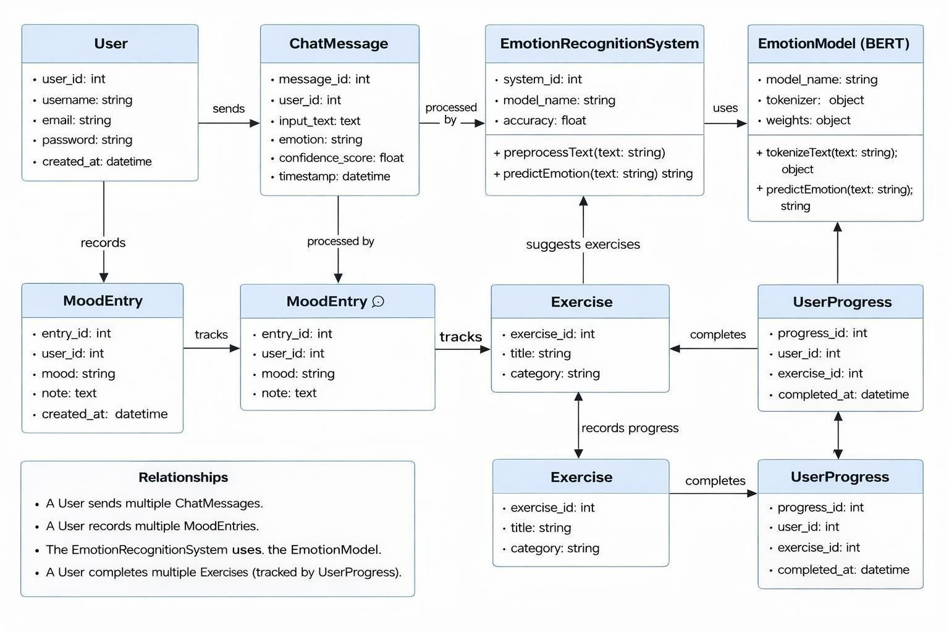
Dig.3.4: Class Diagram
Description:
- This class diagram represents the simplified structural design of the Human Emotion Recognition System.
- It focuses on the core components required for emotion detection, user interaction, and activity tracking.
- The diagram illustrates how main classes such as User, ChatMessage,
EmotionRecognitionSystem, EmotionModel, MoodEntry, Exercise, and UserProgress interact with each other.
- It shows the flow of data from user input to emotion prediction and further to activity tracking.
Key Responsibilities:
User Class:
      - Register and login into the system
      - Enter text describing emotions or thoughts
      - Submit text for emotion analysis
      - View emotion prediction results
      - Record mood entries
      - Complete suggested exercises
ChatMessage Class:
      - Store user input text
      - Store predicted emotion and confidence score
      - Maintain timestamp of each message
      - Represent communication between user and system
EmotionRecognitionSystem
Class:
  - Receive input text from user
  - Preprocess text data
  - Communicate with the emotion model
  - Predict emotion based on input
  - Return emotion results to the user
EmotionModel (BERT Model) Class:
      - Tokenize input text
      - Perform inference using trained model
      - Predict emotion (happy, sad, angry, etc.)
      - Maintain model weights and configuration
      - Provide prediction results to the system
MoodEntry Class:
      - Store user mood records
      - Maintain notes related to mood
      - Track mood history over time
      - Record timestamps of entries
Exercise Class:
1. Store exercise details (title and category) 2. Provide list of suggested exercises
3. Help users manage emotional well-being
UserProgress Class:
  - Track user completion of exercises
  - Store completion timestamps
  - Maintain progress history

3.6.4 Sequence Diagram:
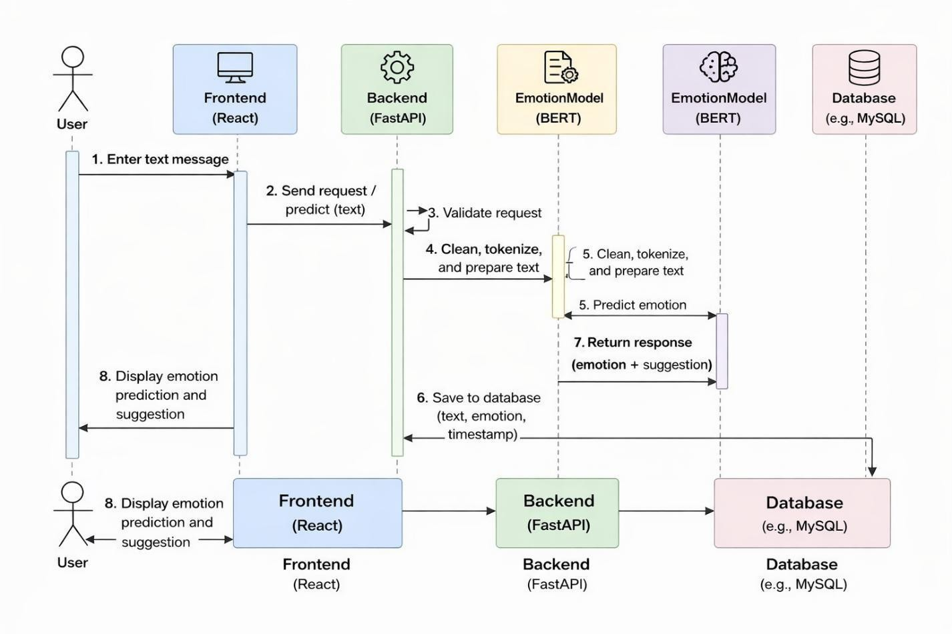
Dig.3.5: Sequence Diagram
Description:
- This diagram represents the working flow of a simplified Human Emotion Recognition System.
- It highlights the interaction between key components: User, Frontend (React), Backend (FastAPI), Emotion Model (Bert), and Database.
- The diagram shows how user input is processed step-by-step to detect emotions and generate responses.
- It also illustrates how data is stored and retrieved within the system.
System Workflow:
- User Interaction
  - The user enters a text message describing their feelings or thoughts.
  - The Frontend (React) captures the input and sends it to the Backend via an API request.
- Backend Processing
  - The Backend (FastAPI) receives the request.
  - It validates the input data to ensure correctness.
  - The text is cleaned and prepared for analysis (basic preprocessing).
- Emotion Prediction
  - The processed text is sent to the Emotion Model (BERT).
  - The model tokenizes the text and performs inference.
  - It predicts the emotion (e.g., happy, sad, angry) along with a confidence score.
  - The prediction result is returned to the Backend.
- Data Storage
  - The Backend stores the user input, predicted emotion, and timestamp in the Database (e.g., MySQL).
  - This helps in maintaining history and tracking user interactions.
- Response Generation
  - The Backend generates a response (emotion result and suggestion if applicable).
  - The response is sent back to the Frontend.
- Display to User
  - The Frontend displays the predicted emotion and suggestion to the user in a readable format.
Key Interactions:
  - User interacts only with the Frontend
  - Frontend communicates with Backend via API
  - Backend handles all processing and logic
  - Backend uses the Emotion Model for prediction
  - Backend stores and retrieves data from the Database 6. Final results are sent back to the user through the Frontend

3.6.5 Activity Diagram:

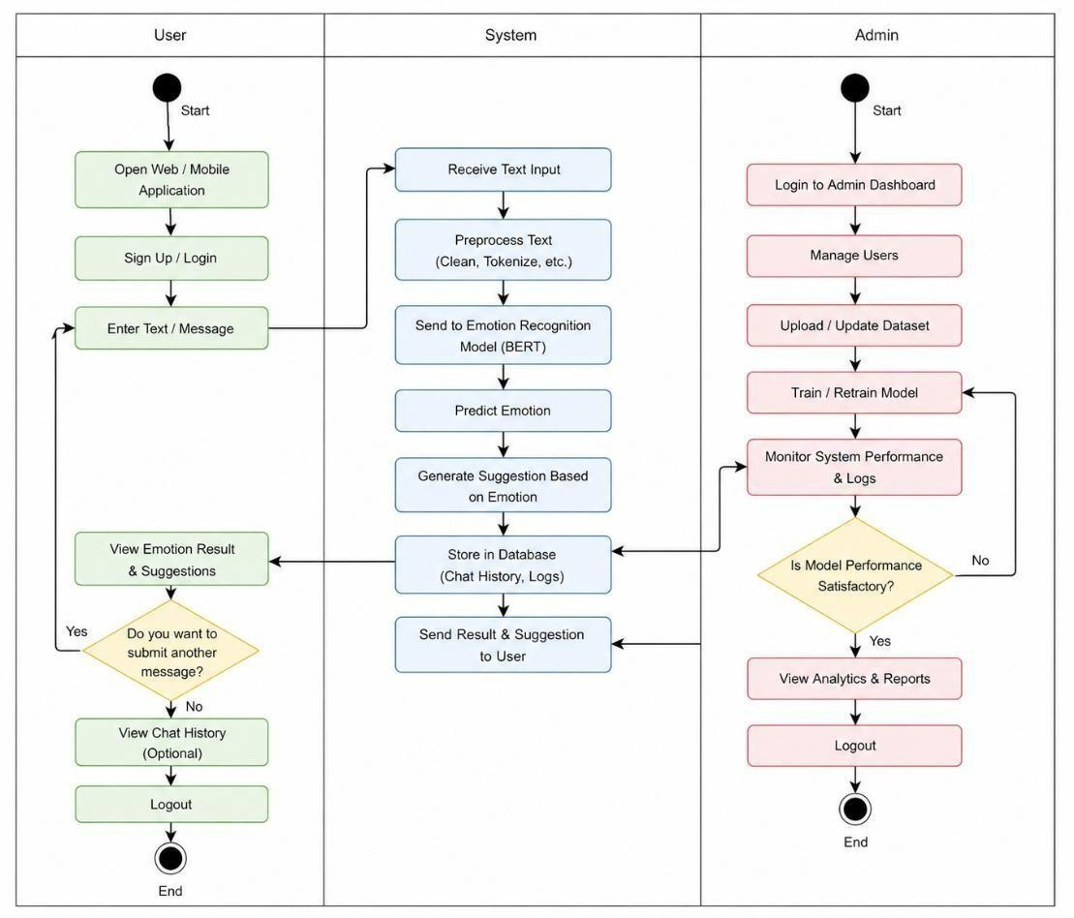
Dig.3.6: Activity Diagram

Description:
      - This activity diagram represents the workflow of the Human Emotion Recognition System.
      - It illustrates the sequence of activities performed by the User, System, and Admin from start to end.
      - The diagram shows how user input is processed, how emotions are predicted, and how system management is handled by the admin.
Actors:
User:
        - Interacts with the system through the web or mobile application
        - Provides input text and views results
        - Can perform multiple interactions
System:
1. | Processes user input
2. | Performs emotion recognition
3.  Admin: | Generates suggestions and stores data
1. | Manages system operations
2.  3.  Activities: | Updates datasets and models  Monitors system performance
User Activities:
        - Start the process
        - Open the web/mobile application
        - Sign up or log in
        - Enter text/message
        - View emotion result and suggestions
        - Decide whether to submit another message
        - (If Yes) Repeat the process
      - (If No) View chat history (optional)
      - Logout and end the process
System Activities:
      - Receive text input from user
      - Preprocess text (cleaning, tokenization, etc.)
      - Send text to emotion recognition model (BERT)
      - Predict emotion
      - Generate suggestion based on emotion
      - Store data in database (chat history, logs)
      - Send result and suggestion back to user
Admin Activities:
      - Start the process
      - Login to admin dashboard
      - Manage users
      - Upload or update dataset
      - Train or retrain model
      - Monitor system performance and logs
      - Check if model performance is satisfactory
      - (If No) Retrain model again
      - (If Yes) View analytics and reports
      - Logout and end the process
3.6.6 Component Diagram:

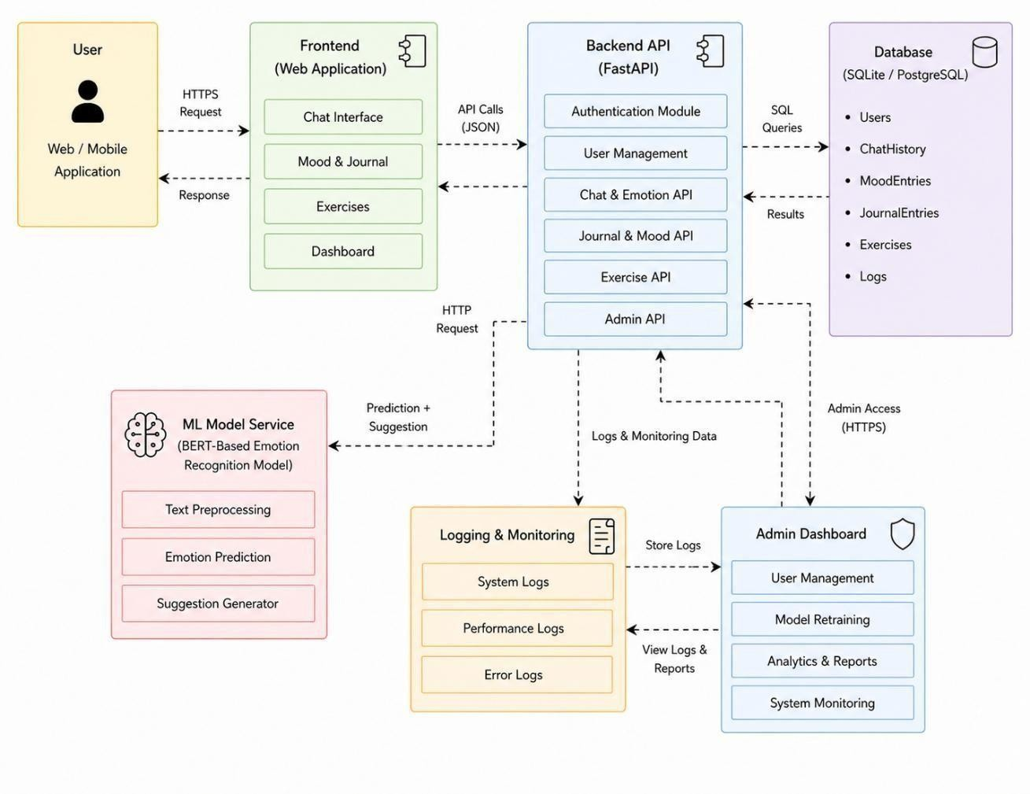
Dig.3.7: Component Diagram

Description:
      - This component diagram represents the overall structure of the Human Emotion Recognition System.
      - It shows how different software components such as the frontend, backend, machine learning model, database, and admin dashboard interact with each other.
      - The diagram illustrates communication between components using APIs, data flow, and system integration.
Actors:
User:
      - Interacts with the system through a web or mobile application.
      - Sends input text and receives emotion prediction results.
Admin:
      - Accesses the admin dashboard.
      - Monitors system performance and manages system components.
Components:
Frontend (Web Application):
      - Provides user interface for interaction.
      - Includes modules like Chat Interface, Mood & Journal, Exercises, and Dashboard.
      - Sends user requests to backend using API calls.
      - Displays results received from backend.
Backend API (FastAPI):
1. Handles all business logic and API requests.
Includes modules such as:
              - Authentication Module.
              - User Management.
            - Communicates with the database and ML model service.
            - Processes requests and returns responses.
ML Model Service (BERT Model):
            - Performs text preprocessing.
            - Predicts emotion from input text.
            - Generates suggestions based on predicted emotion.
            - Returns prediction results to backend.
Database:
            - Stores user information
            - Stores chat history and mood entries.
            - Stores journal entries and exercise data.
            - Maintains system logs and records.
            - Supports data retrieval and storage operations.
Logging & Monitoring:
      - Captures system logs.
      - Tracks performance metrics.
      - Stores error logs.
      - Provides data for analysis and monitoring.
Admin Dashboard:
      - Allows admin to manage users.
      - Supports model retraining.
      - Displays analytics and reports.
      - Monitors system performance.
Interactions (Data Flow):
      - User sends request to frontend via HTTPS.
      - Frontend sends API request to backend (JSON format).
      - Backend processes request and interacts with ML Model Service.
      - ML Model processes input and returns prediction.
      - Backend stores data in database.
      - Backend sends response back to frontend.
      - Frontend displays emotion prediction and suggestions to user.
      - Backend sends logs to logging system.
      - Admin accesses dashboard to view logs, manage users, and monitor system.

3.6.7 E-R Diagram:

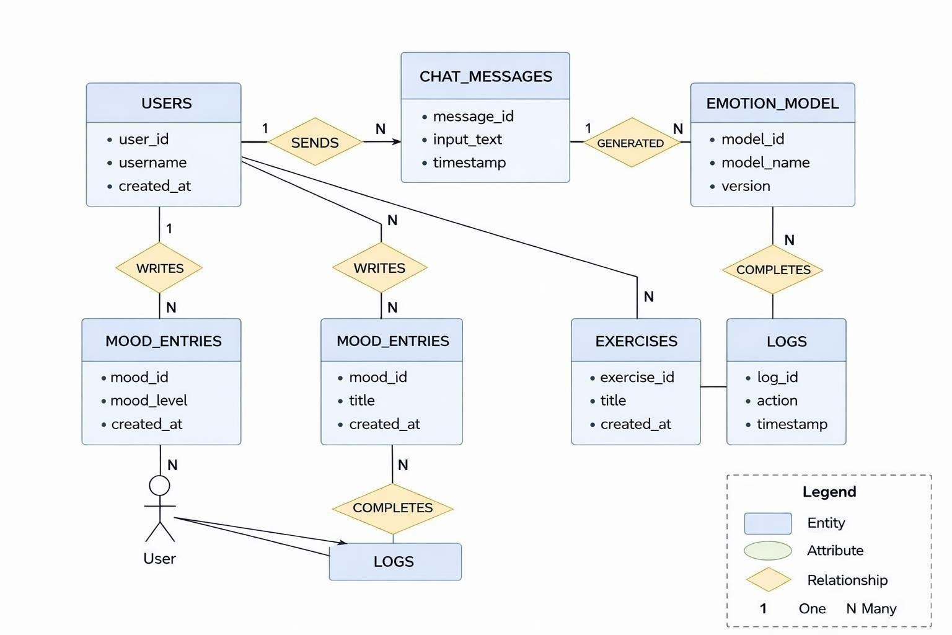
Dig.3.8: E-R Diagram
Description:
This Entity-Relationship (E-R) diagram represents the database structure of the Human Emotion Recognition System.
It illustrates the entities, their attributes, and the relationships between them. The diagram shows how user data, chat messages, emotions, journals, exercises, and system logs are stored and connected in the database.
Entities:
USERS:
description: Stores user information such as user_id, username, email, password, gender, and age.
CHAT_MESSAGES:
- Stores user input text and prediction results.
- Includes attributes like message_id, input_text, emotion, confidence, suggestion, and timestamp.
EMOTION_MODEL:
- Represents the machine learning model.
- Includes attributes like model_id, model_name, version, description, and created_at.
MOOD_ENTRIES:
- Stores user mood records.
- Includes mood_id, mood_level, emotion, notes, and created_at.
JOURNAL_ENTRIES:
- Stores user journal data.
- Includes entry_id, title, content, emotional_tone, and created_at.
EXERCISES:
- Stores exercise details.
Includes exercise_id, title, description, category, duration, and created_at.
USER_EXERCISE_PROGRESS:
- Tracks user progress in exercises.
- Includes progress_id, user_id, exercise_id, rating, and completed_at.
ADMINS:
- Stores admin information.
- Includes admin_id, username, email, and created_at.
SYSTEM_LOGS:
- Stores system activity and logs.
- Includes log_id, action, details, timestamp, and user_id.
Relationships:
- USERS—SENDS→CHAT_MESSAGES(1:N):
One user can send multiple chat messages.
- CHAT_MESSAGESGENERATED_BY→EMOTION_MODEL(
N:1):
Many chat messages are generated using one model.
- USERS—HAS→MOOD_ENTRIES(1:N):
One user can have multiple mood entries.
USERS-WRITES→JOURNAL_ENTRIES(1:N):
One user can write multiple journal entries.

- USERS-COMPLETES→USER_EXERCISE_PROGRESS(1:N):
One user can complete multiple exercises.
- EXERCISES-TRACKS→USER_EXERCISE_PROGRESS(1:N):
One exercise can be completed by multiple users.
- ADMINS—MANAGES→SYSTEM_LOGS(1:N):
One admin can manage multiple system logs.

Chapter- 4

4.1 Implementation
The Human Emotion Recognition project is implemented as a full-stack intelligent web application that integrates Artificial Intelligence, Natural Language Processing (NLP), and modern web technologies into a unified system. The implementation is designed in a modular architecture where each component performs a specific task independently while interacting seamlessly with other modules. This approach improves system maintainability, scalability, and performance. The project mainly consists of frontend, backend, deep learning model, authentication, and database modules working together to provide real-time emotional analysis.
The frontend of the system is developed using React.js, along with HTML, CSS, and JavaScript, to create an interactive and responsive user interface. The frontend includes multiple pages such as Home, Login, Signup, Dashboard, Chat, Mood Tracker, Journal, Exercises, Resources, and Profile. React Router is used for smooth navigation between pages, while protected routes ensure that only authenticated users can access private modules. The chatbot interface allows users to enter their thoughts or feelings in text form and receive instant emotional predictions.
The backend of the project is implemented using Python and FastAPI, which acts as the communication layer between the frontend and the AI prediction engine. FastAPI is used because of its high speed, asynchronous support, and easy API creation. The backend manages user authentication, profile updates, mood tracking records, journaling entries, chat history, and dashboard statistics. It also receives text input from users, processes requests, runs prediction models, and returns structured responses in JSON format.
The core intelligence of the system is powered by transformer-based deep learning models. A finetuned BERT model is used for depression severity classification, while another pretrained transformer model is used for emotion recognition. The system first preprocesses user text through tokenization and encoding, then passes it to the models for prediction. Based on the output, emotions such as happy, sad, affectionate, frustrated, nervous, excited, and neutral are identified. Depression severity levels such as minimum, mild, moderate, and severe are also predicted. The suggestion module then generates personalized guidance or supportive responses according to the user’s emotional state.
The project also includes additional wellness features such as mood tracking, journaling, breathing exercises, coping strategies, and dashboard analytics. User data can be stored in a database for future mood analysis and progress monitoring. The modular implementation ensures that each component can be updated independently and supports future enhancements such as multilingual emotion recognition, voice-based analysis, mobile deployment, and advanced AI integration. Overall, the implementation successfully combines intelligent prediction models with a userfriendly platform to create an effective emotional support system.

4.1.1 Frontend Implementation using React.js (App.js)
The frontend of the project is developed using React.js. It manages page navigation using React
Router and secures internal pages using protected routes. Different modules such as Dashboard, Chat, Mood Tracker, Journal, Exercises, Resources, and Profile are integrated into the application. import { BrowserRouter as Router, Routes, Route } from "react-router-dom"; import Home from
"./pages/Home"; import Login from "./pages/Auth/Login"; import Dashboard from
"./pages/Dashboard"; import Chat from "./pages/Chat"; function App() {
return (
<Router>
<Routes>
<Route path="/" element={<Home />} />
<Route path="/login" element={<Login />} />
<Route path="/dashboard" element={<Dashboard />} />
<Route path="/chat" element={<Chat />} />
</Routes>
</Router>
);
}

export default App;
This code handles the main routing structure of the application and allows smooth navigation between pages.

4.1.2 Backend Initialization using FastAPI (main.py)
The backend server is developed using FastAPI, which handles API requests and communication with the prediction model. from fastapi import FastAPI app = FastAPI( title="Mental Health Wellness API", version="2.0.0"
)
@app.get("/") async def
root():
return {"message": "API Running Successfully"}
This snippet initializes the backend application and creates a root endpoint for testing server status.

4.1.3 Loading AI Models
The system uses a fine-tuned BERT model for depression severity prediction and a transformer model for emotion recognition.
from transformers import AutoTokenizer, AutoModelForSequenceClassification, pipeline dep_tokenizer = AutoTokenizer.from_pretrained("VeenaSree/mentalhealth-BERT")
dep_model =
AutoModelForSequenceClassification.from_pretrained("VeenaSree/mentalhealthBERT") emotion_pipeline = pipeline( "text-classification", model="bhadreshsavani/distilbert-base-uncased-emotion"
)
This code loads pretrained transformer models required for prediction.

4.1.4 Emotion Mapping Function
The predicted labels are converted into user-friendly emotion names. def map_emotion(label): emotion_map = {
"sadness": "sad",
"joy": "happy",
"love": "affectionate",
"anger": "frustrated",
"fear": "nervous",
"surprise": "excited"
}
return emotion_map.get(label.lower(), "neutral")
This function simplifies model output labels into understandable emotional states.

4.1.5 Prediction API Endpoint
The core functionality of the system is implemented in the prediction endpoint.
@app.post("/predict") async def
predict_mental_health(request: Request): data = await request.json() text = data.get("inputText", "") emotion_result = emotion_pipeline(text)[0] emotion = map_emotion(emotion_result["label"]) return
{"emotion": emotion}
This endpoint receives user text, processes it through the AI model, and returns the predicted emotion.

4.1.6 User Authentication Module
The system provides secure login and registration functionality.
@app.post("/auth/login") async def login(credentials:
UserLogin): return {
"access_token": "token",
"token_type": "bearer"
}
Authentication helps secure personal modules such as dashboard, journal, and profile.

4.1.7 Mood Tracking Module
The project includes a mood tracker to record daily emotional states.
@app.post("/mood/create") async def create_mood_entry():
return {"message": "Mood recorded successfully"}
This allows users to monitor emotional trends over time.

4.1.8 Journal Module
Users can maintain personal journal entries for self-reflection.
@app.post("/journal/create") async def create_journal():
return {"message": "Journal saved"}
The journal module can also be analyzed for emotional tone detection.

4.1.9 Dashboard Analytics Module
The dashboard provides mood statistics and user progress.
@app.get("/dashboard/stats") async def get_dashboard_stats():
return {"week_average_mood": 4.2}
This helps users visualize their emotional well-being.

4.2 SCREEN SHOTS

4.2.1 Home Page
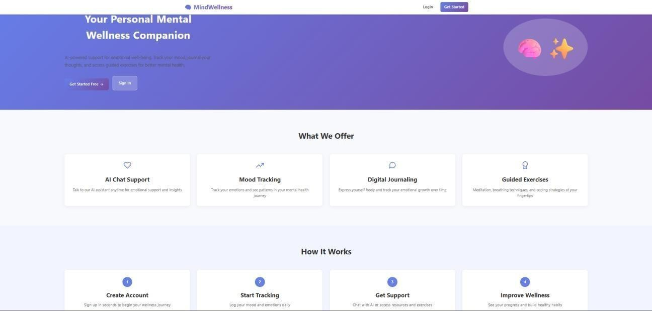
Fig 4.1 Home Page
The above screen shows the Home Page of the Human Emotion Recognition system named MindWellness. It is the main landing page of the application and provides users with an overview of the platform features and services. The page is designed with a clean and user-friendly interface. At the top, a navigation bar is provided with the application title MindWellness along with Login and Get Started options for user access. The main banner section displays the heading “Your Personal Mental Wellness Companion” with a short description about AI-powered emotional support, mood tracking, journaling, and guided exercises. Buttons such as Get Started Free and Sign In are available for quick access. The What We Offer section highlights the main modules of the system such as AI Chat Support, Mood Tracking, Digital Journaling, and Guided Exercises. The How It Works section explains the workflow in simple steps: Create Account, Start Tracking, Get Support, and Improve Wellness.

4.2.2 Sign Up Page
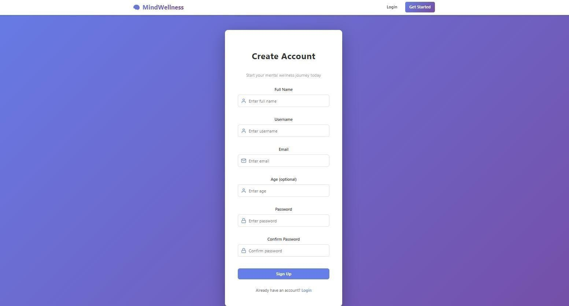
Fig 4.2 Sign Up Page
The above screen shows the User Registration Page of the Human Emotion Recognition system named MindWellness. This page allows new users to create an account and access the features of the platform. At the top, a navigation bar is provided with the application title MindWellness, along with Login and Get Started options. The center section contains a signup form with the heading Create Account and a short message encouraging users to begin their mental wellness journey. The form includes fields such as Full Name, Username, Email, Age (optional), Password, and Confirm Password. A SignUp button is provided to submit the registration details and create a new account. Below the button, an option is available for existing users to navigate to the Login page. This page ensures secure user registration and acts as the first step for accessing the Human Emotion Recognition system features such as chatbot support, mood tracking, journaling, and wellness tools.

4.2.3 User Dashboard Page
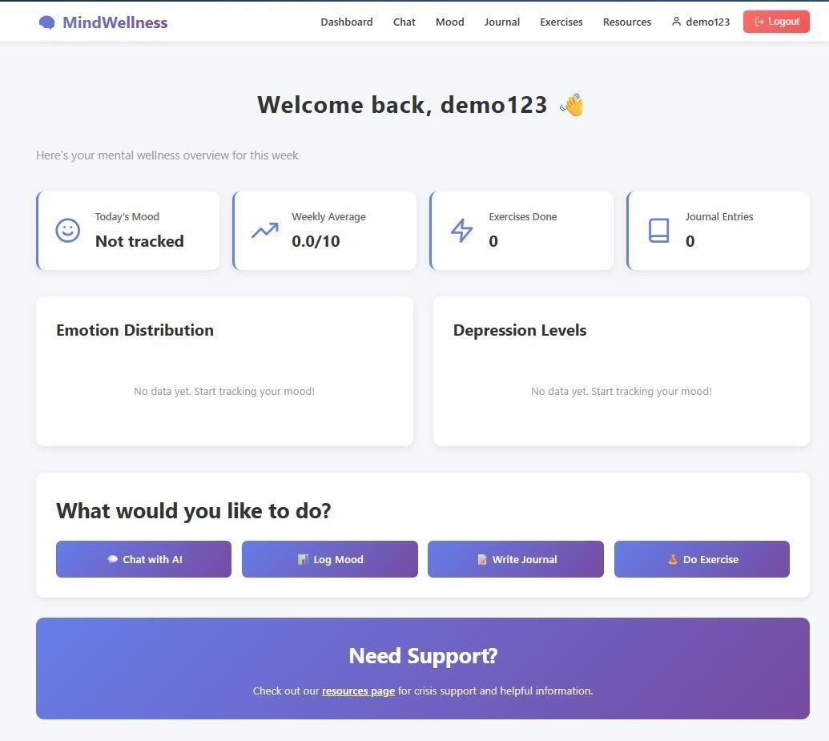
Fig 4.3 User Dashboard Page

The above screen shows the Dashboard Page of the Human Emotion Recognition system named MindWellness. This page appears after successful user login and provides a personalized overview of the user’s mental wellness activities. At the top, a navigation bar is available with menu options such as Dashboard, Chat, Mood, Journal, Exercises, and Resources, along with the logged-in username and Logout button. The main section welcomes the user with a personalized greeting and displays weekly wellness statistics. Summary cards are provided for Today’s Mood, Weekly Average, Exercises Done, and Journal Entries, helping users quickly view their progress. The middle section contains analytics panels for Emotion Distribution and Depression Levels. These sections are used to display charts or graphs based on the user’s tracked emotional data. Below this, quick action buttons are provided for easy access to important features such as Chat with AI, Log Mood, Write Journal, and Do Exercise. At the bottom, a support section is displayed with a message directing users to the Resources Page for crisis support and helpful mental wellness information.

4.2.4 Guided Exercises Page
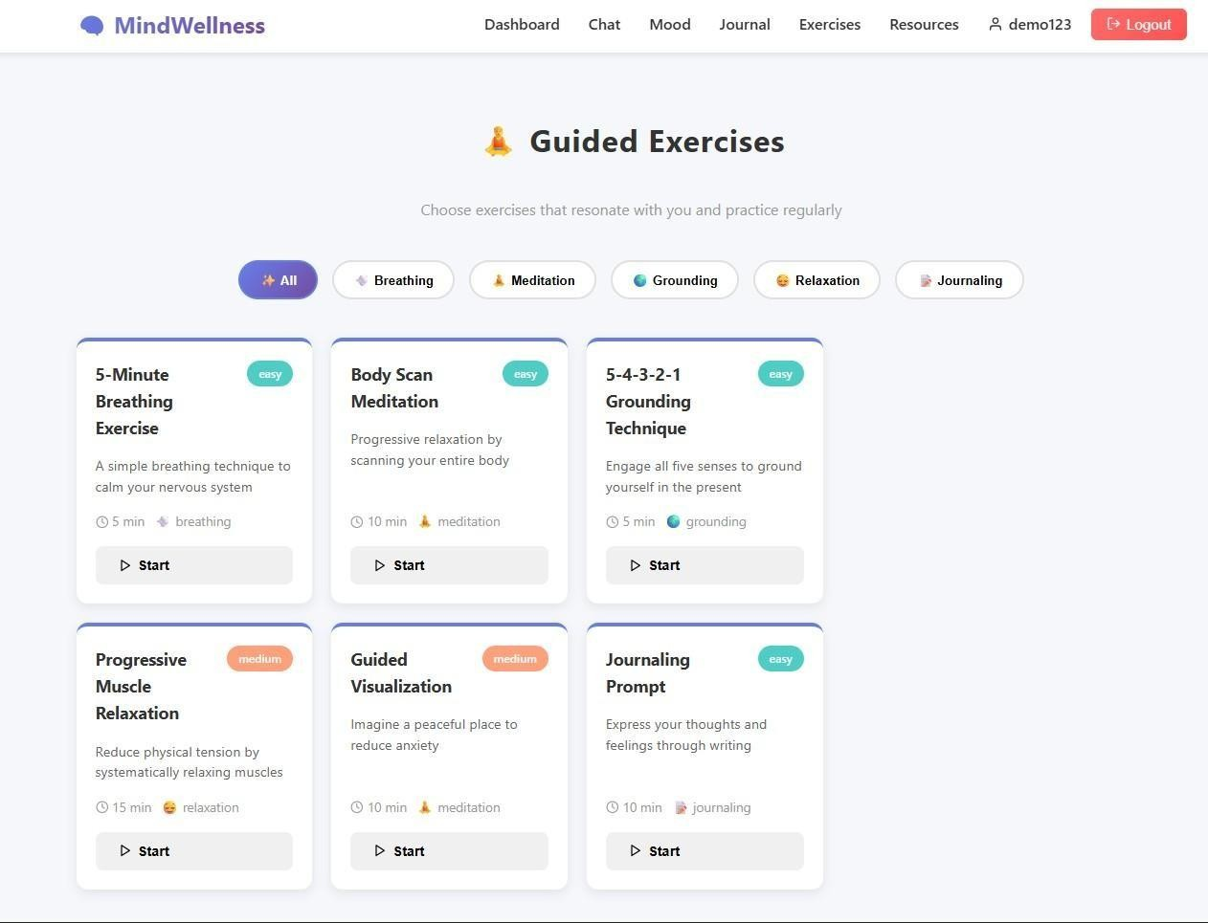
Fig 4.4 Guided Exercises Page
The above screen shows the Guided Exercises Page of the Human Emotion Recognition system named MindWellness, which is designed to support users in improving their mental wellness through guided activities and relaxation techniques. At the top, a navigation bar is provided with menu options such as Dashboard, Chat, Mood, Journal, Exercises, and Resources, along with the username and Logout button. The main section displays the heading Guided Exercises with a short description encouraging users to choose exercises and practice regularly. Category filters such as All, Breathing, Meditation, Grounding, Relaxation, and Journaling are available to help users select suitable activities. Below this, multiple exercise cards are displayed containing details such as exercise title, difficulty level, short description, duration, and category. Examples shown include 5-Minute Breathing Exercise, Body Scan Meditation, 5-4-3-2-1 Grounding Technique, Progressive Muscle Relaxation, Guided Visualization, and Journaling Prompt. Each card includes a Start button that allows users to begin the selected exercise instantly. Overall, this page provides supportive wellness tools that help users reduce stress, improve concentration, relax the mind, and maintain emotional balance.

4.2.5 AI Chat Interface (Mental Wellness Chat Page)

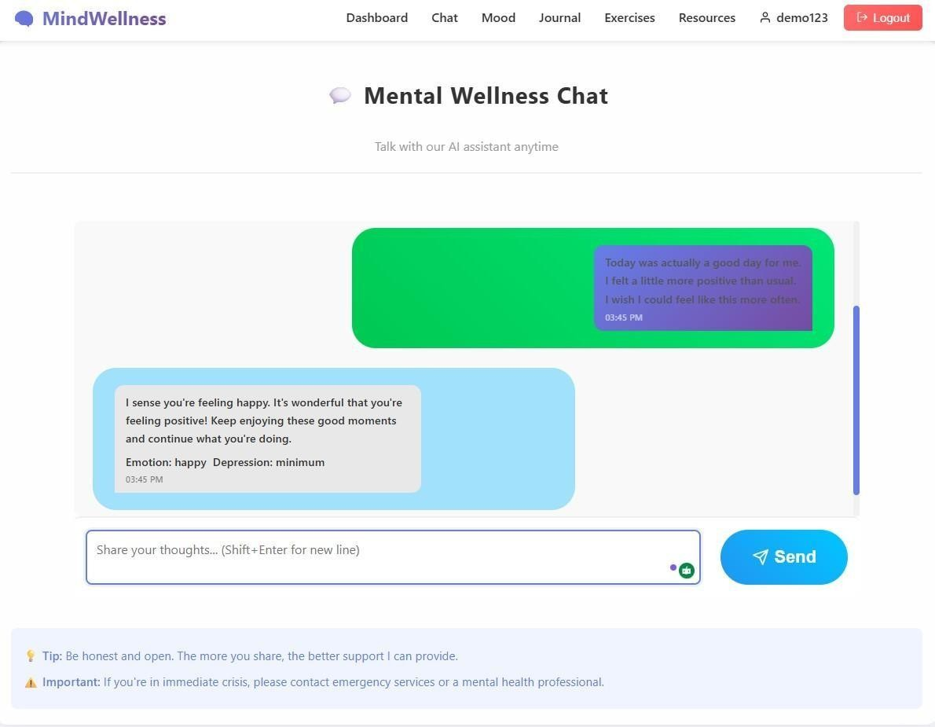
Fig 4.5: AI Chat Interface (Mental Wellness Chat Page)

The AI Chat Interface is a core component of the Human Emotion Recognition System that enables real-time interaction between the user and the AI-powered assistant. This page allows users to express their thoughts and emotions through text, which are then analyzed by the system to detect emotional states and provide supportive responses. 79 The interface displays a conversational layout where user messages and AI responses are clearly distinguished using chat bubbles. The AI analyzes the input text using a BERT-based emotion recognition model and responds with detected emotion, emotional intensity, and personalized suggestions to support the user. A text input field is provided at the bottom of the interface, allowing users to type their messages and send them using the “Send” button. The system supports continuous interaction, enabling users to engage in multiple conversations for better emotional analysis and guidance. Additionally, the interface includes helpful tips encouraging users to share openly and honestly, as well as an important notice advising users to seek professional help in case of serious emotional distress. These elements ensure responsible usage of the system. The chat interface is designed to be simple, interactive, and responsive, providing users with a comfortable environment to communicate and receive AIassisted emotional support in real time.

4.2.6 Crisis Support & Resources Page (Emergency Help Interface)
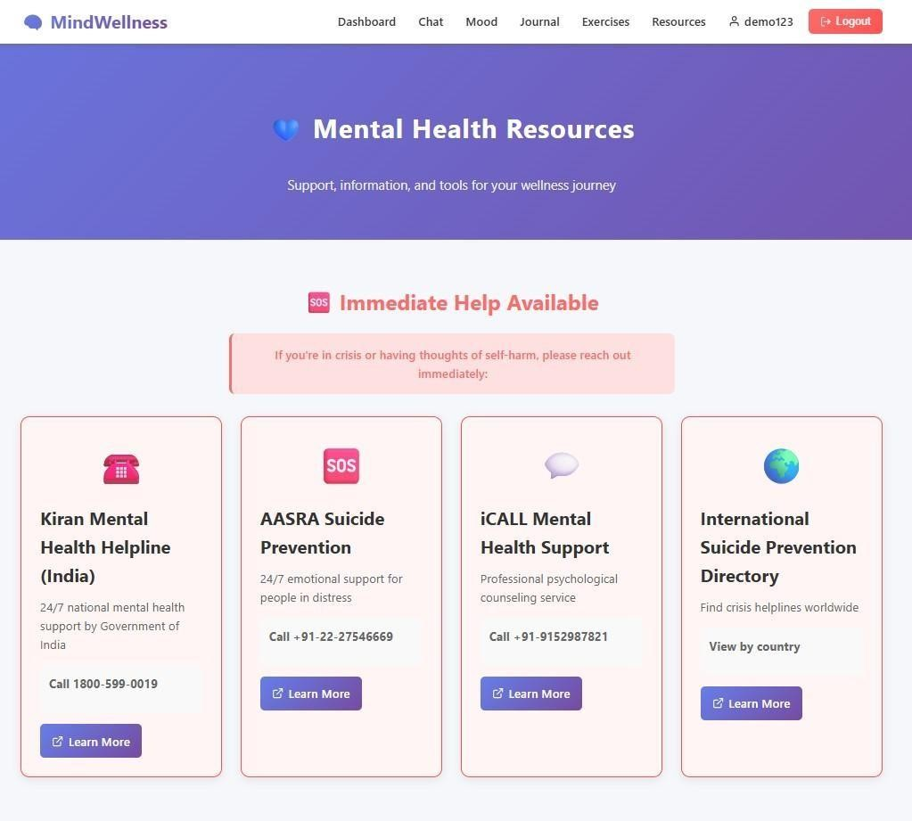
Fig 4.6 Crisis Support & Resources Page (Emergency Help Interface)
The Crisis Support & Resources Page is a critical component of the Human Emotion Recognition System that provides immediate access to mental health support services for users in distress. This page is designed to offer quick and reliable assistance by connecting users to verified helplines and professional support organizations. At the top of the page, an alert message highlights the importance of seeking help in case of emotional crisis or self-harm thoughts. This ensures that users are made aware of the urgency and encouraged to take immediate action. The page displays multiple support options in a card-based layout, including national and international helplines such as the Kiran Mental Health Helpline (India), AASRA Suicide Prevention, iCALL Mental Health Support, and an International Suicide Prevention Directory. Each card provides essential details such as service description, contact number, and access to additional information through a “Learn More” option. These resources are available 24/7, ensuring continuous support for users regardless of time or location. The inclusion of both local and global support options increases accessibility and makes the system more inclusive. 82 The page is designed with a clear and focused layout, using visual cues to emphasize urgency while maintaining readability. By integrating crisis support directly into the application, the system ensures responsible usage and reinforces its role as a supportive mental wellness platform rather than a replacement for professional care.

4.2.7 Mood Tracker Page (Emotional Monitoring Interface)
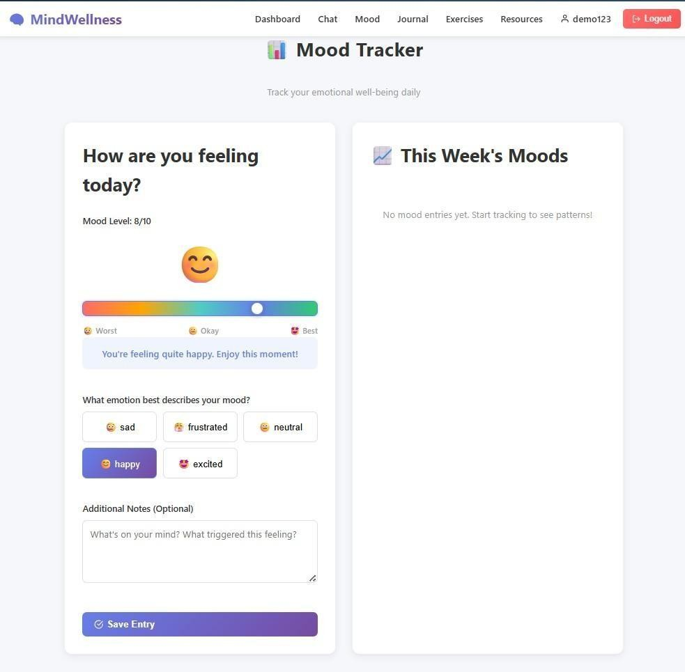
Fig 4.7 Mood Tracker Page (Emotional Monitoring Interface)

The Mood Tracker Page is a key feature of the Human Emotion Recognition System that allows users to record and monitor their daily emotional state. This page is designed to help users reflect on their feelings, track emotional patterns, and maintain awareness of their mental well-being over time. The interface includes an interactive mood slider that enables users to rate their mood on a scale (e.g., 1 to 10), ranging from worst to best. Based on the selected value, the system provides immediate 83 feedback along with a visual emoji representation, helping users better understand their emotional state. Users can also select specific emotions such as sad, frustrated, neutral, happy, or excited, allowing more detailed emotional classification. Additionally, an optional notes section is provided where users can describe their thoughts or the reasons behind their mood, supporting deeper selfreflection. On the right side of the page, a summary section titled “This Week’s Moods” displays previously recorded entries, including mood level, detected emotion, and timestamps. This helps users track emotional trends and identify patterns over time. A “Save Entry” button allows users to store their mood data in the system, which is later used for analysis and visualization in the dashboard. The page is designed to be simple, interactive, and userfriendly, encouraging regular usage and promoting consistent emotional tracking. Overall, the Mood Tracker enhances the system by enabling continuous monitoring, supporting emotional awareness, and providing valuable insights into users’ mental health patterns.
Table 4.1 Test Cases
Test  Case ID | Test Case  Type | Test Case  Description | Expected Value | Actual  Value | Result
TC01 | Functional | User enters valid emotional text | Text accepted for analysis | Accepted | PASS
TC02 | Functional | Submit text for  prediction | Emotion predicted | Accepted | PASS
TC03 | AI | Detect happy emotion | Emotion: Happy | Happy | PASS
TC04 | AI | Detect sad emotion | Emotion: Sad | Sad | PASS
TC05 | AI | Detect angry emotion | Emotion: Angry | Angry | PASS
TC06 | AI | Detect nervous  emotion | Emotion identified correctly | Identified | PASS
TC07 | Functional | Backend API  (/predict) call | JSON response  returned | Returned | PASS
TC08 | Performance | Response time under  5 seconds | < 5 seconds | Within limit | PASS
TC09 | Security | Empty text  submission | Error message shown | Shown | PASS
TC10 | Security | Special  characters input | Handled safely | Handled | PASS

CHAPTER – 5
RESULTS AND DISCUSSION

The results of the Human Emotion Recognition System demonstrate the effectiveness of the proposed model in identifying emotional states and analyzing user text patterns across different categories. The system was evaluated using multiple test instances and standard performance metrics to measure its accuracy, consistency, reliability, and practical usability. The obtained results indicate that the transformer-based model performs efficiently in recognizing emotions from textual input and generating meaningful responses.
The first set of results represents the distribution of emotion and depression severity classification across different categories such as minimum, mild, moderate, and severe. The output graph illustrates how the system responds to different user input instances and classifies them into the most appropriate emotional level. It can be observed that the system produces stable and consistent predictions across multiple test cases. Inputs expressing low emotional intensity are classified under minimum or mild categories, while stronger negative emotional patterns are classified under moderate or severe levels. This shows that the model is capable of distinguishing between different emotional intensities effectively.
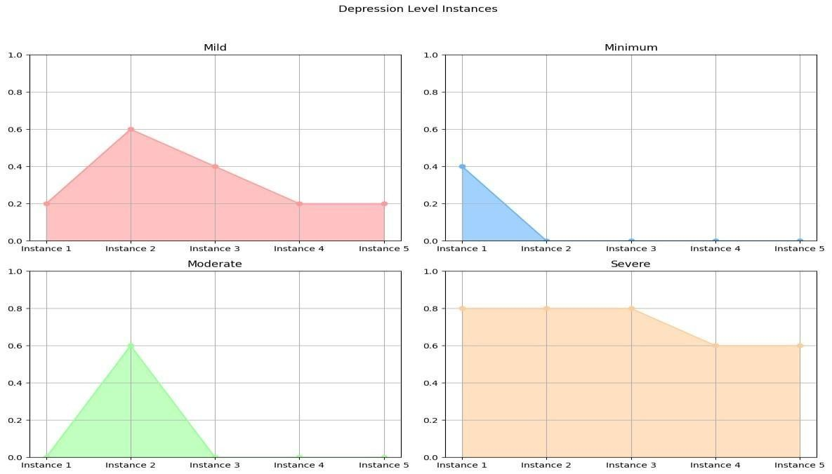
Fig 5.1: Depression / Emotion Level Instances Graph

The second set of results is based on the classification performance metrics such as accuracy, precision, recall, and F1-score. These metrics provide a clear understanding of how well the model predicts emotions correctly. The results show that the model achieves high precision values, meaning it can correctly identify relevant emotional classes while reducing false predictions. High recall values indicate that the model successfully captures most of the actual emotional instances present in the data. The F1-score, which balances both precision and recall, remains consistently high across major classes, demonstrating the overall robustness and reliability of the system.

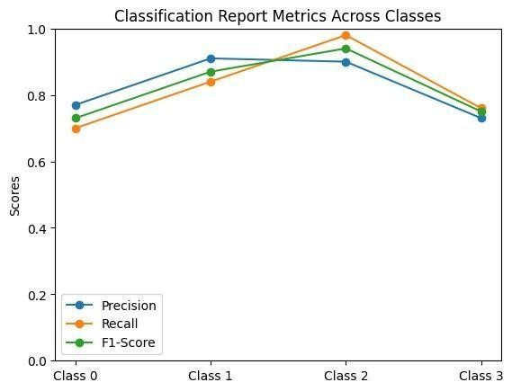
Fig 5.2: Classification Report Metrics Across Classes
The performance analysis also indicates that the model performs exceptionally well in classes that have balanced and sufficient training samples. Slightly lower values in a few classes suggest that performance can be further improved by increasing dataset diversity and balancing underrepresented emotional categories. However, the overall results remain strong and validate the effectiveness of using BERT-based transformer models for emotion recognition tasks.
Another important result is the system’s ability to process real-time user input and generate predictions instantly through the chatbot interface. The response time was found to be efficient, making the system suitable for practical applications. The suggestion generation module further enhances user experience by providing personalized responses, supportive guidance, and motivational messages based on the detected emotional state.
The system also maintained consistency in predictions across repeated inputs and similar textual patterns, which confirms its reliability in real-world scenarios. The integration of frontend, backend, and model components worked successfully, ensuring smooth interaction between the user and the system.
Overall, the results confirm that the proposed Human Emotion Recognition system is capable of accurately detecting emotions, handling different text variations, and providing useful insights through intelligent predictions. The combination of Deep Learning techniques, efficient backend processing, and user-friendly interface contributes significantly to the overall effectiveness of the project.

5.1 Discussion / Clarification on Results – Output
The output generated by the Human Emotion Recognition system clearly demonstrates that the model can understand textual input and classify emotional states effectively. When users entered different types of emotional statements, the system was able to predict relevant categories such as happy, sad, angry, fear, excited, frustrated, and neutral.
For low-intensity emotional expressions, the model generally predicted minimum or mild categories, while stronger emotional statements were classified into moderate or severe levels. This indicates that the system not only detects the type of emotion but also estimates the intensity of emotional condition.
The classification report showed high accuracy and stable performance across most categories. The results validate that transformer-based models like BERT provide better contextual understanding compared to traditional machine learning algorithms.
The chatbot interface also produced instant outputs and supportive suggestions, making the system practical, interactive, and user-friendly.

5.2 Comparative Study
A comparative study was carried out between the proposed BERT-based system and traditional machine learning approaches such as Naïve Bayes, Support Vector Machine (SVM), and Logistic Regression.
Traditional models generally depend on manually extracted features and struggle with context understanding, sarcasm, and sentence complexity. Their prediction accuracy is lower when compared with deep learning models.
The proposed BERT-based system provides the following advantages:
- Better contextual understanding of words and sentences.
- Higher accuracy in emotion prediction.
- Improved precision, recall, and F1-score.
- Real-time chatbot integration.
- Personalized suggestions after prediction.
- Scalability for future enhancements.
Thus, the comparative study confirms that transformer-based models outperform traditional methods in text emotion recognition tasks.

5.3 Outcomes of the Present Work
The major outcomes of the present work are as follows:
- Successfully developed an intelligent Human Emotion Recognition system.
- Accurately classified emotions from textual input.
- Identified depression severity levels such as minimum, mild, moderate, and severe.
- Implemented a real-time chatbot interface for user interaction.
- Generated personalized suggestions based on emotional state.
- Demonstrated the effectiveness of BERT for text classification tasks.
- Improved human-computer interaction through emotionally aware responses.
- Created a scalable platform for future AI-based wellness applications.

Chapter-6
Summary and conclusions

6.1 Conclusion
The project Human Emotion Recognition was successfully designed and implemented with the objective of identifying human emotions and possible depression severity levels from textual input using Artificial Intelligence, Natural Language Processing (NLP), and Deep Learning techniques. In the present digital era, where people frequently communicate through text messages, social media posts, emails, and online chats, understanding emotions through written language has become highly important. The proposed system provides an effective solution for automatically detecting emotions and supporting users through intelligent responses.
The developed system analyzes user text through an interactive chatbot interface and predicts emotional states such as happiness, sadness, anger, fear, excitement, frustration, affection, nervousness, and neutral state. In addition to emotion recognition, the system is capable of classifying possible depression severity levels such as minimum, mild, moderate, and severe. This dual functionality increases the usefulness of the project by combining emotional understanding with preliminary mental wellness support.
The implementation of the project was carried out using modern technologies such as React.js for frontend development, Python and FastAPI for backend processing, and a fine-tuned BERT model using Hugging Face Transformers and PyTorch. The use of BERT proved highly effective because of its ability to understand the contextual meaning of words and sentences. Compared with traditional machine learning methods, transformer-based models provide better prediction accuracy, stronger language understanding, and improved performance in complex text classification tasks.
The system was tested using different user inputs to verify its functionality, response time, and prediction quality. The results demonstrated that the proposed model can process user input efficiently and generate accurate predictions in real time. It was also observed that the chatbot interface makes the system user-friendly and accessible to individuals with different technical backgrounds. This improves the overall interaction between users and the system.
Another important outcome of the project is that it offers a practical and cost-effective alternative to sensor-based emotion recognition systems. Unlike methods that depend on EEG, ECG, or facial recognition hardware, the proposed solution requires only textual input, making it easier to deploy and scale for large numbers of users. This makes the system suitable for web platforms, mobile applications, customer service systems, educational tools, and healthcare support systems.
The project also highlights the growing importance of emotionally intelligent AI systems. By recognizing user emotions and providing suitable suggestions, the system helps bridge the gap between human feelings and machine responses. Such systems can play a valuable role in reducing communication barriers, improving user satisfaction, and supporting emotional well-being.
In conclusion, the Human Emotion Recognition project successfully achieved its objectives and demonstrated the effective use of NLP and Deep Learning in understanding human emotions from text. The project provides a reliable, scalable, and intelligent platform that can be further enhanced in the future. It has strong potential for real-world applications in healthcare, counseling, education, customer support, and smart assistant technologies, thereby contributing toward the development of more empathetic and human-centered AI systems.

6.2 Future Scope
The future scope of the Human Emotion Recognition project is wide and promising, as emotionally intelligent systems are becoming increasingly important in modern society. The current system can be further enhanced in several ways to improve accuracy, usability, accessibility, and realworld impact.
One major enhancement is the addition of multilingual support, which would enable the system to recognize emotions from text written in multiple languages instead of only English. This would make the application useful for a larger number of users across different regions and cultures.
The project can also be extended to voice-based emotion recognition, where speech signals such as tone, pitch, speed, and intensity are analyzed along with text to identify emotions more accurately. This would improve the system’s ability to understand user feelings in spoken conversations.
Another important future enhancement is facial expression recognition using computer vision techniques. By analyzing facial movements and expressions through a camera, the system can combine visual cues with text analysis for more reliable emotion detection.
The current web-based system can be transformed into a mobile application so that users can access emotional analysis and support anytime through smartphones and tablets. This would improve portability and user convenience.
Advanced Large Language Models (LLMs) and next-generation transformer models can be integrated into the system to provide more natural, personalized, and context-aware suggestions. This would enhance the quality of chatbot responses and user engagement.
The project can also include long-term mood tracking and analytics, allowing users to monitor emotional trends over days or months. Such analysis can help users understand behavioral patterns and improve emotional self-awareness.
Integration with wearable devices such as smartwatches or fitness bands can further improve the system by combining physiological signals like heart rate, sleep patterns, and stress indicators with textual emotion analysis.
The system may also be connected with healthcare platforms, counselors, or wellness services so that users experiencing severe emotional distress can receive timely professional support.
In the future, the project can be enhanced with stronger privacy protection, cloud deployment, and support for large numbers of concurrent users, making it suitable for enterprise and public use.

APPENDIX

This appendix presents supplementary implementation and deployment details related to the project titled Human Emotion Recognition. The information included in this section provides additional technical support to the proposed system without repeating the concepts already discussed in the main chapters. The appendix mainly focuses on execution environment, operational workflow, system integration, deployment structure, model pipeline, security mechanisms, and future extensibility of the project. It helps in understanding the practical realization of the proposed system.

A.1 PROJECT EXECUTION ENVIRONMENT
The Human Emotion Recognition system is developed and tested in a full-stack development environment consisting of frontend, backend, database, and deep learning modules.
The implementation environment includes:
- Python-based backend services using FastAPI
- React.js frontend for chatbot interaction
- PyTorch for deep learning model execution
- Hugging Face Transformers for BERT model implementation
- SQLite / MongoDB for data storage and session logs
- REST APIs for communication between frontend and backend modules
This modular setup ensures smooth interaction among user interface, prediction engine, and database components.

A.2 DATA FLOW PROCESS
The system follows a structured data flow pipeline for handling user input and prediction tasks.
The operational flow includes:
- User enters text through chatbot interface
- Validation of input text
- Text preprocessing and tokenization
- Encoding using BERT tokenizer
- Emotion and severity prediction using trained model
- Suggestion generation based on prediction
- Display of results in chatbot interface
- Optional storage of session logs and mood records
This structured workflow improves processing efficiency and ensures consistency across all modules.

A.3 MODULE INTERACTION
The proposed system is divided into independent functional modules that communicate through APIs and shared services.
The major modules include:
- Authentication Module
- User Interaction Module
- Text Preprocessing Module
- Emotion Prediction Engine
- Depression Severity Classification Module
- Suggestion Generation Module
- Reporting and Mood Tracking Module
The separation of modules improves maintainability, scalability, and ease of future enhancement.

A.4 MODEL TRAINING PIPELINE
The BERT-based prediction model follows a sequential training pipeline to ensure accurate emotion classification.
- The training process includes:
- Collection of labeled text dataset
- Data cleaning and preprocessing
- Splitting dataset into training and testing sets
- Tokenization using pretrained BERT tokenizer
- Fine-tuning BERT model using PyTorch
- Validation and loss monitoring
- Prediction generation and performance evaluation
The trained model is stored and reused during inference to reduce computational overhead.

A.5 ERROR HANDLING MECHANISM
The system incorporates validation and exception handling mechanisms to improve reliability and stability.
The implemented checks include:
- Empty text input detection
- Invalid request validation
- API response failure handling
- Runtime exception handling
- Duplicate session record checks
- Model loading error handling
These mechanisms ensure smooth execution and reduce failures during real-time prediction.

A.6 REPORT GENERATION PROCESS
The system supports automated report generation and logging for user analysis.
The generated outputs include:
Predicted emotion summary
Depression severity level
Personalized suggestions
- Mood history reports
- Session logs and observations
Reports may be generated in downloadable formats for documentation and analysis purposes.
A.7 SYSTEM SCALABILITY SUPPORT
The proposed architecture is designed to support scalability for increasing user traffic and future features.
The system supports:
- Handling multiple users simultaneously
- Modular service integration
- Cloud deployment compatibility
- Expansion of language models
- Mobile application integration
The scalable architecture allows the system to adapt to future user requirements.

A.8 SECURITY AND DATA PROTECTION
Basic security mechanisms are incorporated to ensure safe handling of user data.
The implemented measures include:
- Secure API communication using HTTPS
- Password hashing for user login (if enabled)
Controlled backend access
Protected database storage
Confidential handling of mental health related data
These measures help maintain reliability and protect sensitive information.
A.9 DEPLOYMENT STRUCTURE
The project follows a layered deployment architecture consisting of frontend, backend, and model services.
The deployment layers include:
- Client-side React chatbot application
- FastAPI server for business logic
- Machine learning prediction layer
- Database storage layer
This structure enables efficient execution and independent management of system components.

A.10 FUTURE EXTENSIBILITY
The system architecture supports future technological integration.
Potential enhancements include:
- Multilingual emotion recognition
- Voice-based emotion detection
- Facial expression analysis
- Mobile app deployment
- Large Language Model integration
- Wearable device connectivity

The extensible design ensures long-term adaptability.

A.11 IMPLEMENTATION OBSERVATIONS
The implementation process demonstrates that integrating NLP, Deep Learning, and chatbot interaction into a unified framework improves accessibility and user experience.
The modular architecture simplifies development and maintenance, while the BERT-based model enhances prediction reliability. The system also improves usability for non-technical users through an interactive chatbot interface.
Overall, the implementation validates the feasibility of combining AI-driven language understanding with practical emotional support in a scalable and user-friendly environment.

REFERENCES
- Y. Zhang et al., “Depression prediction model based on NLP using XLNet embeddings,” IEEE Access, 2025.
- S. Hameed et al., “Explainable AI-driven depression detection from social media,” Information Sciences, 2025.
- J. Wan et al., “Analyzing depression in college students using NLP and machine learning,” Information Processing & Management, 2025.
- B. Orabi et al., “Depression detection in social media using NLP and deep learning,” Journal of Affective Disorders, 2025.
- S. Hameed et al., “Explainable AI-driven depression detection from social media using hybrid classifiers,” Expert Systems with Applications, 2025.
- A. Qasim et al., “Detection of depression severity in social media text,” Computers in Human Behavior, 2025.
- M. Mansoor et al., “Early detection of mental health crises through artificial intelligence,” Artificial Intelligence in Medicine, 2025.
- D. Teferra et al., “Screening for depression using natural language processing: A survey,” Artificial Intelligence in Medicine, 2024.
- Y. Zhang et al., “NLP for depression prediction on Sina Weibo,” IEEE Transactions on Computational Social Systems, 2024.
- S. R. Siddiqur Rahman et al., “DepressionEmo: A novel dataset for multilabel emotion detection,” Information Sciences, 2024.
- M. Arif et al., “Mental illness classification on social media texts using transformers,” Expert Systems with Applications, 2024.
- N. Shwetha et al., “Depression detection from social media dataset using NLP,” Procedia Computer Science, 2024.
- A. Khalil et al., “Federated learning for privacy-preserving depression detection,” IEEE Access, 2024.
- T. Olawade et al., “Enhancing mental health with artificial intelligence,” Journal of Medical Systems, 2024.
- T. Trotzek et al., “Depression detection from social media text analysis,” CLEF Working Notes, 2024.
- M. Kerasiotis et al., “Depression detection using transformer-based models and metadata,” Applied Soft Computing, 2024.
- S. R. Siddiqur Rahman et al., “DepressionEmo: Novel dataset for multilabel classification,” Information Sciences, 2024.
- A. Kang et al., “Synthetic data generation with LLM for improved depression prediction,” Nature Digital Medicine, 2024.
- A. Kumar et al., “Explainable emotion recognition in text using SHAP and BERT,” Information Sciences, 2024.
- J. Devlin et al., “Recognizing emotions from text using BERT-based deep learning,” Journal of Natural Language Processing, 2023.
- D. Devaguptam et al., “Early detection of depression using BERT and DeBERTa,” IEEE Access, 2022.
- N. Majumder et al., “Emotion detection in conversations using RoBERTa,” IEEE Transactions on Affective Computing, 2022.
- S. Poria et al., “Multimodal emotion recognition with text and speech features,” ACM Transactions on Multimedia Computing, 2021.
- X. Huang et al., “Sentiment and emotion analysis using LSTM networks,” Expert Systems with Applications, 2021.
- K. Demszky et al., “GoEmotions: A dataset of fine-grained emotions,” Proceedings of ACL, 2020.

