**Abstract**

As the name specifies ―HOSTEL MANAGEMENT SYSTEM‖ is software developed for

managing various activities in the hostel. For the past few years the number of educational

institutions is increasing rapidly. Thereby the number of hostels is also increasing for the

accommodation of the students studying in this institution. And hence there is a lot of strain

on the person who are running the hostel and software‘s are not usually used in this context.

This particular project deals with the problems on managing a hostel and avoids the problems

which occur when carried manually. Identification of the drawbacks of the existing system

leads to the designing of computerized system that will be compatible to the existing system

with the system Which is more user friendly and more GUI oriented. We can improve the

efficiency of the system, thus overcome the drawbacks of the existing system. Less human

error, Strength and strain of manual labor can be reduced, High security, Data redundancy

can be avoided to some extent Data consistency, Easy to handle, Easy data updating, Easy

record keeping, Backup data can be easily generated.

**Introduction**

The Hostel Management System is developed in favour of the hostel management team

which helps them to save the records of the students about their rooms and their things. It

helps them from the manual work from which it is very difficult to find the record of the

student and the information about these ones who had help the hostel years before. This

solution is developed on the plight of the hostel management team through this they cannot

require so efficient person to handle and manage the affairs of the students in the hostel, all

you need to do is to login as administrator and you can see the information of all the students

who have obtained and registered their hostel form, click verify to ascertion their elightly and

allocate them to the available hostel. We can improve the efficiency of the hostel

management, thus overcome the drawbacks of the existing management.

**Objective**

Hostel Management system is the system that manages the student data, staff data, students

admission process and create receipt for the fees paid by the student who stay in the hostle

and also help in maintaining visitor‘s messages.

This system is designed in favour of the hostel management which helps them to save the

records of the students about their rooms. It helps them from the manual work from which it

is very difficult to final the record of the students and the mess bills of the students and the

information of about the those ones.

**Admin Panel**

**1.Admin Login**

Admin can login through login form.

**2. Admin Profile**

Admin can manage his own profile. Admin can also change his password

**3.Courses**

Admin can create add course, edit courses and also delete the course

**4. Rooms**

Admin can create rooms and allots seater to particular rooms and assign the fees.

**5. Registration**

Admin can create student profile and allot the rooms

**6. Manage the Registration**

Admin can manage the all the student Profile. Take a print out of all profiles and also delete

the profile.

**7. Forgot Password**

Admin can also retrieve the password if admin forgot the password.

**User Panel**

1. User Registration - User can register through user registration form

2. User Login - User can login through login form

3. Forgot Password - user can retrieve password through forgot password link

4. User Dashboard

5. User Profile - User can manage own profile

6. Book Hostel – User can book hostel

7. Room Details - Booked Room Details

8. Change Password - User Can change own password

9. User access log - User can watch last login detail

2 Requirement and Analysis

2.1 Software Requirement Specification(SRS)

A software requirements specification (SRS) is a detailed description of a software system to be developed with its functional and non-functional requirements. The SRS is developed based the agreement between customer and contractors. It may include the use case of how user is going to interact with software system.

The software requirement specification document consistent of all necessary requirements required for project development. To develop the software system we should have clear understanding of software system. To achieve this we need to continuous communication with customers to gather all requirements.

2.1.1 Data Gathering

Data Gathering is the process of gathering and measuring information on variables of interest, in an established systematic fashion that enables one to answer stated research questions, test hypotheses, and evaluate outcomes. The data collection component of research is common to all fields of study including physical and social sciences, humanities, business, etc. Data gathering techniques used in the (Software Development Lifecycle) SDLC.

2.1.2 Feasibility Study

The measure of how beneficial or practical the development of informant system will be to an organization. along this topic feasibility is measured. So far taking the feasibility study and feasibility analysis during the development of the project food Ordering system we have studied on the following four major categories of feasibility study .

Operational feasibility : Operational feasibility is the measure of how well a proposed system solves the problems, and takes advantage of the opportunities identified during scope definition and how it satisfies the requirements identified in the requirements analysis phase of system development.

Technical feasibility : A technical feasibility study assesses the details of how you intend to deliver a product or service to customers. Think materials, labour, transportation, where your business will be located, and the technology that will be necessary to bring all this together.

: Schedule Feasibility is defined as the probability of a project to

be completed within its scheduled time limits, by a planned due date. If a project has a high probability to be completed on-time, then its schedule feasibility is appraised as high.

Economic feasibility : the degree to which the economic advantages of something to be made, done, or achieved are greater than the economic costs: The state commissioned a report on the economic feasibility of a single-payer health system. During the development of food Ordering system . we have tried to address all these feasibility analysis phases seriously . That‟s why we think , our project will succeed properly.

Software Process Model

To solve an actual problems in an industry , software developer or a team of developers must integrate with a development strategy that include the process , methods and tools layer and generic phases. This strategy is often reffered to a process model or a software developing paradigm.

Our project follows the waterfall model.

The steps of waterfall model are:

* Requirement Defination

* System and software Design

* Implementation

* Integration and System Testing

* Operation and Maintenance

1 PHP

PHP is a scripting language originally designed for producing dynamic web pages. It has evolved to include a command line interface capability and can be used in standalone graphical applications. While PHP was originally created by Rasmus Lerdorf in 1995, the main implementation of PHP is now produced by The PHP Group and serves as the de facto standard for PHP as there is no formal specification. PHP is free software released under the PHP License, however it is incompatible with the GNU General Public License (GPL), due to restrictions on the usage of the term PHP. It is a widely-used general purpose scripting language that is especially suited for web development and can be embedded into HTML. It generally runs on a web server, taking PHP code as its input and creating web pages as output.

Usage

PHP is a general-purpose scripting language that is especially suited for web development. PHP generally runs on a web server, taking PHP code as its input and creating web pages as output. It can also be used for command-line scripting and clientside GUI applications. PHP can be deployed on most web servers, many operating systems and platforms, and can be used with many relational database management systems. It is available free of charge, and the PHP Group provides the complete source code for users to build, customize and extend for their own use. PHP primarily acts as a filter, taking input from a file or stream containing text and/or PHP instructions and outputs another stream of data; most commonly the output will be HTML.

Speed optimization

As with many scripting languages, PHP scripts are normally kept as human-readable source code, even on production web servers. In this case, PHP scripts will be compiled at runtime by the PHP engine, which increases their execution time. PHP scripts are able to be compiled before runtime using PHP compilers as with other programming languages such as C (the language PHP and its extensions are written in). Code optimizers aim to reduce the computational complexity of the compiled code by reducing its size and making other changes that can reduce the execution time with the overall goal of improving performance. The nature of the PHP compiler is such that there are often opportunities for code optimization, and an example of a code optimizer is the Zend Optimizer PHP extension. Another approach for reducing overhead for high load PHP servers is using PHP accelerators. These can offer significant performance gains by caching the compiled form of a PHP script in shared memory to avoid the overhead of parsing and compiling the code every time the script runs.

Security

The National Vulnerability Database stores all vulnerabities found in computer software. The overall proportion of PHP-related vulnerabilities on the database amounted to: 12% in 2003, 20% in 2004, 28% in 2005, 43% in 2006, 36% in 2007, and 35% in 2008. Most of these PHPrelated vulnerabilities can be exploited remotely: they allow hackers to steal or destroy data from data sources linked to the webserver (such as an SQL database), send spam or contribute to DOS attacks using malware, which itself can be installed on the vulnerable servers. These vulnerabilities are caused mostly by not following best practice programming rules: technical security flaws of the language itself or of its core libraries are not frequent. Recognizing that programmers cannot be trusted, some languages include taint checking to detect automatically the lack of input validation which induces many issues. However, such a feature is being developed for PHP Hosting PHP applications on a server requires a careful and constant attention to deal with these security risks. There are advanced protection patches such as Suhosin and Hardening- Patch, especially designed for web hosting environments. Installing PHP as a CGI binary rather than as an Apache module is the preferred method for added security. With respect to securing the code itself, PHP code can be obfuscated to make it difficult to read while remaining functional.

Justification of Selection of Technology

2.4.1 XAMPP

2.4.2 XAMPP is a free and open-source cross-platform web server solution stack package developed by Apache Friends, consisting mainly of the Apache HTTP Server, MariaDB database, and interpreters for scripts written in the PHP and Perl programming languages.

2.4.2 Language

HTML : Hypertext Markup Language is the standard markup language for documents designed to be displayed in a web browser. It can be assisted technologies such as Cascading Style Sheets and scripting languages such as JavaScript.

CSS : Cascading Style Sheets (CSS) is a style sheet language used for describing the presentation of a document written in a markup language like HTML. CSS is a cornerstone technology of the World Wide Web, alongside HTML and JavaScript.

Bootstrap : Bootstrap is a free and open-source CSS framework directed at responsive, mobile-first front-end web development. It contains CSS and JavaScript-based design templates for typography, forms, buttons, modals navigation, and other interface components

JavaScript : JavaScript is a programming language that conforms to the ECMAScript specification. JavaScript is high-level, often just-in-time compiled, and multi-paradigm. It has curly-bracket syntax, dynamic typing, prototype-based objectorientation, and first-class functions.

PHP : Php is a server side scripting language. that is used to develop Static websites or Dynamic websites or Web applications. PHP stands for Hypertext Pre-processor, that earlier stood for Personal Home Pages. PHP scripts can only be interpreted on a server that has PHP installed.

: jQuery is a JavaScript library designed to simplify HTML DOM tree

traversal and manipulation, as well as event handling, CSS animation, and Ajax.

**phpMAdmin**

phpMyAdmin is an open source tool written in PHP intended to handle the administration of MySQL over the World Wide Web. phpMyAdmin supports a wide range of operations with MySQL.Currently it can create and drop databases, create/drop/alter tables, delete/edit/add fields, execute any SQL statement, manage users and permissions, and manage keys on fields. while you still have the ability to directly execute any SQL statement. phpMyAdmin can manage a whole MySQL server (needs a super-user) as well as a single database. To accomplish the latter you’ll need a properly set up MySQL user who can read/write only the desired database. It’s up to you to look up the appropriate part in the MySQL manual.

phpMyAdmin can:

· browse and drop databases, tables, views, fields and indexes

· create, copy, drop, rename and alter databases, tables, fields and indexes

· maintenance server, databases and tables, with proposals on server configuration

· execute, edit and bookmark any SQL-statement, even batch-queries

· load text files into tables

· create and read dumps of tables

· export data to various formats: CSV, XML, PDF, ISO/IEC 26300 - OpenDocument Text and

Spreadsheet, Word, Excel and LATEX formats

· administer multiple servers

· manage MySQL users and privileges

· check referential integrity in MyISAM tables

· using Query-by-example (QBE), create complex queries automatically connecting required tables

· create PDF graphics of your Database layout

· search globally in a database or a subset of it

· transform stored data into any format using a set of predefined functions, like displaying BLOB-

data as image or download-link

· support InnoDB tables and foreign keys

· support mysqli, the improved MySQL extension

SYSTEM TESTING

System testing is the stage of implementation, which is aimed at ensuring that the system works accurately and efficiently before live operation commences. Testing is the process of executing the program with the intent of finding errors and missing operations and also a complete verification to determine whether the objectives are met and the user requirements are satisfied. The ultimate aim is quality assurance.

Tests are carried out and the results are compared with the expected document. In the case of erroneous results, debugging is done. Using detailed testing strategies a test plan is carried out on each module. The various tests performed in “Network Backup System” are unit testing, integration testing and user acceptance testing.

5.1 Unit Testing

The software units in a system are modules and routines that are assembled and integrated to perform a specific function. Unit testing focuses first on modules, independently of one another, to locate errors. This enables, to detect errors in coding and logic that are contained within each module. This testing includes entering data and ascertaining if the value matches to the type and size supported by java. The various controls are tested to ensure that each performs its action as required.

5.2 Integration Testing

Data can be lost across any interface, one module can have an adverse effect on another, sub functions when combined, may not produce the desired major functions. Integration testing is a systematic testing to discover errors associated within the interface. The objective is to take unit tested modules and build a program structure. All the modules are combined and tested as a whole. Here the Server module and Client module options are integrated and tested. This testing provides the assurance that the application is well integrated functional unit with smooth transition of data.

5.3 User Acceptance Testing

User acceptance of a system is the key factor for the success of any system. The system under consideration is tested for user acceptance by constantly keeping in touch with the system users at time of developing and making changes whenever required.

IMPLEMENTATION

Implementation is the stage in the project where the theoretical design is turned into a working system and is giving confidence on the new system for the users that it will work efficiently and effectively. It involves careful planning, investigation of the current system and its constraints on implementation, design of methods to achieve the change over, an evaluation of change over methods. Apart from planning major task of preparing the implementation are education and training of users.

The implementation process begins with preparing a plan for the implementation of the system. According to this plan, the activities are to be carried out, discussions made regarding the equipment and resources and the additional equipment has to be acquired to implement the new system. In network backup system no additional resources are needed.

Implementation is the final and the most important phase. The most critical stage in achieving a successful new system is giving the users confidence that the new system will work and be effective. The system can be implemented only after thorough testing is done and if it is found to be working according to the specification. This method also offers the greatest security since the old system can take over if the errors are found or inability to handle certain type of transactions while using the new system.

**7.1 User Training**

After the system is implemented successfully, training of the user is one of the most important subtasks of the developer. For this purpose user manuals are prepared and handled over to the user to operate the developed system. Thus the users are trained to operate the developed system. Both the hardware and software securities are made to run the developed systems successfully in future. In order to put new application system into use, the following activities were taken care of:

* + - Preparation of user and system documentation
    - Conducting user training with demo and hands on
    - Test run for some period to ensure smooth switching over the system

The users are trained to use the newly developed functions. User manuals describing the procedures for using the functions listed on menu are circulated to all the users. It is confirmed that the system is implemented up to users need and expectations.

**7.2 Security and Maintenance**

Maintenance involves the software industry captive, typing up system resources .It means restoring something to its original condition. Maintenance follows conversion to the extend that changes are necessary to maintain satisfactory operations relative to changes in the user’s environment. Maintenance often includes minor enhancements or corrections to problems that surface in the system’s operation. Maintenance is also done based on fixing the problems reported, changing the interface with other software or hardware enhancing the software.

Any system developed should be secured and protected against possible hazards. Security measures are provided to prevent unauthorized access of the database at various levels. An uninterrupted power supply should be so that the power failure or voltage fluctuations will not erase the data in the files.

**Hardware Requirement**

1. Pentium IV Processor

2. 512 MB RAM

3. 40GB HDD

4. 1024 * 768 Resolution Color Monitor

**Software Requirement**

1. OS : Windows XP

2. PHP Triad (PHP5.6, MySQL, Apache, and PHP MyAdmin)

Data Flow Diagram

A Data Flow Diagram (DFD) is a graphical representation of the "flow" of data through an http://en.wikipedia.org/wiki/Information_system Information System. A data flow diagram can also be used for the visualization of Data Processing.

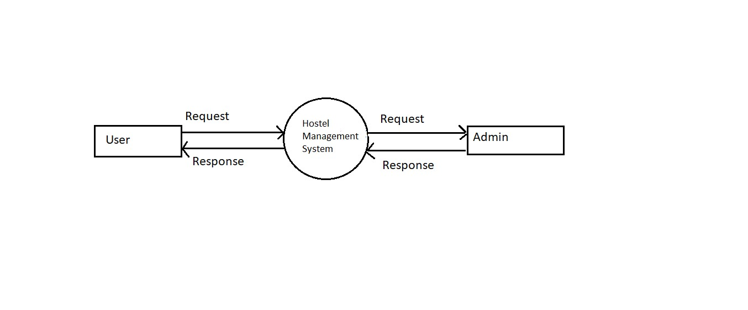

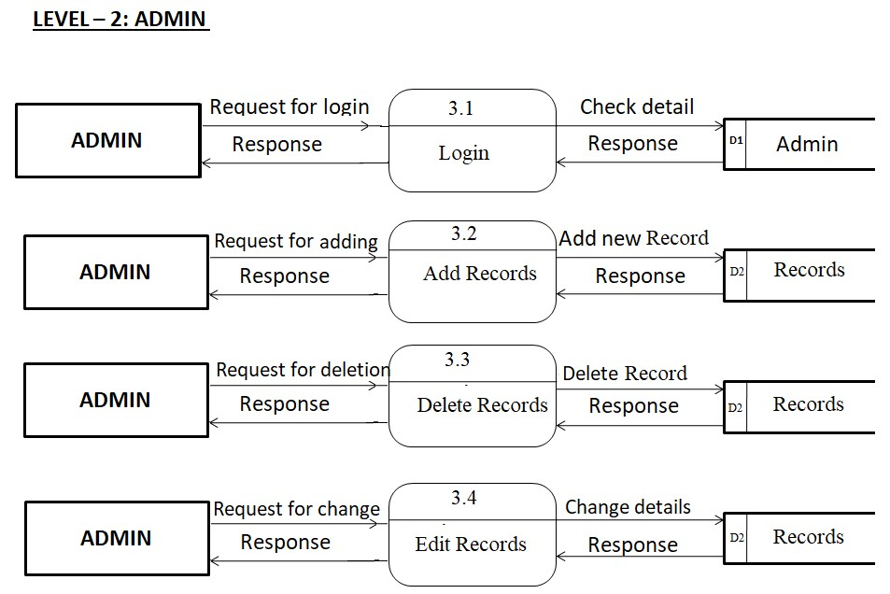

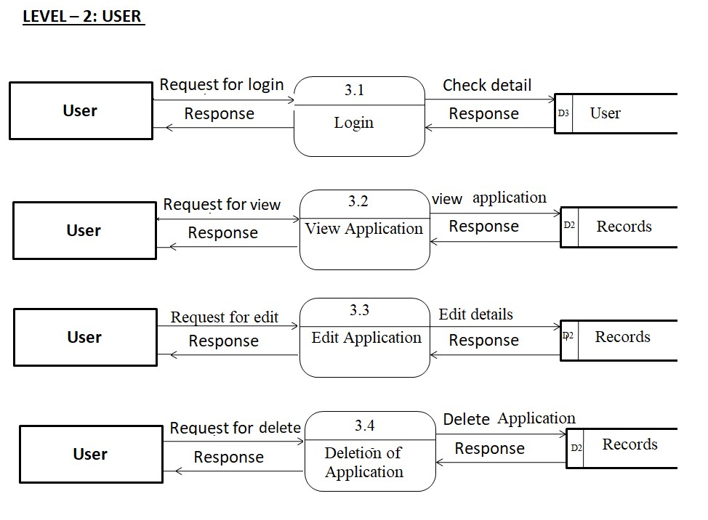

Entity Relational Diagram (ER – Diagram)

An Entity Relation(ER) Diagram is a specialized graphics that illustrates the interrelationship between entities in a database. ER diagrams often use symbols to represent 3 different types of information. Boxes are commonly used to represent entities. Diamonds are normally used to represent relationships and ovals are used to represent attributes

**ER Diagram:**

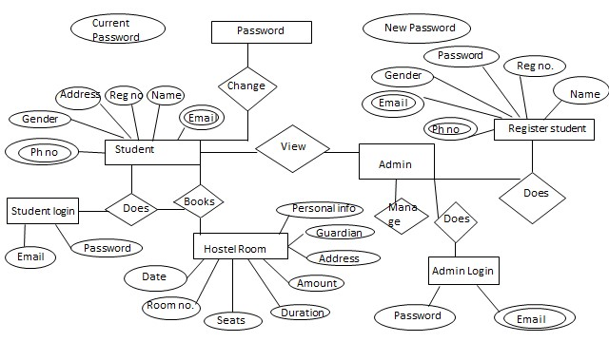

FUTURE SCOPE

It is easy to extend the system that we have proposed. A person could see any of the issued, unissued or all the rooms according to his/her will. In future we can implement some features for ―HOSTEL MANAGEMENT SYSTEM‖ project. In this system its possible to categorize room rent for middle class students and poor students. Some poor students are given a particular concession for the entire year.

**Conclusion**

To conclude the description about the project : The project, developed using PHP and MySQL is based on the requirement specification of the user and the analysis of the existing system, with flexibility for future enhancement. The expanded functionality of today‘s software requires an appropriate approach towards software development. This hostel management software is designed for people who want to manage various activities in the hostel. For the past few years the number of educational institutions are increasing rapidly. Thereby the number of hostels are also increasing for the accommodation of the students studying in this institution. And hence there is a lot of strain on the person who are running the hostel and software‘s are not usually used in this context. This particular project deals with the problems on managing a hostel and avoids the problems which occur when carried manually. Identification of the drawbacks of the existing system leads to the designing of computerized system that will be compatible to the existing system with the system which is more user friendly and more GUI oriented.

References

1. www.w3schools.com

2. in.php.net

3. en.wikipedia.org/wiki/PHP

. www.hotscripts.com/category/php/

4. www.apache.org/

5. www.mysql.com/click.php?e=35050