1. Identify three features relevant to the driver-free parking feature.

Driver free parking system, a complicated system needs some important features;

1. A sensor to observe and scan in multiple directions for a parking spot.
2. A camera provides necessary input to navigate the car safely and check its surroundings.
3. A radar used to determine the distance of objects, facing angle and speed of the vehicle.

There may be other sensors involved like ultrasonic sensor to send sound waves and measure distance between the objects, touch sensor to give a sense of touch and gyro sensor to measure the angle. Radars are more appropriate to use as it uses electromagnetic waves rather than sound waves. They are less affected by environmental variables like temperature, light and more. All the features are used for cruise control and auto-breaking. It allows the vehicle to keep pace with the car it is following, slow down when it moves closer to other vehicle and accelerating back to pre-set speed.

1. Describe each of the three features as a use case

The driving system parks the vehicle at a remote location after the passengers have exited. It also searches for a parking spot and re-parks the vehicle. This saves the time of searching for parking lot and the walking from and to the parking. The parking space is used efficiently when the space is not required to open the door.

Use case: Driverless parking

Actors: Sensor, Camera, Radar and Vehicle

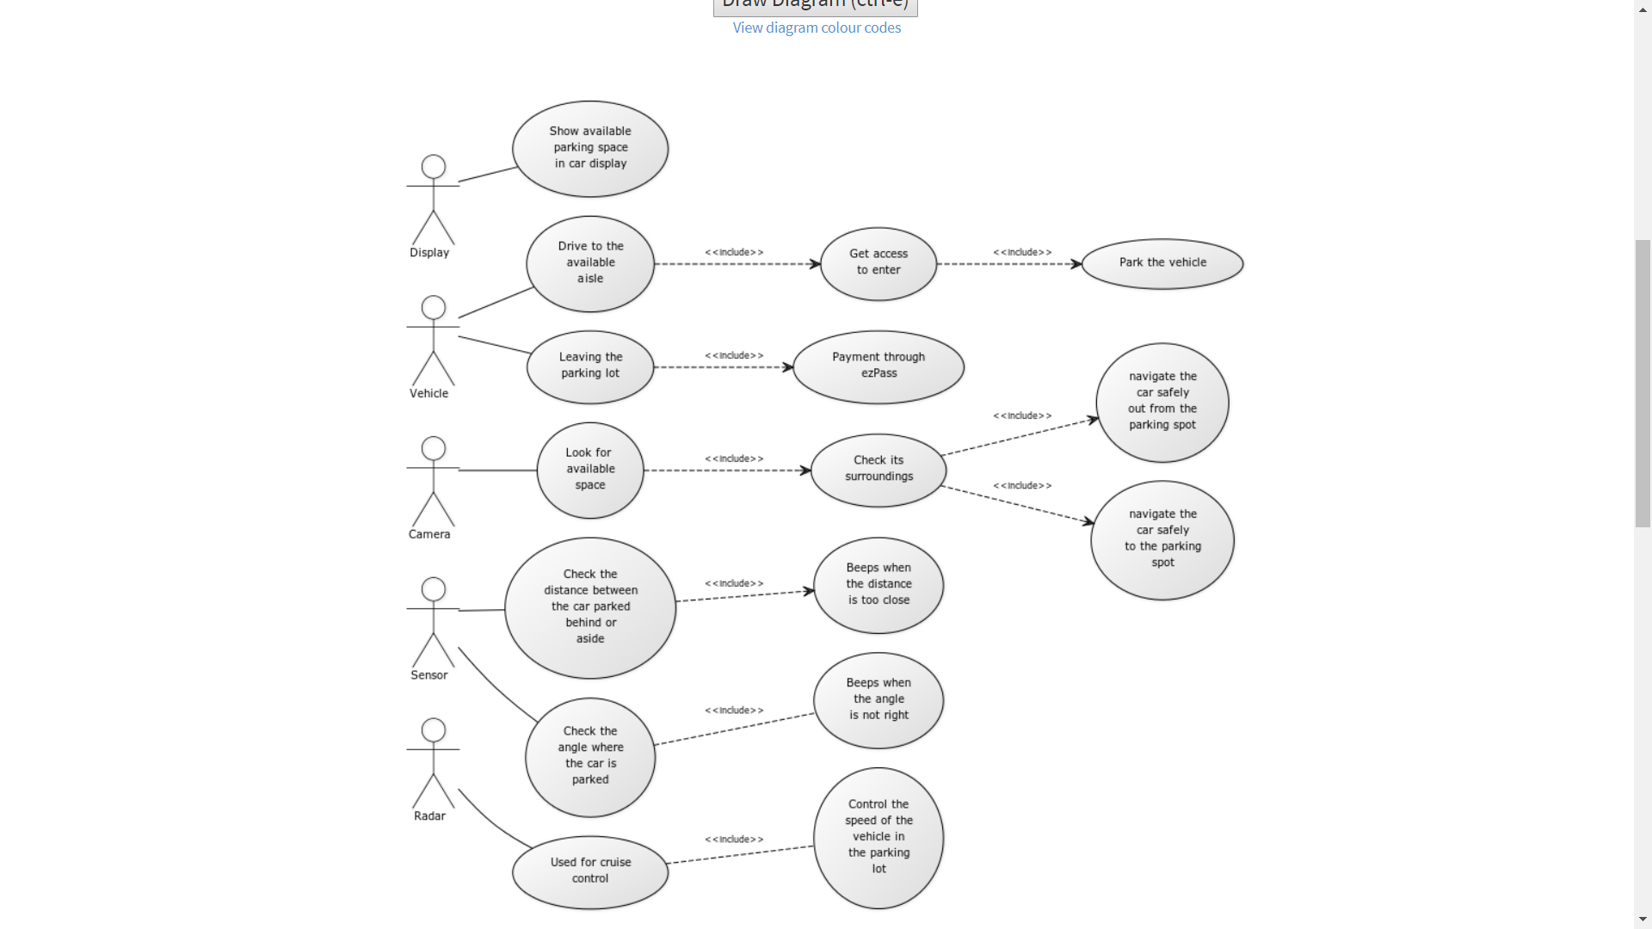

1. Describe each of the same features as user stories
2. **Title: Camera to look for parking spot**

User story: As a car owner, I want the camera to look for the parking spot in the display so that the robot can park in the space.

Priority:1. Story Points: 3.

Description: I want the car to be parked safely in a spot.

1. **Title: Sensor to sense the surrounding**

User story: As a car owner, I want the sensor to check for parking angles and distance between other vehicles so that there will be less accidents.

Priority:2. Story Points: 3.

Description: I want the car to check for distance between surrounding vehicles and check for angle the vehicle is parked. It can avoid accidents to and by other vehicles.

1. **Title: Radar to control the speed inside the lot**

User story: As a car owner, I want the radar to control the speed inside the parking lot to minimum of 10mph.

Priority:3. Story Points: 2.

Description: I want the car to control and maintain the same speed in the parking to avoid damages.

All these user stories can reduce the waste of time in searching for space, parking and walking to and fro from the lot. This can keep my insurance premiums low.

1. Describe the advantages and disadvantages of use cases and user stories for this task?

**Use Case Diagram:**

**Pros and Cons-** Most useful method of visualization. It is simple to learn. It is like a prototype that can be extended with additional features. It visualizes the functional requirement of the system. It is effective for modelling. Steps by step approach. It doesn’t have object-oriented concept. There is no formal representation. Missing the non-functional requirements.

**User stories:**

**Advantages and disadvantages-** Simple communication language between the client and developer. Facilitating time estimations and priorities. Improve reusability. Lack of step by step approach. No visualization of thoughts. Lack of information regarding the method of development. Missing the non-functional requirements.