1. Provide an overall description of the Scrum process and roles.

Scrum is a people-centric framework for organizing and managing work. It is an agile way to manage a software project.

**Diagram Ref:**

<https://www.itemis.com/en/agile/scrum/compact/introduction-to-scrum/scrum-process>

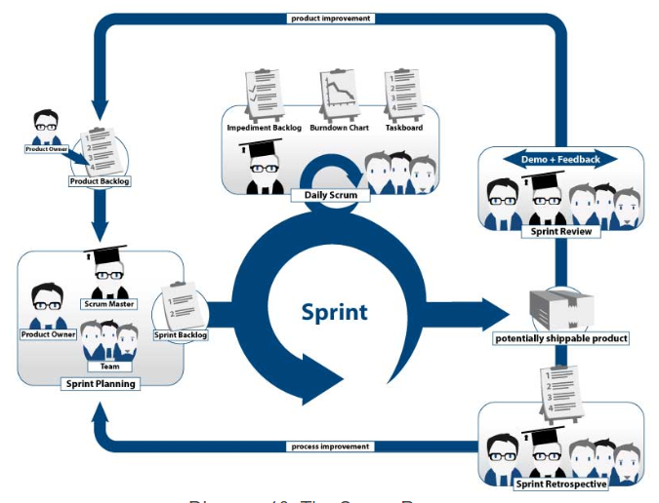

**Scrum Process:**

In Scrum process, there are different roles performed by the stake holders and scrum team.

Sprint review

Daily Stand-up

Sprint retrospective

Sprint planning

**Sprint planning:** It is done by product owner, scrum master and development team. It takes place at the beginning of the sprint. The team and the product owner decide on the contents of next sprint. They choose items from product backlog and prioritizes it.

**Daily Stand-up:** The daily meetings are between development team and scrum master. It is the informal meet lasting up to 15 minutes. The scrum masters resolve the blockers. The development team answers some questions on their previous day work, current work and any obstacles they face to reach the sprint goal.

**Sprint review:** The product owner, stake holders, development team and scrum master take part in the review meeting. They will review the sprint results with product owner. It is an informal meet up to brainstorm and plan for next sprint. It takes place at the end of each sprint to discuss about the feedback of the release.

**Sprint retrospective:** The development team and scrum master discuss about the success of the previous sprint and improvement of next sprint. They also revise about the product and release backlog.

These steps are repeated for each sprint.

**Roles:**

**Product owner**

Product owner is an active member of the scrum team. They represent the customers and their needs. They provide the product visionary like proving user stories, functional and non-functional features. They communicate with stake holders. They are responsible for return on investment. They manage and maintain the product backlog, decides about the next release.

**Development Team**

Developers are small, self-sufficient group with 3 to 10 people in the team. They possess development, testing or special skills. They choose tasks and organize themselves. They are co-located in one location.

**Scrum Master**

Scrum Masters helps development team practice scrum. They manage the scrum artifacts like burn down charts. They protect the development team from stake holders. But the scrum master does not have any authority over the team which means he cannot make technical or business decisions. They clear any roadblock. They maximize the communication. Scrum master is a coach and collaborator.

1. Explain the planning process for Sprint 1.  Who is involved?  What are the work products?  What are the roles and deliverables of each participant?  Who delivers what and when?

The product owner, scrum master and development team will discuss about the first sprint. The product owner gives the user story. The scrum master and development team will give the priority and story points. The sprint 1 is to fix a camera. The camera will look for an available parking spot in the display. The goal of the product owner is to park the car in a safe spot. The goal of the scrum master is to help the team with the burn down chart and work in progress board. The developers write code to look for a spot in the display and park the vehicle based on the directions in the map. The developer delivers the project based on the story points given in the user story.

1. Describe what happens, day to day, during Sprint 1.  Who is involved?  What are the work products?

The development team and scrum master will participate in a daily meet up. It is an informal meeting to discuss about the daily work. Each developer reports what they did since last scrum, what they will do before next scrum, what impediments require action. Managers observes but do not participate. Developers creates a new build each day.

The developers discuss with the scrum master about the coding completed. The completed piece of code will be tested. The first day of the sprint 1 will be opening the display on the car screen. The second day would be looking for spot. Third day code will direct the robot to follow directions using map and park the vehicle.

1. Describe what happens at the end of Sprint 1. Who is involved?  What are the work products?

At the end of each sprint, review meeting is conducted in which everyone including the stake holders participates. They demonstrate the features released during the sprint. They update the product architecture, refine the items. They plan for next sprint.

The car with camera is tested and delivered to the product owner. The product owners test the car’s parking assistance utility. They discuss about the deliverable.

1. How does the team measure progress?

The progress of the team is measured using the **burn down charts**. It is the graphical representation of remaining work maintained by the development team. It shows both estimated and actual values. The slope of the line is velocity. The horizontal axis contains the time required to complete the user story. The vertical axis contains the backlog user stories.

The progress can also be measured using the product/release/ sprint backlog board. It is a physical board with prioritized list of desired features.

These kind of tracking boards are called sprint artifacts.

1. How and when can the team adjust priorities?  Who sets the priorities?  When can changes be made?

The team adjust the priorities when grooming the product backlog. The grooming of product backlog has 3 main tasks;

1. Creating and refining: Original large items are refined into small items. Some items can be deleted if it is not feasible. This refining can be done by anyone in the team.
2. Prioritizing: It is done by the product owner. Some items can be re prioritized based on the importance.
3. Estimating items: Estimation of effort is done by developers based on their experience.

The changes can be made in the upcoming sprint.