1. **In the reading assignment this week Poppendieck and Cusumano point out that some of the principles of the lean philosophy have been practiced by software developers in the past, before agile methods like XP and Scrum were invented. Describe how Microsoft applied Lean principles according to the Poppendieck paper.**

In 1990’s Microsoft practiced agile development by applying Lean principles. The process was to develop small scale features. They automated build tools and quick tests. Most of the tests were automated. They focused on small, multifunctional teams. They followed the design, coding and testing standards. The also implemented continuous development and integration(CI/CD). They had overlapping responsibilities, so none of them were idle. They scheduled all the features and completed the milestones. They fixed bugs on daily basis. All these processes helped reduce the calendar time and engineering hours. In addition, they implemented eliminating waste and bureaucracy, fast iterations, rigid plans. It was a light weight development.

1. **Value stream mapping is an important tool used by Lean team.   Describe Value Stream mapping.**

Value stream mapping is the diagram in which the flow of goods or information is represented. It is one of the principles of lean developed for manufacturing and adapted for software development. It consists of;

Current map: It shows the current situation of the project.

Future map: It shows the desired situation.

It is useful for identifying the wastes that should be removed from the current map and changes must be established in the future map. The below depicted shows the value stream mapping referenced from the lecture.

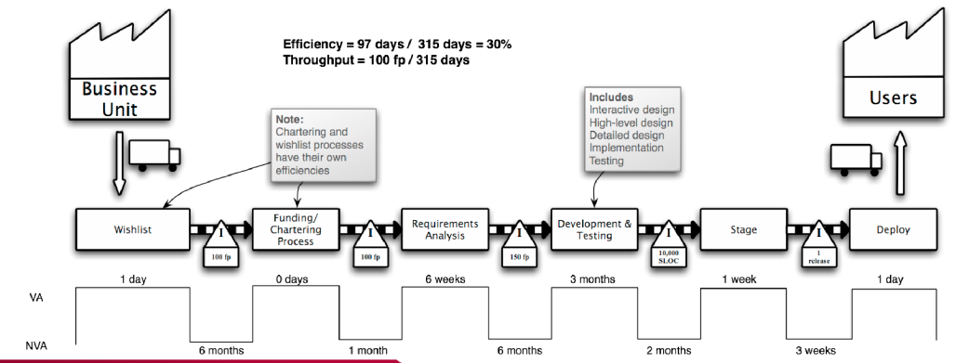

1. **Describe your GEDCOM team's current process (you don't need to draw a diagram) including how you communicate, how you integrate code from each team member, how you test code from all test members, and how you package and submit the results.**

Our team consists of 3 members. Each of us contribute to the project every week by coding our sprints. We have 2 sprints each to complete. We communicate through GroupMe(messenger) and GitHub. I code in PyCharm community and do check in with Git. We meet every week after the class. We test our own code by ourselves. We use nose tools to test the code. We also do pair programming to find bugs. It is time consuming and creates dependency. But still it is very useful to create a quality code. We all check in together and communicate to each other. We then test everyone’s code in our own system. We give the related links of git, drive in the final word document or pdf and submit in Canvas.

1. **Evaluate your GEDCOM team's current process and identify waste in your process.   Describe a new process for your team to follow to eliminate waste in your team's current process.**

Eliminating waste is one of the principles of lean. Anything that does not add value to the customer is waste. Value stream mapping must be implemented. Some examples of waste are unneeded features, delay in development process and more. We currently have less time to spend together to discuss the project. It creates dependency to submit the project on due date. This dependency must be reduced. We are starting the sprint coding late. We have to start immediately after submitting one sprint. We eliminate the unwanted line of code while pair programming. My code is reviewed by Trevor. Trevor’s code is reviewed by Amr. Amr’s code is reviewed by Trevor. We also test each other’s code.