1. Display a list of all instructors, showing their ID, name, and the number of sections that they have taught. Make sure to show the number of sections as 0 for instructors who have not taught any section. Your query should use an outer join and should not use scalar subqueries.

select ID, name,

count(Tch.ID) as ’NumOfSections’

from instructor Ins natural left outer join teaches Tch

group by ID, Name

order by ID

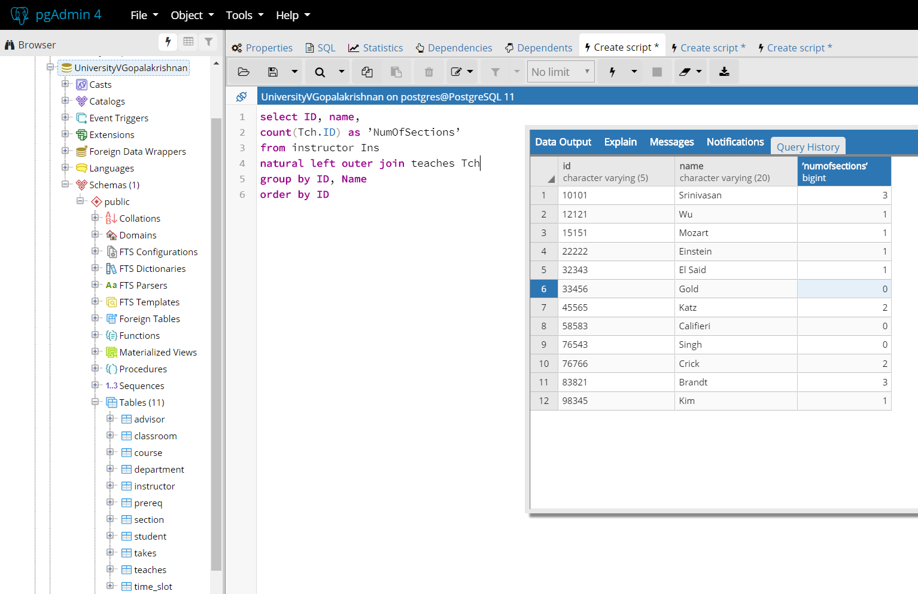

2. Write the same query as above without using join.

select ID, name,

(select count(Tch.id) as ’NumberOfSections’ from teaches Tch where Tch.id = Ins.id)

from instructor Ins

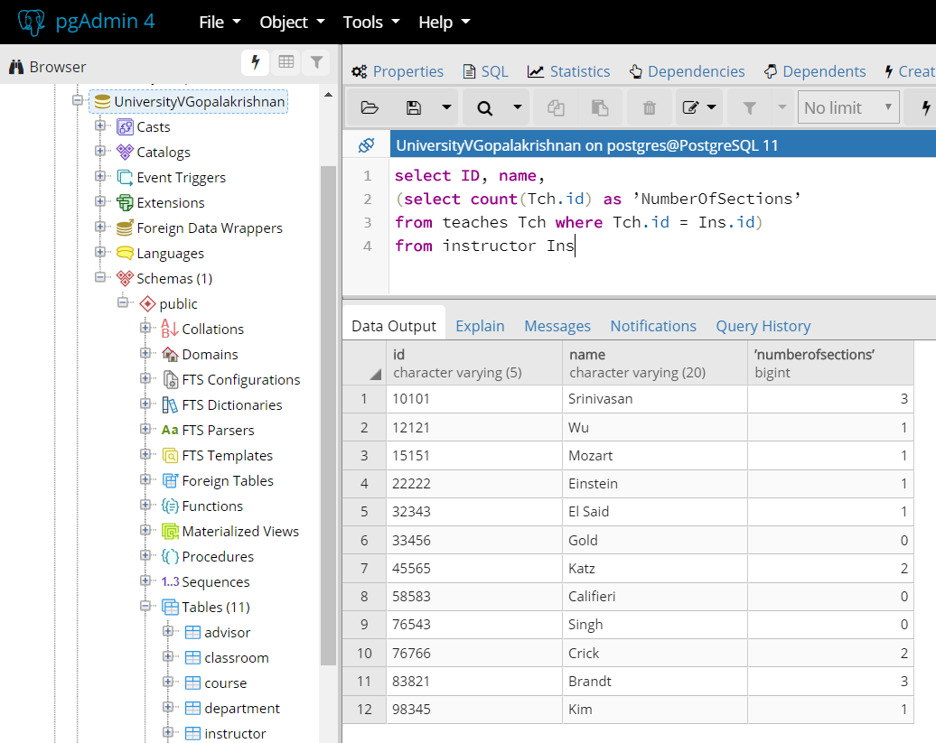

3. Display the list of all departments, with the total number of instructors in each department, without using scalar subqueries. Make sure to correctly handle departments with no instructors. Use a different outer join than you used in the first question.

select dept_name, count(ID) as TotInstructors

from department

natural join instructor

group by dept_name

order by dept_name

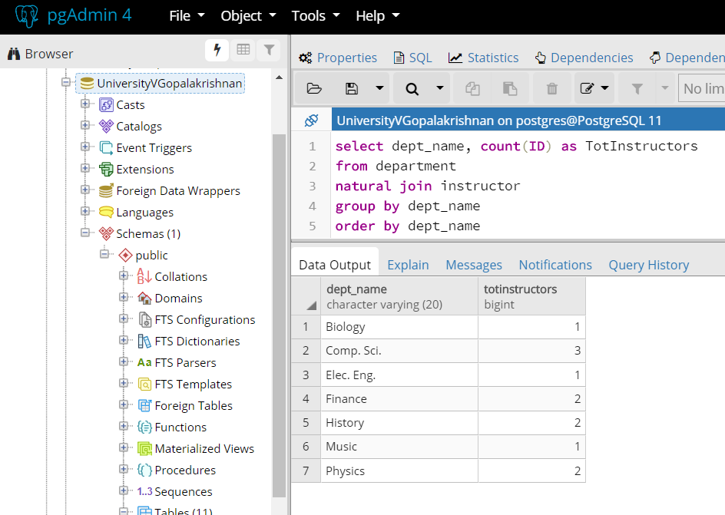

4. Retrieve the names of all instructors who work in the department that has the employee with the highest salary among all instructors.

select ID, Name from instructor where dept_name=

( select dept_name from instructor where salary=

( select max(salary) from instructor ))

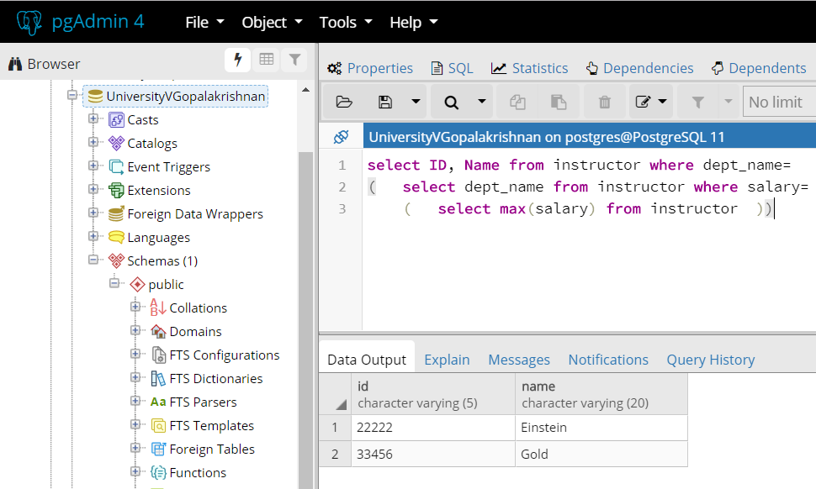

5. Retrieve the names of instructors who make at least $10,000 more than the instructor who is paid the least in the university.

select ID, name

from instructor

where salary >= 10000+ (select min(salary) from instructor)

