1. Write appropriate SQL DDL statements for declaring the LIBRARY relational database schema.

CREATE TABLE BOOK

(Book_id INT NOT NULL,

Title VARCHAR(100) NOT NULL,

Publisher_name VARCHAR(100),

PRIMARY KEY (Book_id));

CREATE TABLE BOOK_AUTHORS (Book_id INT NOT NULL,

Author_name VARCHAR(100)NOT NULL,

PRIMARY KEY (Book_id, Author_name),

FOREIGN KEY (Book_id) REFERENCES BOOK (Book_id));

CREATE TABLE PUBLISHER (Name VARCHAR(100) NOT NULL,

Address VARCHAR(100) NOT NULL,

Phone CHAR(15),

PRIMARY KEY (Name));

CREATE TABLE BOOK_COPIES (Book_id INT NOT NULL,

Branch_id INT NOT NULL,

No_of_copies INT NOT NULL,

PRIMARY KEY (Book_id, Branch_id),

FOREIGN KEY (Book_id) REFERENCES BOOK (Book_id));

CREATE TABLE BOOK_LOANS (Book_id INT NOT NULL,

Branch_id INT NOT NULL,

Card_no INT NOT NULL,

Date_out DATE NOT NULL,

Due_date DATE NOT NULL,

PRIMARY KEY (Card_no, Book_id, Branch_id),

FOREIGN KEY (Book_id) REFERENCES BOOK (Book_id));

CREATE TABLE LIBRARY_BRANCH (Branch_id INT NOT NULL,

Branch_name VARCHAR(100)NOT NULL,

Address VARCHAR(100)NOT NULL,

PRIMARY KEY (Branch_id));

CREATE TABLE BORROWER (Card_no INT NOT NULL,

Name VARCHAR(100)NOT NULL,

Address VARCHAR(100) NOT NULL,

Phone CHAR(15),

PRIMARY KEY (Card_no));

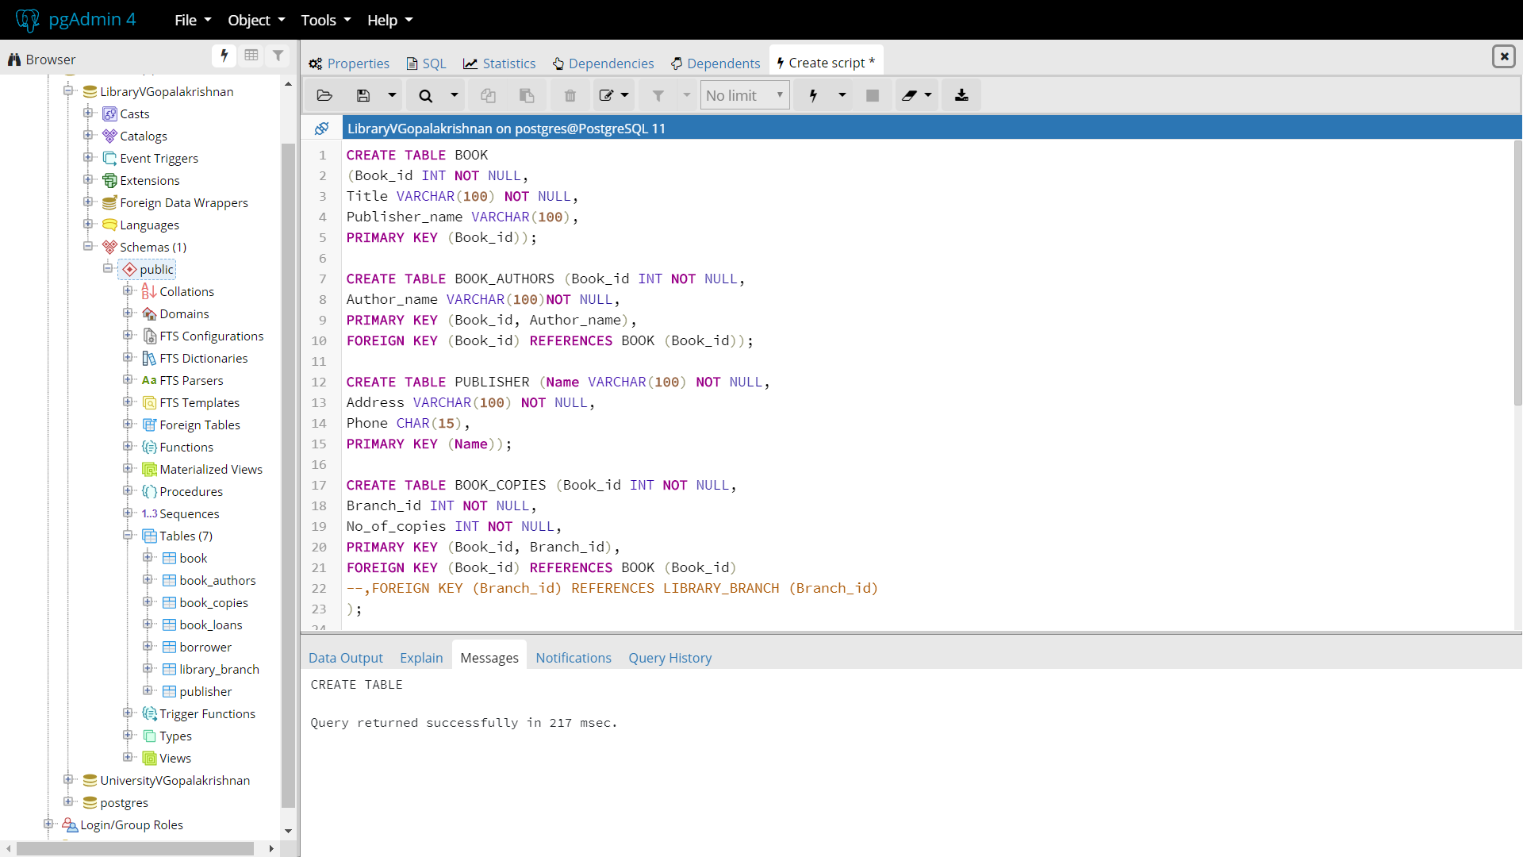

1. Write the appropriate SQL statements to populate the BOOK and PUBLISHER relations with 3 records in both relations.

insert into book values(1001, 'Harry Potter', 'JK Rowling');

insert into book values(1002, 'Dairy of a Wimpy Kid', 'Jeff Kinney');

insert into book values(1003, 'Dog Man', 'Dav Pilkey');

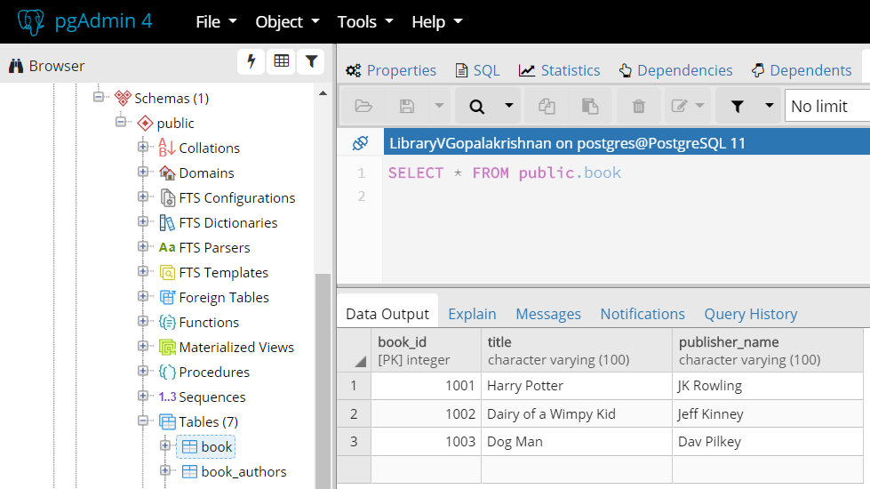

insert into publisher values('JK Rowling','3208 kestrel ct NJ',9790936236);

insert into publisher values('Jeff Kinney','64 white oak GA',9790706060);

insert into publisher values('Dav Pilkey','2508 carlton dr VA',9790706653);

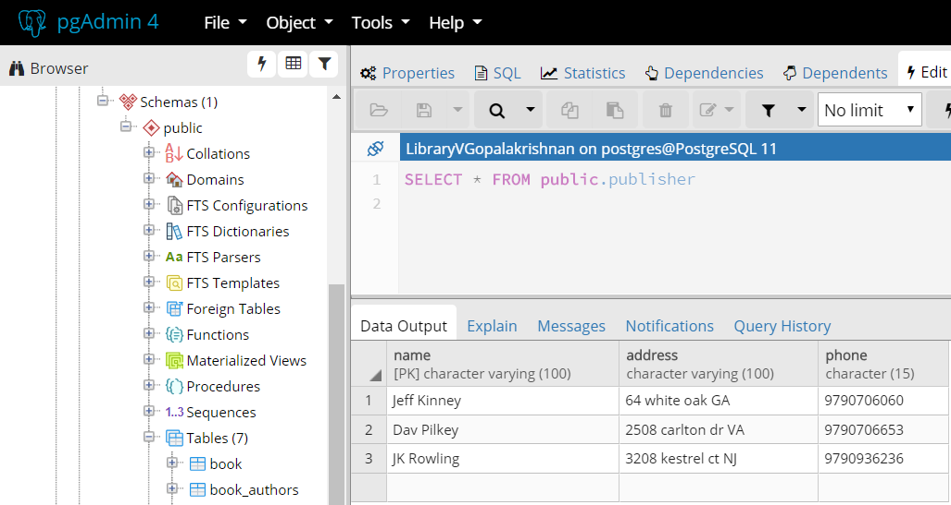

1. Write the appropriate SQL statement(s) to remove the records from the book table but leave the table structure intact. (5 points)

delete from book

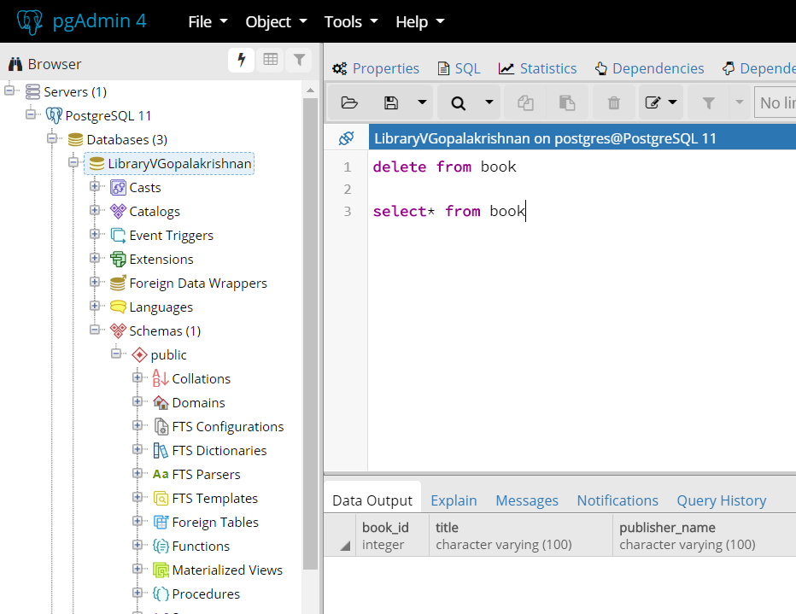

1. Write SELECT statements to do the following: (4 points each)
2. List all of the Publishers names. There should not be any duplicates.

select distinct name from publisher

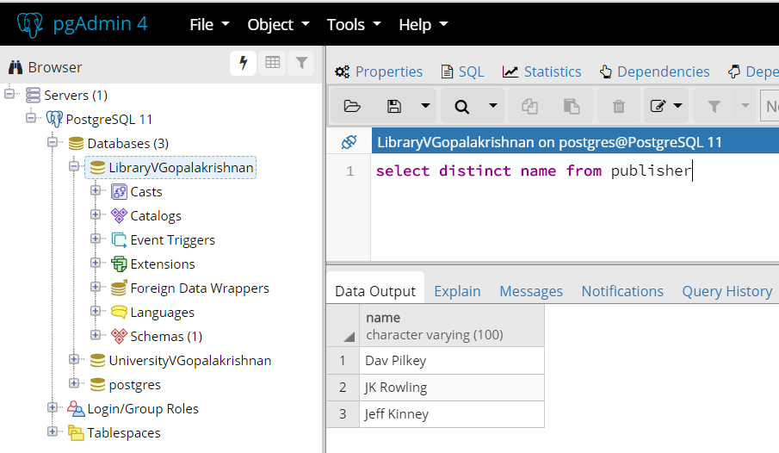

1. The names of the borrowers who currently have books from the library.

select name from borrower

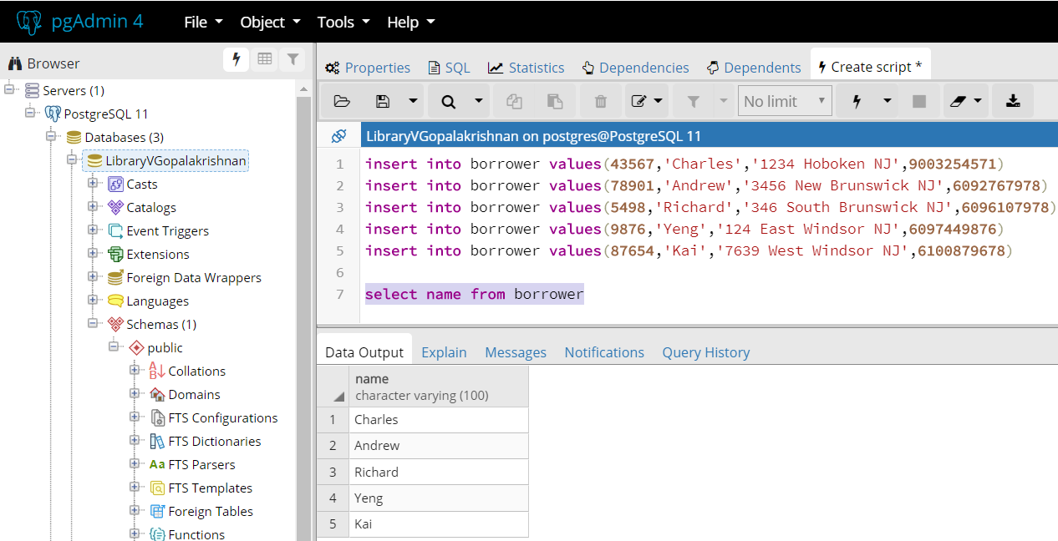

1. List all the books published by ‘Bookshelf’ that are on loan to card 43576

select * from book_loans where card_no = 43576;

