1. Write the following SQL queries.

a. Find the titles of courses in the Comp. Sci. department that have 3 credits.

select title from course

where dept_name='Comp. Sci.' and credits=3

b. Find the IDs of all students who were taught by an instructor named Einstein; make sure there are no duplicates in the result.

select distinct student.id

from student

inner join instructor on student.dept_name=instructor.dept_name

where

instructor.name='Einstein'

c. Find the highest salary of any instructor.

select max(salary)

from instructor

d. Find all instructors earning the highest salary (there may be more than one with the same salary).

select ID, name

from instructor

where salary = (select max(salary) from instructor)

e. Find the enrolment of each section that was offered in Fall 2009. Remember just a number is meaningless unless you include what it refers to.

select course_id, sec_id, count(id) as count

from section

natural join takes

where semester='Fall' and year = '2009'

group by 1, 2

f. Find the maximum enrolment, across all sections, in Fall 2009.

select max(maxcount) as Max_Enrollment

from

(

select count(id) as maxcount

from section

natural join takes

where semester='Fall' and year = '2009'

group by course_id,sec_id) as count

g. Find the sections that had the maximum enrolment in Fall 2009. Make sure you use a WITH clause.

with secmax

as (

select course_id, sec_id, count(ID) as maxcount

from section

natural join takes

where semester = 'Fall'

and year = 2009

group by 1,2)

select course_id, sec_id

from secmax

where maxcount = (select max(maxcount) from secmax)

2. Now run these queries on your university database and submit the screen shots of each answer. If the answer does not match what you think it should be, correct the query and try again. This is a way for you to learn from your mistakes. You can submit each one separately but make sure you label them appropriately. Otherwise paste them all into one Word document and submit that. Make sure I can see all rows and columns for the output. You might have to make the result window full screen.

a. Find the titles of courses in the Comp. Sci. department that have 3 credits.

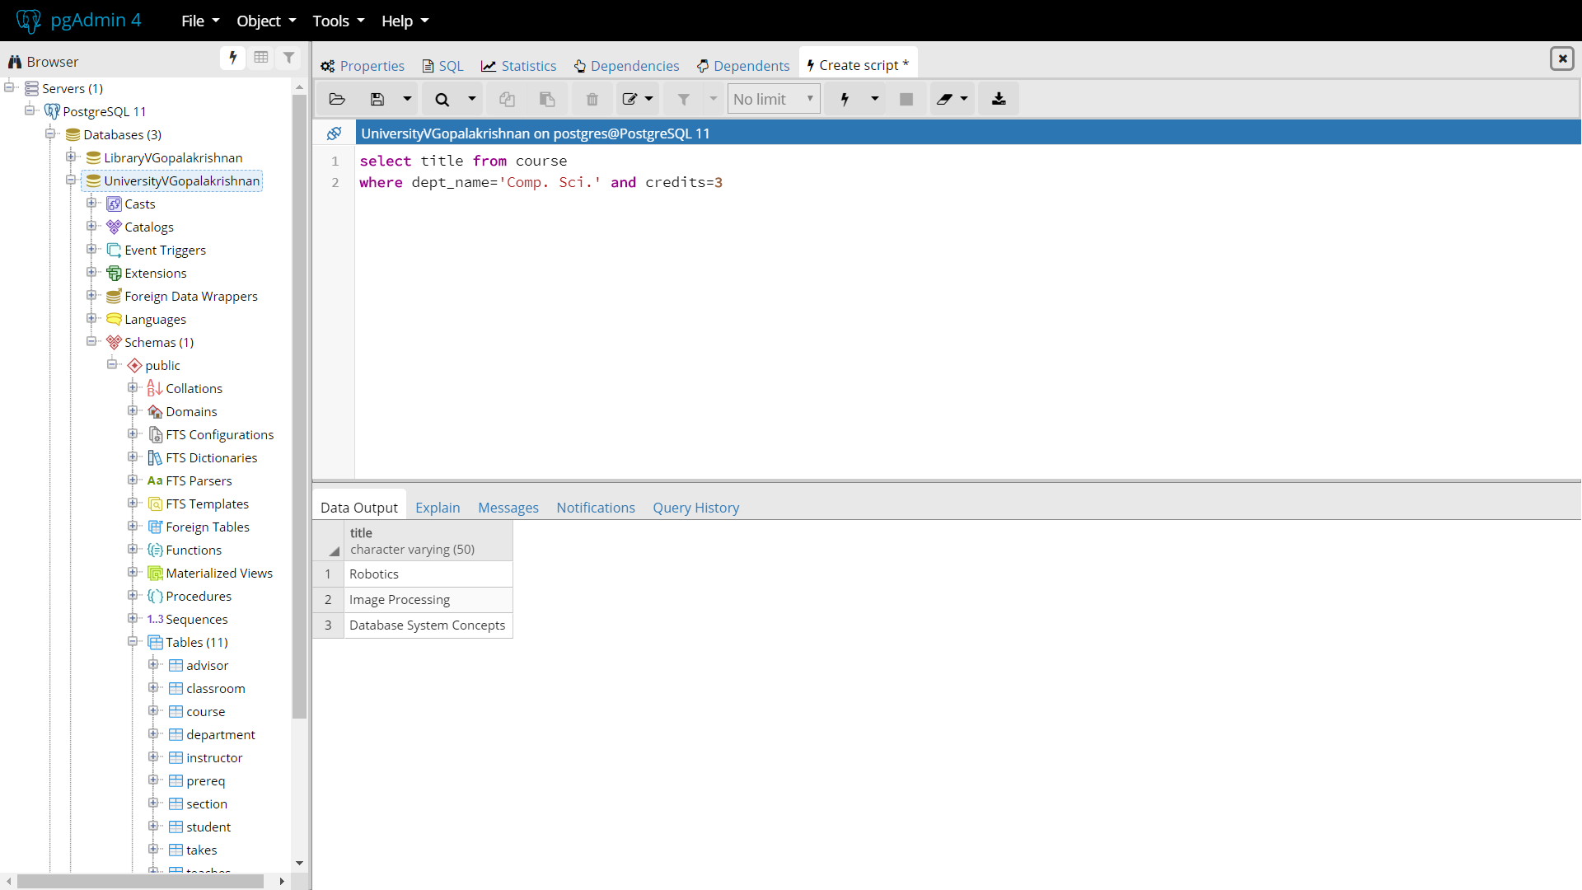

b. Find the IDs of all students who were taught by an instructor named Einstein; make sure there are no duplicates in the result.

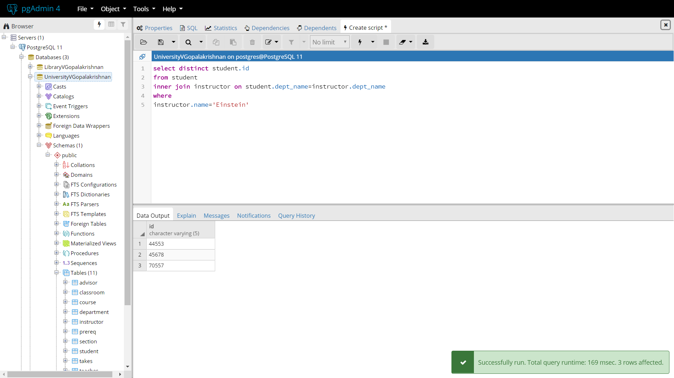

c. Find the highest salary of any instructor.

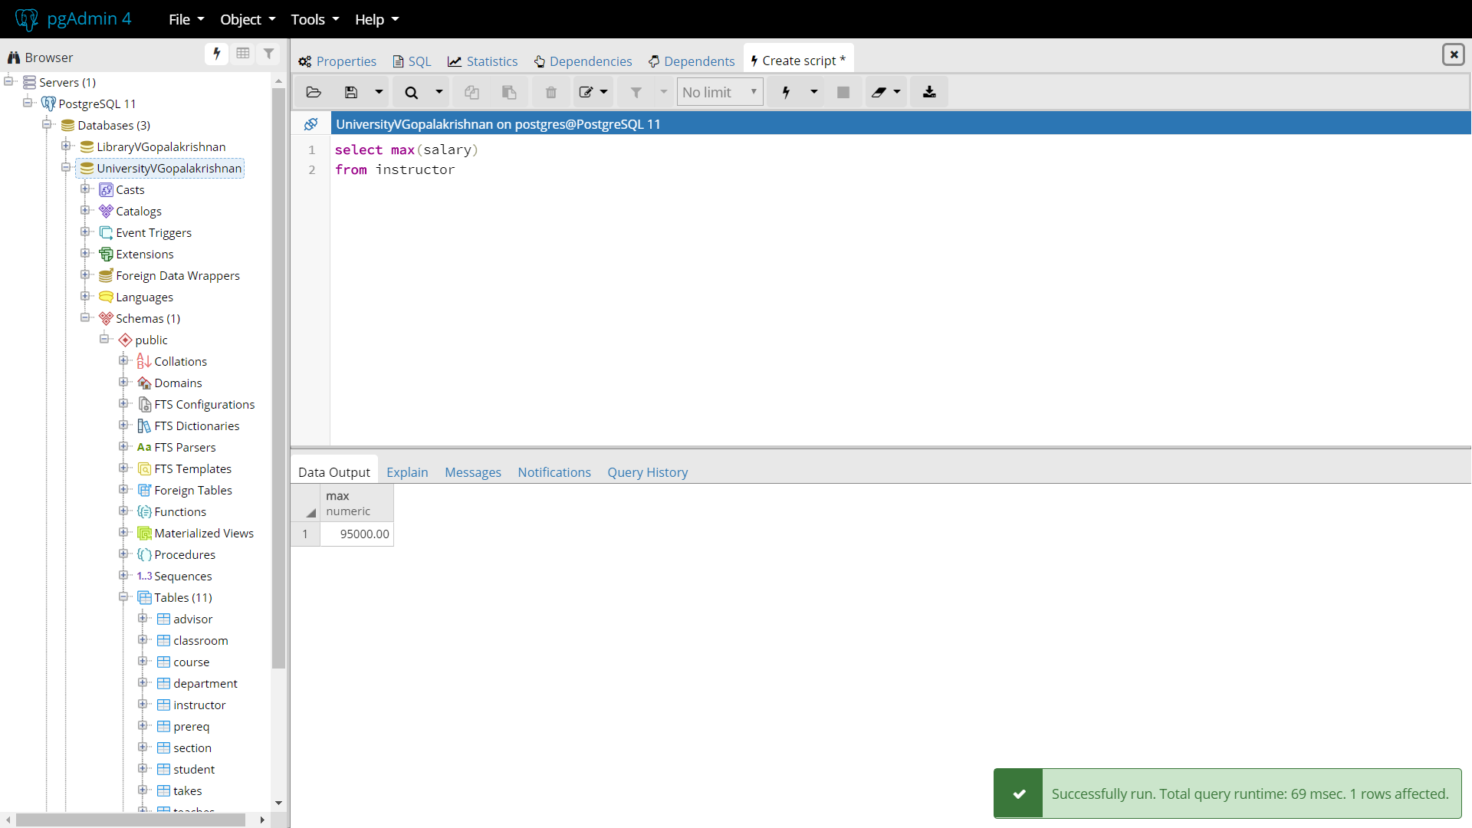

d. Find all instructors earning the highest salary (there may be more than one with the same salary).

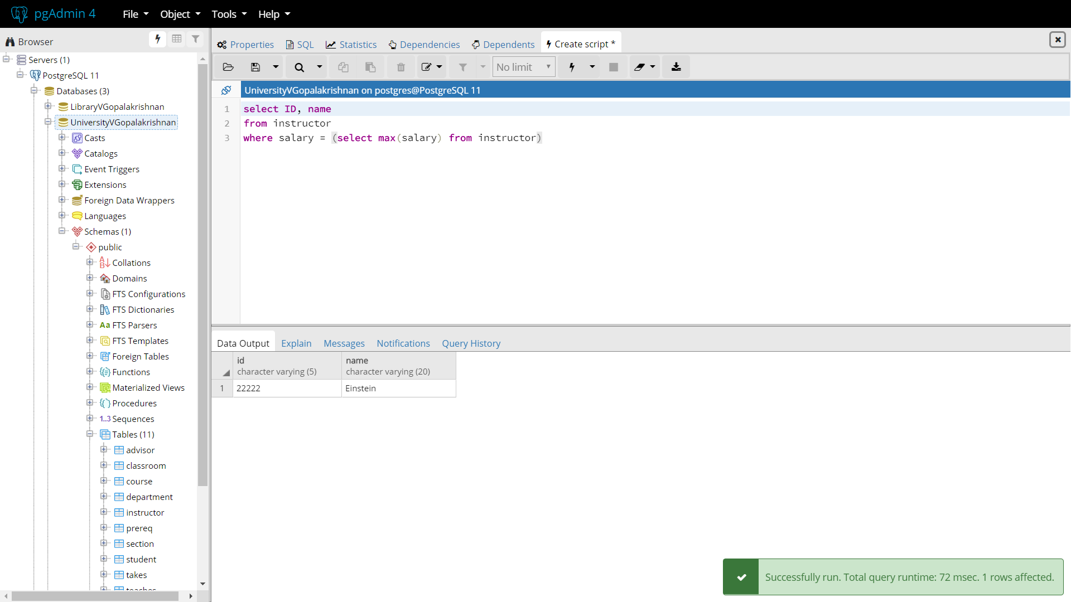

e. Find the enrolment of each section that was offered in Fall 2009. Remember just a number is meaningless unless you include what it refers to.

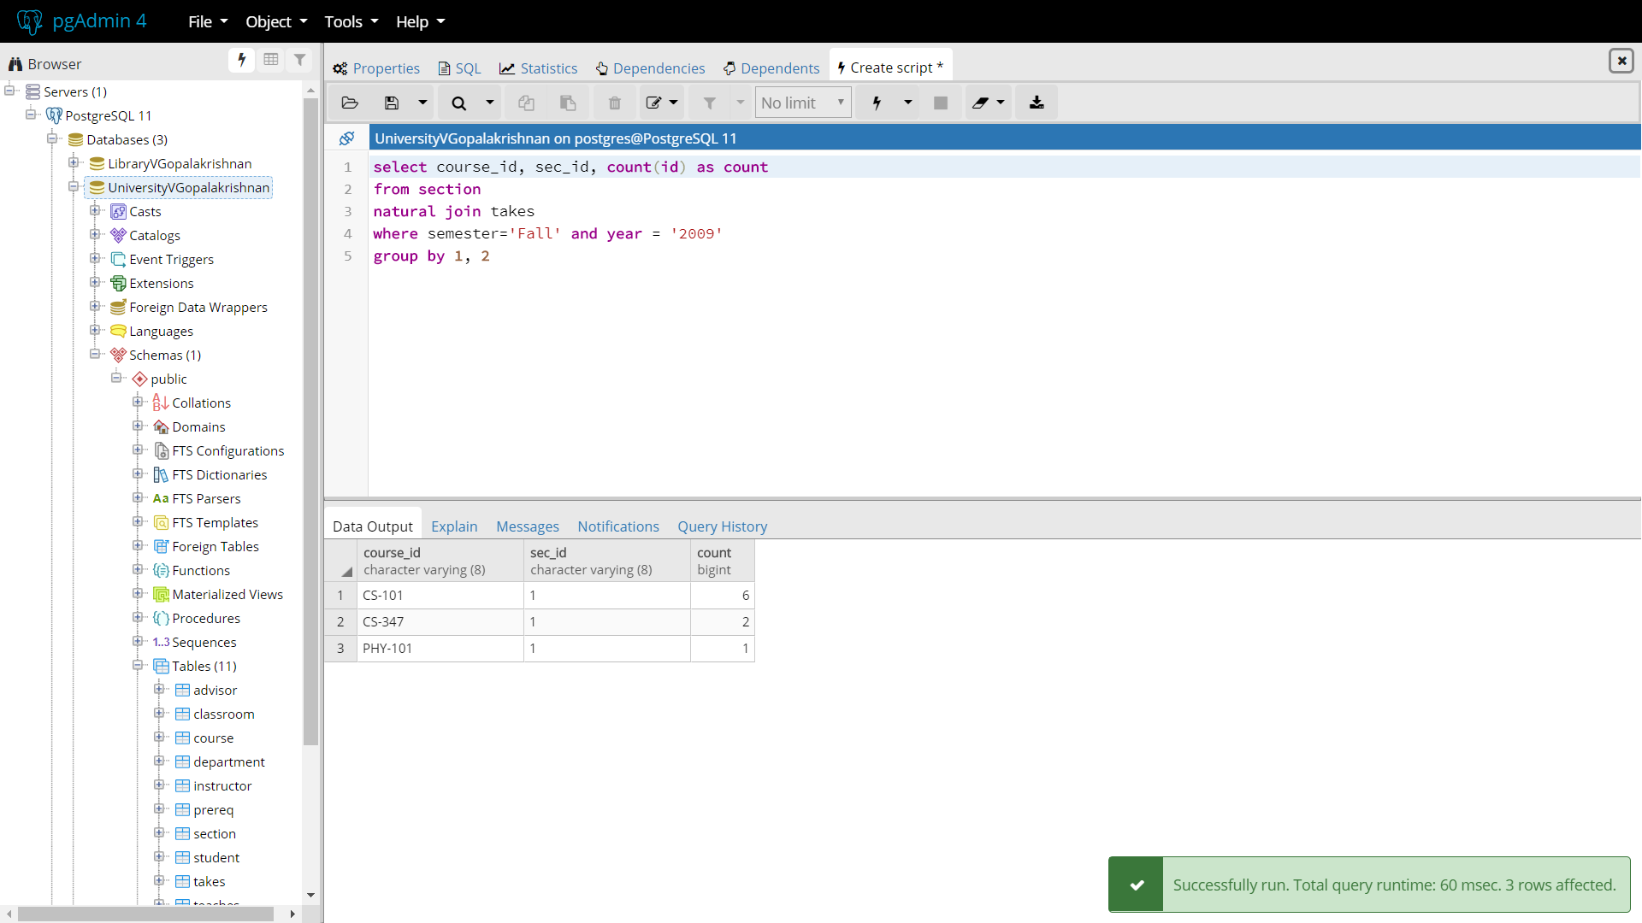

f. Find the maximum enrolment, across all sections, in Fall 2009.

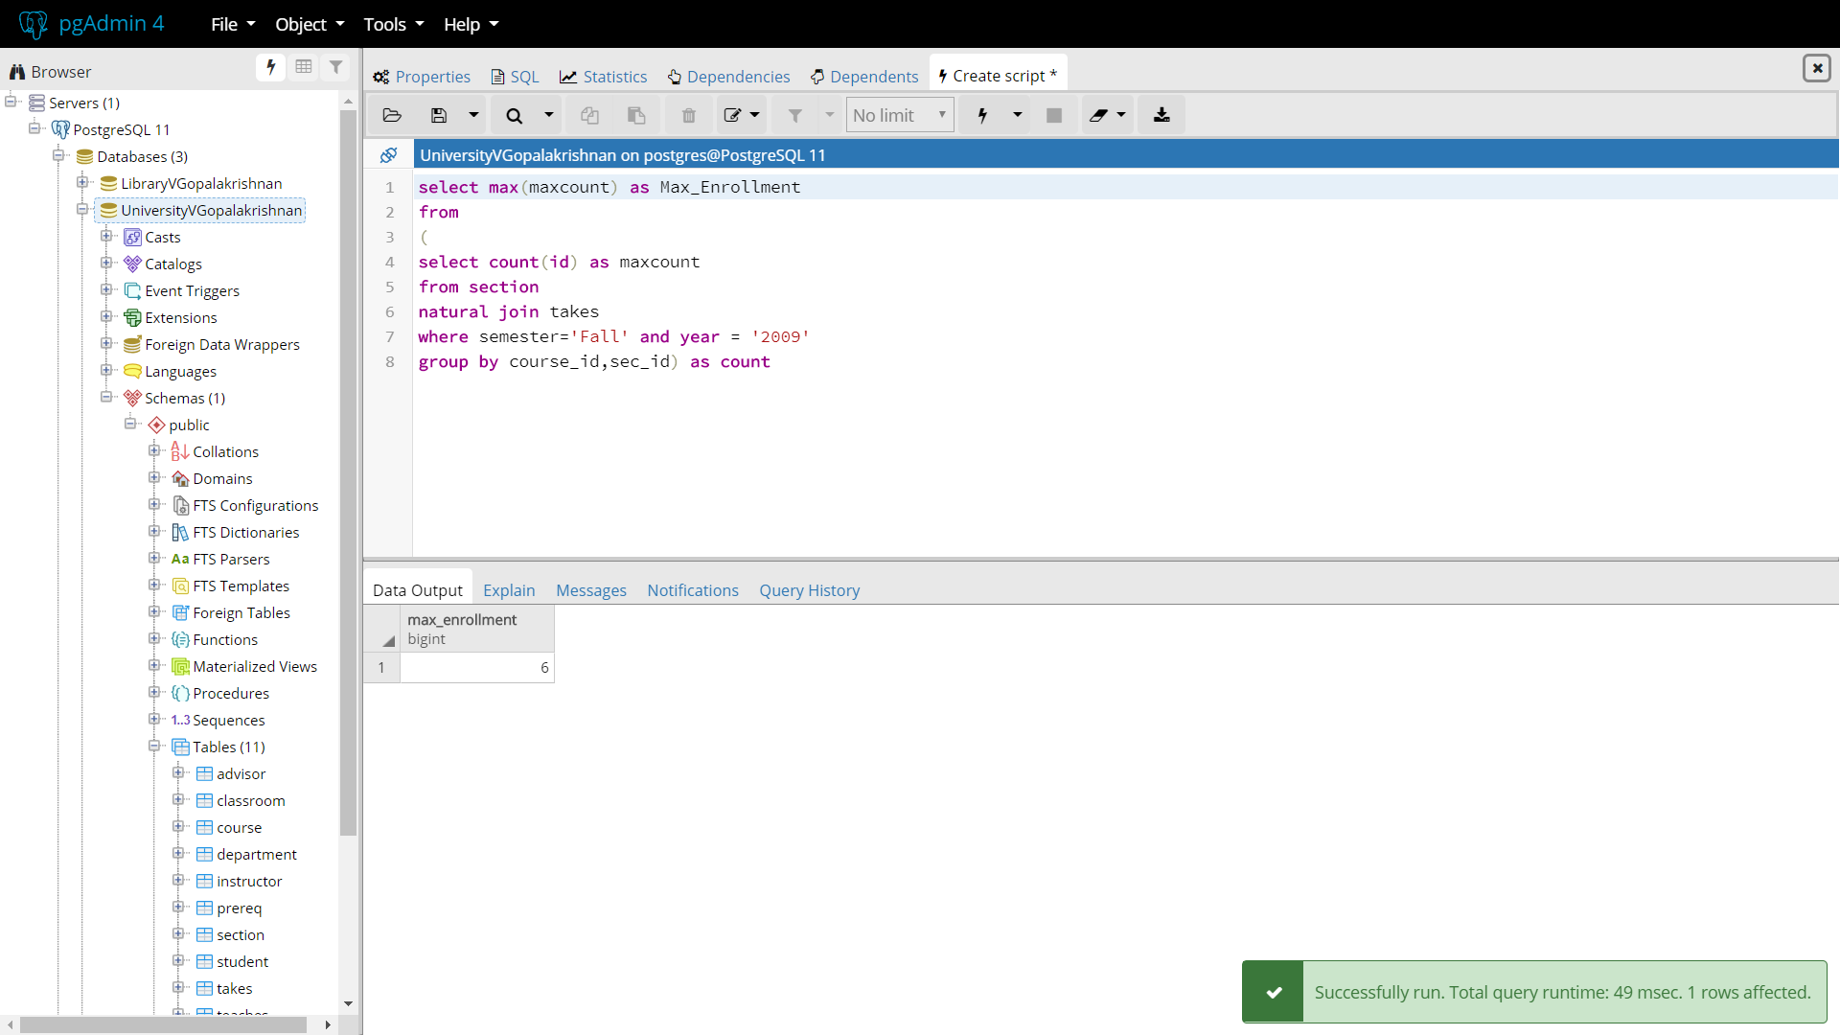

g. Find the sections that had the maximum enrolment in Fall 2009. Make sure you use a WITH clause.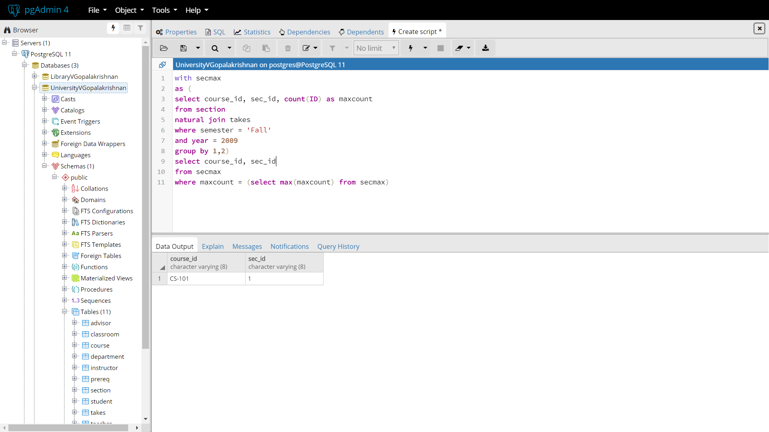

3. Write the statements to insert 3 records into the student relation. Test them on our database. If they do not work, tell me why. If they work, tell me what happened. (5 points each – 3 points for insertion statement and 2 points for explanation of what happened)

a. Insert a student with your last name into the Finance department with an id of 00005 and 0 credits.

insert into student values(‘00005’,'Gopalakrishnan','Finance',0)

The statement worked as I inserted values only after checking the data types of the attributes in the table.

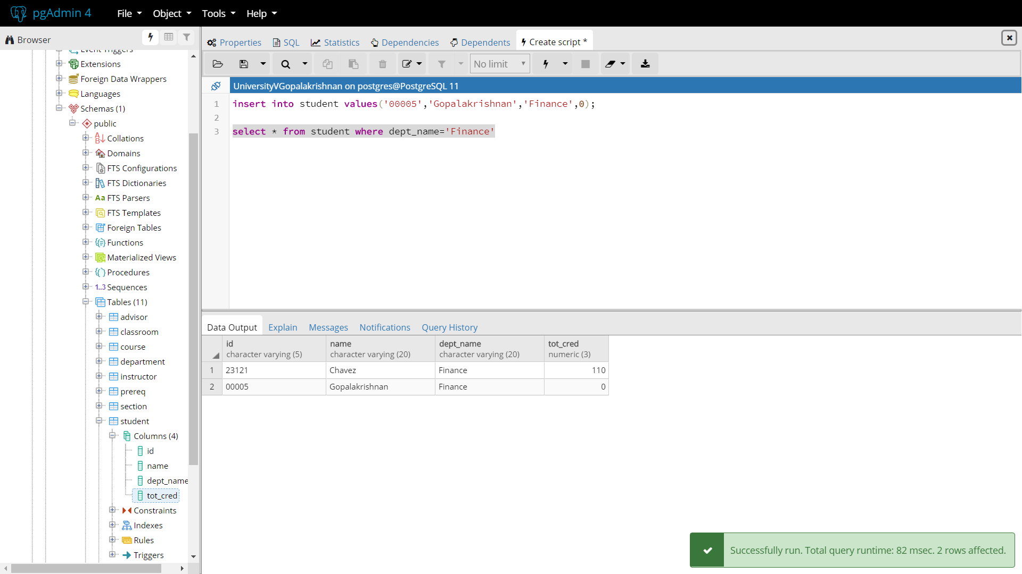

b. Insert a student with my last name into the Comp. Sci. department with an id of 12345 and null credits.

The insert did not work. I checked the table for existing values and there was already a person with the same ID. I deleted the record and inserted the new record.

select * from student where ID = '12345';

delete from student where ID = '12345';

insert into student values('12345','Schwartz','Comp. Sci.',NULL);

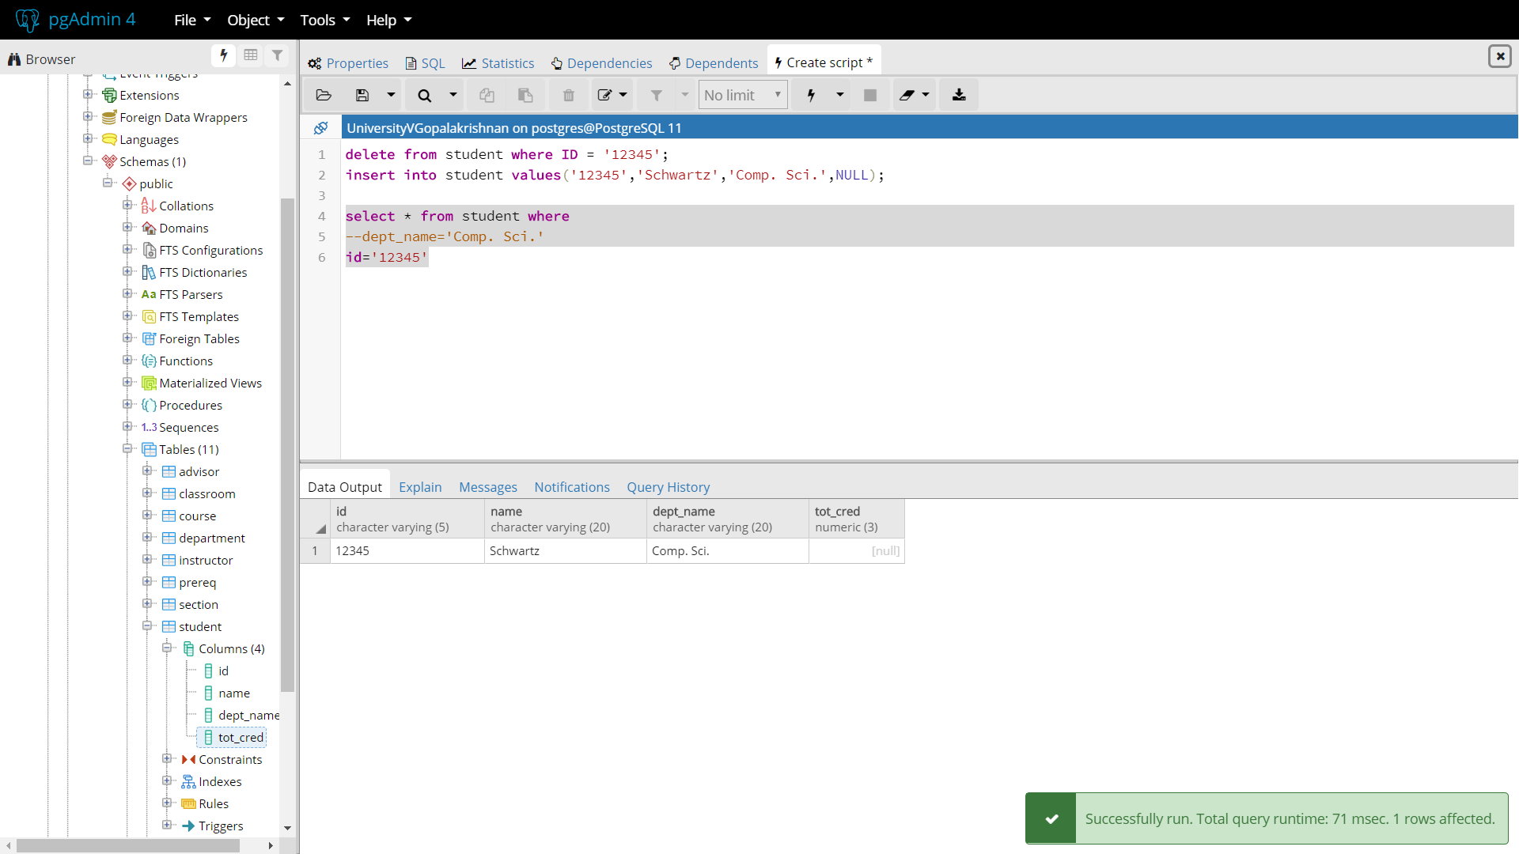

c. Insert a student with the last name of Zhang into the Comp. Sci. department with an id of 00300 and 100 total credits.

The insert did not work. I checked the table for existing values and the person was already there with different ID. I deleted the record and inserted the new record.

select * from student where Name='Zhang';

delete from student where Name='Zhang';

insert into student values('00300','Zhang','Comp. Sci.',100);

Alternate way is to update the existing record with the below query.

update student

set ID = '00300' and tot_cred=100

where Name='Zhang';

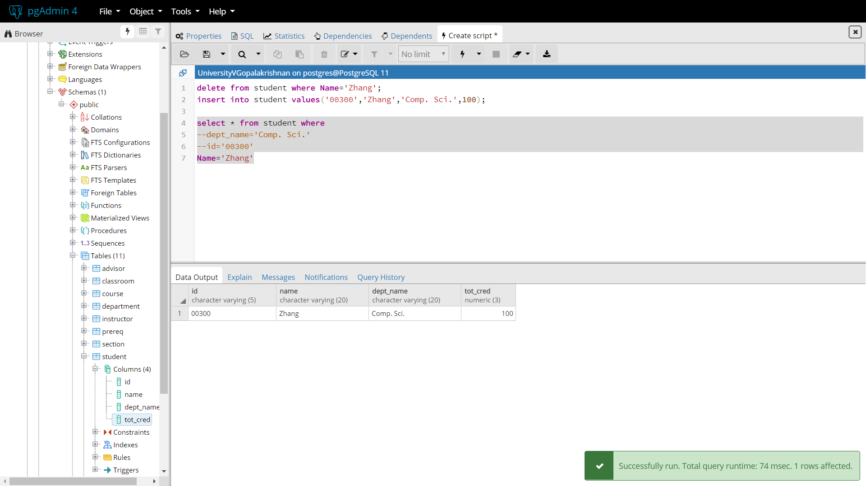

4. Show me a screen shot of the contents of the student relation. Make sure it shows all the content and is large enough for me to read without a magnifying glass.

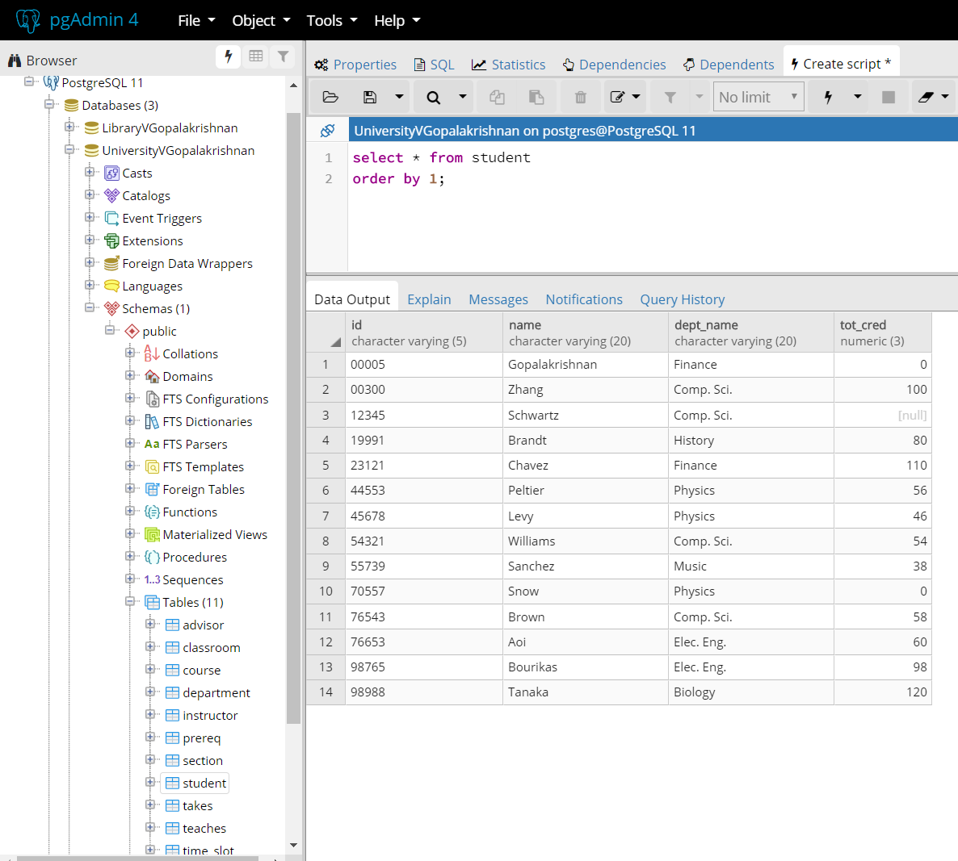

5. Write but do NOT execute the following queries.

a. Delete the contents of the prereq table.

delete from prereq;

b. Delete student 00300 from the student table.

delete from student where ID = '00300';

6. Find any department whose name contains all the letters ‘psy ’in this order but be careful because you want to include departments that might start with those letters and the first one would be capitalized. See if you can write it with only one WHERE predicate. If not, I will accept two.

select dept_name from department

where dept_name like 'P%s%y%'

order by 1;

select dept_name from department

where dept_name like 'p%s%y%'

order by 1;

There are no departments with the letters “psy” in it.

But there is one department if it is “Phy”

select dept_name from department

where dept_name like 'P%h%y%'

order by 1;

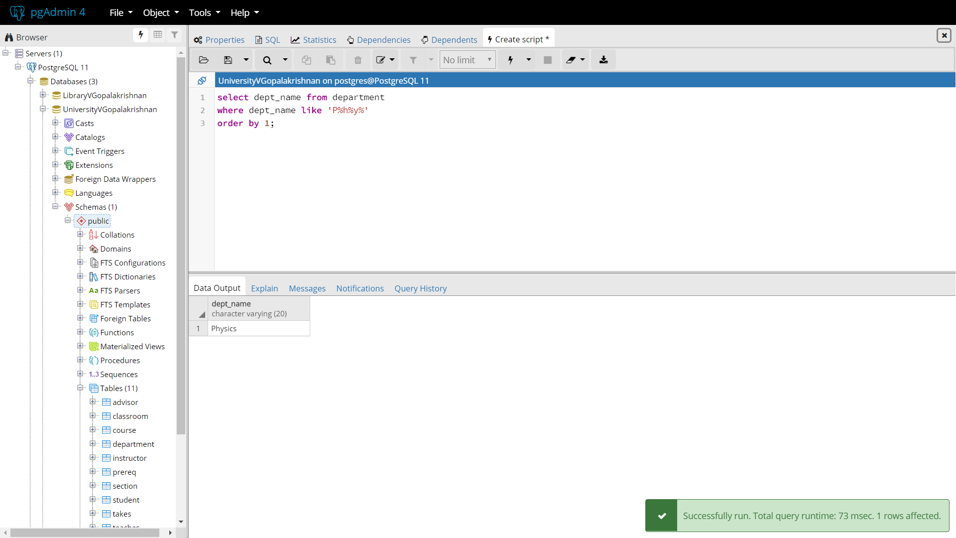

7. Find the names and major departments of all straight A students. This does not include

students with A- as even one grade. We do not give A+. A course that has not yet had a grade assigned should be ignored as the grade does not affect the GPA.

select s.name, c.dept_name, t.semester, t.grade

from takes t

natural join student s

natural join course c

where

s.id= t.id and c.course_id=t.course_id

and grade = 'A'

order by 1;

8. Run the statement from 7 in our database and explain the results.

There are 2 students with Grade A where student Brown obtained A grade in both Fall and Spring semester. Student Tagada obtained A grade in Summer. The result is illustrated in the below screen shot.

